THIRD sunday AFTER EPIPHANY

TRINITY EVANGELICAL LUTHERAN CHURCH | Saline, Michigan
WELCOME TO WORSHIP January 22, 2023
Thank you for joining us in God’s house today! We cordially ask that our Guests sign one of the guestbooks located at either the front or back entryways, or fill out a “Let’s Get Acquainted” card located in the hymnal pew rack and place it in the collection plate.

THANK OFFERING: Members of Trinity give their offering as an expression of love and thankfulness to the Lord and to help support the Lord’s work in our community and around the world. Visitors need not feel obligated to participate in this offering which supports our ministry.

Restrooms are located at the back of the upper level (the annex), and in the basement (down the back stairs of the sanctuary or annex). Handicap access is available, please ask an usher for assistance.

Young Families / Toddler Bags – We are GLAD YOU BROUGHT YOUR CHILDREN to our worship service. Jesus said: “Let the little children come to me and do not hinder them, for the kingdom of God belongs to such as these.” We know that having little children in church can be a challenge, but DO NOT WORRY about it. Many of your fellow worshippers have been in your shoes and are just happy you brought your children with you. For your convenience, we have reserved the back rows of seating for parents with small children. These areas provide more flexibility for your family, as well as, easy access to move downstairs if necessary. A closed-circuit TV system allows families to continue participating in the service while downstairs. Pre-school toddler bags and children’s bulletins are available for their enjoyment. Ask an usher for one to use during the service and please return the toddler bag afterwards.

the SERVICE – setting one - WITHOUT HOLY COMMUNION CW, page 154

381 The People Who in Darkness Walked CW 381
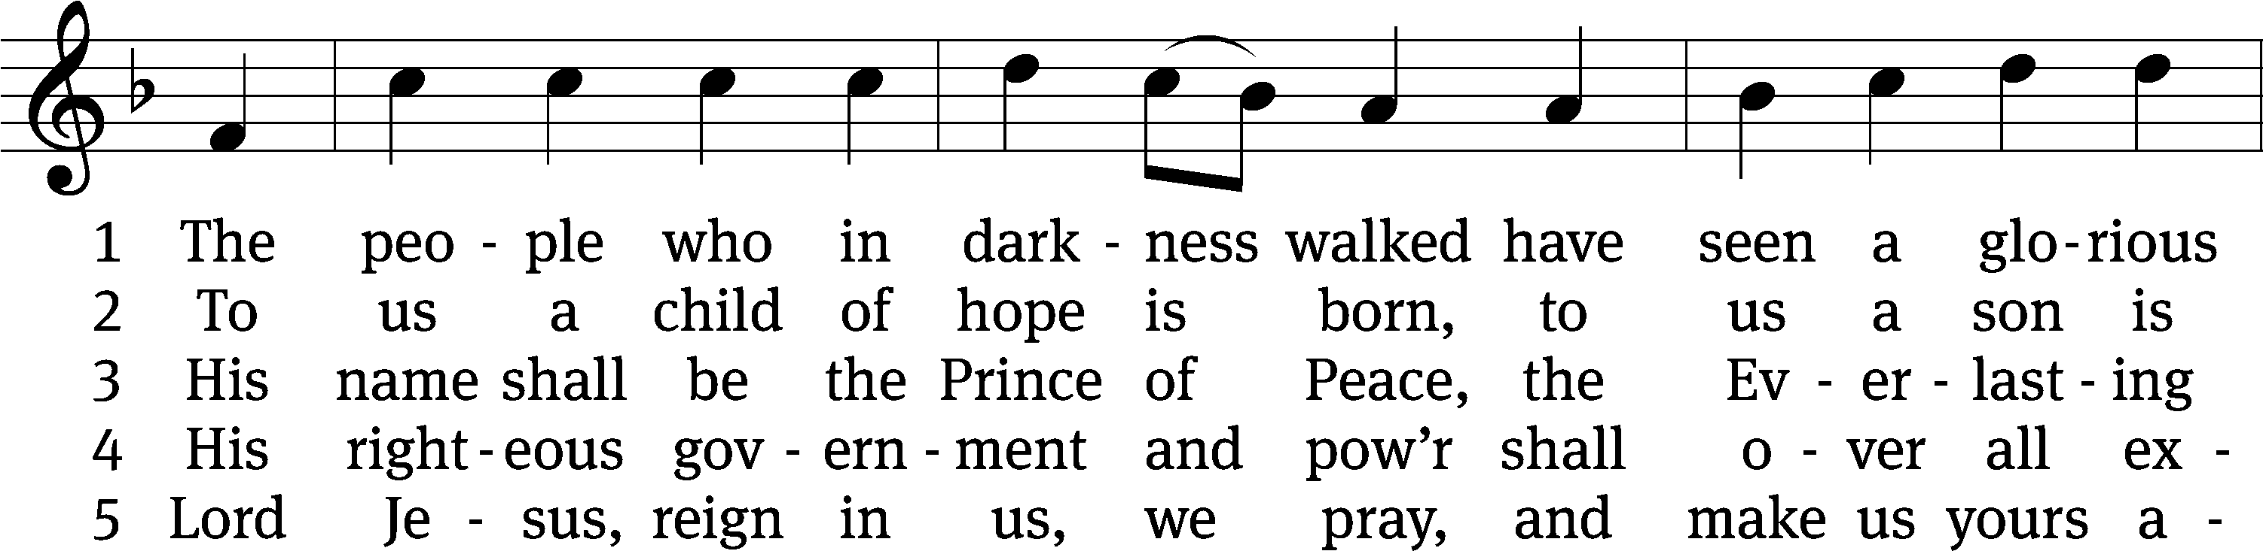
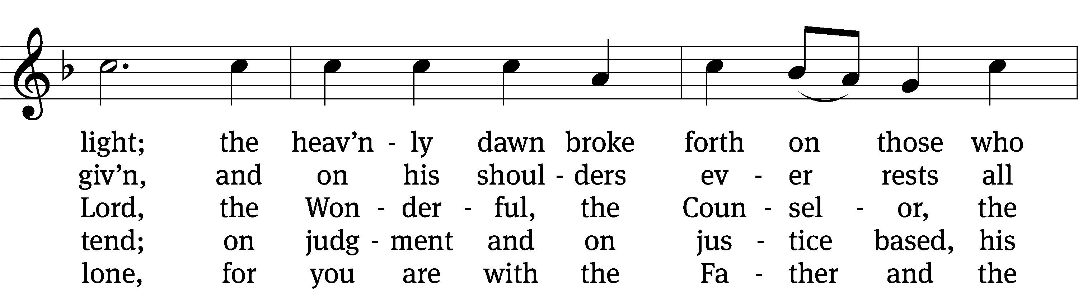
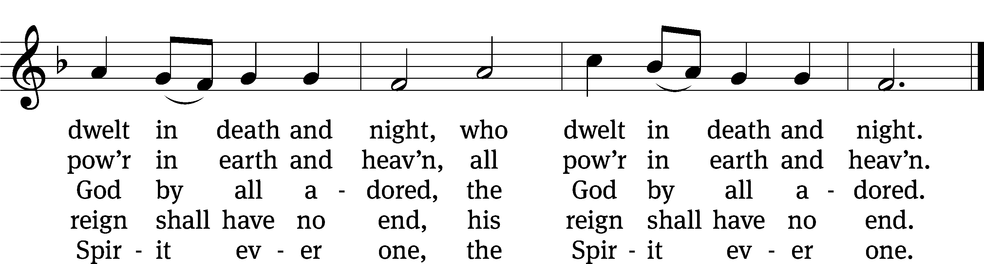
Text: John Morison, 1749–1798, abr., alt.
Tune: Nicolaus Herman, c. 1480–1561
Text and tune: Public domain

Please stand, if you are able
Invocation
In the name of the Father and of the Son and of the Holy Spirit.
Amen.
Confession
If we claim to be without sin, we deceive ourselves and the truth is not in us.
If we confess our sins, God is faithful and just
and will forgive us our sins
and purify us from all unrighteousness.

Let us confess our sins to the Lord.
Holy God, gracious Father,
I am sinful by nature
and have sinned against you in my thoughts, words, and actions.
I have not loved you with my whole heart;
I have not loved others as I should.
I deserve your punishment both now and forever.
But Jesus, my Savior, paid for my sins
with his innocent suffering and death.
Trusting in him, I pray: God, have mercy on me, a sinner.

Our gracious Father in heaven has been merciful to us. He sent his only Son, Jesus Christ, who gave his life as the atoning sacrifice for the sins of the whole world. Therefore, as a called servant of Christ and by his authority, I forgive you all your sins in the name of the Father and of the the Son and of the Holy Spirit.
Amen.

Lord, Have Mercy

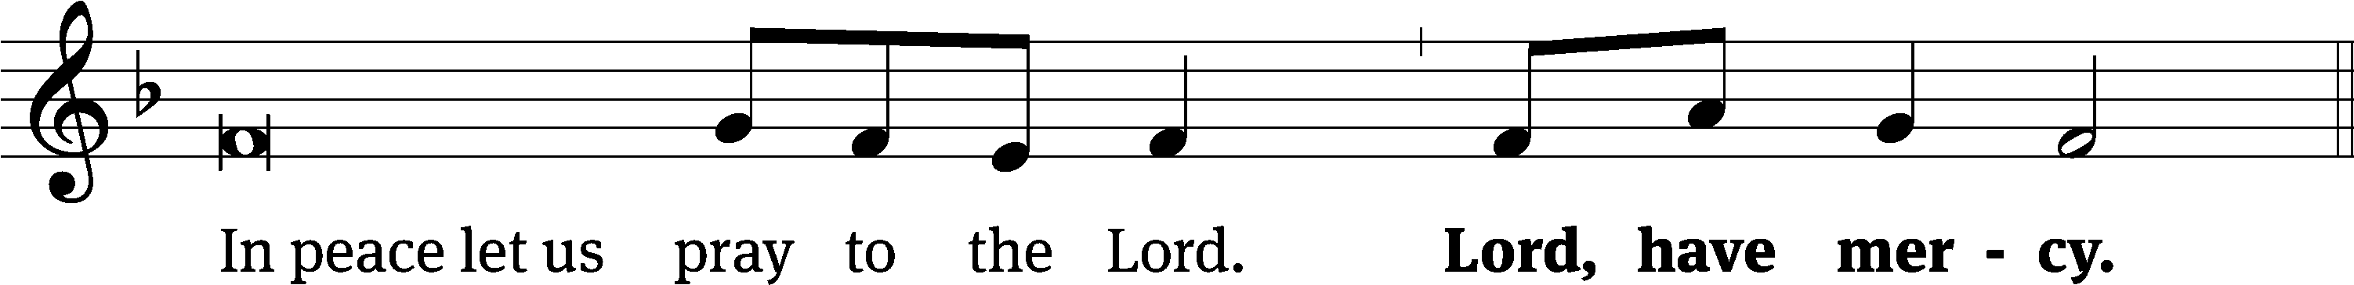
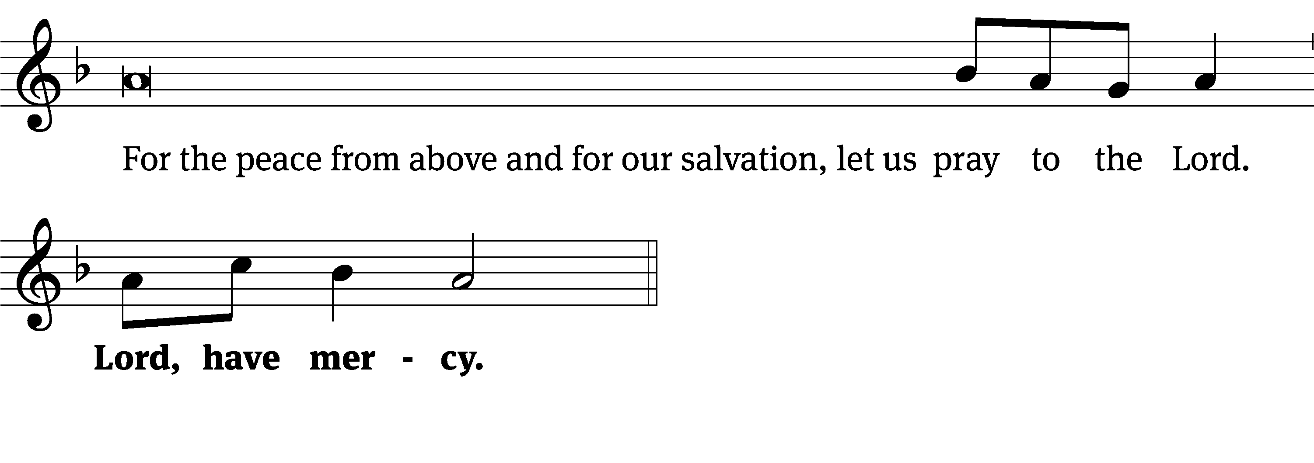
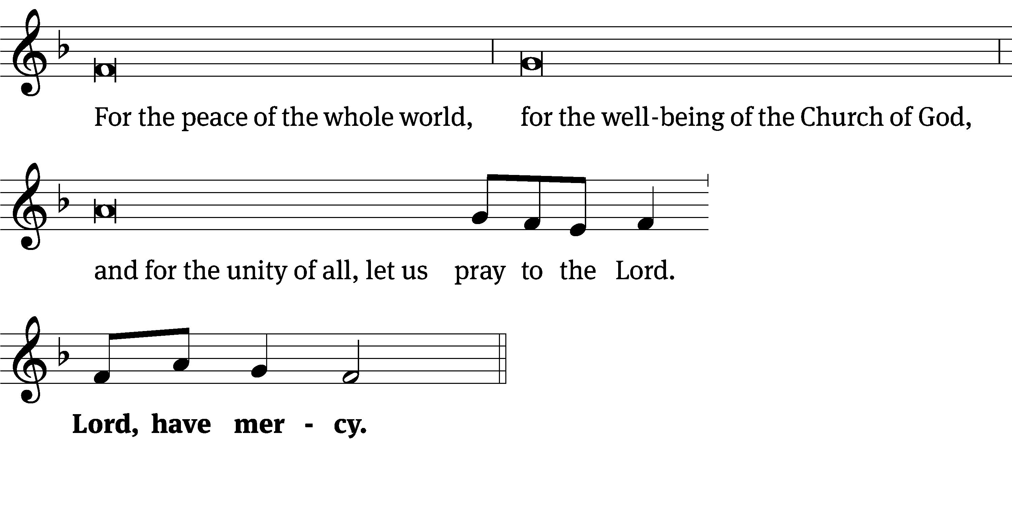
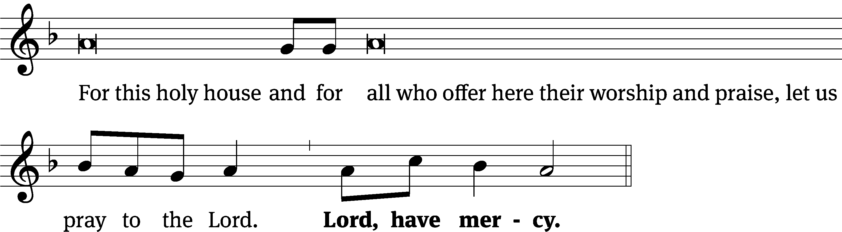
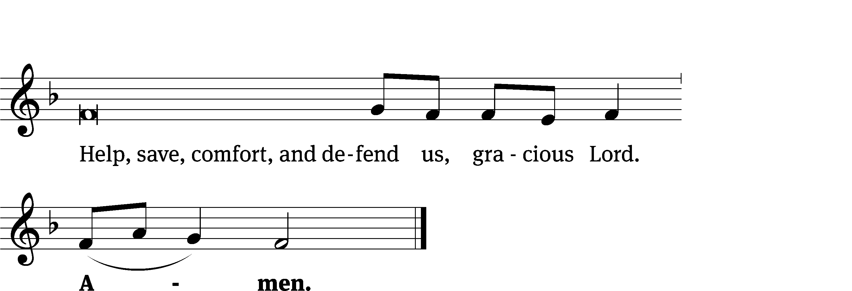
Glory Be to God CW 157
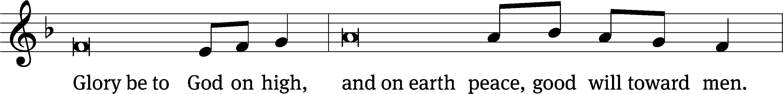
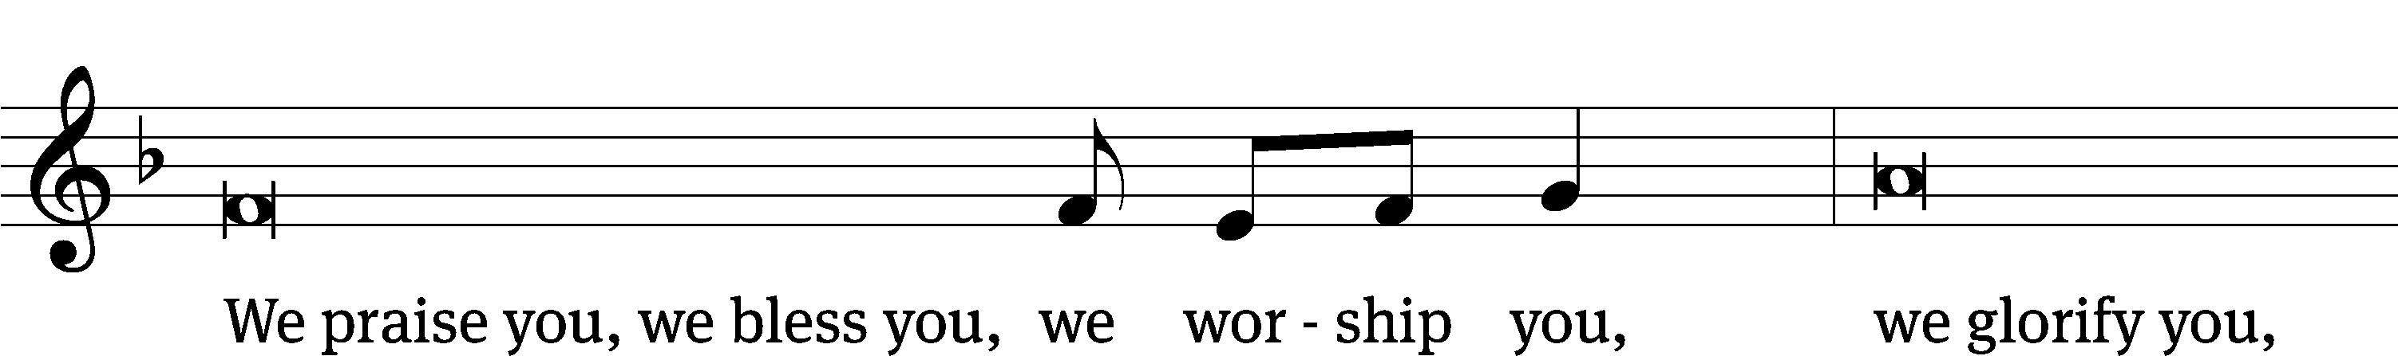
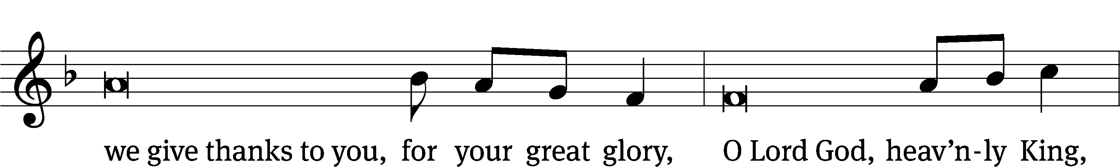
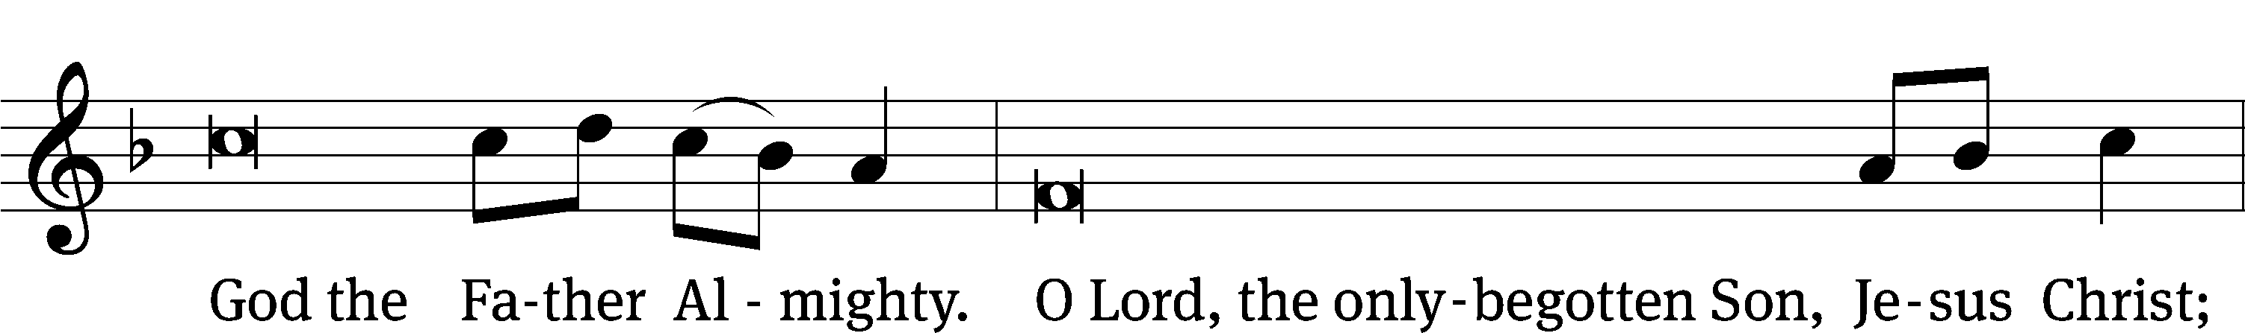
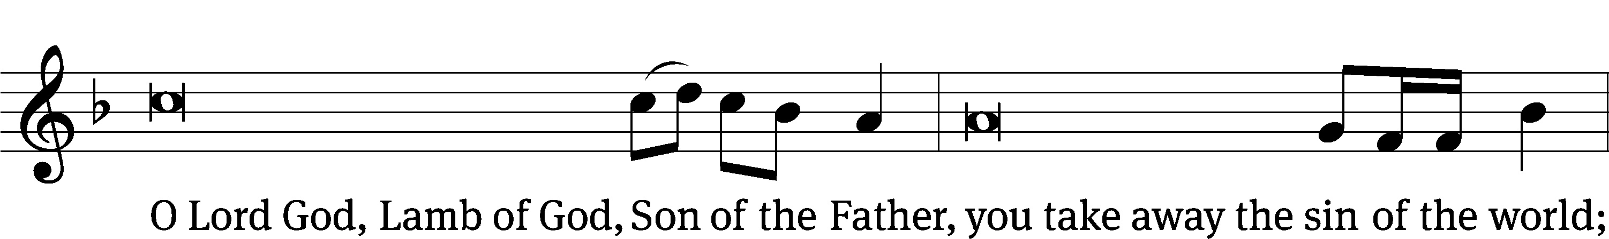
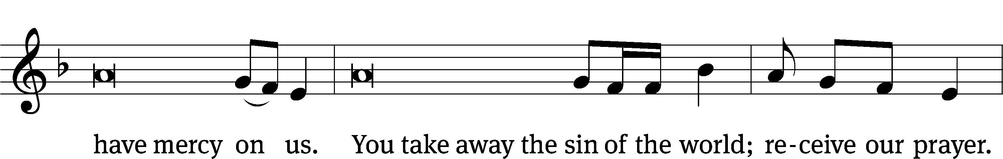
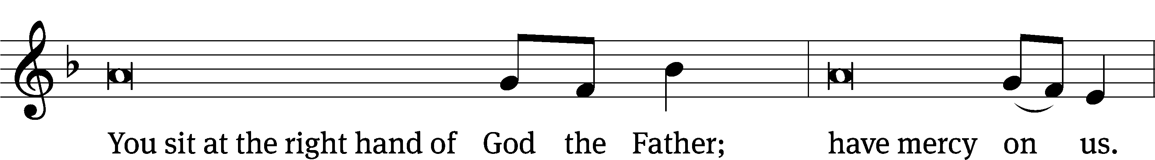
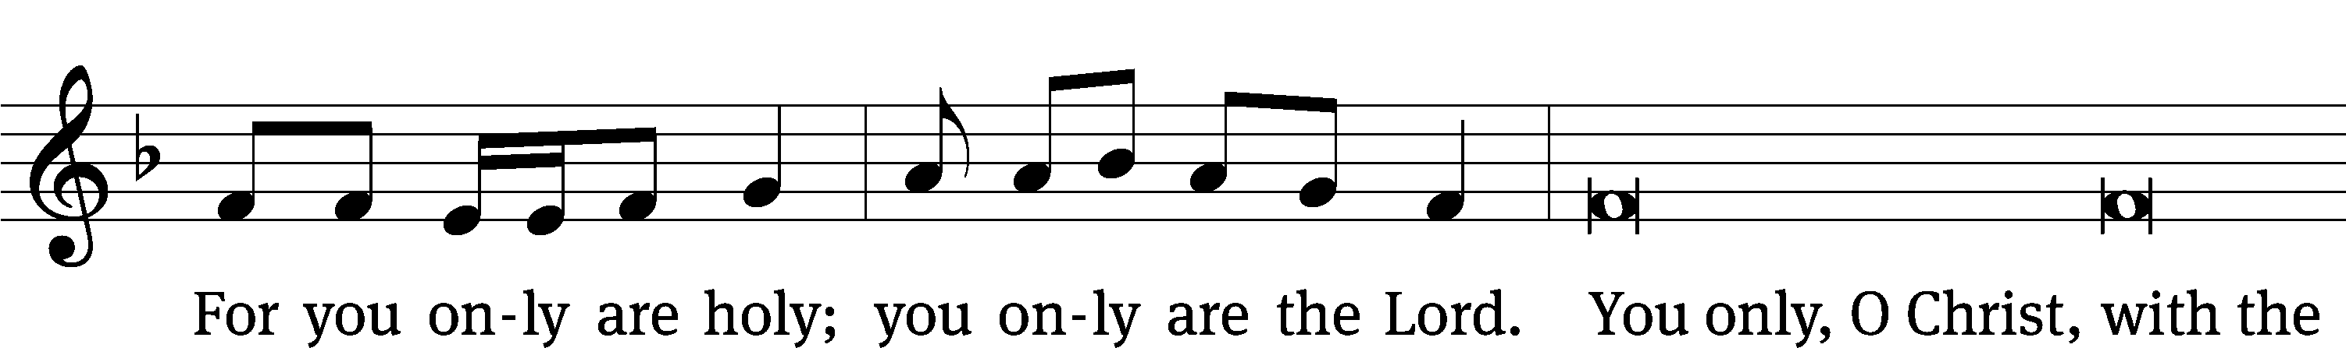
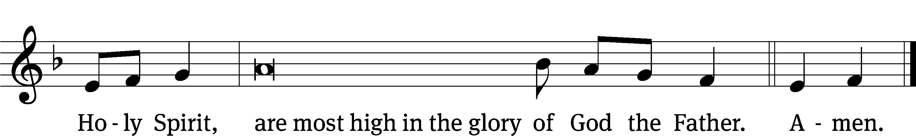

Tune: © 2021 Northwestern Publishing House. Used by permission: OneLicense no. 727703
The Lord be with you.
And also with you.
Prayer of the Day
Let us pray.

Almighty God, you sent your Son to proclaim your kingdom and teach with authority. Anoint us with the power of your Spirit that we too may bring good news to the afflicted, bind up the brokenhearted, and proclaim liberty to the captive; through your Son, Jesus Christ our Lord, who lives and reigns with you and the Holy Spirit, one God, now and forever.
Amen.

Please be seated

First Reading Isaiah 8:19-9:4
¹⁹ When they tell you, “Consult the mediums and the spiritists, who whisper and mutter,” shouldn’t a people consult their God? Should they consult the dead on behalf of the living? ²⁰ To the law and to the testimony! If people do not speak according to this word, there will be no dawn for them. ²¹ They will pass through the land, distressed and starving, but when this takes place and they are starving, they will be frustrated, and they will curse their king and their God. They will turn their faces upward, ²² and then they will look down to the ground, but I tell you, they will see only distress, darkness, and the gloom that brings anguish. They will be banished into thick darkness.
9 Nevertheless, there will be no more gloom for the land that was in anguish. In former times, he humbled the land of Zebulun and the land of Naphtali, but in the latter time he will cause it to be glorious, along the way of the sea, beyond the Jordan, in Galilee of the Gentiles.
² The people walking in darkness have seen a great light.
For those living in the land of the shadow of death, the light has dawned.
³ You have multiplied the nation. You have increased its joy.
They rejoice before you like the joy at harvest time,
like the celebration when people divide the plunder.
⁴ For you have shattered the yoke that burdened them.
You have broken the bar on their shoulders and
the rod of their oppressor,
as you did in the day of Midian.
The Word of the Lord.
Thanks be to God.

Senior Choir – “It Is Well with My Soul”

When peace, like a river, attendeth my way,
When sorrows like the sea billows roll;
Whatever my lot, thou hast taught me to say,
It is well, it is well with my soul.
(Refrain) It is well, it is well,
With my soul, with my soul.
It is well, it is well, with my soul.

My sin - oh the bliss of this glorious thought –
My sin, not in part, but the whole,
Is nailed to the cross and I bear it no more,
Praise the Lord, praise the Lord, O my soul.
(Refrain)
And Lord, haste the day
When my faith shall be sight,
The clouds be rolled back as a scroll,
The trumpet shall resound and the Lord shall descend,
“Even so,” it is well with my soul.
(Refrain)
Second Reading 1 John 2:3-11
³ This is how we know that we have known him: if we keep his commands. ⁴ The one who says, “I know him,” but does not keep his commands is a liar, and the truth is not in him. ⁵ If anyone keeps God’s word, the love of God is truly made complete in him. This is how we know that we are in him: ⁶ The one who says he remains in him should walk as Jesus^{[a]} walked.
⁷ Dear friends, I am not writing you a new command but an old one that you have had since the beginning. The old command is the message you heard. ⁸ At the same time, the command I am writing is new—it is true in Jesus^{[b]} and in you, because the darkness is passing away, and the true light is already shining. ⁹ The one who says he is in the light and yet hates his brother is still in the darkness. ¹⁰ The one who loves his brother remains in the light, and nothing causes him to stumble. ¹¹ The one who hates his brother is in the darkness and walks in the darkness and does not know where he is going, because the darkness has blinded his eyes.
The Word of the Lord.
Thanks be to God.

Please stand, if you are able
Gospel Acclamation Isaiah 9:2
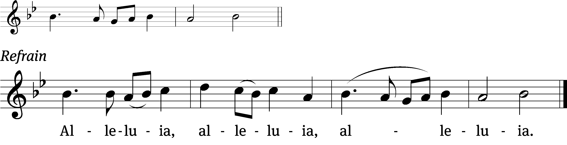
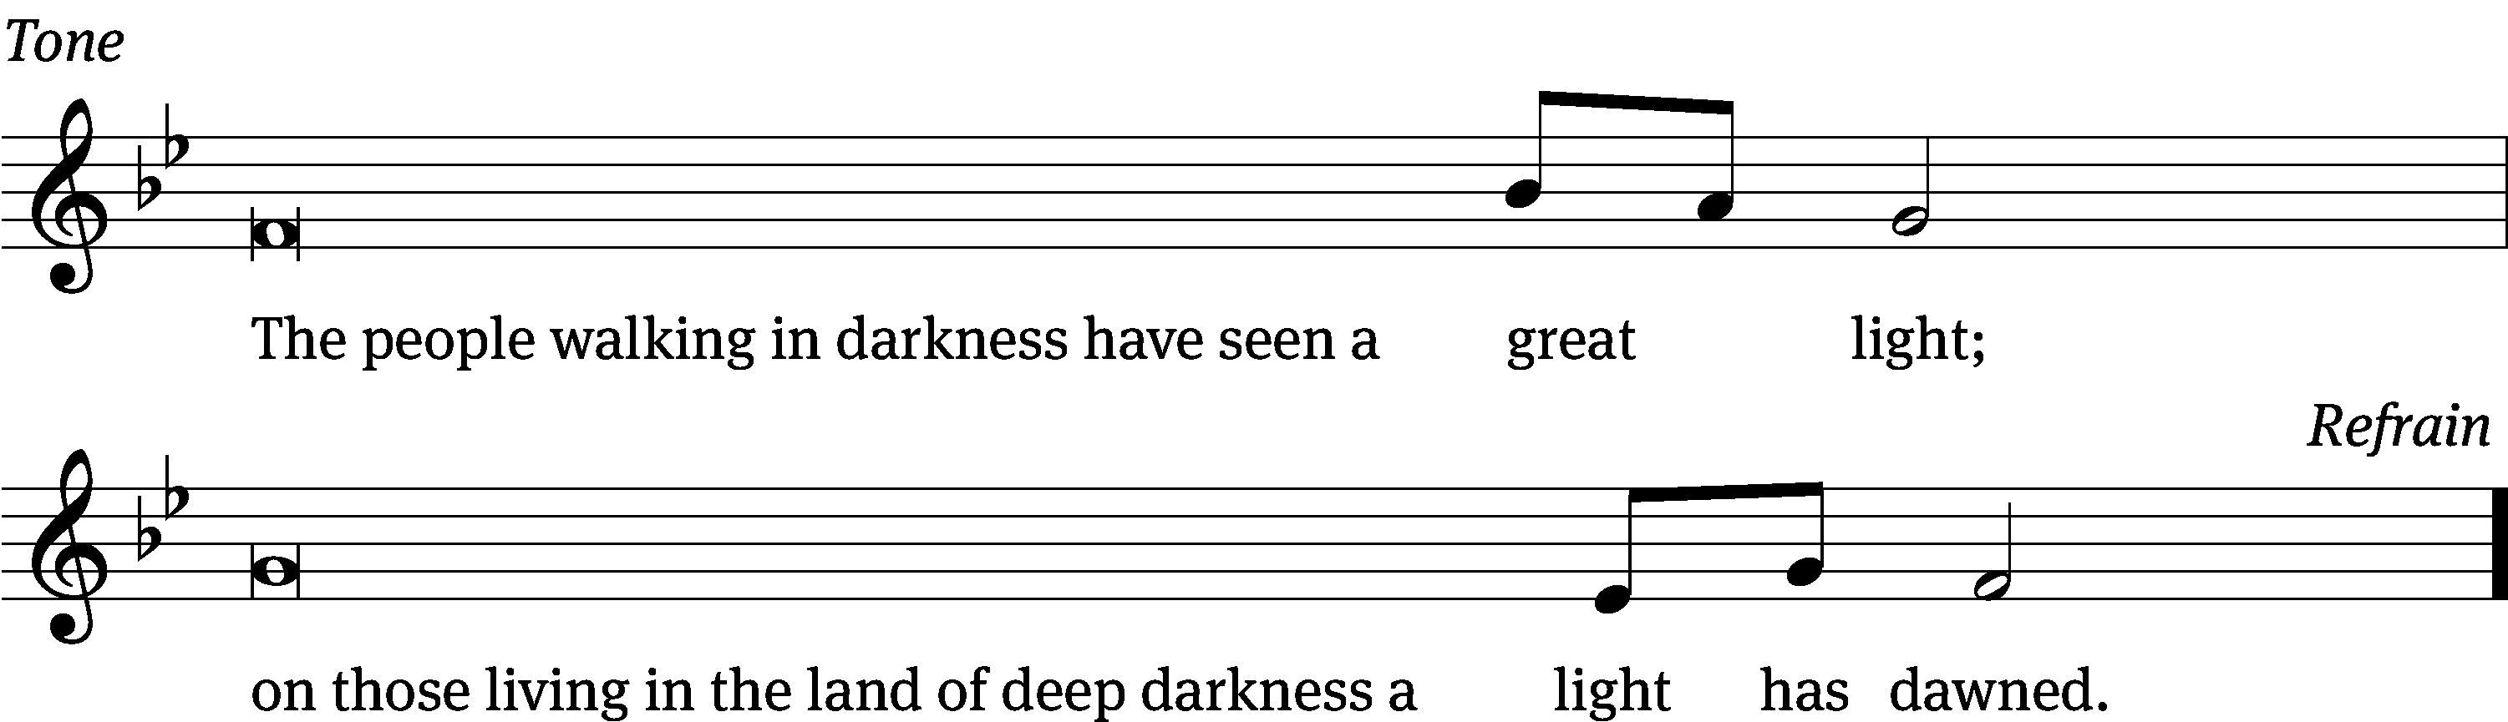
Tune: © 2021 Northwestern Publishing House. Used by permission: OneLicense no. 727703

Gospel Matthew 4:12-23
¹² When Jesus heard that John was put in prison, he withdrew into Galilee. ¹³ He left Nazareth and went to live in Capernaum, which is by the sea, in the region of Zebulun and Naphtali. ¹⁴ He did this to fulfill what was spoken through the prophet Isaiah:
¹⁵ Land of Zebulun and land of Naphtali,
along the way of the sea, beyond the Jordan,
Galilee of the Gentiles,
¹⁶ the people dwelling in darkness have seen a great light,
and on those dwelling in the region and the shadow of death a light has dawned.
¹⁷ From that time, Jesus began to preach: “Repent, because the kingdom of heaven is near.”
¹⁸ As Jesus was walking by the Sea of Galilee, he saw two brothers, Simon, who is called Peter, and his brother Andrew. They were casting a net into the sea, since they were fishermen. ¹⁹ He said to them, “Come, follow me, and I will make you fishers of men.”
²⁰ They immediately left their nets and followed him. ²¹ Going on from there, he saw two other brothers, James the son of Zebedee and his brother John. They were in the boat with their father Zebedee, mending their nets. Jesus called them. ²² Immediately they left the boat and their father and followed him.
²³ Jesus traveled throughout Galilee, teaching in their synagogues, preaching the gospel of the kingdom, and healing every disease and every sickness among the people.
The Gospel of the Lord.
Praise be to you, O Christ!

Please be seated

904 O Christ, Our True and Only Light CW 904
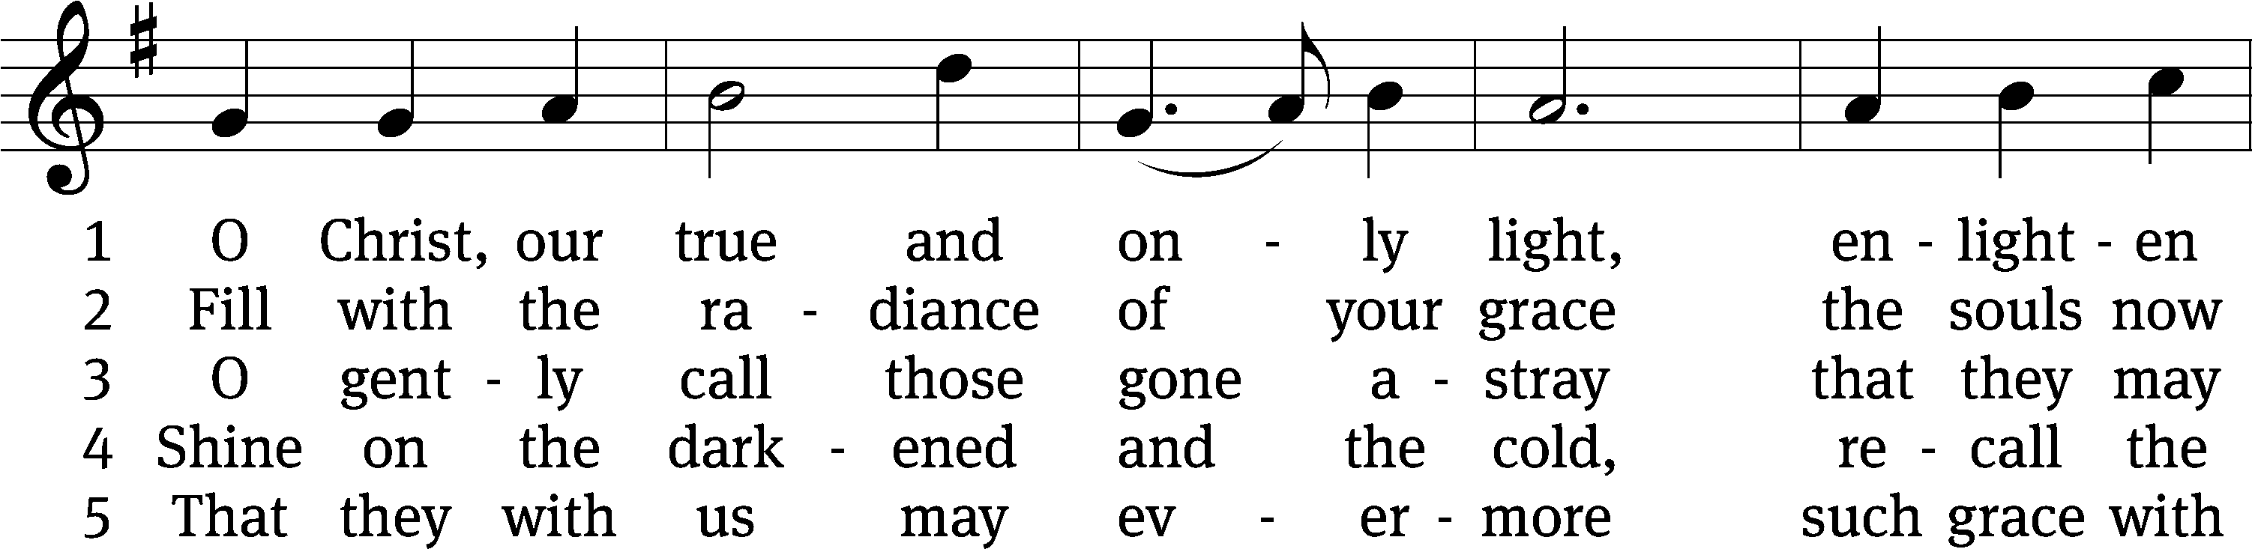
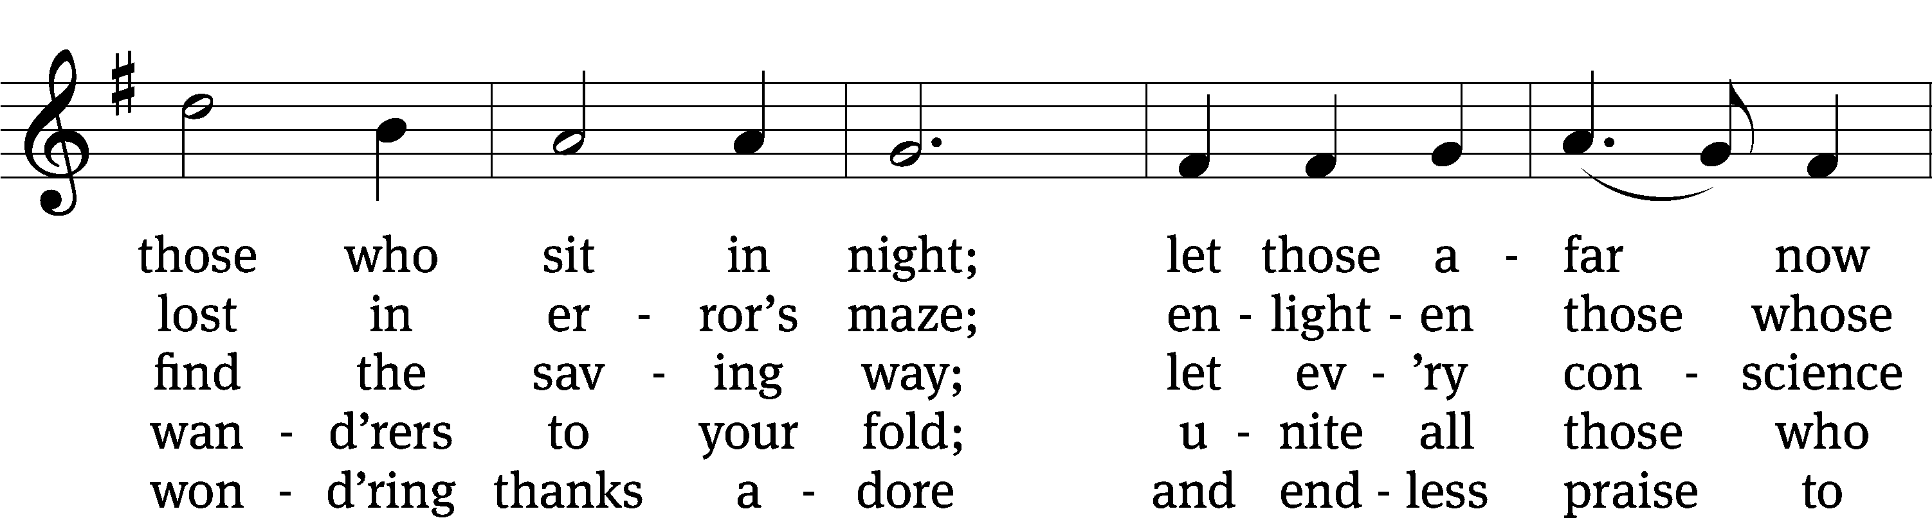
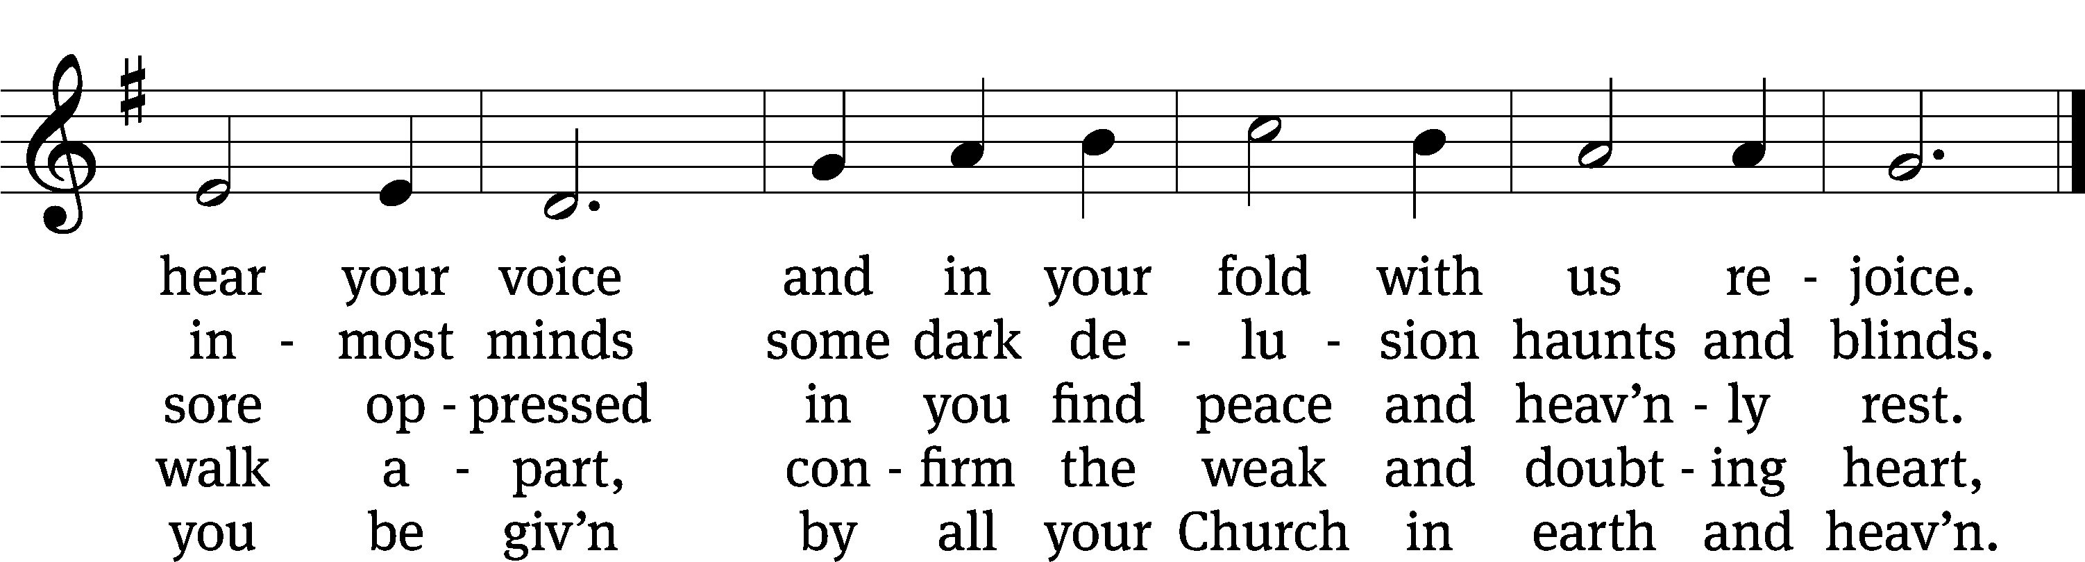
Text: tr. Catherine Winkworth, 1827–1878, alt.; Johann Heermann, 1585–1647
Tune: Andächtige Haus-Kirche, Nürnberg, 1676, alt.
Text and tune: Public domain

Sermon Matthew 4:18-20
“The Fish that Caught Men”

Please stand, if you are able

Apostles’ Creed
I believe in God, the Father Almighty,
maker of heaven and earth.

I believe in Jesus Christ, his only Son, our Lord,
who was conceived by the Holy Spirit,
born of the Virgin Mary,
suffered under Pontius Pilate,
was crucified, died, and was buried.
He descended into hell.
The third day he rose again from the dead.
He ascended into heaven
and is seated at the right hand of God the Father Almighty.
From there he will come to judge the living and the dead.

I believe in the Holy Spirit,
the holy Christian Church,
the communion of saints,
the forgiveness of sins,
the resurrection of the body,
and the life everlasting. Amen.

Prayer of the Church

Please be seated

736 Lord, You Call Us as Your People CW 736
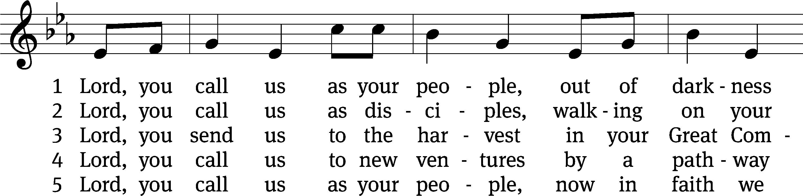
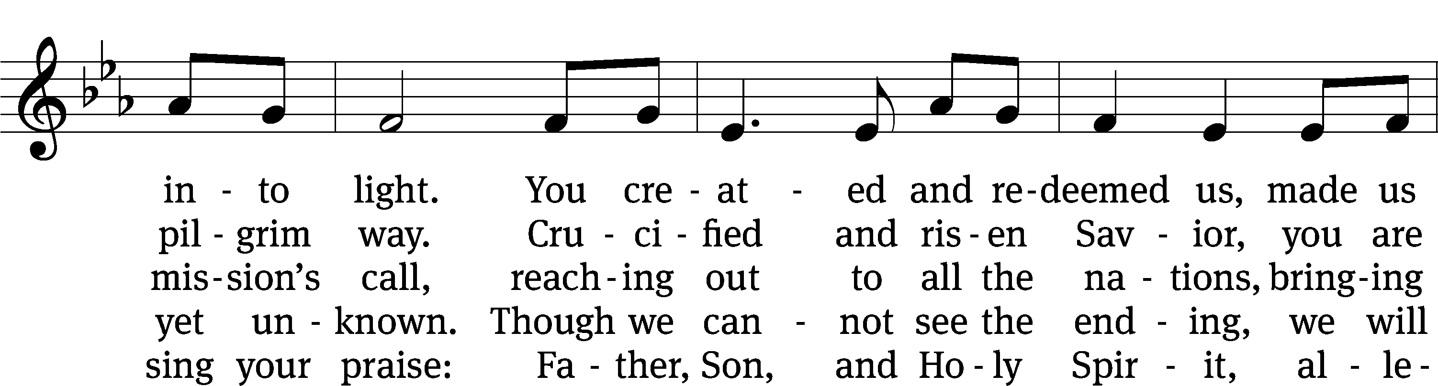
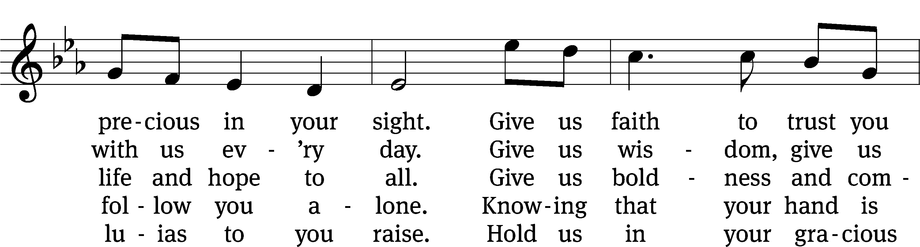
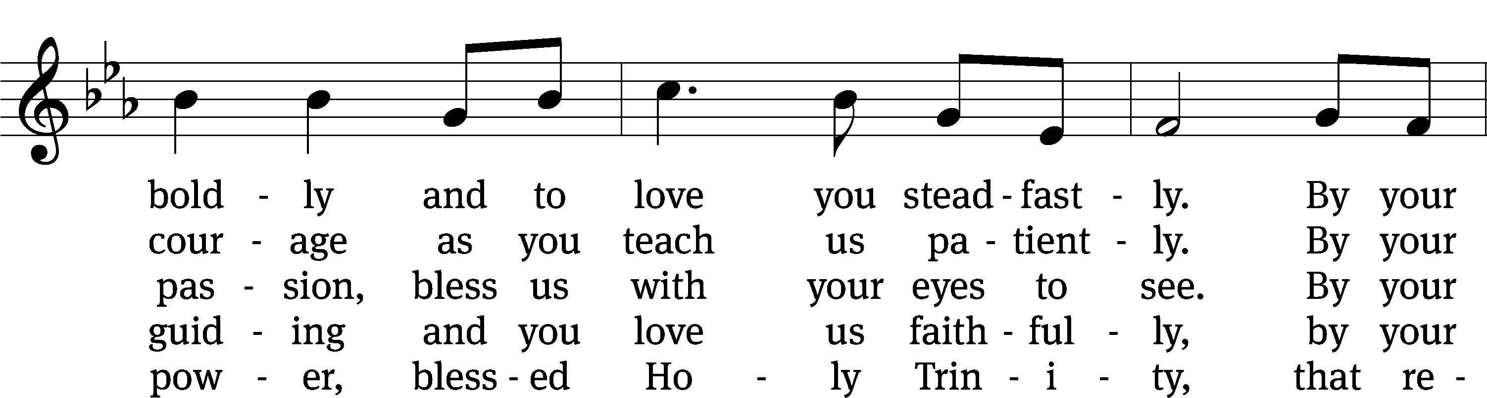
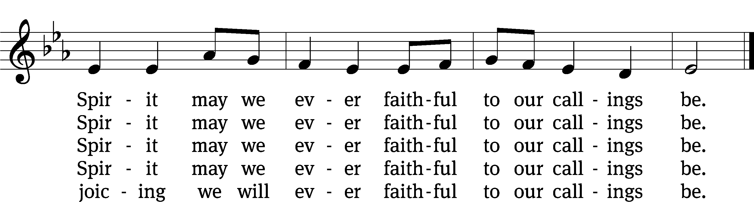
Tune: Marty Haugen, b. 1950
Text: © 2010 Stephen P. Mueller. Used by permission: OneLicense no. 727703
Tune: © 1987 GIA Publications, Inc. Used by permission: OneLicense no. 727703

Please stand, if you are able

Prayer
Blessed Lord, you have given us your Holy Scriptures for our learning. May we so hear them, read, learn, and take them to heart that, being strengthened and comforted by your holy Word, we may cling to the blessed hope of everlasting life; through Jesus Christ our Lord, who lives and reigns with you and the Holy Spirit, one God, now and forever.
Amen.
Lord’s Prayer
Our Father, who art in heaven, hallowed be thy name, thy kingdom come, thy will be done on earth as it is in heaven. Give us this day our daily bread; and forgive us our trespasses, as we forgive those who trespass against us; and lead us not into temptation, but deliver us from evil. For thine is the kingdom and the power and the glory forever and ever. Amen.

Blessing
The Lord bless you and keep you.
The Lord make his face shine on you and be gracious to you.
The Lord look on you with favor and give you peace.
Amen.

Please be seated

642 O Word of God Incarnate CW 642
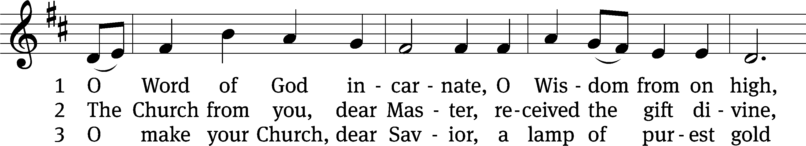
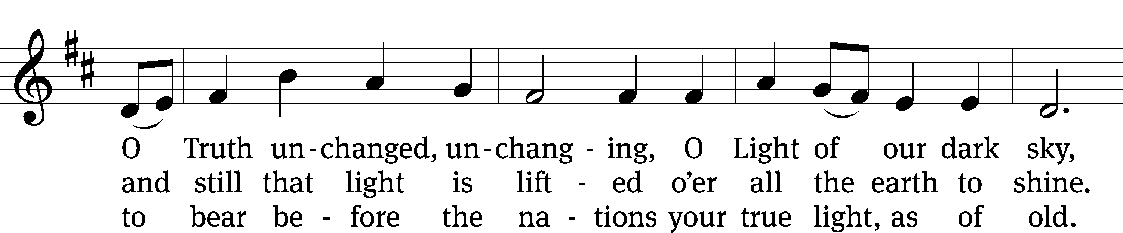
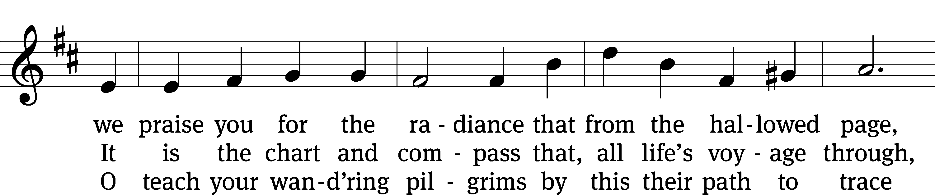
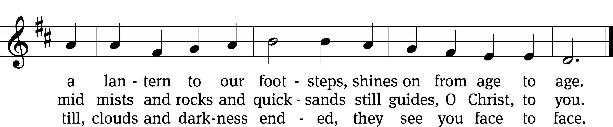
Text: William W. How, 1823–1897, abr., alt.
Tune: Neu-vermehrtes . . . Gesangbuch, 3rd. ed., Meiningen, 1693
Text and tune: Public domain

Acknowledgments
Setting One from Christian Worship
Software distributed in partnership with Northwestern Publishing House.
Created by Christian Worship: Service Builder © 2022 Concordia Publishing House.

Serving in Worship
Officiant Pastor Natsis
Organist Sarah Hanke
Choir Director Cynthia Natsis
Accompanist Laura Sala
Deacons (8:30) Dave Stevenson and Jim Tice
(11:00) Steve Hoeft and Jeff Neuburger
Ushers (8:30) Dale Finkbeiner and Mark Finkbeiner
(11:00) Al Whitley
Altar Guild Sharon Boswell and Brenda Stevenson
Videographer Cindy Dresch

