The LAST SUNDay after EPIPHANy
THE TRANSFIGURATION
OF OUR LORD

TRINITY EVANGELICAL LUTHERAN CHURCH | Saline, Michigan
February 27, 2022

WELCOME TO WORSHIP
Thank you for joining us in God’s house today! We cordially ask that our Guests sign one of the guestbooks located at either the front or back entryways, or fill out a “Let’s Get Acquainted” card located in the hymnal pew rack and place it in the collection plate.

THANK OFFERING: Members of Trinity give their offering as an expression of love and thankfulness to the Lord and to help support the Lord’s work in our community and around the world. Visitors need not feel obligated to participate in this offering which supports our ministry.

Restrooms are located at the back of the upper level (the annex), and in the basement (down the back stairs of the sanctuary or annex). Handicap access is available, please ask an usher for assistance.

Young Families / Toddler Bags – We are GLAD YOU BROUGHT YOUR CHILDREN to our worship service. Jesus said: “Let the little children come to me and do not hinder them, for the kingdom of God belongs to such as these.” We know that having little children in church can be a challenge, but DO NOT WORRY about it. Many of your fellow worshippers have been in your shoes and are just happy you brought your children with you. For your convenience, we have reserved the back rows of seating for parents with small children. These areas provide more flexibility for your family, as well as, easy access to move downstairs if necessary. A closed-circuit TV system allows families to continue participating in the service while downstairs. Pre-school toddler bags and children’s bulletins are available for their enjoyment. Ask an usher for one to use during the service and please return the toddler bag afterwards.

THE COMMON SERVICE
THE OPENING HYMN CW #390
390 Jesus, Take Us to the Mountain CW 390
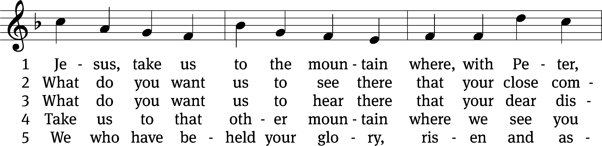
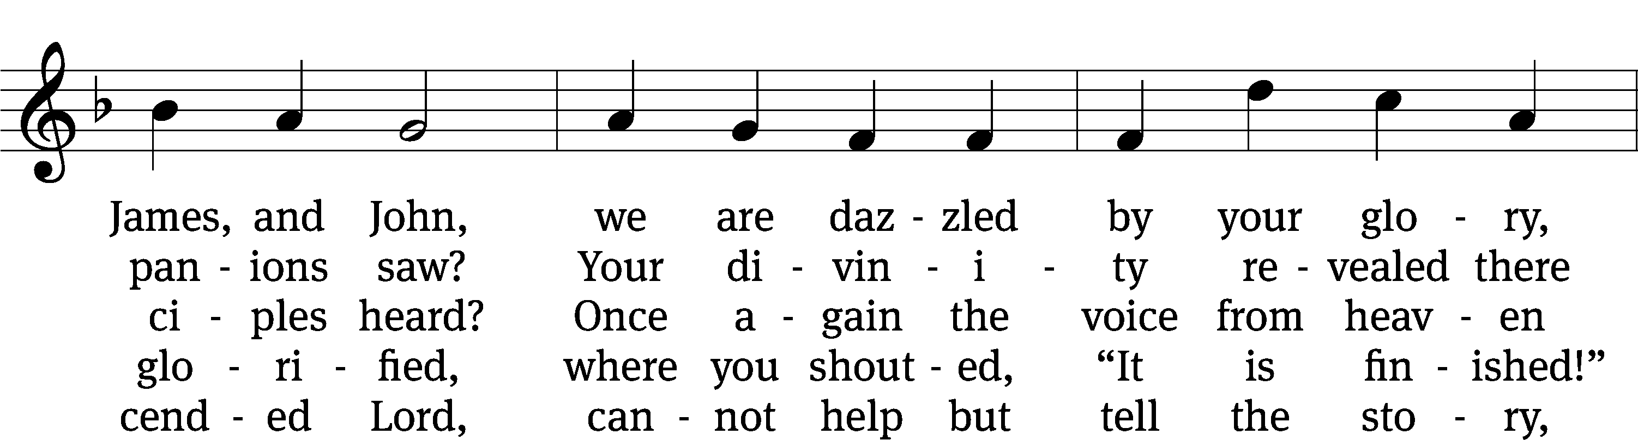
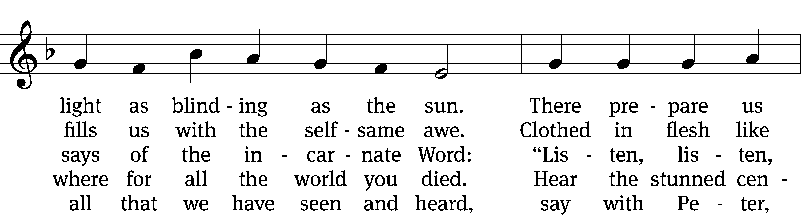
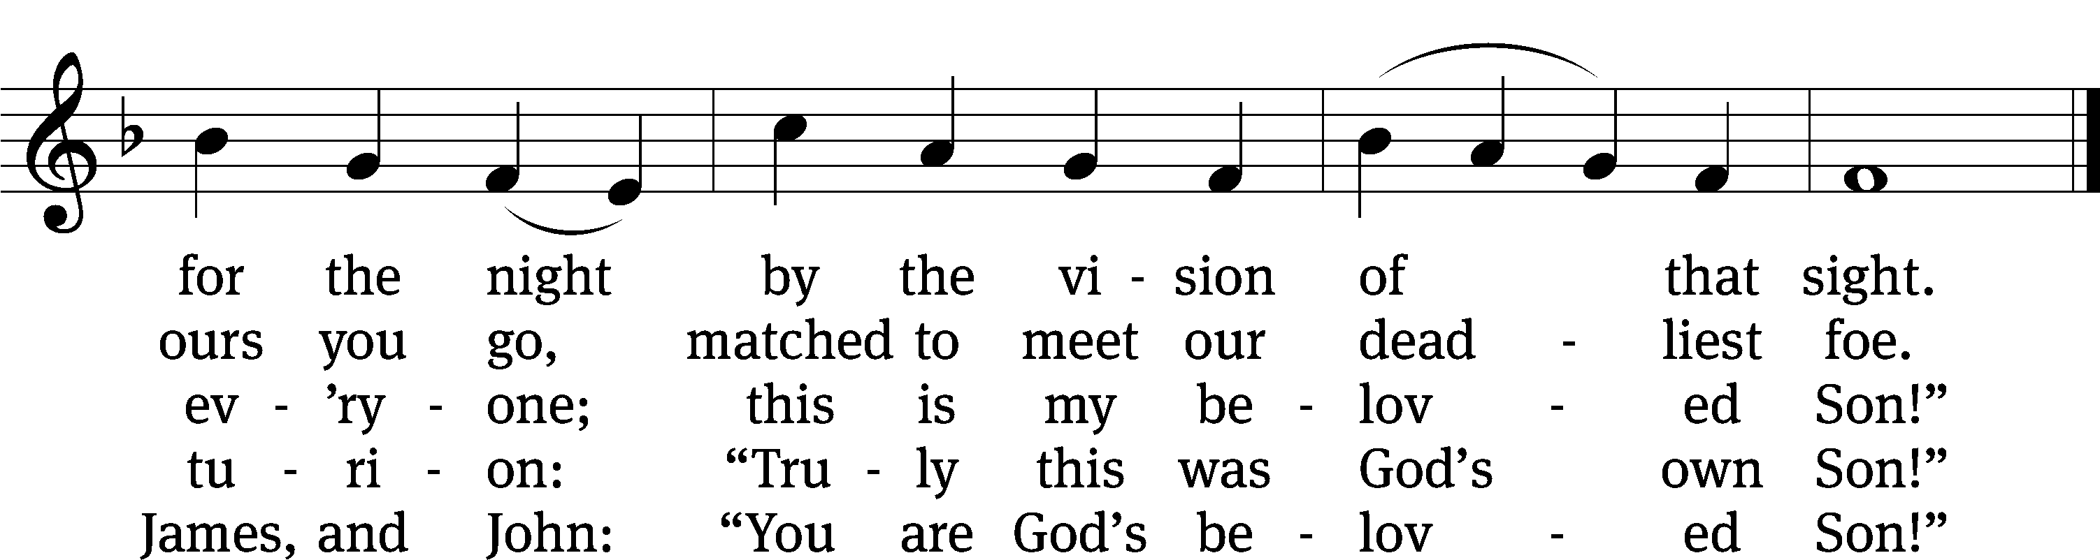
Text: Jaroslav J. Vajda, 1919–2008
Tune: Carl F. Schalk, b. 1929
Text: © 1991 Concordia Publishing House. Used by permission: OneLicense no. 727703
Tune: © 1991 Carl F. Schalk. Used by permission: OneLicense no. 727703

Please stand, if you are able

invocation
M: In the name of the Father and of the ☩ Son and of the Holy Spirit.

Confession AND ABSOLUTION
M: Beloved in the Lord: let us draw near with a true heart and confess our sins to God our Father, asking him in the name of our Lord Jesus Christ to grant us forgiveness.
C: Holy and merciful Father, I confess that I am by nature sinful and that I have disobeyed you in my thoughts, words, and actions. I have done what is evil and failed to do what is good. For this I deserve your punishment both now and in eternity. But I am truly sorry for my sins, and trusting in my Savior Jesus Christ, I pray: Lord, have mercy on me, a sinner.

M: God, our heavenly Father, has been merciful to us and has given his only Son to be the atoning sacrifice for our sins. Therefore, as a called servant of Christ and by his authority, I forgive you all your sins in the name of the Father and of the Son (+) and of the Holy Spirit.

PRAYER AND PRAISE

M: In the peace of forgiveness, let us praise the Lord.

PRAYER OF THE DAY
M: The Lord be with you.

M: Let us pray.
THE MINISTER SAYS THE PRAYER OF THE DAY

BE SEATED

The Word

THE FIRST LESSON Exodus 34:29-35

²⁹ When Moses came down from Mount Sinai, with the two tablets of the Testimony in his hand as he came down from the mountain, Moses did not realize that the skin of his face was shining because he had been speaking with the Lord. ³⁰ When Aaron and all the people of Israel saw Moses, they were amazed that the skin of his face was shining, so they were afraid to come close to him. ³¹ Moses called to them, so Aaron and all the rulers of the community returned to him, and Moses spoke to them. ³² Afterward, all the people of Israel came close to him, and he gave them all of the commands that the Lord had spoken to him on Mount Sinai. ³³ When Moses was finished speaking with them, he put a veil over his face. ³⁴ But whenever Moses went in before the Lord to speak with him, he would take the veil off until he came out again. Then he would come out and tell the people of Israel what he had been commanded. ³⁵ Whenever the people of Israel saw Moses’ face, they would see that the skin of Moses’ face was shining. Then Moses would put the veil on his face again, until he went in to speak with the Lord again.

SENIOR CHOIR “This Is My Beloved Son”

Long, long ago, the prophets spoke to ancient generations.
But in these days, God shows his ways and through the Son he’s spoken.
The Son is in God’s likeness, in glory and in brightness, in high authority.

“You are my Son, beloved One, you are my first begotten.
The heavens you made, your hand has laid the very earth’s foundation.
The Son is in God’s likeness, in glory and in brightness, in high authority.
The Son your sins has lightened. He sits upon the right hand of power and majesty.
The first begotten One, this is my high and holy Son.”

On earth one day, John, Peter, James followed him up a mountain.
Before their eyes, his face would shine with light as bright as morning.
His garments shone and brightened. The disciples were so frightened, their faces on the ground.
A bright cloud overwhelmed them, a voice came forth to tell them,
“Now listen to this One, for this is my beloved Son!”

“You are my Son, beloved One, you are my first begotten.
The heavens you made, your hand has laid the very earth’s foundation.
The Son is in God’s likeness, in glory and in brightness, in high authority.
The Son your sins has lightened. He sits upon the right hand of power and majesty.
For this is my Son. For this is my beloved Son. This is my Son!”

THE SECOND LESSON 2 Corinthians 3:7-18
⁷ If the ministry that brought death (which was engraved in letters on stone) came with glory, so that the Israelites could not look directly at the face of Moses because of the glory of his face (though it was fading), ⁸ how will the ministry of the spirit^{[a]} not be much more glorious? ⁹ For if the ministry that brought condemnation has glory, the ministry that brought righteousness has even more glory. ¹⁰ In fact, in this case, what was glorious is no longer very glorious, because of the greater glory of that which surpasses it. ¹¹ Indeed, if what is fading away was glorious, how much more glorious is that which is permanent!

¹² Therefore, since we have this kind of hope, we act with great boldness. ¹³ We are not like Moses, who put a veil over his face, so that the Israelites could not continue to look at the end of the radiance, as it was fading away. ¹⁴ In spite of this, their minds were hardened. Yes, up to the present day, the same veil remains when the Old Testament is read. It has not been removed because it is taken away only in Christ. ¹⁵ Instead, to this day, whenever Moses is read, a veil lies over their hearts. ¹⁶ But whenever someone turns to the Lord, the veil is taken away. ¹⁷ Now the Lord is the Spirit, and where the Spirit of the Lord is, there is freedom. ¹⁸ But all of us who reflect the Lord’s glory with an unveiled face are being transformed into his own image, from one degree of glory to another. This too is from the Lord, who is the Spirit.

Verse of the day

PLEASE Stand, IF YOU ARE ABLE

THE gospel LESSON Luke 9:28-36

M: The Gospel according to St. Luke chapter 9, verses 28-36

²⁸ About eight days after he said these words, Jesus took Peter, John, and James and went up on the mountain to pray. ²⁹ While he was praying, the appearance of his face changed, and his clothing became dazzling white. ³⁰ Just then, two men, Moses and Elijah, were talking with him! ³¹ They appeared in glory and were talking about his departure, which he was going to bring to fulfillment in Jerusalem.
³² Peter and those with him were weighed down with sleep, but when they were completely awake, they saw his glory and the two men standing with him.
³³ As the men were leaving Jesus, Peter said to him, “Master, it is good for us to be here. Let’s make three tents: one for you, one for Moses, and one for Elijah.” He did not realize what he was saying.
³⁴ While he was saying these things, a cloud came and overshadowed them. They were afraid as they went into the cloud. ³⁵ Then a voice came out of the cloud, saying, “This is my Son, whom I love. Listen to him!” ³⁶ After the voice had spoken, they found Jesus alone. They kept this secret and told no one in those days any of the things they had seen.

M: This is the Gospel of the Lord.

tHE APOSTLES’ CREED
I believe in God, the Father almighty,
maker of heaven and earth.
I believe in Jesus Christ, his only Son, our Lord,
who was conceived by the Holy Spirit,
born of the virgin Mary,
suffered under Pontius Pilate,
was crucified, died, and was buried.
He descended into hell.
The third day he rose again from the dead.
He ascended into heaven
and is seated at the right hand of God the Father almighty.
From there he will come to judge the living and the dead.
I believe in the Holy Spirit,
the holy Christian Church,
the communion of saints,
the forgiveness of sins,
the resurrection of the body,
and the life everlasting. Amen.

PLEASE BE SEATED
SERMON HYMN CW #388
388 Down from the Mount of Glory CW 388
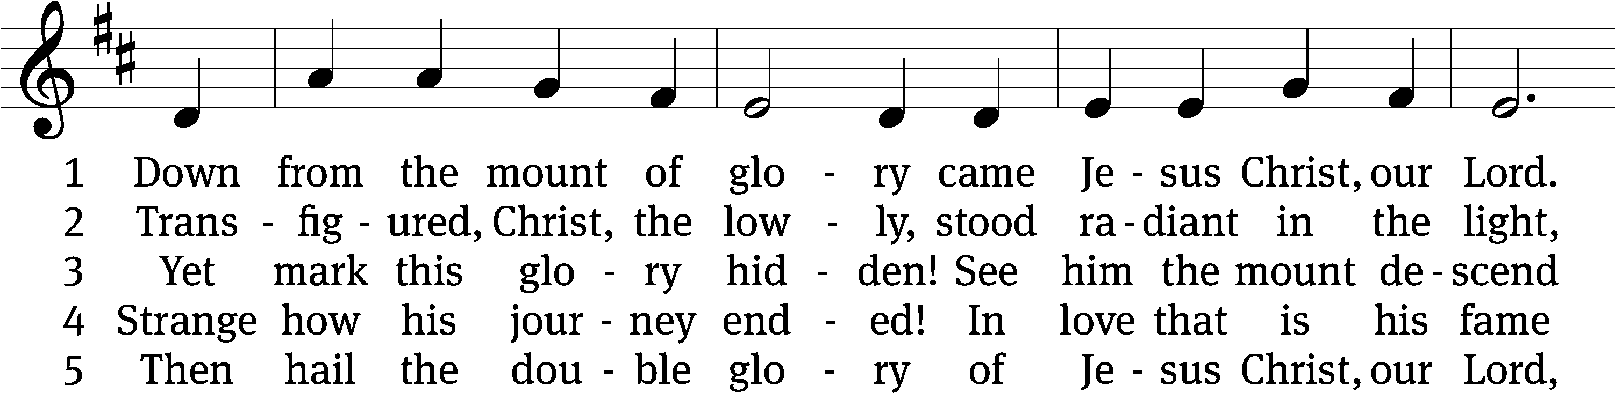
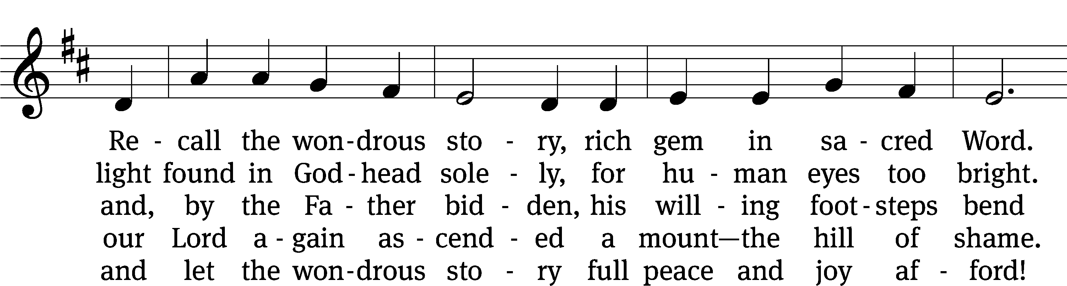
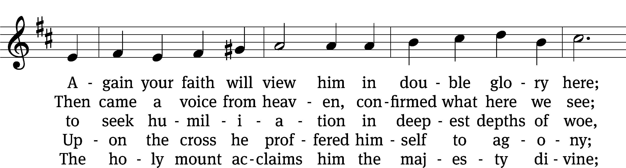
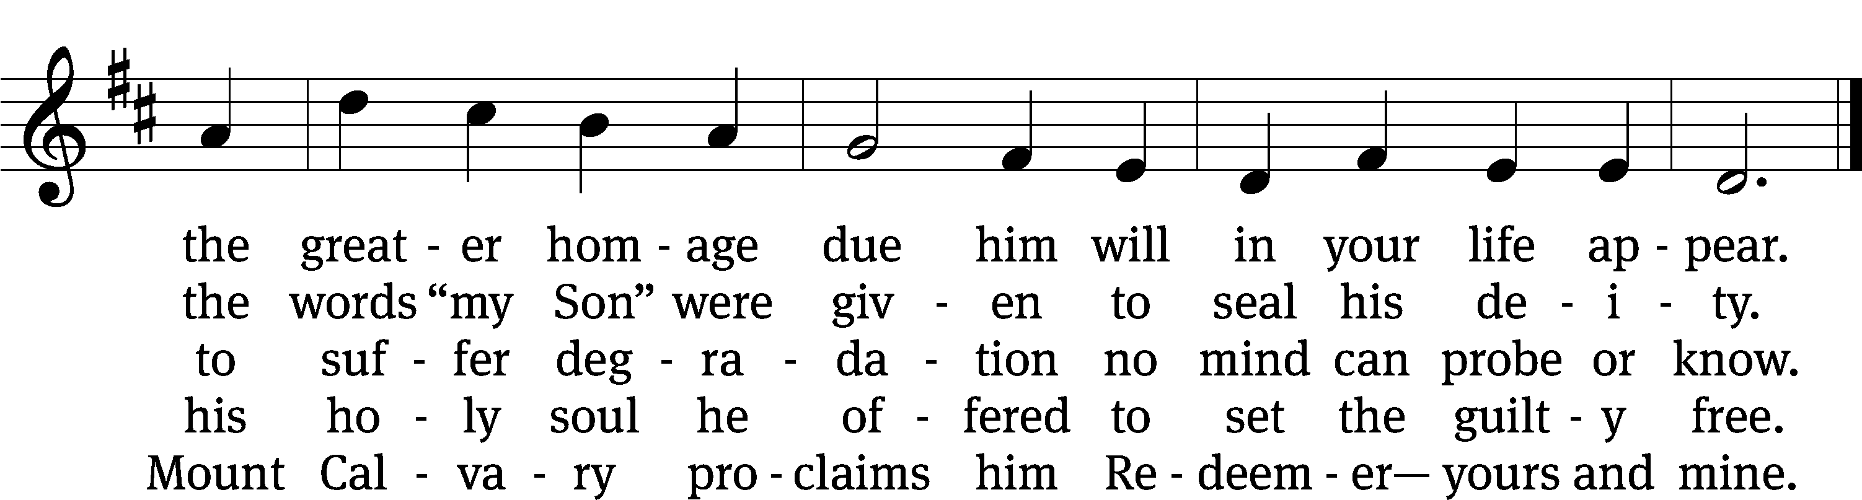
Text: Werner H. Franzmann, 1905–1996
Tune: Bartholomäus Helder, 1585–1635
Text: © 1968 Werner H. Franzmann, admin. Northwestern Publishing House. Used by permission: OneLicense no. 727703
Tune: Public domain

SERMON Luke 9:28-36
“Let the Son Shine”

PLEASE STAND, IF YOU ARE ABLE

Create in me

PRAYER OF THE CHURCH

THE LORD’S PRAYER

Our Father, who art in heaven, hallowed be thy name, thy kingdom come, thy will be done on earth as it is in heaven. Give us this day our daily bread; and forgive us our trespasses, as we forgive those who trespass against us; and lead us not into temptation, but deliver us from evil. For thine is the kingdom and the power and the glory forever and ever. Amen.
PLEASE BE SEATED
HYMN #391
391 O Wondrous Type! O Vision Fair CW 391
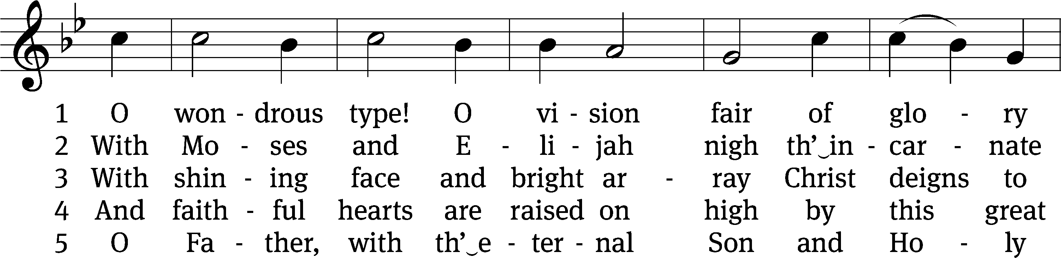
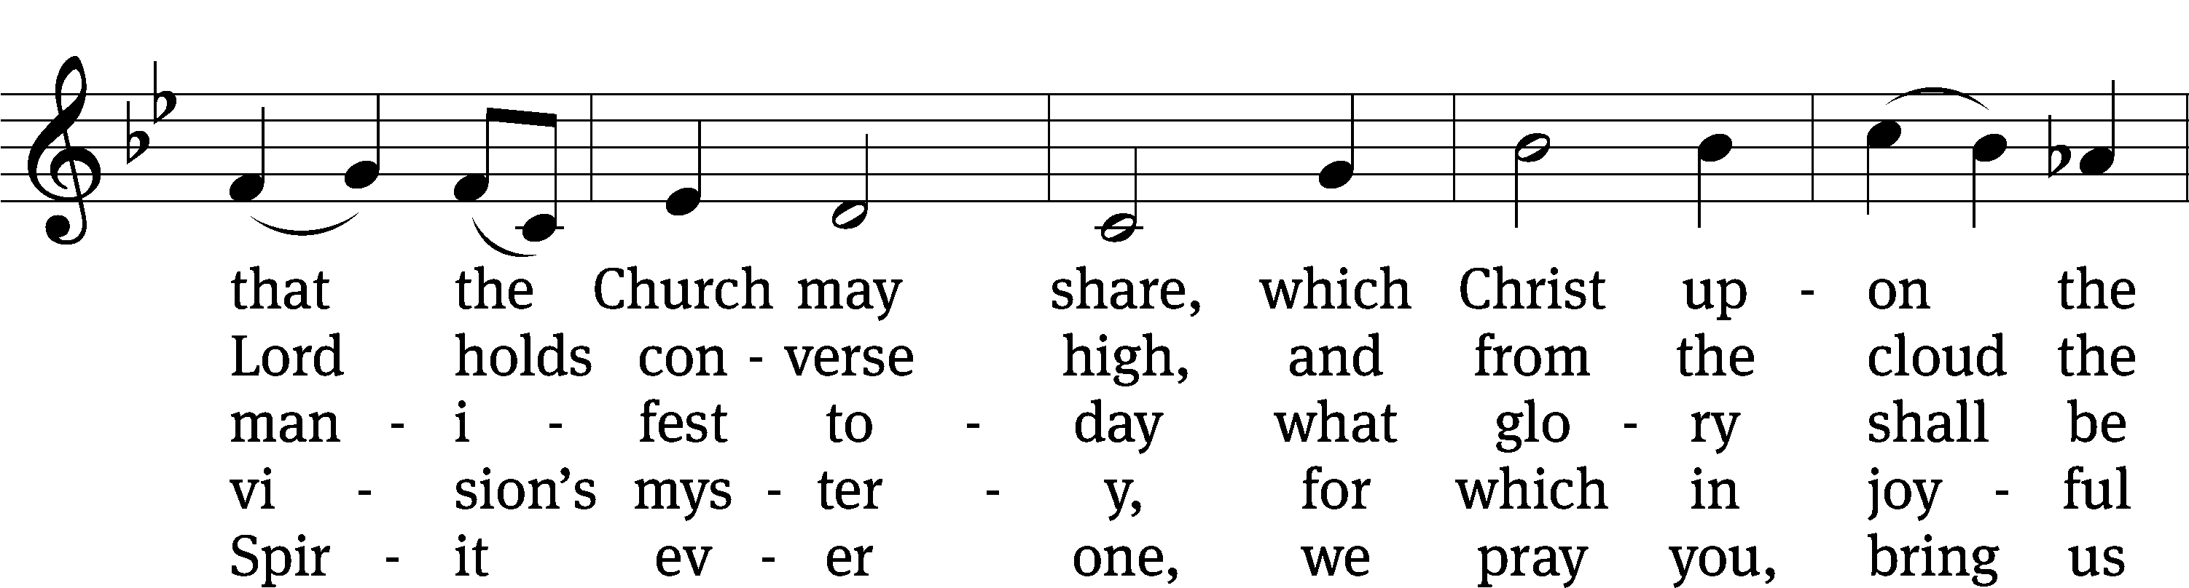
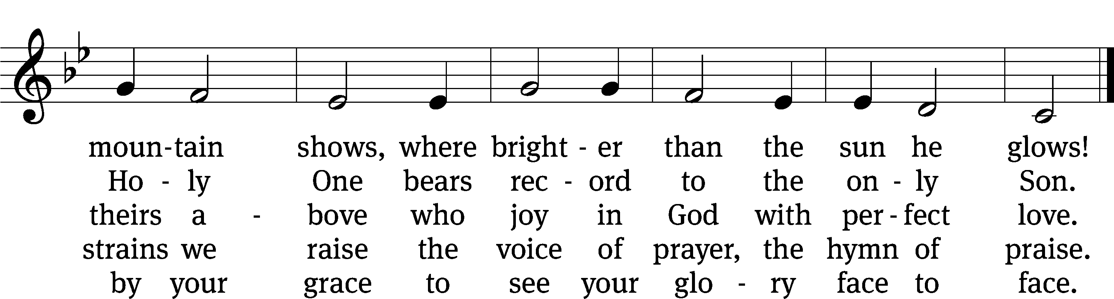
Text: tr. John Mason Neale, 1818–1866, alt.; Latin hymn, 15th cent.
Tune: English, 15th cent.
Text and tune: Public domain

PLEASE STAND, IF YOU ARE ABLE

M: Blessed Lord, you have given us your Holy Scriptures for our learning. May we so hear them, read, learn, and take them to heart, that being strengthened and comforted by your holy Word, we may cling to the blessed hope of everlasting life, through Jesus Christ, our Lord, who lives and reigns with you and the Holy Spirit, one God, now and forever.

M: The Lord bless you and keep you.
The Lord make his face shine on you and be gracious to you.
The Lord look on you with favor and (+) give you peace.

BE SEATED

CLOSING HYMN CW #389
389 How Good, Lord, to Be Here CW 389
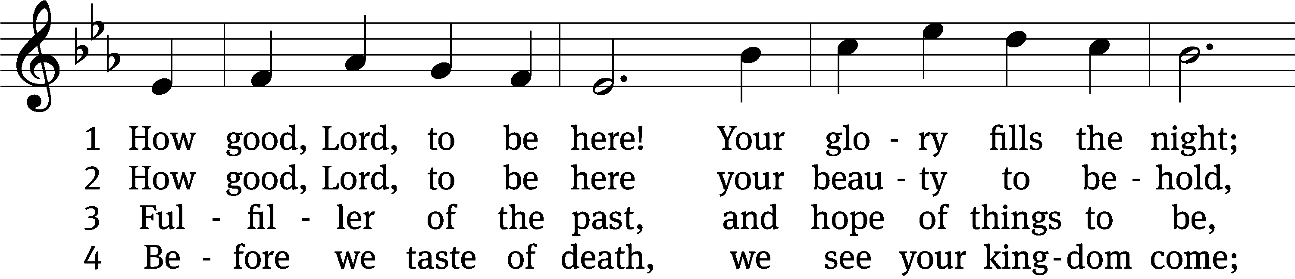
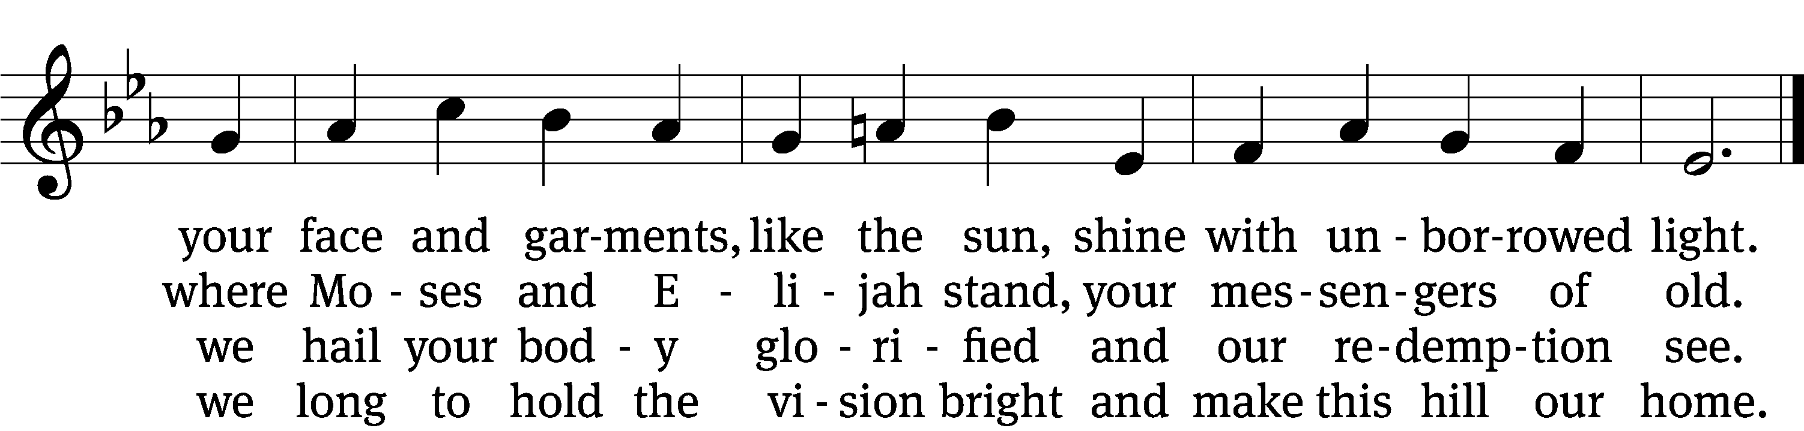

5 But you, Lord, do not stay.
With mercy resolute
you leave this glorious hill to die—
our perfect substitute.

6 How good, Lord, to be here!
Yet we may not remain;
but since you bid us leave the mount,
come with us to the plain.
Text (sts. 1–4, 6): Joseph A. Robinson, 1858–1933, sts. 1-4,6, alt.; (st. 5): Bryan Gerlach, b. 1954, st. 5
Tune: Johann Sebastian Bach, 1685–1750, adapt.
Text (st. 5): © 2021 Northwestern Publishing House. Used by permission: OneLicense no. 727703
Text (sts. 1–4, 6) and tune: Public domain

Serving In Worship

Officiant Pastor William Natsis
Organist Sarah Hanke
Choir Director Cynthia Natsis
Deacons (8:30) Dave Frey and Dave Stevenson
(11:00) Steve Hoeft and Ed Wheeler
Ushers (8:30) Dale Radak
(11:00) Ron Zahn
Altar Guild Margaret Hoeft and Brenda Stevenson
Videographer Rick Schneider

Words and Music: All rights reserved. Reprinted/Podcast/Streamed with permission under ONE LICENSE #A-727703 and CCLI #1151741/CSPL126093

