THE SECOND SUNDAY
IN LENT

TRINITY EVANGELICAL LUTHERAN CHURCH | Saline, Michigan
WELCOME TO WORSHIP March 5, 2023
Thank you for joining us in God’s house today! We cordially ask that our Guests sign one of the guestbooks located at either the front or back entryways, or fill out a “Let’s Get Acquainted” card located in the hymnal pew rack and place it in the collection plate.

Thank Offering: Members of Trinity give their offering as an expression of love and thankfulness to the Lord and to help support the Lord’s work in our community and around the world. Visitors need not feel obligated to participate in this offering .

Restrooms are located at the back of the upper level (the annex), and in the basement (down the back stairs of the sanctuary or annex). Handicap access is available, please ask an usher for assistance.

Young Families / Toddler Bags – We are GLAD YOU BROUGHT YOUR CHILDREN to our worship service. Jesus said: “Let the little children come to me and do not hinder them, for the kingdom of God belongs to such as these.” We know that having little children in church can be a challenge, but DO NOT WORRY about it. Many of your fellow worshippers have been in your shoes and are just happy you brought your children with you. For your convenience, we have reserved the back rows of seating for parents with small children. These areas provide more flexibility for your family, as well as, easy access to move downstairs if necessary. A closed-circuit TV system allows families to continue participating in the service while downstairs. Pre-school toddler bags and children’s bulletins are available for their enjoyment. Ask an usher for one to use during the service and please return the toddler bag afterwards.

Holy Communion – In His Word, God makes it clear that the Lord’s Supper is to be shared by people of a common proclamation of faith (1 Corinthians 11:26; 1 Corinthians 10:16-17). Without judging anyone’s hearts, we invite those who share in our confession by their membership in our congregation or another congregation of the Wisconsin Evangelical Lutheran Synod (WELS) or the Evangelical Lutheran Synod (ELS) and who are properly prepared (1 Corinthians 11;27-29) to receive the Sacrament. Page 295 in Christian Worship provides a guide for preparation.
Guests, we would love to have you join us in communion fellowship in the future, and for that to be possible, we ask that you speak with one of the pastors so that we may speak with you on how that would be possible. We thank you for respecting the way we celebrate the Lord’s Supper in our congregations.

the SERVICE – setting one - WITH HOLY COMMUNION CW, page 154
797 I Know My Faith Is Founded CW 797
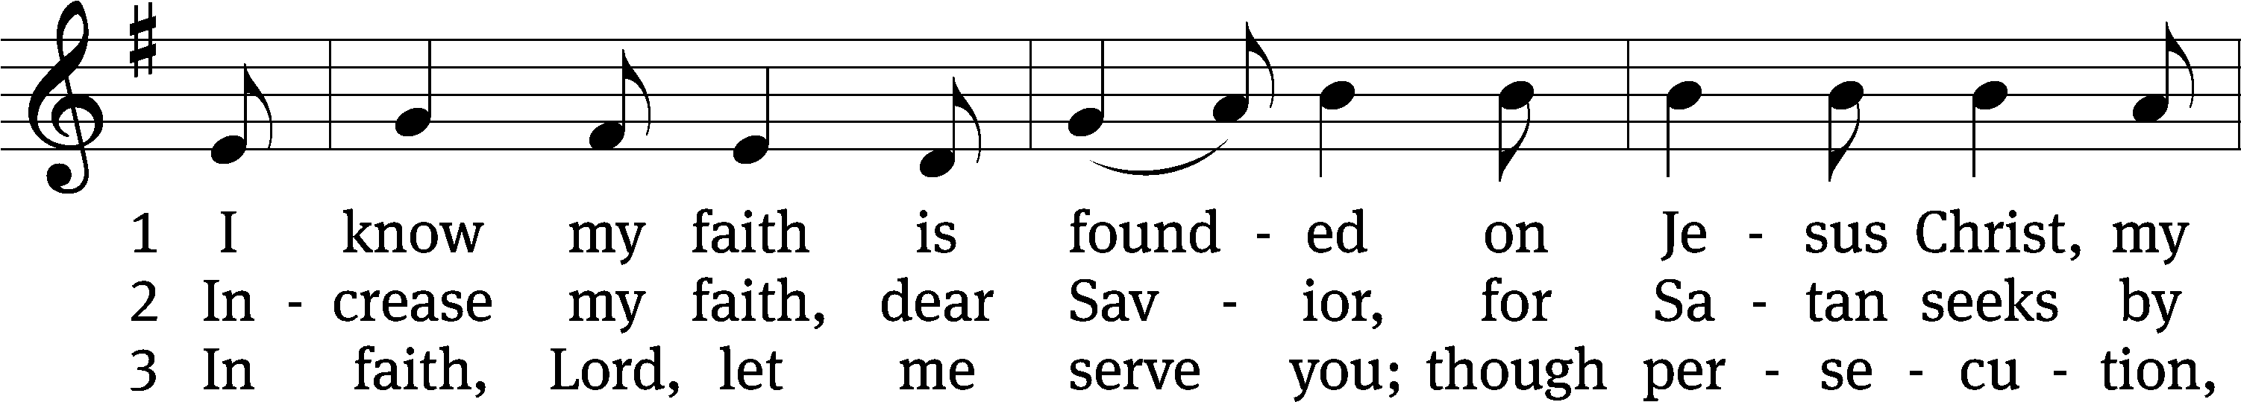
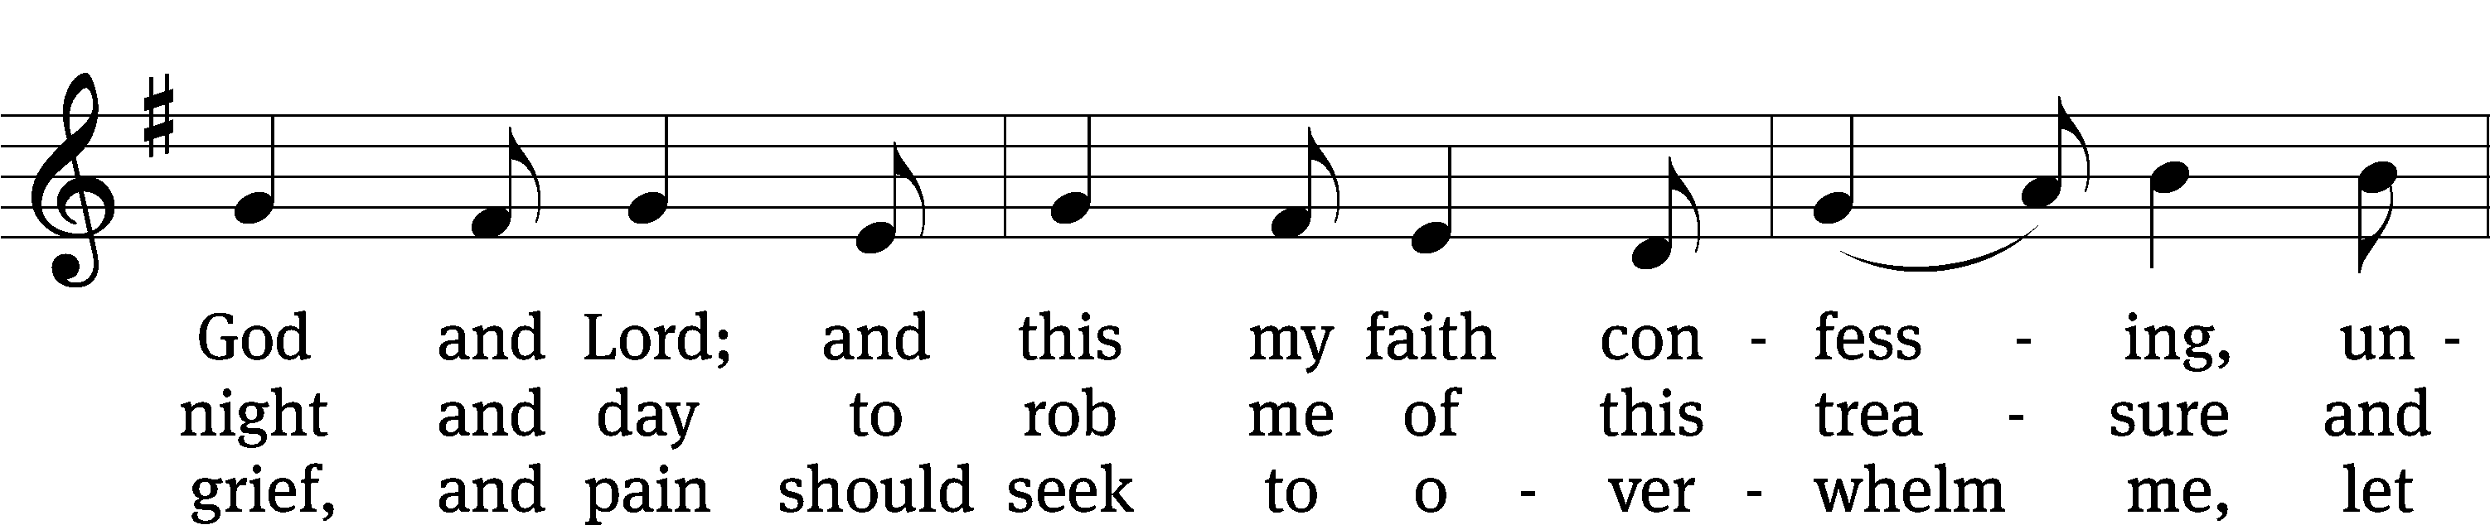
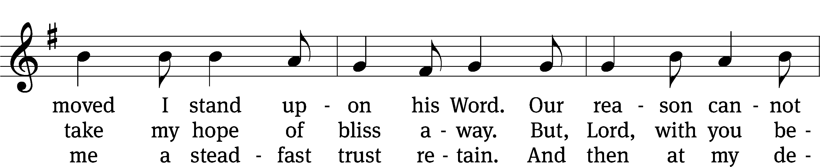
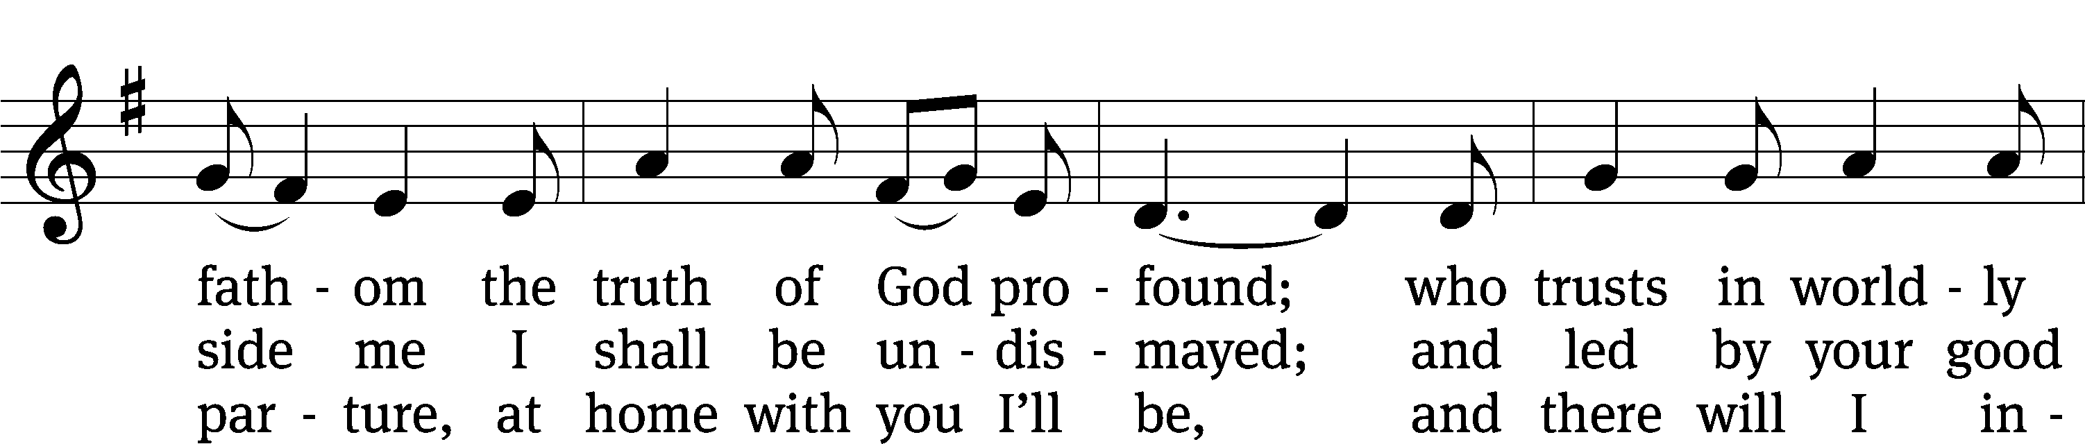
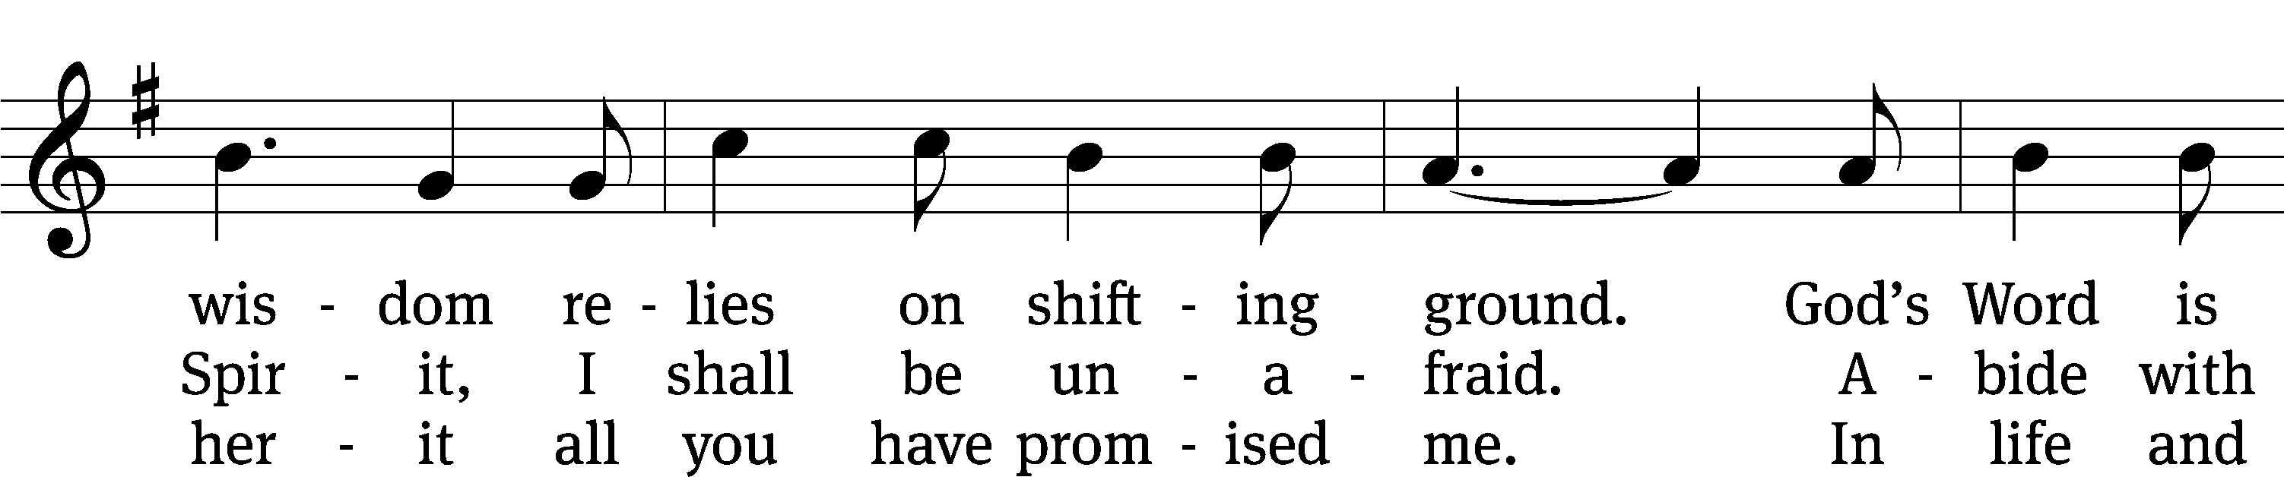
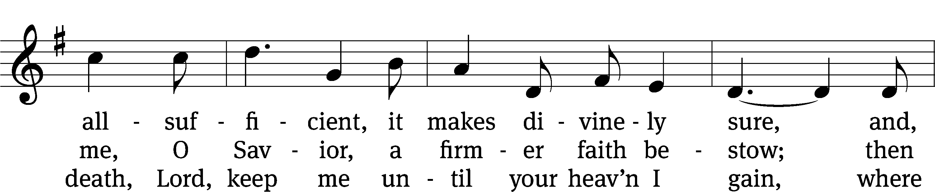
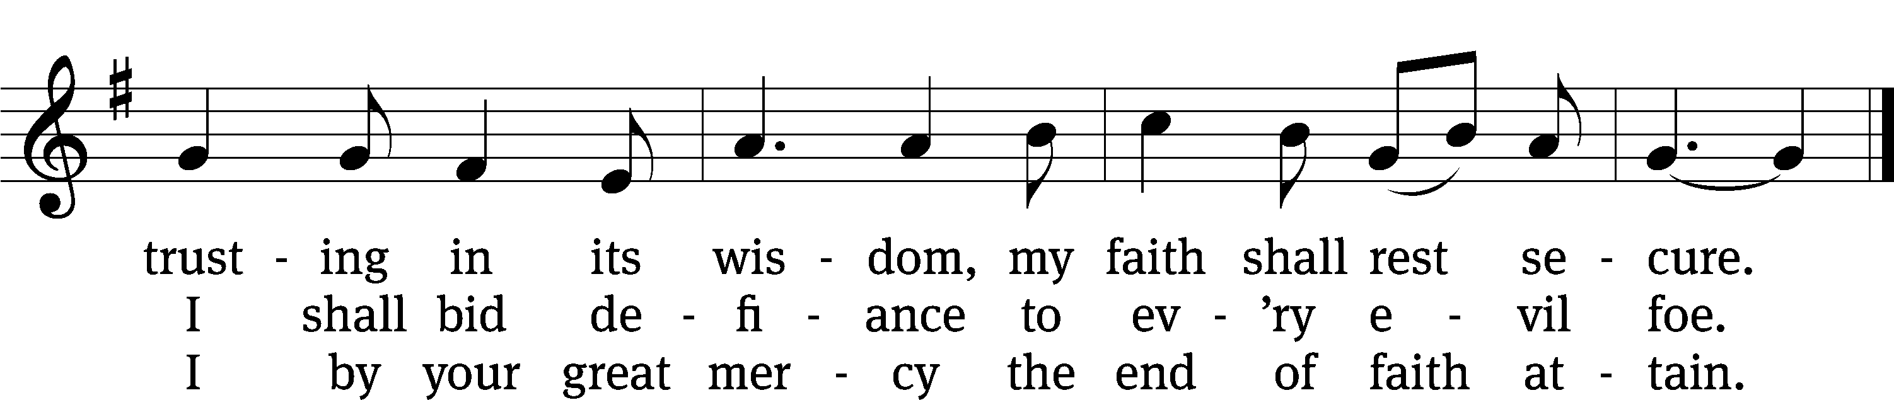
Text: tr. The Lutheran Hymnal, 1941, alt.; Erdmann Neumeister, 1671–1756
Tune: Concentus novi, Augsburg, 1540, ed. Johann Kugelmann
Text and tune: Public domain

Please stand, if you are able
Invocation
In the name of the Father and of the Son and of the Holy Spirit.
Amen.
Confession
If we claim to be without sin, we deceive ourselves and the truth is not in us.
If we confess our sins, God is faithful and just
and will forgive us our sins
and purify us from all unrighteousness.

Let us confess our sins to the Lord.
Holy God, gracious Father,
I am sinful by nature
and have sinned against you in my thoughts, words, and actions.
I have not loved you with my whole heart;
I have not loved others as I should.
I deserve your punishment both now and forever.
But Jesus, my Savior, paid for my sins
with his innocent suffering and death.
Trusting in him, I pray: God, have mercy on me, a sinner.

Our gracious Father in heaven has been merciful to us. He sent his only Son, Jesus Christ, who gave his life as the atoning sacrifice for the sins of the whole world. Therefore, as a called servant of Christ and by his authority, I forgive you all your sins in the name of the Father and of the Son and of the Holy Spirit.
Amen.

Lord, Have Mercy

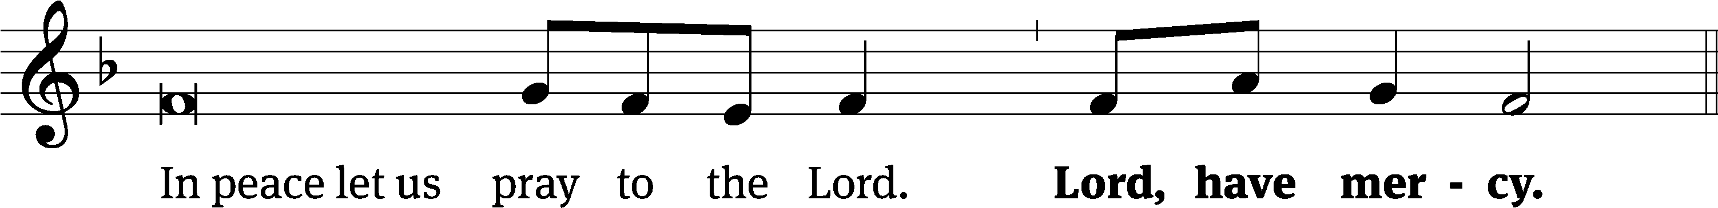
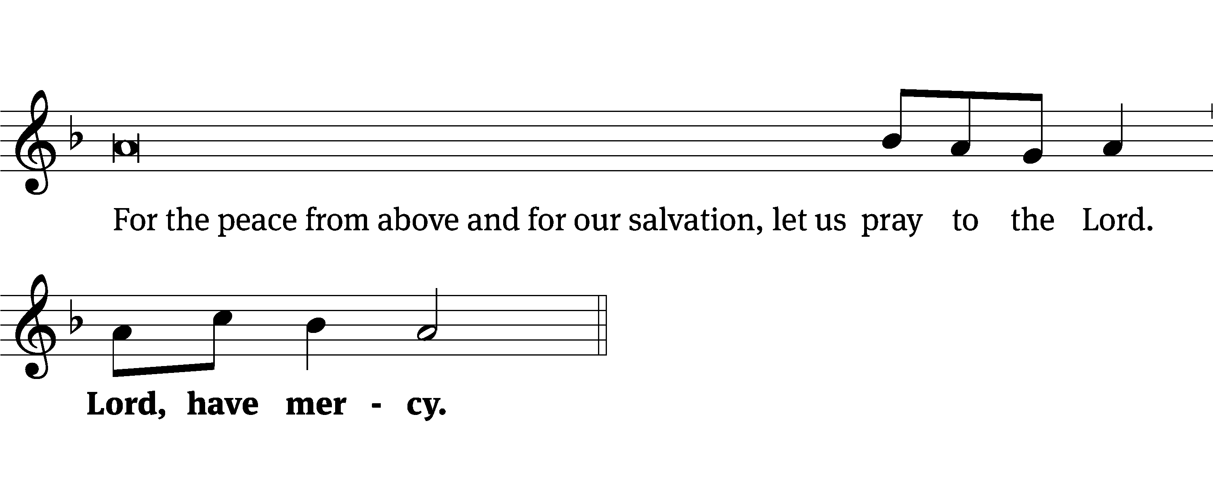
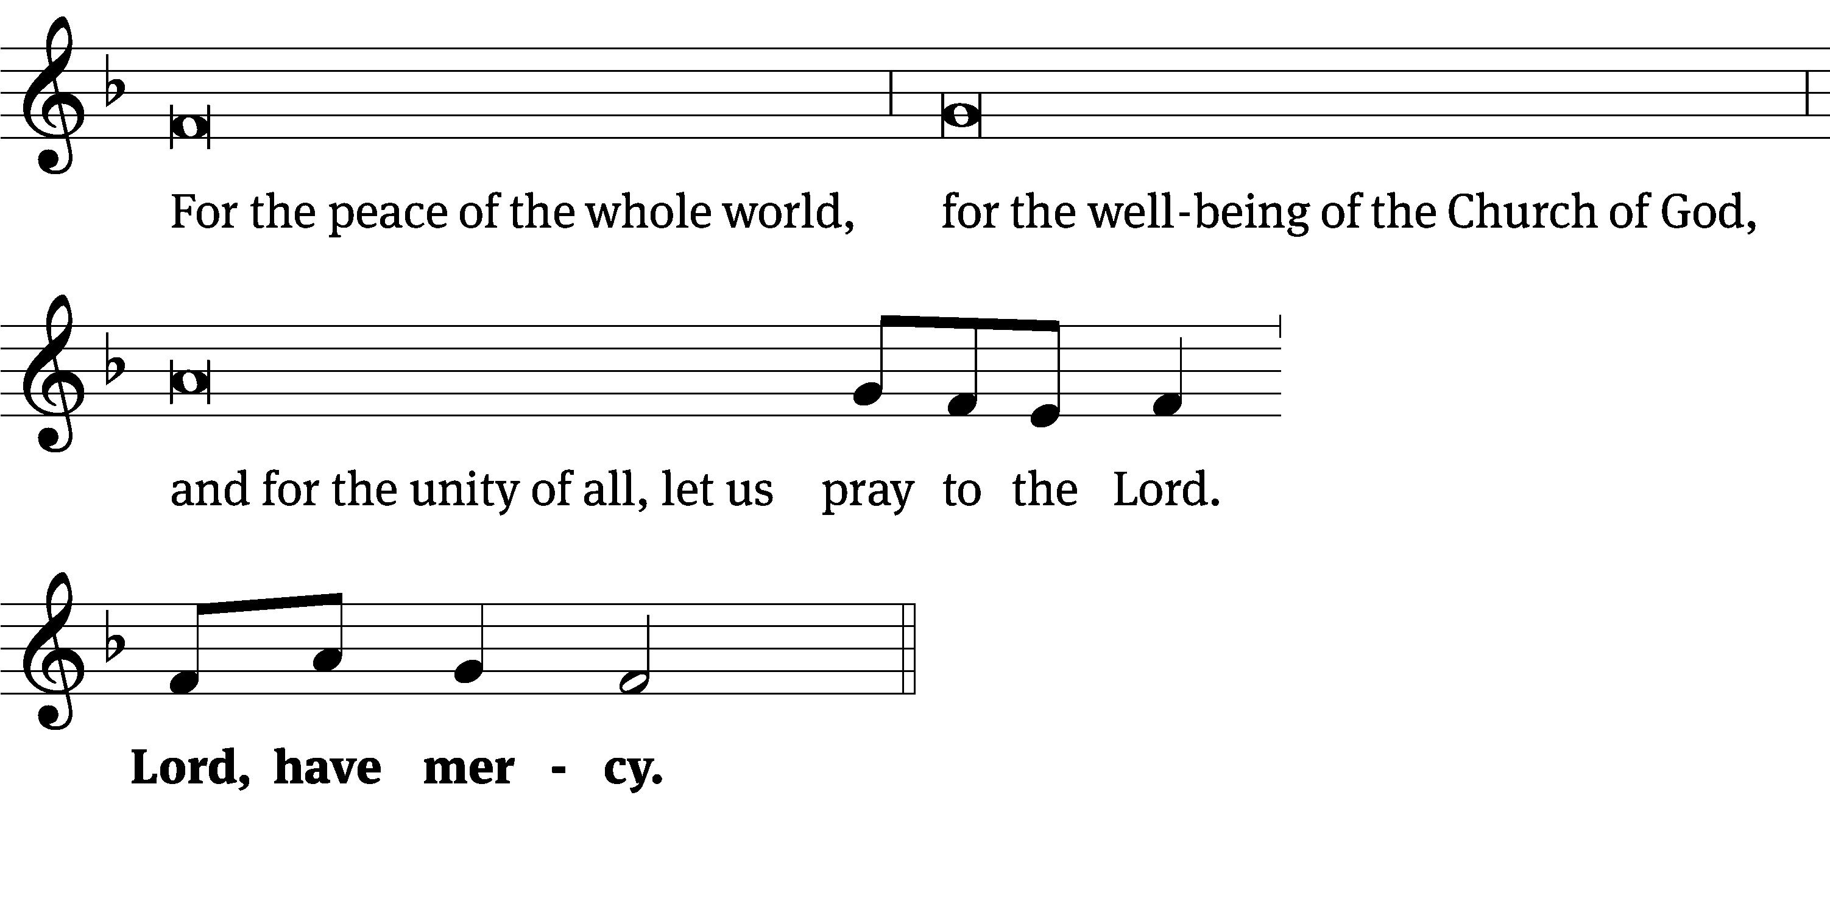
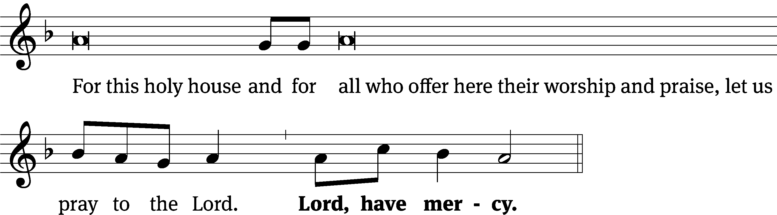
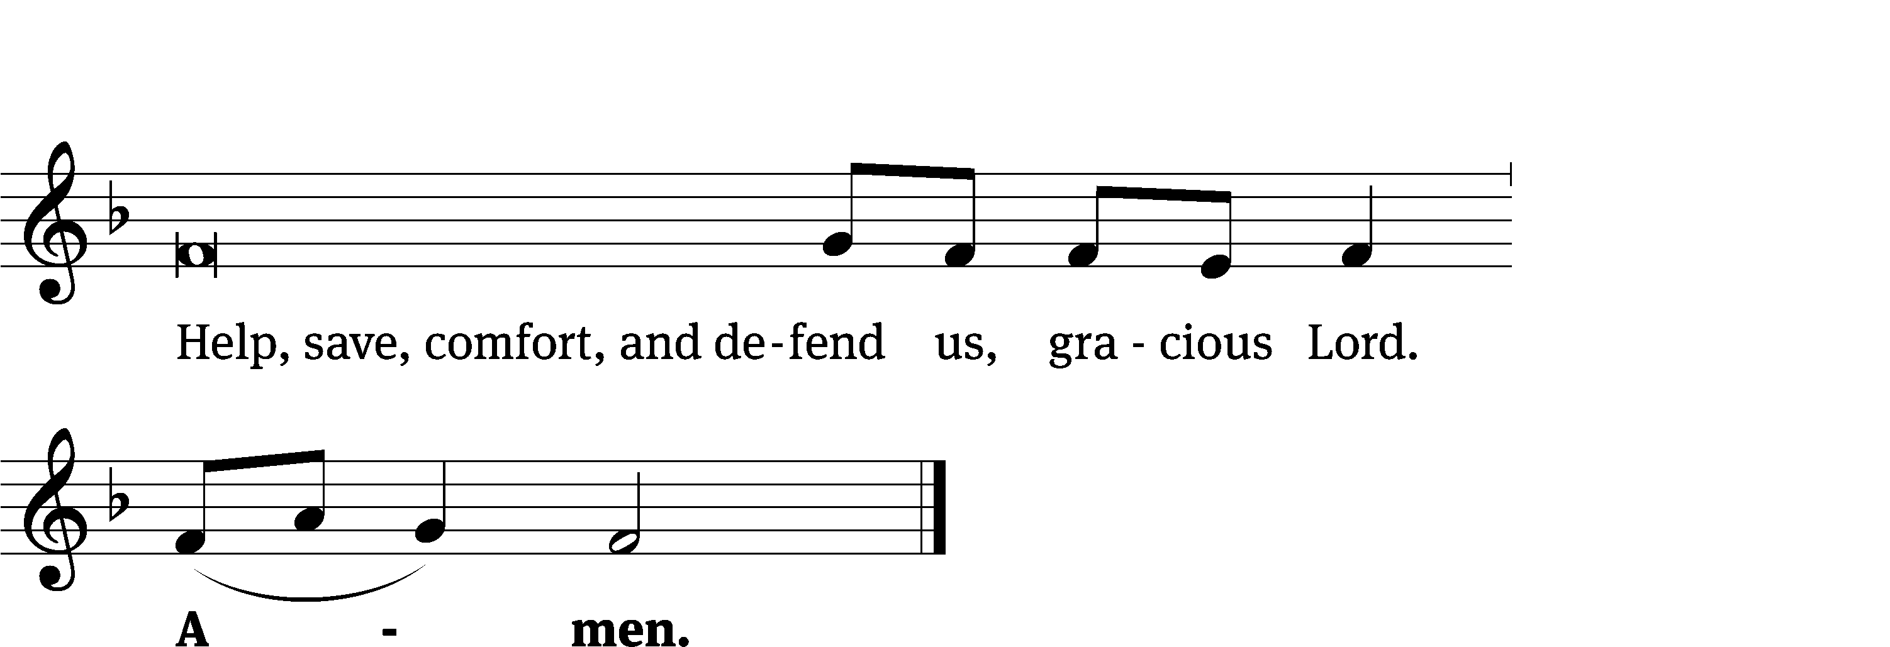

Glory Be to God on High CW 157
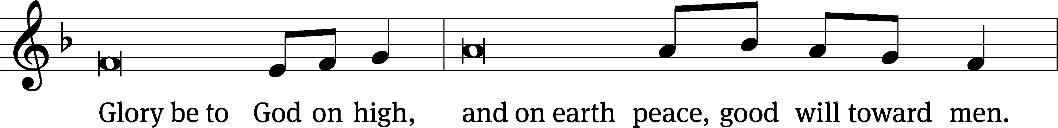
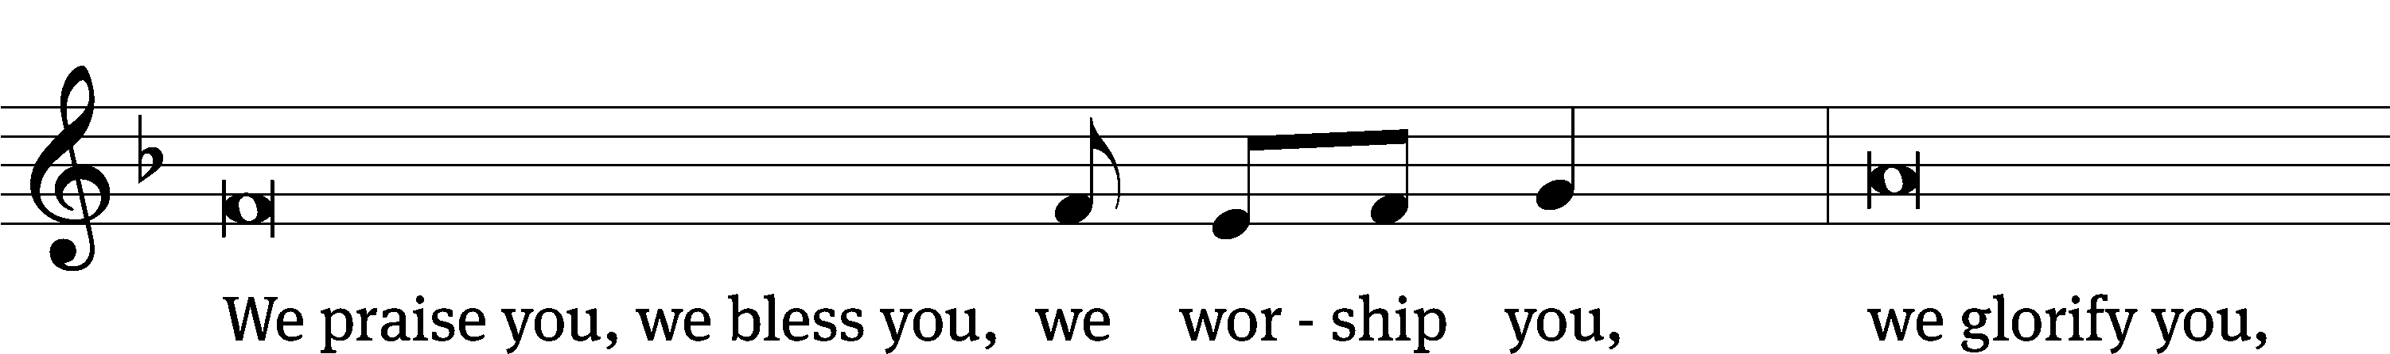
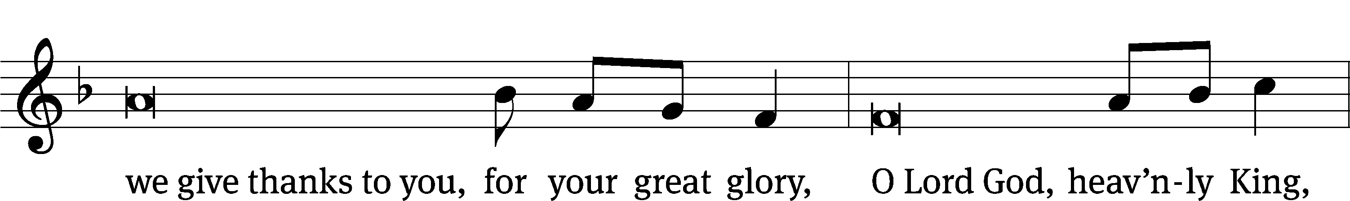
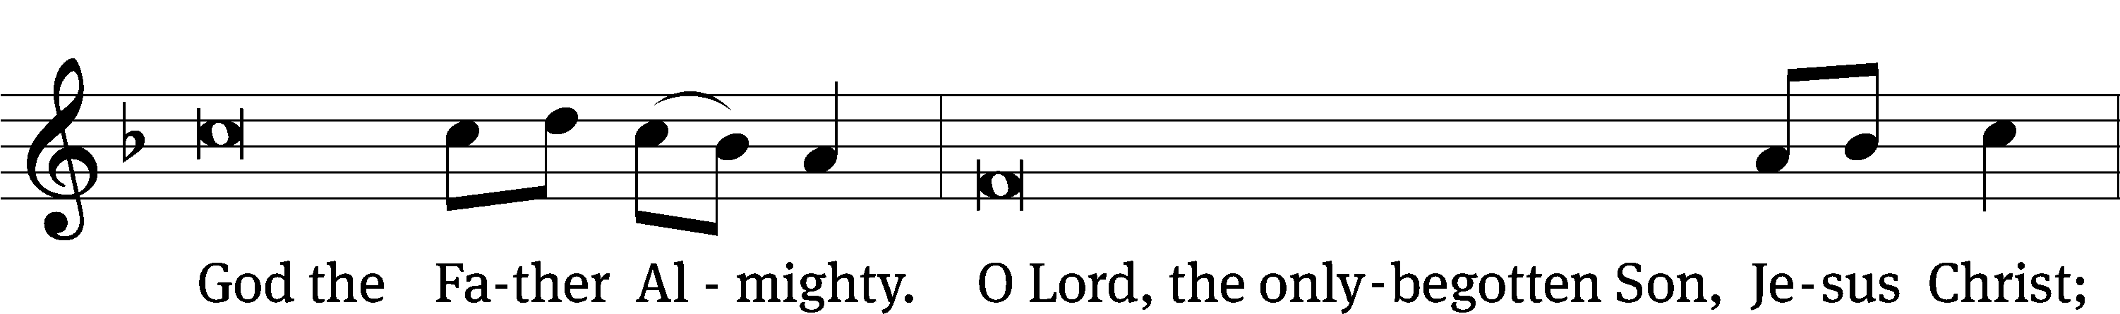
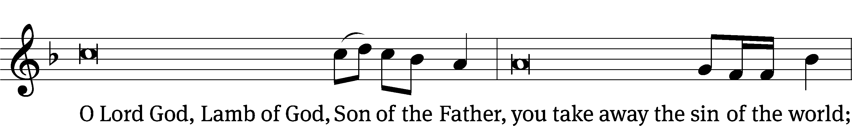
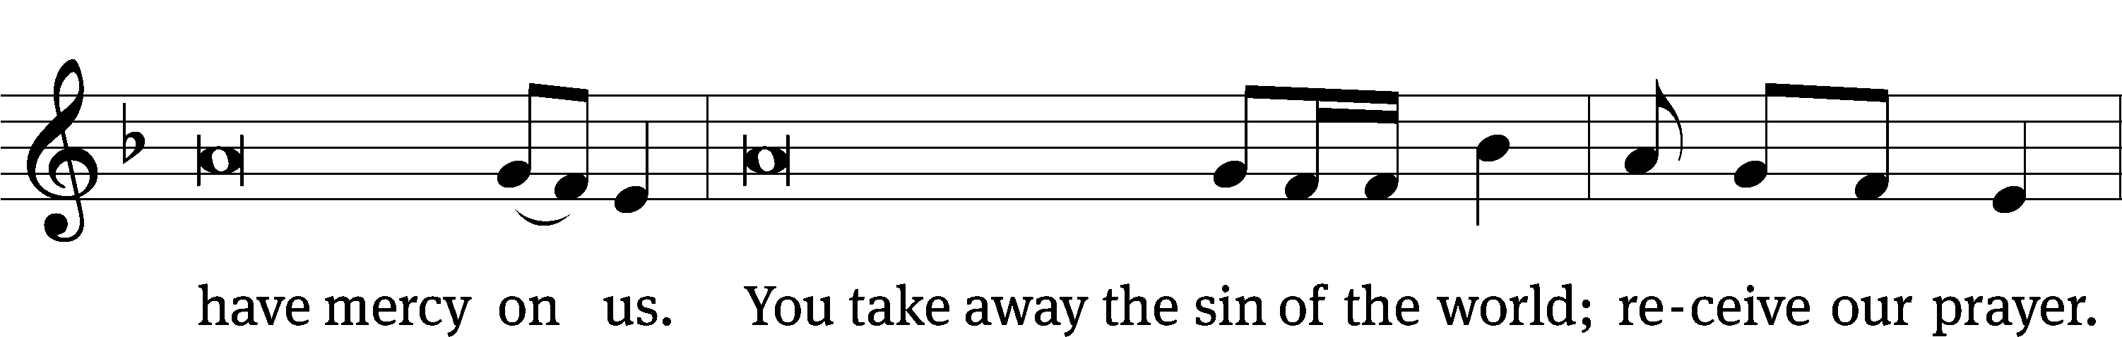
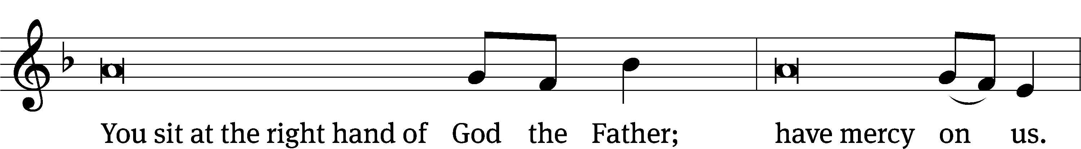
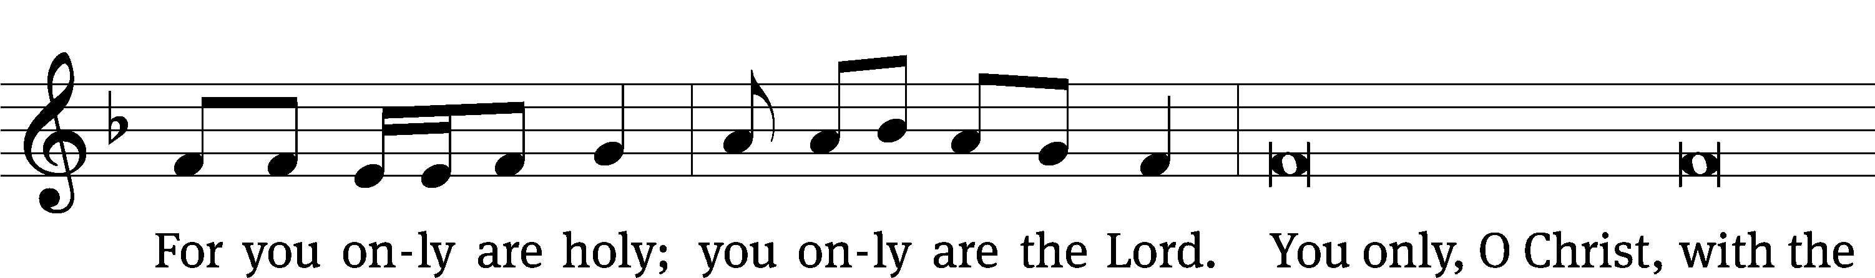
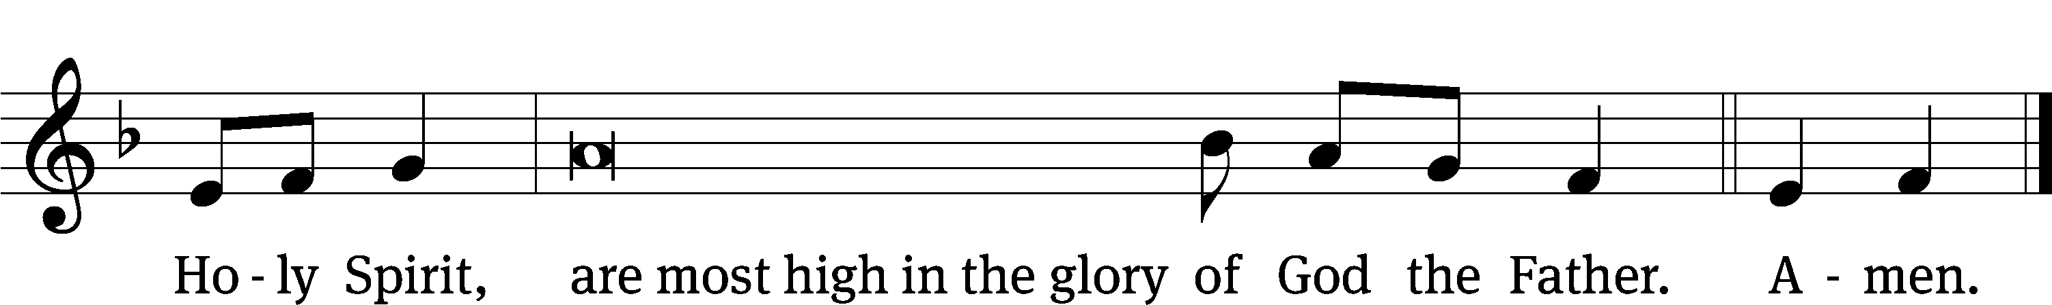

The Lord be with you.
And also with you.
Prayer of the Day
Let us pray.

Almighty God, you see that we have no power to defend ourselves. Guard and keep us both outwardly and inwardly from all adversities that may happen to the body and all evil thoughts that may assault and hurt the soul; through your Son, Jesus Christ our Lord, who lives and reigns with you and the Holy Spirit, one God, now and forever.
Amen.

Please be seated

First Reading Genesis 12:1-8
¹ Now the Lord said to Abram, “Get out of your country and away from your relatives and from your father’s house and go to the land that I will show you. ² I will make you a great nation. I will bless you and make your name great. You will be a blessing. ³ I will bless those who bless you, and I will curse anyone who dishonors you. All of the families of the earth will be blessed in you.”

⁴ So Abram went, as the Lord had told him. Lot went with him. Abram was seventy-five years old when he departed from Haran. ⁵ Abram took Sarai his wife, Lot his brother’s son, and all the possessions they had accumulated and the people that they had acquired in Haran, and they set out to travel to the land of Canaan. Eventually they arrived in the land of Canaan. ⁶ Abram passed through the land until he came to the Oak of Moreh at the place called Shechem. The Canaanites were in the land at that time.
⁷ The Lord appeared to Abram and said, “I will give this land to your descendants.”^{[a]} Abram built an altar there to the Lord, who had appeared to him.
⁸ He moved on from there to the hill country east of Bethel and pitched his tent there, with Bethel on the west and Ai on the east. There he built an altar to the Lord and proclaimed^{[b]} the name of the Lord.

The Word of the Lord.
Thanks be to God.

Choir “Incline your Ear, O Lord”

Incline your ear, O Lord, answer me when I call.
Give ear, Lord, to my prayer, hear my supplication.
Teach me your ways, O Lord, guide the steps I take, your truth to walk in.
All nations you have made glorify your name for everlasting.
Your love is steadfast; your love ever is faithful.
I give my thanks to you, Lord. I give thanks to you, Lord.
Help me, Lord, be kind to me; have pity on your servant. Amen.

Second Reading Romans 4:1-5; 13-17
¹ What then will we say that Abraham, our forefather, discovered according to the flesh? ² If indeed Abraham had been justified by works, he would have had a reason to boast—but not before God. ³ For what does Scripture say? “Abraham believed God and it was credited to him as righteousness.”
⁴ Now to a person who works, his pay is not counted as a gift but as something owed. ⁵ But to the person who does not work but believes in the God who justifies the ungodly, his faith is credited to him as righteousness.
¹³ Indeed, the promise that he would be the heir of the world was not given to Abraham or his descendants through the law, but through the righteousness that is by faith. ¹⁴ To be sure, if people are heirs by the law, faith is empty and the promise is nullified. ¹⁵ For law brings wrath. (Where there is no law, there is no transgression.) ¹⁶ For this reason, the promise is by faith, so that it may be according to grace and may be guaranteed to all of Abraham’s descendants—not only to the one who is a descendant by law, but also to the one who has the faith of Abraham. He is the father of us all. ¹⁷ As it is written: “I have made you a father of many nations.”

The Word of the Lord.
Thanks be to God.

Please stand, if you are able

Gospel Acclamation John 3:16
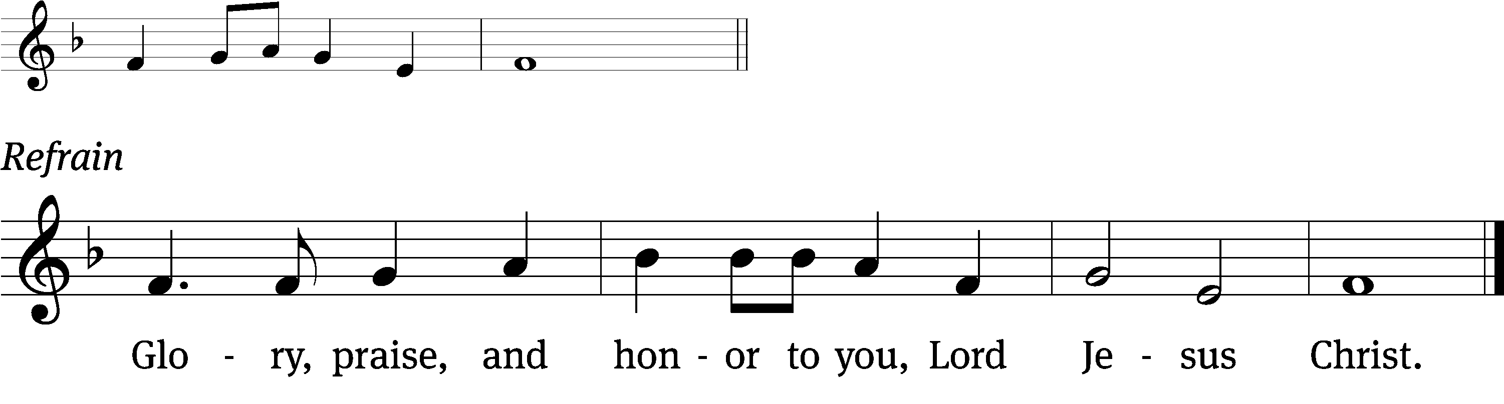
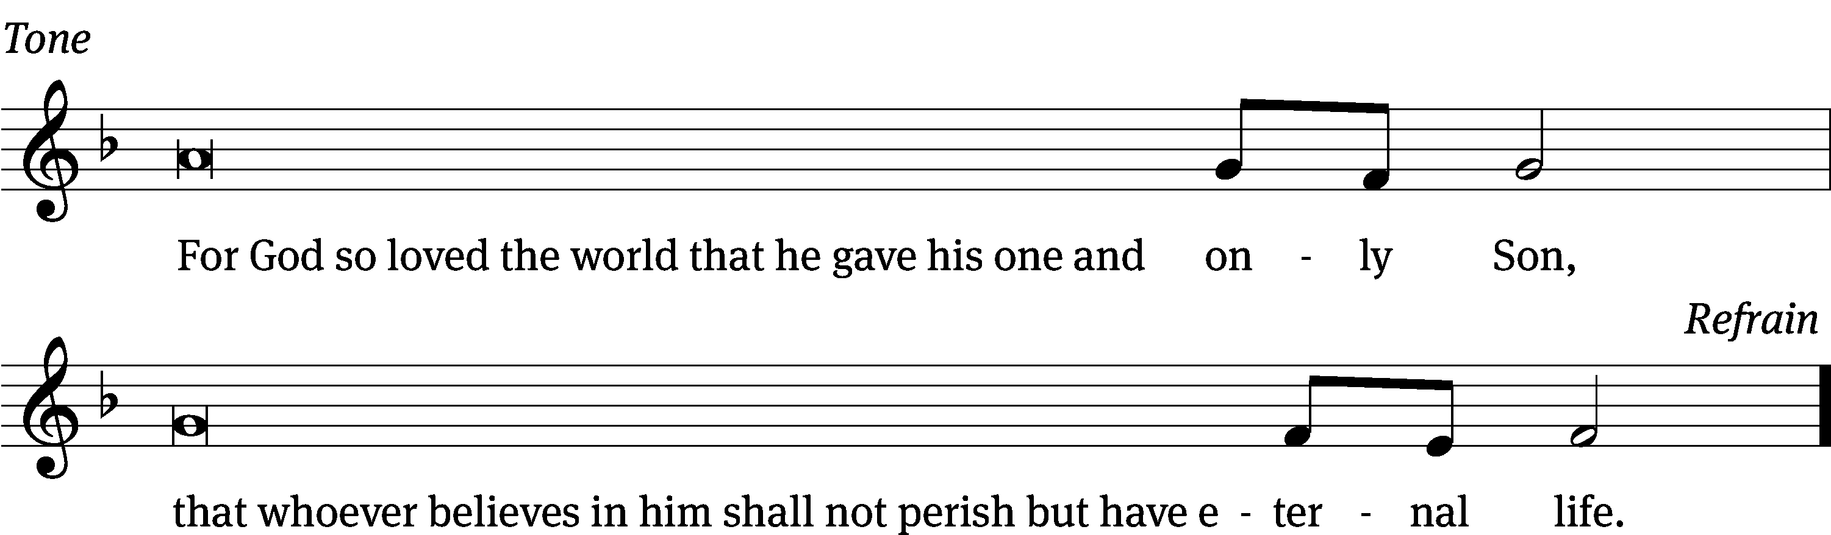
Tune: © 2021 Northwestern Publishing House. Used by permission: OneLicense no. 727703

Gospel John 3:1-17
¹ There was a man of the Pharisees named Nicodemus, a member of the Jewish ruling council. ² He came to Jesus at night and said to him, “Rabbi, we know that you are a teacher who has come from God, for no one can do these miraculous signs you are doing unless God is with him.”
³ Jesus replied, “Amen, Amen, I tell you: Unless someone is born from above, he cannot see the kingdom of God.”
⁴ Nicodemus said to him, “How can a man be born when he is old? He cannot enter a second time into his mother’s womb and be born, can he?”
⁵ Jesus answered, “Amen, Amen, I tell you: Unless someone is born of water and the Spirit, he cannot enter the kingdom of God! ⁶ Whatever is born of the flesh is flesh. Whatever is born of the Spirit is spirit. ⁷ Do not be surprised when I tell you that you must be born from above. ⁸ The wind blows where it pleases. You hear its sound, but you do not know where it comes from or where it is going. So it is with everyone who is born of the Spirit.”
⁹ “How can these things be?” asked Nicodemus.
¹⁰ “You are the teacher of Israel,” Jesus answered, “and you do not know these things? ¹¹ Amen, Amen, I tell you: We speak what we know, and we testify about what we have seen. But you people do not accept our testimony. ¹² If I have told you earthly things and you do not believe, how will you believe if I tell you heavenly things? ¹³ No one has ascended into heaven, except the one who descended from heaven, the Son of Man, who is in heaven.
¹⁴ “Just as Moses lifted up the snake in the wilderness, so the Son of Man must be lifted up, ¹⁵ so that everyone who believes in him shall not perish but have eternal life.
¹⁶ “For God so loved the world that he gave his only-begotten Son, that whoever believes in him shall not perish, but have eternal life. ¹⁷ For God did not send his Son into the world to condemn the world, but to save the world through him.

The Gospel of the Lord.
Praise be to you, O Christ!

Please be seated
570 God Loved the World So That He Gave CW 570
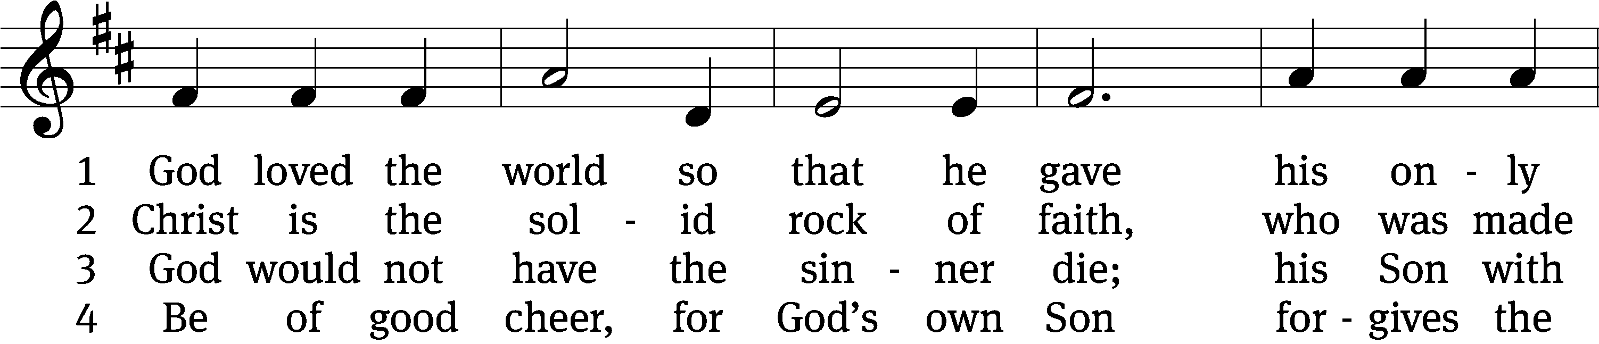
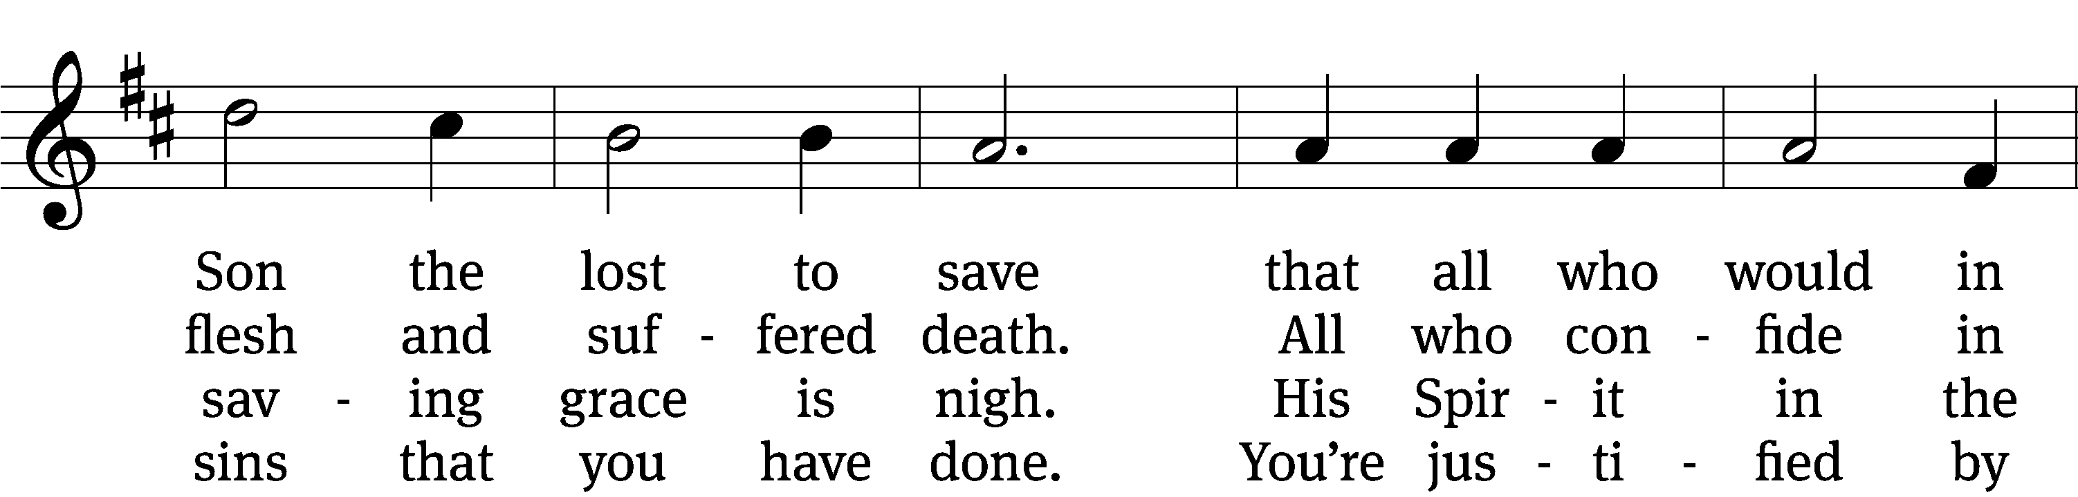
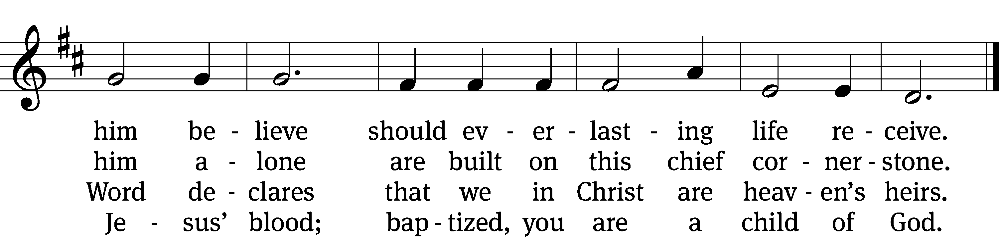

5 If you are sick, if death is near,
this truth your troubled heart can cheer:
Christ Jesus saves my soul from death;
this is the anchor of my faith!

6 Glory to God the Father, Son,
and Holy Spirit, Three in One!
To you, O blessèd Trinity,
be praise now and eternally!
Text: tr. August Crull, 1845–1923, alt.; Heiliges Lippen- und Hertzens- Opffer, Stettin, c. 1778
Tune: George J. Elvey, 1816–1893
Text and tune: Public domain

SERMON John 3:1-17
“A Teacher Gets Schooled about Faith”

Please stand, if you are able
Nicene Creed
We believe in one God, the Father, the Almighty,
maker of heaven and earth,
of all that is,
seen and unseen.
We believe in one Lord, Jesus Christ, the only Son of God,
eternally begotten of the Father,
God from God, Light from Light, true God from true God,
begotten, not made,
of one being with the Father.
Through him all things were made.
For us and for our salvation, he came down from heaven,
was incarnate of the Holy Spirit and the Virgin Mary,
and became truly human.
For our sake he was crucified under Pontius Pilate.
He suffered death and was buried.
On the third day he rose again in accordance with the Scriptures.
He ascended into heaven
and is seated at the right hand of the Father.
He will come again in glory to judge the living and the dead,
and his kingdom will have no end.
We believe in the Holy Spirit,
the Lord, the giver of life,
who proceeds from the Father and the Son,
who in unity with the Father and the Son
is worshiped and glorified,
who has spoken through the prophets.
We believe in one holy Christian and apostolic Church.
We acknowledge one baptism for the forgiveness of sins.
We look for the resurrection of the dead
and the life of the world to come. Amen.

Prayer of the Church

The Sacrament
Preface CW 165
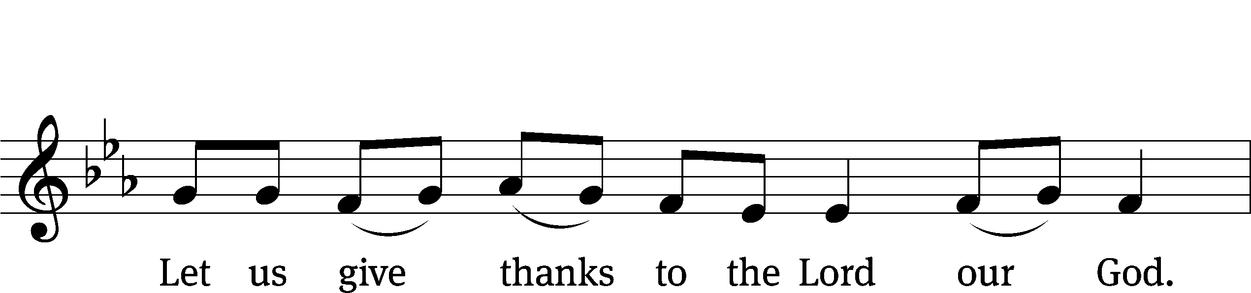
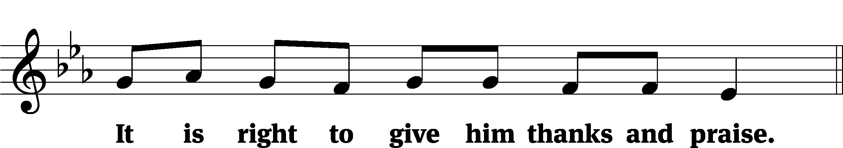

It is truly good and right that we should at all times and in all places give you thanks, O Lord, holy Father, almighty and everlasting God, through Jesus Christ our Lord, who promised that wherever two or three come together in his name, there he is with them to shepherd his flock until he comes again in glory. Therefore, with all the saints on earth and hosts of heaven, we praise your holy name and join their glorious song:
Holy, Holy, Holy CW 167
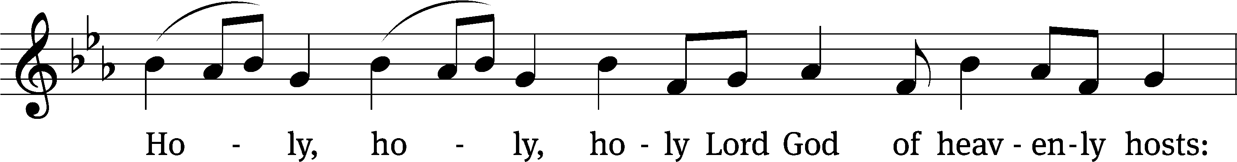
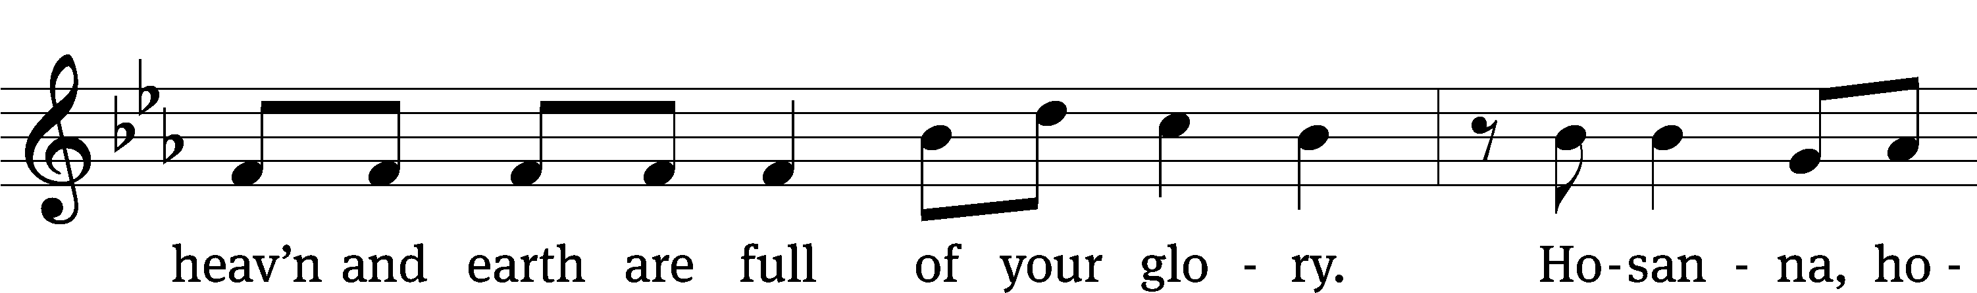
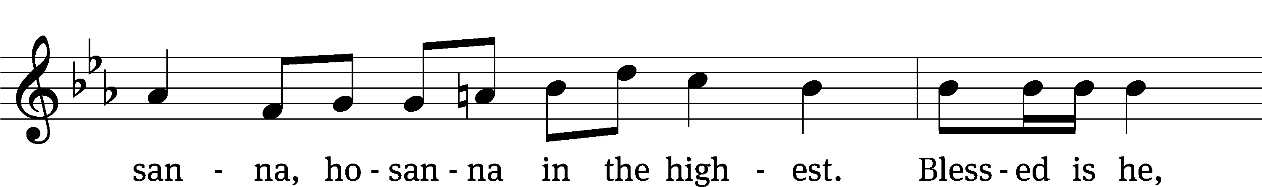
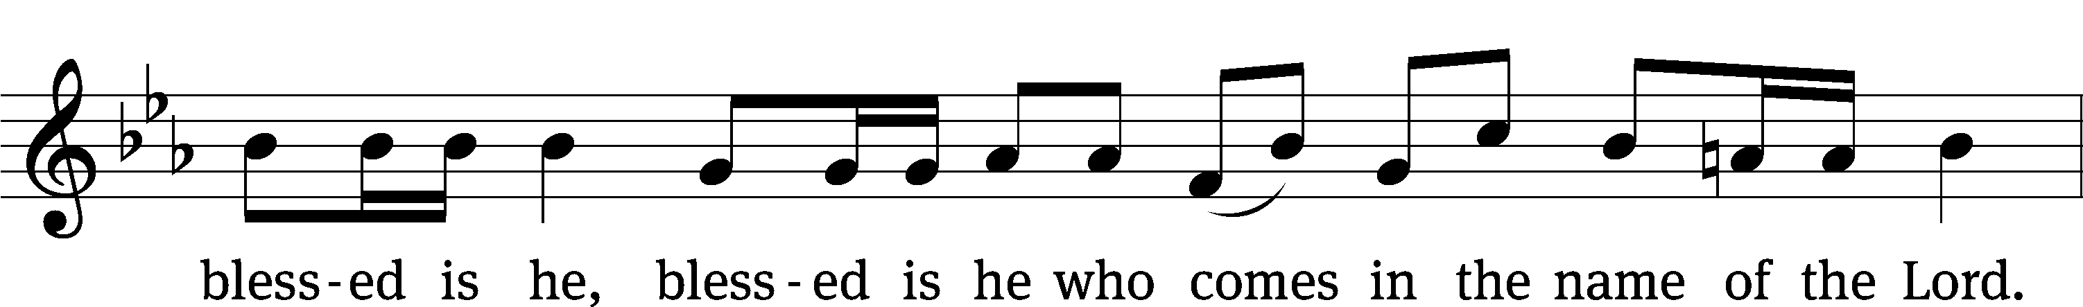
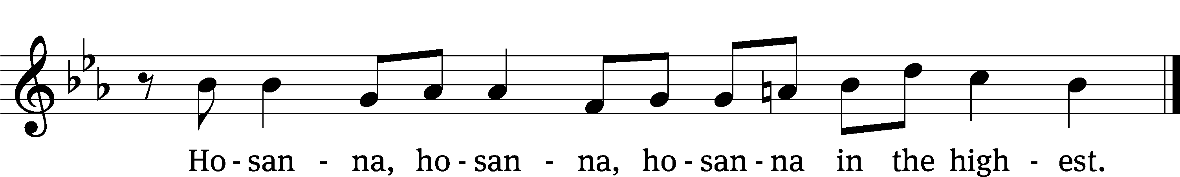

Prayer of Thanksgiving
We give thanks to you, O God, through your dear Son, Jesus Christ, whom you sent to be our Savior, our Redeemer, and the messenger of your grace. Through him you made all things; in him you are well pleased. He is the incarnate Word, conceived by the Holy Spirit and born of the Virgin Mary. To fulfill your promises, he stretched out his hands on the cross and released from eternal death all who believe in you.

As we remember Jesus’ death and resurrection, we thank you that you have gathered us together to receive your Son’s body and blood. Send us your Spirit, unite us as one, and strengthen our faith so that we may praise you in your Son, Jesus Christ. Through him, we glorify and honor you, O God our Father, with the Holy Spirit, one God, now and forever.
Amen.

Lord’s Prayer
Our Father, who art in heaven, hallowed be thy name, thy kingdom come, thy will be done on earth as it is in heaven. Give us this day our daily bread; and forgive us our trespasses, as we forgive those who trespass against us; and lead us not into temptation, but deliver us from evil. For thine is the kingdom and the power and the glory forever and ever. Amen.

Words of Institution
Our Lord Jesus Christ, on the night he was betrayed, took bread; and when he had given thanks, he broke it and gave it to his disciples, saying, “Take and eat; this is my body, which is given for you. Do this in remembrance of me.”
Then he took the cup, gave thanks, and gave it to them, saying, “Drink from it, all of you; this is my blood of the new covenant, which is poured out for you for the forgiveness of sins. Do this, whenever you drink it, in remembrance of me.”

The peace of the Lord be with you always.
Amen.
O Christ, Lamb of God CW 169
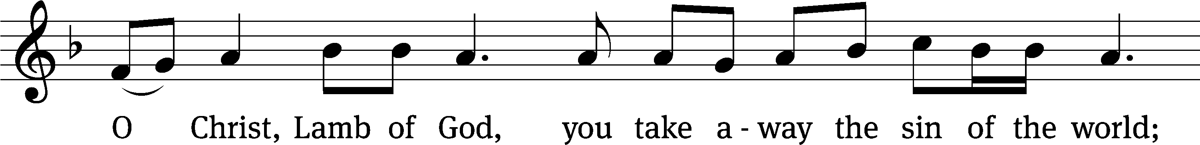
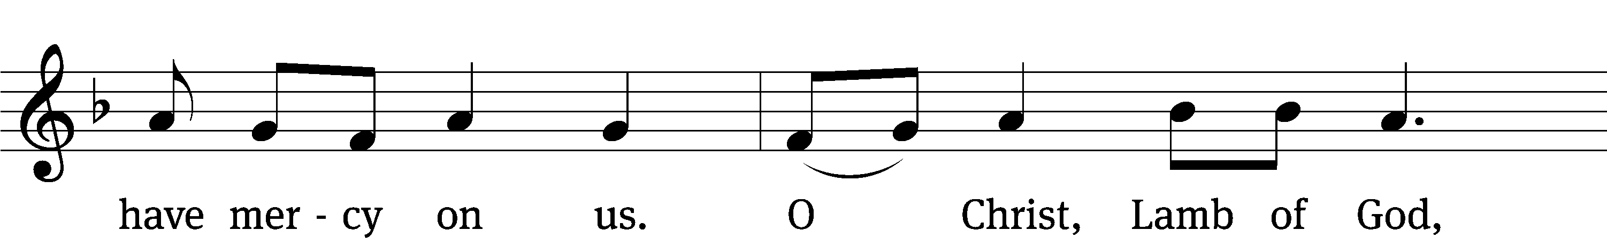
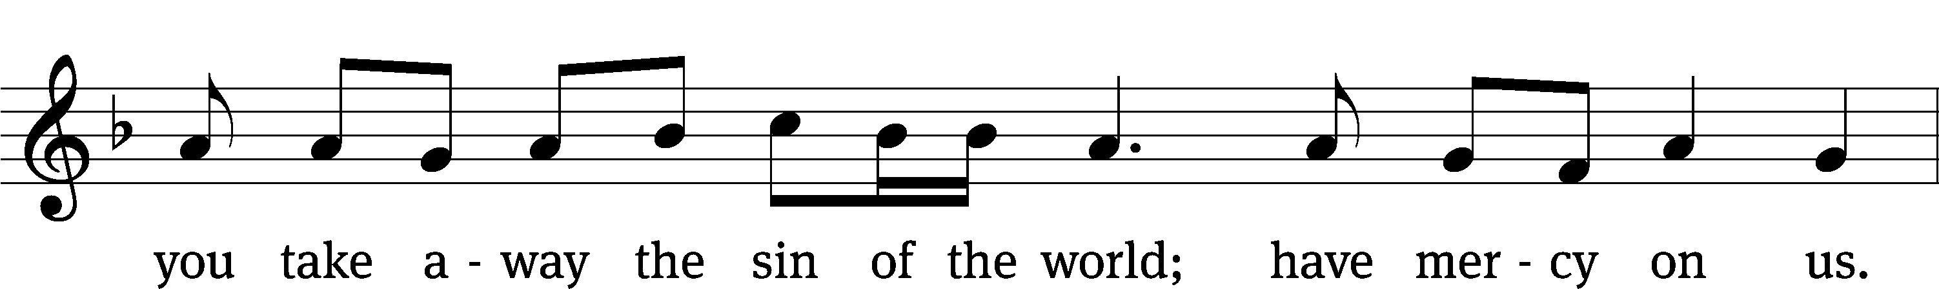
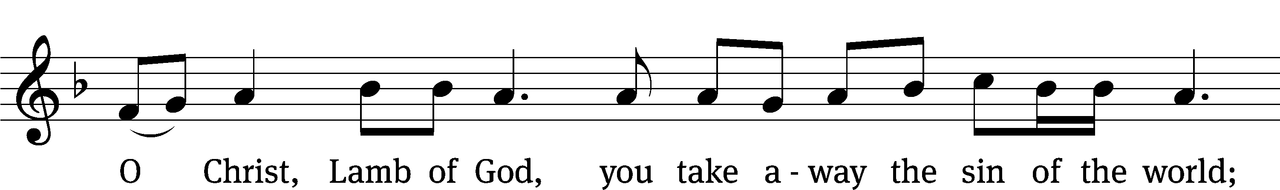
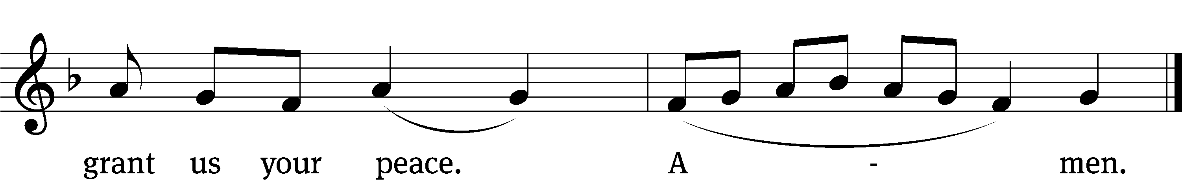
Please be seated
557 Dear Christians, One and All, Rejoice CW 557
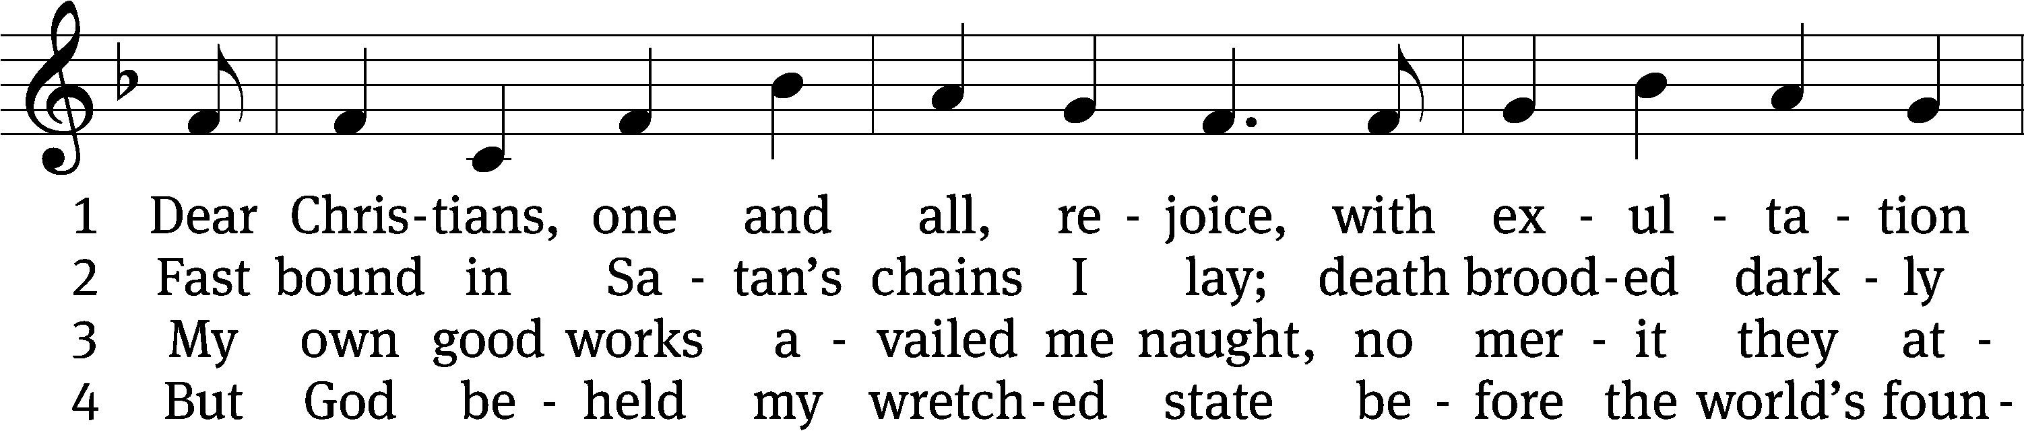
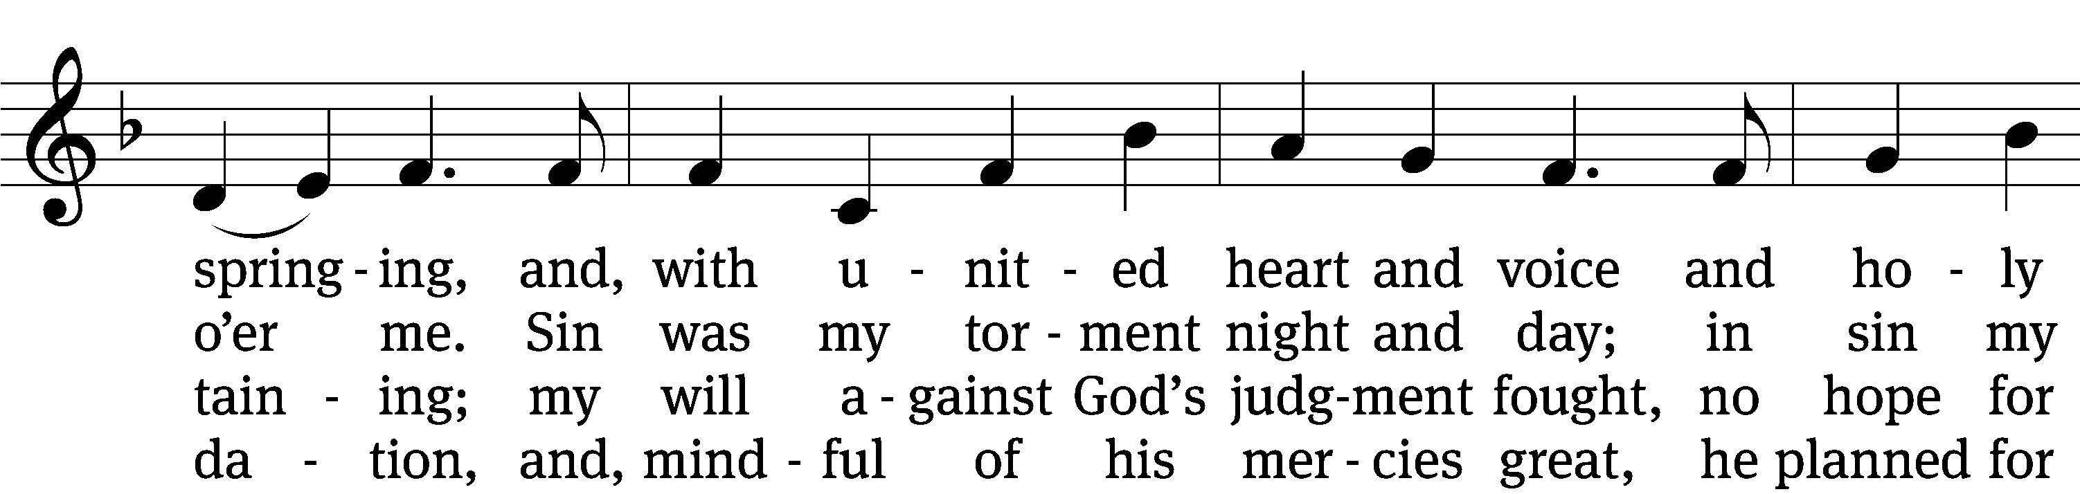
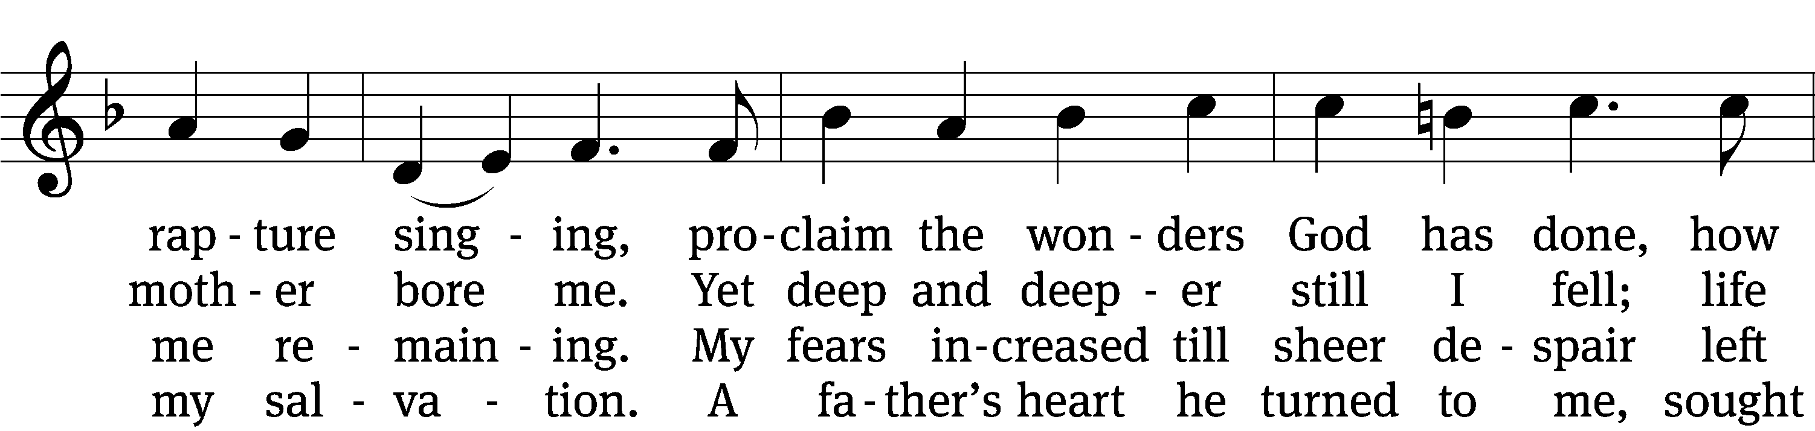
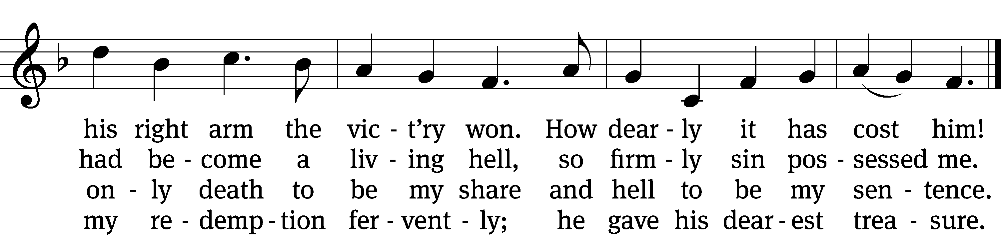

5 He spoke to his belovèd Son:
“It’s time to have compassion.
Then go, bright jewel of my crown,
and bring to all salvation.
From sin and sorrow set them free;
slay bitter death for them that they
may live with you forever.”

6 The Son obeyed his Father’s will,
was born of virgin mother,
and, God’s good pleasure to fulfill,
he came to be my brother.
No garb of pomp or pow’r he wore;
a servant’s form like mine he bore
to lead the devil captive.

7 To me he spoke, “Hold fast to me,
I am your rock and castle.
Your ransom I myself will be;
for you I strive and wrestle.
For I am yours, your friend divine,
and evermore you shall be mine;
the foe shall not divide us.

8 “The foe will shed my precious blood,
me of my life bereaving;
all this I suffer for your good;
be steadfast and believing.
Life will from death the vict’ry win;
my innocence shall bear your sin,
and you are blest forever.

9 “Now to my Father I depart,
the Holy Spirit sending
and, heav’nly wisdom to impart,
my help to you extending.
He will a source of comfort be,
teach you to know and follow me,
and in all truth will guide you.

10 “What I on earth have lived and taught
be all your life and teaching;
so shall my kingdom’s work be wrought
and honored in your preaching.
Take care that no one’s man-made laws
should e’er destroy the gospel’s cause;
this final word I leave you.”
Text: tr. Richard Massie, 1800–1887, alt.; Martin Luther, 1483–1546
Tune: Etlich Cristlich lider, Wittenberg, 1524
Text and tune: Public domain

Please stand, if you are able

Give thanks to the Lord, for he is good;
his mercy endures forever.

Whenever we eat this bread and drink this cup,
we proclaim the Lord’s death until he comes.

We give thanks, almighty God, that you have refreshed us with this saving gift. We pray that through it you will strengthen our faith in you and increase our love for one another. We ask this in the name of Jesus Christ our Lord, who lives and reigns with you and the Holy Spirit, one God, now and forever.
Amen.

Blessing
The Lord bless you and keep you.
The Lord make his face shine on you and be gracious to you.
The Lord look on you with favor and give you peace.
Amen.

Please be seated

811 My Faith Looks Up to Thee CW 811
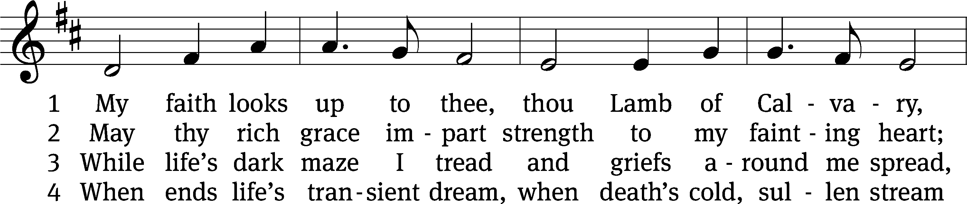
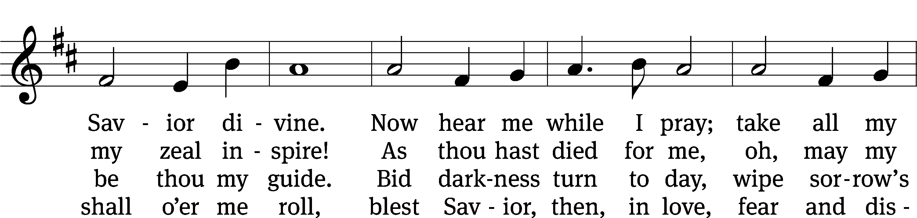
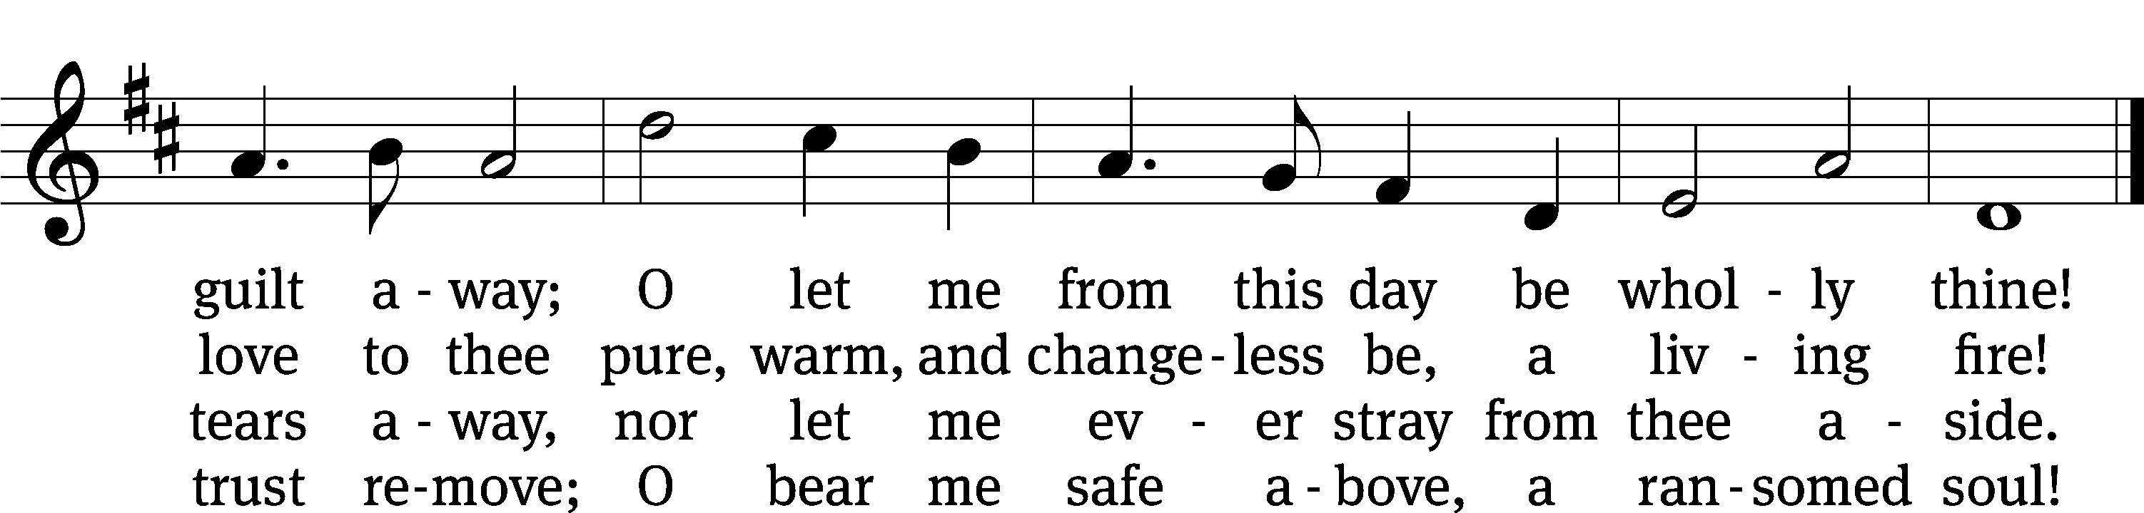
Text: Ray Palmer, 1808–1887
Tune: Lowell Mason, 1792–1872
Text and tune: Public domain

Acknowledgments
Setting One from Christian Worship
Software distributed in partnership with Northwestern Publishing House.
Created by Christian Worship: Service Builder © 2022 Concordia Publishing House.
Serving in Worship
Officiant Pastor William Natsis
Organist Sarah Hanke
Accompanist Sarah Hanke
Choir Director Cynthia Natsis
Deacons (8:30) Duane Mason and Jim Tice
Deacons (11:00) Steve Hoeft and Robert Niethammer
Ushers (8:30) Robert Newman and Henry Schneider
Ushers (11:00) Bill Barnett and Jake Vershum
Altar Guild Jean Fiegel and Ann Latowski
Videographer Cindy Dresch

