Palm Sunday

TRINITY EVANGELICAL LUTHERAN CHURCH | Saline, Michigan
WELCOME TO WORSHIP March 24, 2024
Thank you for joining us in God’s house today! We cordially ask that our Guests sign one of the guestbooks located at either the front or back entryways, or fill out a “Let’s Get Acquainted” card located in the hymnal pew rack and place it in the collection plate.

THANK OFFERING: Members of Trinity give their offering as an expression of love and thankfulness to the Lord and to help support the Lord’s work in our community and around the world. Visitors need not feel obligated to participate in this offering which supports our ministry.

Restrooms are located at the back of the upper level (the annex), and in the basement (down the back stairs of the sanctuary or annex). Handicap access is available, please ask an usher for assistance.

Young Families / Toddler Bags – We are GLAD YOU BROUGHT YOUR CHILDREN to our worship service. Jesus said: “Let the little children come to me and do not hinder them, for the kingdom of God belongs to such as these.” We know that having little children in church can be a challenge, but DO NOT WORRY about it. Many of your fellow worshippers have been in your shoes and are just happy you brought your children with you. For your convenience, we have reserved the back rows of seating for parents with small children. These areas provide more flexibility for your family, as well as, easy access to move downstairs if necessary. A closed-circuit TV system allows families to continue participating in the service while downstairs. Pre-school toddler bags and children’s bulletins are available for their enjoyment. Ask an usher for one to use during the service and please return the toddler bag afterwards.

the SERVICE – setting one - WITHOUT HOLY COMMUNION CW, page 154

Choir and Sunday School Palm Sunday Processional

Sing and shout to the Son of David, bring unto the King a jubilant song.
Raise your voices, sing hosanna. Sing unto the King a jubilant song.

Sing hosanna, blessed is the One who comes in the name of the Lord.
Sing hosanna, blessed is the One who comes.

Sing to the King a jubilant song. Sing hosanna!
412 All Glory, Laud, and Honor CW 412
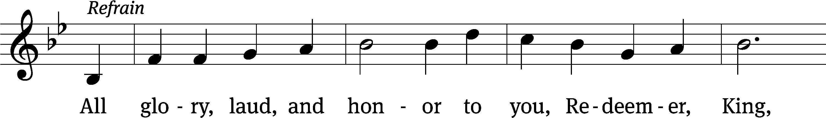
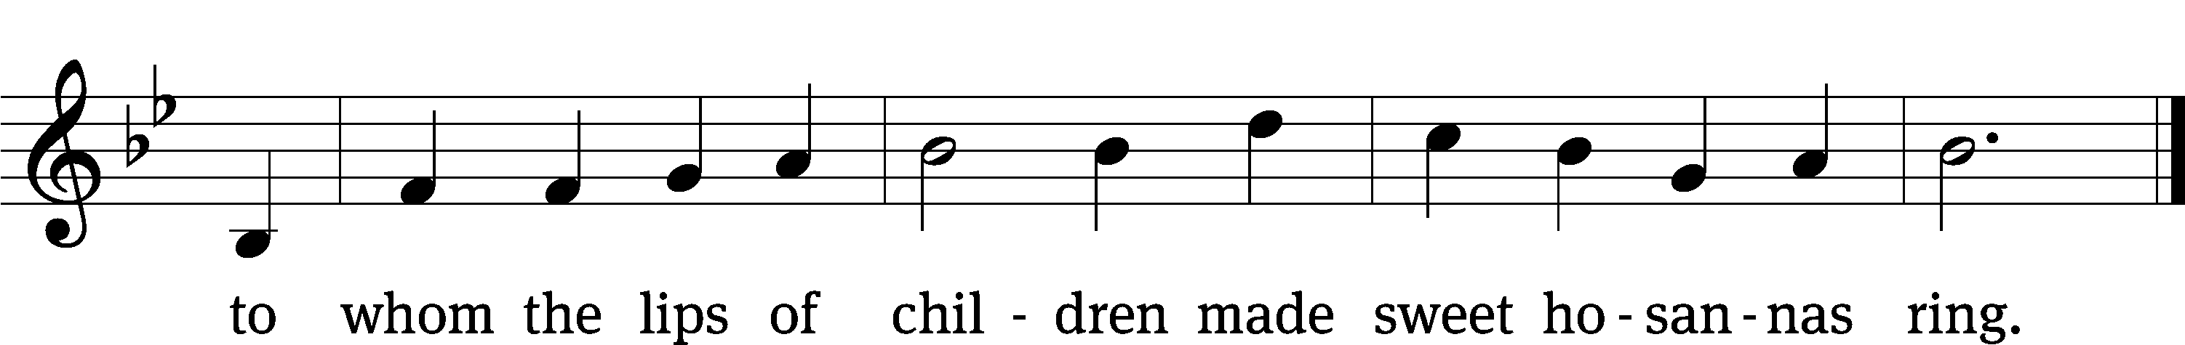
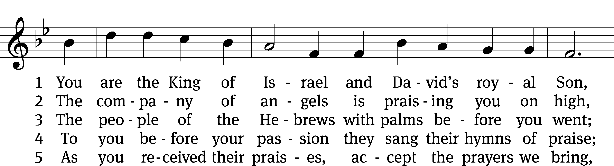
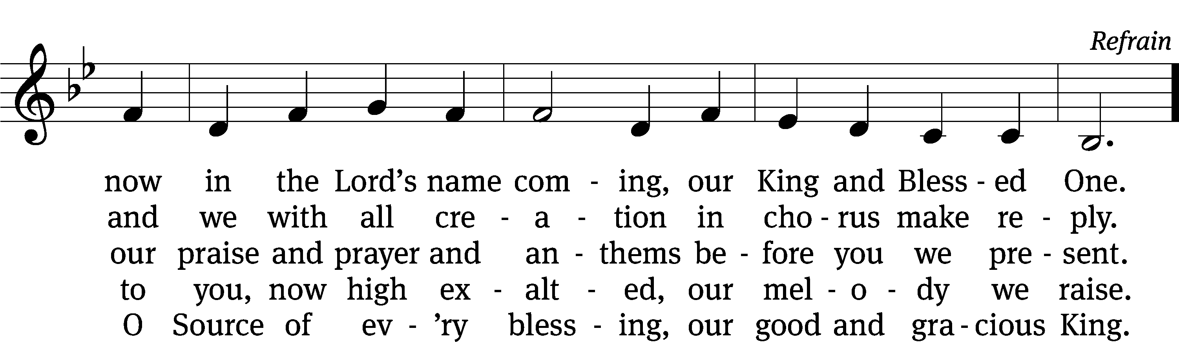
Text: tr. John Mason Neale, 1818–1866, alt.; Theodulph of Orleans, c. 762–821
Tune: Melchior Teschner, 1584–1635, alt.
Text and tune: Public domain

Please stand, if you are able
Invocation
In the name of the Father and of the Son and of the Holy Spirit.
Amen.

Confession
If we claim to be without sin, we deceive ourselves and the truth is not in us.
If we confess our sins, God is faithful and just
and will forgive us our sins
and purify us from all unrighteousness.

Let us confess our sins to the Lord.
Holy God, gracious Father,
I am sinful by nature
and have sinned against you in my thoughts, words, and actions.
I have not loved you with my whole heart;
I have not loved others as I should.
I deserve your punishment both now and forever.
But Jesus, my Savior, paid for my sins
with his innocent suffering and death.
Trusting in him, I pray: God, have mercy on me, a sinner.

Our gracious Father in heaven has been merciful to us. He sent his only Son, Jesus Christ, who gave his life as the atoning sacrifice for the sins of the whole world. Therefore, as a called servant of Christ and by his authority, I forgive you all your sins in the name of the Father and of the Son and of the Holy Spirit.
Amen.

Lord, Have Mercy
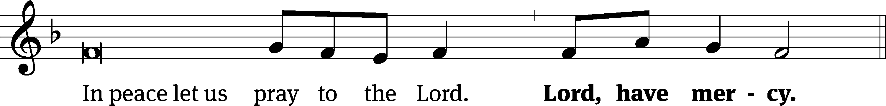
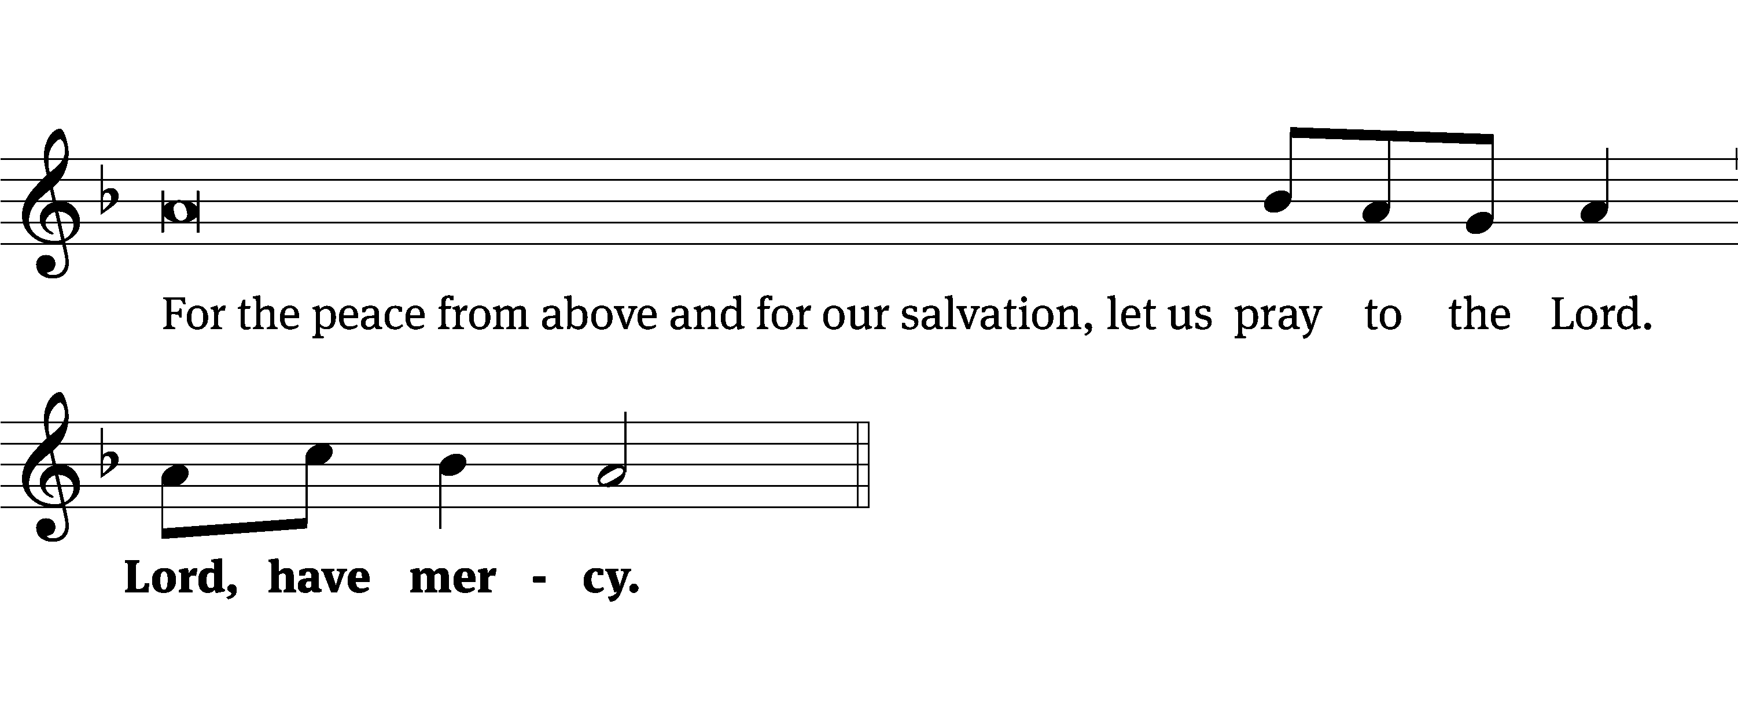
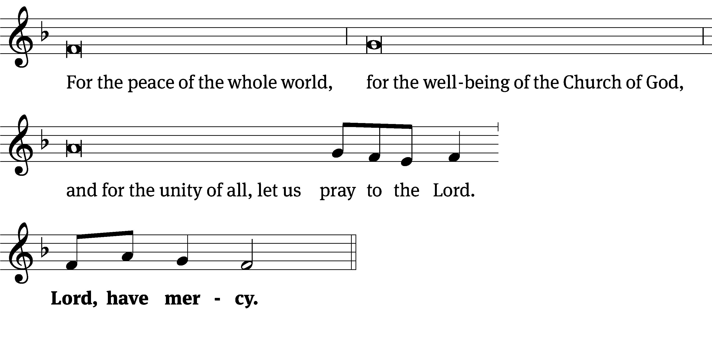
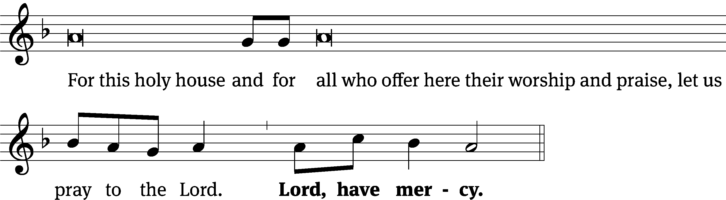
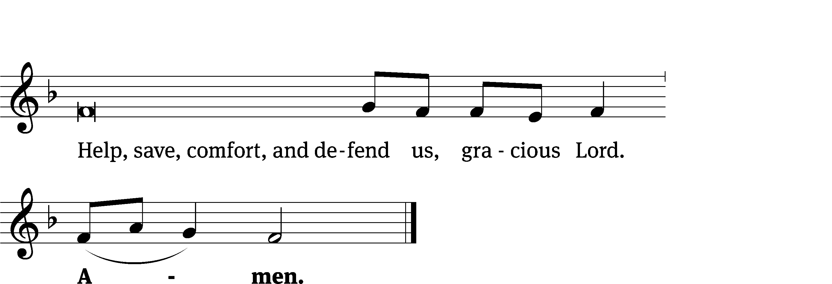
Tune: Kevin Becker
Tune: © 2021 Northwestern Publishing House. Used by permission: OneLicense no. 727703

The Lord be with you.
And also with you.
Prayer of the Day
Let us pray.

We praise you, O God, for the great acts of love by which you have redeemed us through your Son, Jesus Christ. As he was acclaimed by those who scattered their garments and branches of palms in his path, so may we always hail him as our King and follow him with perfect confidence; who lives and reigns with you and the Holy Spirit, one God, now and forever.
Amen.

Please be seated

First Reading Zechariah 9:9-12

⁹ Rejoice greatly, Daughter of Zion!
Shout, Daughter of Jerusalem!
Look! Your King is coming to you.
He is righteous and brings salvation.
He is humble and is riding on a donkey,
on a colt, the foal of a donkey.
¹⁰ I will cut off the chariot from Ephraim
and the horse from Jerusalem.
The battle bow will be taken away,
and he will proclaim peace to the nations.
His kingdom will extend from sea to sea,
from the River to the ends of the earth.
¹¹ As for you, because of the blood of my covenant with you,
I will release your prisoners from the waterless pit.
¹² Return to the stronghold, you prisoners who have hope.
This very day I declare that I will restore double to you.

The Word of the Lord.
Thanks be to God.
24B Welcome the King Psalm 24B
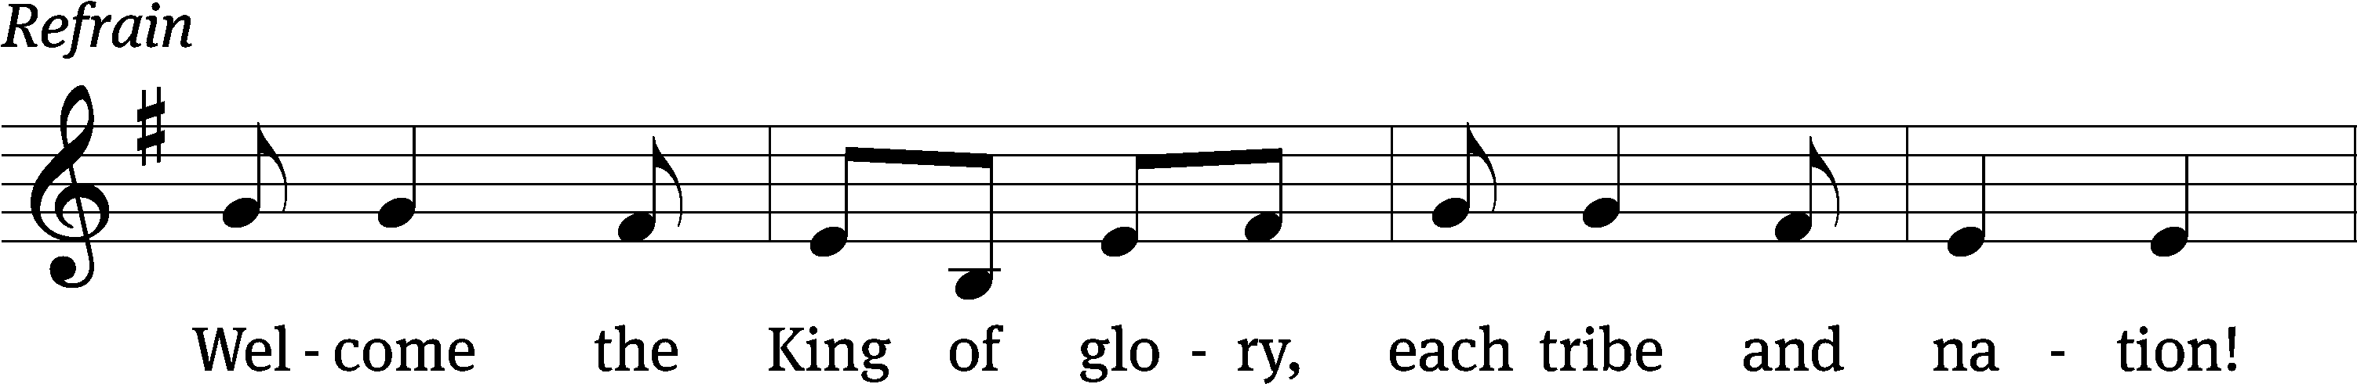
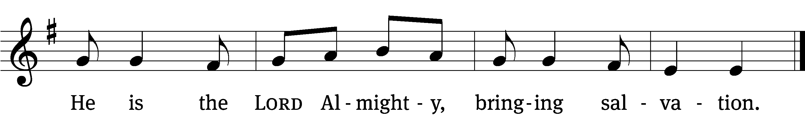
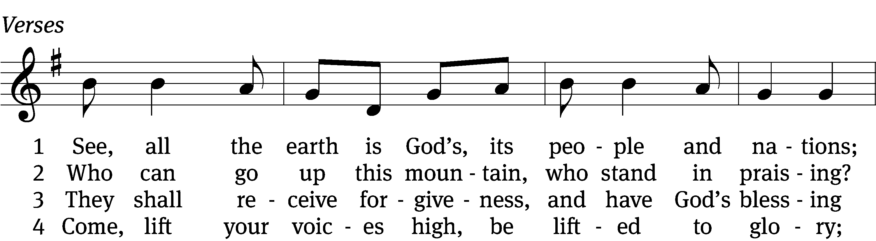
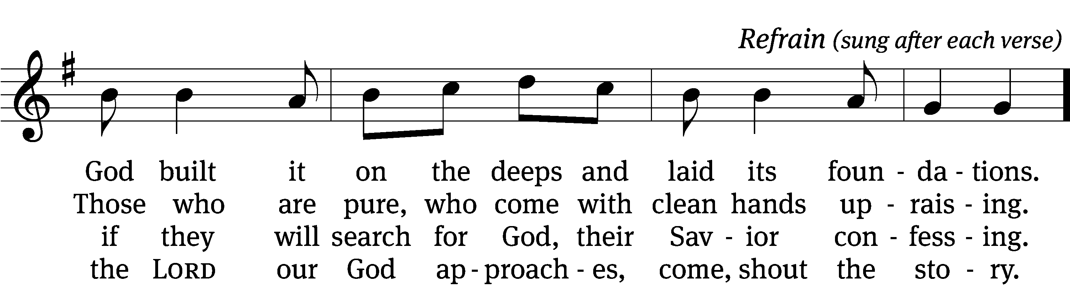

5 Who is this glorious one, for whom we are waiting?
We wait the mighty LORD, our God celebrating. (Refrain)

6 Come, lift your heads with joy; come, lift up your tower;
the King of glory comes in full might and power. (Refrain)

7 Who is this King of glory of whom we’re singing?
Our God, this LORD of hosts, the vict’ry is bringing. (Refrain)
Text (sts. 1–7): Arlo D. Duba; (Ref): Northwestern Publishing House
Tune: Israeli
Text (sts. 1–7): © 1986 Arlo D. Duba; (Ref): © 2021 Northwestern Publishing House. Used by permission: OneLicense no. 727703
Tune: Public domain

Second Reading Hebrews 12:1-3

12 Therefore, since we are surrounded by such a great cloud of witnesses, let us get rid of every burden and the sin that so easily ensnares us, and let us run with patient endurance the race that is laid out for us. ² Let us keep our eyes fixed on Jesus, who is the author of our faith and the one who brings it to its goal. In view of the joy set before him, he endured the cross, disregarding its shame, and has taken his seat at the right hand of God’s throne. ³ Carefully consider him who endured such hostility against himself from sinful people, so that you do not grow weary and lose heart.

The Word of the Lord.
Thanks be to God.

Please stand, if you are able

Gospel Acclamation John 12:23

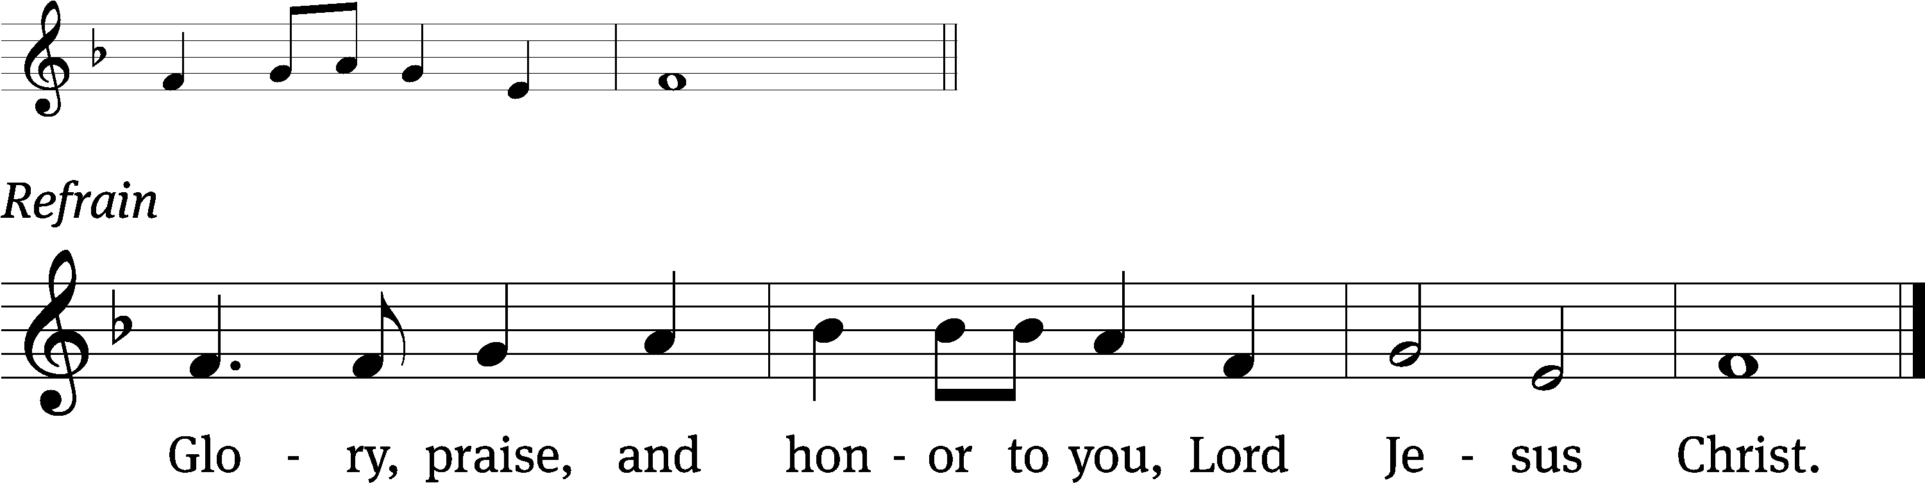
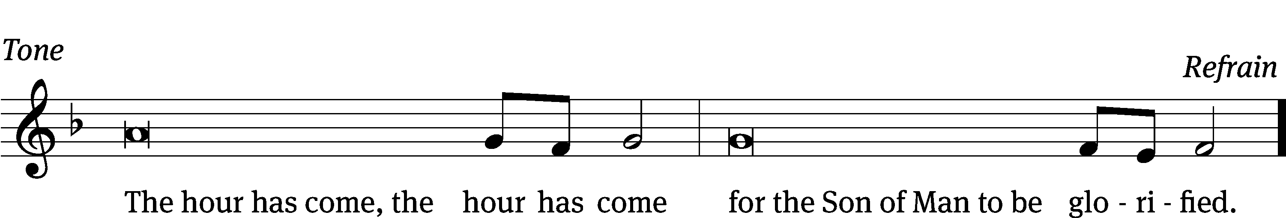
Tune: © 2021 Northwestern Publishing House. Used by permission: OneLicense no. 727703

Gospel Mark 11:1-10
11 As they approached Jerusalem, at Bethphage and Bethany, on the Mount of Olives, he sent two of his disciples ² and told them, “Go into the village ahead of you. As soon as you enter it, you will find a colt tied there, on which no one has ever sat. Untie it and bring it here. ³ If anyone asks you, ‘Why are you doing this?’ say, ‘The Lord needs it, and he will send it back here without delay.’”
⁴ They left and found a colt on the street, tied at a door; and they untied it. ⁵ Some who were standing there asked them, “What are you doing, untying that colt?” ⁶ The disciples answered them just as Jesus had instructed them, and the men let them go.
⁷ They brought the colt to Jesus, threw their garments on it, and Jesus sat on it. ⁸ Many people spread their garments on the road. Others spread branches that they had cut from the fields. ⁹ Those who went in front and those who followed were crying out,
Hosanna!
Blessed is he who comes in the name of the Lord!
¹⁰ Blessed is the coming kingdom of our father David!
Hosanna in the highest!

The Gospel of the Lord.
Praise be to you, O Christ!

Please be seated

413 Hosanna, Loud Hosanna CW 413
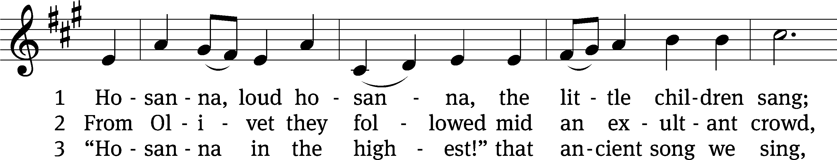
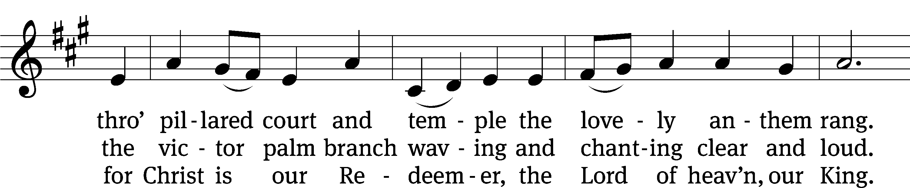
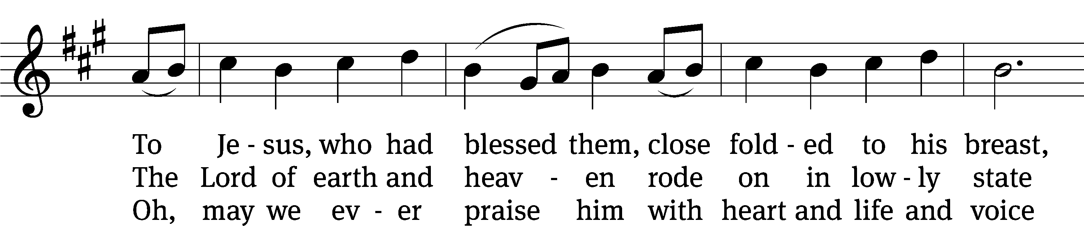
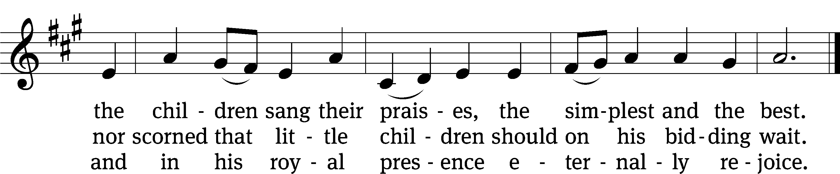
Text: Jeannette Threlfall, 1821–1880, alt.
Tune: Gesang-Buch Herzogl. Hofkapelle, Württemberg, 1784
Text and tune: Public domain

Sermon Mark 11:9b/15:13

“Two Words that Really Say It All”

Please stand, if you are able
Apostles’ Creed
I believe in God, the Father Almighty,
maker of heaven and earth.

I believe in Jesus Christ, his only Son, our Lord,
who was conceived by the Holy Spirit,
born of the Virgin Mary,
suffered under Pontius Pilate,
was crucified, died, and was buried.

He descended into hell.
The third day he rose again from the dead.
He ascended into heaven
and is seated at the right hand of God the Father Almighty.
From there he will come to judge the living and the dead.

I believe in the Holy Spirit,
the holy Christian Church,
the communion of saints,
the forgiveness of sins,
the resurrection of the body,
and the life everlasting. Amen.

Prayer of the Church

Please be seated

414 No Tramp of Soldiers’ Marching Feet CW 414
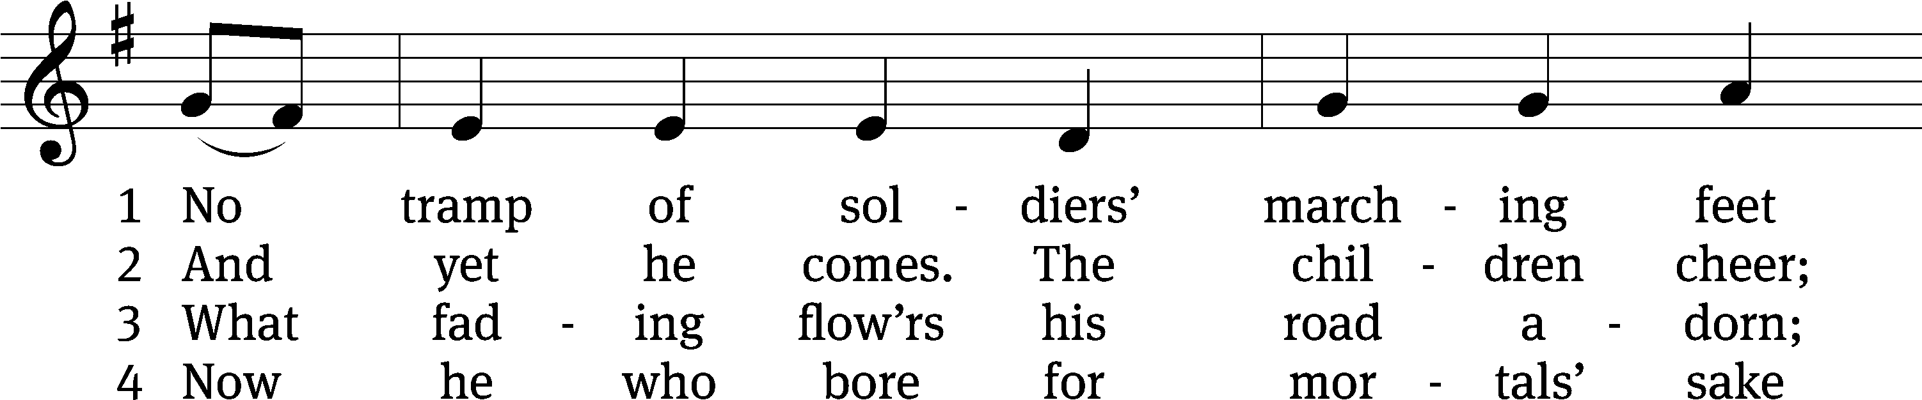
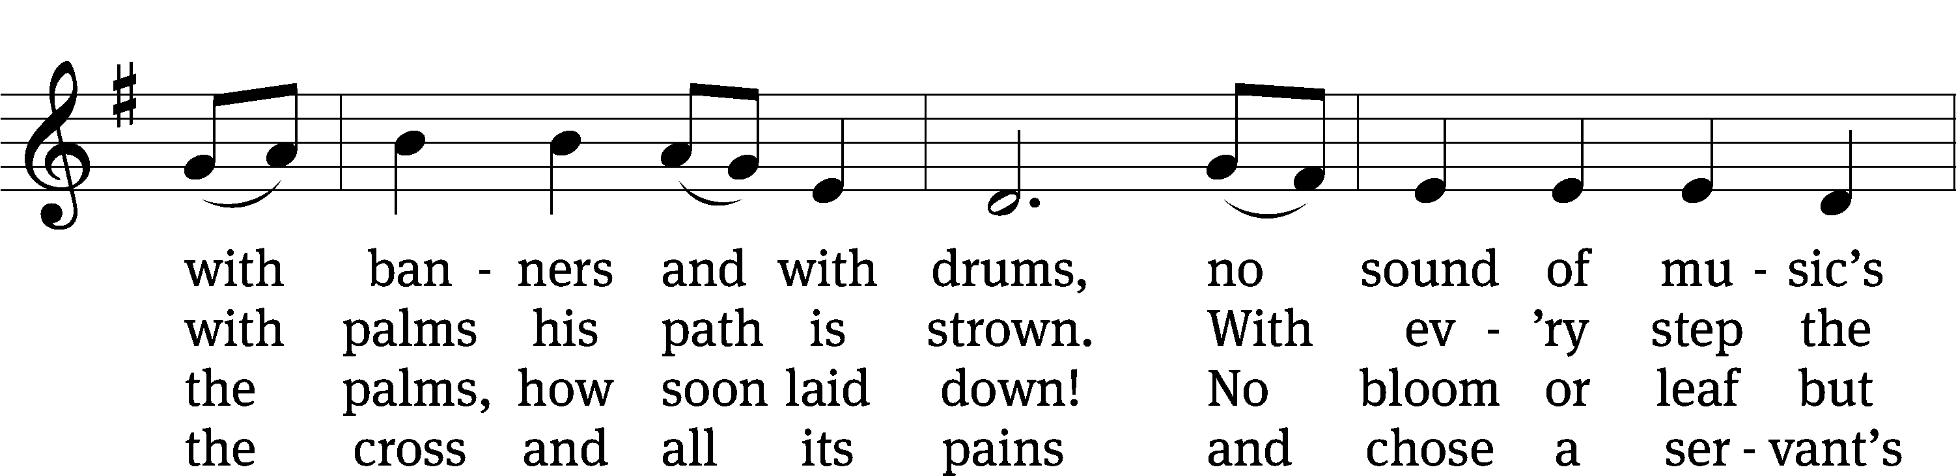
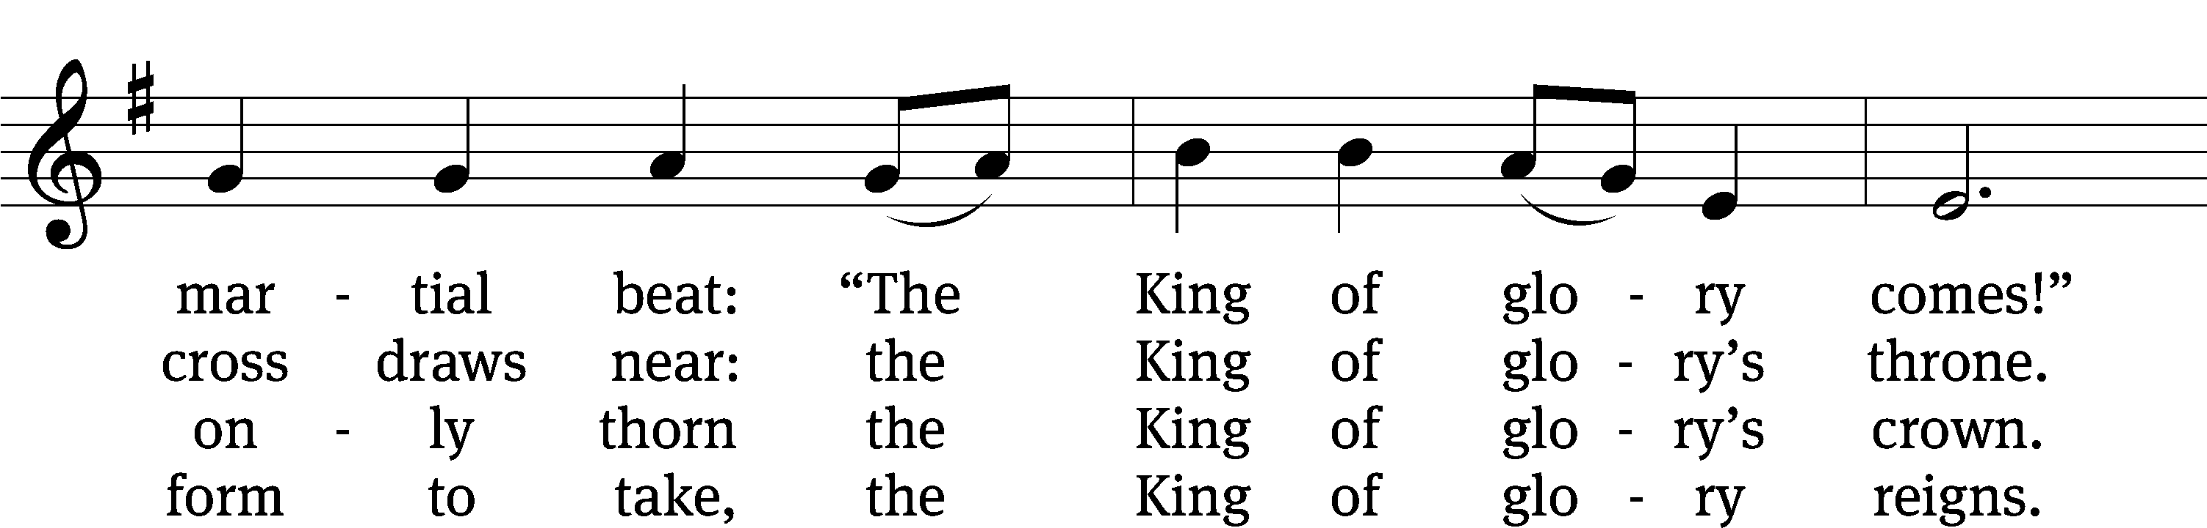
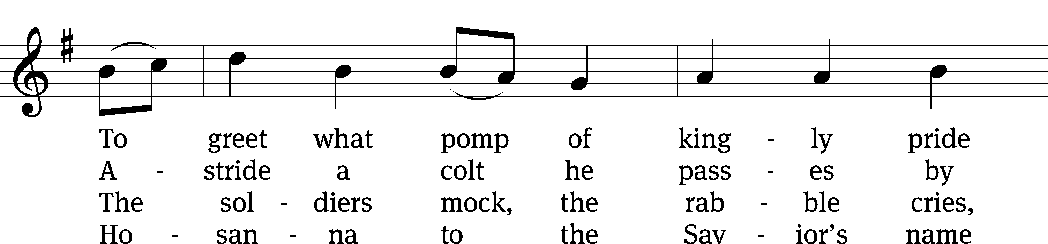
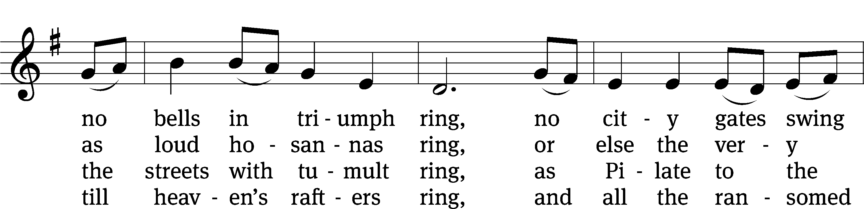
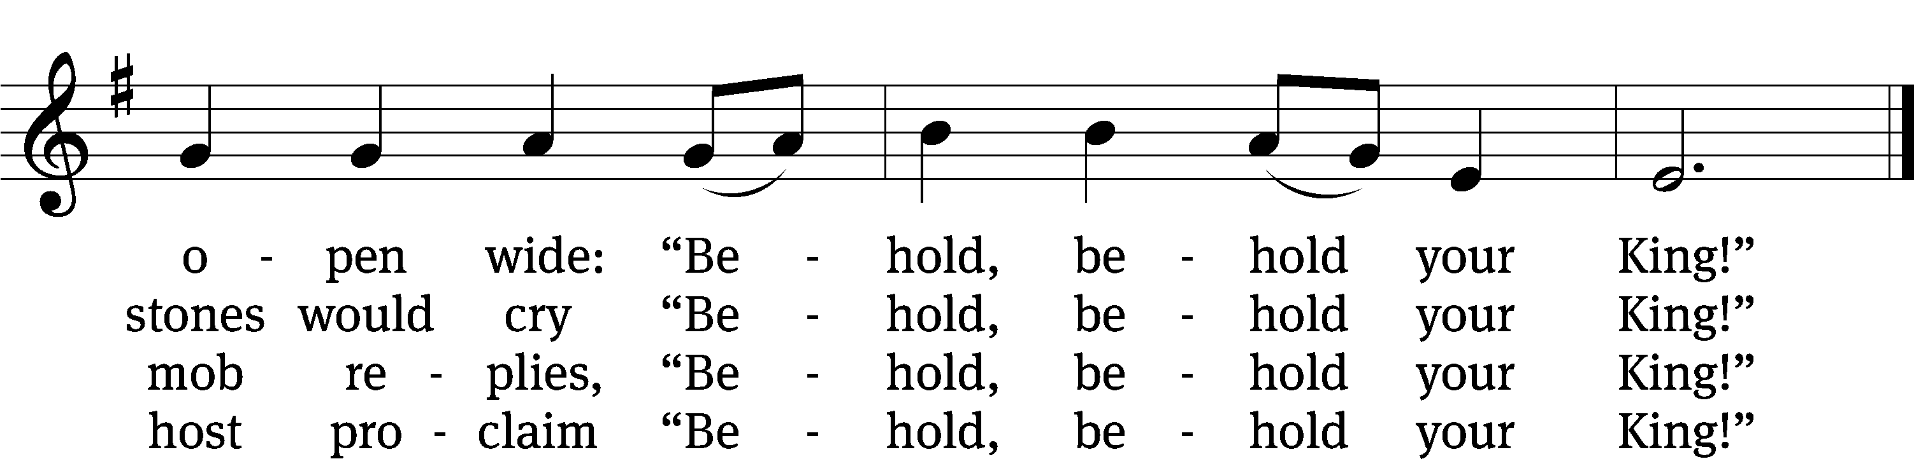
Text: Timothy Dudley-Smith, b. 1926
Tune: English; adapt. Ralph Vaughan Williams, 1872–1958
Text: © 1984 Hope Publishing Co. Used by permission: OneLicense no. 727703
Tune: Public domain

Please stand, if you are able

Prayer
Blessed Lord, you have given us your Holy Scriptures for our learning. May we so hear them, read, learn, and take them to heart that, being strengthened and comforted by your holy Word, we may cling to the blessed hope of everlasting life; through Jesus Christ our Lord, who lives and reigns with you and the Holy Spirit, one God, now and forever.
Amen.

Lord’s Prayer
Our Father, who art in heaven, hallowed be thy name, thy kingdom come, thy will be done on earth as it is in heaven. Give us this day our daily bread; and forgive us our trespasses, as we forgive those who trespass against us; and lead us not into temptation, but deliver us from evil. For thine is the kingdom and the power and the glory forever and ever. Amen.

Blessing
The Lord bless you and keep you.
The Lord make his face shine on you and be gracious to you.
The Lord look on you with favor and give you peace.
Amen.

Please be seated
411 Ride On, Ride On in Majesty CW 411
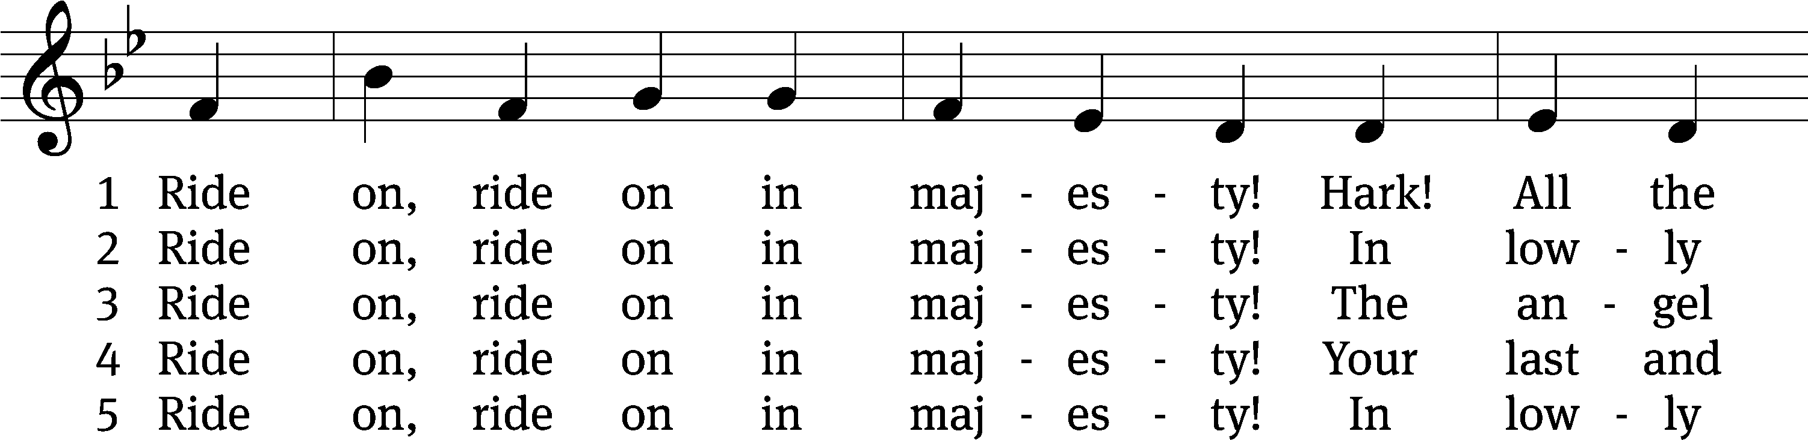
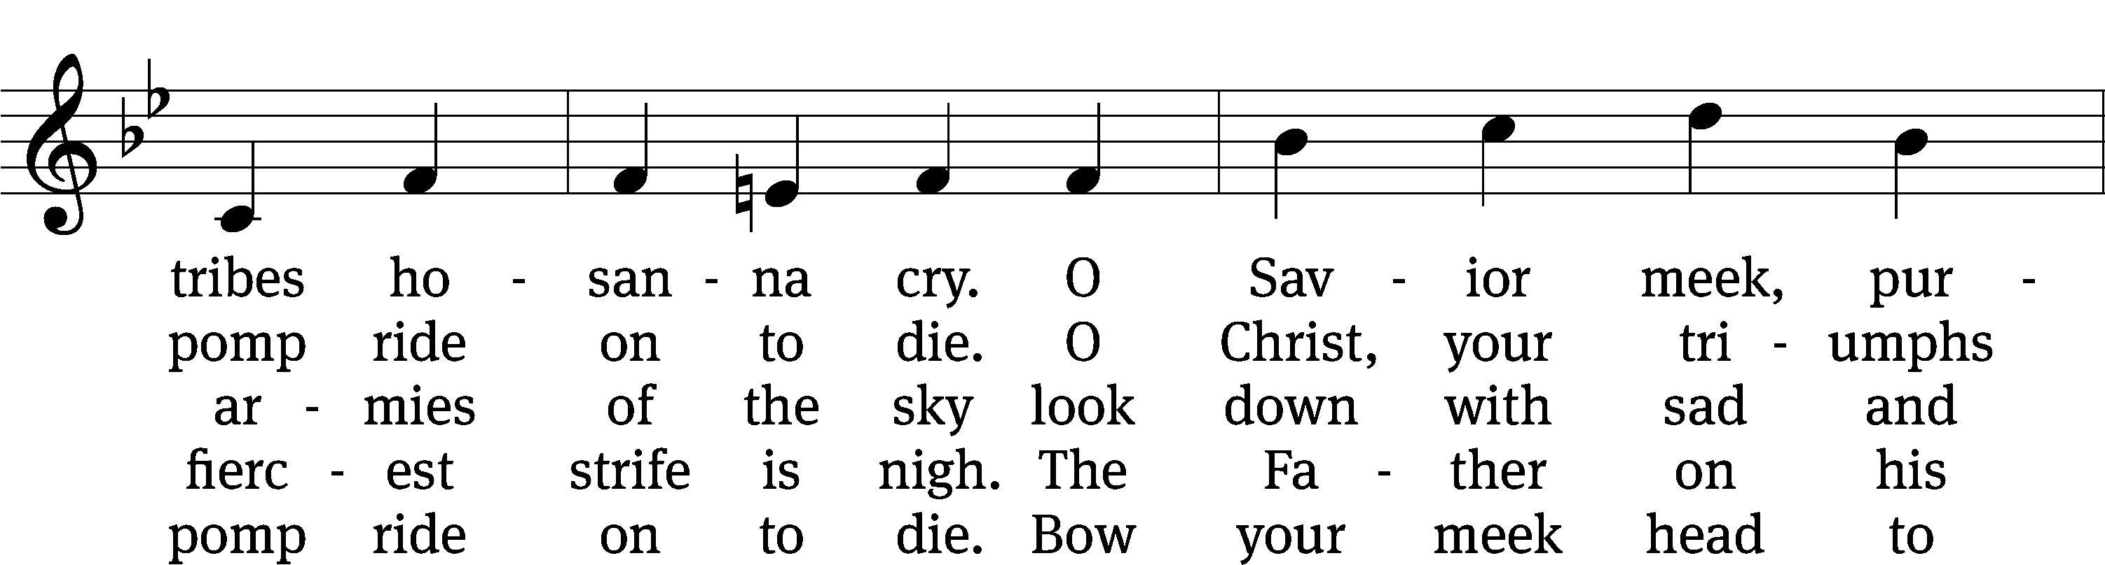
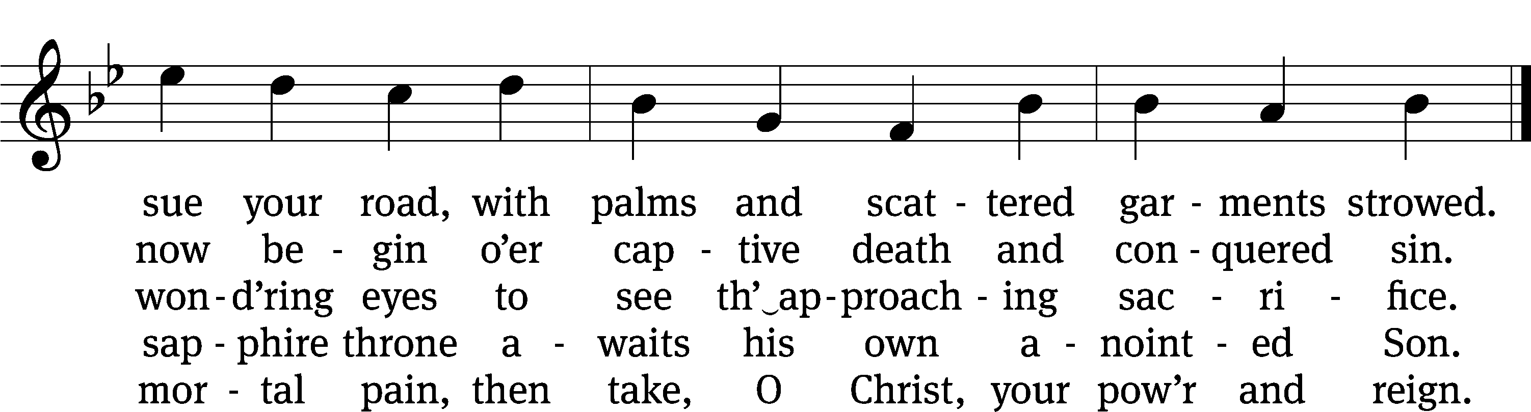
Text: Henry H. Milman, 1791–1868, alt.
Tune: Musicalisch Hand-Buch der Geistlichen Melodien, Hamburg, 1690, alt.
Text and tune: Public domain

Acknowledgments
Setting One from Christian Worship
Software distributed in partnership with Northwestern Publishing House.
Created by Christian Worship: Service Builder © 2022 Concordia Publishing House.

Serving in Worship
Officiant Pastor Natsis
Organist Marcia Marion Ackling
Choir Director Cynthia Natsis
Accompanist Laura Sala
Deacons (8:30) Duane Mason and Dave Stevenson
(11:00) Robert Niethammer and Gary Knowlton
Ushers (8:30) Dale Finkbeiner and Mark Finkbeiner
(11:00) Dave Boswell and Jake Vershum
Altar Guild Ann Latowski and Jean Fiegel
Videographer Jake Vershum

