FOURTH SUNDAY in lent

TRINITY EVANGELICAL LUTHERAN CHURCH | Saline, Michigan
WELCOME TO WORSHIP March 27, 2022
Thank you for joining us in God’s house today! We cordially ask that our Guests sign one of the guestbooks located at either the front or back entryways, or fill out a “Let’s Get Acquainted” card located in the hymnal pew rack and place it in the collection plate.

THANK OFFERING: Members of Trinity give their offering as an expression of love and thankfulness to the Lord and to help support the Lord’s work in our community and around the world. Visitors need not feel obligated to participate in this offering which supports our ministry.

Restrooms are located at the back of the upper level (the annex), and in the basement (down the back stairs of the sanctuary or annex). Handicap access is available, please ask an usher for assistance.

Young Families / Toddler Bags – We are GLAD YOU BROUGHT YOUR CHILDREN to our worship service. Jesus said: “Let the little children come to me and do not hinder them, for the kingdom of God belongs to such as these.” We know that having little children in church can be a challenge, but DO NOT WORRY about it. Many of your fellow worshippers have been in your shoes and are just happy you brought your children with you. For your convenience, we have reserved the back rows of seating for parents with small children. These areas provide more flexibility for your family, as well as, easy access to move downstairs if necessary. A closed-circuit TV system allows families to continue participating in the service while downstairs. Pre-school toddler bags and children’s bulletins are available for their enjoyment. Ask an usher for one to use during the service and please return the toddler bag afterwards.

the SERVICE – setting one - WITHOUT HOLY COMMUNION CW, page 154

624 Praise to the Lord, the Almighty CW 624
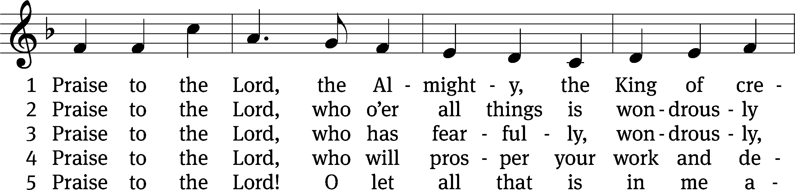
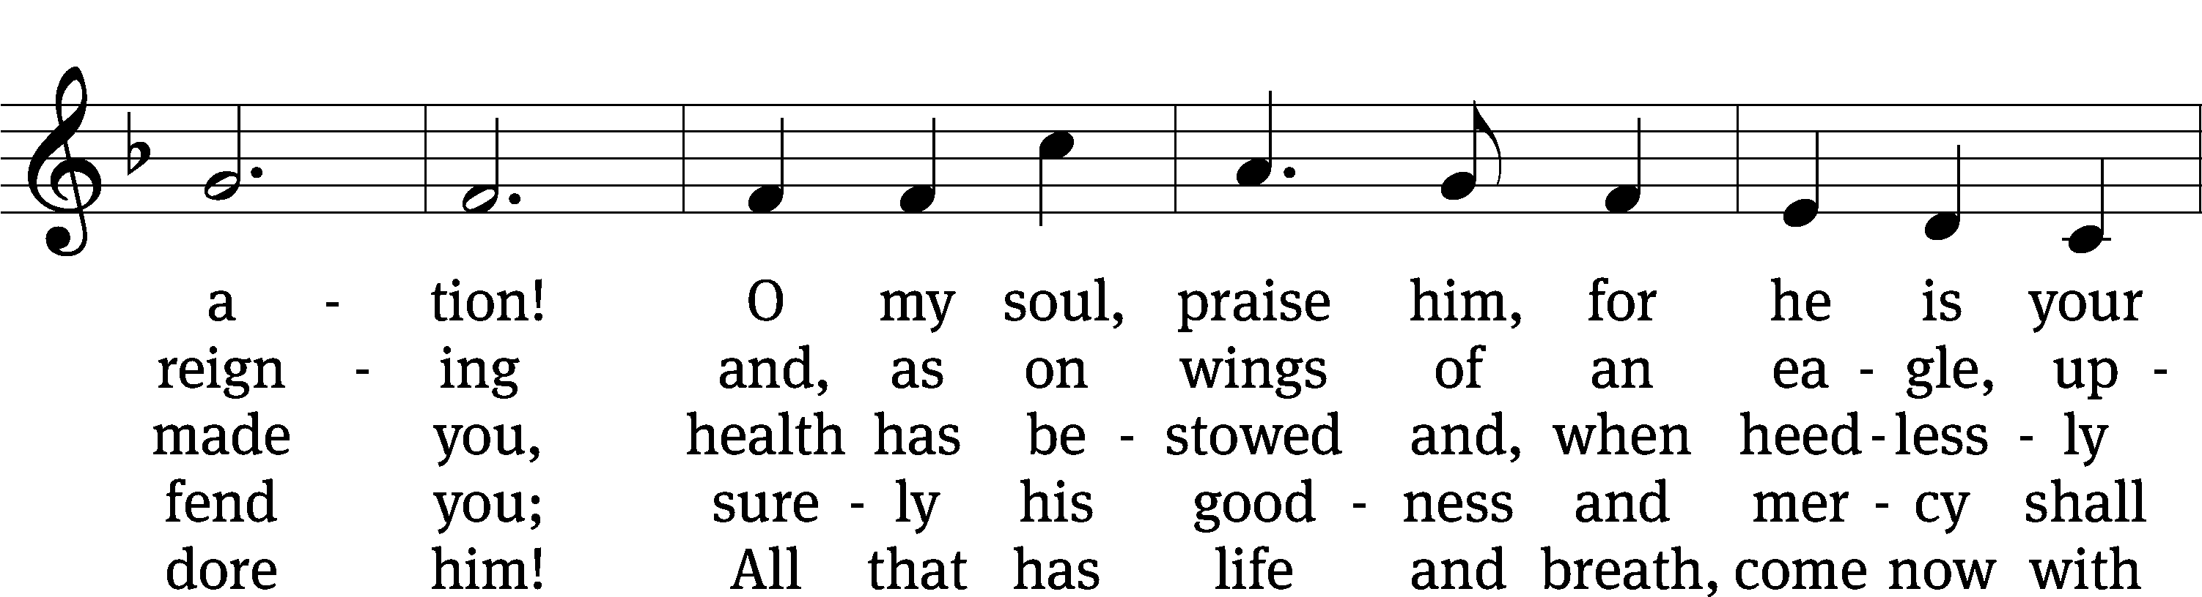
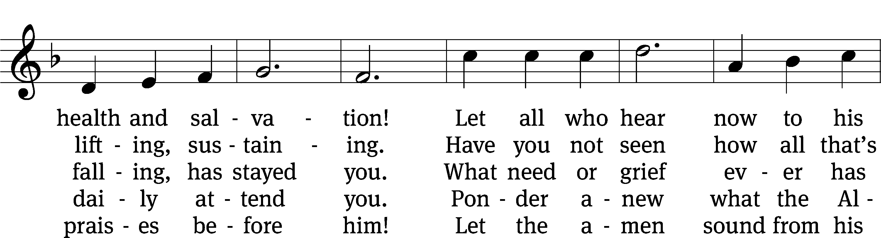
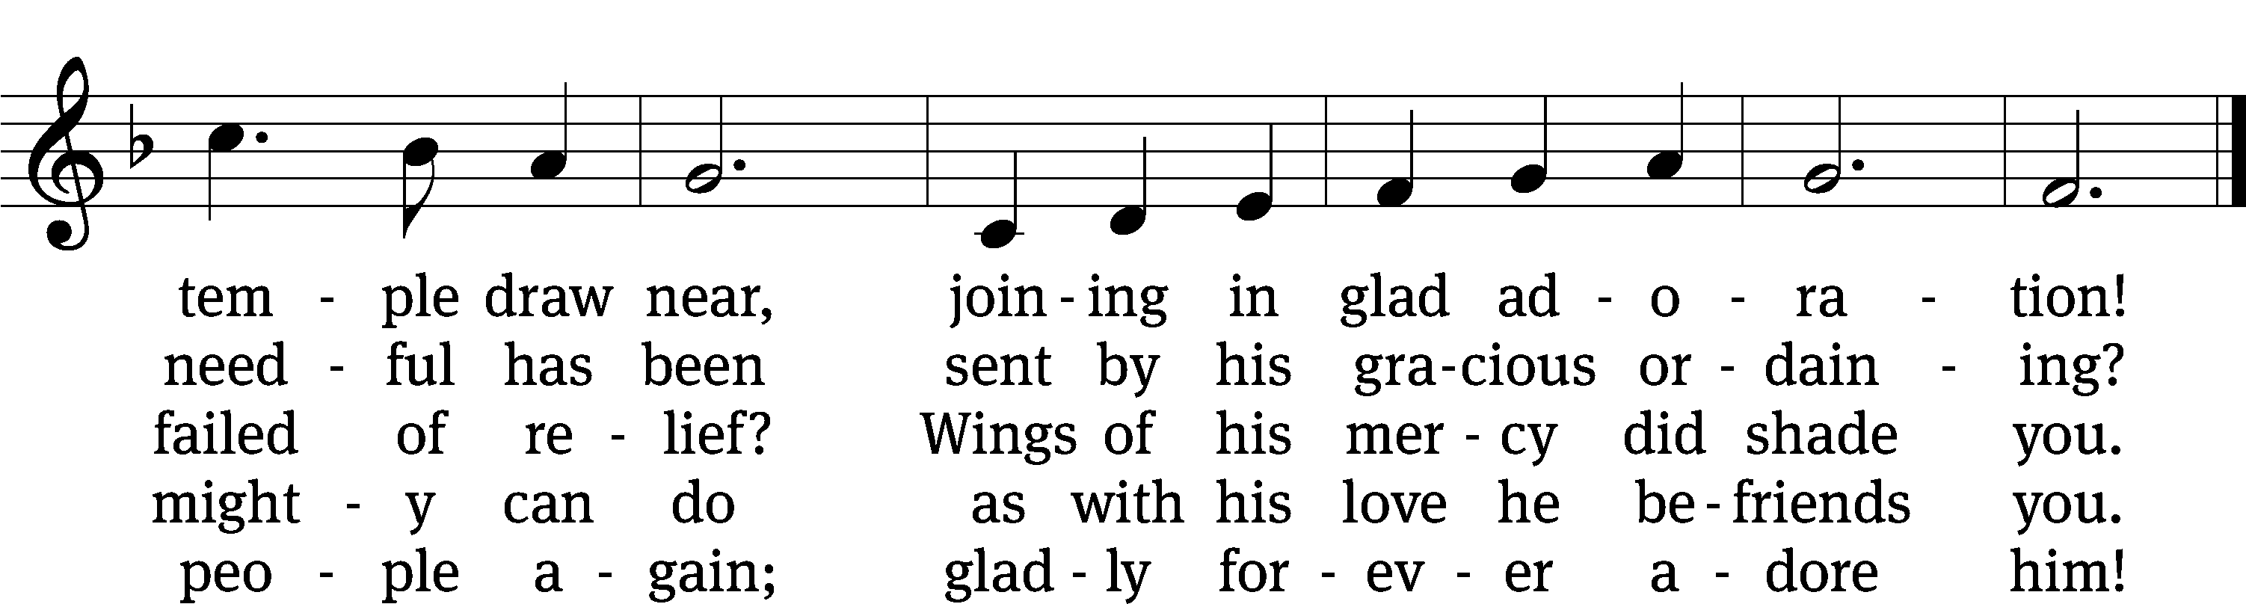
Text: tr. Catherine Winkworth, 1827–1878, alt.; Joachim Neander, 1650–1680
Tune: Ander Theil Des Erneuerten Gesang-Buchs, Stralsund, 1665, alt
Text and tune: Public domain

Please stand, if you are able
Invocation
In the name of the Father and of the T Son and of the Holy Spirit.
Amen.
Confession
If we claim to be without sin, we deceive ourselves and the truth is not in us.
If we confess our sins, God is faithful and just
and will forgive us our sins
and purify us from all unrighteousness.

Let us confess our sins to the Lord.
Holy God, gracious Father,
I am sinful by nature
and have sinned against you in my thoughts, words, and actions.
I have not loved you with my whole heart;
I have not loved others as I should.
I deserve your punishment both now and forever.
But Jesus, my Savior, paid for my sins
with his innocent suffering and death.
Trusting in him, I pray: God, have mercy on me, a sinner.

Our gracious Father in heaven has been merciful to us. He sent his only Son, Jesus Christ, who gave his life as the atoning sacrifice for the sins of the whole world. Therefore, as a called servant of Christ and by his authority, I forgive you all your sins in the name of the Father and of the T Son and of the Holy Spirit.
Amen.

Lord, Have Mercy

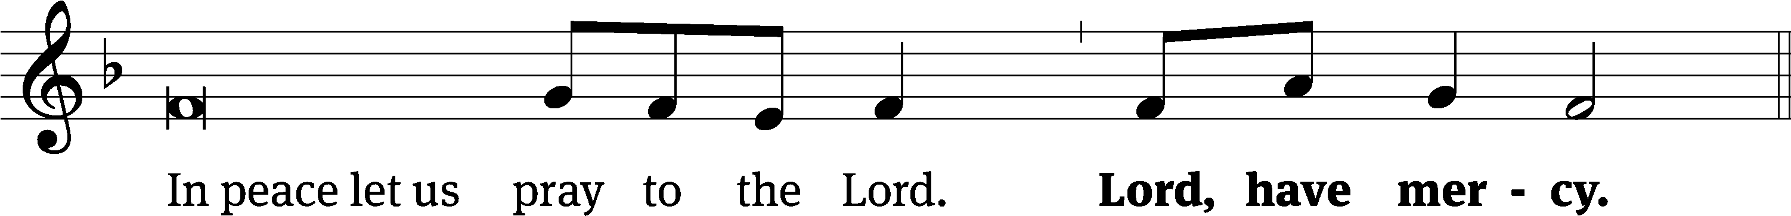
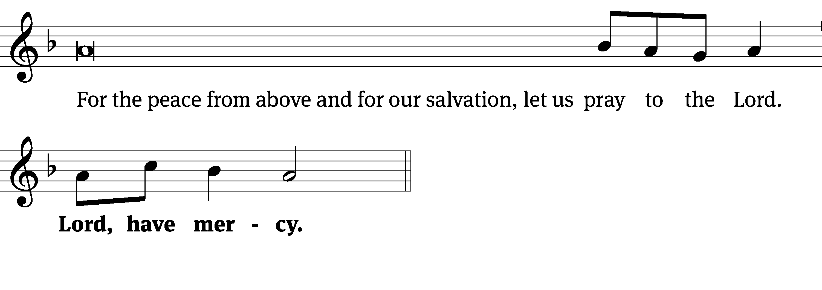
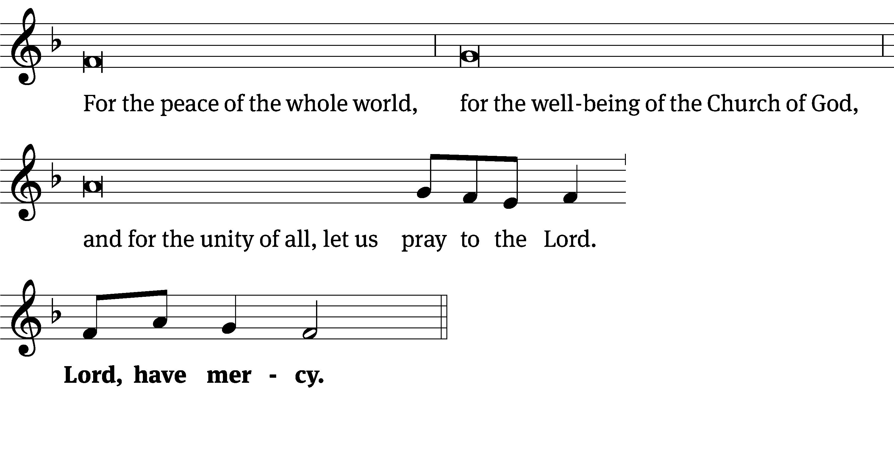
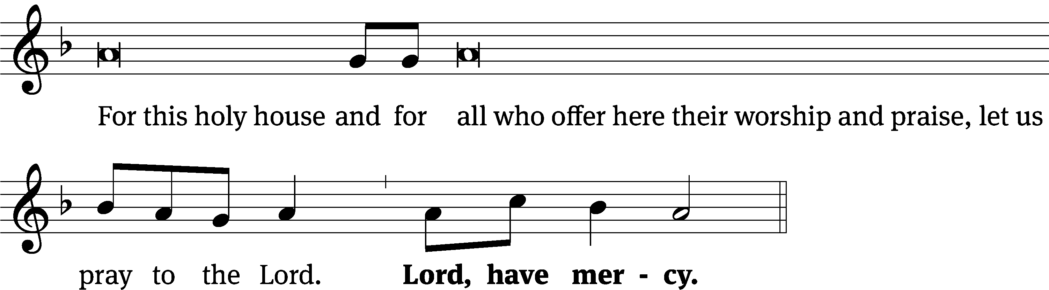
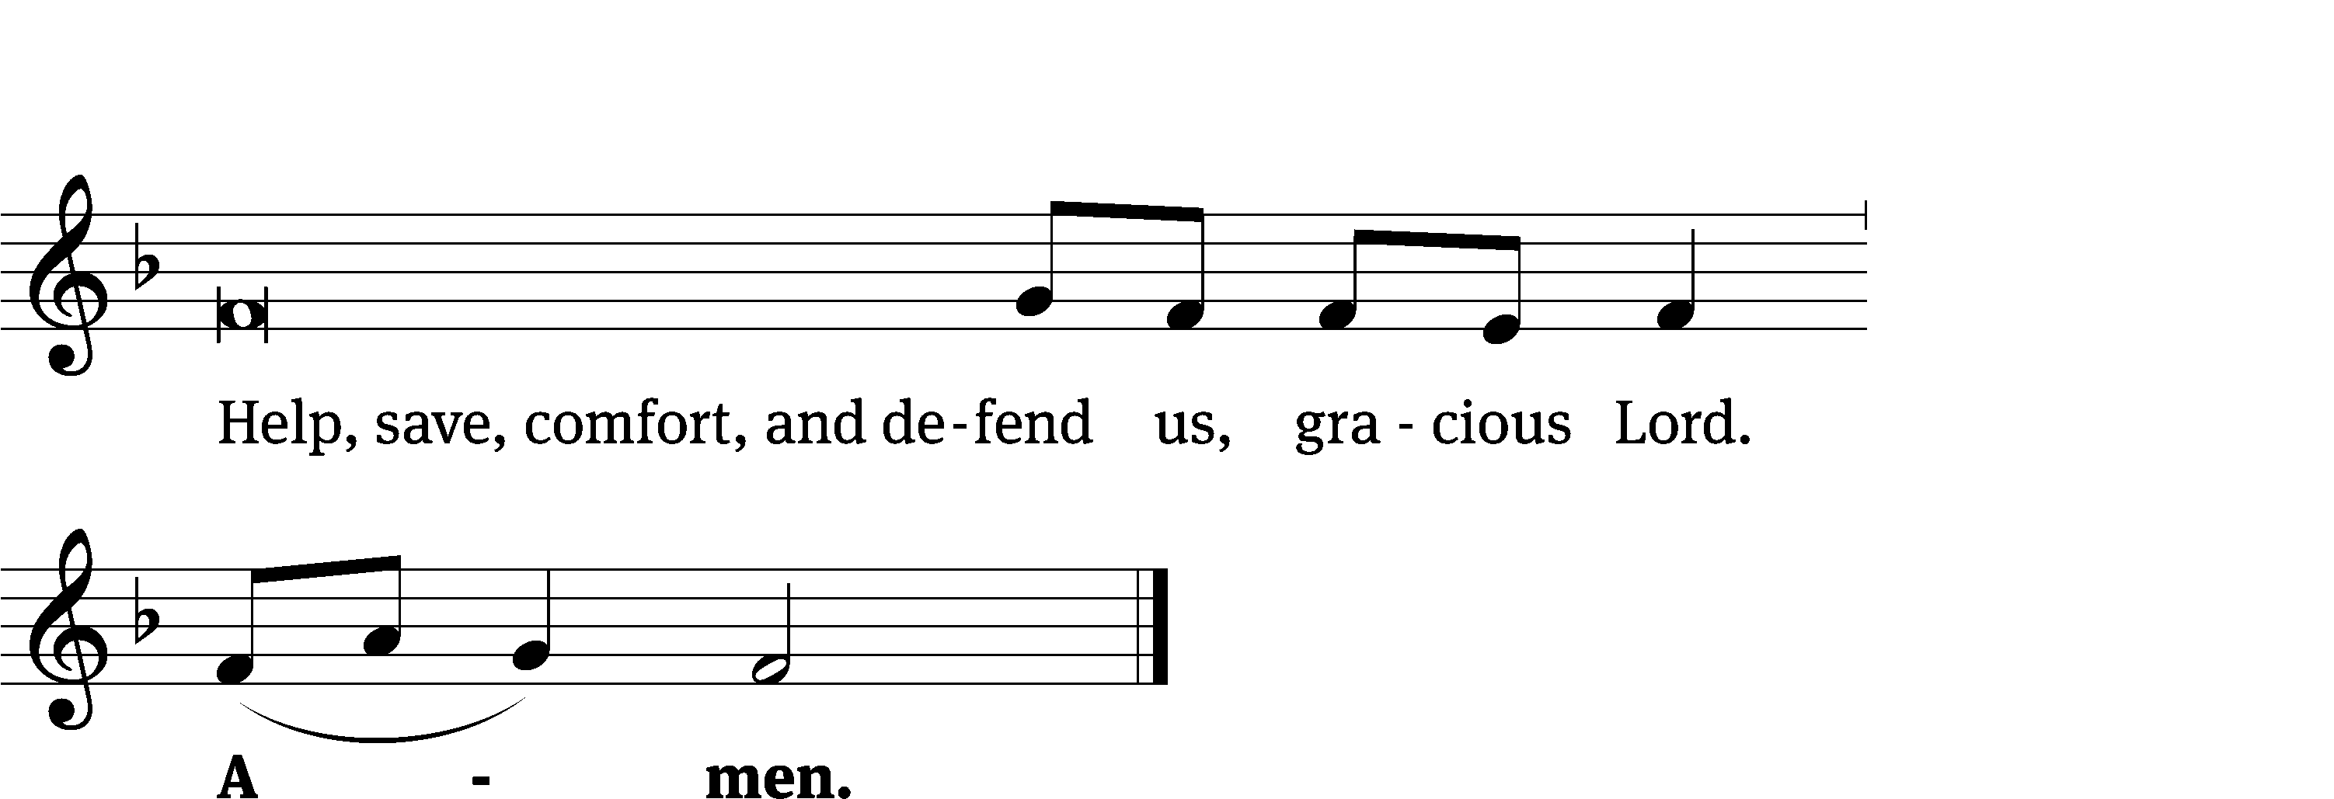
Glory Be to God CW 157
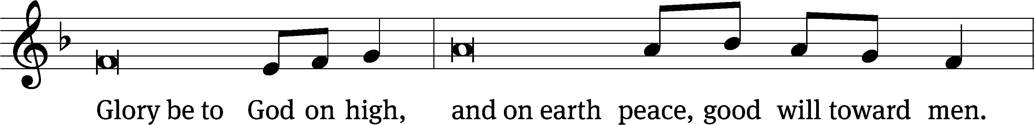
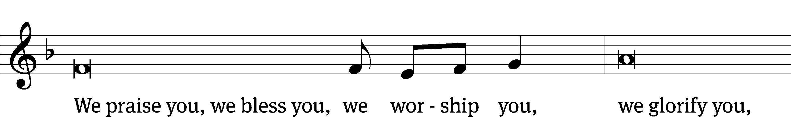
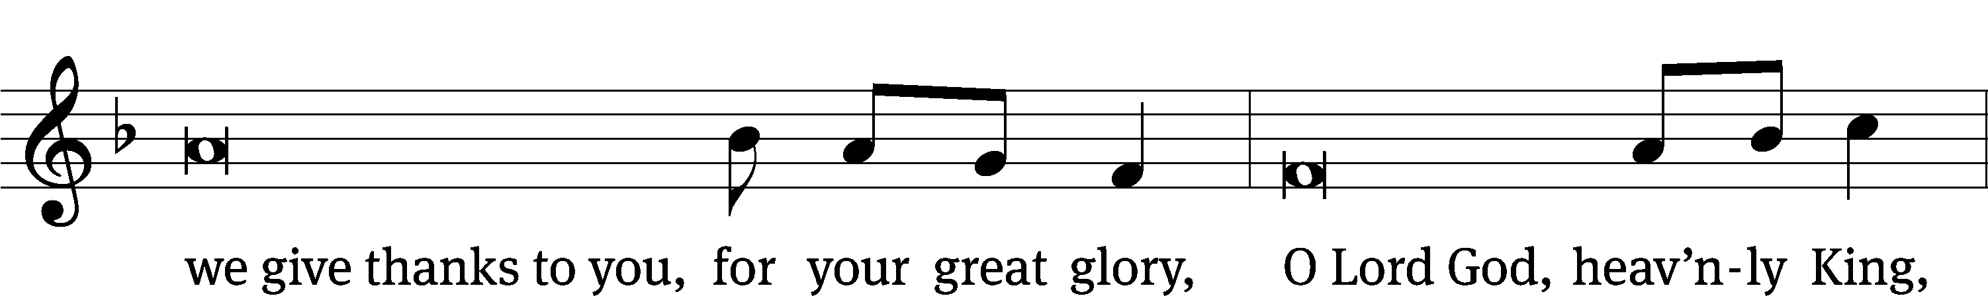
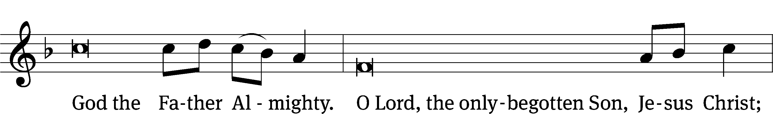
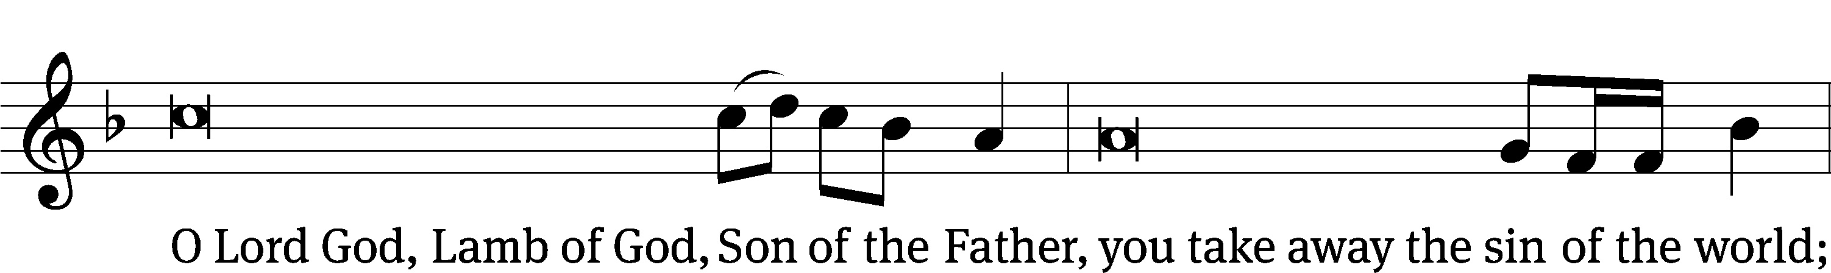
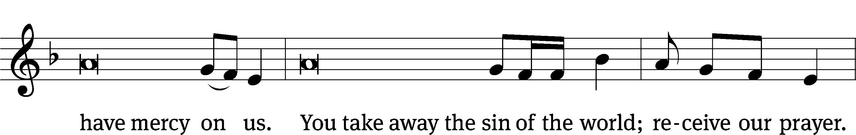
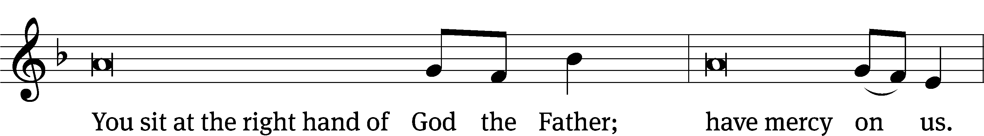
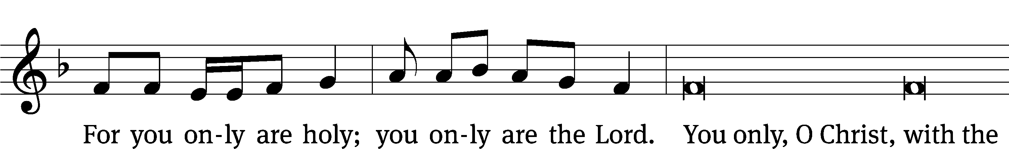
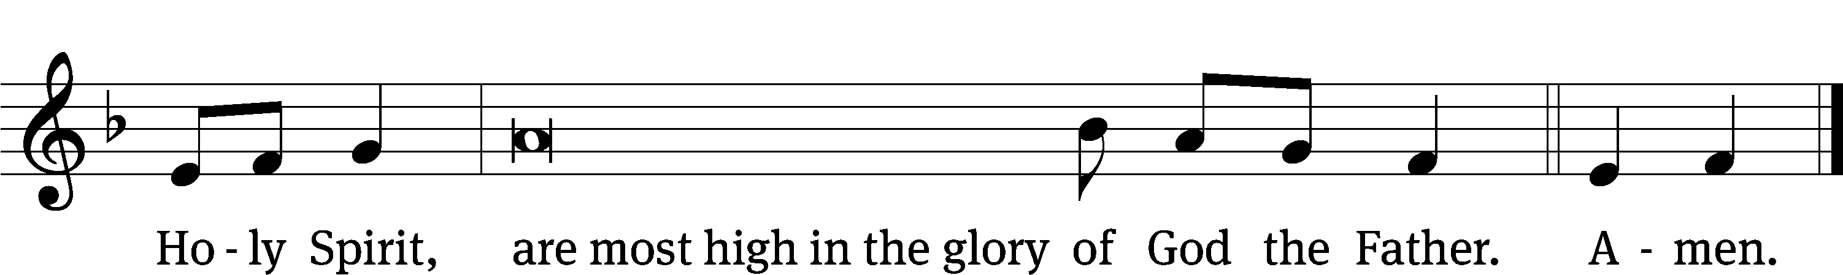

Tune: © 2021 Northwestern Publishing House. Used by permission: OneLicense no. 727703
The Lord be with you.
And also with you.
Prayer of the Day
Let us pray.

Almighty God, our heavenly Father, your mercies are new every morning; and though we deserve only punishment, you receive us as your children and provide for all our needs of body and soul. Grant that we may heartily acknowledge your merciful goodness, give thanks for all your benefits, and serve you in willing obedience; through your Son, Jesus Christ our Lord, who lives and reigns with you and the Holy Spirit, one God, now and forever.
Amen.

Please be seated

First Reading Isaiah 12:1-6

In that day you will say:
I will give thanks to you, Lord,
for though you were angry with me,
your anger has turned away,
and you comfort me.
² Surely God is my salvation.
I will trust him and will not be afraid,
because Yah, the Lord, is my strength and song,
and he has become my salvation.
³ Therefore with joy you will draw water from the wells of salvation.
⁴ In that day you will say:
Give thanks to the Lord! Proclaim his name.
Declare among the peoples what he has done.
Proclaim that his name is exalted!
⁵ Sing to the Lord, for he has done amazing things!
Let this be known in all the earth!
⁶ Shout aloud and sing for joy, daughter of Zion,
for the Holy One of Israel is great among you!
The Word of the Lord.
Thanks be to God.

Psalm of the Day
32B How Blest Are Those Psalm 32B
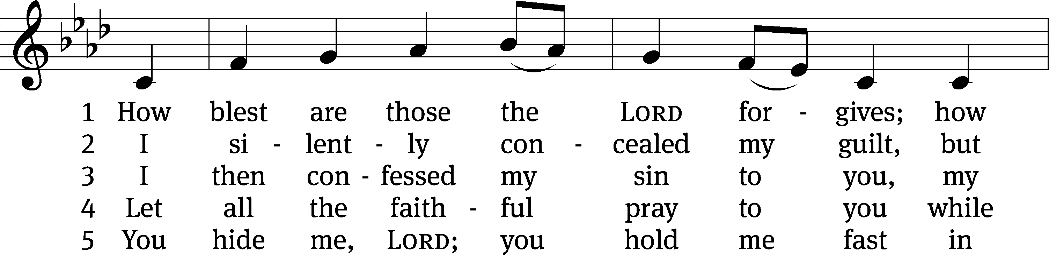
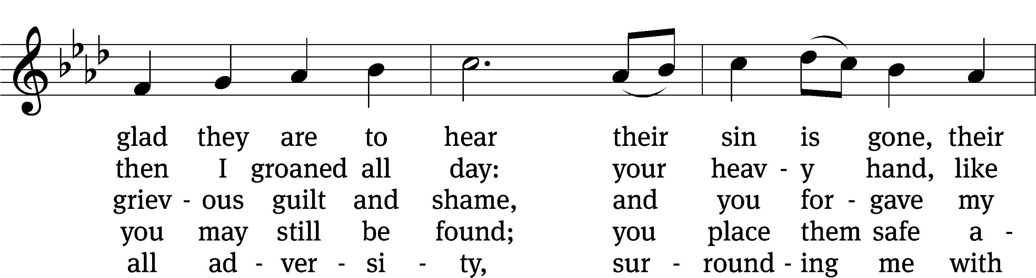
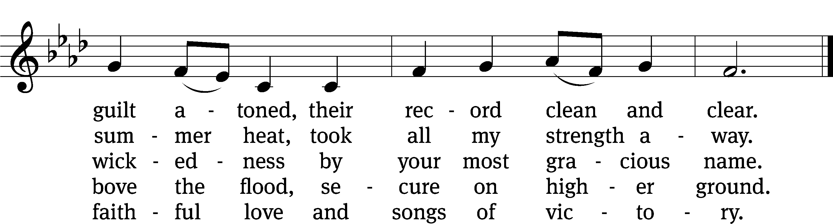
Text: Michael D. Schultz
Tune: Repository of Sacred Music, Part Second, 1813, ed. John Wyeth
Text: © 2021 Northwestern Publishing House. Used by permission: OneLicense no. 727703
Tune: Public domain

Second Reading Romans 8:1-10
¹ So then, there is now no condemnation for those who are in Christ Jesus. ² For in Christ Jesus the law of the Spirit of life set me free from the law of sin and death. ³ Indeed, what the law was unable to do, because it was weakened by the flesh, God did, when he sent his own Son in the likeness of sinful flesh to deal with sin. God condemned sin in his flesh, ⁴ so that the righteous decree of the law would be fully satisfied in us who are not walking according to the flesh, but according to the spirit.
⁵ To be sure, those who are in harmony with the sinful flesh think about things the way the sinful flesh does, and those in harmony with the spirit think about things the way the spirit does. ⁶ Now, the way the sinful flesh thinks results in death, but the way the spirit thinks results in life and peace. ⁷ For the mind-set of the sinful flesh is hostile to God, since it does not submit to God’s law, and in fact, it cannot. ⁸ Those who are in the sinful flesh cannot please God.
⁹ But you are not in the sinful flesh but in the spirit, if indeed God’s Spirit lives in you. And if someone does not have the Spirit of Christ, that person does not belong to Christ. ¹⁰ But if Christ is in you, your body is dead because of sin, but your spirit is alive because of righteousness.
The Word of the Lord.
Thanks be to God.

Please stand, if you are able

Gospel Acclamation Luke 15:10
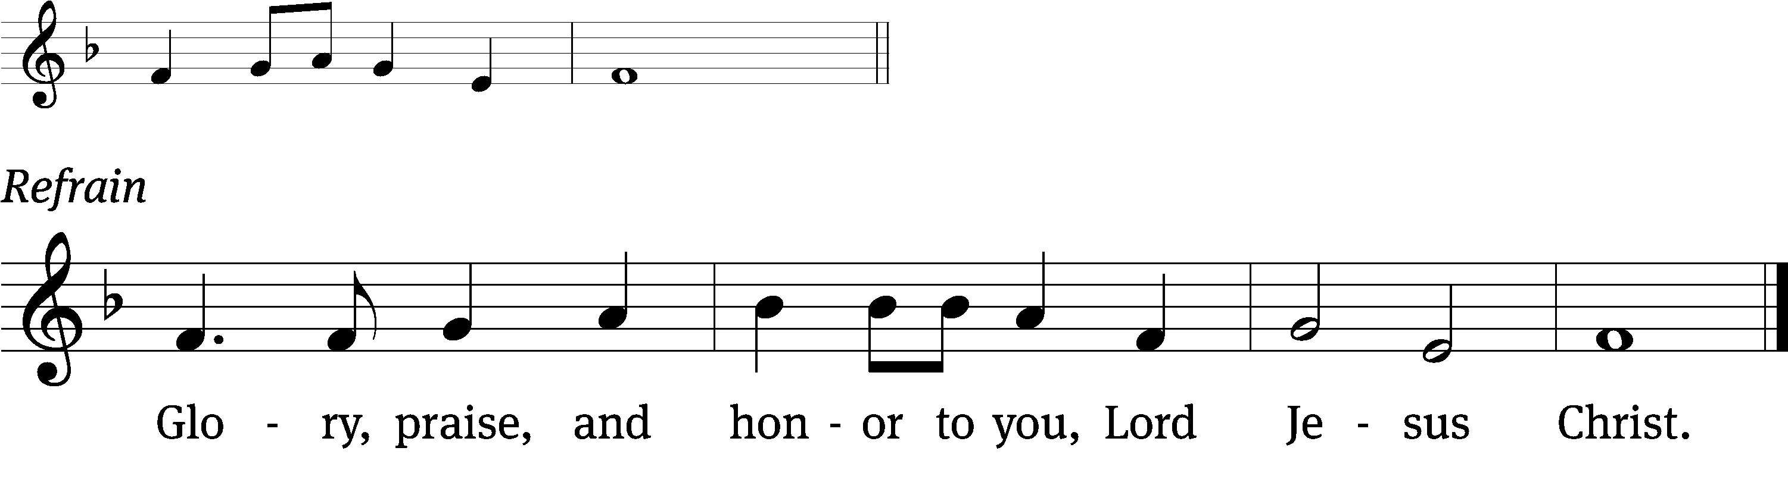
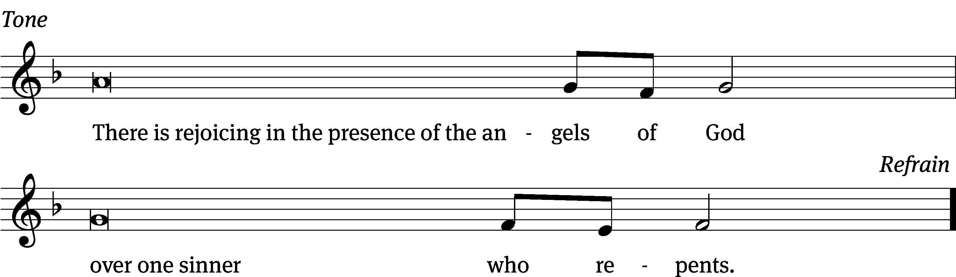
Tune: © 2021 Northwestern Publishing House. Used by permission: OneLicense no. 727703

Gospel Luke 15:1-3,11-32
¹ All the tax collectors and sinners were coming to Jesus to hear him. ² But the Pharisees and the experts in the law were complaining, “This man welcomes sinners and eats with them.”
³ He told them this parable:
¹¹ Jesus said, “A certain man had two sons. ¹² The younger of them said to his father, ‘Father, give me my share of the estate.’ So he divided his property between them. ¹³ Not many days later, the younger son gathered together all that he had and traveled to a distant country. There he wasted his wealth with reckless living. ¹⁴ After he had spent everything, there was a severe famine in that country, and he began to be in need. ¹⁵ He went and hired himself out to one of the citizens of that country, who sent him into his fields to feed pigs. ¹⁶ He would have liked to fill his stomach with the carob pods that the pigs were eating, but no one gave him anything.
¹⁷ “When he came to his senses, he said, ‘How many of my father’s hired servants have more than enough bread, and I am dying from hunger! ¹⁸ I will get up, go to my father, and tell him, “Father, I have sinned against heaven and in your sight. ¹⁹ I am no longer worthy to be called your son. Make me like one of your hired servants.”’
²⁰ “He got up and went to his father. While he was still far away, his father saw him and was filled with compassion. He ran, hugged his son, and kissed him. ²¹ The son said to him, ‘Father, I have sinned against heaven and in your sight. I am no longer worthy to be called your son.’
²² “But the father said to his servants, ‘Quick, bring out the best robe and put it on him. Put a ring on his finger and sandals on his feet. ²³ Bring the fattened calf and kill it. Let us eat and celebrate, ²⁴ because this son of mine was dead and is alive again. He was lost and is found.’ Then they began to celebrate.
²⁵ “His older son was in the field. As he approached the house, he heard music and dancing. ²⁶ He called one of the servants and asked what was going on. ²⁷ The servant told him, ‘Your brother is here! Your father killed the fattened calf, because he has received him back safe and sound.’ ²⁸ The older brother was angry and refused to go in. His father came out and began to plead with him.
²⁹ “He answered his father, ‘Look, these many years I’ve been serving you, and I never disobeyed your command, but you never gave me even a young goat so that I could celebrate with my friends. ³⁰ But when this son of yours arrived after wasting your property with prostitutes, you killed the fattened calf for him!’
³¹ “The father said to him, ‘Son, you are always with me, and all that I have is yours. ³² But it was fitting to celebrate and be glad, because this brother of yours was dead and is alive again. He was lost and is found.’”

The Gospel of the Lord.
Praise be to you, O Christ!

Please be seated
Sermon Hymn
654 Jesus Sinners Does Receive CW 654
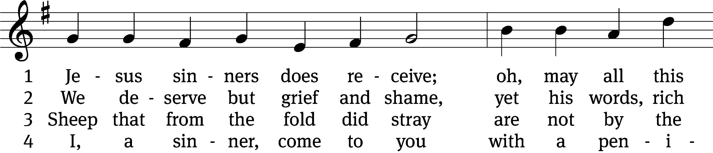
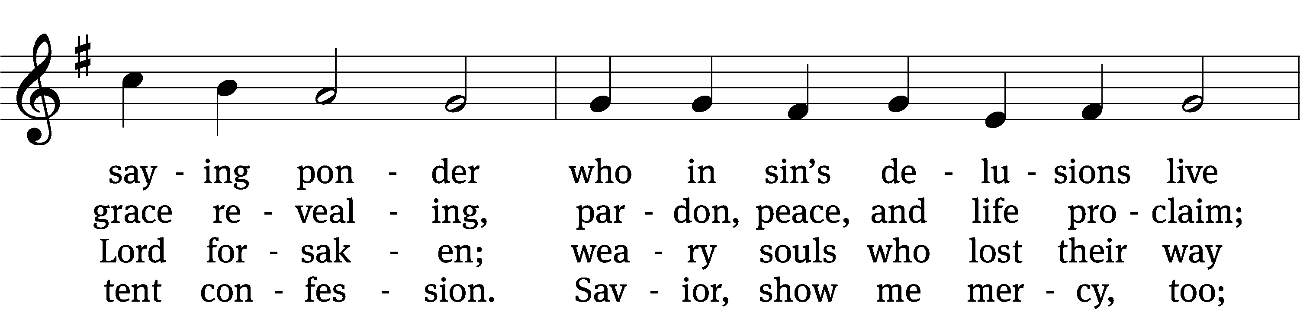
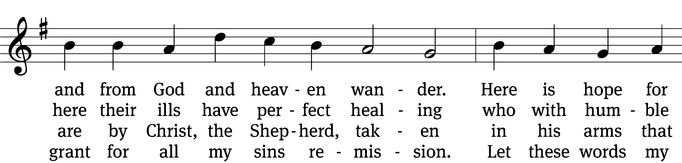
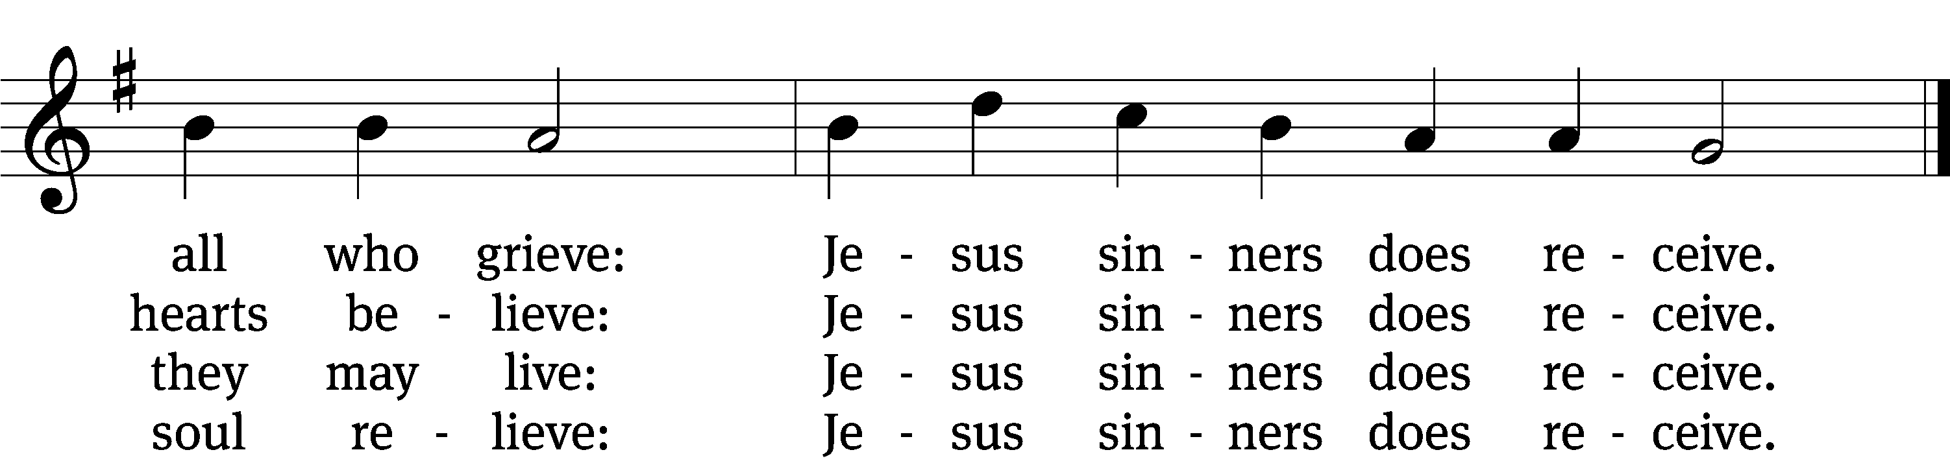

5 Oh, how blest it is to know,
were as scarlet my transgression,
it shall be as white as snow
by your blood and bitter passion,
for these words I do believe:
Jesus sinners does receive.

6 Now my conscience is at peace,
from the law I stand acquitted.
Christ has purchased my release
and my ev’ry sin remitted.
Naught remains my soul to grieve:
Jesus sinners does receive.

7 Jesus sinners does receive,
even I have been forgiven.
And when I this earth must leave,
I shall find an open heaven.
Dying, still to him I cleave:
Jesus sinners does receive.
Text: tr. The Lutheran Hymnal, 1941, alt.; Erdmann Neumeister, 1671–1756, abr. Tune: Neu-verfertigtes Darmstädtisches Gesang-Buch, Darmstadt, 1699
Sermon Luke 15:25-32
“The Other Lost Son”

Please stand, if you are able
Apostles’ Creed
I believe in God, the Father Almighty,
maker of heaven and earth.

I believe in Jesus Christ, his only Son, our Lord,
who was conceived by the Holy Spirit,
born of the Virgin Mary,
suffered under Pontius Pilate,
was crucified, died, and was buried.
He descended into hell.
The third day he rose again from the dead.
He ascended into heaven
and is seated at the right hand of God the Father Almighty.
From there he will come to judge the living and the dead.

I believe in the Holy Spirit,
the holy Christian Church,
the communion of saints,
the forgiveness of sins,
the resurrection of the body,
and the life everlasting. Amen.

Prayer of the Church

653 Lord, to You I Make Confession CW 653
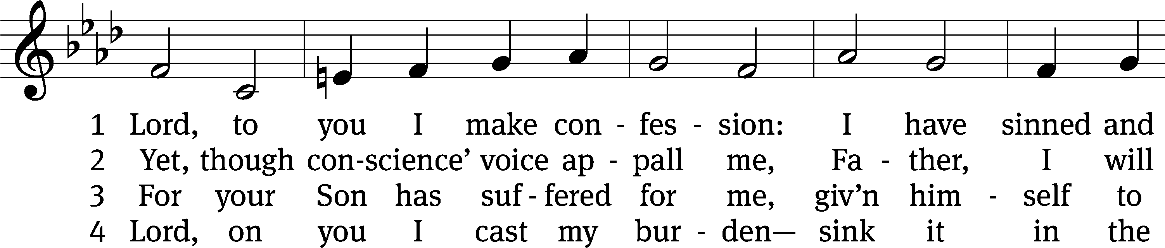
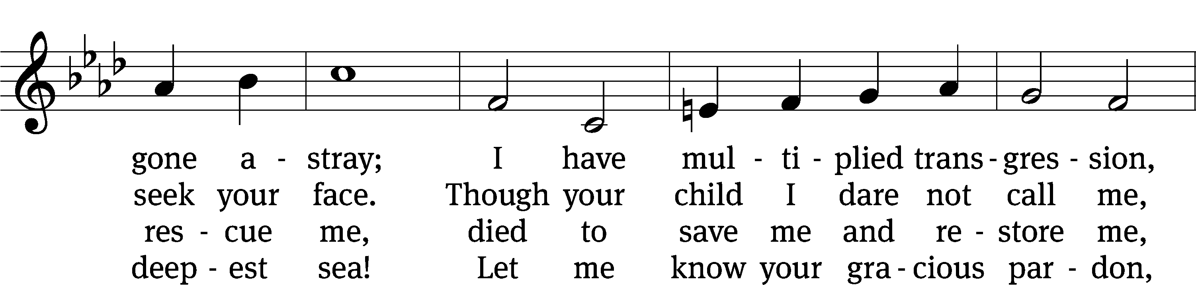
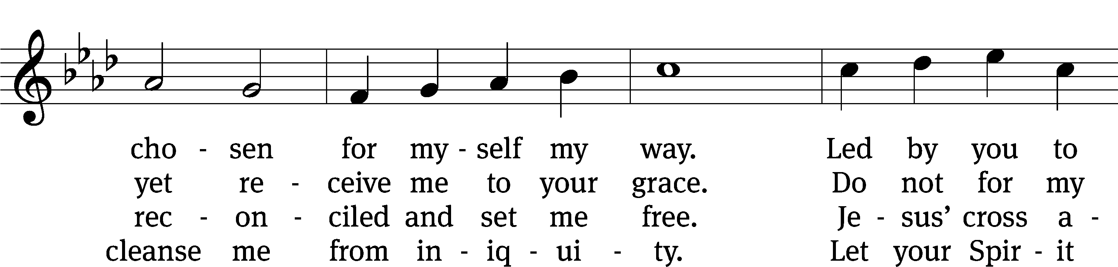
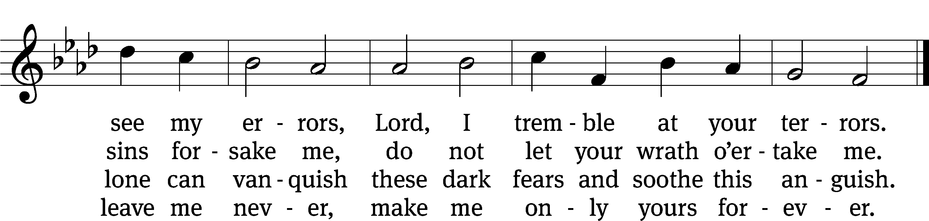
Text: tr. Catherine Winkworth, 1827–1878, alt.; Johann Franck, 1618–1677, abr.
Tune: Johann Crüger, 1598–1662, alt.
Text and tune: Public domain

Prayer
Blessed Lord, you have given us your Holy Scriptures for our learning. May we so hear them, read, learn, and take them to heart that, being strengthened and comforted by your holy Word, we may cling to the blessed hope of everlasting life; through Jesus Christ our Lord, who lives and reigns with you and the Holy Spirit, one God, now and forever.
Amen.
Lord’s Prayer
Our Father, who art in heaven, hallowed be thy name, thy kingdom come, thy will be done on earth as it is in heaven. Give us this day our daily bread; and forgive us our trespasses, as we forgive those who trespass against us; and lead us not into temptation, but deliver us from evil. For thine is the kingdom and the power and the glory forever and ever. Amen.

Blessing
The Lord bless you and keep you.
The Lord make his face shine on you and be gracious to you.
The Lord look on you with favor and T give you peace.
Amen.

Please be seated

924 Abide, O Dearest Jesus CW 924
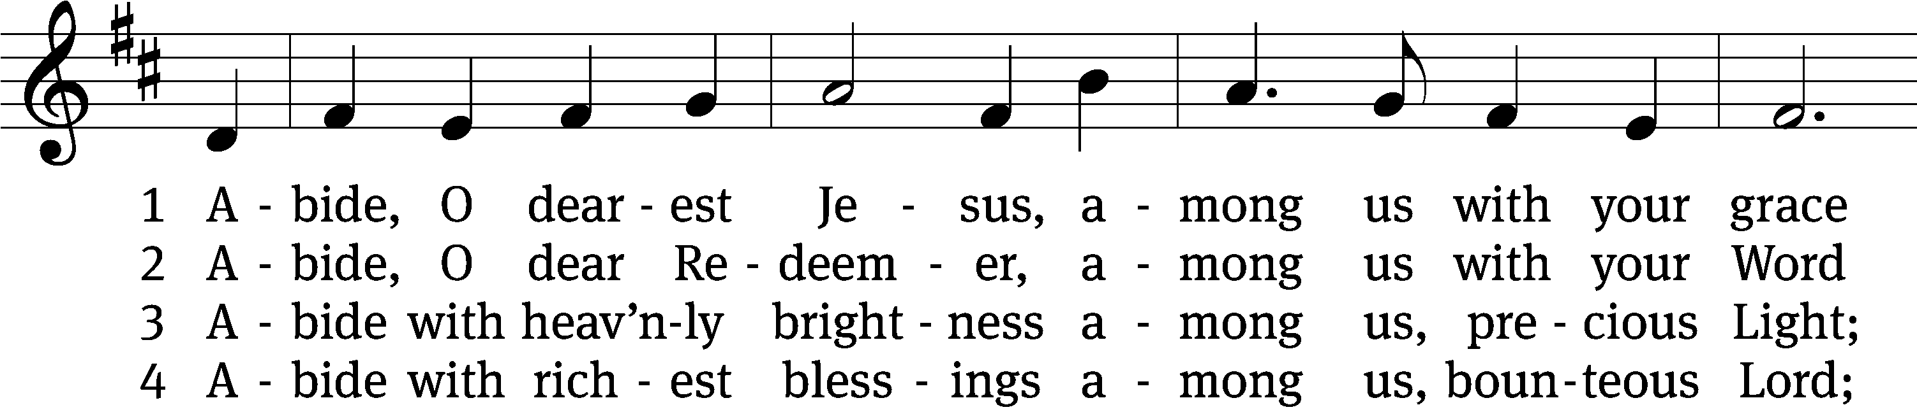
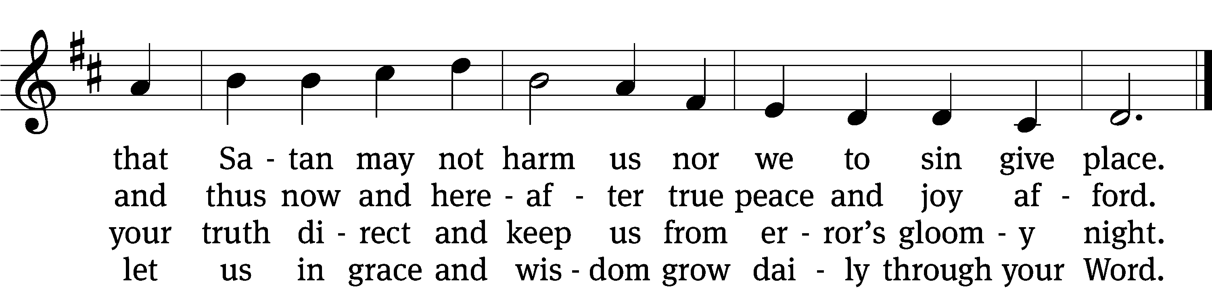

5 Abide with your protection
among us, Lord, our strength,
lest world and Satan fell us
and overcome at length.

6 Abide, O faithful Savior,
among us with your love;
grant steadfastness and help us
to reach our home above.
Text: tr. August Crull, 1845–1923, alt.; Josua Stegmann, 1588–1632
Tune: Melchior Vulpius, c. 1570–1615
Text and tune: Public domain
Acknowledgments
Setting One from Christian Worship
Software distributed in partnership with Northwestern Publishing House.
Created by Christian Worship: Service Builder © 2022 Concordia Publishing House.

Serving in Worship
Officiant Pastor Natsis
Organist Ann Hoeft
Deacons (8:30) Jim Tice and Ed Wheeler
(11:00) Dave Frey and Jeff Neuburger
Ushers (8:30) Robert Newman and Henry Schneider
(11:00) Bill Barnett and Jake Vershum
Altar Guild Shirley Klumpp and Ann Latowski
Videographer Rick Schneider

