THE SECOND sunday
OF EASTER

TRINITY EVANGELICAL LUTHERAN CHURCH | Saline, Michigan
WELCOME TO WORSHIP April 16, 2023

Thank you for joining us in God’s house today! We cordially ask that our guests sign one of the guestbooks located at either the front or back entryways.

THANK OFFERING: Members of Trinity give their offering as an expression of love and thankfulness to the Lord and to help support the Lord’s work in our community and around the world. Visitors need not feel obligated to participate in this offering which supports our ministry.

Restrooms are located at the back of the upper level (the annex), and in the basement (down the back stairs of the sanctuary or annex). Handicap access is available, please ask an usher for assistance.

celebration of holy communion:
In His Word, God makes it clear that the Lord’s Supper is to be shared by people of a common proclamation of faith (1 Corinthians 11:26; 1 Corinthians 10:16-17). Without judging anyone’s hearts, we invite those who share in our confession by their membership in our congregation or another congregation of the Wisconsin Evangelical Lutheran Synod (WELS) or the Evangelical Lutheran Synod (ELS) and who are properly prepared (1 Corinthians 11;27-29) to receive the Sacrament. Page 295 in the front of Christian Worship provides a guide for preparation.

Guests, we would love to have you join us in communion fellowship in the future, and for that to be possible, we ask that you speak with one of the pastors so that we may speak with you on how that would be possible. We thank you for respecting the way we celebrate the Lord’s Supper in our congregations.

SERVICE OF WORD AND SACRAMENT
449 This Joyful Eastertide CW 449
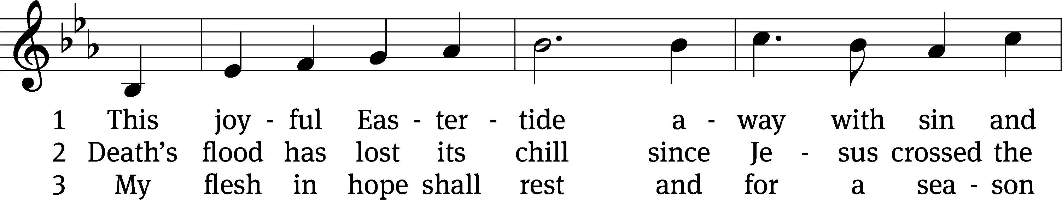
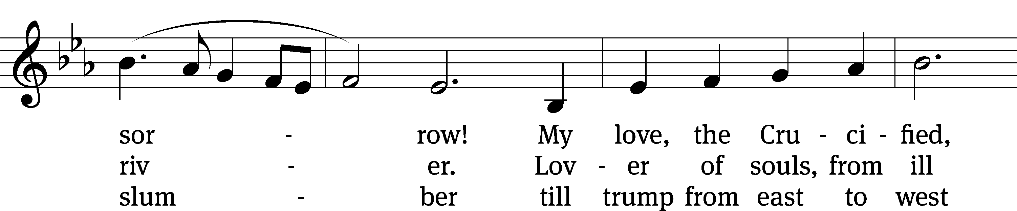
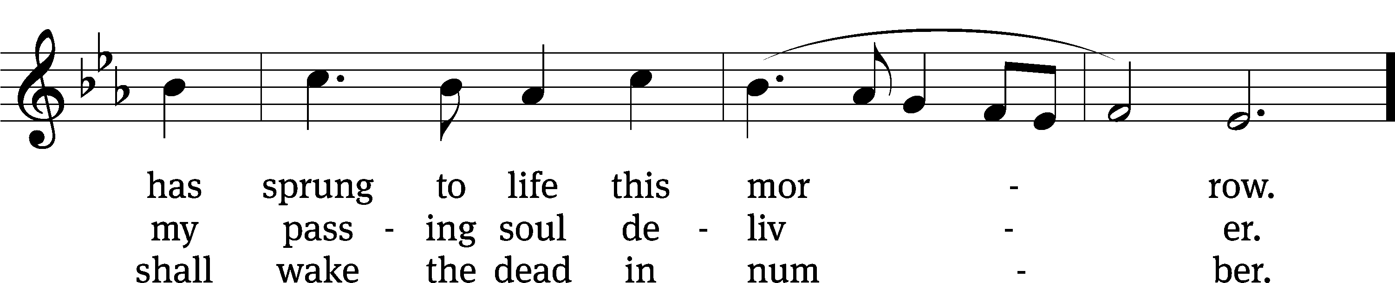
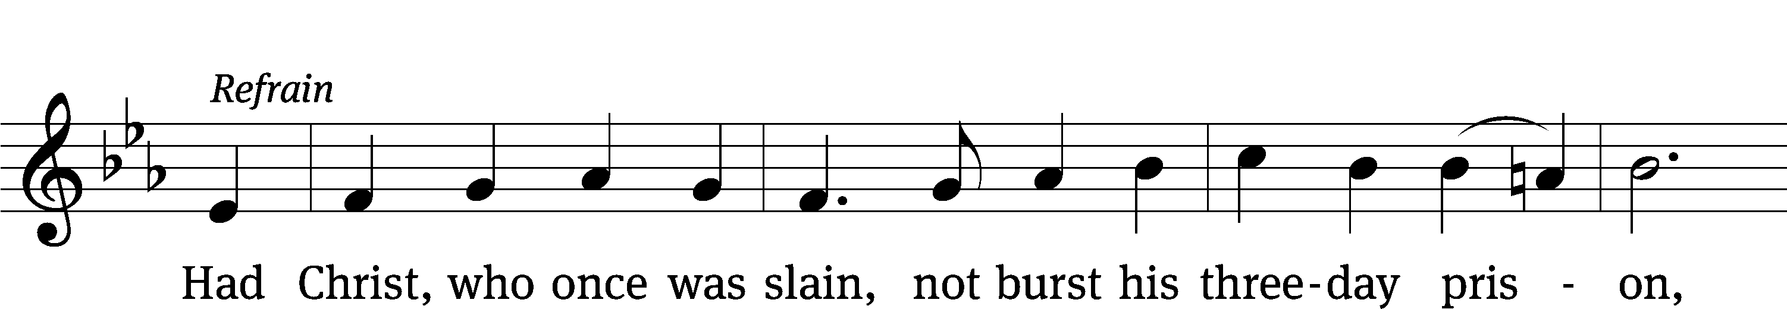
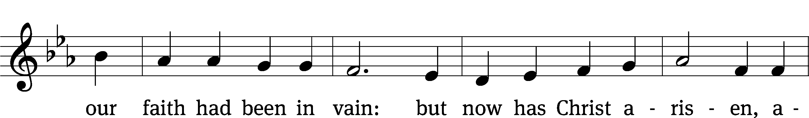
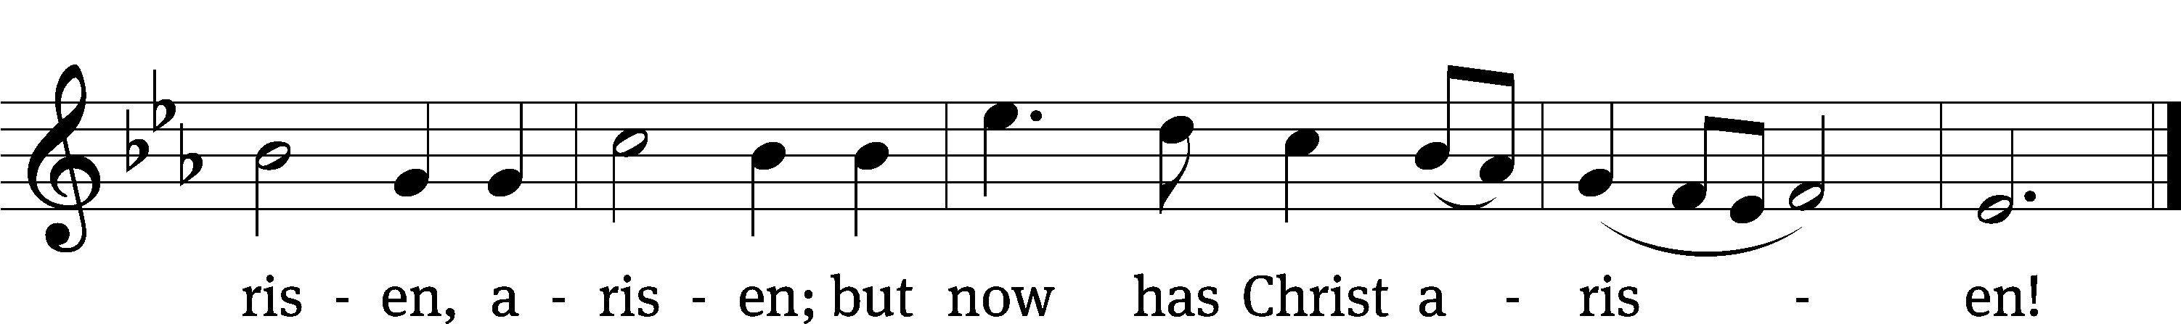
Text: George R. Woodward, 1848–1934
Tune: Davids Psalmen, Amsterdam, 1684
Text and tune: Public domain

PLEASE STAND, IF YOU ARE ABLE

invocation

M: The grace of our Lord (+) Jesus Christ and the love of God and the fellowship of the Holy Spirit be with you.
C: And also with you.

CONFESSION OF SINS
M: God invites us to come into his presence and worship him with humble and penitent hearts. Therefore, let us acknowledge our sinfulness and ask him to forgive us.
C: Holy and merciful Father, I confess that I am by nature sinful, and that I have disobeyed you in my thoughts, words, and actions. I have done what is evil and failed to do what is good. For this I deserve your punishment both now and in eternity. But I am truly sorry for my sins, and trusting in my Savior Jesus Christ, I pray: Lord, have mercy on me, a sinner.
M: God, our heavenly Father, has been merciful to us and has given his only Son to be the atoning sacrifice for our sins. Therefore, as a called servant of Christ and by his authority, I forgive you all your sins in the name of the Father and of the Son (+) and of the Holy Spirit.
C: Amen.
PRAYER AND PRAISE
LORD, HAVE MERCY
Kyrie
M: For all that we need in life and for the wisdom to use all your gifts with gratitude and joy, hear our prayer, O Lord.

M: For the steadfast assurance that nothing can separate us from your love and for the courage to stand firm against the assaults of Satan and every evil, hear our prayer, O Christ.

M: For the well-being of your holy Church in all the world and for those who offer here their worship and praise, hear our prayer, O Lord.

M: Merciful God, maker and preserver of life, uphold us by your power and keep us in your tender care:

M: The works of the Lord are great and glorious; his name is worthy of praise.

Prayer of the day

M: Let us pray.
The minister says the Prayer of the Day.

PLEASE BE SEATED

The Word

first lesson Acts 2:14a, 22-32

¹⁴ Then Peter stood up with the Eleven, raised his voice, and spoke loudly and clearly to them:
²² “Men of Israel, hear these words! Jesus the Nazarene was a man recommended to you by God with miracles, wonders, and signs that God did through him among you, as you yourselves know. ²³ This man, who was handed over by God’s set plan and foreknowledge, you killed by having lawless men nail him to a cross. ²⁴ He is the one God raised up by freeing him from the agony of death, because death was not able to hold him in its grip. ²⁵ “Indeed, David says concerning him:
I saw the Lord always before me.
Because he is at my right hand,
I will not be shaken.
²⁶ Therefore my heart was glad,
and my tongue rejoiced.
My flesh also will rest in hope,
²⁷ because you will not abandon my life to the grave,
nor will you let your Holy One see decay.
²⁸ You have made known to me the paths of life.
You will fill me with joy in your presence.
²⁹ “Gentlemen, brothers, I can speak confidently to you about the patriarch David, that he both died and was buried, and his tomb is with us to this day. ³⁰ Since he was a prophet and knew that God had sworn to him with an oath that he would seat one of his descendants on his throne, ³¹ he saw what was coming and spoke about the resurrection of Christ, saying that he was neither abandoned to the grave nor did his flesh see decay.
³² “This Jesus is the one God has raised up. We are all witnesses of that.
116B I Will Walk in the Presence of the Lord Psalm 116B
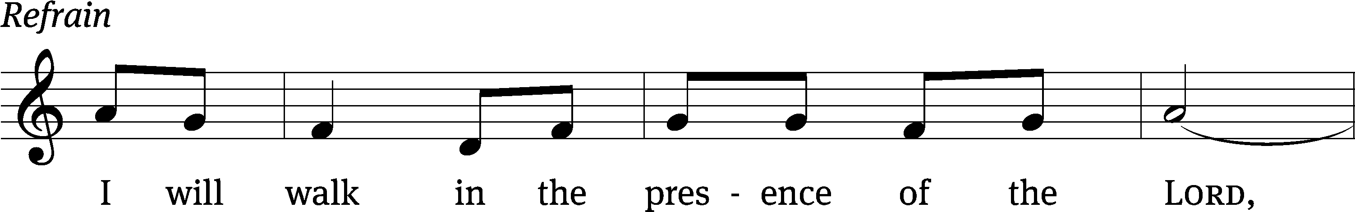
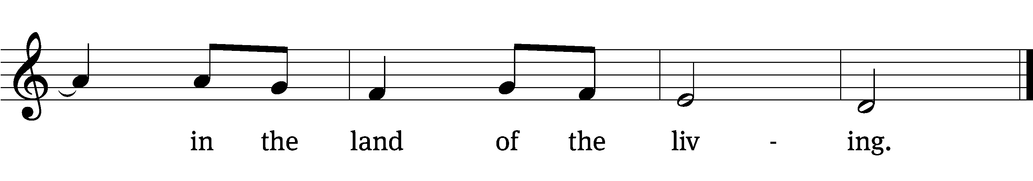
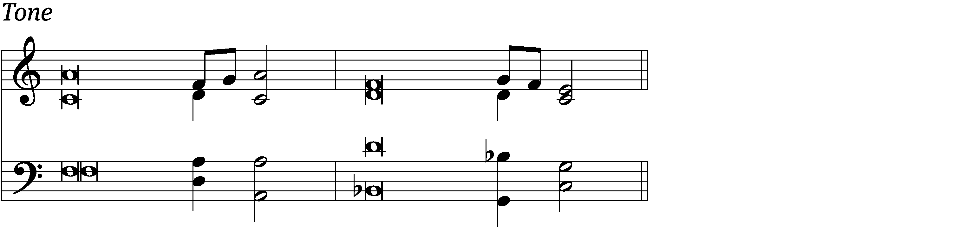

I love the Lord, for he / heard my voice;
he heard my cry for / mercy.
Because he turned his / ear to me,
I will call on him as long / as I live.
The Lord is gracious and / righteous;
when I was brought low, he / saved me. Refrain

What shall I return / to the Lord
for all his good- / ness to me?
I will lift up the cup of sal- / vation
and call on the name / of the Lord.
Precious in the sight / of the Lord
is the death of his faithful / servants.
Glory be to the Father and / to the Son
and to the Holy / Spirit,
as it was in the be- / ginning,
is now, and will be forever. / Amen. Refrain
Tune: Richard T. Proulx
Text: © 1963, 1993 The Grail, GIA Publications, Inc., agent (refrain). Used by permission: OneLicense no. 727703
Tune: © 1975 GIA Publications, Inc. Used by permission: OneLicense no. 727703
Setting: © 1993 Kermit G. Moldenhauer, admin. Northwestern Publishing House. Used by permission: OneLicense no. 727703

second lesson 1 Peter 1:3-9
³ Blessed be the God and Father of our Lord Jesus Christ! By his great mercy he gave us a new birth into a living hope through the resurrection of Jesus Christ from the dead, ⁴ into an inheritance that is undying, undefiled, and unfading, kept in heaven for you. ⁵ Through faith you are being protected by God’s power for the salvation that is ready to be revealed at the end of time.
⁶ Because of this you rejoice very much, even though now for a little while, if necessary, you have been grieved by various kinds of trials ⁷ so that the proven character of your faith—which is more valuable than gold, which passes away even though it is tested by fire—may be found to result in praise, glory, and honor when Jesus Christ is revealed.
⁸ Though you have not seen him, you love him. Though you do not see him now, yet by believing in him, you are filled with a joy that is inexpressible and filled with glory, ⁹ because you are receiving the goal of your faith, the salvation of your souls.

PLEASE STAND, IF YOU ARE ABLE

VERSE OF THE DAY
Alleluia. Blessed ar5e those who have not seen, and yet have believed. Alleluia.
GOSPEL John 20:19-31
¹⁹ On the evening of that first day of the week, the disciples were together behind locked doors because of their fear of the Jews. Jesus came, stood among them, and said to them, “Peace be with you!” ²⁰ After he said this, he showed them his hands and side. So the disciples rejoiced when they saw the Lord.
²¹ Jesus said to them again, “Peace be with you! Just as the Father has sent me, I am also sending you.” ²² After saying this, he breathed on them and said, “Receive the Holy Spirit. ²³ Whenever you forgive people’s sins, they are forgiven. Whenever you do not forgive them, they are not forgiven.”
²⁴ But Thomas, one of the Twelve, the one called the Twin,^{[a]} was not with them when Jesus came. ²⁵ So the other disciples kept telling him, “We have seen the Lord!”
But he said to them, “Unless I see the nail marks in his hands, and put my finger into the mark of the nails, and put my hand into his side, I will never believe.”
²⁶ After eight days, his disciples were inside again, and Thomas was with them. Though the doors were locked, Jesus came and stood among them. “Peace be with you,” he said. ²⁷ Then he said to Thomas, “Put your finger here and look at my hands. Take your hand and put it into my side. Do not continue to doubt, but believe.”
²⁸ Thomas answered him, “My Lord and my God!”
²⁹ Jesus said to him, “Because you have seen me, you have believed. Blessed are those who have not seen and yet have believed.”
³⁰ Jesus, in the presence of his disciples, did many other miraculous signs that are not written in this book. ³¹ But these are written that you may believe that Jesus is the Christ, the Son of God, and that by believing you may have life in his name.
M: This is the Gospel of the Lord.

PLEASE BE SEATED
444 Jesus Lives! The Victory’s Won CW 444
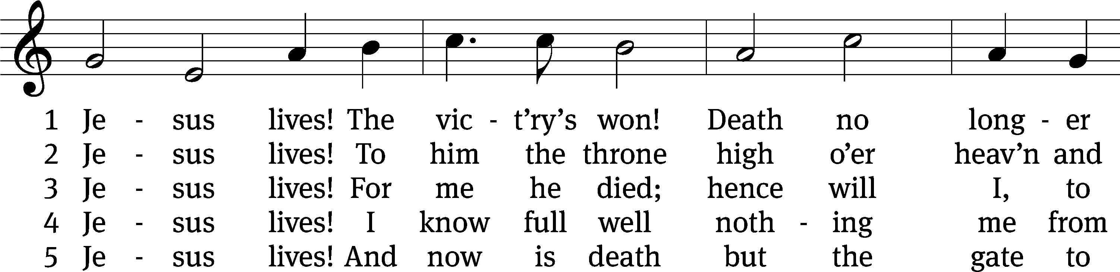
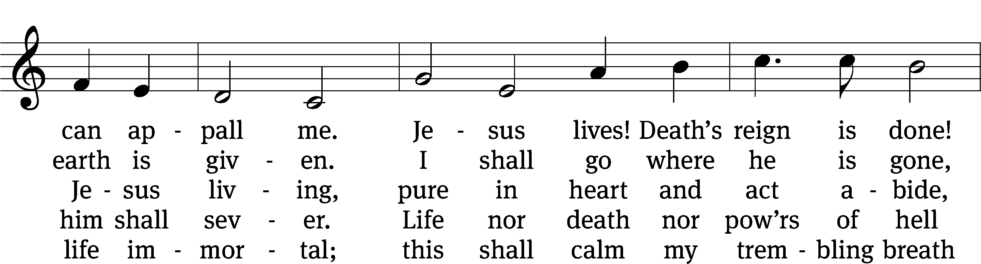
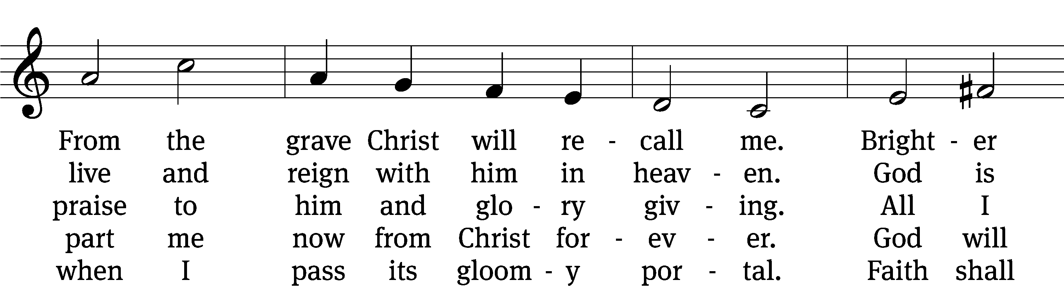
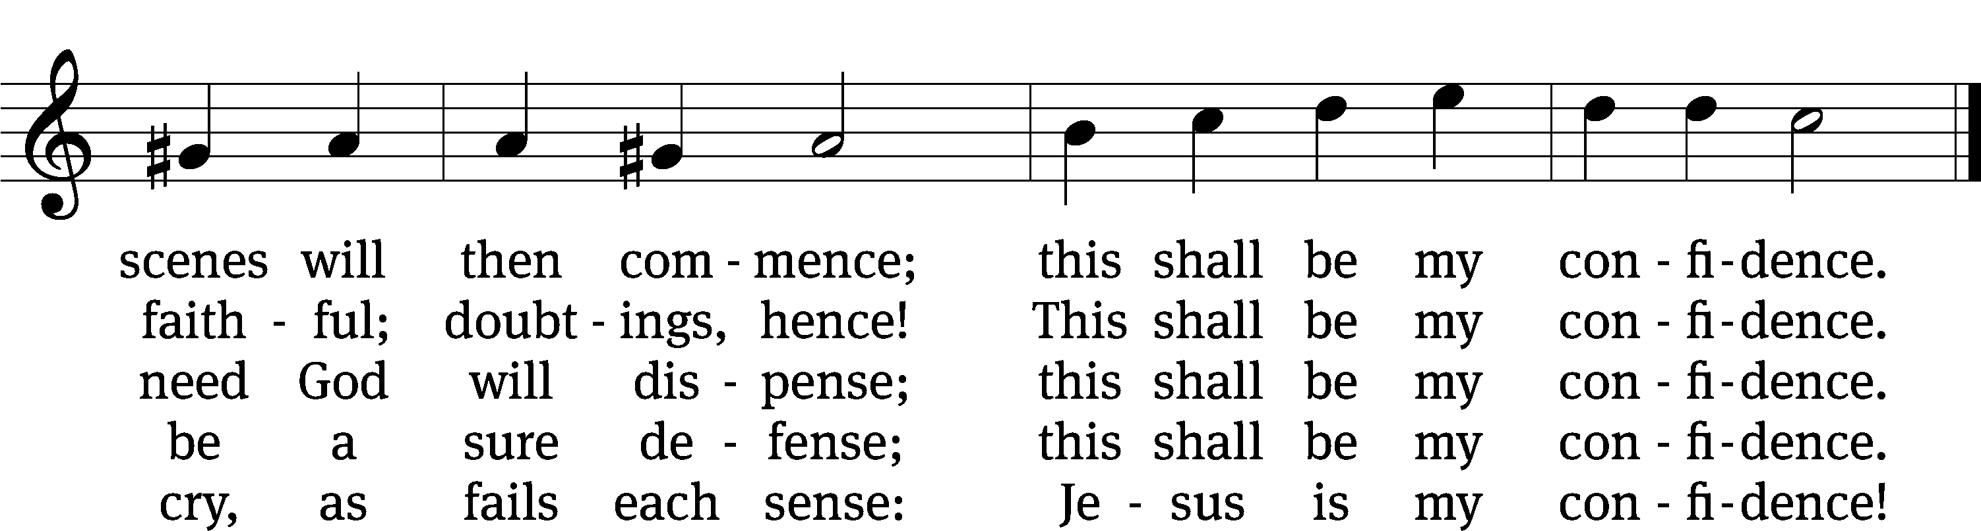
Text: tr. Frances E. Cox, 1812–1897, alt.; Christian F. Gellert, 1715–1769, abr.
Tune: Johann Crüger, 1598–1662
Text and tune: Public domain

Sermon John 20:19-31

“Jesus’ three messages of peace”

please stand, if you are able

nicene creed
We believe in one God, the Father, the Almighty, maker of heaven and earth, of all that is, seen and unseen.
We believe in one Lord, Jesus Christ, the only Son of God, eternally begotten of the Father, God from God, Light from Light, true God from true God, begotten, not made, of one being with the Father. Through him all things were made. For us and for our salvation, he came down from heaven, was incarnate of the Holy Spirit and the virgin Mary, and became truly human. For our sake he was crucified under Pontius Pilate. He suffered death and was buried. On the third day he rose again in accordance with the Scriptures. He ascended into heaven and is seated at the right hand of the Father. He will come again in glory to judge the living and the dead, and his kingdom will have no end.
We believe in the Holy Spirit, the Lord, the giver of life, who proceeds from the Father and the Son, who in unity with the Father and the Son is worshiped and glorified, who has spoken through the prophets. We believe in one holy Christian and apostolic Church. We acknowledge one baptism for the forgiveness of sins. We look for the resurrection of the dead and the life of the world to come. Amen.

prayer of the church

lord’s prayer

C: Our Father, who art in heaven,
hallowed be thy name,
thy kingdom come,
thy will be done
on earth as it is in heaven.
Give us this day our daily bread;
and forgive us our trespasses,
as we forgive those
who trespass against us;
and lead us not into temptation,
but deliver us from evil.
For thine is the kingdom
and the power and the glory
forever and ever. Amen.
The Sacrament of Holy Communion
Trinity Lutheran Church follows the historic Christian practice of close communion. We ask that only members of Trinity or one of our sister congregations partake of the sacrament. If you are not a member, please see the note about Holy Communion in the beginning of the Worship Folder.

M: The Lord be with you.

M: Lift up your hearts.

M: Let us give thanks to the Lord our God.

M: Praise to the God and Father of our Lord Jesus Christ! In love he has blessed us with every spiritual blessing. He sends the Holy Spirit to testify that we are his children and to strengthen us when we are weak. Now have come the salvation and the power and the kingdom of our God and the authority of his Christ. To him who sits on the throne and to the Lamb be praise and thanks and honor and glory for ever and ever:

Holy, Holy, Holy

Words of institution
M: Our Lord Jesus Christ, on the night he was betrayed, took bread; and when he had given thanks, he broke it and gave it to his disciples, saying: “Take and eat. This is my ✙ body, which is given for you. Do this in remembrance of me.”
Then he took the cup, gave thanks, and gave it to them, saying, “Drink from it all of you; this is my ✙ blood of the new covenant, which is poured out for you for the forgiveness of sins. Do this, whenever you drink it, in remembrance of me.”

The peace of the Lord be with you always.

O CHRIST, LAMB OF GOD

PLEASE BE SEATED
456 O Sons and Daughters of the King CW 456
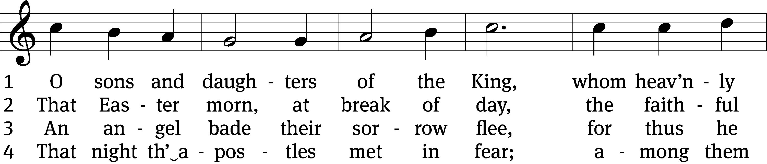
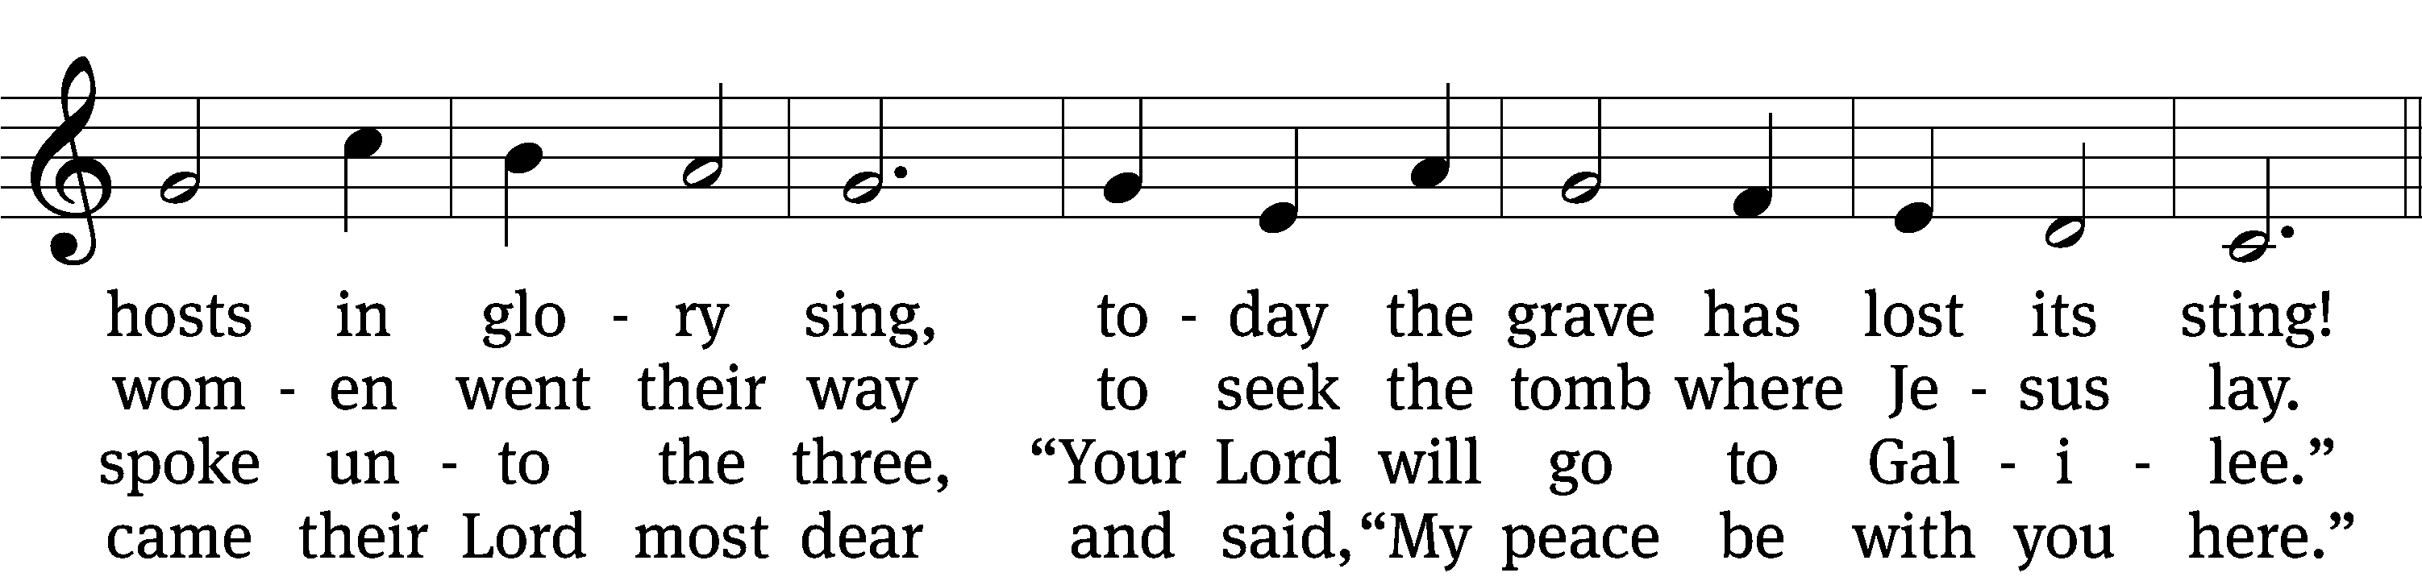
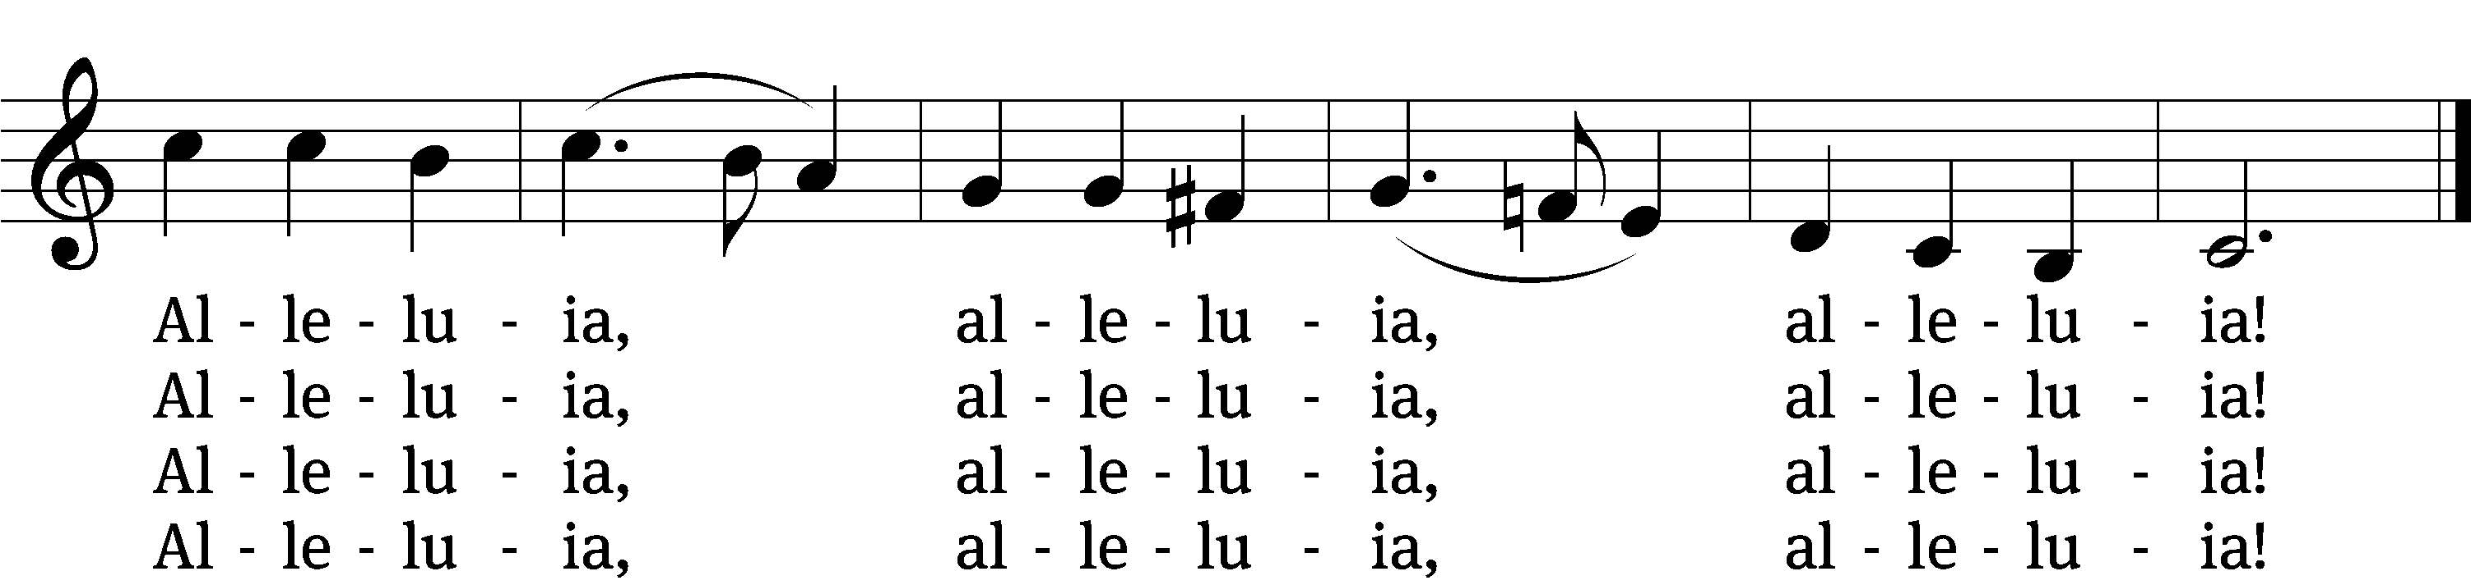

5 When Thomas afterwards had heard
that Jesus had fulfilled his word,
he doubted that it was the Lord.
Alleluia, alleluia, alleluia!

6 “Thomas, behold my side,” said he,
“my hands, my feet, my body see;
and doubt not, but believe in me.”
Alleluia, alleluia, alleluia!

7 No longer Thomas then denied;
he saw the feet, the hands, the side;
“You are my Lord and God,” he cried.
Alleluia, alleluia, alleluia!

8 Blessèd are they that have not seen
and yet whose faith has constant been;
in life eternal they shall reign.
Alleluia, alleluia, alleluia!

9 On this most holy day of days
to God your hearts and voices raise
in laud and jubilee and praise.
Alleluia, alleluia, alleluia!
Text: tr. John Mason Neale, 1818–1866, alt.; attr. Jean Tisserand, d. 1494, abr.
Tune: Melchior Vulpius, c. 1570–1615;
Text and tune: Public domain

PLEASE STAND, IF YOU ARE ABLE

M: Hear the prayer of your people, O Lord, that the lips which have praised you here may glorify you in the world, that the eyes which have seen the coming of your Son may long for his coming again, and that all who have received in his true body and blood the pledge of your forgiveness may be restored to live a new and holy life, through Jesus Christ, our Lord, who lives and reigns with you and the Holy Spirit, one God, now and forever.

M: Brothers and sisters, go in peace. Live in harmony with one another.
Serve the Lord with gladness.

The Lord bless you and keep you.
The Lord make his face shine on you and be gracious to you.
The Lord look on you with favor and (+) give you peace.

PLEASE BE SEATED

Serving In Worship

Officiant Pastor Natsis
Organist Sarah Hanke
Deacons (8:30) Dave Stevenson and Jim Tice
(11:00) Steve Hoeft and Jeff Neuburger
Ushers (8:30) Dale Finkbeiner and Mark Finkbeiner
(11:00) Al Whitley
Altar Guild Jean Fiegel and Ann Latowski
Videographer Ann Latowski

Copyright information
Service of Word and Sacrament: Christian Worship. © 1993 Northwestern Publishing House. All rights reserved. Reprinted under ONE LICENSE #A-727703 and CCLI #1151741/ CSPL126093
Words and Music: All rights reserved. Reprinted/Podcast/Streamed with permission under ONE LICENSE #A-727703 and CCLI #1151741/CSPL126093

