SIXTH SUNDAY OF EASTER

TRINITY EVANGELICAL LUTHERAN CHURCH | Saline, Michigan
WELCOME TO WORSHIP May 22, 2022
Thank you for joining us in God’s house today! We cordially ask that our Guests sign one of the guestbooks located at either the front or back entryways, or fill out a “Let’s Get Acquainted” card located in the hymnal pew rack and place it in the collection plate.

THANK OFFERING: Members of Trinity give their offering as an expression of love and thankfulness to the Lord and to help support the Lord’s work in our community and around the world. Visitors need not feel obligated to participate in this offering which supports our ministry.

Restrooms are located at the back of the upper level (the annex), and in the basement (down the back stairs of the sanctuary or annex). Handicap access is available, please ask an usher for assistance.

Young Families / Toddler Bags – We are GLAD YOU BROUGHT YOUR CHILDREN to our worship service. Jesus said: “Let the little children come to me and do not hinder them, for the kingdom of God belongs to such as these.” We know that having little children in church can be a challenge, but DO NOT WORRY about it. Many of your fellow worshippers have been in your shoes and are just happy you brought your children with you. For your convenience, we have reserved the back rows of seating for parents with small children. These areas provide more flexibility for your family, as well as, easy access to move downstairs if necessary. A closed-circuit TV system allows families to continue participating in the service while downstairs. Pre-school toddler bags and children’s bulletins are available for their enjoyment. Ask an usher for one to use during the service and please return the toddler bag afterwards.

the SERVICE – setting one - WITHOUT HOLY COMMUNION CW, page 154

Sunday School Children “Seek Ye First”
890 Jerusalem the Golden CW 890
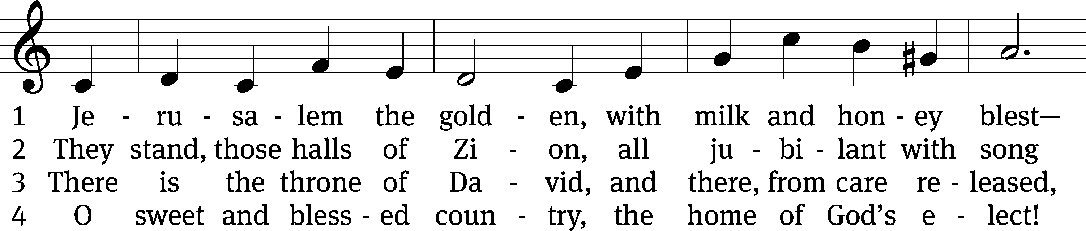
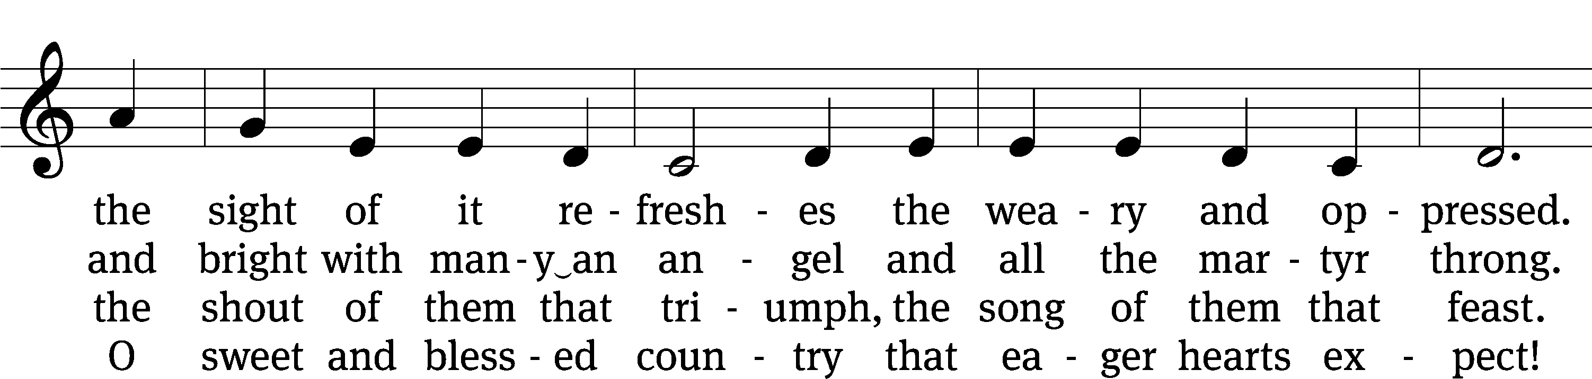
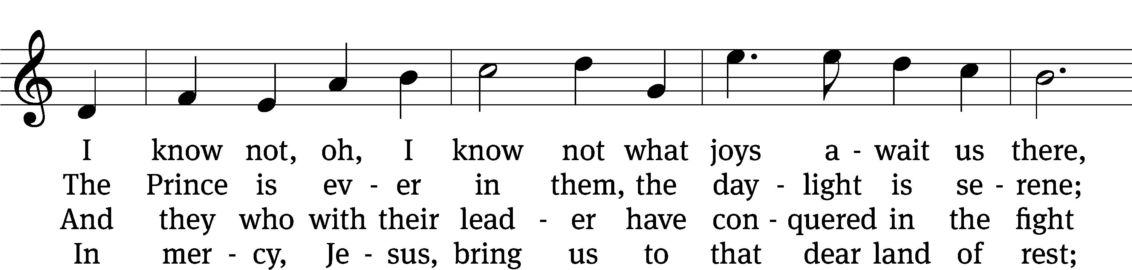
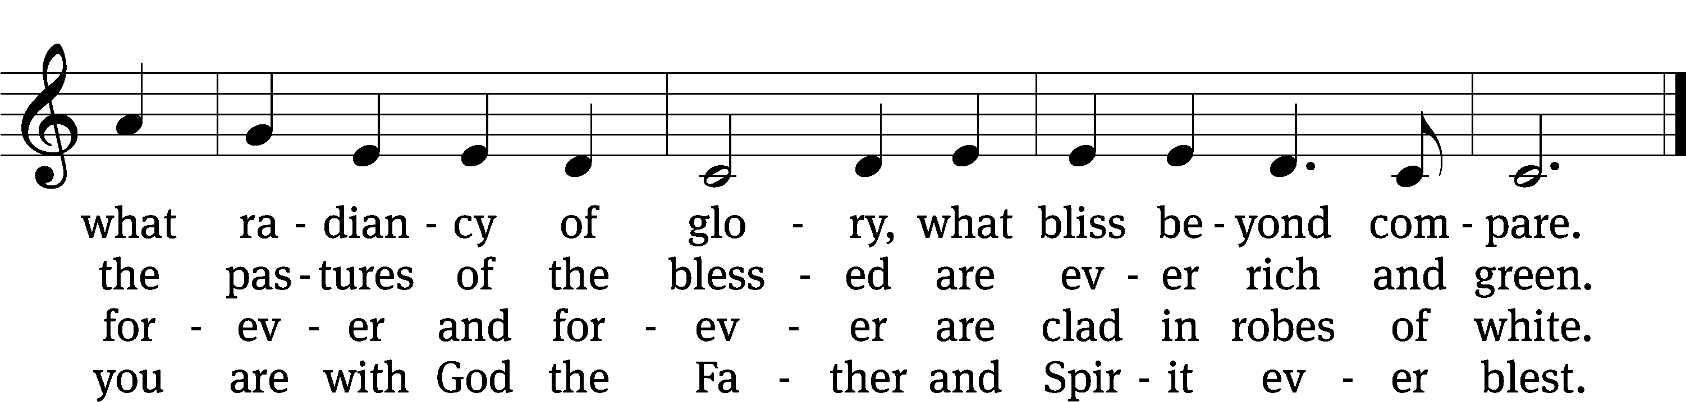
Text and tune: Public domain
Text: tr. John Mason Neale, 1818–1866, alt.; Bernard of Cluny, 12th cent., abr.
Tune: Alexander C. Ewing, 1830–1895

Please stand, if you are able
Invocation
In the name of the Father and of the Son and of the Holy Spirit.
Amen.
Confession
If we claim to be without sin, we deceive ourselves and the truth is not in us.
If we confess our sins, God is faithful and just
and will forgive us our sins
and purify us from all unrighteousness.

Let us confess our sins to the Lord.
Holy God, gracious Father,
I am sinful by nature
and have sinned against you in my thoughts, words, and actions.
I have not loved you with my whole heart;
I have not loved others as I should.
I deserve your punishment both now and forever.
But Jesus, my Savior, paid for my sins
with his innocent suffering and death.
Trusting in him, I pray: God, have mercy on me, a sinner.

Our gracious Father in heaven has been merciful to us. He sent his only Son, Jesus Christ, who gave his life as the atoning sacrifice for the sins of the whole world. Therefore, as a called servant of Christ and by his authority, I forgive you all your sins in the name of the Father and of the the Son and of the Holy Spirit.
Amen.

Lord, Have Mercy

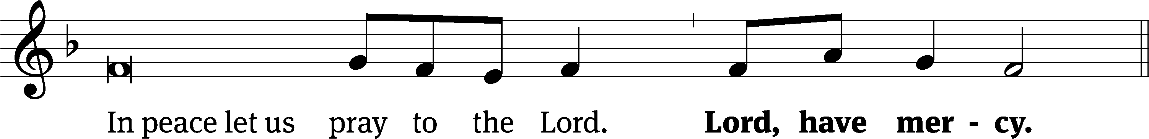
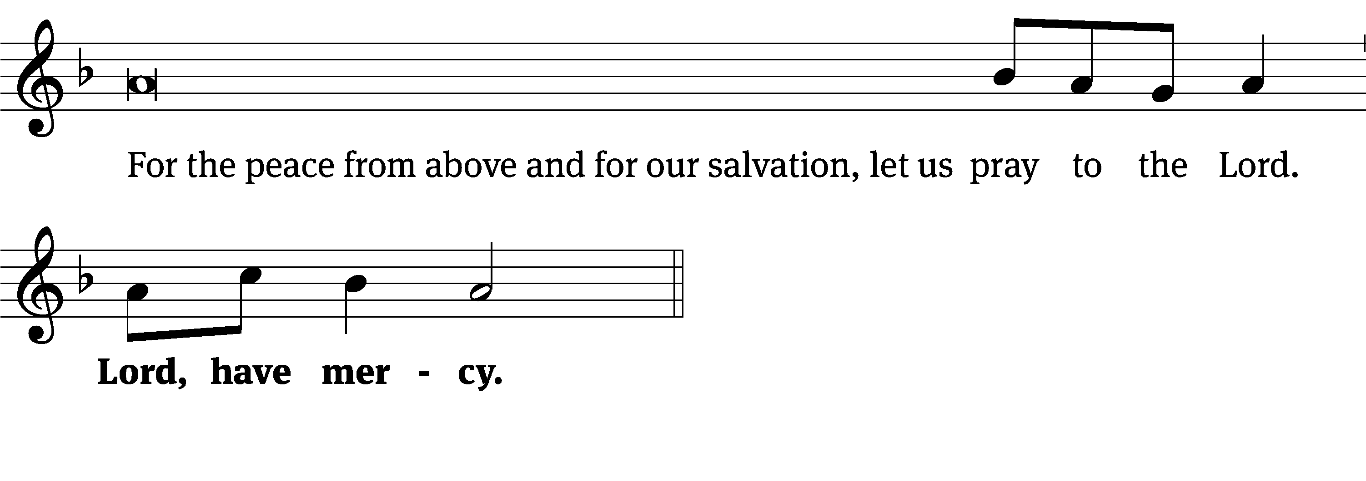
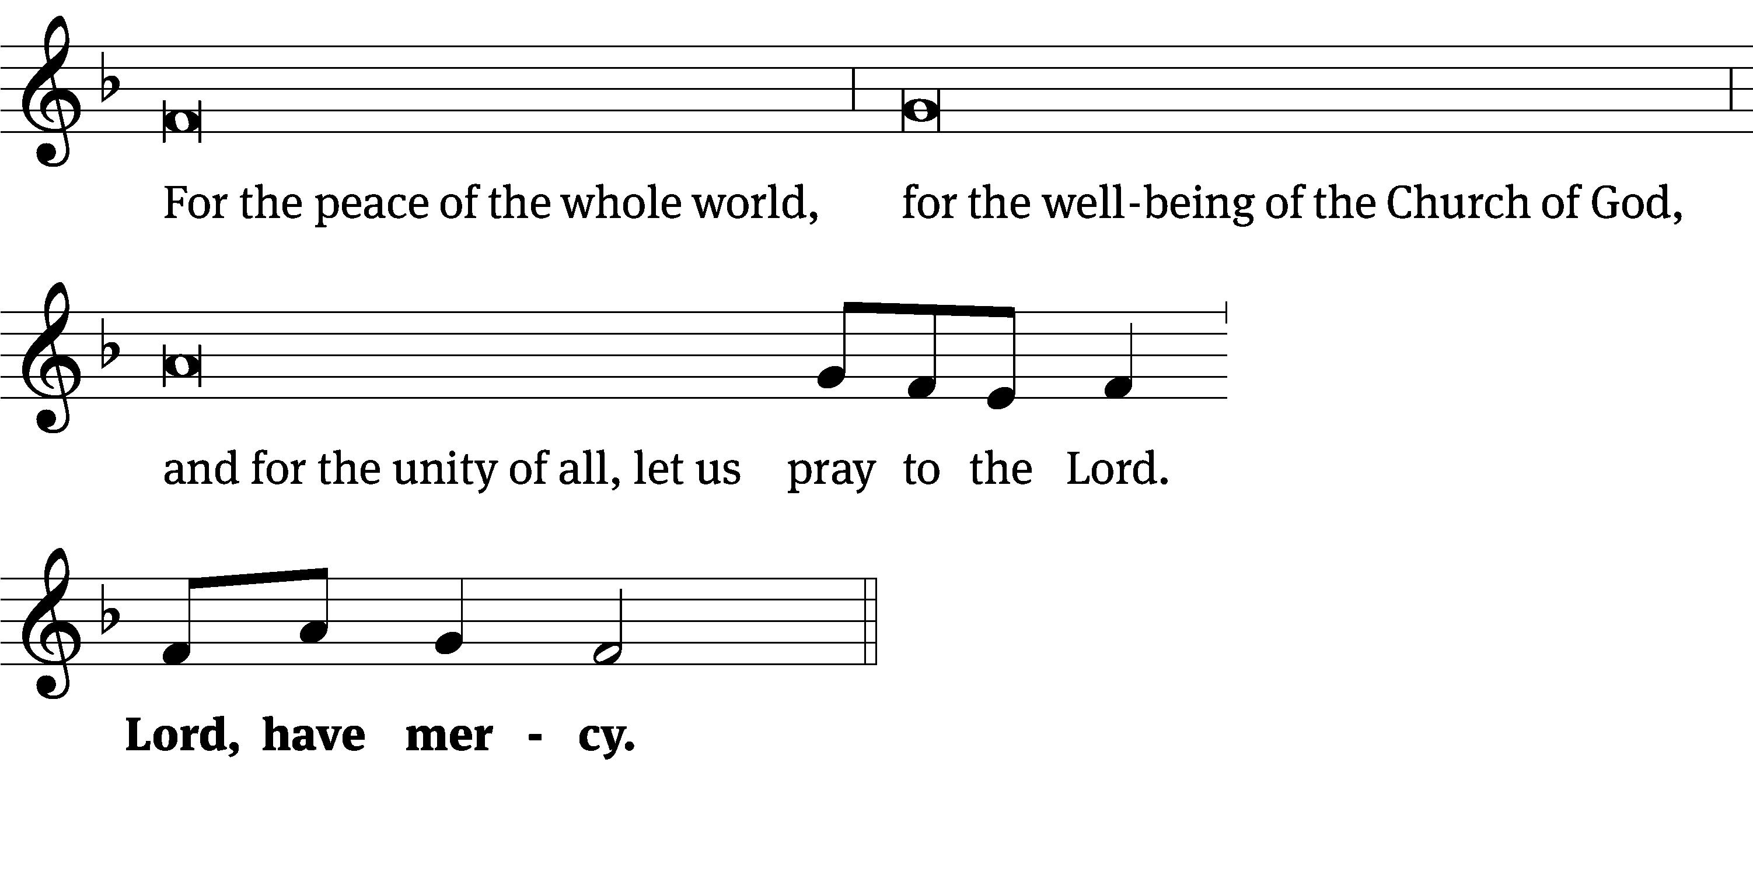
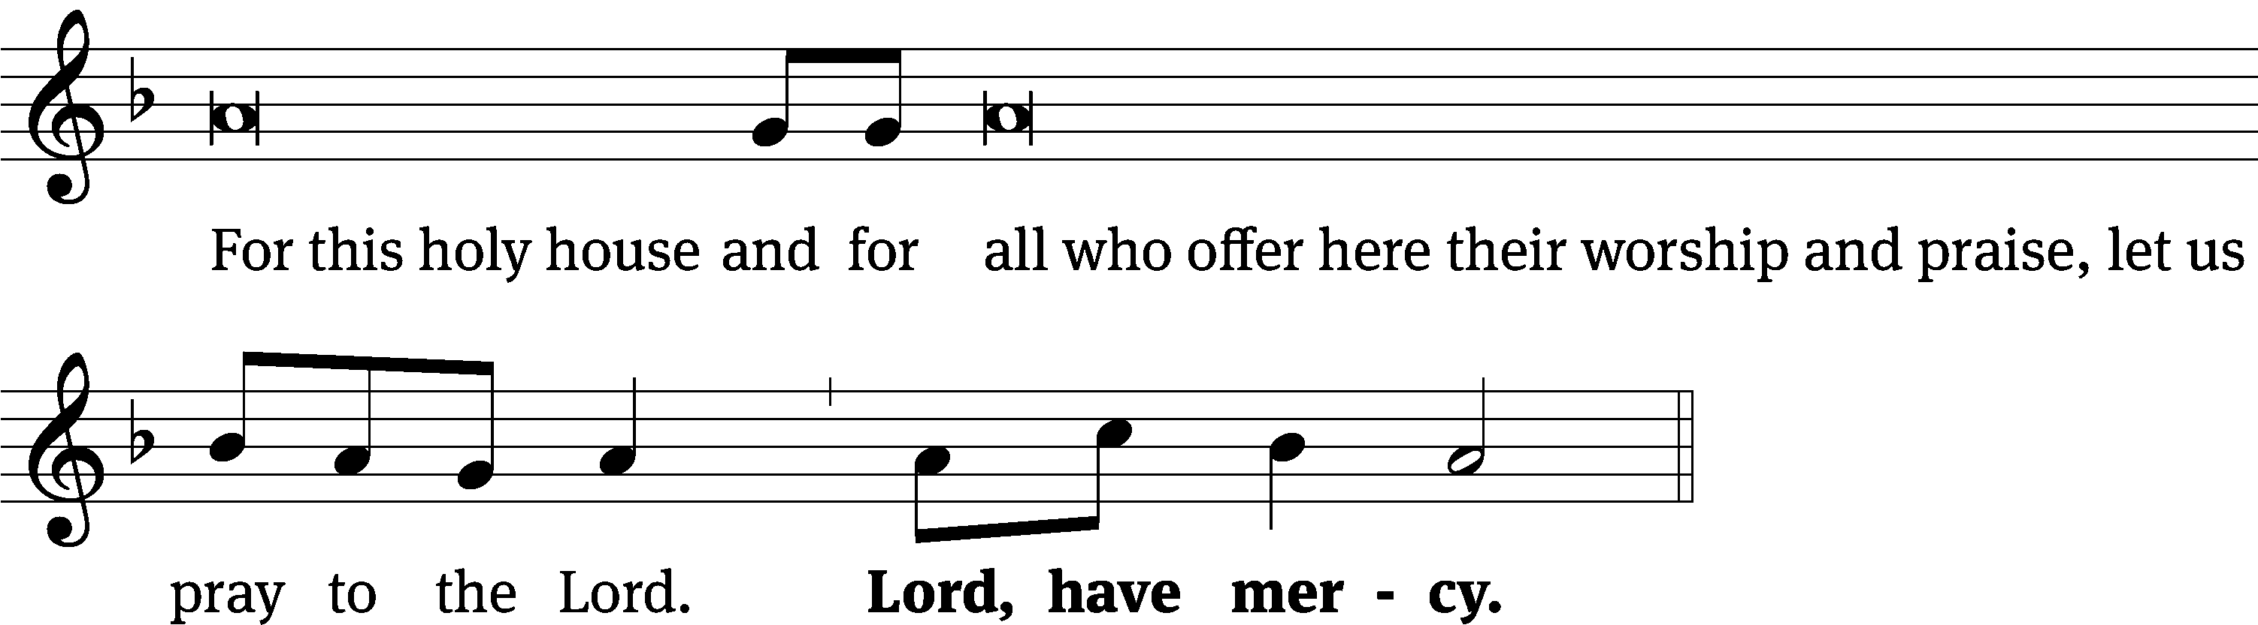
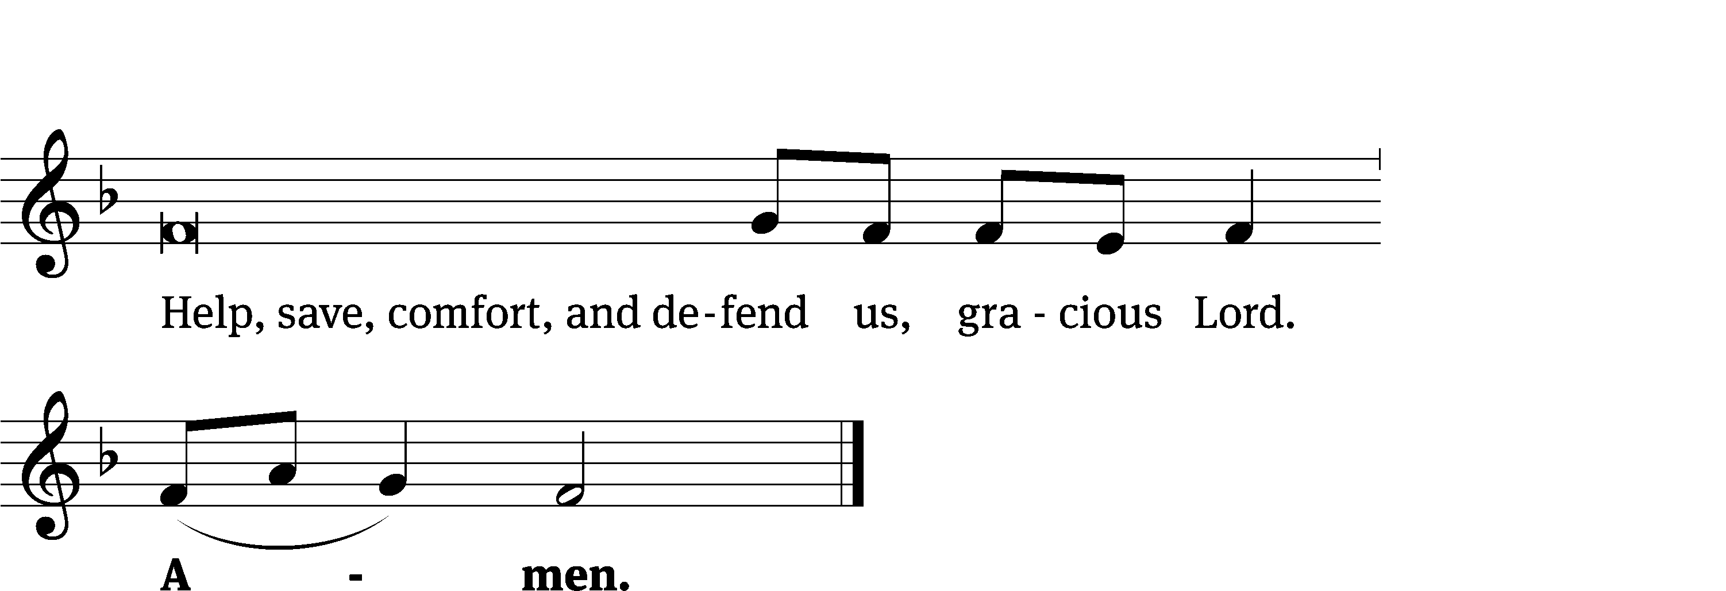

Glory Be to God CW 157
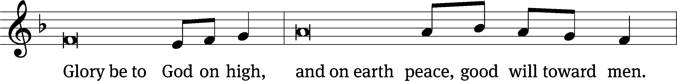
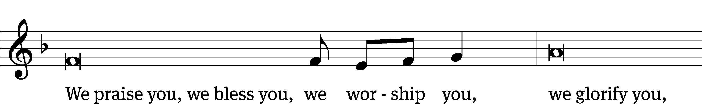
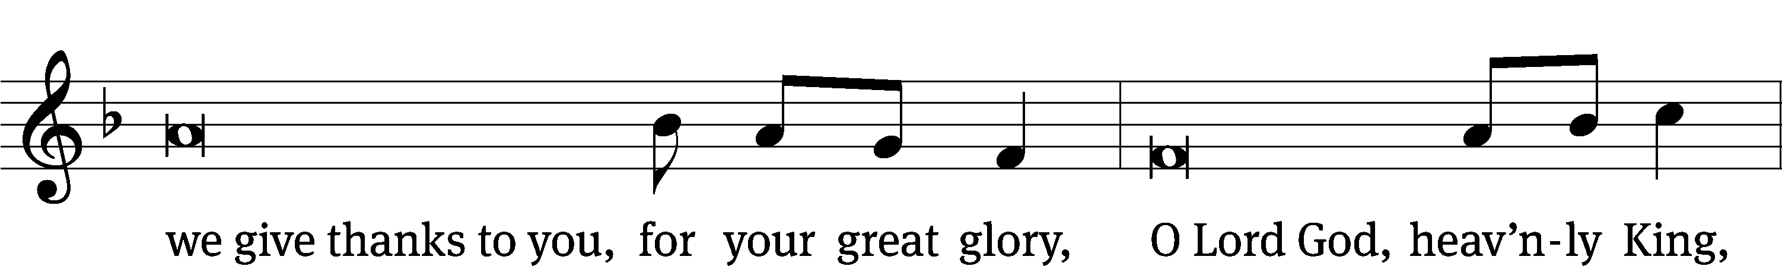
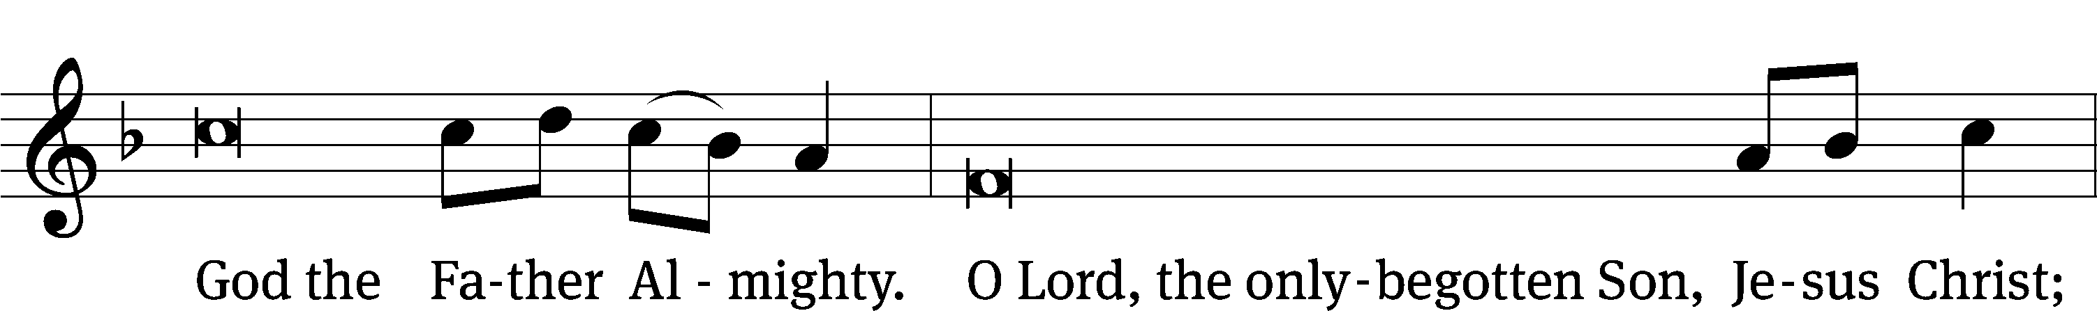
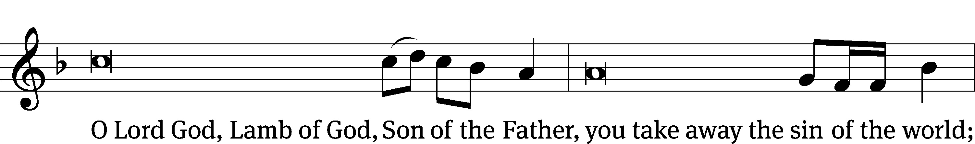
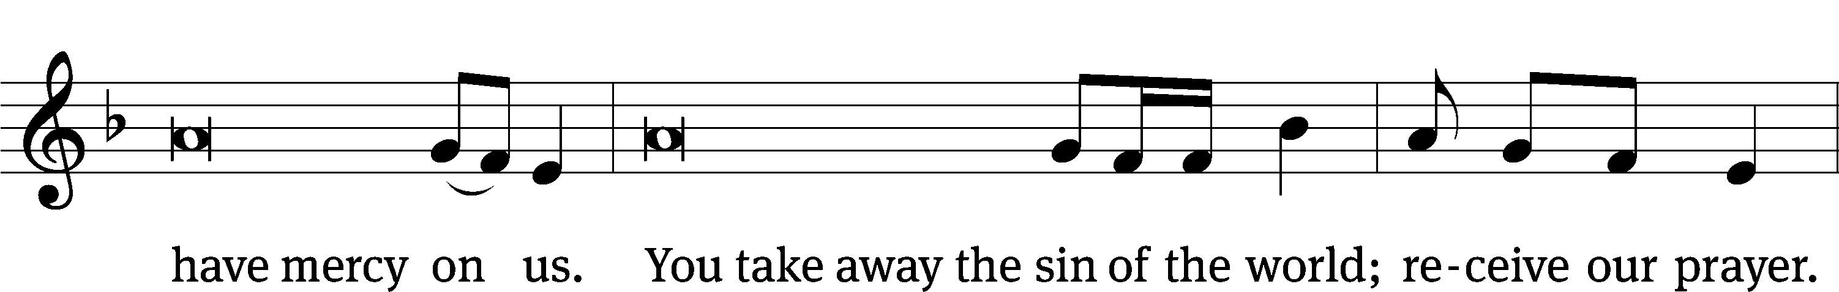
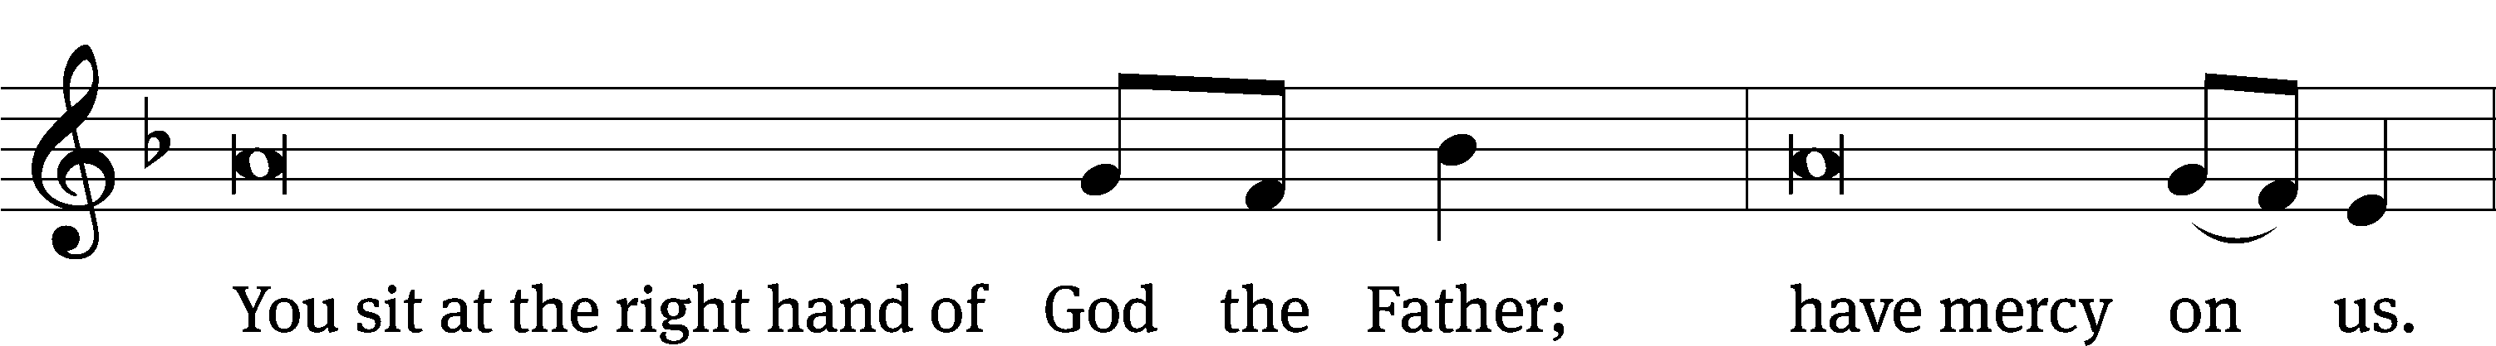
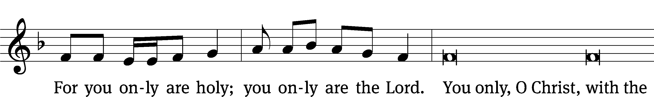
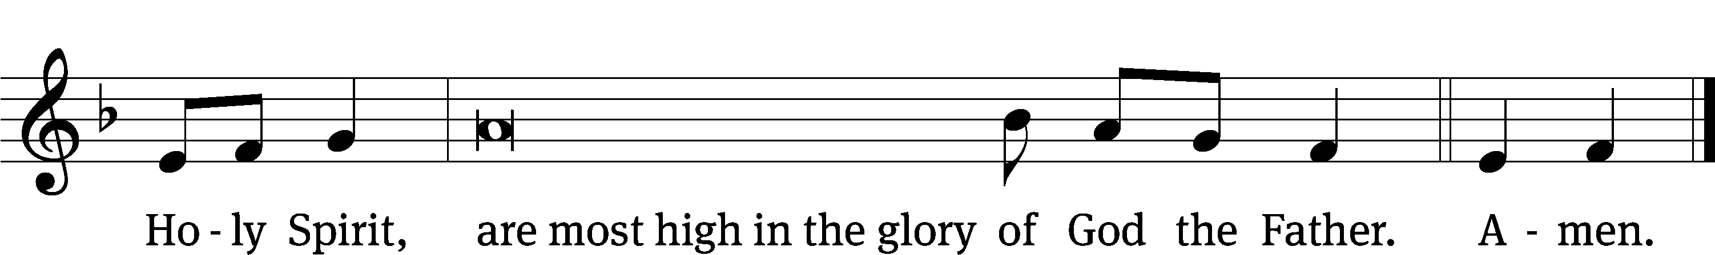

Tune: © 2021 Northwestern Publishing House. Used by permission: OneLicense no. 727703

The Lord be with you.
And also with you.
Prayer of the Day
Let us pray.

O God, you are the giver of everything good. Inspire us, your humble servants, to long for what is right and, through your gracious guidance, accomplish it to your glory; through your Son, Jesus Christ our Lord, who lives and reigns with you and the Holy Spirit, one God, now and forever.
Amen.

Please be seated

First Reading Acts 14:8-22
⁸ In Lystra there was a man who was sitting down because he had no strength in his feet. He had never walked because he was lame from birth. ⁹ When he was listening to Paul as he was speaking, Paul looked at him closely and saw that he had faith to be healed. ¹⁰ Paul said in a loud voice, “Stand up on your feet!” And the man jumped up and began to walk.
¹¹ When the crowds saw what Paul had done, they raised their voices, saying in the Lycaonian language, “The gods have come down to us in human form.” ¹² Barnabas they called Zeus, and Paul they called Hermes, because he was the main speaker. ¹³ The priest of Zeus, whose temple was just outside the city, brought bulls and garlands to the city gates, because he wanted to offer sacrifices along with the crowds.
¹⁴ But when the apostles Paul and Barnabas heard about this, they tore their clothes and rushed into the crowd, shouting, ¹⁵ “Men, why are you doing these things? We too are men with the same nature as you. We are preaching the good news to you so that you turn from these worthless things to the living God, who made the heaven, the earth, the sea, and everything in them. ¹⁶ In past generations he allowed all the nations to go their own ways. ¹⁷ Yet he did not leave himself without testimony of the good he does. He gives you rain from heaven and crops in their seasons. He fills you with food and fills your hearts with gladness.” ¹⁸ Even though they said these things, they had a hard time stopping the crowds from sacrificing to them.
¹⁹ Then some Jews came from Antioch and Iconium and persuaded the crowds to stone Paul. When they thought he was dead, they dragged him out of the city. ²⁰ But after the disciples had gathered around him, he stood up and went into the city. The next day, he left with Barnabas for Derbe.
²¹ After they preached the good news in that city and had gathered many disciples, they returned to Lystra, Iconium, and Antioch, ²² strengthening the souls of the disciples and encouraging them to continue in the faith. They told them, “We must go through many troubles on our way to the kingdom of God.”
The Word of the Lord.
Thanks be to God.

Psalm of the Day
65B Every Heart Its Tribute Pays Psalm 65B
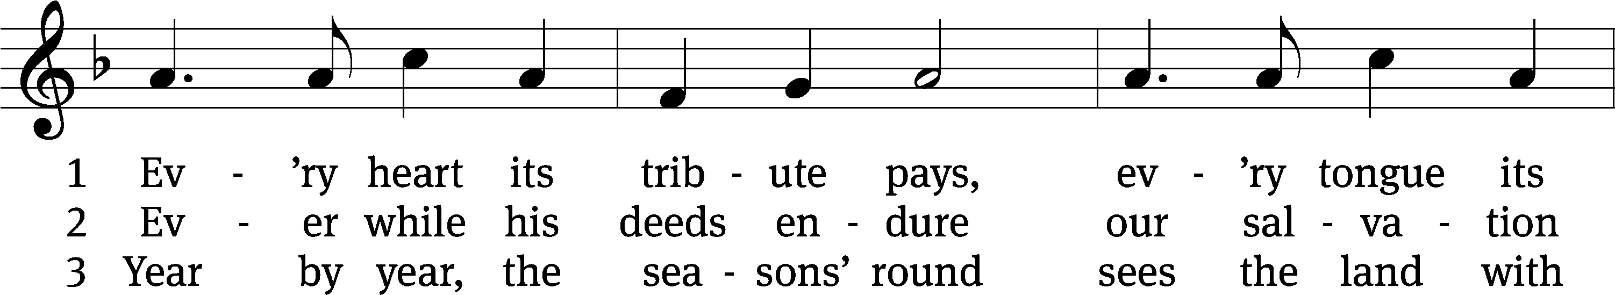
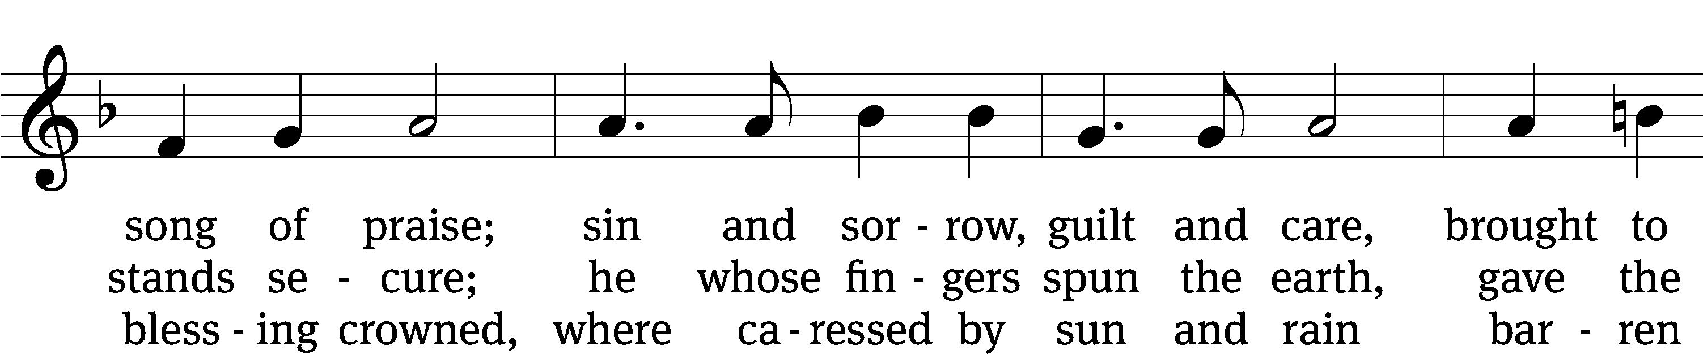
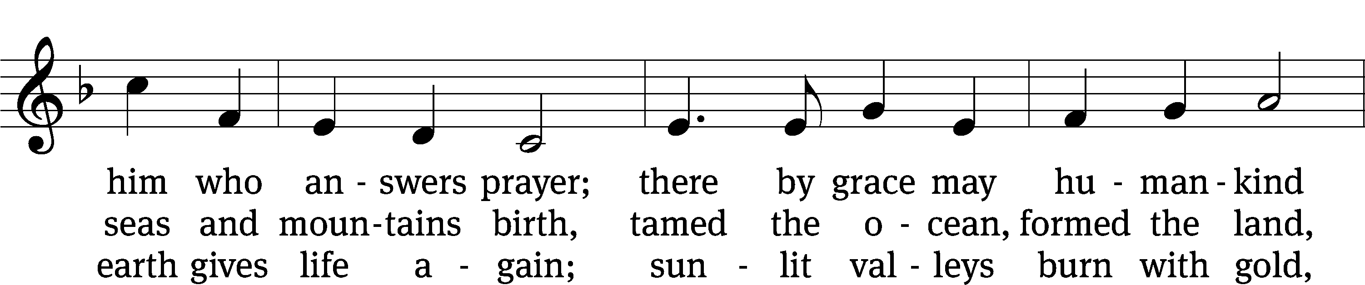
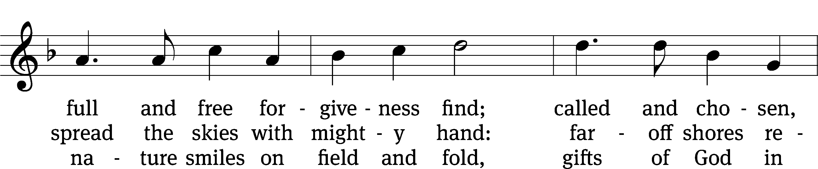
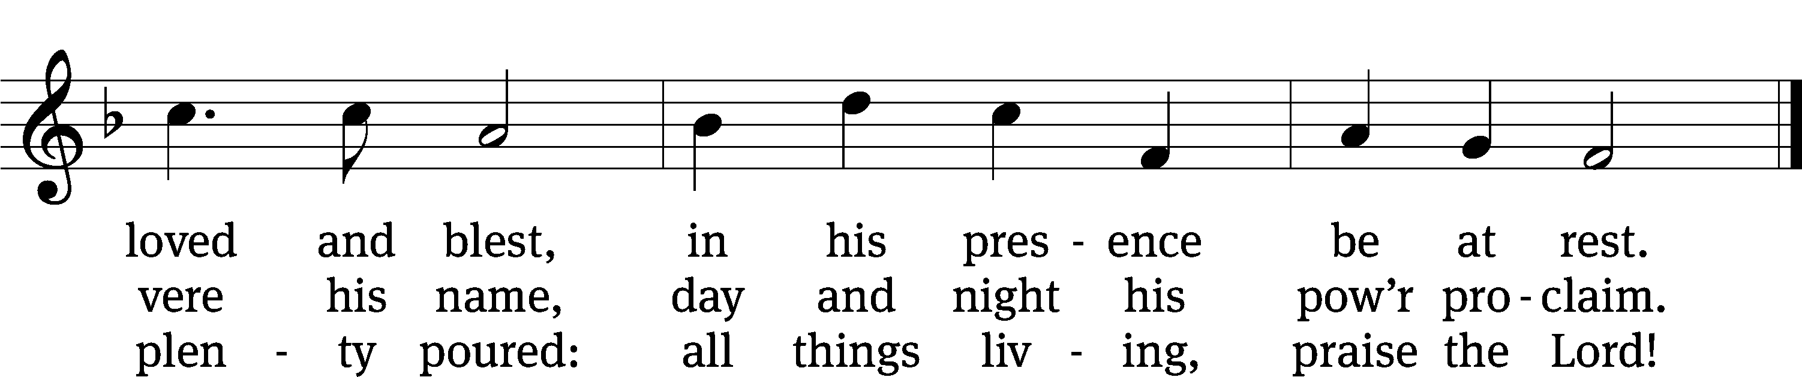

Text: © 1984 Hope Publishing Co. Used by permission: OneLicense no. 727703
Tune: Public domain
Text: Timothy Dudley-Smith
Tune: George J. Elvey

Second Reading Revelation 21:21-27
²¹ The twelve gates are twelve pearls. Each of the gates is made out of one pearl. And the street of the city is pure gold, like transparent glass.
²² I did not see a temple in the city, because the Lord God Almighty and the Lamb are its temple. ²³ The city does not need the sun or the moon to shine on it, because the glory of God has given it light, and the Lamb is its lamp. ²⁴ The nations^{[a]} will walk by its light, and the kings of the earth will bring their glory^{[b]} into it. ²⁵ There is no day when its gates will be shut, for there will be no night in that place. ²⁶ They will bring the glory and the honor of the nations into it. ²⁷ Nothing that is unclean and no one who does what is detestable or who tells lies will ever enter it, but only those who are written in the Lamb’s Book of Life.

The Word of the Lord.
Thanks be to God.

Please stand, if you are able
Gospel Acclamation Psalm 30:5
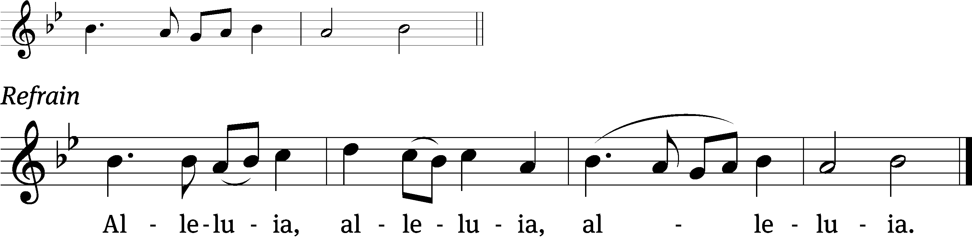
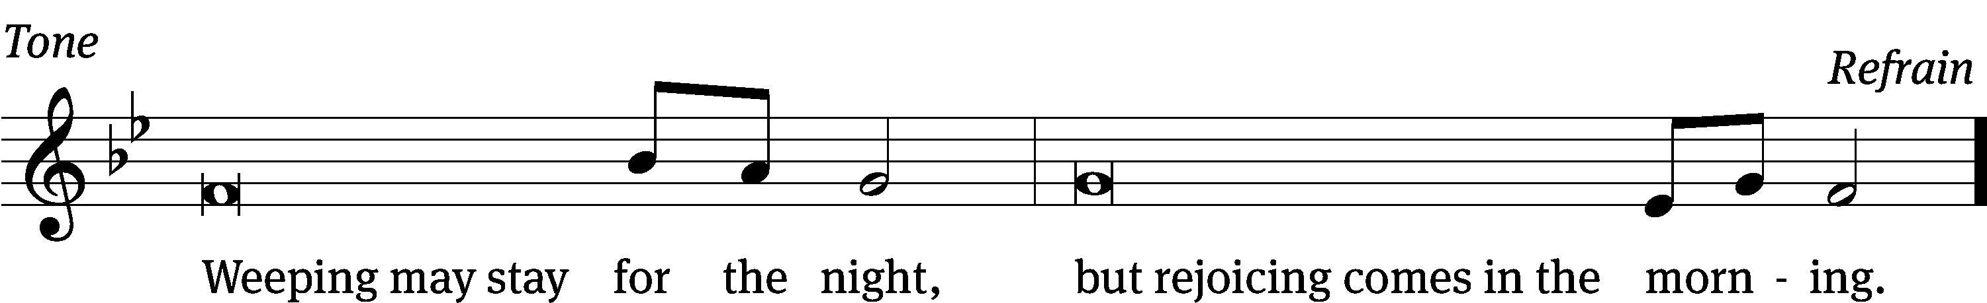
Tune: © 2021 Northwestern Publishing House. Used by permission: OneLicense no. 727703

Gospel John 16:16-24
¹⁶ “In a little while you are not going to see me anymore, and again in a little while you will see me, because I am going away to the Father.”^{[a]}
¹⁷ Therefore some of his disciples asked one another, “What does he mean when he tells us, ‘In a little while you are not going to see me, and again in a little while you will see me,’ and ‘Because I am going away to the Father’?” ¹⁸ So they kept asking, “What does he mean by ‘a little while’? We don’t understand what he’s saying.”
¹⁹ Jesus knew that they wanted to ask him about this, so he said to them, “Are you trying to determine with one another what I meant by saying, ‘In a little while you are not going to see me, and again in a little while you will see me’? ²⁰ Amen, Amen, I tell you: You will weep and wail, but the world will rejoice. You will become sorrowful, but your sorrow will turn to joy. ²¹ A woman giving birth has pain, because her time has come. But when she has delivered the child, she no longer remembers the anguish, because of her joy that a person has been born into the world.
²² “So you also have sorrow now. But I will see you again. Your heart will rejoice, and no one will take your joy away from you. ²³ In that day you will not ask me anything. Amen, Amen, I tell you: Whatever you ask the Father in my name, he will give you. ²⁴ Until now you have not asked for anything in my name. Ask, and you will receive, so that your joy may be made complete.

The Gospel of the Lord.
Praise be to you, O Christ!

Please be seated

Sermon Hymn
713 I Want to Walk as a Child of the Light CW 713
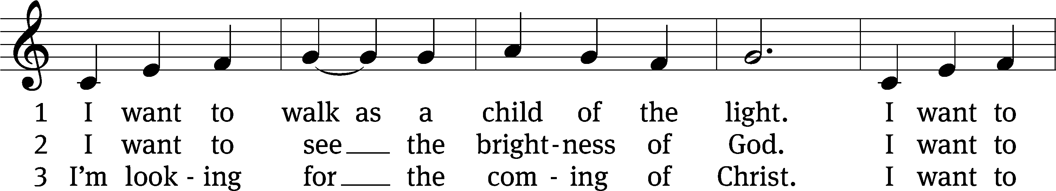
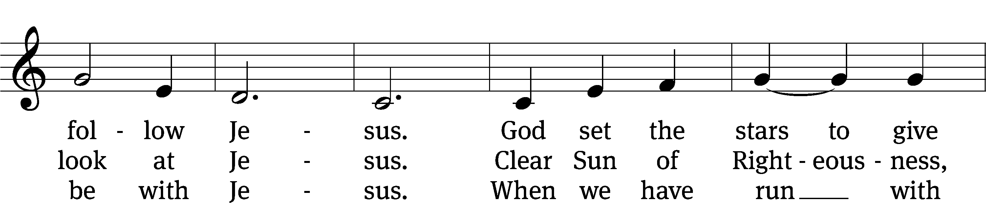
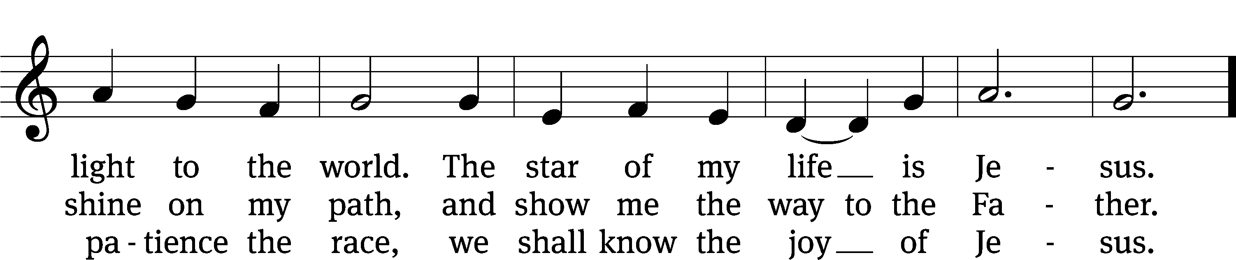
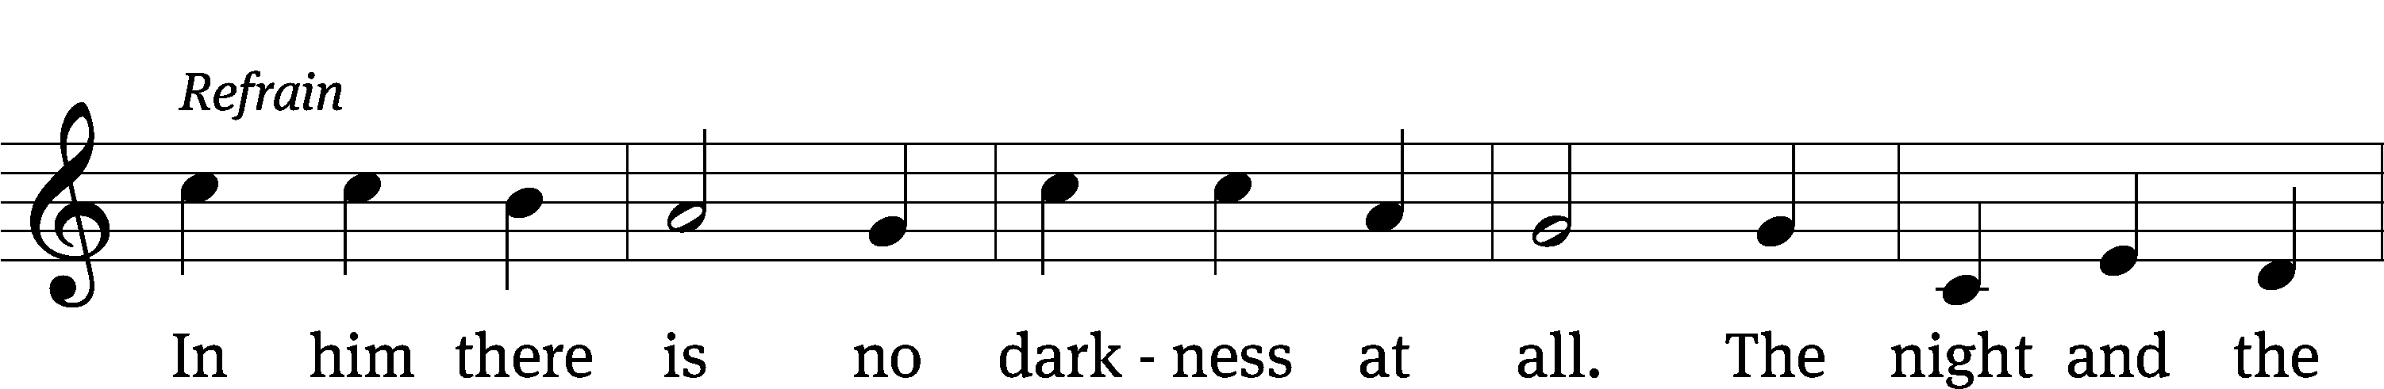
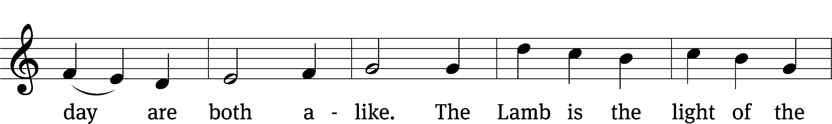
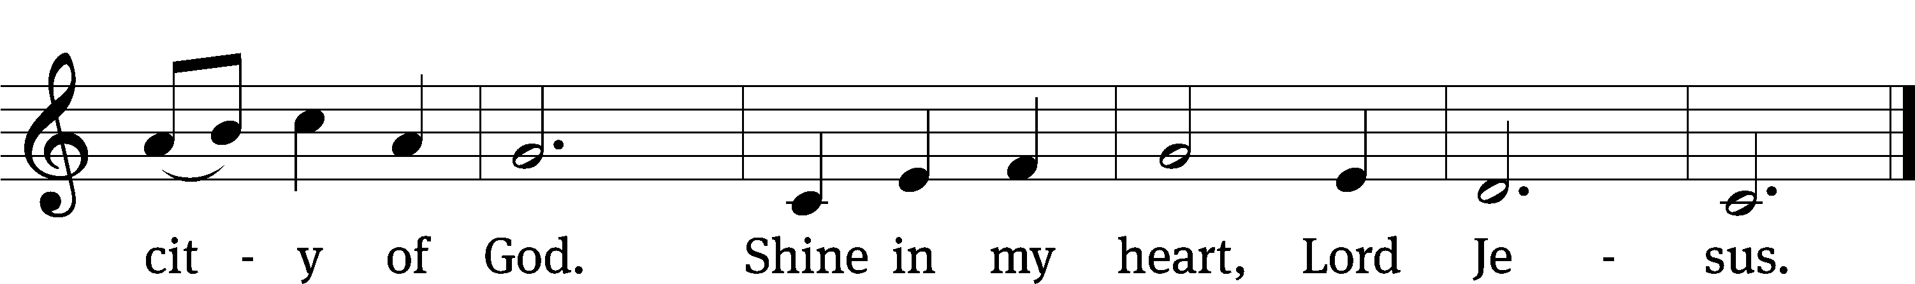
Text and tune: © 1970, 1975 Celebration. Used by permission: OneLicense no. 727703
Text: Kathleen Thomerson, b. 1934

Sermon Acts 14:19-22
“Paul’s First Missionary Journey Would Not Be His Last”

Please stand, if you are able
Apostles’ Creed
I believe in God, the Father Almighty,
maker of heaven and earth.

I believe in Jesus Christ, his only Son, our Lord,
who was conceived by the Holy Spirit,
born of the Virgin Mary,
suffered under Pontius Pilate,
was crucified, died, and was buried.
He descended into hell.
The third day he rose again from the dead.
He ascended into heaven
and is seated at the right hand of God the Father Almighty.
From there he will come to judge the living and the dead.

I believe in the Holy Spirit,
the holy Christian Church,
the communion of saints,
the forgiveness of sins,
the resurrection of the body,
and the life everlasting. Amen.

Prayer of the Church

880 For All the Saints CW 880 sts. 1–3, 5–6
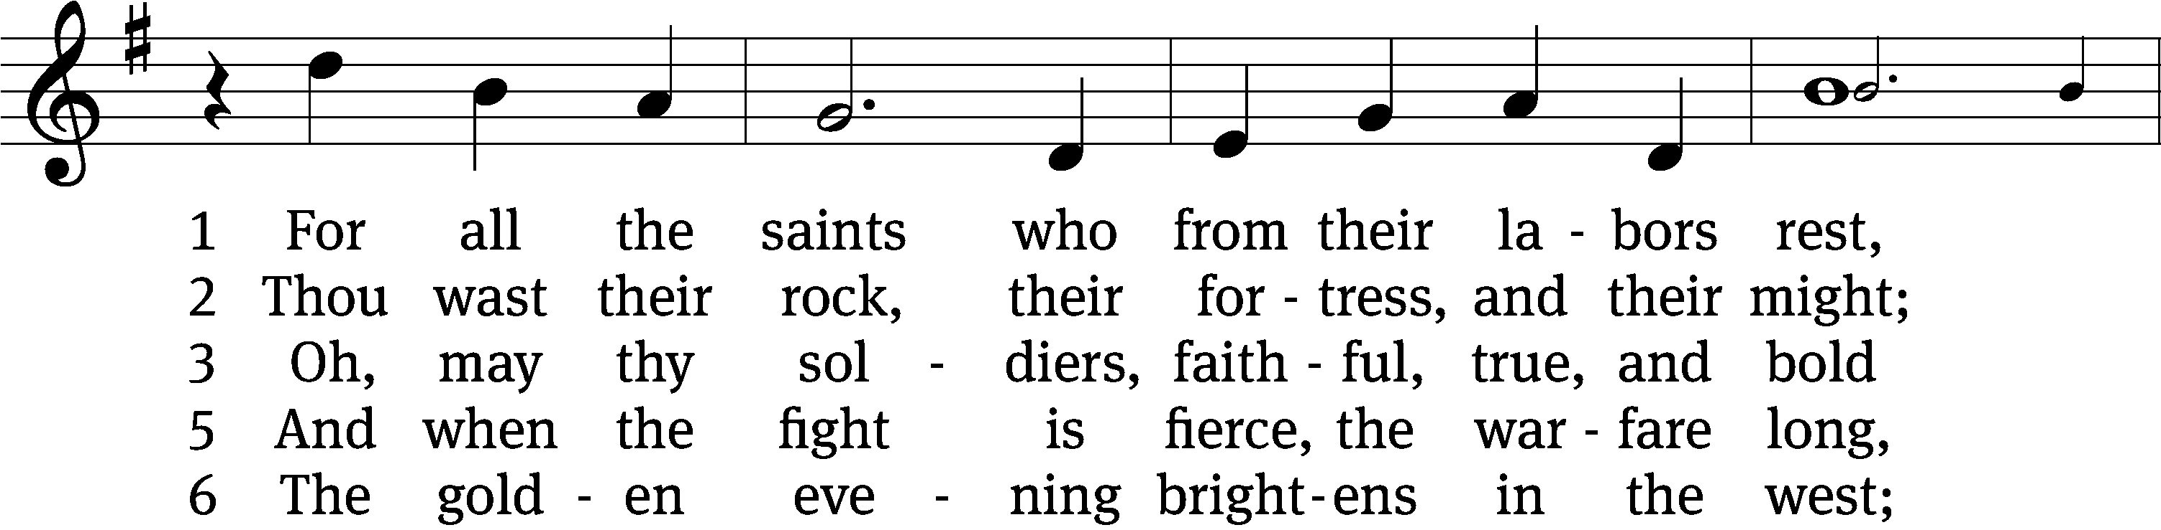
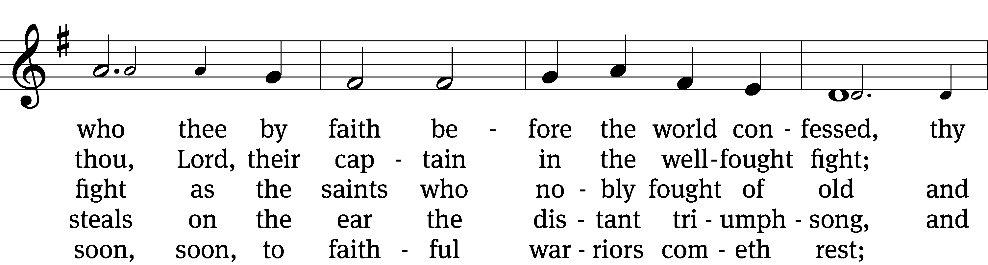
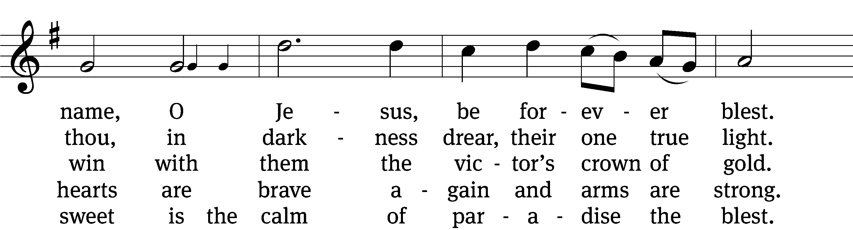
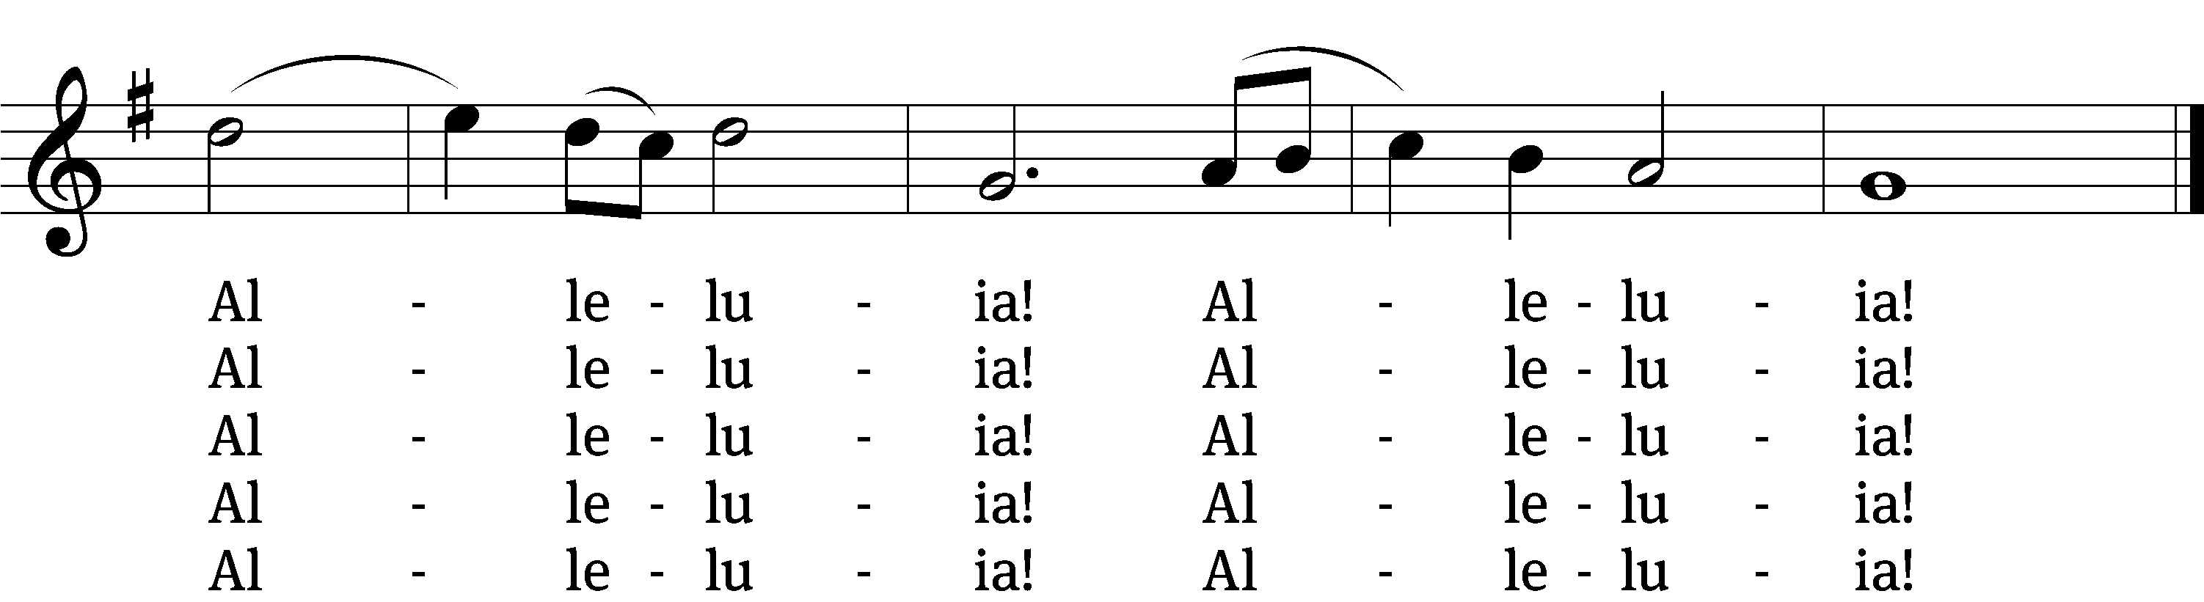
Text and tune: Public domain
Text: William W. How, 1823–1897, alt.
Tune: Ralph Vaughan Williams, 1872–1958

Prayer
Blessed Lord, you have given us your Holy Scriptures for our learning. May we so hear them, read, learn, and take them to heart that, being strengthened and comforted by your holy Word, we may cling to the blessed hope of everlasting life; through Jesus Christ our Lord, who lives and reigns with you and the Holy Spirit, one God, now and forever.
Amen.
Lord’s Prayer
Our Father, who art in heaven, hallowed be thy name, thy kingdom come, thy will be done on earth as it is in heaven. Give us this day our daily bread; and forgive us our trespasses, as we forgive those who trespass against us; and lead us not into temptation, but deliver us from evil. For thine is the kingdom and the power and the glory forever and ever. Amen.

Blessing
The Lord bless you and keep you.
The Lord make his face shine on you and be gracious to you.
The Lord look on you with favor and give you peace.
Amen.

Please be seated

885 There Is a Higher Throne CW 885
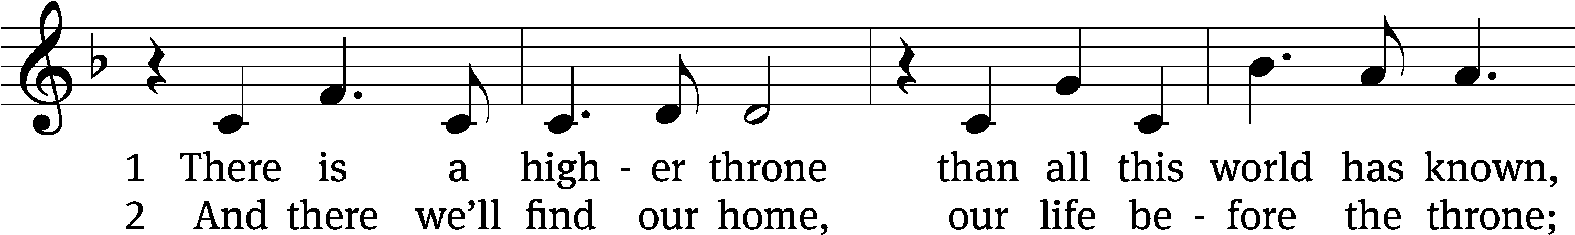
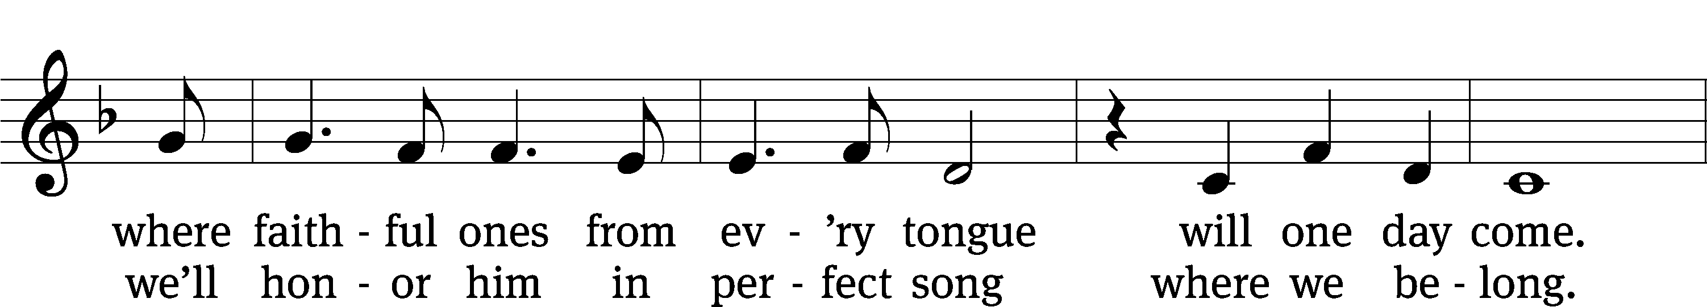
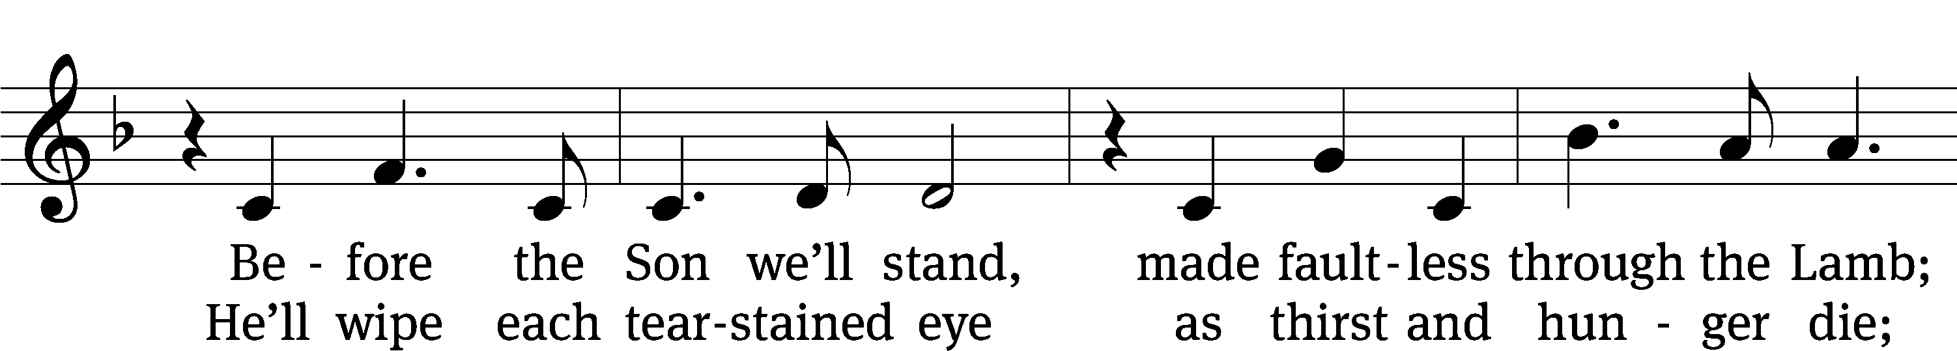
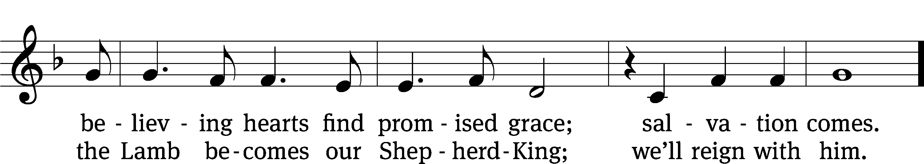
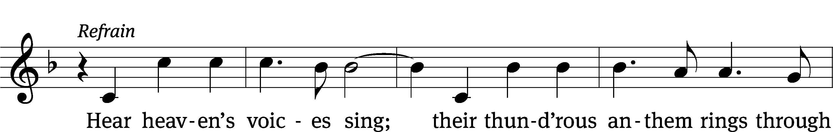
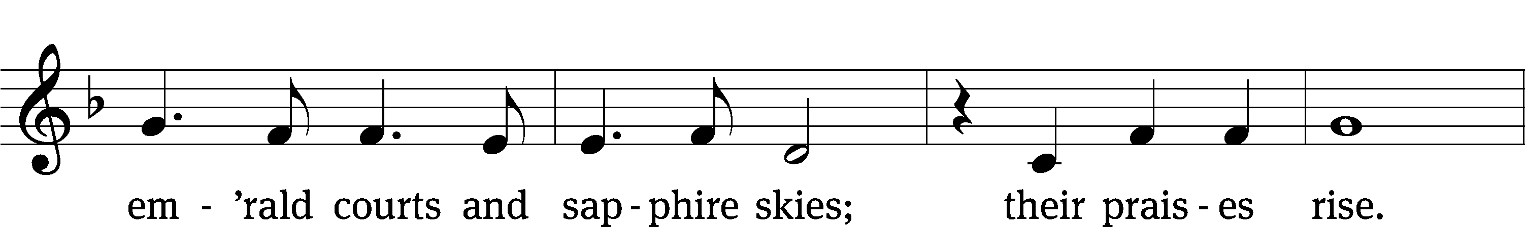
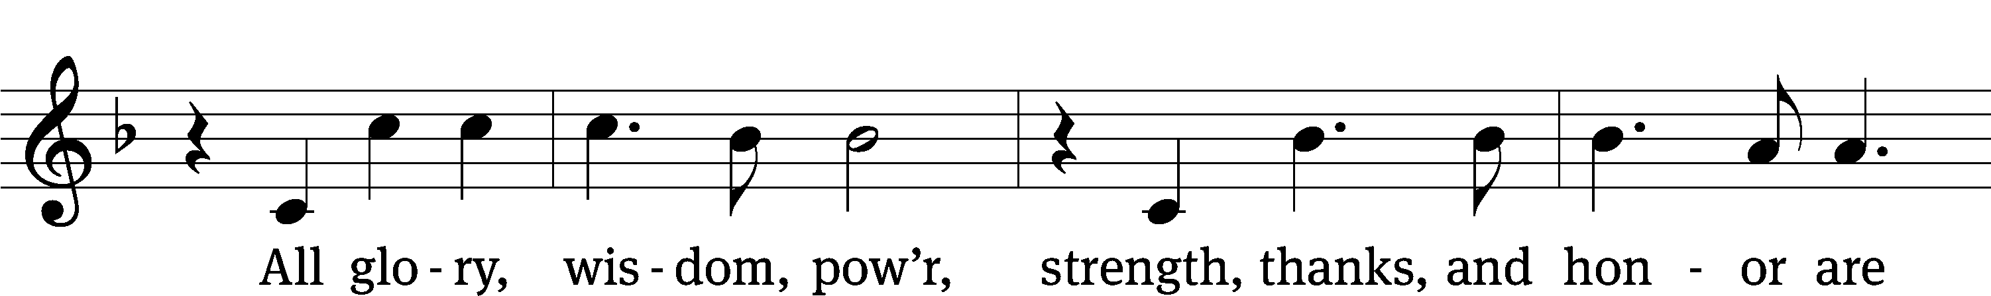
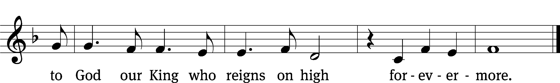
Text and tune: © 2003 Thankyou Music, admin. Capitol CMG Publishing. Used by permission: OneLicense no. 727703
Text: Kristyn Getty, b. 1980; Keith Getty, b. 1974
Tune: Kristyn Getty, b. 1980; Keith Getty, b. 1974

Acknowledgments
Setting One from Christian Worship
Software distributed in partnership with Northwestern Publishing House.
Created by Christian Worship: Service Builder © 2022 Concordia Publishing House.

Serving in Worship
Officiant Pastor Natsis
Organist and Accompanist Marcia Marion Ackling
Director Cynthia Natsis
Deacons (8:30) Dave Stevenson and Ed Wheeler
(11:00) Dave Frey and Steve Hoeft
Ushers (8:30) Dale Radak
(11:00) Ron Zahn
Altar Guild Sandy Kirkpatrick and Barb Neuburger
Videographer Rick Schneider

