The day of pentecost

TRINITY EVANGELICAL LUTHERAN CHURCH | Saline, Michigan
WELCOME TO WORSHIP May 25/28, 2023
Thank you for joining us in God’s house today! We cordially ask that our Guests sign one of the guestbooks located at either the front or back entryways, or fill out a “Let’s Get Acquainted” card located in the hymnal pew rack and place it in the collection plate.

THANK OFFERING: Members of Trinity give their offering as an expression of love and thankfulness to the Lord and to help support the Lord’s work in our community and around the world. Visitors need not feel obligated to participate in this offering which supports our ministry.

Restrooms are located at the back of the upper level (the annex), and in the basement (down the back stairs of the sanctuary or annex). Handicap access is available, please ask an usher for assistance.

Young Families / Toddler Bags – We are GLAD YOU BROUGHT YOUR CHILDREN to our worship service. Jesus said: “Let the little children come to me and do not hinder them, for the kingdom of God belongs to such as these.” We know that having little children in church can be a challenge, but DO NOT WORRY about it. Many of your fellow worshippers have been in your shoes and are just happy you brought your children with you. For your convenience, we have reserved the back rows of seating for parents with small children. These areas provide more flexibility for your family, as well as, easy access to move downstairs if necessary. A closed-circuit TV system allows families to continue participating in the service while downstairs. Pre-school toddler bags and children’s bulletins are available for their enjoyment. Ask an usher for one to use during the service and please return the toddler bag afterwards.

the SERVICE – setting one - WITHOUT HOLY COMMUNION CW, page 154

477 O Day Full of Grace CW 477
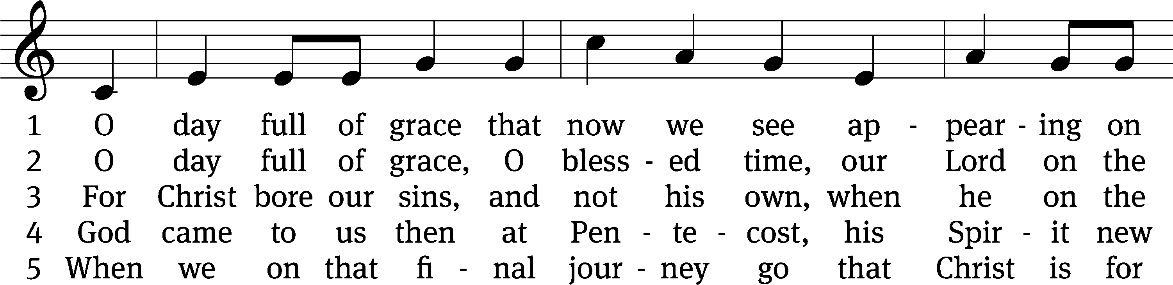
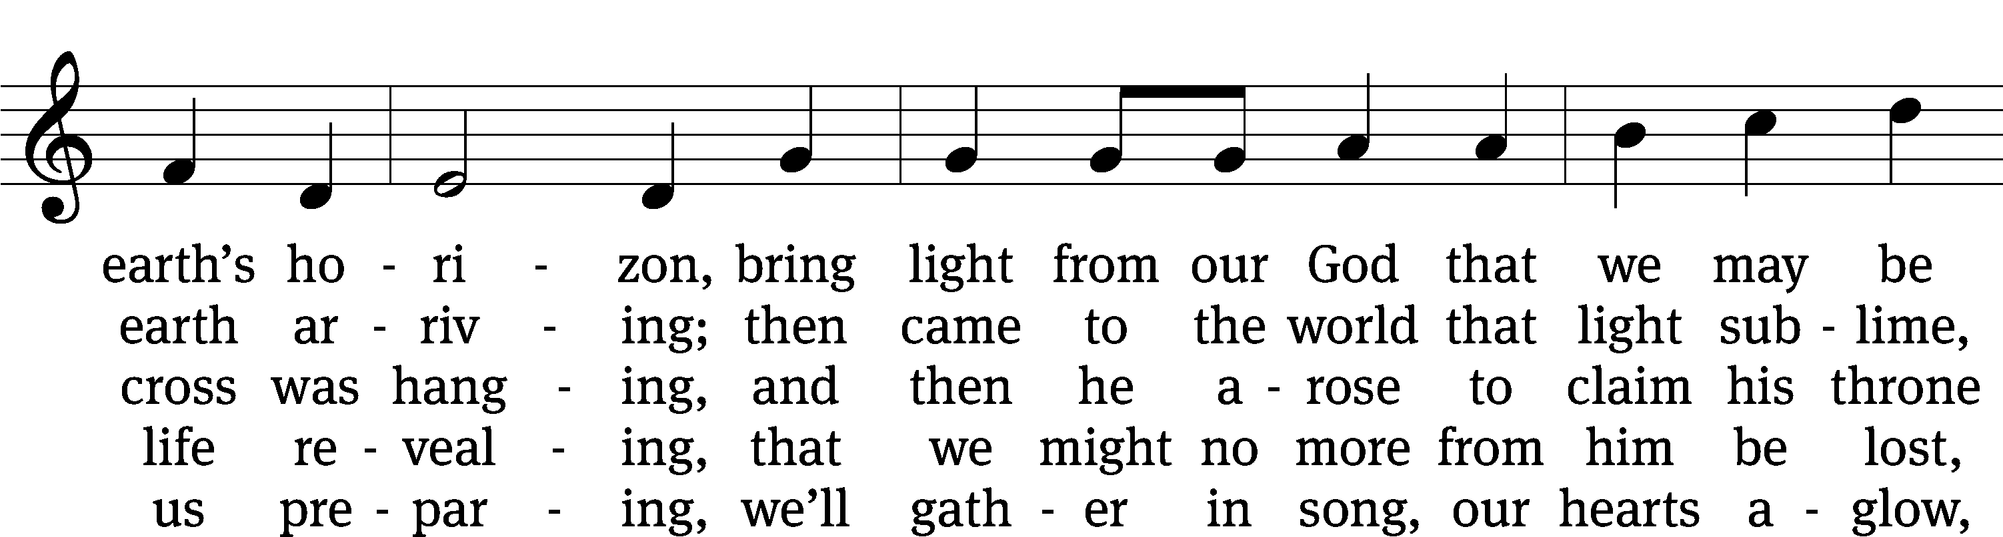
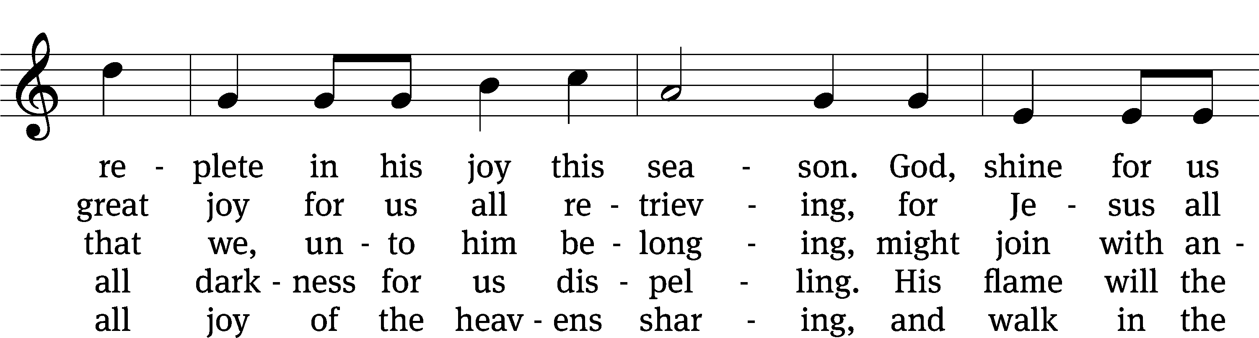
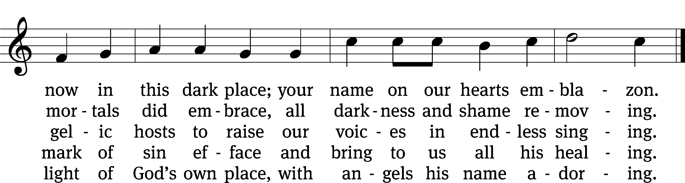
Text: tr. Gerald Thorson, 1921–2001; Scandinavian, c. 1450
Tune: Christoph E. F. Weyse, 1774–1842
Text: © 1978 Lutheran Book of Worship, admin. Augsburg Fortress. Used by permission: OneLicense no. 727703
Tune: Public domain

Please stand, if you are able
Invocation
In the name of the Father and of the Son and of the Holy Spirit.
Amen.
Confession
If we claim to be without sin, we deceive ourselves and the truth is not in us.
If we confess our sins, God is faithful and just
and will forgive us our sins
and purify us from all unrighteousness.

Let us confess our sins to the Lord.
Holy God, gracious Father,
I am sinful by nature
and have sinned against you in my thoughts, words, and actions.
I have not loved you with my whole heart;
I have not loved others as I should.
I deserve your punishment both now and forever.
But Jesus, my Savior, paid for my sins
with his innocent suffering and death.
Trusting in him, I pray: God, have mercy on me, a sinner.

Our gracious Father in heaven has been merciful to us. He sent his only Son, Jesus Christ, who gave his life as the atoning sacrifice for the sins of the whole world. Therefore, as a called servant of Christ and by his authority, I forgive you all your sins in the name of the Father and of the Son and of the Holy Spirit.
Amen.

Lord, Have Mercy
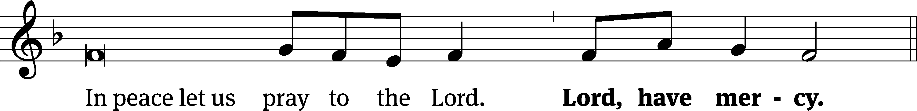
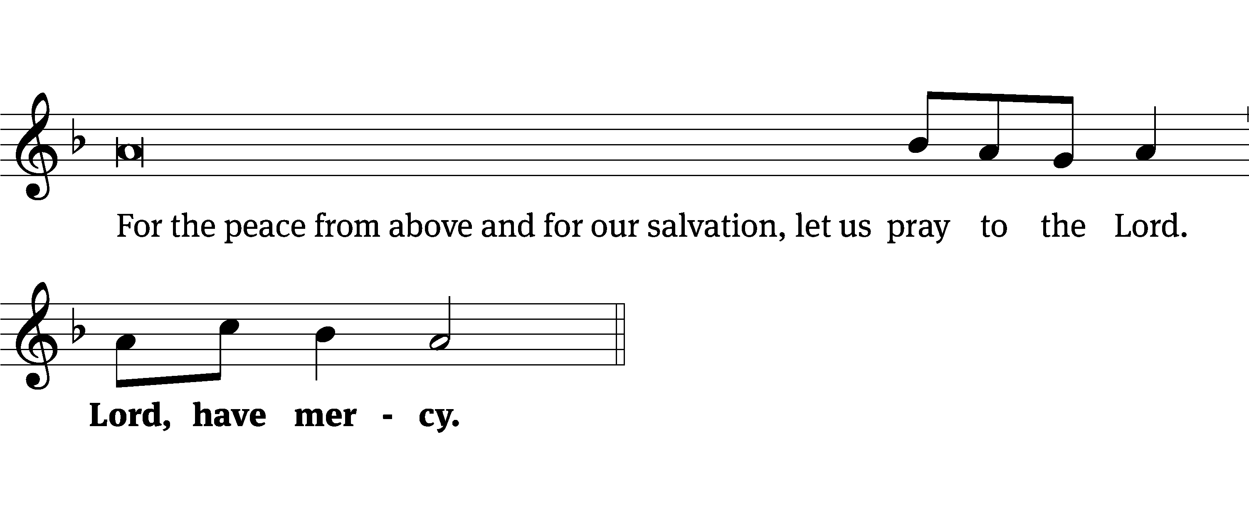
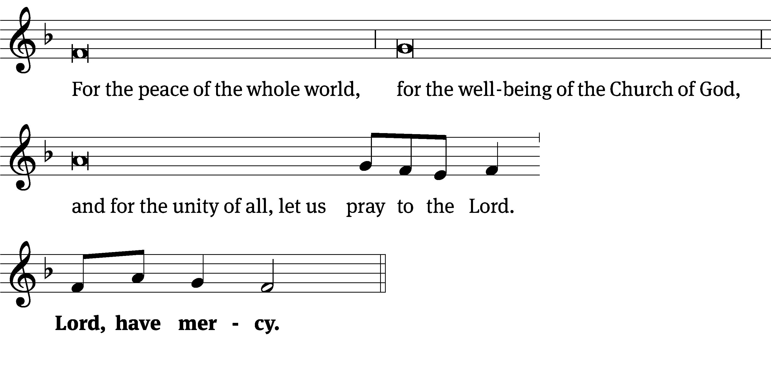
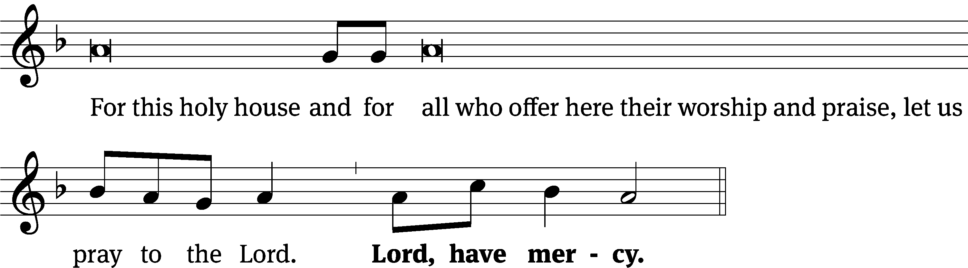
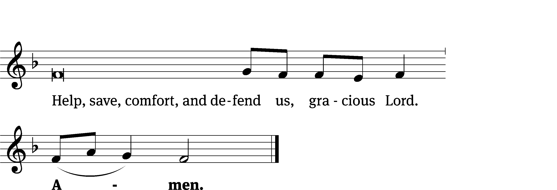
Tune: Kevin Becker
Tune: © 2021 Northwestern Publishing House. Used by permission: OneLicense no. 727703

Glory Be to God CW 157
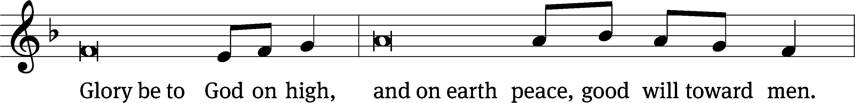
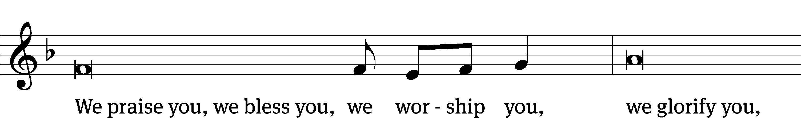
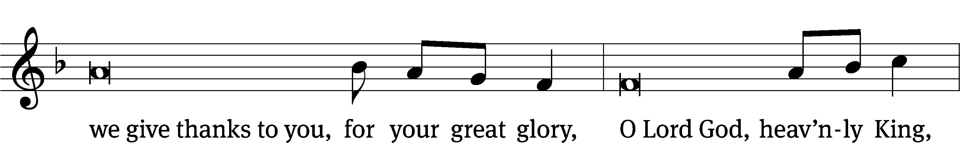
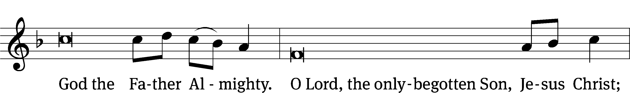
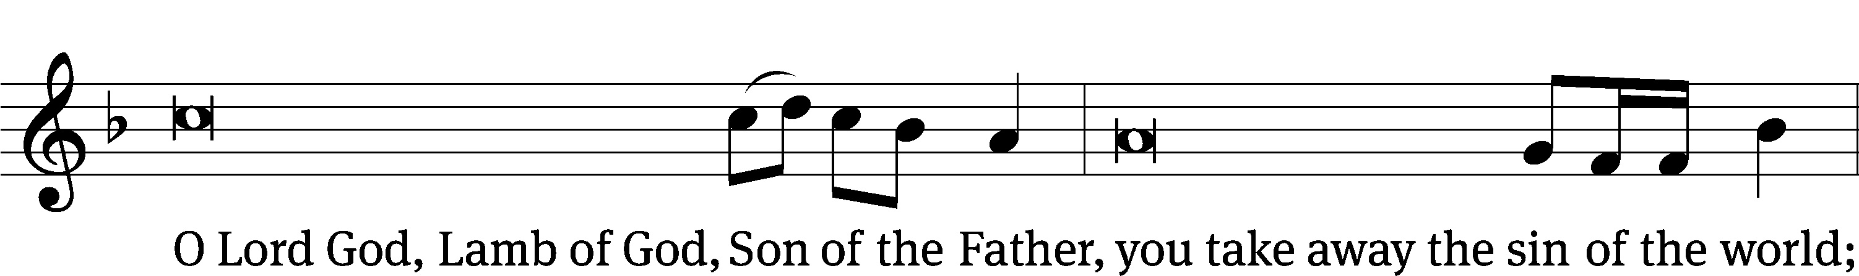
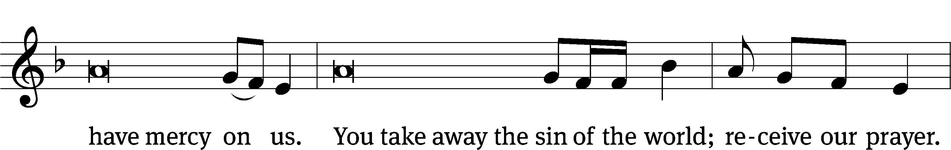
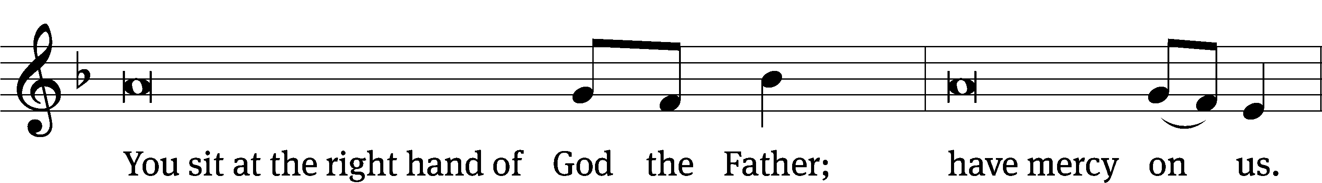
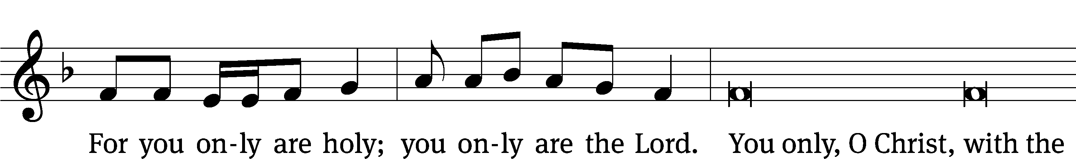
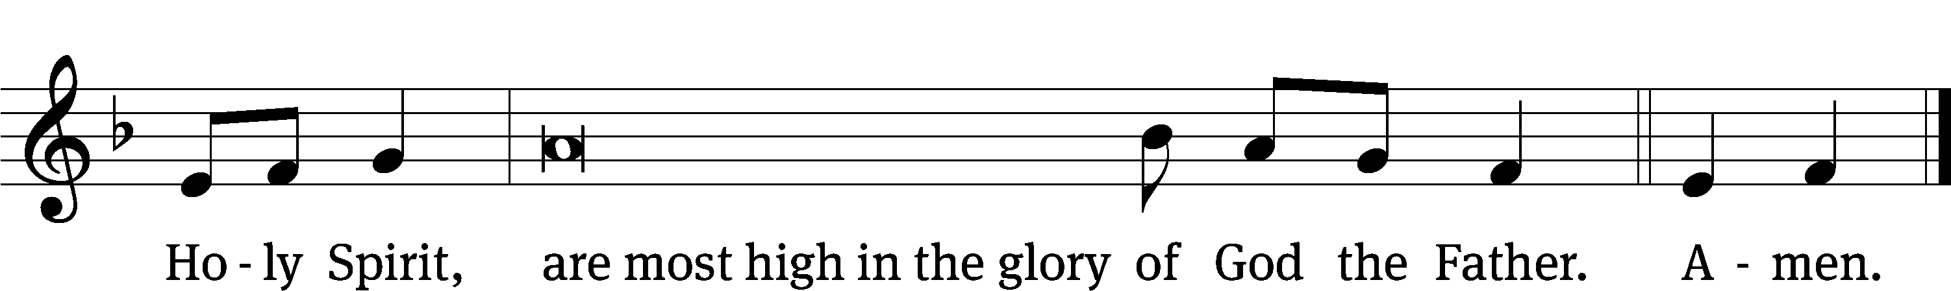

Tune: © 2021 Northwestern Publishing House. Used by permission: OneLicense no. 727703

The Lord be with you.
And also with you.
Prayer of the Day
Let us pray.
Holy Spirit, God and Lord, come to us this joyful day with your sevenfold gift of grace. Rekindle in our hearts the holy fire of your love that in a true and living faith we may tell abroad the glory of our Savior, Jesus Christ, who lives and reigns with you and the Father, one God, now and forever.
Amen.

Please be seated

First Reading Acts 2:1-21
¹ When the day of Pentecost came, they were all together in one place. ² Suddenly a sound like the rushing of a violent wind came from heaven, and it filled the whole house where they were sitting. ³ They saw divided tongues that were like fire resting on each one of them. ⁴ They were all filled with the Holy Spirit and began to speak in other languages, since the Spirit was giving them the ability to speak fluently.
⁵ Now there were godly Jewish men from every nation under heaven living in Jerusalem. ⁶ When this sound was heard, a crowd came together and was confused, because each one heard them speaking in his own language. ⁷ They were completely baffled and said to each other, “Look, are not all these men who are speaking Galileans? ⁸ Then how is it that each of us hears them speaking in his own native language? ⁹ Parthians, Medes, and Elamites; residents of Mesopotamia, and of Judea, Cappadocia, Pontus and Asia, ¹⁰ Phrygia and Pamphylia, Egypt, and the parts of Libya around Cyrene; visitors from Rome, both Jews and proselytes; ¹¹ Cretans and Arabs—we hear them declaring in our own languages the wonderful works of God.” ¹² They were all amazed and perplexed. They kept saying to one another, “What does this mean?” ¹³ But others mocked them and said, “They are full of new wine.”
¹⁴ Then Peter stood up with the Eleven, raised his voice, and spoke loudly and clearly to them: “Men of Judea, and all you residents of Jerusalem, understand this, and listen closely to my words. ¹⁵ These men are not drunk, as you suppose, for it is only the third hour of the day. ¹⁶ On the contrary, this is what was spoken by the prophet Joel:
¹⁷ This is what God says will happen in the last days:
I will pour out my Spirit on all flesh.
Your sons and your daughters will prophesy.
Your young men will see visions.
Your old men will dream dreams.
¹⁸ Even on my servants, both men and women,
I will pour out my Spirit in those days,
and they will prophesy.
¹⁹ I will show wonders in the sky above,
and signs on the earth below,
blood and fire and a rising cloud of smoke.
²⁰ The sun will be turned to darkness
and the moon to blood
before the coming of the great and glorious day of the Lord.
²¹ And this will happen: Everyone who calls on the name of the Lord
will be saved.

The Word of the Lord.
Thanks be to God.

Psalm 51

O Lord, open my lips,*
and my mouth will declare your praise.
You do not delight in sacrifice, or I would bring it;*
you do not take pleasure in burnt offerings.
The sacrifices of God are a broken spirit;*
a broken and contrite heart, O God, you will not despise.
Refrain
Create in me a pure heart, O God,*
and renew a steadfast spirit within me.
Do not cast me from your presence*
or take your Holy Spirit from me.
Restore to me the joy of your salvation,*
and grant me a willing spirit, to sustain me.
Then I will teach transgressors your ways,*
and sinners will turn back to you.
Glory be to the Father and to the Son*
and to the Holy Spirit,
as it was in the beginning,*
is now, and will be forever. Amen.
Refrain

Refrain Tune: Kermit G. Moldenhauer. © 1993 Kermit G. Moldenhauer (admin. Northwestern Publishing House). All rights reserved. Used by permission.

Second Reading 1 Corinthians 12:3-11
³ Therefore I am informing you that no one speaking by God’s Spirit says, “A curse be upon Jesus,” and no one can say, “Jesus is Lord,” except by the Holy Spirit.
⁴ There are various kinds of gifts, but the same Spirit. ⁵ There are different kinds of ministries, and yet the same Lord. ⁶ There are various kinds of activity, but the same God, who produces all of them in everyone.
⁷ Each person is given a manifestation of the Spirit for the common good. ⁸ To one person a message of wisdom is given by the Spirit; to another, a message of knowledge, as the same Spirit provides it; ⁹ by the same Spirit, faith is given to someone else; and to another, the same^{[a]} Spirit gives healing gifts. ¹⁰ Another is given powers to do miracles; another, the gift of prophecy; another, the evaluating of spirits; someone else, different kinds of tongues;^{[b]} and another, the interpretation of tongues. ¹¹ One and the same Spirit produces all of these, distributing them to each one individually as he desires.
The Word of the Lord.
Thanks be to God.

Please stand, if you are able
Gospel Acclamation Antiphon for Pentecost
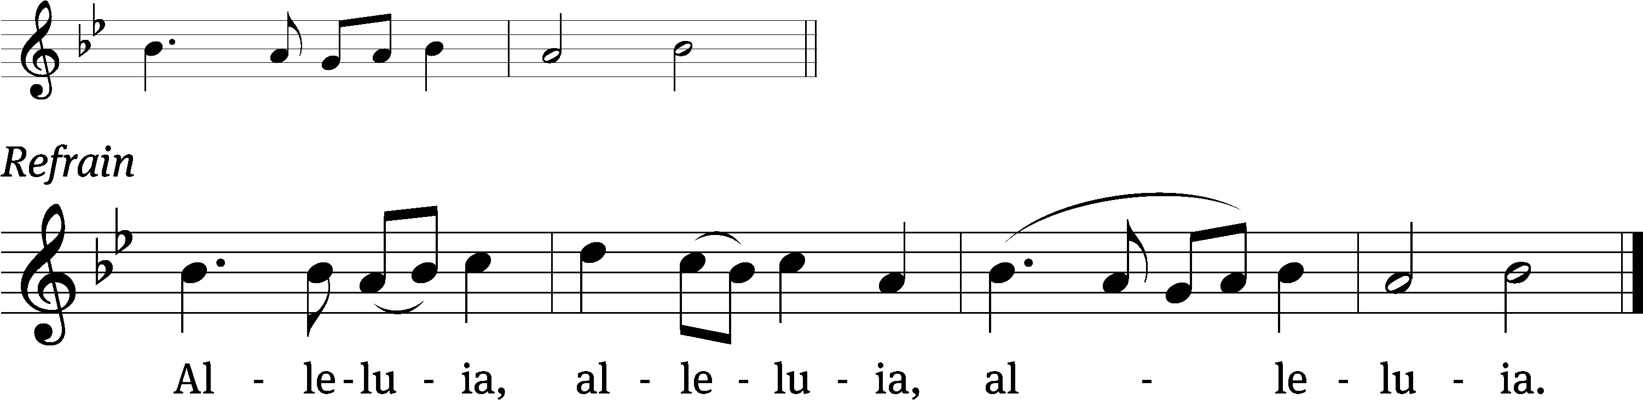
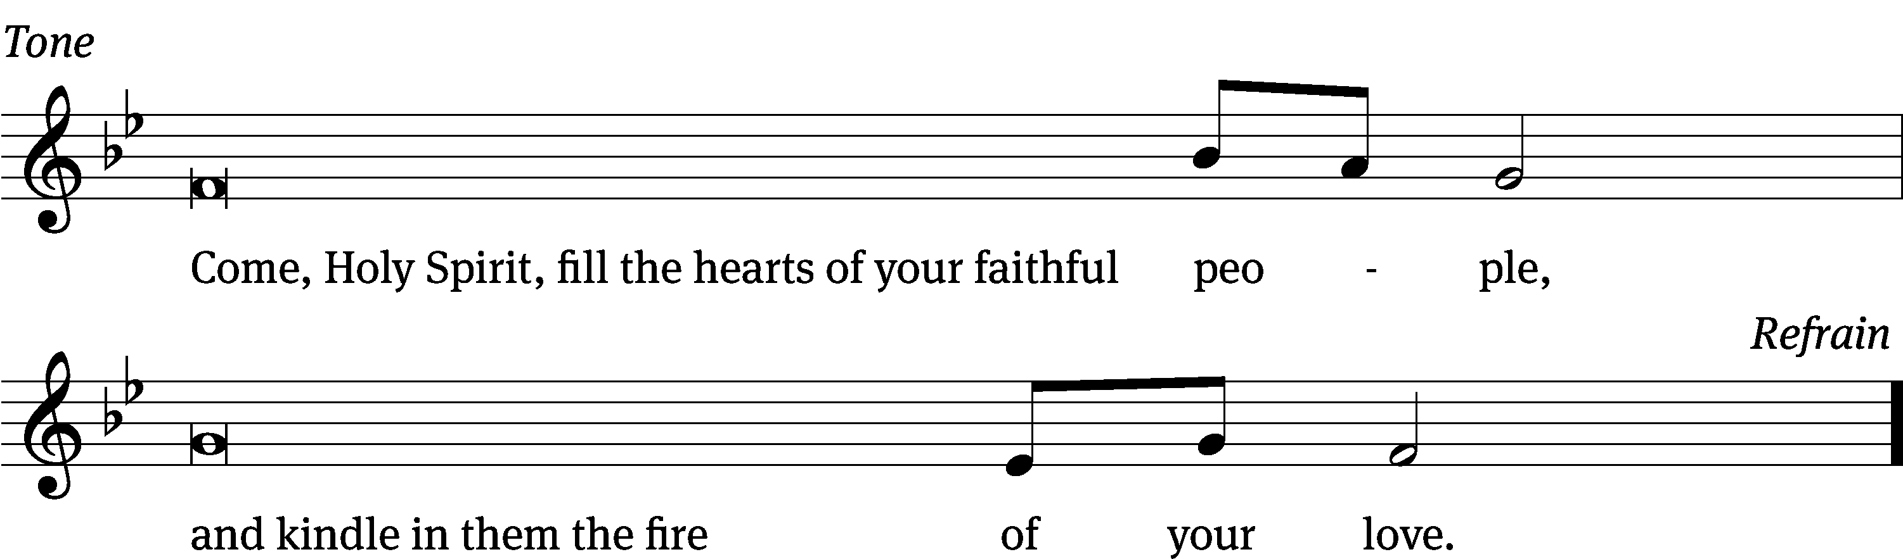

Gospel John 7:37-39

³⁷ On the last and most important day of the festival, Jesus stood up and called out, “If anyone is thirsty, let him come to me and drink! ³⁸ As the Scripture has said, streams of living water will flow from deep within the person who believes in me.” ³⁹ By this he meant the Spirit, whom those who believed in him were going to receive. For the Holy Spirit had not yet come, because Jesus had not yet been glorified.

The Gospel of the Lord.
Praise be to you, O Christ!

Please be seated

585 Come, Holy Ghost, God and Lord CW 585
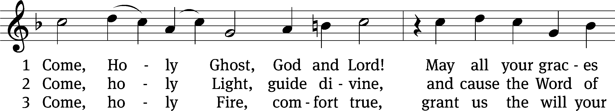
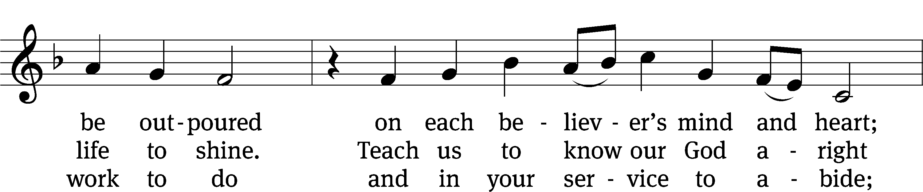
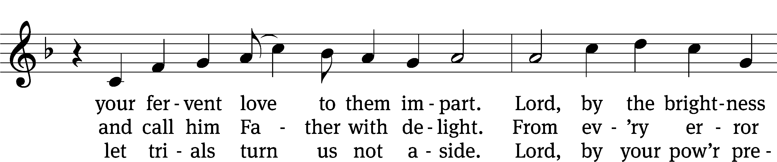
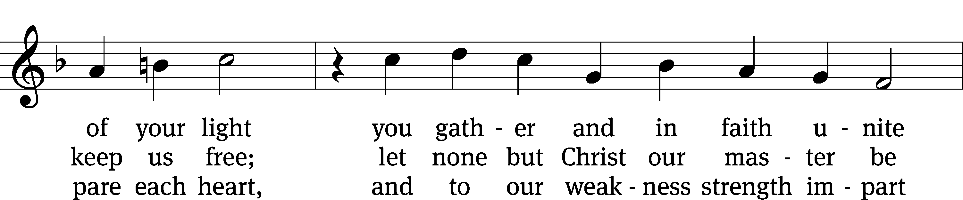
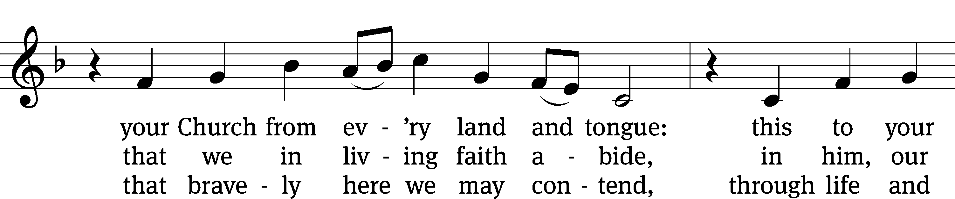
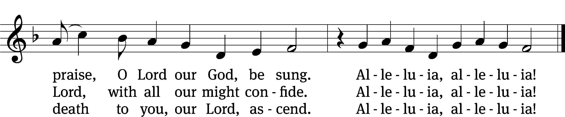
Text: tr. The Lutheran Hymnal, 1941, alt.; (st. 1): German, 15th cent.; (sts. 2–3): Martin Luther, 1483–1546
Tune: Eyn Enchiridion oder Handbüchlein, Erfurt, 1524
Text: © 1941 Concordia Publishing House. Used by permission: OneLicense no. 727703
Tune: Public domain

Sermon Acts 2:1-41
“God’s Ultimate Harvest Festival”

(Continuation of the Gospel Lesson)
²² “Men of Israel, hear these words! Jesus the Nazarene was a man recommended to you by God with miracles, wonders, and signs that God did through him among you, as you yourselves know. ²³ This man, who was handed over by God’s set plan and foreknowledge, you killed by having lawless men nail him to a cross. ²⁴ He is the one God raised up by freeing him from the agony of death, because death was not able to hold him in its grip.
²⁵ “Indeed, David says concerning him:
I saw the Lord always before me.
Because he is at my right hand,
I will not be shaken.
²⁶ Therefore my heart was glad,
and my tongue rejoiced.
My flesh also will rest in hope,
²⁷ because you will not abandon my life to the grave, nor will you let your Holy One see decay.
²⁸ You have made known to me the paths of life.
You will fill me with joy in your presence.
²⁹ “Gentlemen, brothers, I can speak confidently to you about the patriarch David, that he both died and was buried, and his tomb is with us to this day. ³⁰ Since he was a prophet and knew that God had sworn to him with an oath that he would seat one of his descendants on his throne, ³¹ he saw what was coming and spoke about the resurrection of Christ, saying that he was neither abandoned to the grave nor did his flesh see decay.
³² “This Jesus is the one God has raised up. We are all witnesses of that. ³³ So, after he was exalted to the right hand of God and after he received the promised Holy Spirit from the Father, he poured out what you are now seeing and hearing.
³⁴ “For David did not ascend into heaven, and yet he says:
The Lord said to my Lord,
‘Sit at my right hand,
³⁵ until I make your enemies
a footstool under your feet.’
³⁶ “Therefore let all the house of Israel know for certain that God has made this Jesus, whom you crucified, both Lord and Christ.”
³⁷ Now when the people heard this, they were cut to the heart and said to Peter and the other apostles, “Gentlemen, brothers, what should we do?”
³⁸ Peter answered them, “Repent and be baptized, every one of you, in the name of Jesus Christ for the forgiveness of your sins, and you will receive the gift of the Holy Spirit. ³⁹ For the promise is for you and for your children and for all who are far away, as many as the Lord our God will call.”
⁴⁰ He testified solemnly with many other words and was appealing to them, saying, “Save yourselves from this crooked generation.”
⁴¹ Those who accepted his message were baptized, and that day about three thousand people were added.
Please stand, if you are able
Apostles’ Creed
I believe in God, the Father Almighty,
maker of heaven and earth.

I believe in Jesus Christ, his only Son, our Lord,
who was conceived by the Holy Spirit,
born of the Virgin Mary,
suffered under Pontius Pilate,
was crucified, died, and was buried.
He descended into hell.
The third day he rose again from the dead.
He ascended into heaven
and is seated at the right hand of God the Father Almighty.
From there he will come to judge the living and the dead.

I believe in the Holy Spirit,
the holy Christian Church,
the communion of saints,
the forgiveness of sins,
the resurrection of the body,
and the life everlasting. Amen.

Responsive Prayer of the Church

Lord Jesus Christ, our Savior and Lord, we thank you that you kept your promise and sent the Holy Spirit to your Church. Move us to celebrate the Day of Pentecost with special joy because you continue to send your Spirit to equip and empower us to be your witnesses in the world.
Come, Holy Spirit, renew our hearts and kindle in us the fire of your love.

The signs of fire and wind accompanied the outpouring of the Spirit on Pentecost. We seek no signs but rely on your promise that the power of the Spirit will encourage us as we believe and proclaim the good news.
Come, Holy Spirit, renew our hearts and kindle in us the fire of your love.

You, Lord Jesus, received the sevenfold gifts of the Spirit to equip you for your mission. Send those blessings to us, we pray. Cause your Spirit to rest on us and enrich us with wisdom and understanding, counsel and might, and the knowledge and fear of the Lord. Guide us to seek these gifts and use them as we share the message of your love.
Come, Holy Spirit, renew our hearts and kindle in us the fire of your love.

Through the power of the Spirit grant us a determined zeal to reach out to the lost. Give us courage to confess the truth clearly and compassion to confess the truth in love. Guide us as we encourage brothers and sisters to join us in your mission and enable us to work together to make disciples of all nations.
Come, Holy Spirit, renew our hearts and kindle in us the fire of your love.

We pray that your Spirit may raise up many more men and women who are willing to be our voices in our nation and around the world. Prepare these witnesses in their education and life experiences to be able to reach out to every nation, tribe, language, and people. Keep them in your care as they serve in our place and for your cause.
Come, Holy Spirit, renew our hearts and kindle in us the fire of your love.

Restrain the evil of Satan as we proclaim your truth. Protect all your people from social and physical persecution. When we endure the cross for following you, provide courage and patience. Safeguard our economy and guide our political leaders so that we may proclaim the gospel freely to all.
Come, Holy Spirit, renew our hearts and kindle in us the fire of your love.

We pray each day that you keep in your care all who are enduring the troubles and tragedies of life: those whose bodies are racked with pain, those who struggle with depression and fear, those who endure the frustration of poverty, those who grieve because of a sudden loss, and those who are facing the reality of death. Let your Spirit bring their prayers and ours to your Father’s throne of grace.
Come, Holy Spirit, renew our hearts and kindle in us the fire of your love.

Hear us, Lord, as we offer our private petitions.

Silent prayer

Lord Jesus, continue to pour out your Holy Spirit that he may renew us with his pentecostal power. May his love ignite our hearts and his breath impel our steps to preach the gospel to every creature.
Come, Holy Spirit, renew our hearts and kindle in us the fire of your love. Amen.

Please be seated

592 Holy Spirit, Ever Dwelling CW 592
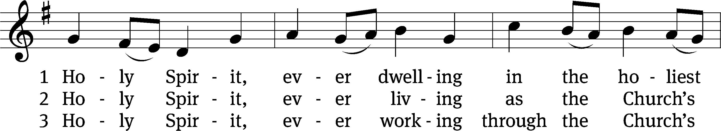
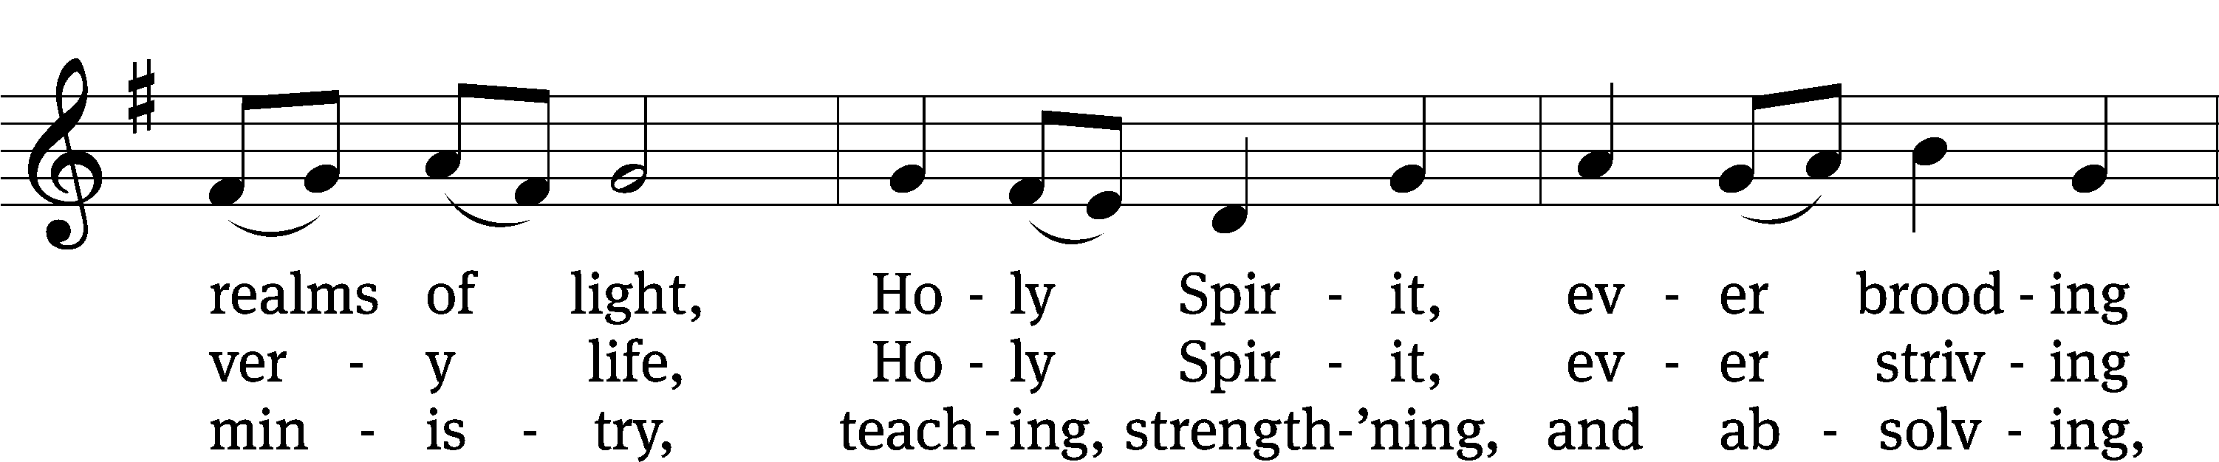
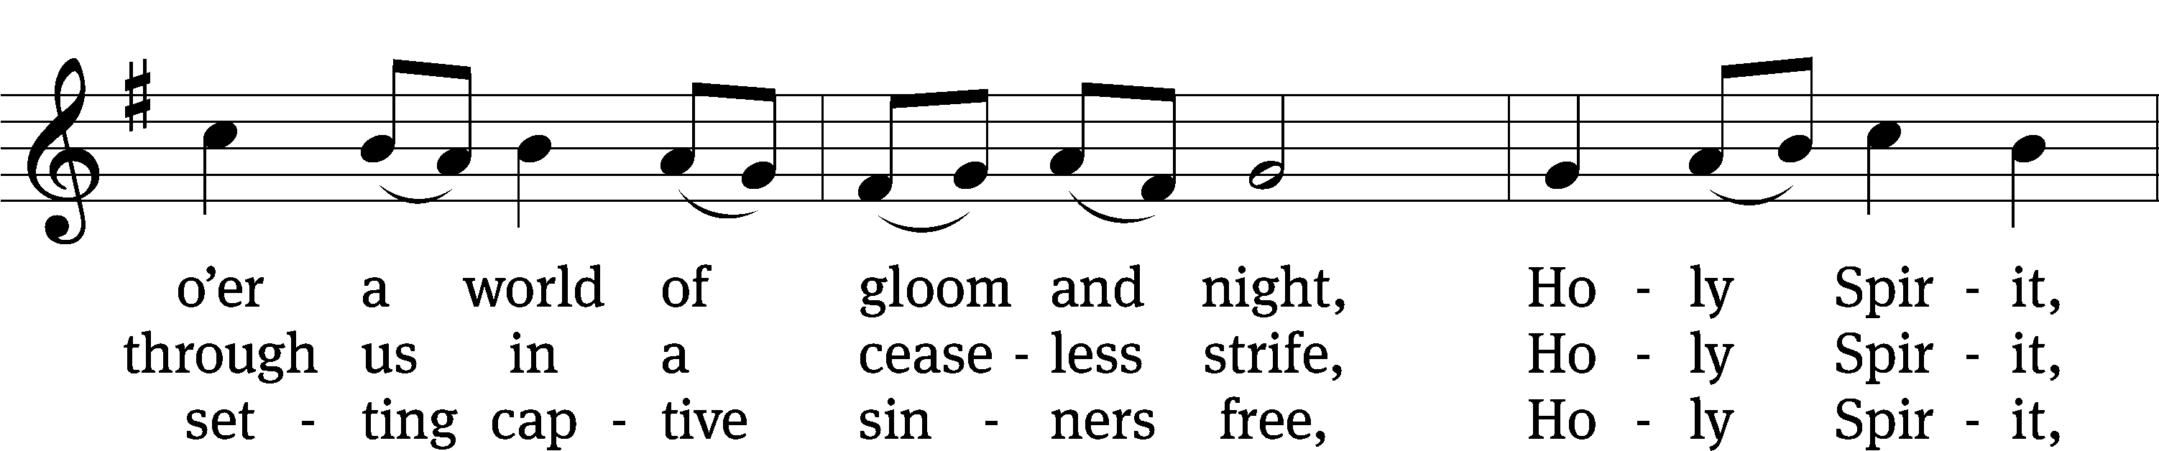
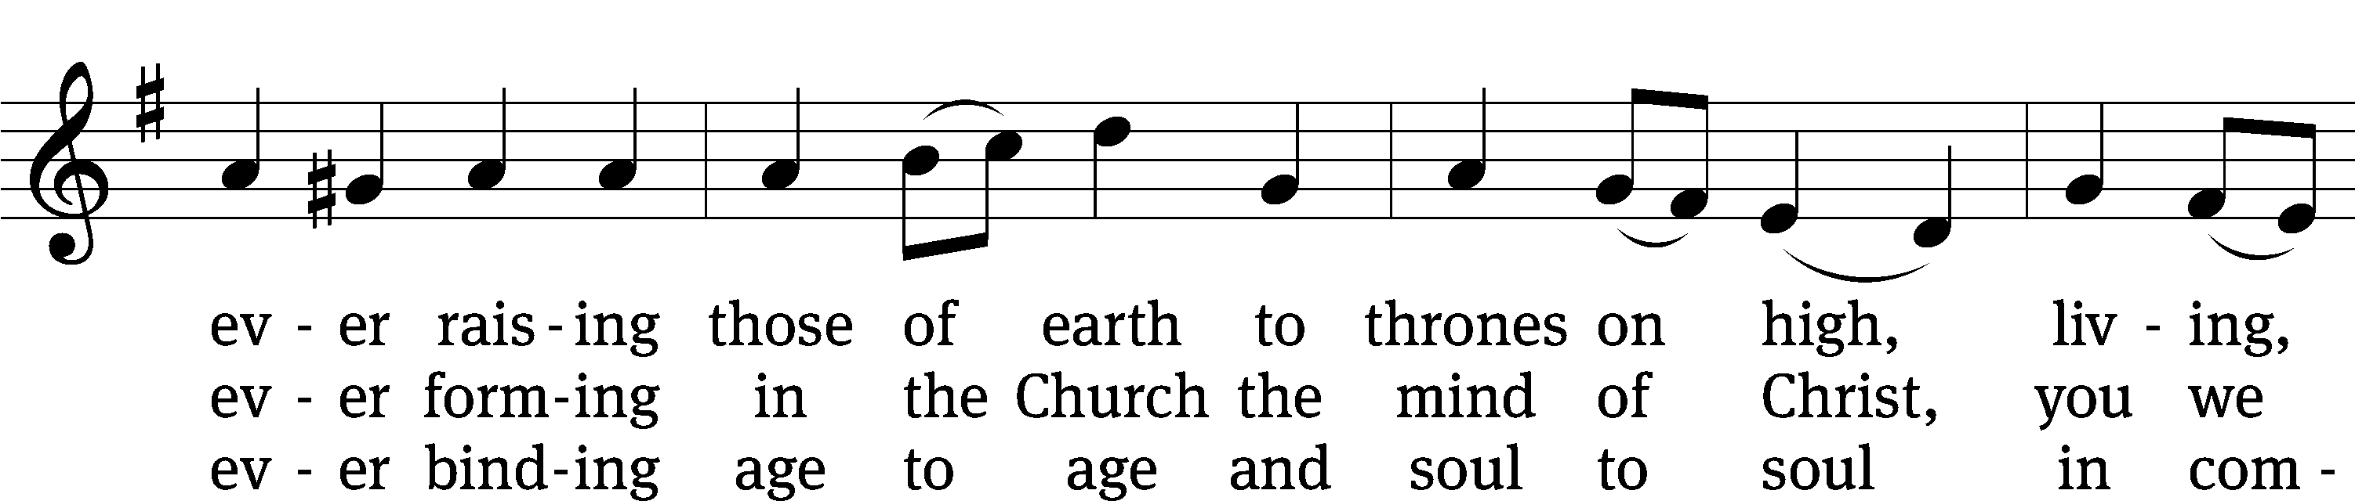
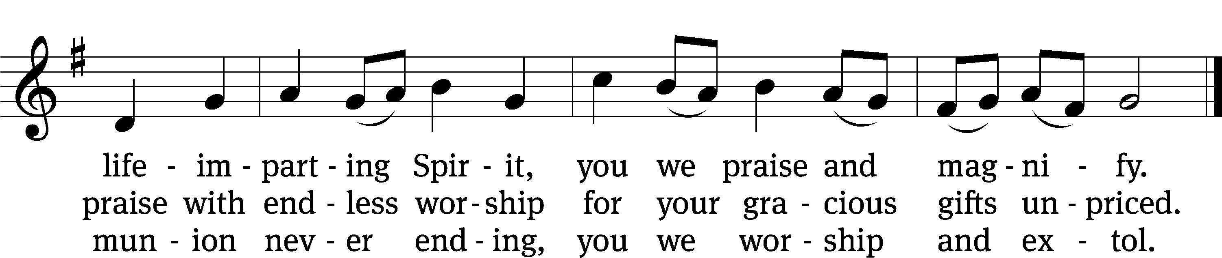
Text: Timothy Rees, 1874–1939, alt.
Tune: Oude en Nieuwe Hollantse . . . Contradanseu, Amsterdam, c. 1710
Text and tune: Public domain

Please stand, if you are able

Prayer
Blessed Lord, you have given us your Holy Scriptures for our learning. May we so hear them, read, learn, and take them to heart that, being strengthened and comforted by your holy Word, we may cling to the blessed hope of everlasting life; through Jesus Christ our Lord, who lives and reigns with you and the Holy Spirit, one God, now and forever.
Amen.
Lord’s Prayer
Our Father, who art in heaven, hallowed be thy name, thy kingdom come, thy will be done on earth as it is in heaven. Give us this day our daily bread; and forgive us our trespasses, as we forgive those who trespass against us; and lead us not into temptation, but deliver us from evil. For thine is the kingdom and the power and the glory forever and ever. Amen.

Blessing
The Lord bless you and keep you.
The Lord make his face shine on you and be gracious to you.
The Lord look on you with favor and give you peace.
Amen.

Please be seated

593 Holy Spirit, Light Divine CW 593
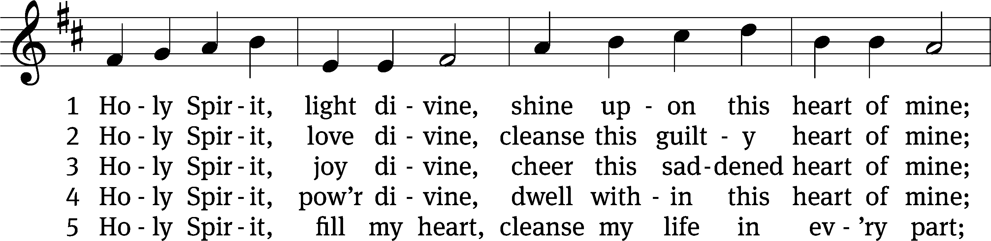
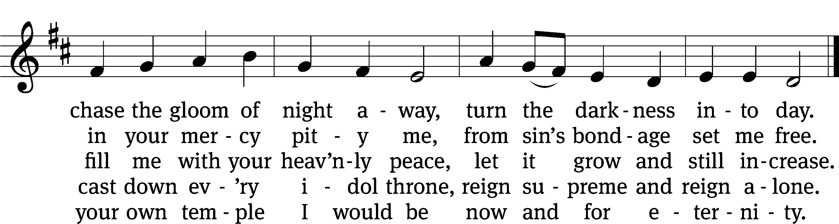
Text: Andrew Reed, 1787–1862, abr., alt.
Tune: Orlando Gibbons, 1583–1625
Text and tune: Public domain

Acknowledgments
Setting One from Christian Worship
Software distributed in partnership with Northwestern Publishing House.
Created by Christian Worship: Service Builder © 2022 Concordia Publishing House.

Serving in Worship
Officiant Pastor Natsis
Organist Ann Hoeft
Deacons (Thursday) Duane Mason and Dave Stevenson
(Sunday) Jeff Neuburger and Robert Niethammer
Ushers (Thursday) Tim Phelps
(Sunday) Ron Zahn
Altar Guild Sandy Kirkpatrick and Barb Neuburger
Videographer Rick Schneider

