THE DAY OF PENTECOST

TRINITY EVANGELICAL LUTHERAN CHURCH | Saline, Michigan
WELCOME TO WORSHIP June 2/5, 2022
Thank you for joining us in God’s house today! We cordially ask that our Guests sign one of the guestbooks located at either the front or back entryways, or fill out a “Let’s Get Acquainted” card located in the hymnal pew rack and place it in the collection plate.

THANK OFFERING: Members of Trinity give their offering as an expression of love and thankfulness to the Lord and to help support the Lord’s work in our community and around the world. Visitors need not feel obligated to participate in this offering which supports our ministry.

Restrooms are located at the back of the upper level (the annex), and in the basement (down the back stairs of the sanctuary or annex). Handicap access is available, please ask an usher for assistance.

Young Families / Toddler Bags – We are GLAD YOU BROUGHT YOUR CHILDREN to our worship service. Jesus said: “Let the little children come to me and do not hinder them, for the kingdom of God belongs to such as these.” We know that having little children in church can be a challenge, but DO NOT WORRY about it. Many of your fellow worshippers have been in your shoes and are just happy you brought your children with you. For your convenience, we have reserved the back rows of seating for parents with small children. These areas provide more flexibility for your family, as well as, easy access to move downstairs if necessary. A closed-circuit TV system allows families to continue participating in the service while downstairs. Pre-school toddler bags and children’s bulletins are available for their enjoyment. Ask an usher for one to use during the service and please return the toddler bag afterwards.

celebration of holy communion:
In His Word, God makes it clear that the Lord’s Supper is to be shared by people of a common proclamation of faith (1 Corinthians 11:26; 1 Corinthians 10:16-17). Without judging anyone’s hearts, we invite those who share in our confession by their membership in our congregation or another congregation of the Wisconsin Evangelical Lutheran Synod (WELS) or the Evangelical Lutheran Synod (ELS) and who are properly prepared (1 Corinthians 11;27-29) to receive the Sacrament. Page 295 in Christian Worship provides a guide for preparation.
Guests, we would love to have you join us in communion fellowship in the future, and for that to be possible, we ask that you speak with one of the pastors so that we may speak with you on how that would be possible. We thank you for respecting the way we celebrate the Lord’s Supper in our congregations.
the SERVICE – setting one - WITH HOLY COMMUNION CW, page 154

477 O Day Full of Grace CW 477
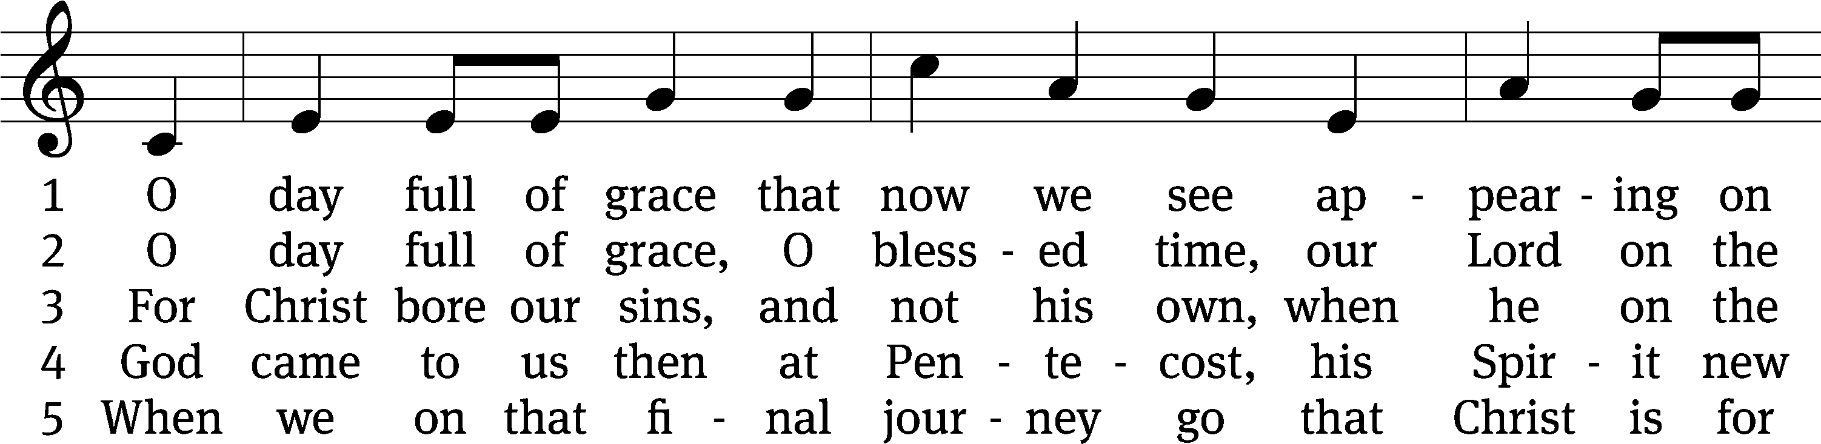
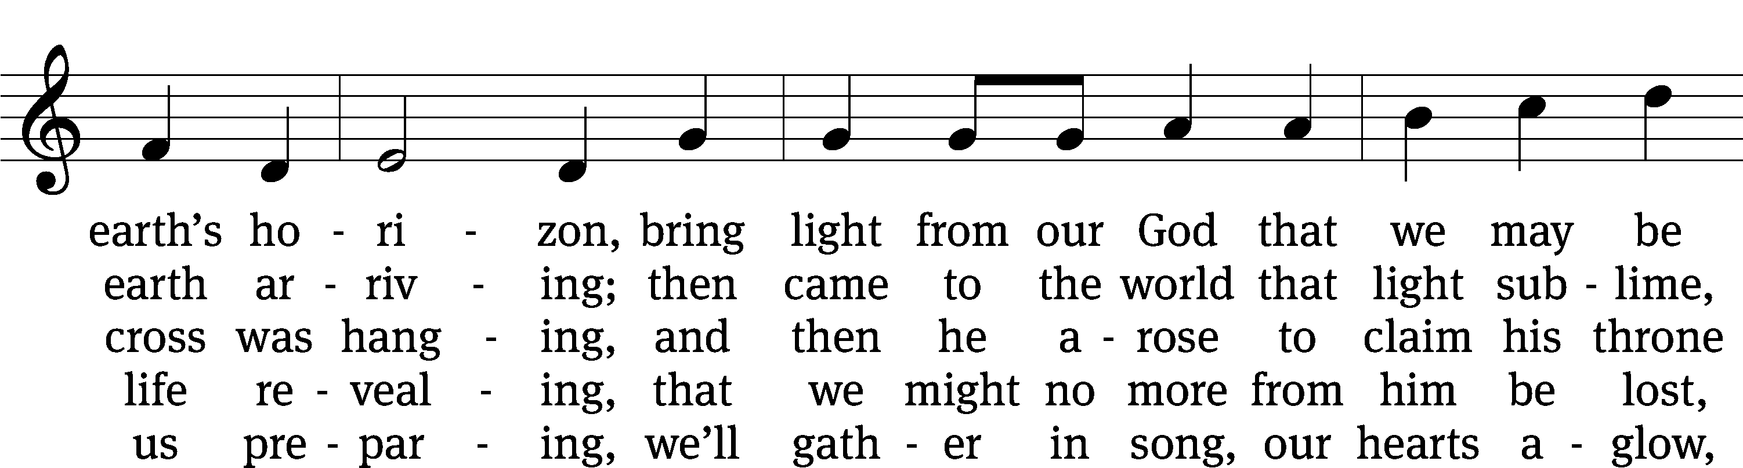
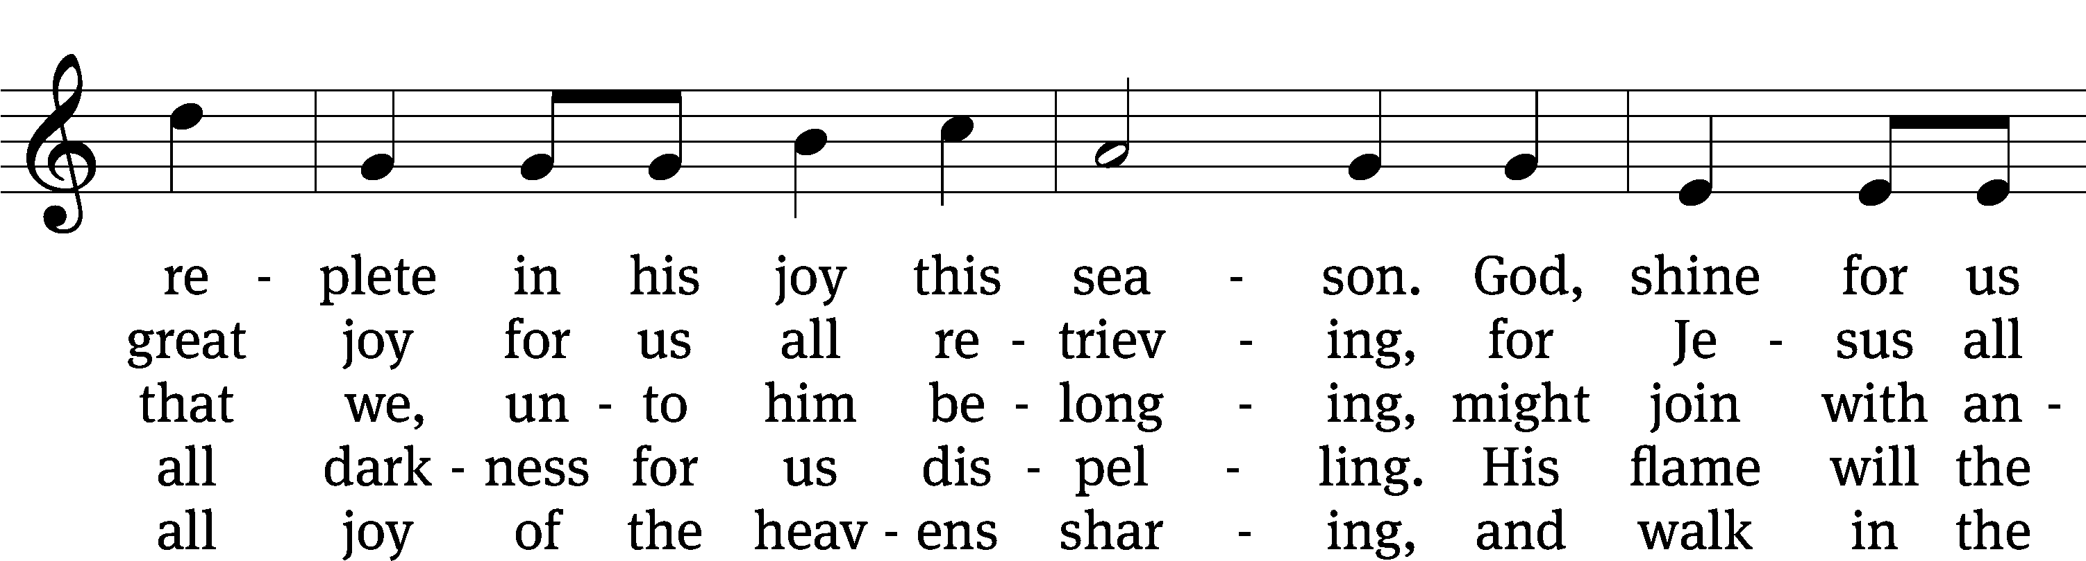
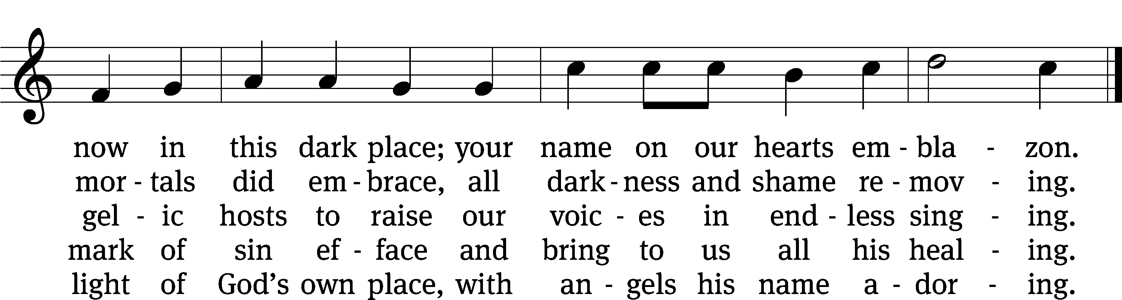
Text: tr. Gerald Thorson, 1921–2001; Scandinavian, c. 1450
Tune: Christoph E. F. Weyse, 1774–1842
Text: © 1978 Lutheran Book of Worship, admin. Augsburg Fortress. Used by permission: OneLicense no. 727703
Tune: Public domain

Please stand, if you are able
Invocation
In the name of the Father and of the Son and of the Holy Spirit.
Amen.
Confession
If we claim to be without sin, we deceive ourselves and the truth is not in us.
If we confess our sins, God is faithful and just
and will forgive us our sins
and purify us from all unrighteousness.

Let us confess our sins to the Lord.
Holy God, gracious Father,
I am sinful by nature
and have sinned against you in my thoughts, words, and actions.
I have not loved you with my whole heart;
I have not loved others as I should.
I deserve your punishment both now and forever.
But Jesus, my Savior, paid for my sins
with his innocent suffering and death.
Trusting in him, I pray: God, have mercy on me, a sinner.

Our gracious Father in heaven has been merciful to us. He sent his only Son, Jesus Christ, who gave his life as the atoning sacrifice for the sins of the whole world. Therefore, as a called servant of Christ and by his authority, I forgive you all your sins in the name of the Father and of the Son and of the Holy Spirit.
Amen.

Lord, Have Mercy

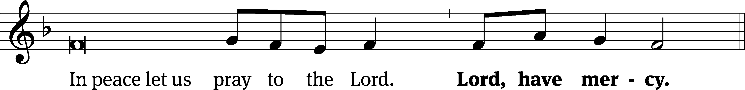
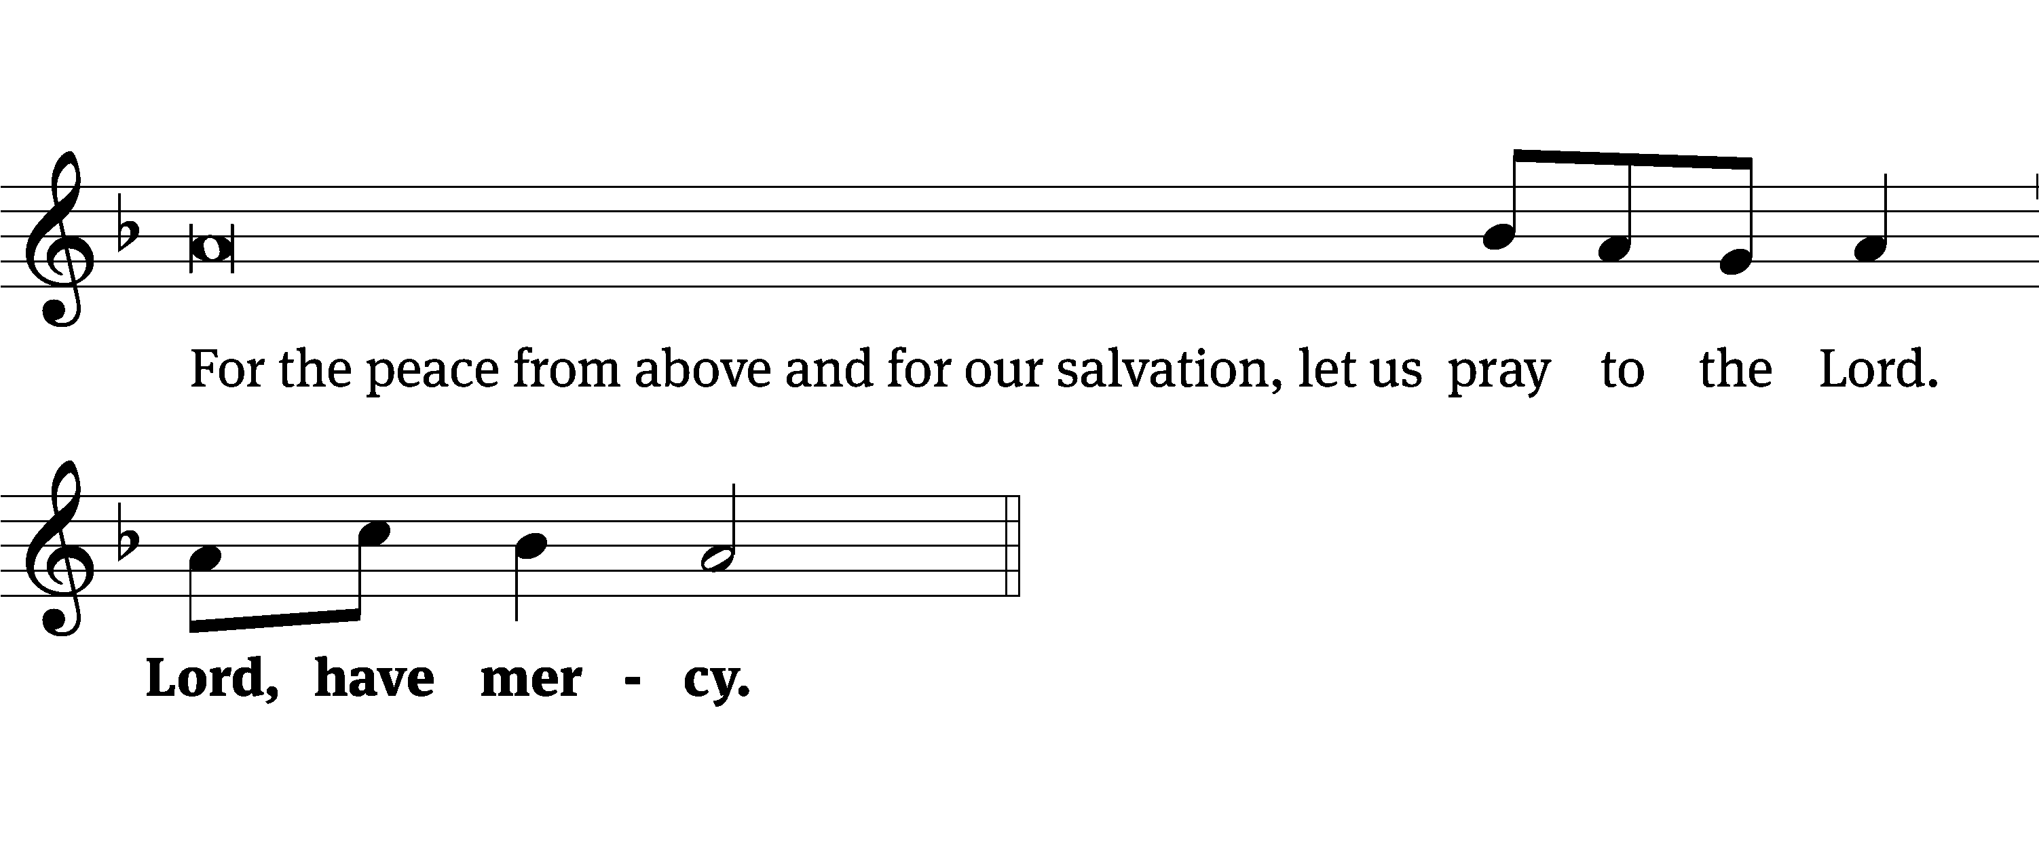
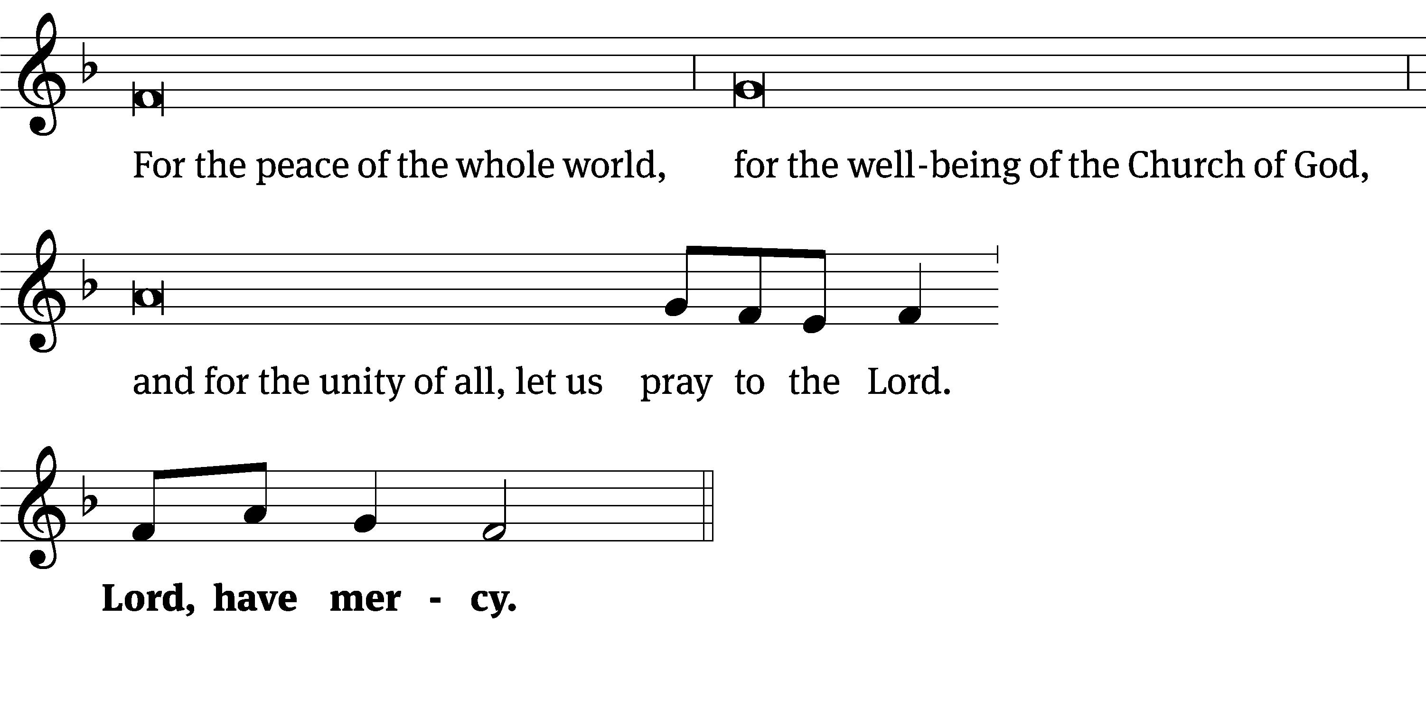
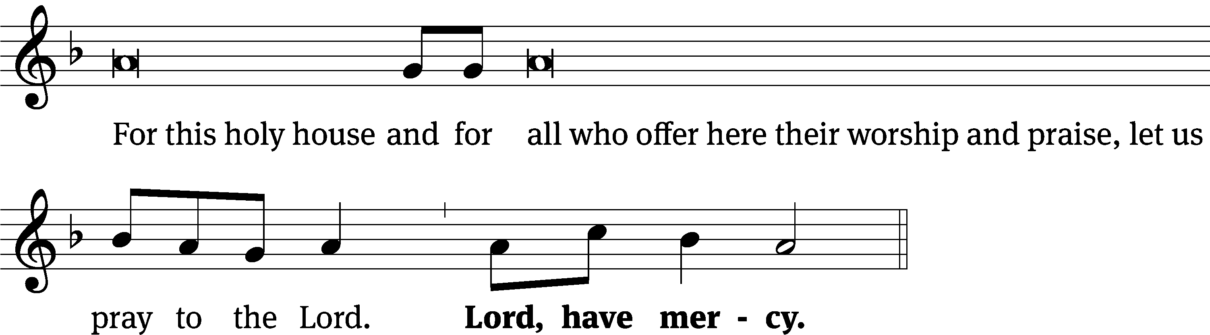
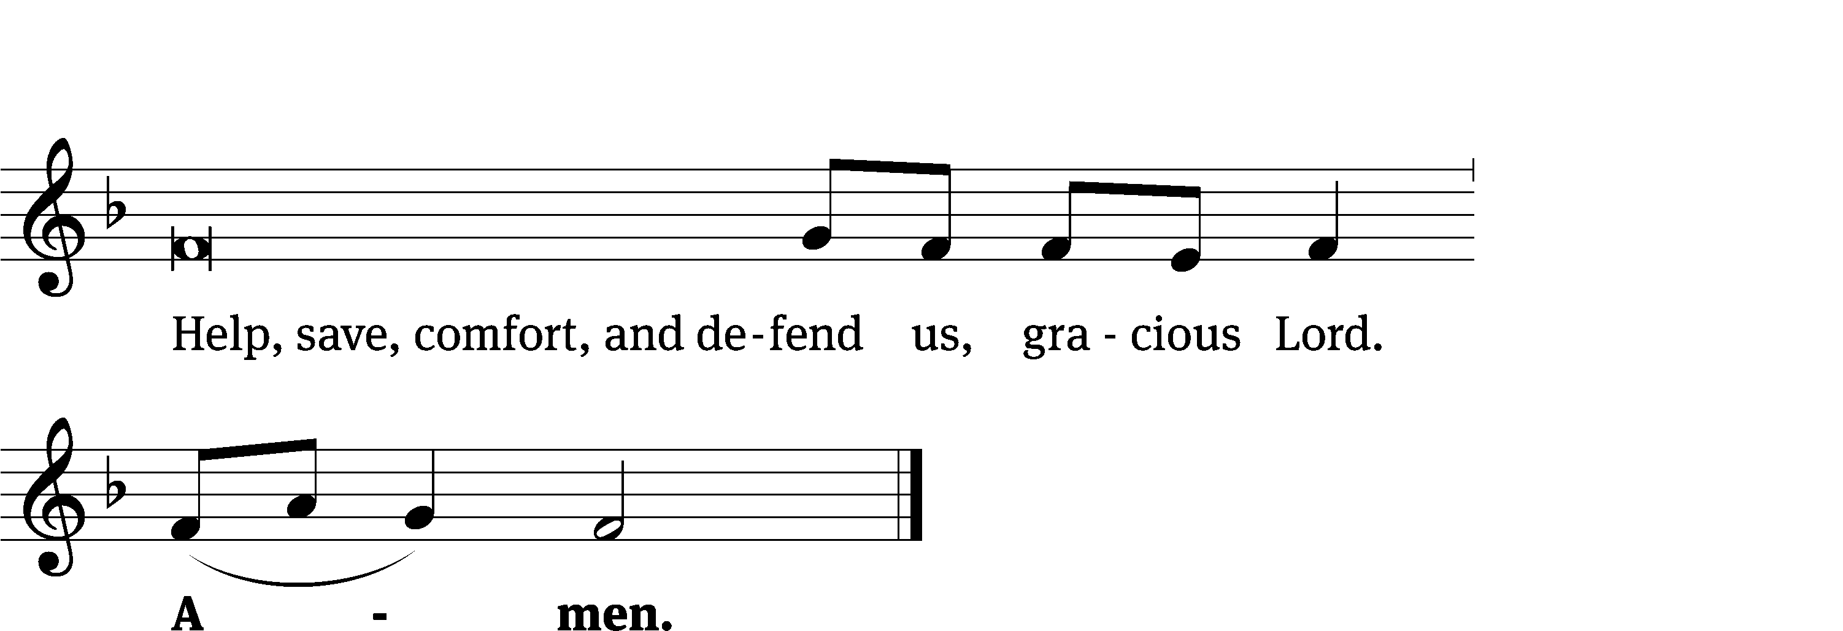
Tune: Kevin Becker
Tune: © 2021 Northwestern Publishing House. Used by permission: OneLicense no. 727703

Glory Be to God CW 157
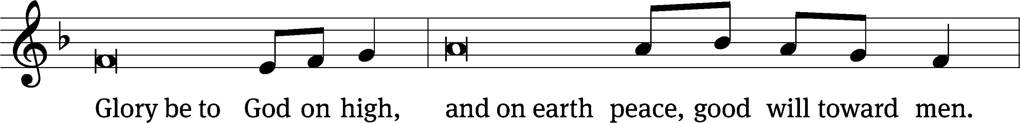
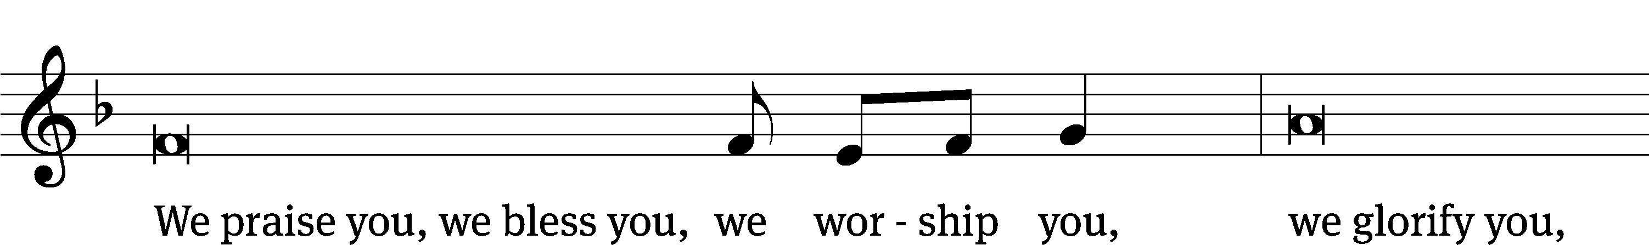
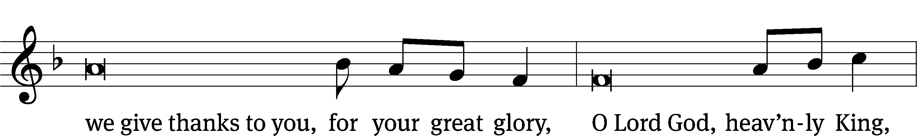
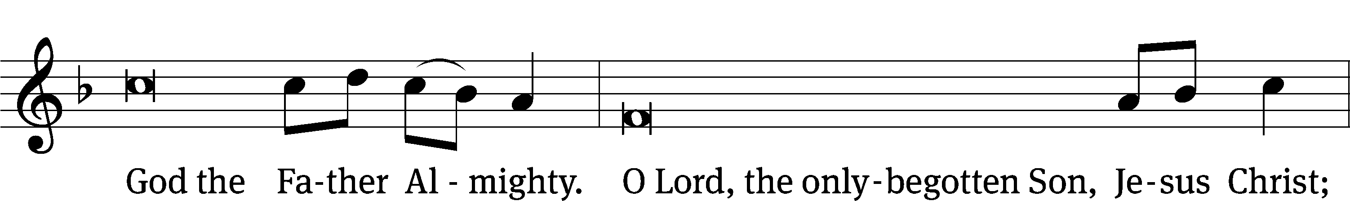
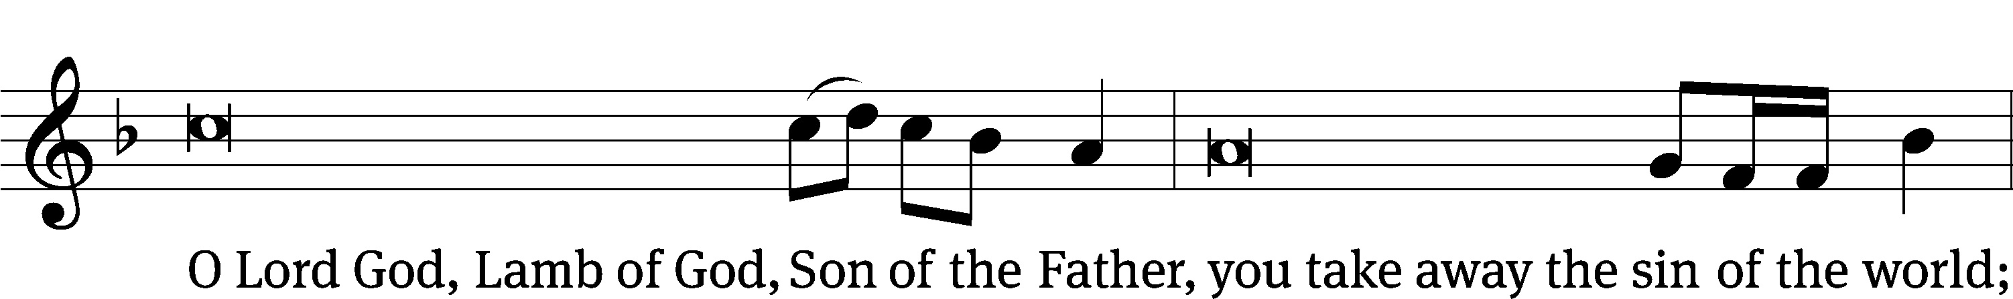
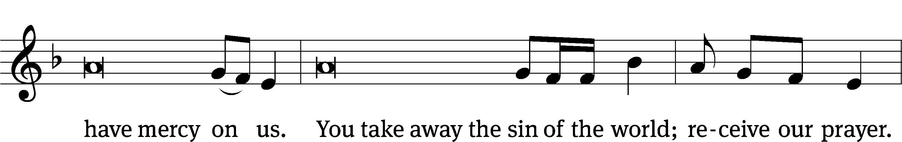
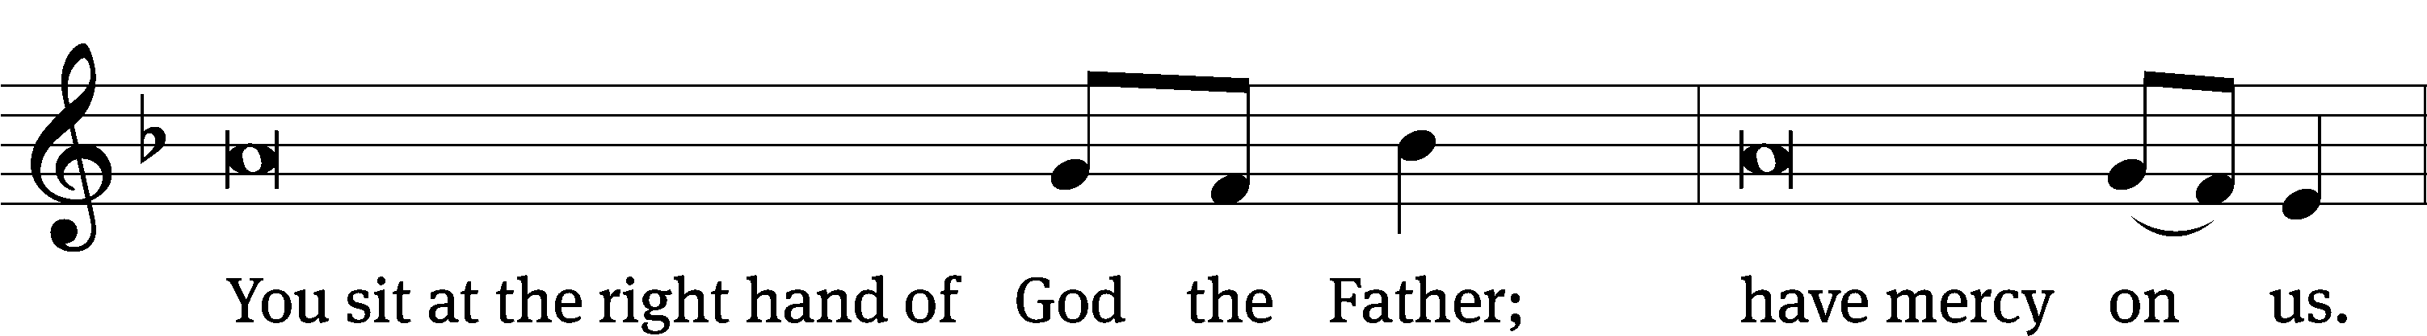
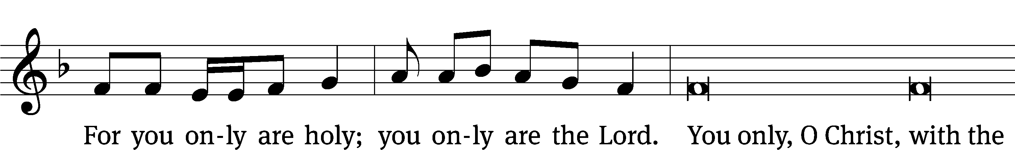
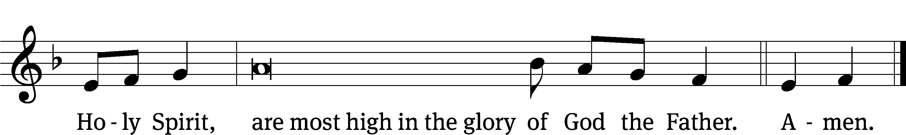

The Lord be with you.
And also with you.
Prayer of the Day
Let us pray.

Holy Spirit, God and Lord, come to us this joyful day with your sevenfold gift of grace. Rekindle in our hearts the holy fire of your love that in a true and living faith we may tell abroad the glory of our Savior, Jesus Christ, who lives and reigns with you and the Father, one God, now and forever.
Amen.

Please be seated

First Reading Genesis 11:1-9
¹ The whole earth had one language and a single vocabulary. ² As people traveled in the east, they found a plain in the land of Shinar, and they settled there. ³ They said to one another, “Come, let’s make bricks and bake them thoroughly.” They used mud brick instead of stone for building material, and they used tar for mortar. ⁴ They said, “Come, let’s build a city for ourselves and a tower whose top reaches to the sky, and let’s make a name for ourselves, so that we will not be scattered abroad over the face of the whole earth.”

⁵ The Lord came down to see the city and the tower that the people were building. ⁶ The Lord said, “If this is the first thing they are doing as one people, who all have one language, then nothing that they intend to do will be too difficult for them. ⁷ Come, let’s go down there and confuse their language, so that they cannot understand one another’s speech.”
⁸ So the Lord scattered them from there over the face of the whole earth, and they stopped building the city. ⁹ It was named Babel, because there the Lord confused the language of the whole earth. From there the Lord scattered them over the face of the whole earth.

The Word of the Lord.
Thanks be to God.

Psalm 104A Lord, Send Out Your Spirit Psalm 104A

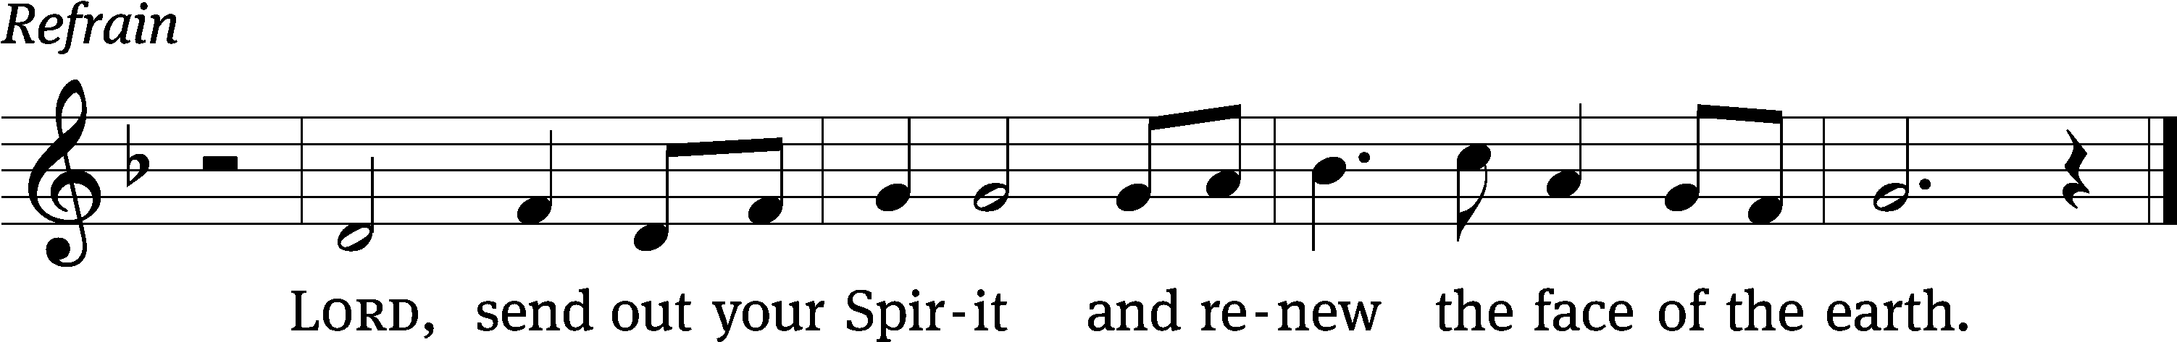

How many are your / works, Lord!
In wisdom you / made them all.
All creatures / look to you
to give them their food at the / proper time.
When you give it to them, they gather / it up;
when you open your hand, they are satisfied / with good things. Refrain

May the glory of the Lord endure for- / ever;
may the Lord rejoice / in his works—
he makes winds his / messengers,
flames of fire his / servants.
I will sing to the Lord / all my life;
I will sing praise to my God as long / as I live.
Glory be to the Father and / to the Son
and to the Holy / Spirit,
as it was in the be- / ginning,
is now, and will be forever. / Amen. Refrain
Text: © 1980 Arlo D. Duba. Used by permission: OneLicense no. 727703
Tune: © 1981 Richard T. Proulx. Used by permission: OneLicense no. 727703
Setting: © 2011 Faith Alive Christian Resources. Used by permission: License no. 130003540
Second Reading Acts 2:1-21
¹ When the day of Pentecost came, they were all together in one place. ² Suddenly a sound like the rushing of a violent wind came from heaven, and it filled the whole house where they were sitting. ³ They saw divided tongues that were like fire resting on each one of them. ⁴ They were all filled with the Holy Spirit and began to speak in other languages, since the Spirit was giving them the ability to speak fluently.
⁵ Now there were godly Jewish men from every nation under heaven living in Jerusalem. ⁶ When this sound was heard, a crowd came together and was confused, because each one heard them speaking in his own language. ⁷ They were completely baffled and said to each other, “Look, are not all these men who are speaking Galileans? ⁸ Then how is it that each of us hears them speaking in his own native language? ⁹ Parthians, Medes, and Elamites; residents of Mesopotamia, and of Judea, Cappadocia, Pontus and Asia, ¹⁰ Phrygia and Pamphylia, Egypt, and the parts of Libya around Cyrene; visitors from Rome, both Jews and proselytes; ¹¹ Cretans and Arabs—we hear them declaring in our own languages the wonderful works of God.” ¹² They were all amazed and perplexed. They kept saying to one another, “What does this mean?” ¹³ But others mocked them and said, “They are full of new wine.”
¹⁴ Then Peter stood up with the Eleven, raised his voice, and spoke loudly and clearly to them: “Men of Judea, and all you residents of Jerusalem, understand this, and listen closely to my words. ¹⁵ These men are not drunk, as you suppose, for it is only the third hour of the day. ¹⁶ On the contrary, this is what was spoken by the prophet Joel:
¹⁷ This is what God says will happen in the last days:
I will pour out my Spirit on all flesh.
Your sons and your daughters will prophesy.
Your young men will see visions.
Your old men will dream dreams.
¹⁸ Even on my servants, both men and women,
I will pour out my Spirit in those days,
and they will prophesy.
¹⁹ I will show wonders in the sky above,
and signs on the earth below,
blood and fire and a rising cloud of smoke.
²⁰ The sun will be turned to darkness
and the moon to blood
before the coming of the great and glorious day of the Lord.
²¹ And this will happen: Everyone who calls on the name of the Lord
will be saved.

The Word of the Lord.
Thanks be to God.

Please stand, if you are able
Gospel Acclamation Antiphon for Pentecost
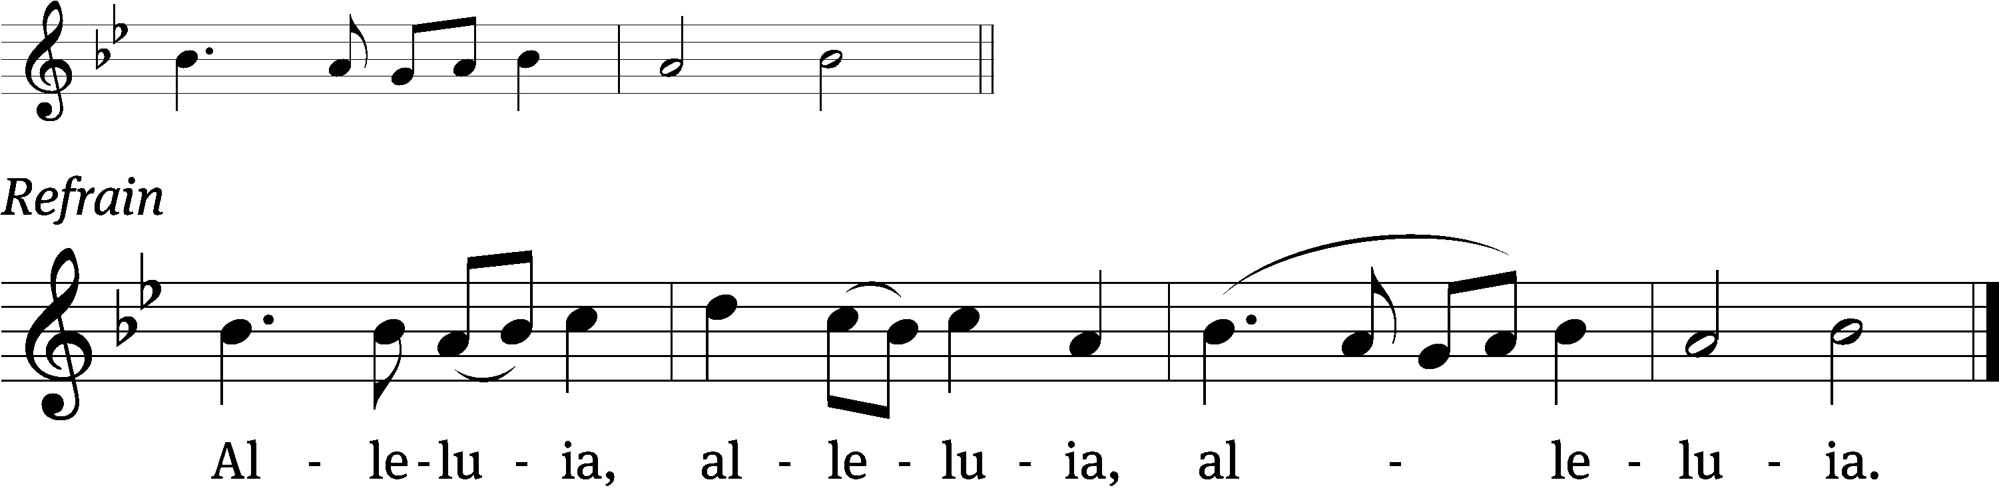
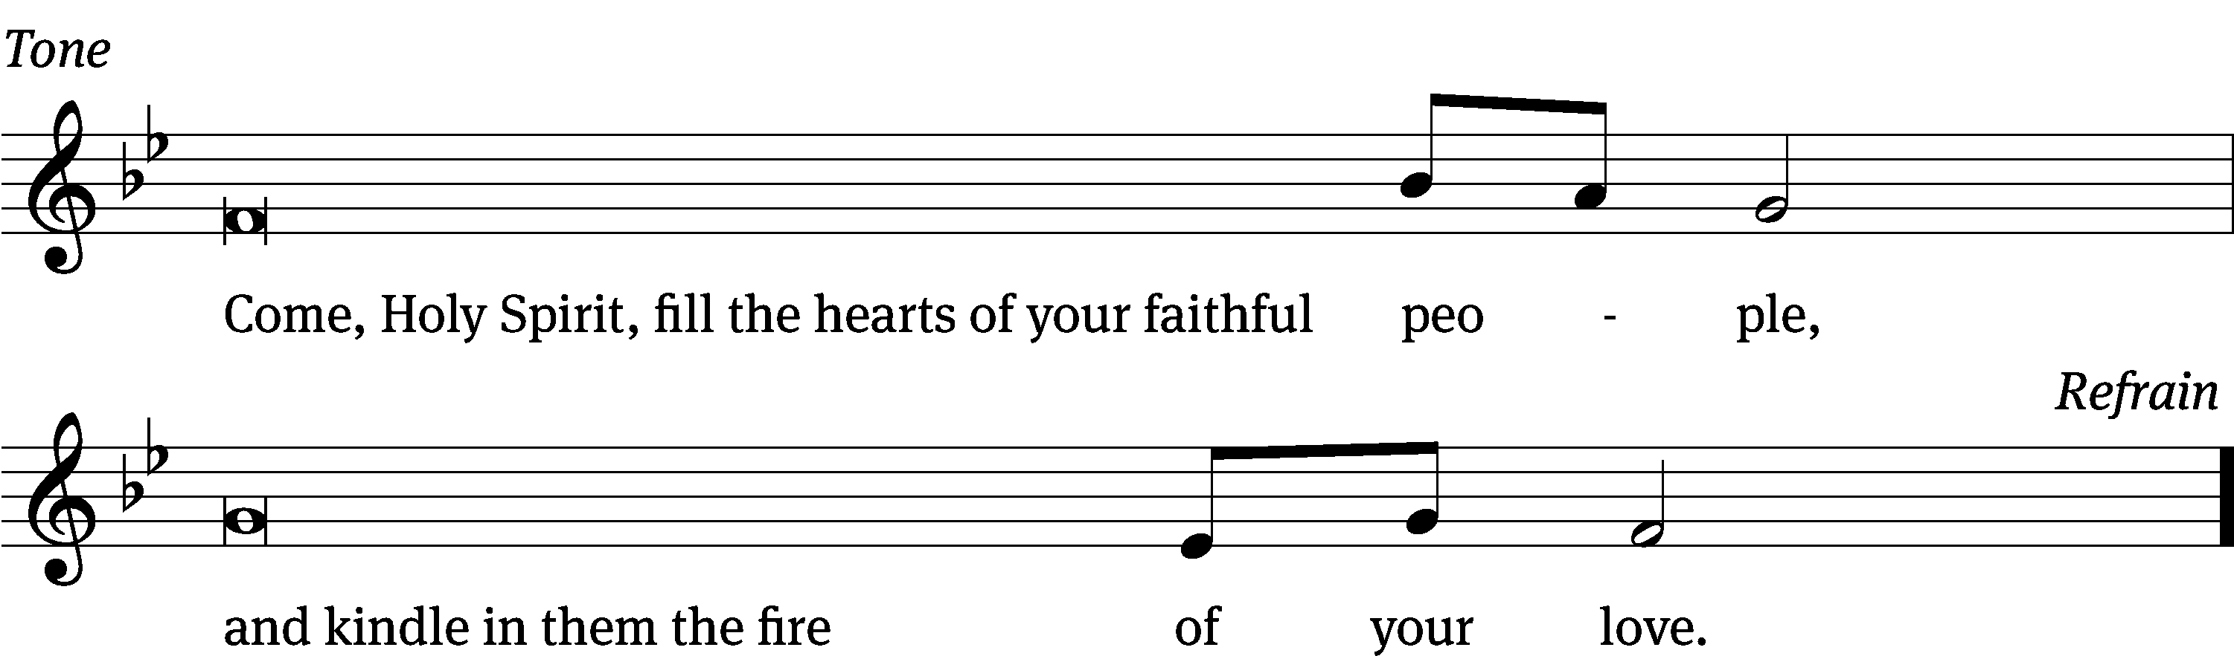
Tune: © 2021 Northwestern Publishing House. Used by permission: OneLicense no. 727703

Gospel John 14:23-27
²³ Jesus answered him, “If anyone loves me, he will hold on to my word. My Father will love him, and we will come to him and make our home with him. ²⁴ The one who does not love me does not hold on to my words. The word that you are hearing is not mine, but it is from the Father who sent me.
²⁵ “I have told you these things while staying with you. ²⁶ But the Counselor, the Holy Spirit, whom the Father will send in my name, will teach you all things and remind you of everything I told you.
²⁷ “Peace I leave with you. My peace I give to you. Not as the world gives do I give to you. Do not let your heart be troubled, and do not let it be afraid.
The Gospel of the Lord.
Praise be to you, O Christ!
Please be seated
585 Come, Holy Ghost, God and Lord CW 585
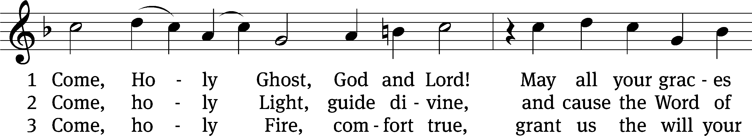
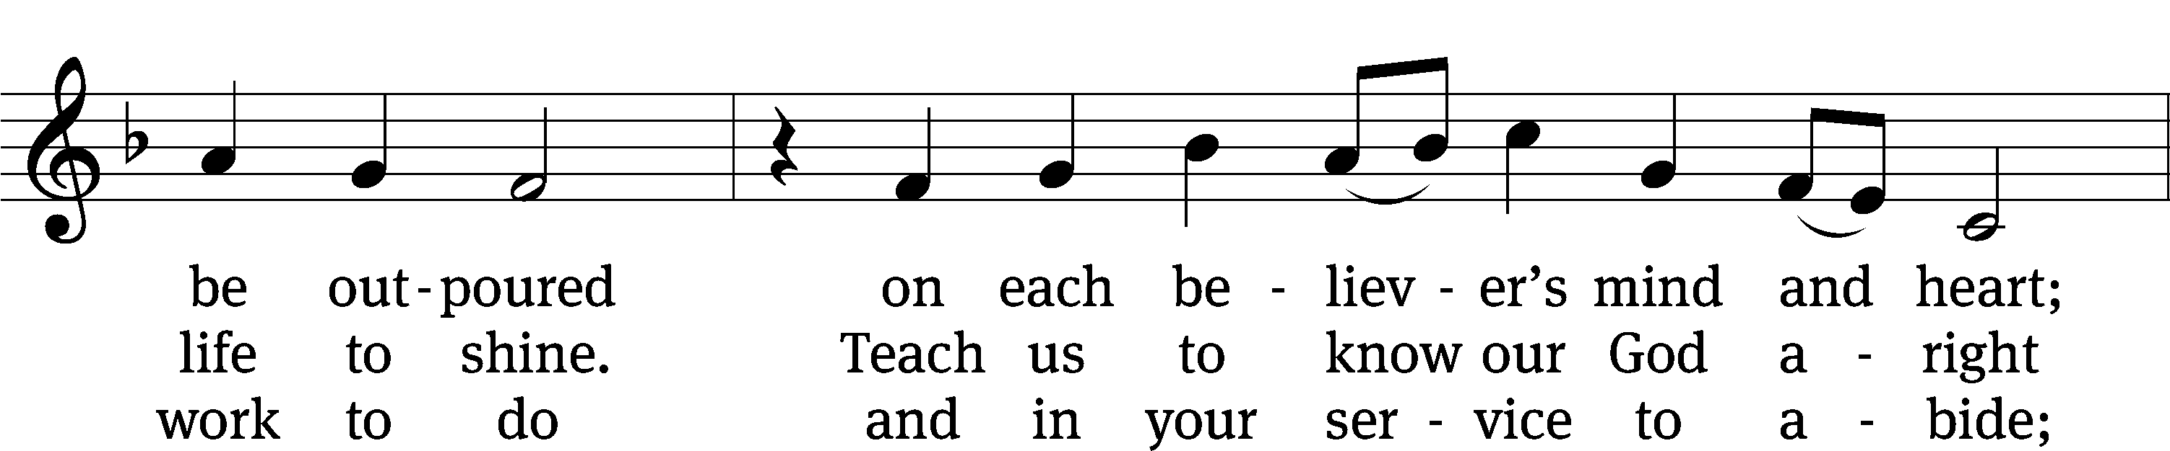
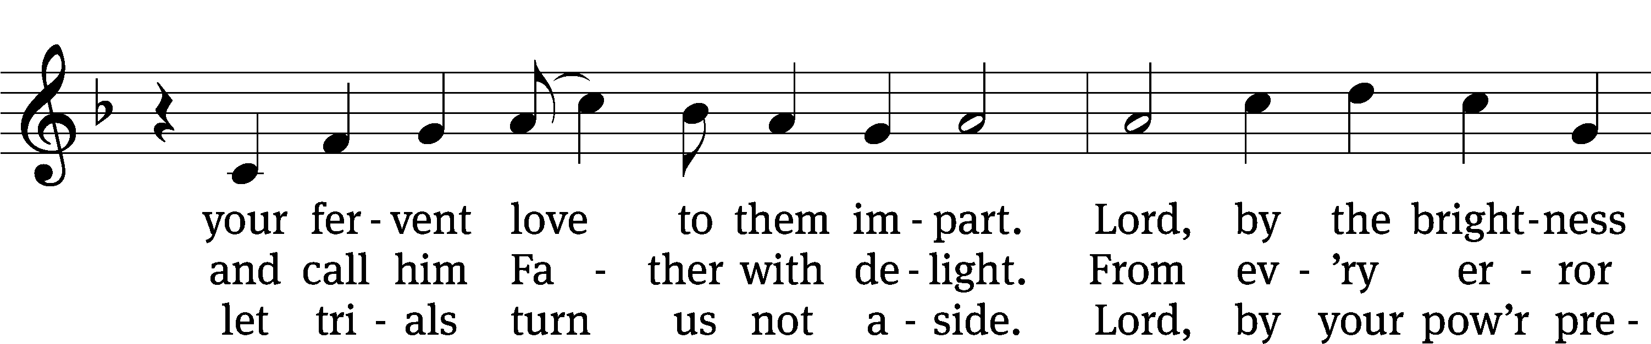
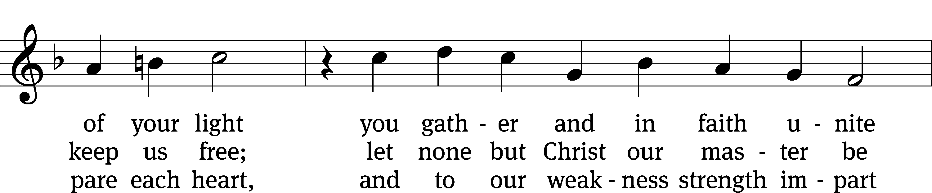
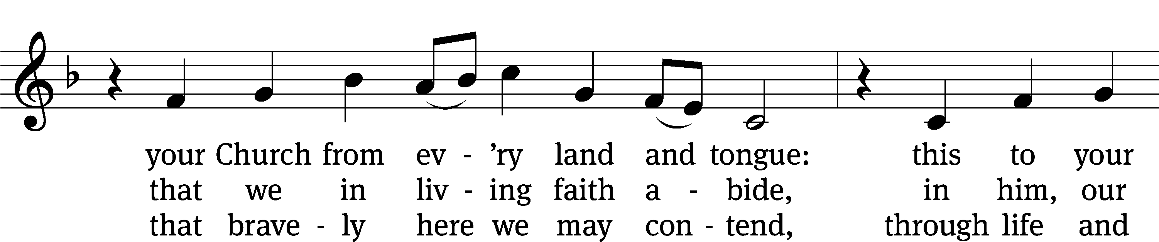
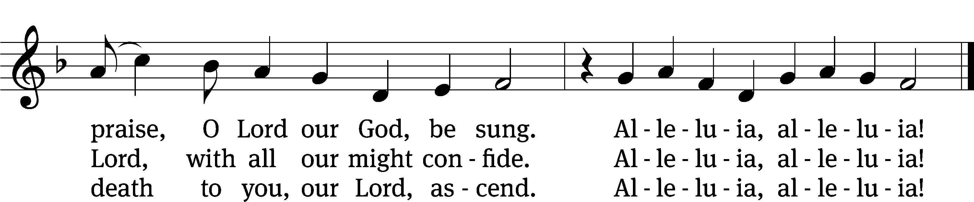
Text: tr. The Lutheran Hymnal, 1941, alt.; (st. 1): German, 15th cent.; (sts. 2–3): Martin Luther, 1483–1546
Tune: Eyn Enchiridion oder Handbüchlein, Erfurt, 1524
Text: © 1941 Concordia Publishing House. Used by permission: OneLicense no. 727703
Tune: Public domain

SERMON John 14:23-27
“The Word Sends His Word though His Spirit”

Please stand, if you are able
Nicene Creed
We believe in one God, the Father, the Almighty,
maker of heaven and earth,
of all that is,
seen and unseen.
We believe in one Lord, Jesus Christ, the only Son of God,
eternally begotten of the Father,
God from God, Light from Light, true God from true God,
begotten, not made,
of one being with the Father.
Through him all things were made.
For us and for our salvation, he came down from heaven,
was incarnate of the Holy Spirit and the Virgin Mary,
and became truly human.
For our sake he was crucified under Pontius Pilate.
He suffered death and was buried.
On the third day he rose again in accordance with the Scriptures.
He ascended into heaven
and is seated at the right hand of the Father.
He will come again in glory to judge the living and the dead,
and his kingdom will have no end.
We believe in the Holy Spirit,
the Lord, the giver of life,
who proceeds from the Father and the Son,
who in unity with the Father and the Son
is worshiped and glorified,
who has spoken through the prophets.
We believe in one holy Christian and apostolic Church.
We acknowledge one baptism for the forgiveness of sins.
We look for the resurrection of the dead
and the life of the world to come. Amen.
Offertory
Prayer of the Church

The Sacrament
Preface CW 165
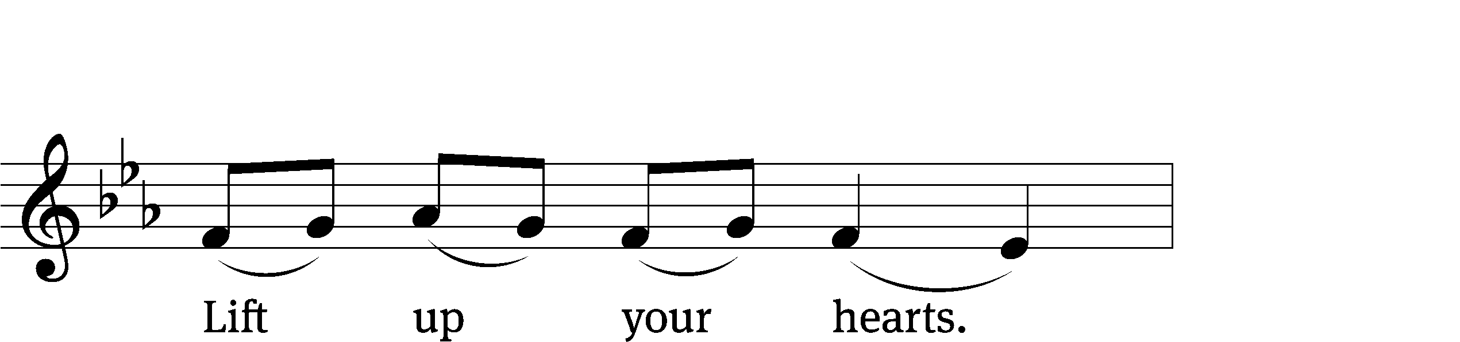
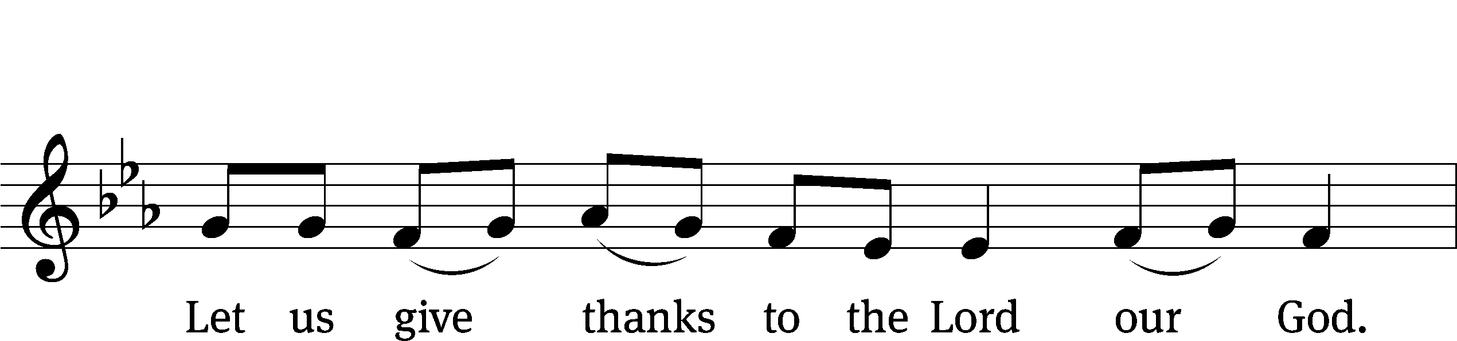
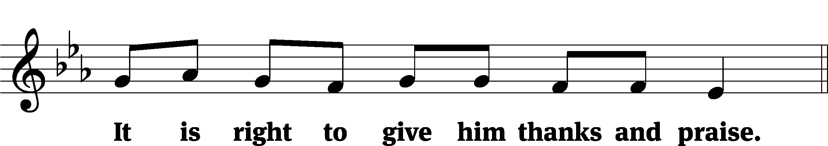

It is truly good and right that we should at all times and in all places give you thanks, O Lord, holy Father, almighty and everlasting God, through Jesus Christ our Lord, who on this day kept his promise and poured out the Holy Spirit to empower his Church to proclaim the gospel in all the world. Therefore, with all the saints on earth and hosts of heaven, we praise your holy name and join their glorious song:

Holy, Holy, Holy CW 167
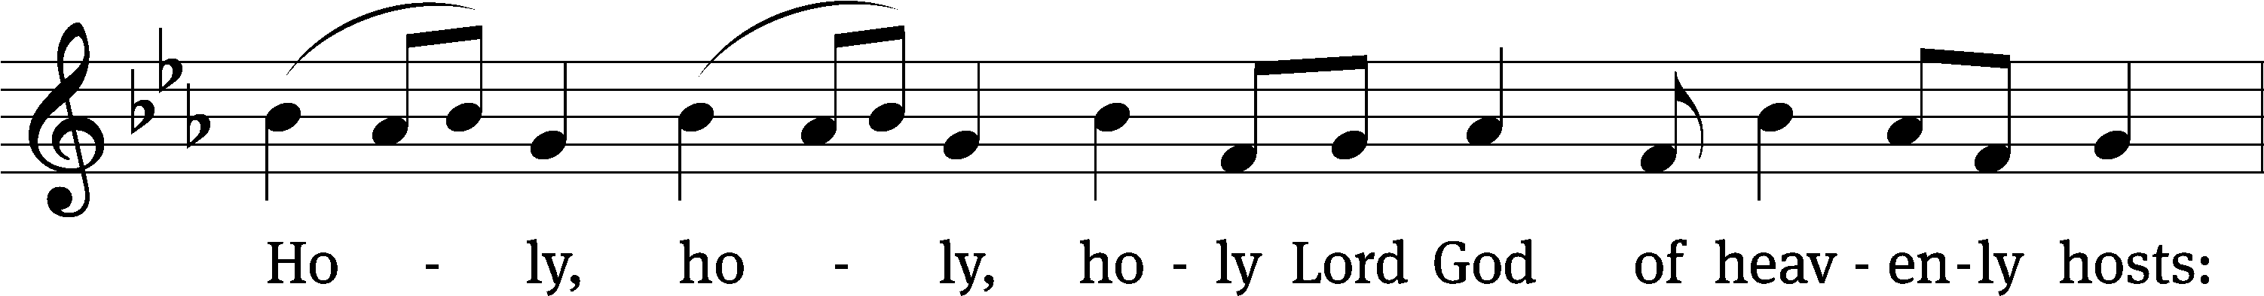
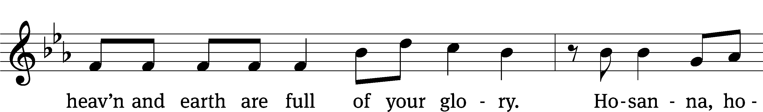
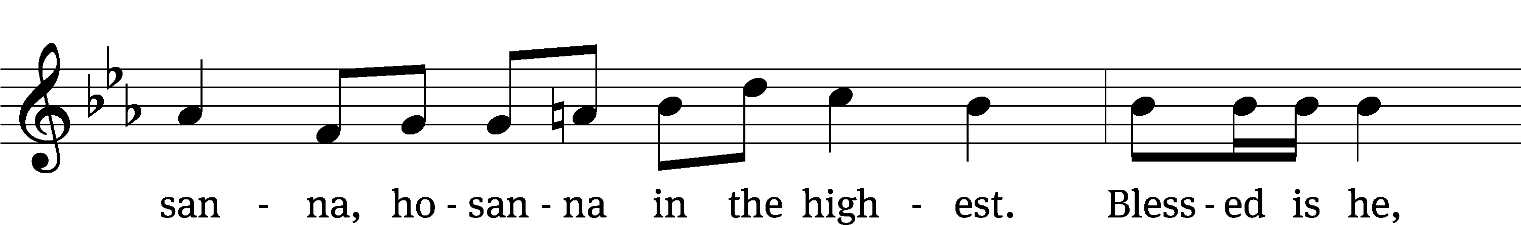
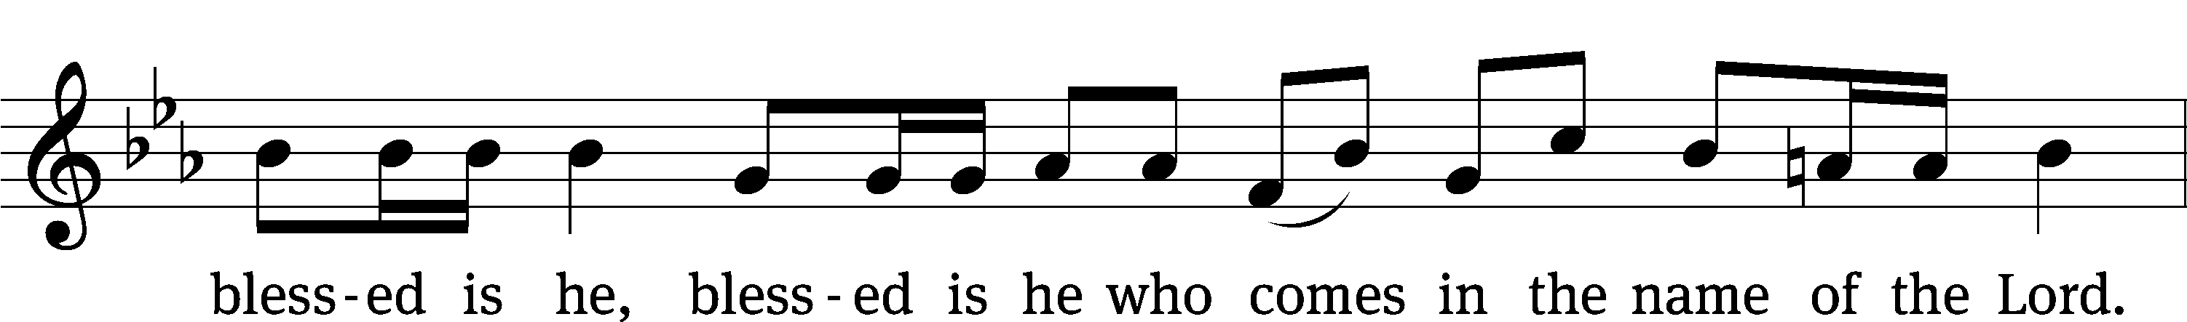
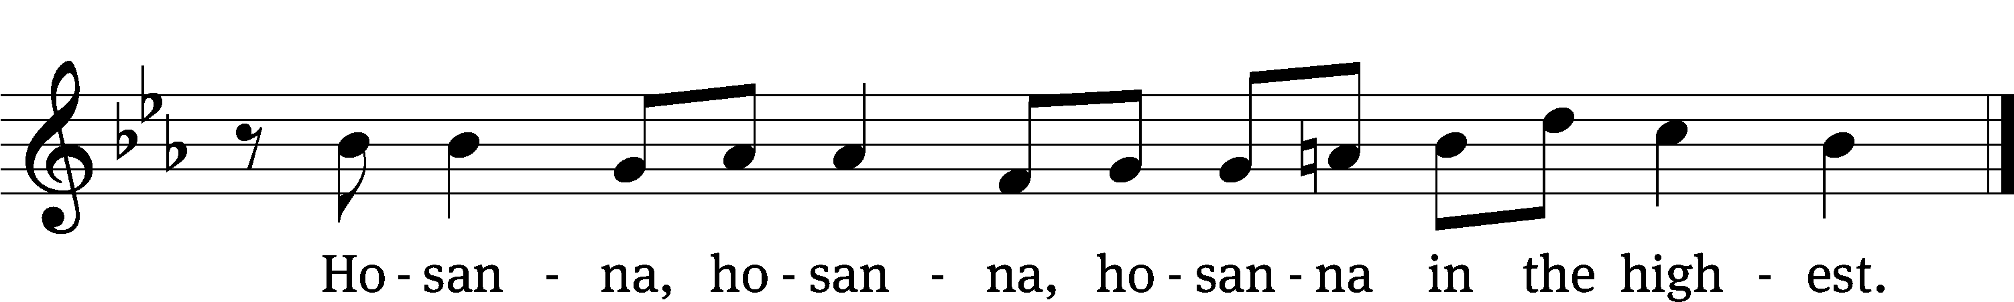

Prayer of Thanksgiving
We give thanks to you, O God, through your dear Son, Jesus Christ, whom you sent to be our Savior, our Redeemer, and the messenger of your grace. Through him you made all things; in him you are well pleased. He is the incarnate Word, conceived by the Holy Spirit and born of the Virgin Mary. To fulfill your promises, he stretched out his hands on the cross and released from eternal death all who believe in you.

As we remember Jesus’ death and resurrection, we thank you that you have gathered us together to receive your Son’s body and blood. Send us your Spirit, unite us as one, and strengthen our faith so that we may praise you in your Son, Jesus Christ. Through him, we glorify and honor you, O God our Father, with the Holy Spirit, one God, now and forever.
Amen.

Lord’s Prayer
Our Father, who art in heaven, hallowed be thy name, thy kingdom come, thy will be done on earth as it is in heaven. Give us this day our daily bread; and forgive us our trespasses, as we forgive those who trespass against us; and lead us not into temptation, but deliver us from evil. For thine is the kingdom and the power and the glory forever and ever. Amen.

Words of Institution
Our Lord Jesus Christ, on the night he was betrayed, took bread; and when he had given thanks, he broke it and gave it to his disciples, saying, “Take and eat; this is my body, which is given for you. Do this in remembrance of me.”
Then he took the cup, gave thanks, and gave it to them, saying, “Drink from it, all of you; this is my blood of the new covenant, which is poured out for you for the forgiveness of sins. Do this, whenever you drink it, in remembrance of me.”

The peace of the Lord be with you always.
Amen.

O Christ, Lamb of God CW 169
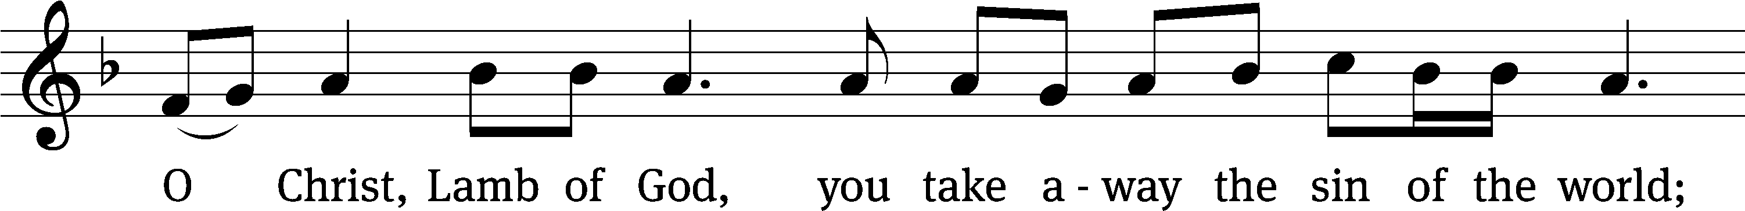
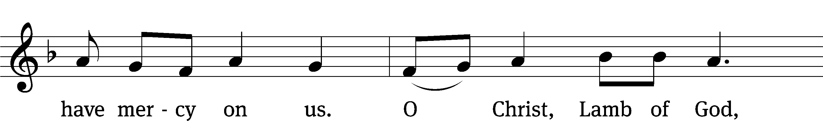
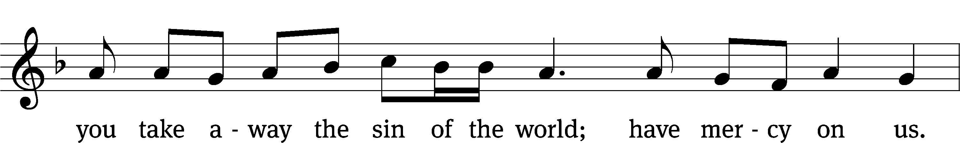
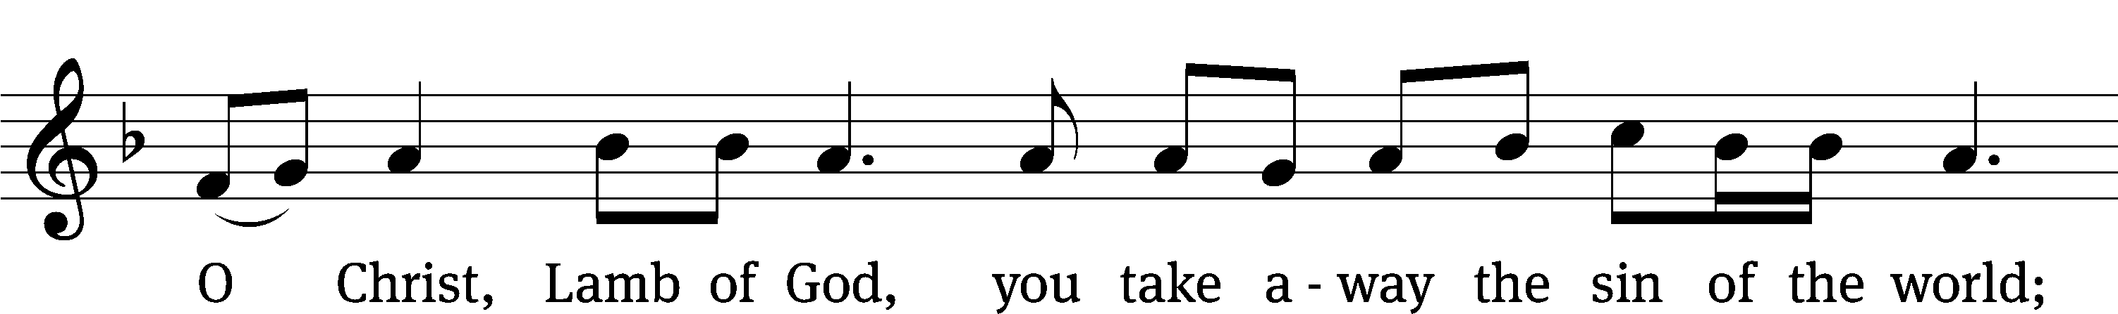
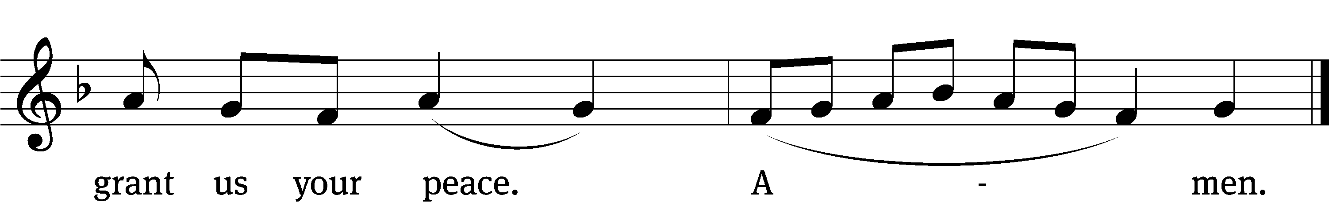

Please be seated

566 Father, God of Grace, You Knew Us CW 566
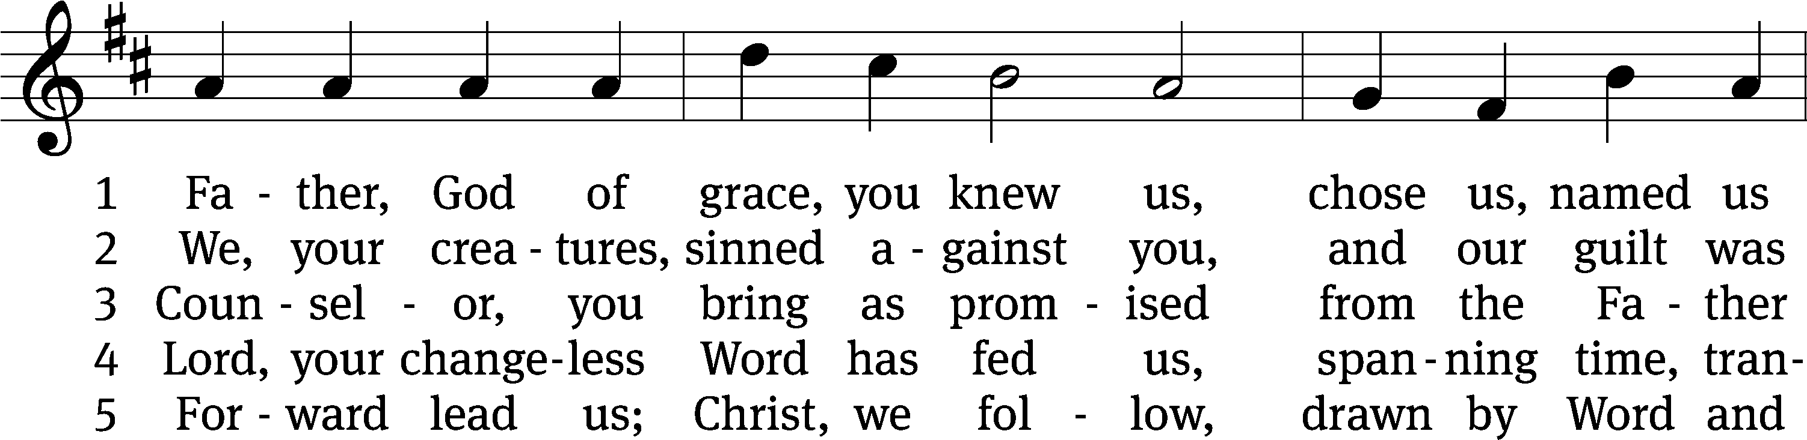
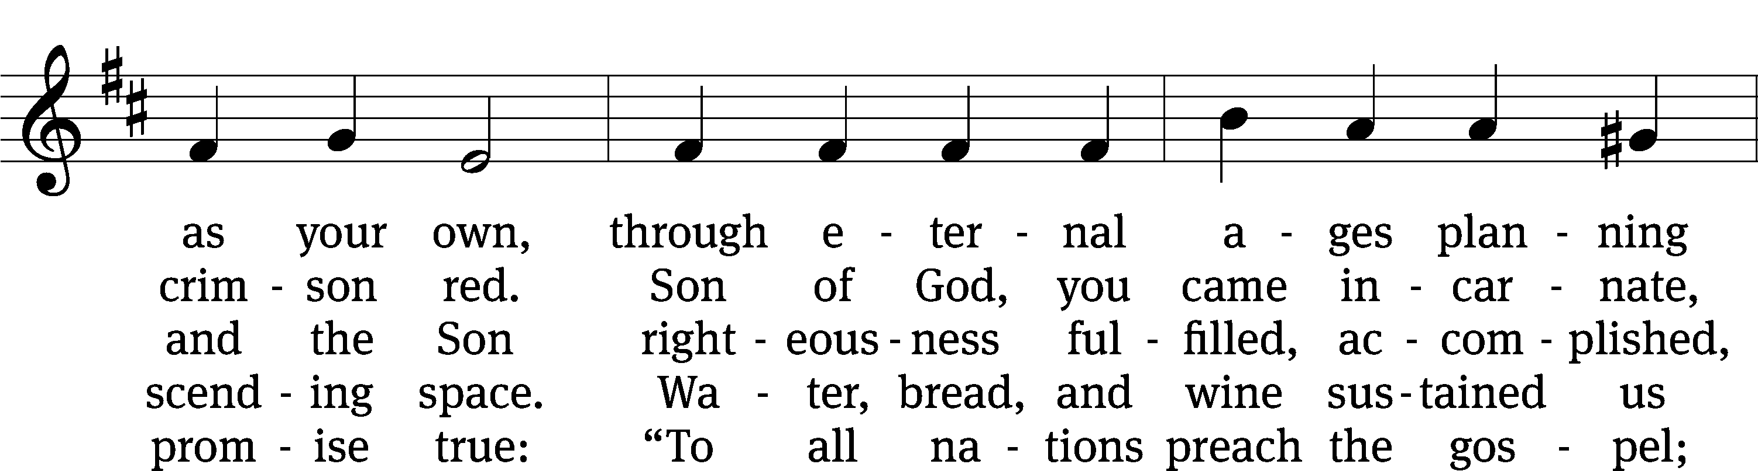
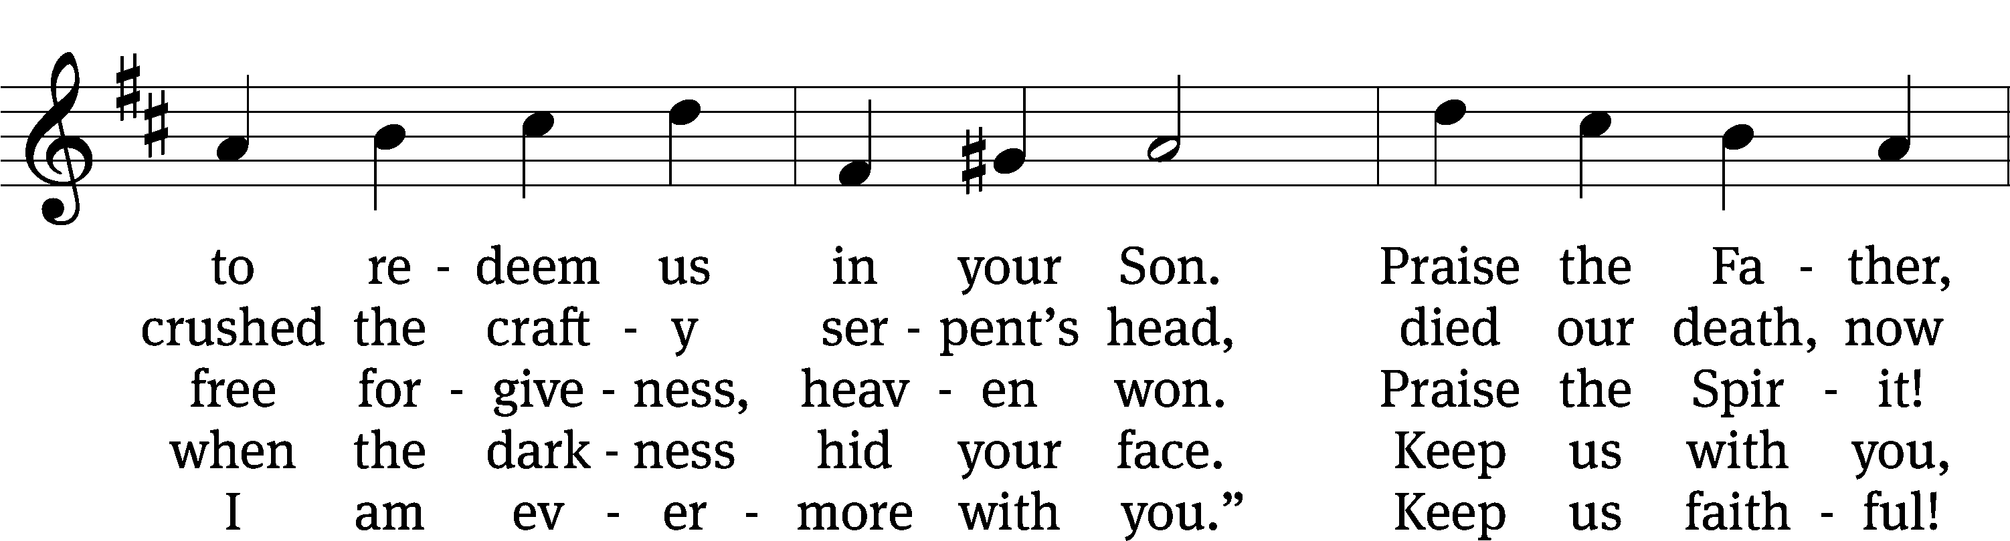
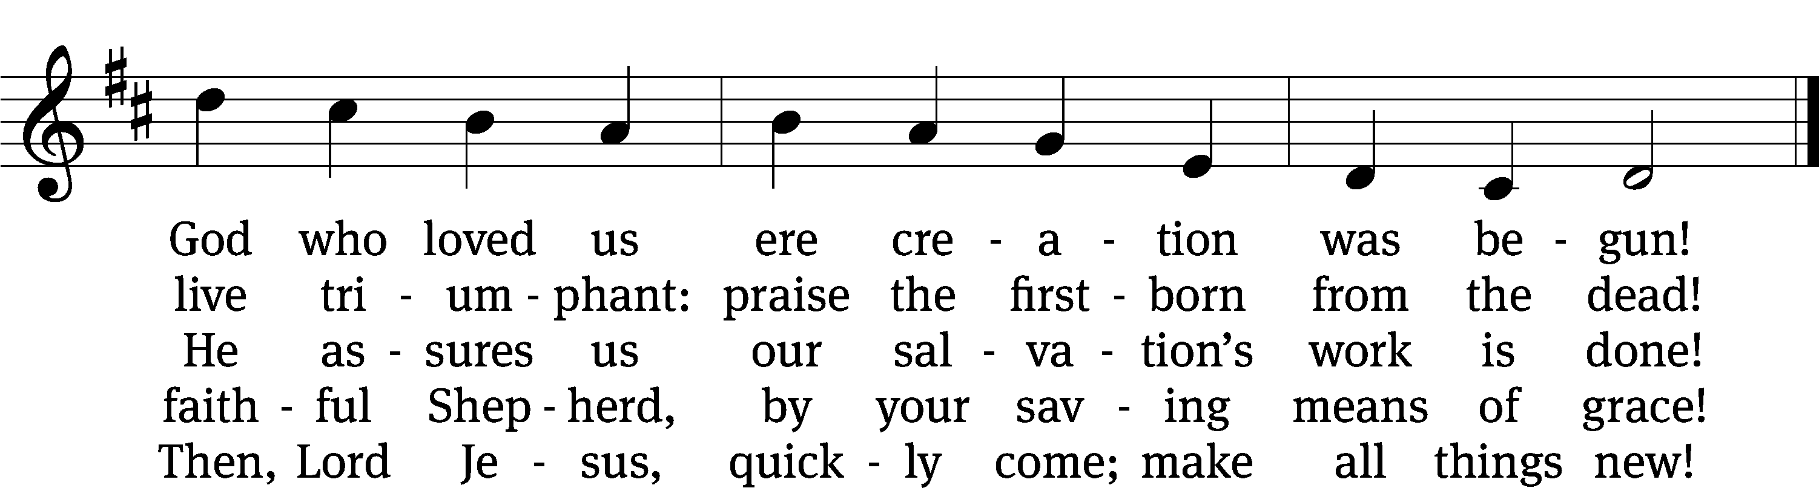
Text: Paul E. Eickmann, 1928–2006, abr.
Tune: John Goss, 1800–1880
Text: © 1999 Northwestern Publishing House. Used by permission: OneLicense no. 727703
Tune: Public domain

481 Alleluia! Let Praises Ring CW 481
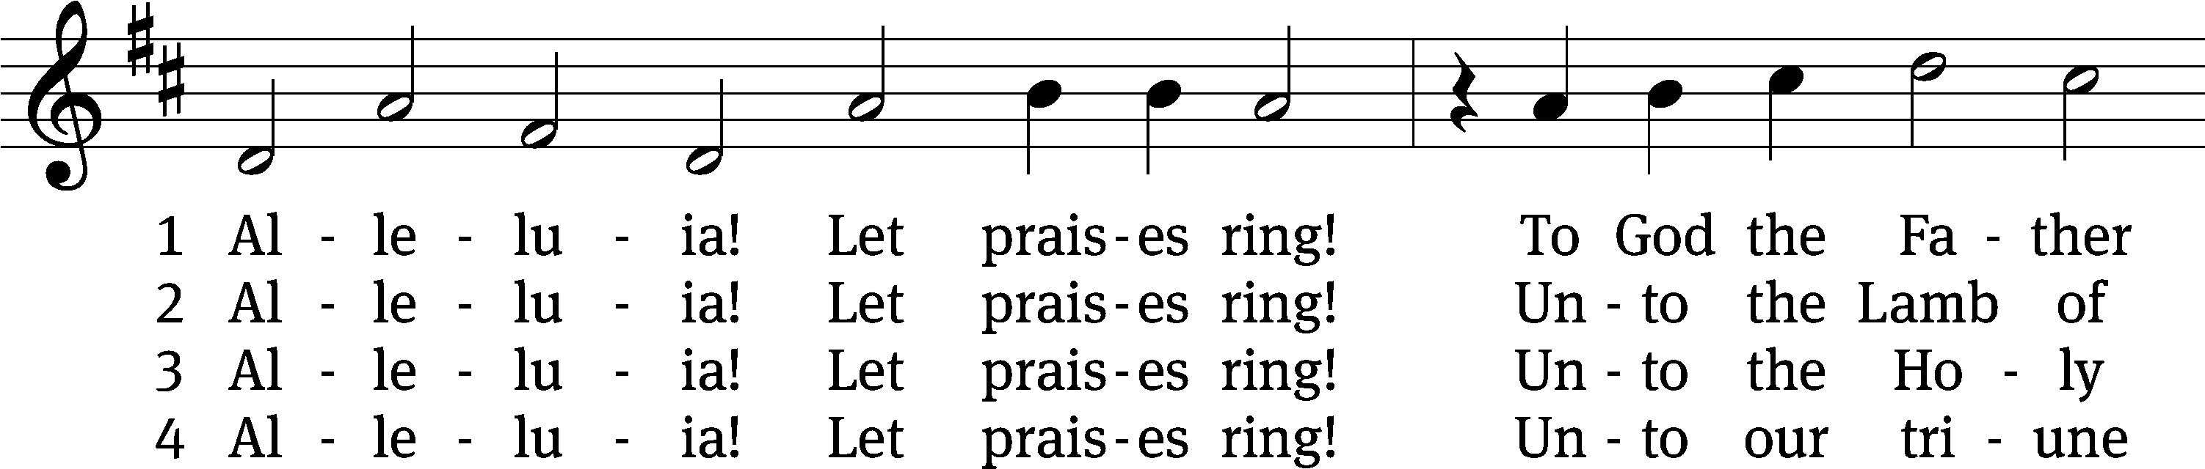
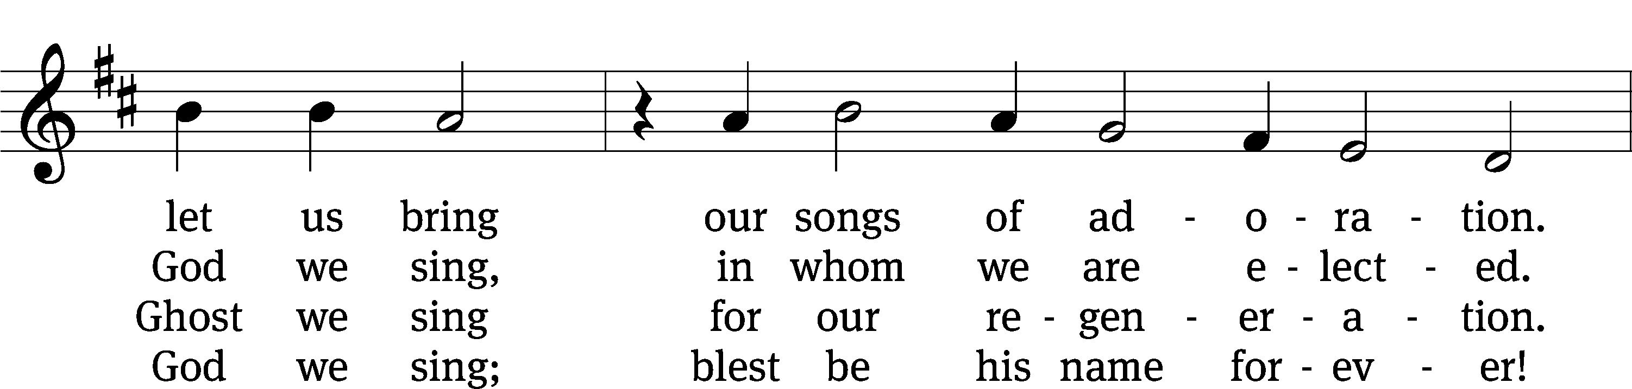
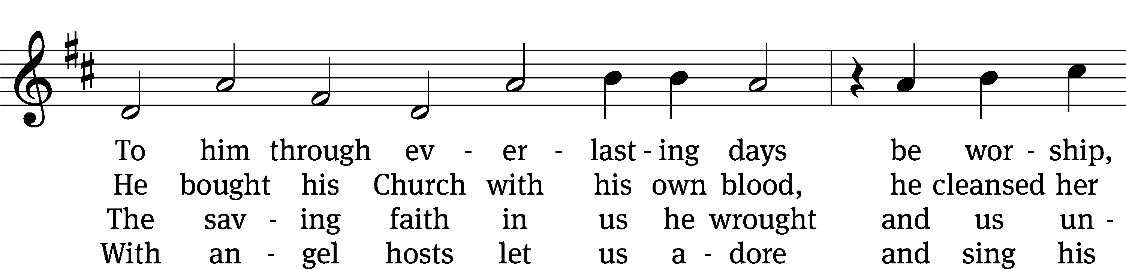
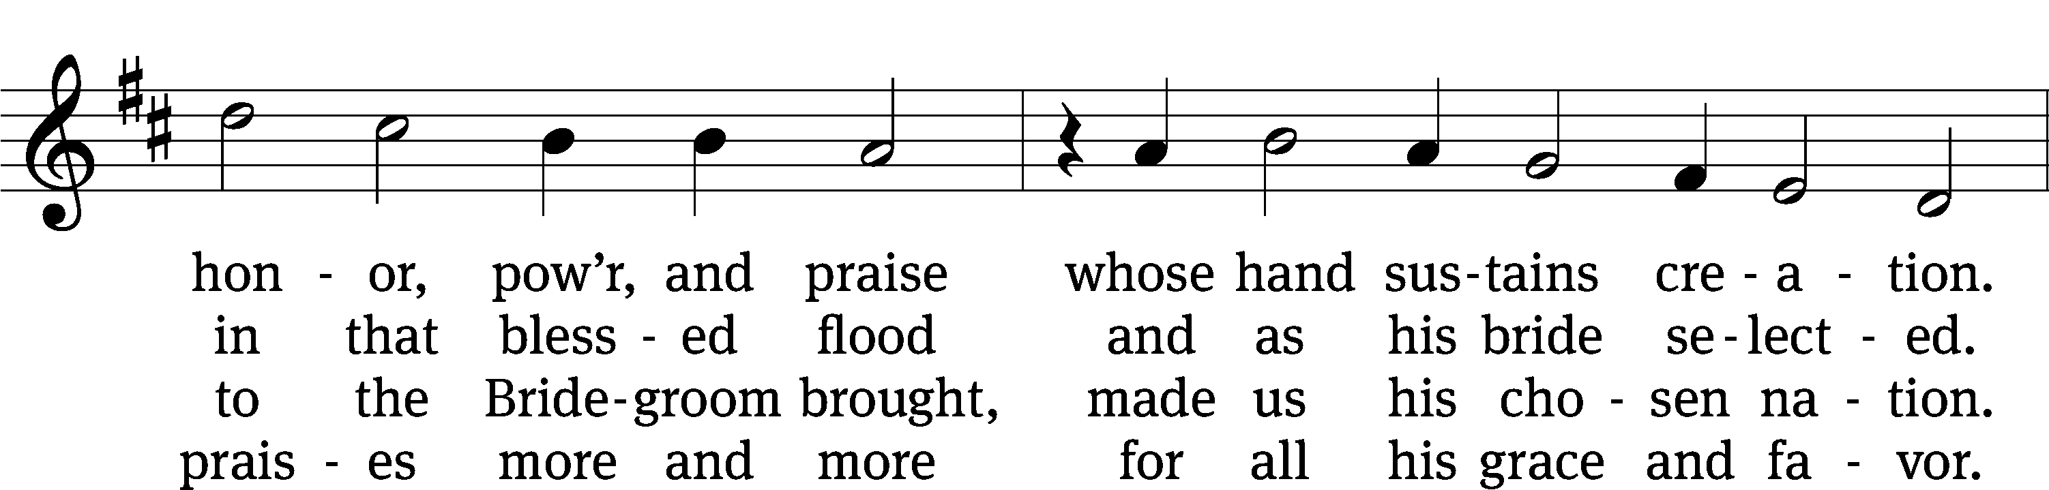
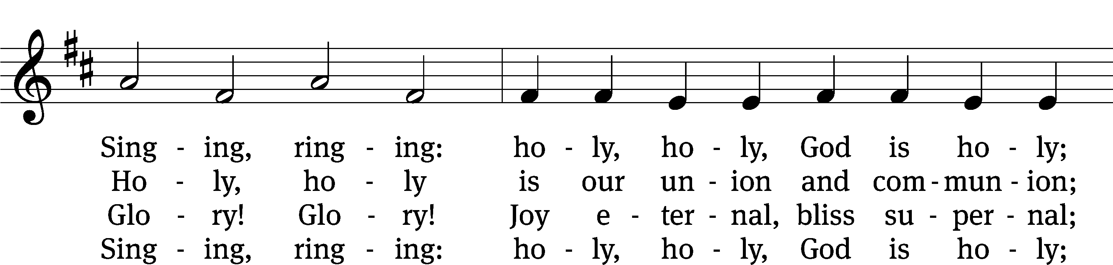
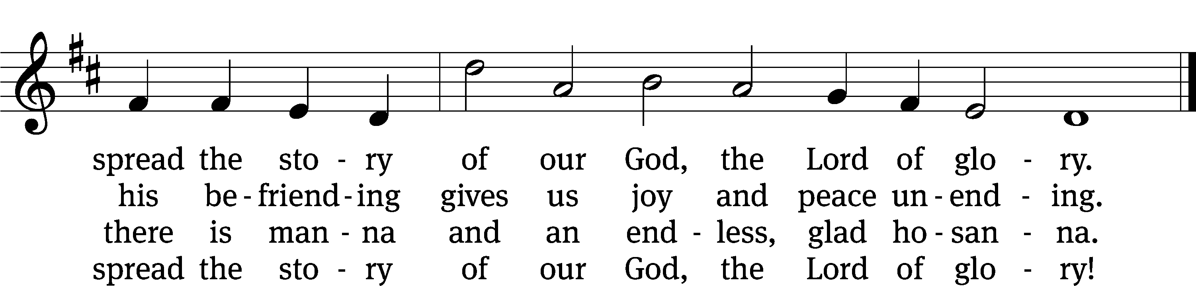
Text: tr. The Lutheran Hymnal, 1941, alt.; Geistreiches Gesang-Buch, Darmstadt, 1698, abr.
Tune: Philipp Nicolai, 1556–1608
Text and tune: Public domain

Please stand, if you are able

Give thanks to the Lord, for he is good;
his mercy endures forever.
Whenever we eat this bread and drink this cup,
we proclaim the Lord’s death until he comes.

We give thanks, almighty God, that you have refreshed us with this saving gift. We pray that through it you will strengthen our faith in you and increase our love for one another. We ask this in the name of Jesus Christ our Lord, who lives and reigns with you and the Holy Spirit, one God, now and forever.
Amen.

Blessing
The Lord bless you and keep you.
The Lord make his face shine on you and be gracious to you.
The Lord look on you with favor and give you peace.
Amen.

Please be seated

593 Holy Spirit, Light Divine CW 593
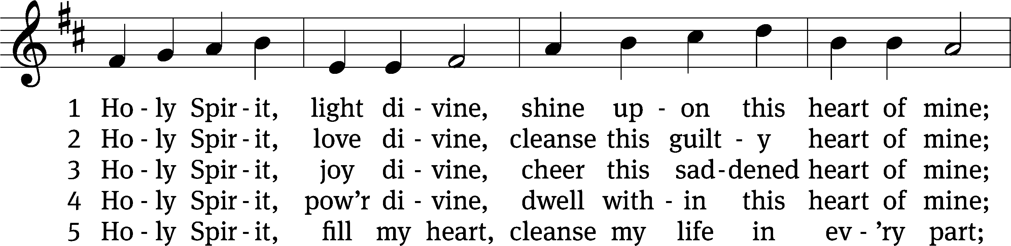
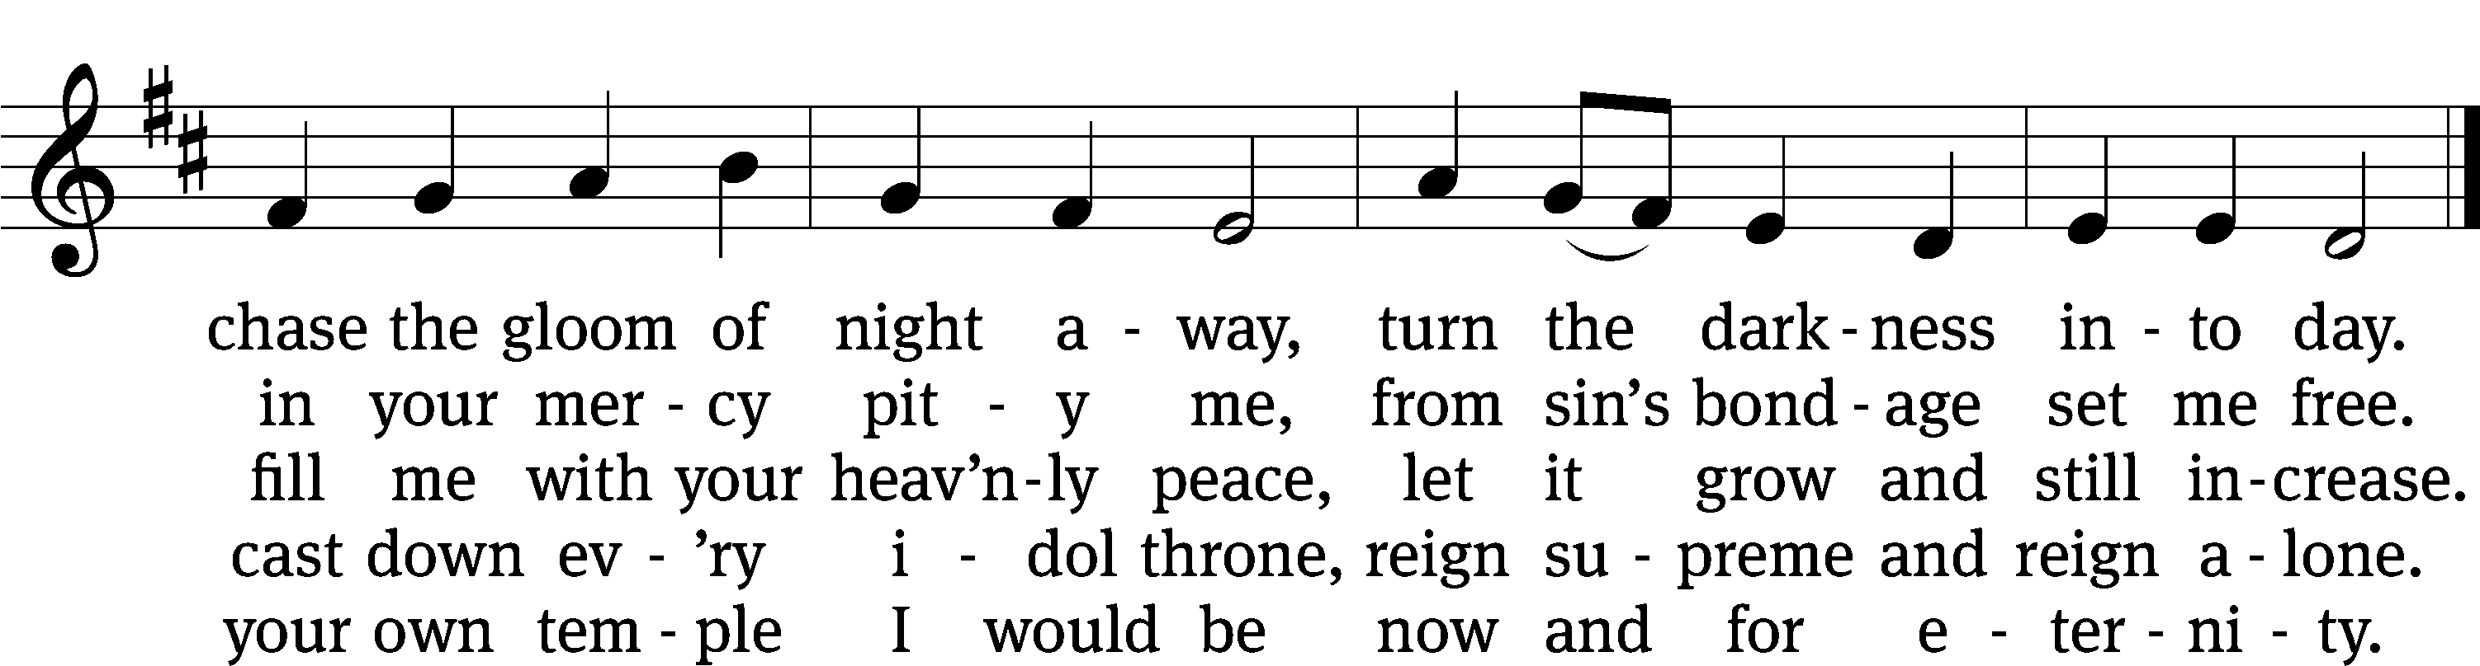
Text: Andrew Reed, 1787–1862, abr., alt.
Tune: Orlando Gibbons, 1583–1625
Text and tune: Public domain

Acknowledgments
Setting One from Christian Worship
Software distributed in partnership with Northwestern Publishing House.
Created by Christian Worship: Service Builder © 2022 Concordia Publishing House.

Serving in Worship
Officiant Pastor Natsis
Organist Marcia Marion Ackling
Deacons (Thursday) Dave Frey and Jim Tice
(Sunday) Jeff Neuburger and Ed Wheeler
Ushers (Thursday) Robert Newman and Henry Schneider
(Sunday) Ed Sala and Al Whitley
Altar Guild Esther Gross and Diane Stevenson
Videographer Ann Latowski

