THE FIRST SUNDAY
AFTER PENTECOST

“THE HOLY TRINITY”

tRINITY EVANGELICAL LUTHERAN CHURCH | Saline, Michigan
June 9/12, 2022

WELCOME TO WORSHIP

Thank you for joining us in God’s house today! We cordially ask that our Guests with us this morning sign one of the guestbooks located at either the front or back entryways.

THANK OFFERING: Members of Trinity give their offering as an expression of love and thankfulness to the Lord and to help support the Lord’s work in our community and around the world. Visitors need not feel obligated to participate in this offering which supports our ministry.

Restrooms are located at the back of the upper level (the annex), and in the basement (down the back stairs of the sanctuary or annex). Handicap access is available, please ask an usher for assistance.

Young Families / Toddler Bags – We are GLAD YOU BROUGHT YOUR CHILDREN to our worship service. Jesus said: “Let the little children come to me and do not hinder them, for the kingdom of God belongs to such as these.” We know that having little children in church can be a challenge, but DO NOT WORRY about it. Many of your fellow worshippers have been in your shoes and are just happy you brought your children with you. For your convenience, we have reserved the back rows of seating for parents with small children. These areas provide more flexibility for your family, as well as, easy access to move downstairs if necessary. A closed-circuit TV system allows families to continue participating in the service while downstairs. Pre-school toddler bags and children’s bulletins are available for their enjoyment. Ask an usher for one to use during the service and please return the toddler bag afterwards.

SERVICE of the word

483 Holy, Holy, Holy! Lord God Almighty CW 483
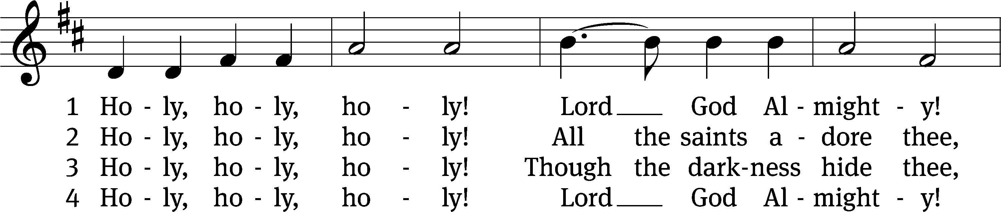
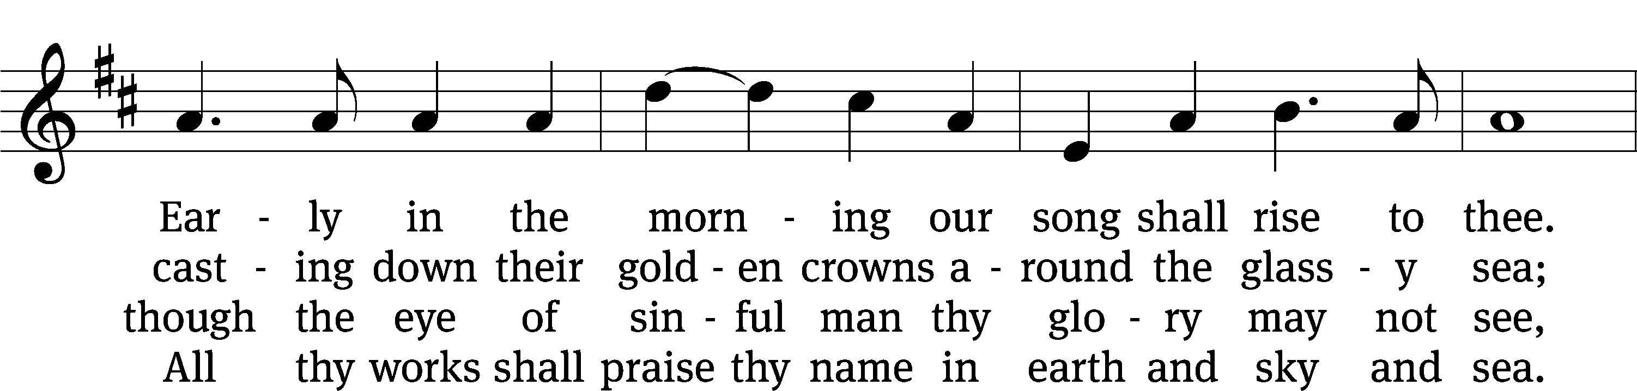
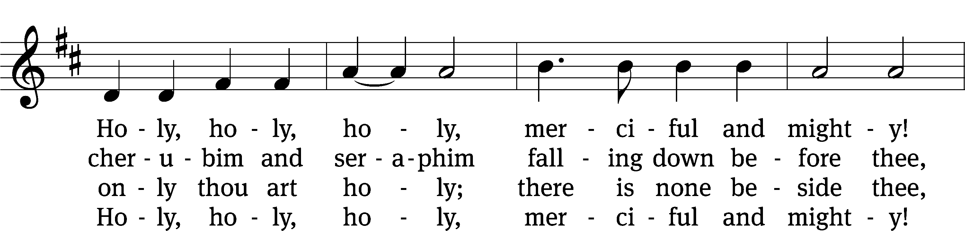
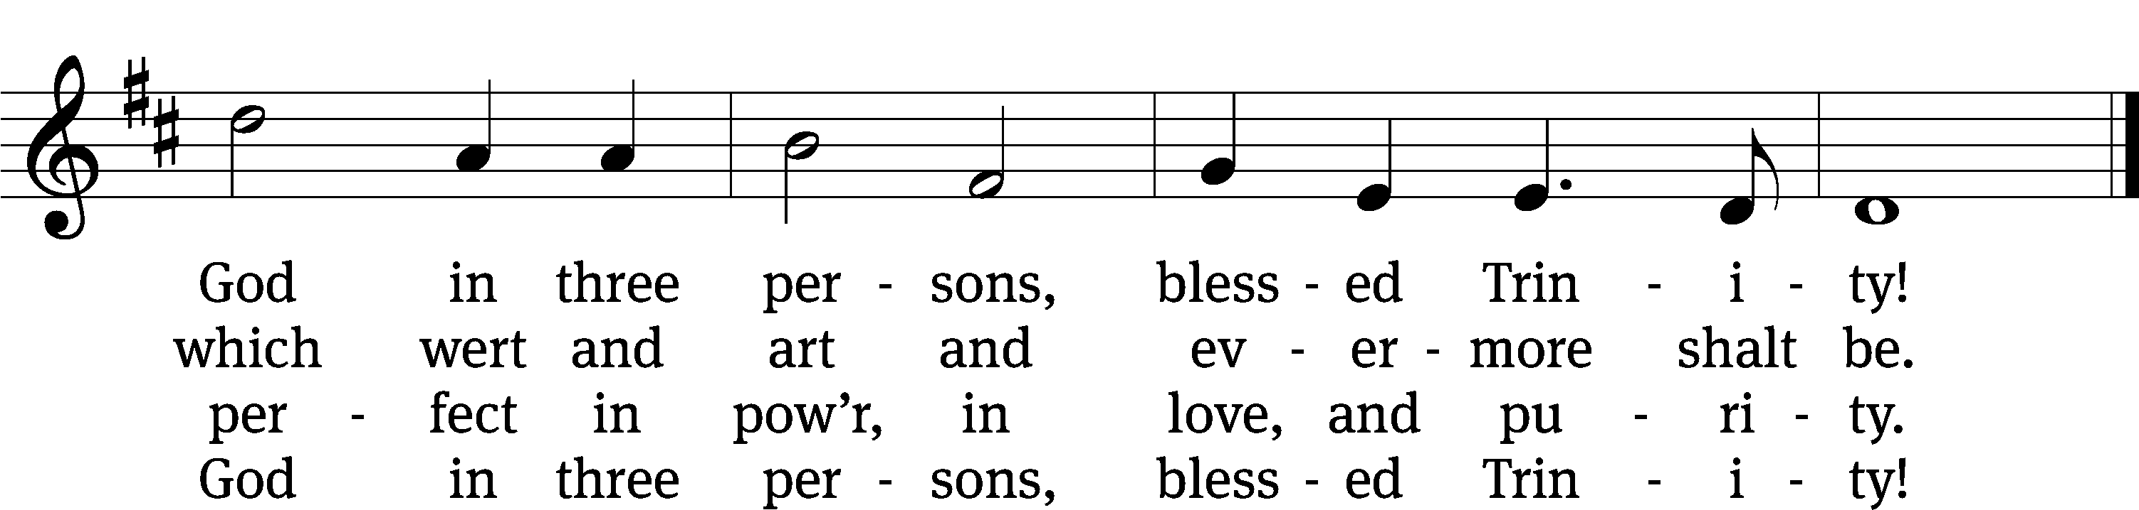
Text: Reginald Heber, 1783–1826, alt.
Tune: John B. Dykes, 1823–1876
Text and tune: Public domain

PLEASE STAND, IF YOU ARE ABLE

invocation
M: The grace of our Lord (+) Jesus Christ and the love of God and the fellowship of the Holy Spirit be with you.
C: And also with you.
CONFESSION OF SINS
M: We have come into the presence of God, who created us to love and serve him as his dear children. But we have disobeyed him and deserve only his wrath and punishment. Therefore, let us confess our sins to him and plead for his mercy.

C: Merciful Father in heaven, I am altogether sinful from birth. In countless ways I have sinned against you and do not deserve to be called your child. But trusting in Jesus, my Savior, I pray: Have mercy on me according to your unfailing love. Cleanse me from my sin, and take away my guilt.
M: God, our heavenly Father, has forgiven all your sins. By the perfect life and innocent death of our Lord Jesus Christ, he has removed your guilt forever. You are his own dear child. May God give you strength to live according to his will.

C: Amen.
PRAYER AND PRAISE

M: In the peace of forgiveness, let us praise the Lord.

OH, TASTE AND SEE

PRAYER OF THE DAY

M: Let us pray.
The minister says the Prayer of the Day.

PLEASE BE SEATED

The Word

the FIRST LESSON nUMBERS 6:22-27
²² The Lord told Moses ²³ to speak to Aaron and to his sons and to tell them to bless the Israelites with these words:
²⁴ The Lord bless you and keep you.
²⁵ The Lord make his face shine on you
and be gracious to you.
²⁶ The Lord look on you with favor
and give you peace.
²⁷ In this way they will put my name on the Israelites, and I will bless them.

PSALM OF THE DAY
8D I Will Praise Your Name Forever Psalm 8D
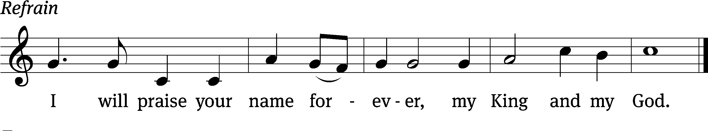

Lord, our Lord, how majestic is your name in / all the earth!
You have set your glory in the / heavens.
When I consider your heavens, the work of your / fingers,
the moon and the stars, which you have / set in place,
what is a human being that you are mind- / ful of him,
a Son of Man that you / care for him? Refrain

You made him a little lower than the / angels
and crowned him with glory and / honor.
You made him ruler over the works / of your hands;
you put everything un- / der his feet.
Glory be to the Father and / to the Son
and to the Holy / Spirit,
as it was in the be- / ginning,
is now, and will be forever. / Amen. Refrain
Text: Lectionary for Mass
Tune: Lynn Trapp
Setting: Kermit G. Moldenhauer
Text: © 1969 ICEL. Used by permission: License no. 130003540
Tune: © 1989 MorningStar Music Publishers. Used by permission: OneLicense no. 727703
Setting: © 1993 Kermit G. Moldenhauer, admin. Northwestern Publishing House. Used by permission: OneLicense no. 727703

THE SECOND LESSON ROMANS 5:1-5
¹ Therefore, since we have been justified by faith, we have peace with God through our Lord Jesus Christ. ² Through him we also have obtained access by faith into this grace in which we stand. And we rejoice confidently on the basis of our hope for the glory of God.
³ Not only this, but we also rejoice confidently in our sufferings, because we know that suffering produces patient endurance, ⁴ and patient endurance produces tested character, and tested character produces hope. ⁵ And hope will not put us to shame, because God’s love has been poured out into our hearts by the Holy Spirit, who was given to us.

PLEASE Stand, if you are able

Verse of the day

THE GOSPEL LESSON JOHN 16:12-15
M: The Gospel according to John chapter 16, verses 12-15

¹² “I still have many things to tell you, but you cannot bear them now. ¹³ But when he, the Spirit of truth, comes, he will guide you into all truth. For he will not speak on his own, but whatever he hears he will speak. He will also declare to you what is to come. ¹⁴ He will glorify me, because he will take from what is mine and declare it to you. ¹⁵ Everything the Father has is mine. This is why I said that he takes from what is mine and will declare it to you.

M: This is the Gospel of the Lord.

PLEASE BE SEATED

586 Come, Holy Ghost, Creator Blest CW 586 sts. 1–2, 5–7
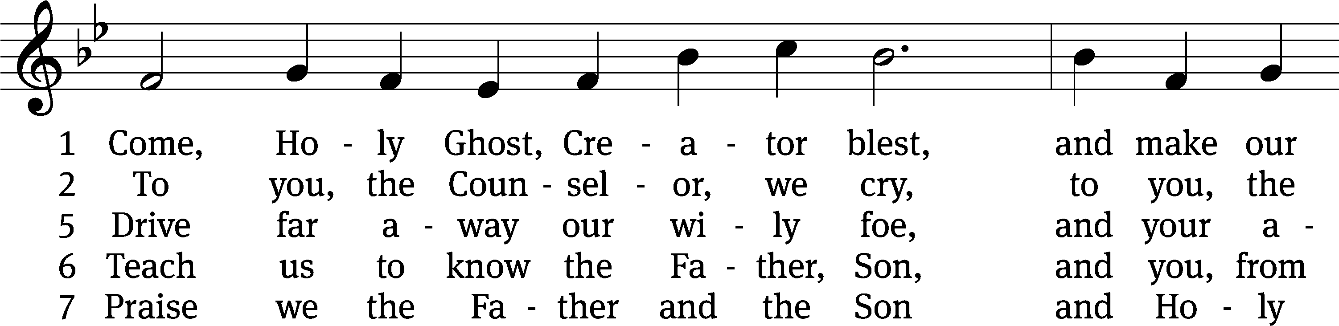
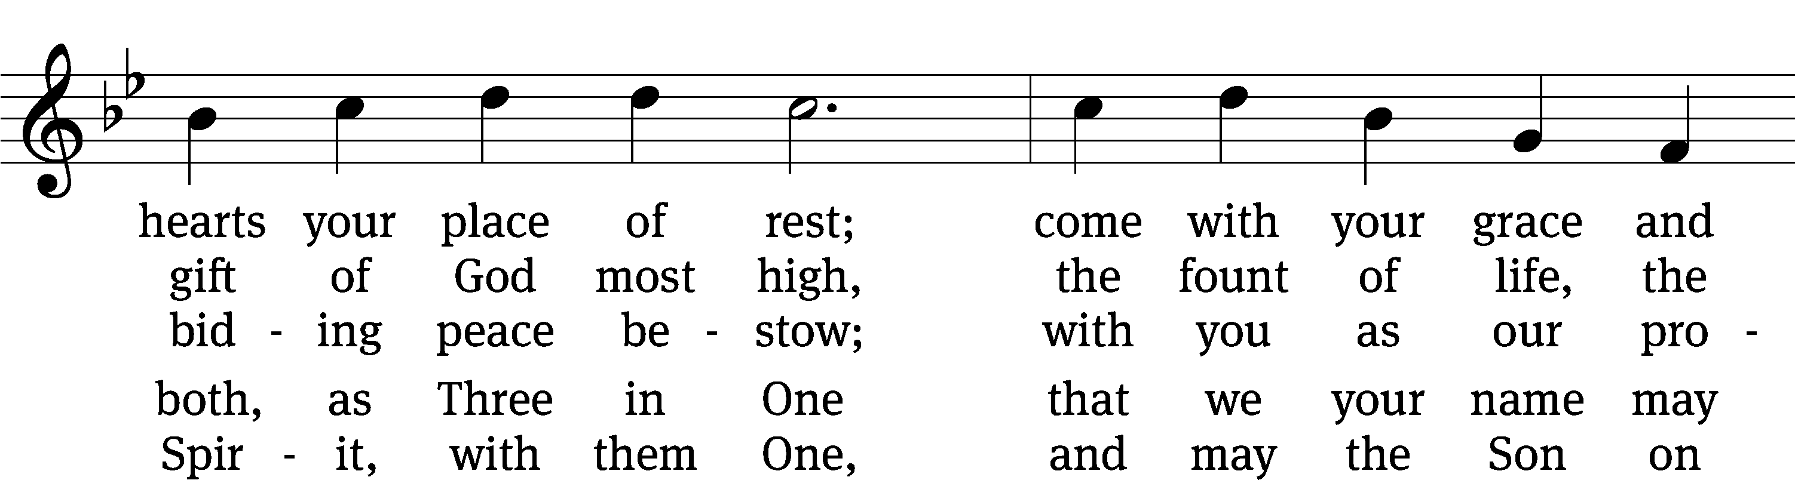
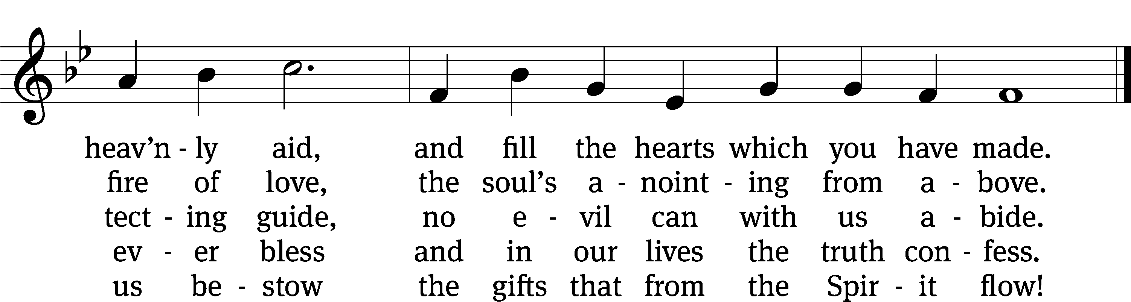
Text: tr. Edward Caswall, 1814–1878, alt.; attr. Rhabanus Maurus, 776–856
Tune: Geistliche lieder auffs new gebessert, Wittenberg, 1533, ed. Joseph Klug
Text and tune: Public domain

SERMON TEXT AND THEME NUMBERS 6:22-27
“More than a Mystery”

PLEASE STAND, IF YOU ARE ABLE

THE ATHANASIAN CREED
Whoever wishes to be saved must, above all else, hold to the true Christian faith.
Whoever does not keep this faith pure in all points will certainly perish forever.

Now this is the true Christian faith:
We worship one God in three persons and three persons in one God,
without mixing the persons or dividing the divine being.
For each person—the Father, the Son, and the Holy Spirit—is distinct,
but the deity of Father, Son, and Holy Spirit is one,
equal in glory and coeternal in majesty.
What the Father is, so is the Son, and so is the Holy Spirit.
The Father is uncreated, the Son uncreated, the Holy Spirit uncreated;
the Father is infinite, the Son infinite, the Holy Spirit infinite;
the Father is eternal, the Son eternal, the Holy Spirit eternal;
yet they are not three who are eternal, but there is one who is eternal,
just as they are not three who are uncreated, nor three who are infinite,
but there is one who is uncreated and one who is infinite.
In the same way the Father is almighty, the Son is almighty, the Holy Spirit is almighty;
yet they are not three who are almighty, but there is one who is almighty.
So the Father is God, the Son is God, the Holy Spirit is God;
yet they are not three Gods, but one God.
So the Father is Lord, the Son is Lord, the Holy Spirit is Lord;
yet they are not three Lords, but one Lord.
For just as Christian truth compels us to confess each person individually to be God and Lord,
so the true Christian faith forbids us to speak of three Gods or three Lords.
The Father is neither made nor created nor begotten of anyone.
The Son is neither made nor created, but is begotten of the Father alone.
The Holy Spirit is neither made nor created nor begotten,
but proceeds from the Father and the Son.
So there is one Father, not three Fathers; one Son, not three Sons;
one Holy Spirit, not three Holy Spirits.
And within this Trinity none comes before or after; none is greater or inferior,
but all three persons are coequal and coeternal,
so that in every way, as stated before, all three persons are to be worshiped as one God
and one God worshiped as three persons.
Whoever wishes to be saved must have this conviction of the Trinity.

It is furthermore necessary for eternal salvation truly to believe
that our Lord Jesus Christ also took on human flesh.
Now this is the true Christian faith:
We believe and confess that our Lord Jesus Christ, God’s Son,
is both God and man.
He is God, eternally begotten from the nature of the Father, and he is man, born in time
from the nature of his mother, fully God, fully man, with rational soul and human flesh,
equal to the Father as to his deity, less than the Father as to his humanity;
and though he is both God and man, Christ is not two persons but one,
one, not by changing the deity into flesh, but by taking the humanity into God;
one, indeed, not by mixture of the natures, but by unity in one person;
for just as the rational soul and flesh are one human being,
so God and man are one Christ.
He suffered for our salvation, descended into hell, rose the third day from the dead.
He ascended into heaven, is seated at the right hand of God the Father almighty,
and from there will come to judge the living and the dead.
At his coming all people will rise with their own bodies
to answer for their personal deeds.
Those who have done good will enter eternal life,
but those who have done evil will go into eternal fire.

This is the true Christian faith.
Whoever does not faithfully and firmly believe this cannot be saved.

PRAYER OF THE CHURCH

THE LORD’S PRAYER

C: Our Father, who art in heaven, hallowed be thy name, thy kingdom come, thy will be done on earth as it is in heaven. Give us this day our daily bread; and forgive us our trespasses, as we forgive those who trespass against us; and lead us not into temptation, but deliver us from evil. For thine is the kingdom and the power and the glory forever and ever. Amen.

PLEASE BE SEATED

940 We All Believe in One True God CW 940
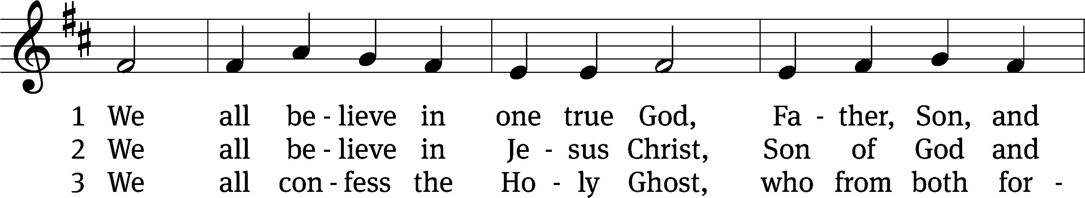
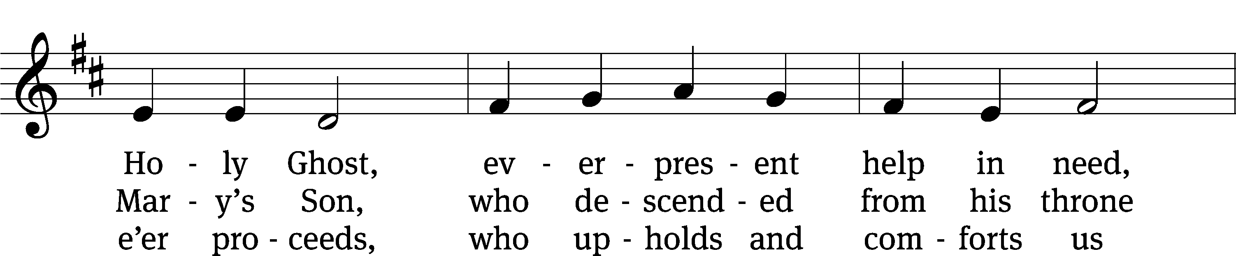
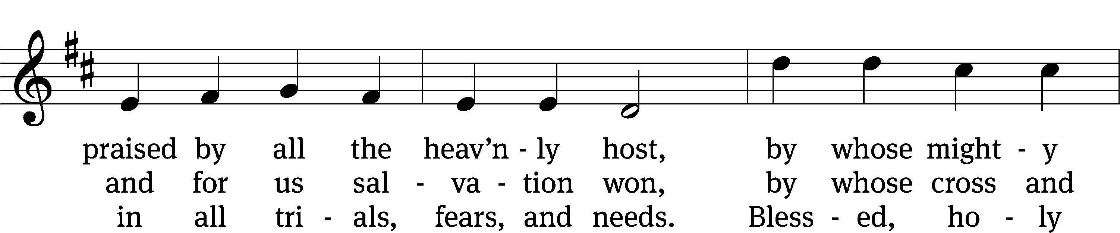
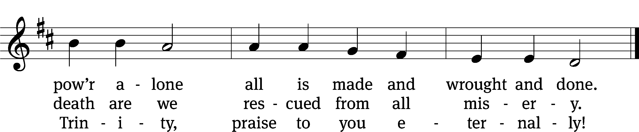
Text: tr. Catherine Winkworth, 1827–1878, alt.; Tobias Clausnitzer, 1619–1684
Tune: adapt. Cornelius H. Dretzel, 1697–1775; Neu-vermehrtes . . . Gesangbuch, 3rd. ed., Meiningen, 1693
Text and tune: Public domain

PLEASE STAND, IF YOU ARE ABLE

CLOSING PRAYER
M: Almighty God, we thank you for teaching us the things you want us to believe and do. Help us by your Holy Spirit to keep your Word in pure hearts that we may be strengthened in faith, guided in holiness, and comforted in life and in death, through Jesus Christ, our Lord, who lives and reigns with you and the Holy Spirit, one God, now and forever.

M: Brothers and sisters, go in peace. Live in harmony with one another. Serve the Lord with gladness.
The Lord bless you and keep you.
The Lord make his face shine on you and be gracious to you.
The Lord look on you with favor and (+) give you peace.

PLEASE BE SEATED

930 Go, My Children, with My Blessing CW 930
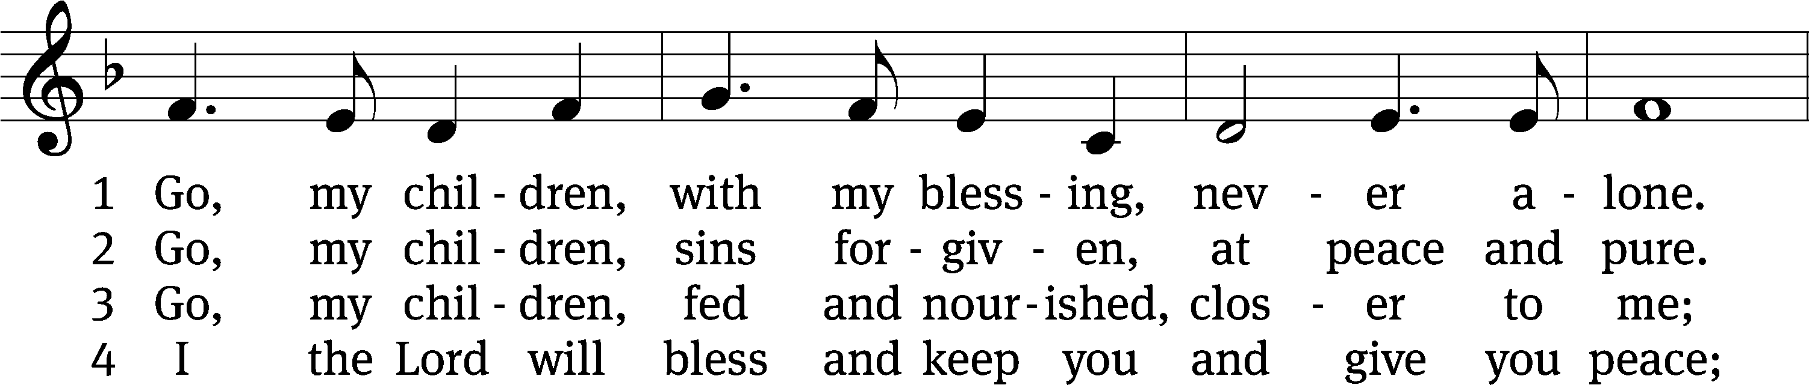
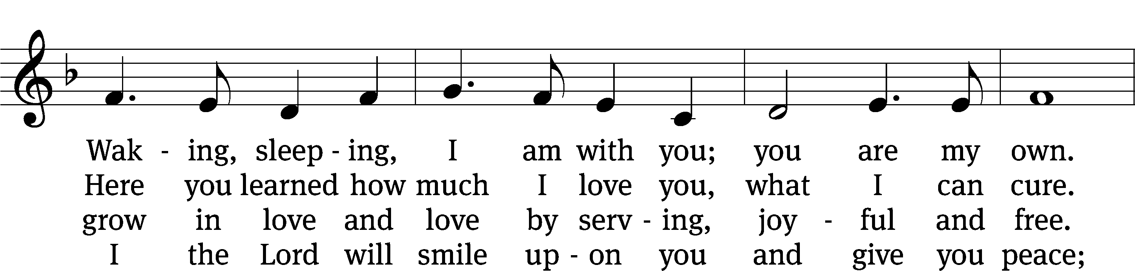
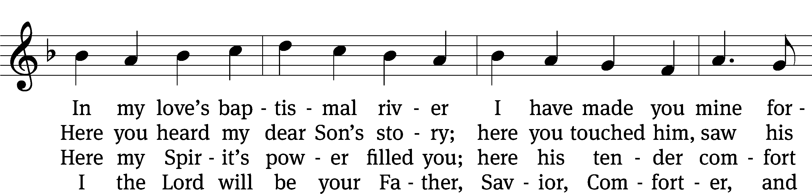
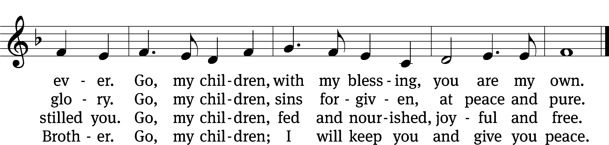
Text: Jaroslav J. Vajda, 1919–2008
Tune: Welsh, 18th cent.
Text: © 1983 Concordia Publishing House. Used by permission: OneLicense no. 727703
Tune: Public domain

Serving In Worship
Officiant Pastor William Natsis
Organist Sarah Hanke
Deacons (Thursday) Dave Frey and Jim Tice
(Sunday) Jeff Neuburger and Ed Wheeler
Ushers (Thursday) Bob Newman and Henry Schneider
(Sunday) Ed Sala and Al Whitley
Altar Guild Esther Gross and Diane Stevenson
Videographer Jake Vershunm

Copyright information
Service of the Word: Christian Worship. © 1993 Northwestern Publishing House. All rights reserved.
Reprinted with permission under ONE LICENSE #A-727703 and CCLI #1151741/CSPL126093

Words and Music: All rights reserved. Reprinted with permission under ONE LICENSE #A-727703 and
CCLI #1151741/CSPL126093

tlcsaline.church

