THE THIRD SUNDAY
AFTER PENTECOST

TRINITY EVANGELICAL LUTHERAN CHURCH | Saline, Michigan
WELCOME TO WORSHIP June 15/18, 2023

Thank you for joining us in God’s house today! We cordially ask that our guests sign one of the guestbooks located at either the front or back entryways.

THANK OFFERING: Members of Trinity give their offering as an expression of love and thankfulness to the Lord and to help support the Lord’s work in our community and around the world. Visitors need not feel obligated to participate in this offering which supports our ministry.

Restrooms are located at the back of the upper level (the annex), and in the basement (down the back stairs of the sanctuary or annex). Handicap access is available, please ask an usher for assistance.

celebration of holy communion:
In His Word, God makes it clear that the Lord’s Supper is to be shared by people of a common proclamation of faith (1 Corinthians 11:26; 1 Corinthians 10:16-17). Without judging anyone’s hearts, we invite those who share in our confession by their membership in our congregation or another congregation of the Wisconsin Evangelical Lutheran Synod (WELS) or the Evangelical Lutheran Synod (ELS) and who are properly prepared (1 Corinthians 11;27-29) to receive the Sacrament. Page 295 in the front of Christian Worship provides a guide for preparation.

Guests, we would love to have you join us in communion fellowship in the future, and for that to be possible, we ask that you speak with one of the pastors so that we may speak with you on how that would be possible. We thank you for respecting the way we celebrate the Lord’s Supper in our congregations.

SERVICE OF WORD AND SACRAMENT
897 Lord Jesus, You Have Come CW 897
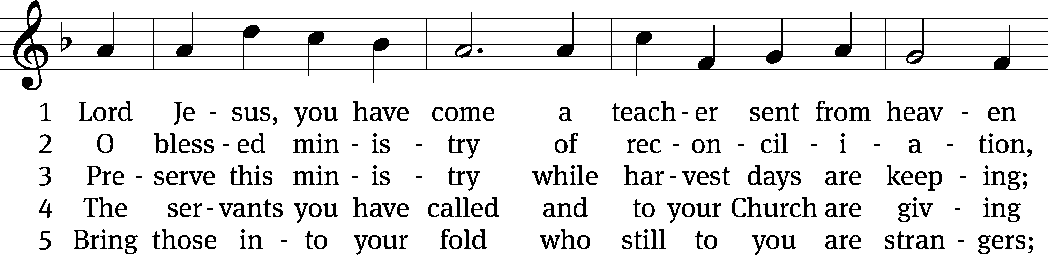
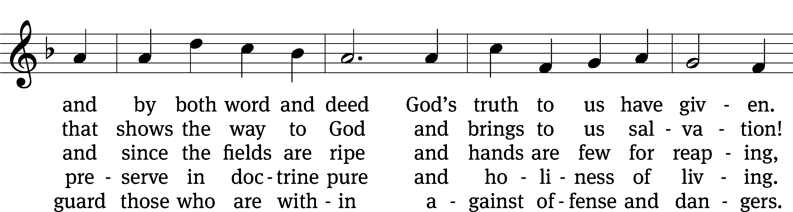
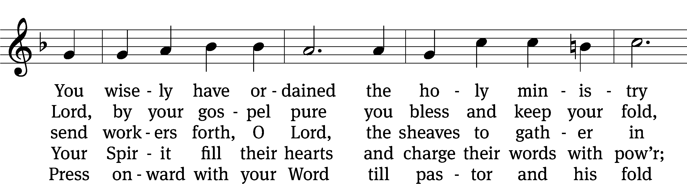
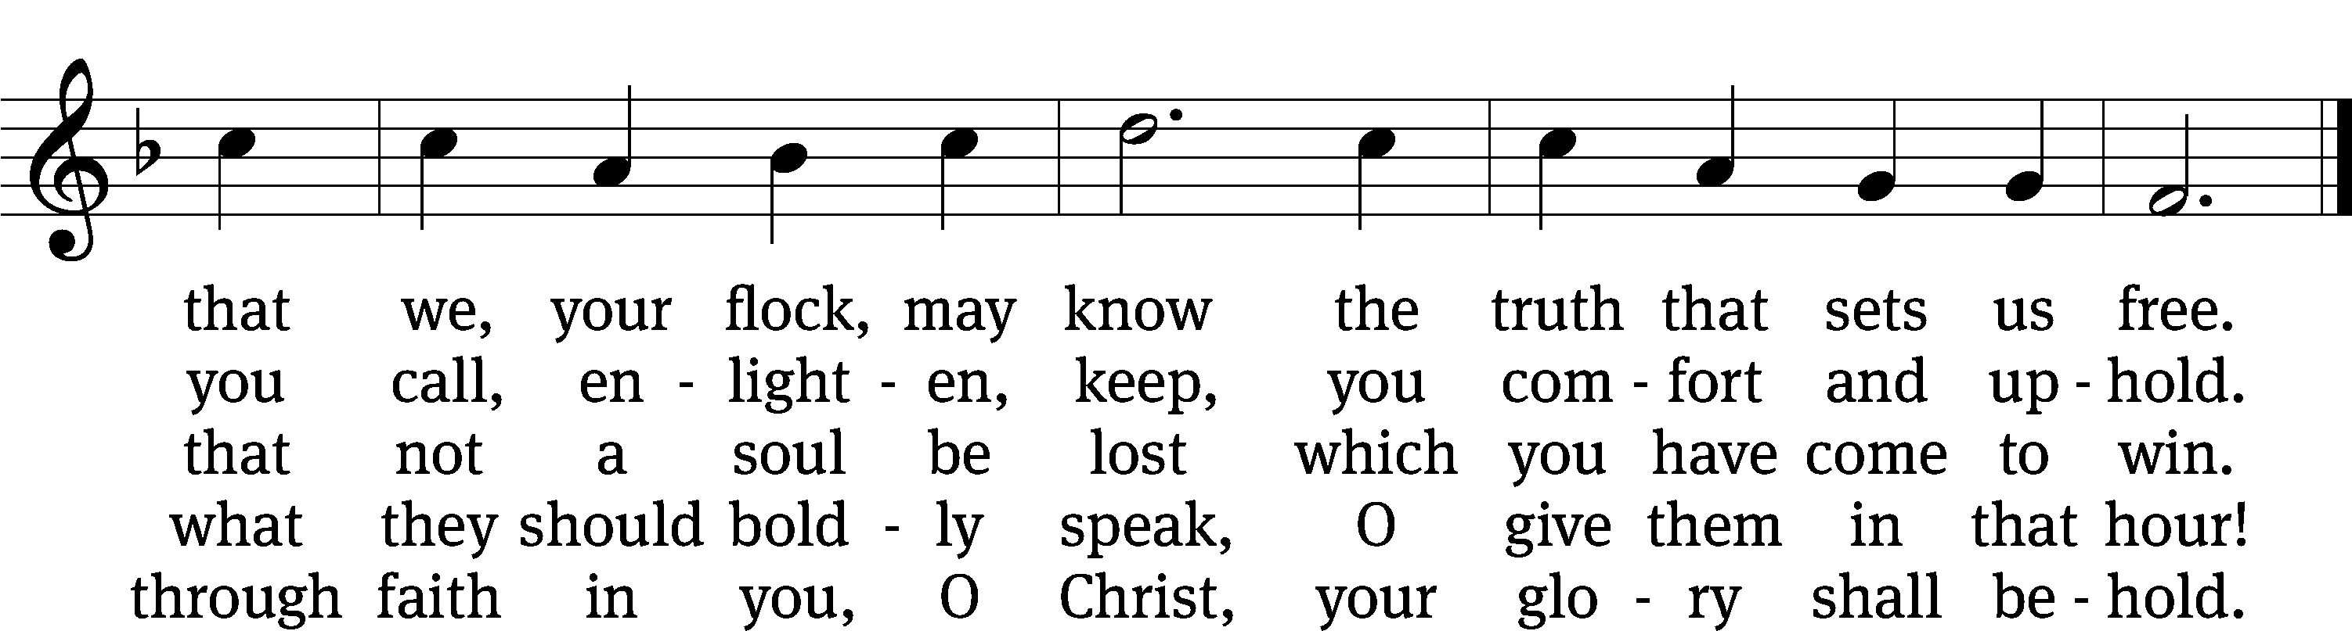
Text: tr. composite; Eberhard L. Fischer, 1695–1773, abr.
Tune: Neu-vermehrtes . . . Gesangbuch, 3rd ed., Meiningen, 1693
Text and tune: Public domain

PLEASE STAND, IF YOU ARE ABLE

invocation
M: The grace of our Lord (+) Jesus Christ and the love of God and the fellowship of the Holy Spirit be with you.
C: And also with you.
CONFESSION OF SINS
M: God invites us to come into his presence and worship him with humble and penitent hearts. Therefore, let us acknowledge our sinfulness and ask him to forgive us.
C: Holy and merciful Father, I confess that I am by nature sinful, and that I have disobeyed you in my thoughts, words, and actions. I have done what is evil and failed to do what is good. For this I deserve your punishment both now and in eternity. But I am truly sorry for my sins, and trusting in my Savior Jesus Christ, I pray: Lord, have mercy on me, a sinner.
M: God, our heavenly Father, has been merciful to us and has given his only Son to be the atoning sacrifice for our sins. Therefore, as a called servant of Christ and by his authority, I forgive you all your sins in the name of the Father and of the Son (+) and of the Holy Spirit.
C: Amen.
PRAYER AND PRAISE
LORD, HAVE MERCY
Kyrie
M: For all that we need in life and for the wisdom to use all your gifts with gratitude and joy, hear our prayer, O Lord.

M: For the steadfast assurance that nothing can separate us from your love and for the courage to stand firm against the assaults of Satan and every evil, hear our prayer, O Christ.

M: For the well-being of your holy Church in all the world and for those who offer here their worship and praise, hear our prayer, O Lord.

M: Merciful God, maker and preserver of life, uphold us by your power and keep us in your tender care:

M: The works of the Lord are great and glorious; his name is worthy of praise.

Prayer of the day

M: Let us pray.

The minister says the Prayer of the Day.

PLEASE BE SEATED

The Word

first lesson Numbers 27:15-23
¹⁵ Moses spoke to the Lord, ¹⁶ “May the Lord, the God of the spirits of all flesh, appoint a man over the community, ¹⁷ who will go out before them and come in before them, who will lead them out and bring them in, so that the community of the Lord will not be like sheep without a shepherd.”
¹⁸ The Lord said to Moses, “Take Joshua son of Nun, a man in whom is the Spirit, and place your hand on him. ¹⁹ Have him stand in front of Eleazar the priest and the entire community. You will commission him in their sight. ²⁰ You will give some of your authority to him so that the entire Israelite community will listen to him. ²¹ He will stand before Eleazar the priest, who will inquire for him before the Lord with the decision of the Urim. He and all the Israelites with him, the entire community, will go out at his command and come in at his command.”
²² Moses did just as the Lord commanded him. He took Joshua and had him stand in front of Eleazar the priest and the entire community. ²³ He placed his hands on him and commissioned him, just as the Lord spoke through Moses.

100B All People That on Earth Do Dwell Psalm 100B
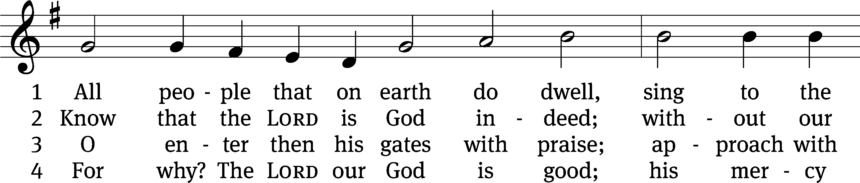
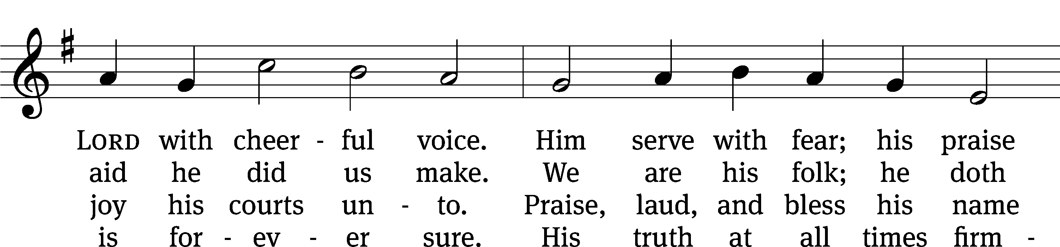
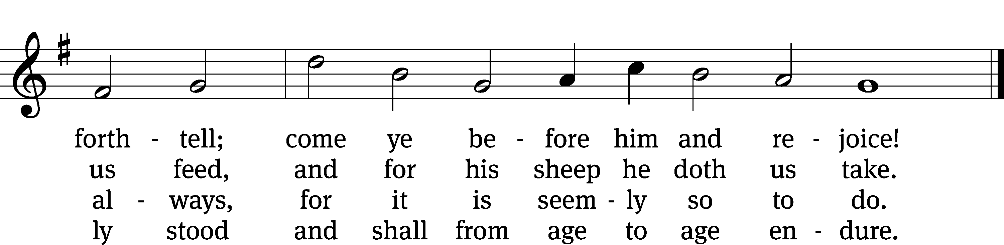
Text: William Kethe, alt.
Tune: Trente quatre Pseaumes de David, Geneva, 1551
Tune: Public domain

second lesson 1 Corinthian 4:1-7
¹ This is the way a person should think of us: as servants of Christ and stewards of God’s mysteries. ² In this connection, moreover, it is required of stewards that they be found faithful. ³ But it is a trivial matter to me if I am evaluated by you or by a day in a human court. Why, I do not even evaluate myself. ⁴ I do not in fact know of anything against myself, but I am not justified by this; rather, the one who evaluates me is the Lord. ⁵ Therefore judge nothing ahead of time, until the Lord comes. He will bring to light whatever is hidden in darkness and also reveal the intentions of hearts. Then there will be praise for each person from God.
⁶ Brothers, I turned these things into a lesson using myself and Apollos as examples. I did this for your benefit, so that you may learn from us not to go beyond what is written. Then you will not be arrogant, favoring one person over the other. ⁷ For who makes you so special? And what do you have that you did not receive? But if you did receive it, why do you boast as if you had not received it?
PLEASE STAND, IF YOU ARE ABLE

VERSE OF THE DAY Matthew 9:38
Alleluia. Ask the Lord of the harvest to send out workers into his harvest field. Alleluia.

GOSPEL Matthew 9:35-10:8
³⁵ Jesus traveled through all the towns and villages, teaching in their synagogues, preaching the gospel of the kingdom, and healing every disease and every sickness.
³⁶ When he saw the crowds, he was moved with compassion for them, because they were troubled and downcast, like sheep without a shepherd. ³⁷ Then he said to his disciples, “The harvest is plentiful, but the workers are few. ³⁸ Therefore pray that the Lord of the harvest will send out workers into his harvest.”
10 Jesus called his twelve disciples to himself and gave them authority to drive out unclean spirits and to heal every disease and every sickness. ² These are the names of the twelve apostles: first, Simon (who is called Peter) and his brother Andrew; James the son of Zebedee and his brother John; ³ Philip and Bartholomew; Thomas and Matthew the tax collector; James the son of Alphaeus, and Thaddaeus; ⁴ Simon the Zealot and Judas Iscariot, who betrayed him.
⁵ Jesus sent these twelve out and commanded them, “Do not go among the Gentiles, and do not enter any town of the Samaritans. ⁶ Go instead to the lost sheep of the house of Israel. ⁷ As you go, preach this message: ‘The kingdom of heaven is near!’ ⁸ Heal the sick. Raise the dead. Cleanse lepers. Drive out demons. Freely you have received; freely give.

M: This is the Gospel of the Lord.

PLEASE BE SEATED

528 Christ, the Word of God Incarnate CW 528
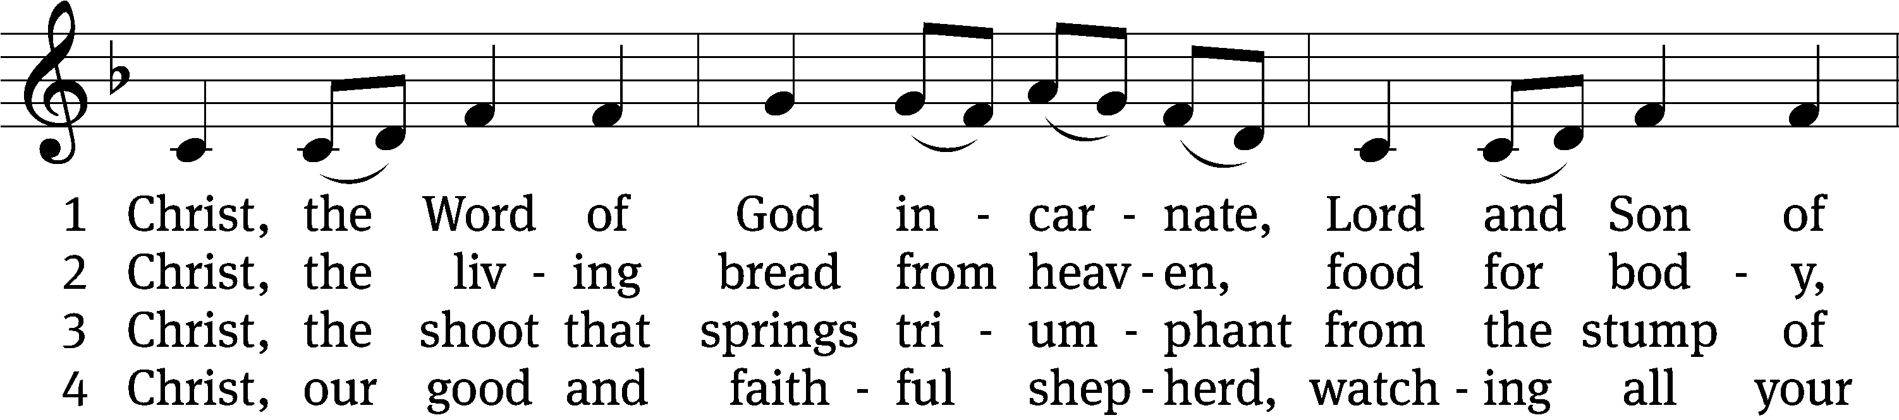
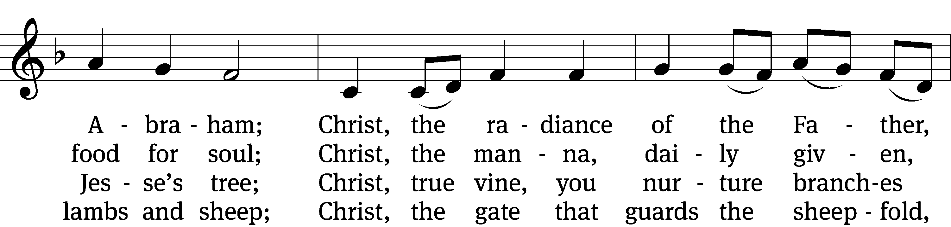
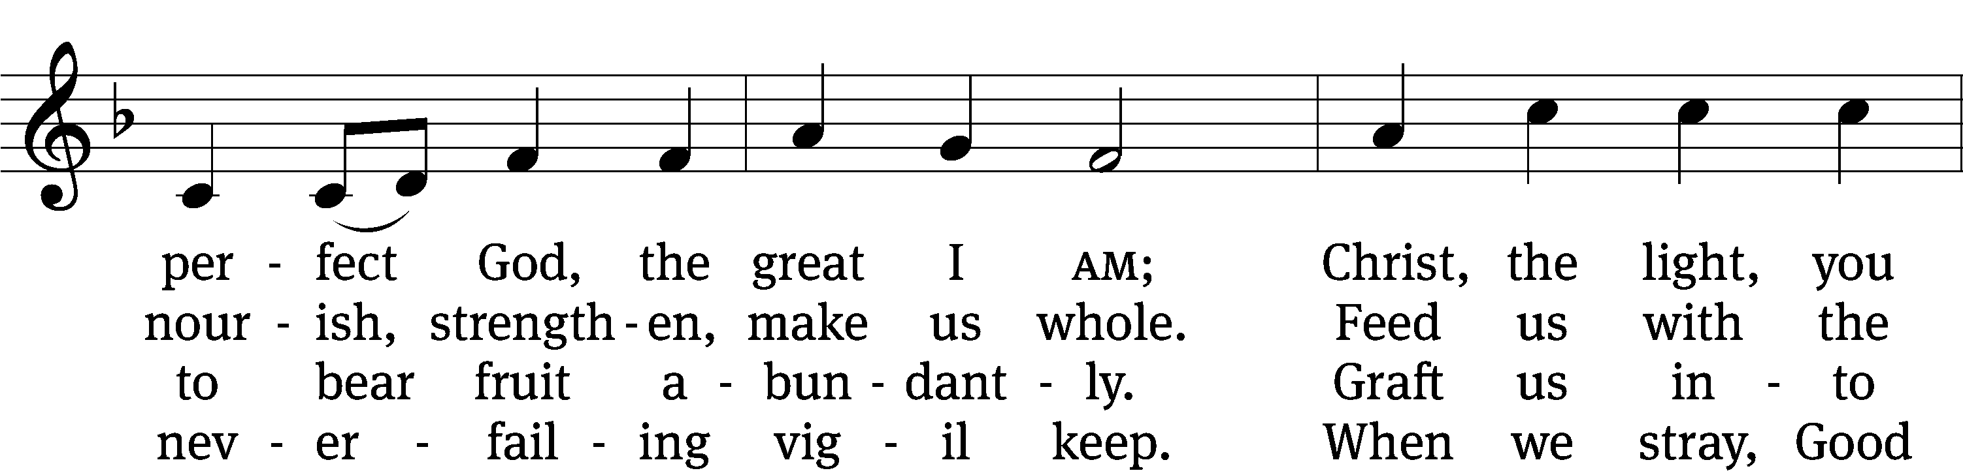
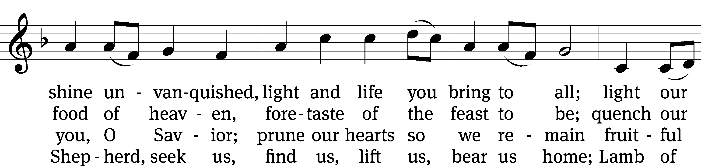
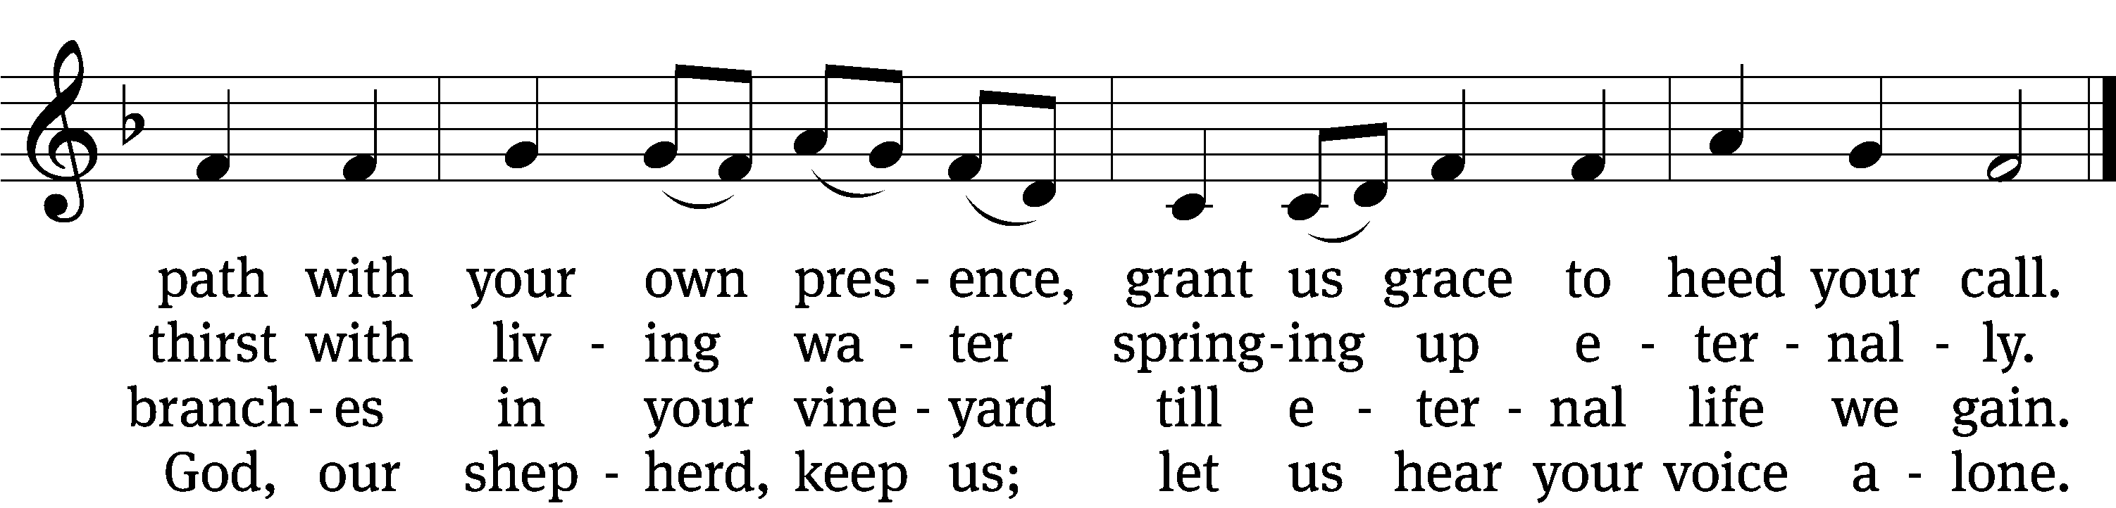

5 Christ, the way that leads unfailing
to the Father’s home on high;
Christ, the truth that frees the captive,
Christ, the life that cannot die;
mediator to the Father,
sacrifice and great High Priest:
lead us to your heav’nly mansions,
there to share your wedding feast.

6 Christ, the Alpha and Omega,
Christ, the firstborn from the dead;
Christ, the life and resurrection,
Christ, the Church’s glorious head:
praise and thanks and adoration
and unending worship be
to the Father and the Spirit
and to you eternally.
Text: Steven P. Mueller, b. 1964
Tune: Columbian Harmony, Cincinatti, 1825, ed. William Moore
Text: © 2001 Steven P. Mueller. Used by permission: OneLicense no. 727703
Tune: Public domain

Sermon John 8:52-59

“Jesus IS THE GREAT “I AM”

⁵² So the Jews said to him, “Now we know that you have a demon. Abraham died, and so did the prophets. Yet you say, ‘If anyone holds on to my word, he will certainly never taste death.’ ⁵³ You are not greater than our father, Abraham, are you? He died. And the prophets died. Who do you think you are?”
⁵⁴ Jesus answered, “If I glorify myself, my glory is nothing. It is my Father who glorifies me, about whom you say, ‘He is our God.’ ⁵⁵ Yet you do not really know him, but I do know him. If I said, ‘I do not know him,’ I would be a liar like you. But I do know him, and I hold on to his word. ⁵⁶ Your father Abraham was glad that he would see my day. He saw it and rejoiced.”
⁵⁷ The Jews replied, “You aren’t even fifty years old, and you have seen Abraham?”
⁵⁸ Jesus said to them, “Amen, Amen, I tell you: Before Abraham was born, I am.” ⁵⁹ Then they picked up stones to throw at him. But Jesus was hidden and left the temple area.

please stand, if you are able

nicene creed
We believe in one God, the Father, the Almighty, maker of heaven and earth, of all that is, seen and unseen.
We believe in one Lord, Jesus Christ, the only Son of God, eternally begotten of the Father, God from God, Light from Light, true God from true God, begotten, not made, of one being with the Father. Through him all things were made. For us and for our salvation, he came down from heaven, was incarnate of the Holy Spirit and the virgin Mary, and became truly human. For our sake he was crucified under Pontius Pilate. He suffered death and was buried. On the third day he rose again in accordance with the Scriptures. He ascended into heaven and is seated at the right hand of the Father. He will come again in glory to judge the living and the dead, and his kingdom will have no end.
We believe in the Holy Spirit, the Lord, the giver of life, who proceeds from the Father and the Son, who in unity with the Father and the Son is worshiped and glorified, who has spoken through the prophets. We believe in one holy Christian and apostolic Church. We acknowledge one baptism for the forgiveness of sins. We look for the resurrection of the dead and the life of the world to come. Amen.

prayer of the church

lord’s prayer

C: Our Father, who art in heaven,
hallowed be thy name,
thy kingdom come,
thy will be done
on earth as it is in heaven.
Give us this day our daily bread;
and forgive us our trespasses,
as we forgive those
who trespass against us;
and lead us not into temptation,
but deliver us from evil.
For thine is the kingdom
and the power and the glory
forever and ever. Amen.

The Sacrament of Holy Communion
Trinity Lutheran Church follows the historic Christian practice of close communion. We ask that only members of Trinity or one of our sister congregations partake of the sacrament. If you are not a member, please see the note about Holy Communion in the beginning of the Worship Folder.

M: The Lord be with you.

M: Lift up your hearts.

M: Let us give thanks to the Lord our God.

M: Praise to the God and Father of our Lord Jesus Christ! In love he has blessed us with every spiritual blessing. He sends the Holy Spirit to testify that we are his children and to strengthen us when we are weak. Now have come the salvation and the power and the kingdom of our God and the authority of his Christ. To him who sits on the throne and to the Lamb be praise and thanks and honor and glory for ever and ever:

Holy, Holy, Holy

Words of institution
M: Our Lord Jesus Christ, on the night he was betrayed, took bread; and when he had given thanks, he broke it and gave it to his disciples, saying: “Take and eat. This is my ✙ body, which is given for you. Do this in remembrance of me.”
Then he took the cup, gave thanks, and gave it to them, saying, “Drink from it all of you; this is my ✙ blood of the new covenant, which is poured out for you for the forgiveness of sins. Do this, whenever you drink it, in remembrance of me.”
M: The peace of the Lord be with you always.

O CHRIST, LAMB OF GOD

PLEASE BE SEATED

716 O Christ, Who Called the Twelve CW 716
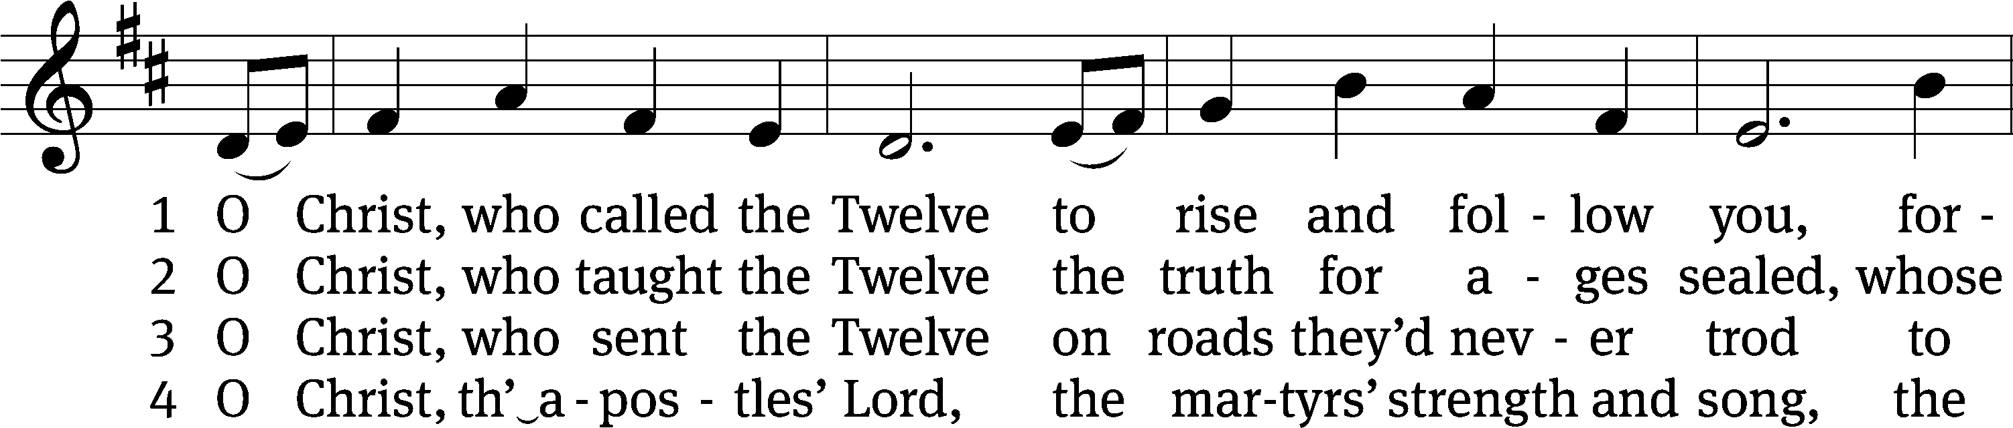
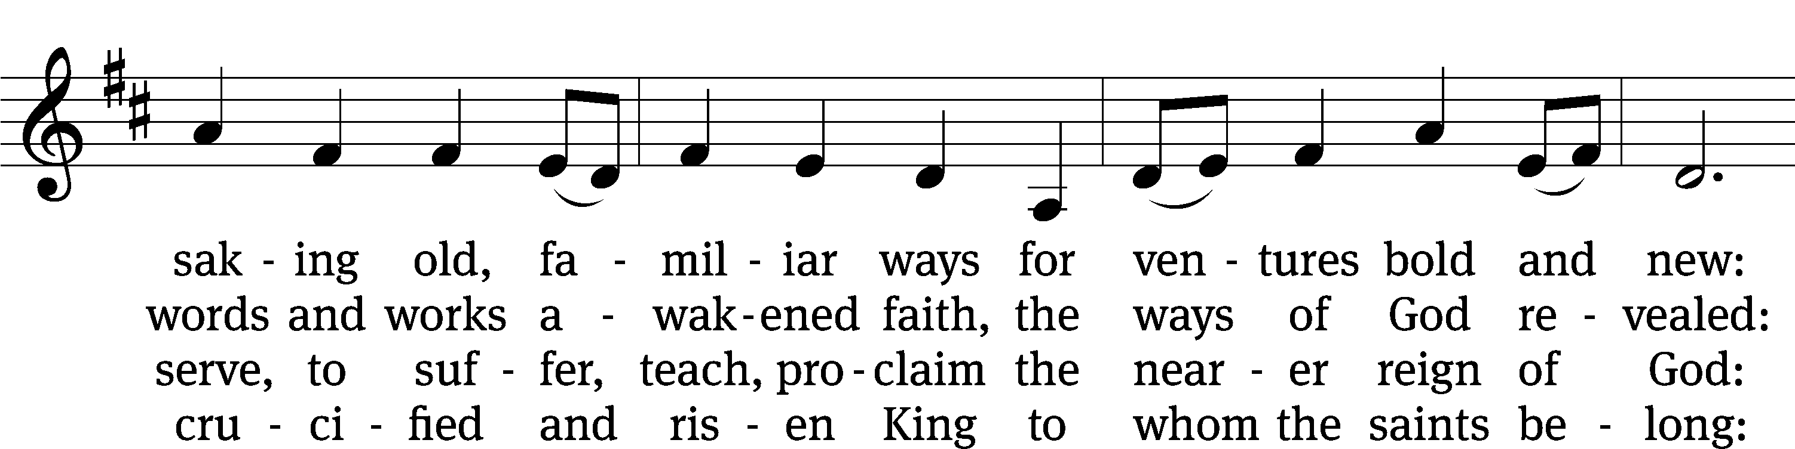
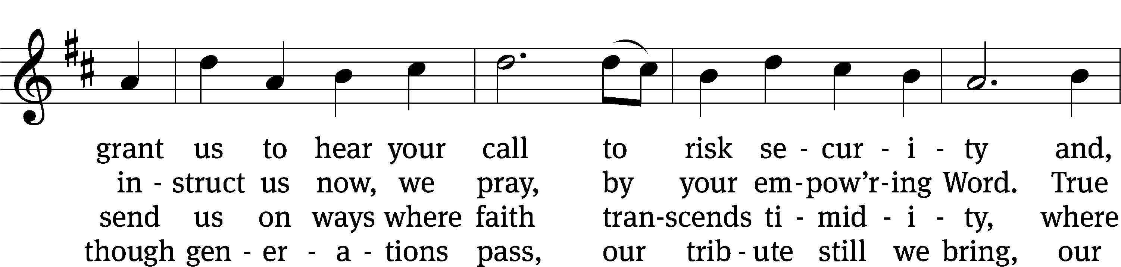
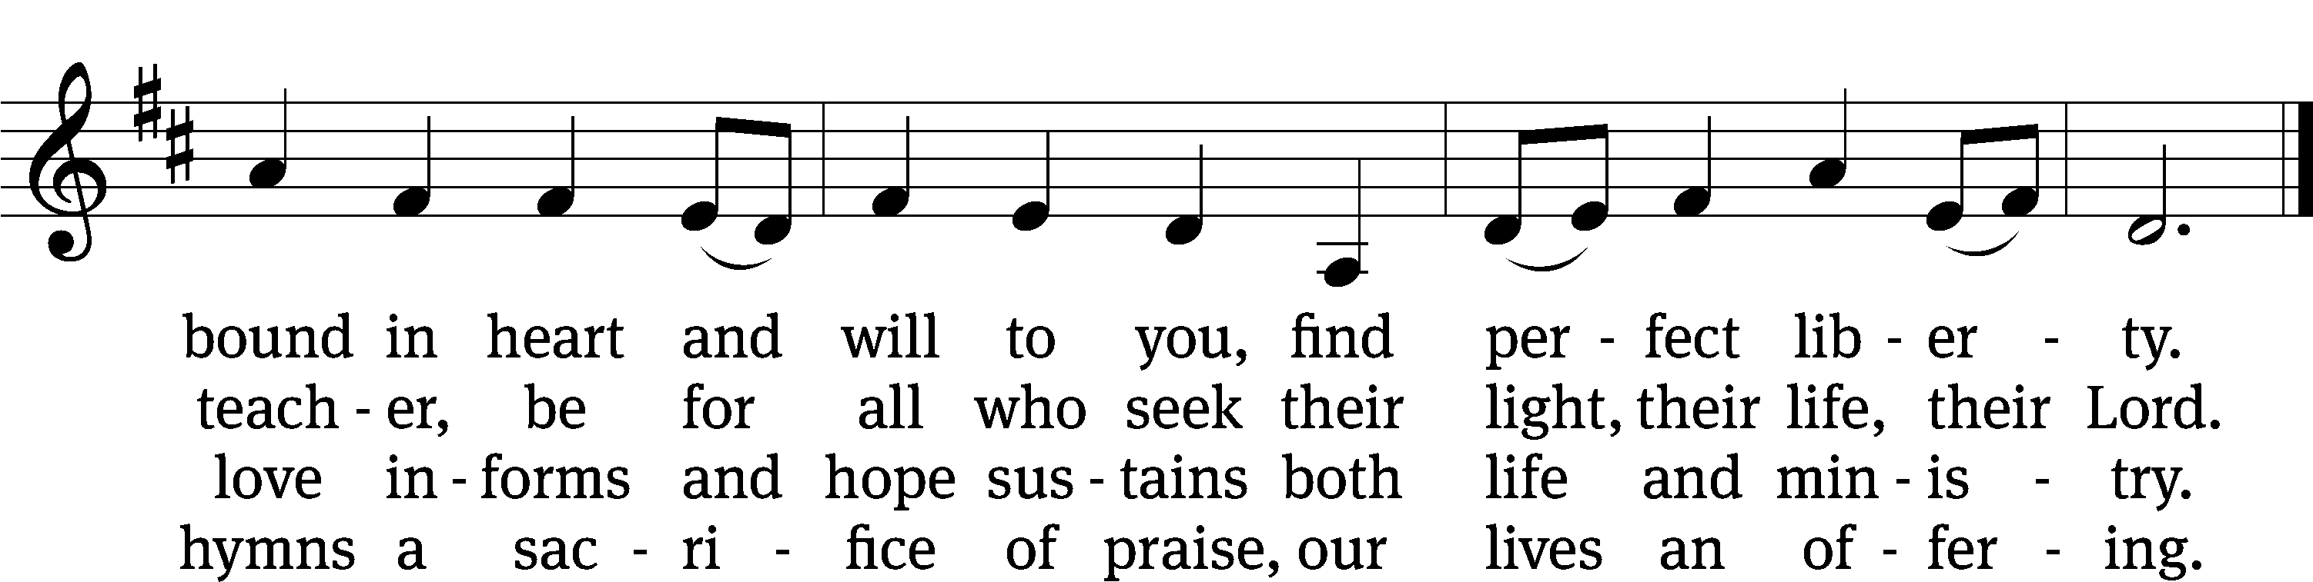
Text: Herman G. Stuempfle, Jr., 1923–2007
Tune: English; adapt. Franklin L. Sheppard, 1852–1930
Text: © 1993 GIA Publications, Inc. Used by permission: OneLicense no. 727703
Tune: Public domain

766 Lord, Whose Love in Humble Service CW 766
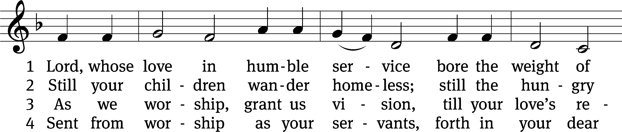
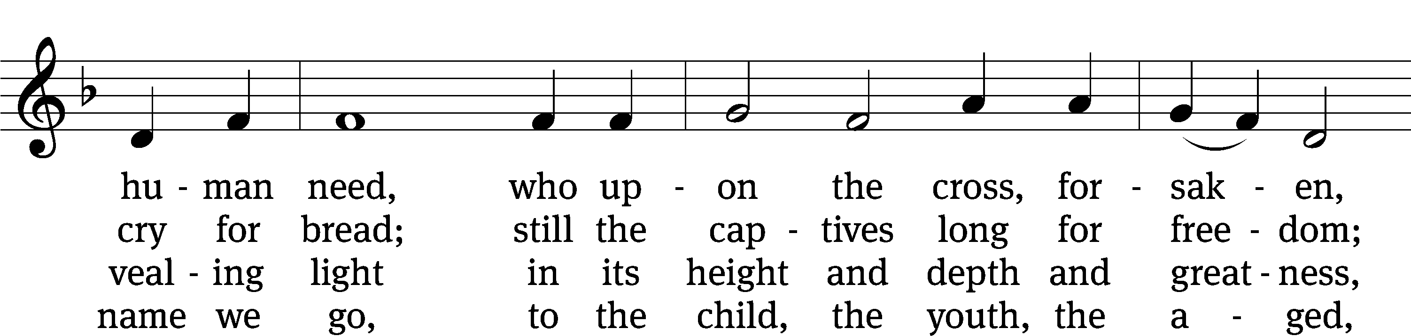
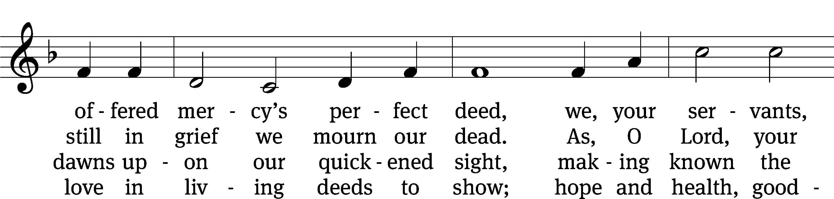
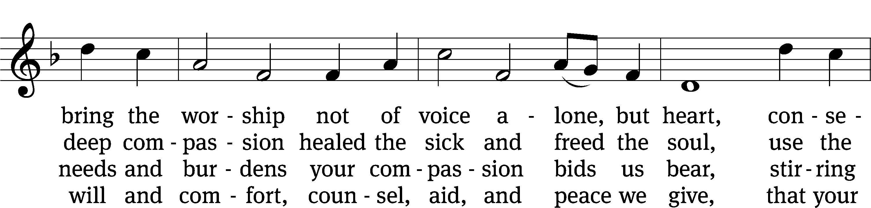
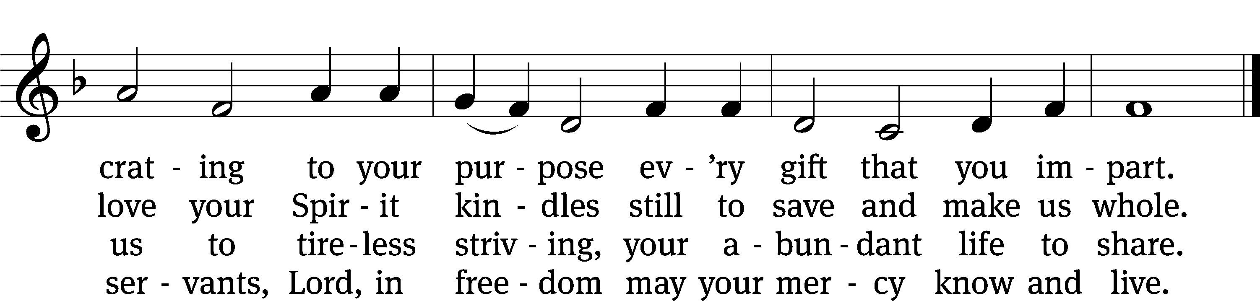
Text: Albert F. Bayly, 1901–1984, alt.
Tune: The Sacred Harp, Philadelphia, 1844
Text: © 1988 Oxford University Press. Used by permission: OneLicense no. 727703
Tune: Public domain

PLEASE STAND, IF YOU ARE ABLE

M: Hear the prayer of your people, O Lord, that the lips which have praised you here may glorify you in the world, that the eyes which have seen the coming of your Son may long for his coming again, and that all who have received in his true body and blood the pledge of your forgiveness may be restored to live a new and holy life, through Jesus Christ, our Lord, who lives and reigns with you and the Holy Spirit, one God, now and forever.

M: Brothers and sisters, go in peace. Live in harmony with one another.
Serve the Lord with gladness.
The Lord bless you and keep you.
The Lord make his face shine on you and be gracious to you.
The Lord look on you with favor and (+) give you peace.

PLEASE BE SEATED
896 Dear Lord, to Your True Servants Give CW 896
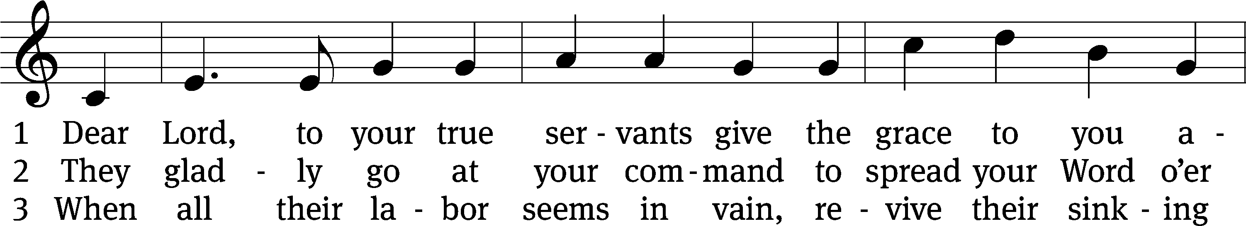
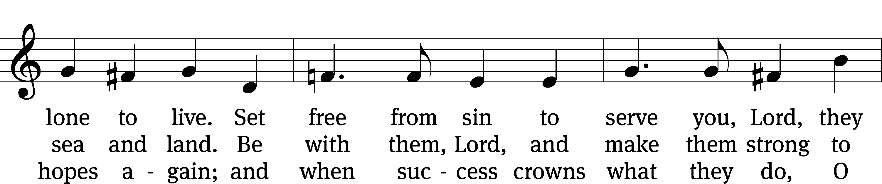
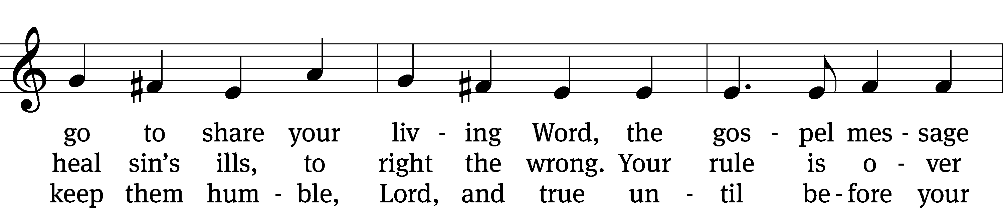
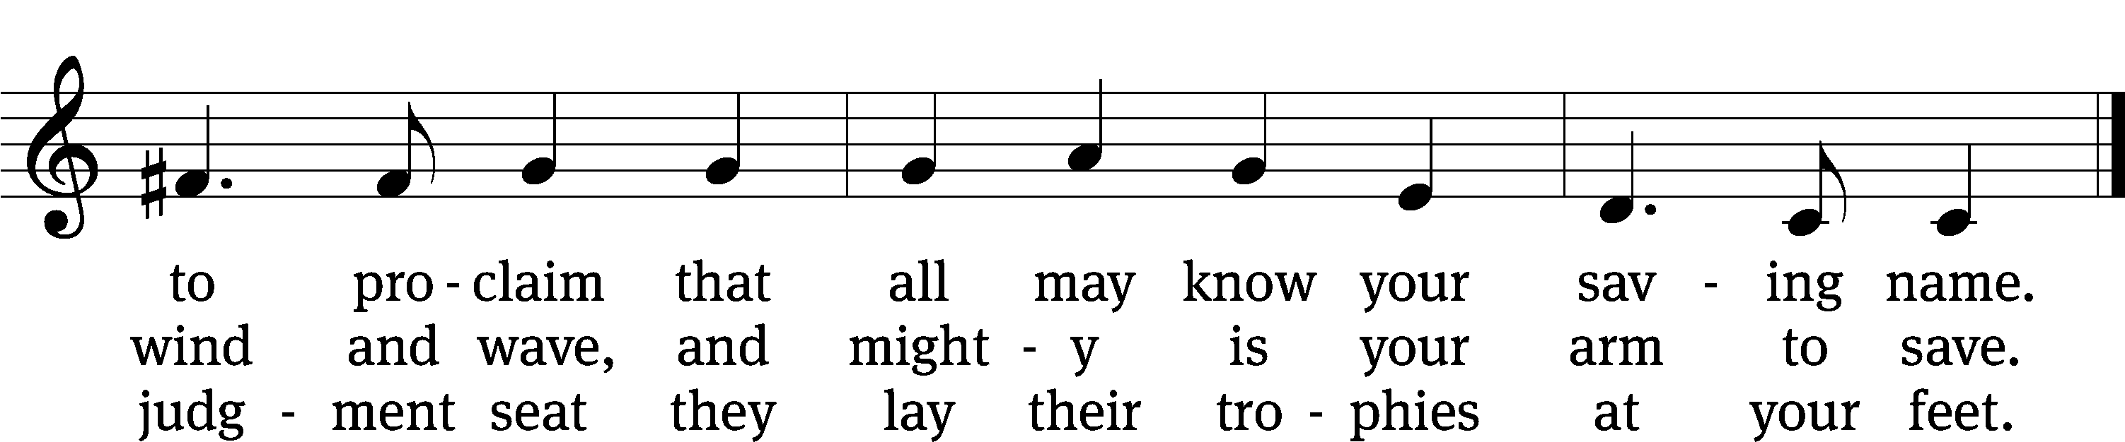
Text: W. Gustave Polack, 1890–1950, alt.
Tune: John B. Dykes, 1823–1876
Text: © 1941 Concordia Publishing House. Used by permission: OneLicense no. 727703
Tune: Public domain

Serving In Worship

Officiant Pastor Natsis
Organist Marcia Marion Ackling
Deacons (Thursday) Duane Mason and Jim Tice
(Sunday) Steve Hoeft and Robert Niethammer
Ushers (Thursday) Robert Newman and Henry Schneider
(Sunday) Dave Boswell and Jake Vershum
Altar Guild Diane Stevenson and Karen Tice
Videographer Jake Vershum

Copyright information
Service of Word and Sacrament: Christian Worship. © 1993 Northwestern Publishing House. All rights reserved. Reprinted under ONE LICENSE #A-727703 and CCLI #1151741/ CSPL126093
Words and Music: All rights reserved. Reprinted/Podcast/Streamed with permission under ONE LICENSE #A-727703 and CCLI #1151741/CSPL126093

