The EIGHTH SUNDAY
AFTER pentecost

TRINITY EVANGELICAL LUTHERAN CHURCH | Saline, Michigan
WELCOME TO WORSHIP July 20/23, 2023
Thank you for joining us in God’s house today! We cordially ask that our Guests sign one of the guestbooks located at either the front or back entryways, or fill out a “Let’s Get Acquainted” card located in the hymnal pew rack and place it in the collection plate.

THANK OFFERING: Members of Trinity give their offering as an expression of love and thankfulness to the Lord and to help support the Lord’s work in our community and around the world. Visitors need not feel obligated to participate in this offering which supports our ministry.

Restrooms are located at the back of the upper level (the annex), and in the basement (down the back stairs of the sanctuary or annex). Handicap access is available, please ask an usher for assistance.

Young Families / Toddler Bags – We are GLAD YOU BROUGHT YOUR CHILDREN to our worship service. Jesus said: “Let the little children come to me and do not hinder them, for the kingdom of God belongs to such as these.” We know that having little children in church can be a challenge, but DO NOT WORRY about it. Many of your fellow worshippers have been in your shoes and are just happy you brought your children with you. For your convenience, we have reserved the back rows of seating for parents with small children. These areas provide more flexibility for your family, as well as, easy access to move downstairs if necessary. A closed-circuit TV system allows families to continue participating in the service while downstairs. Pre-school toddler bags and children’s bulletins are available for their enjoyment. Ask an usher for one to use during the service and please return the toddler bag afterwards.

the SERVICE – setting one - WITHOUT HOLY COMMUNION CW, page 154

515 Christ Is the World’s Light CW 515
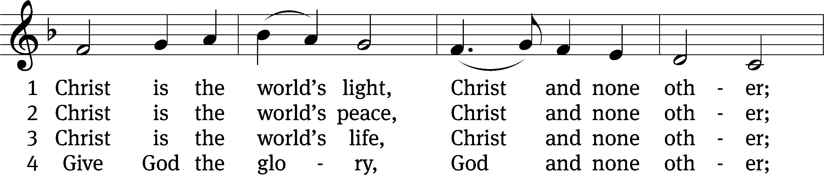
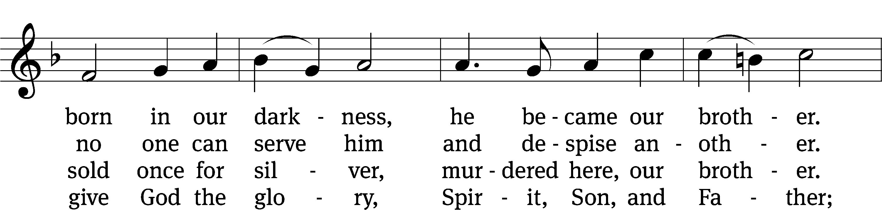
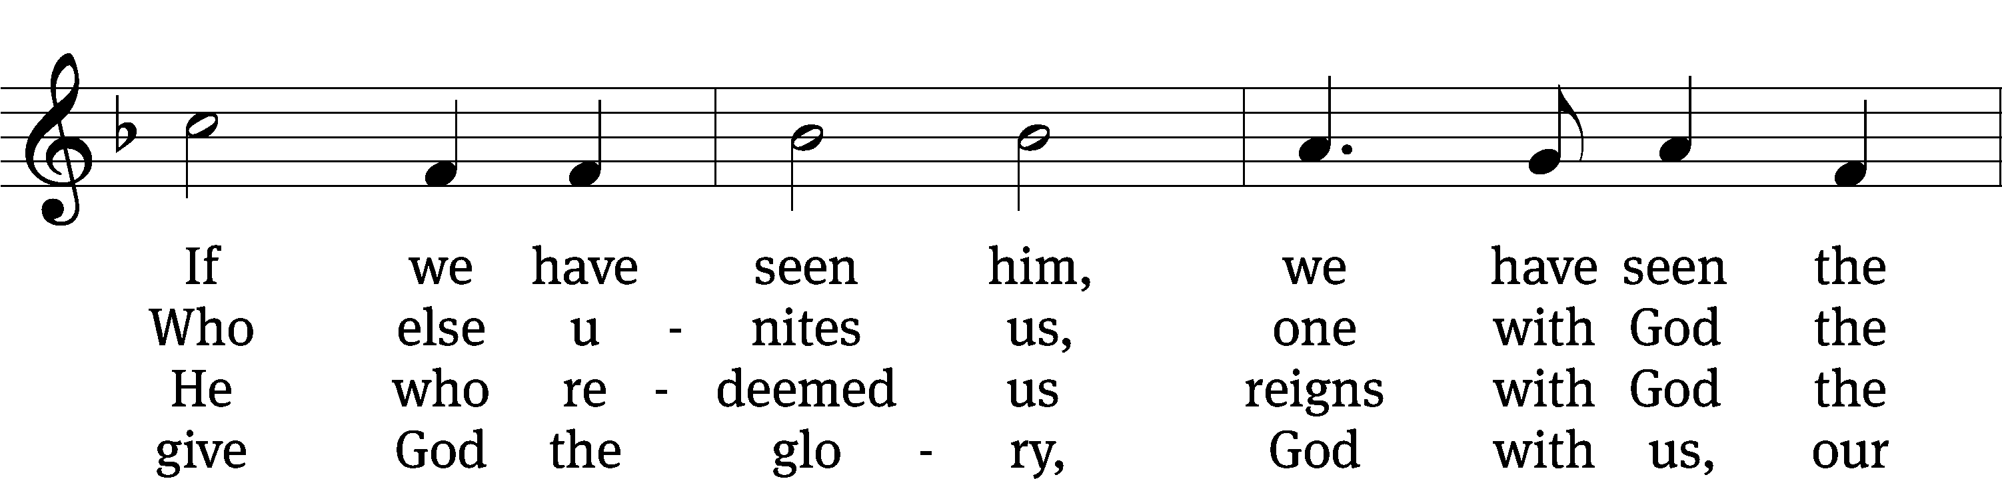
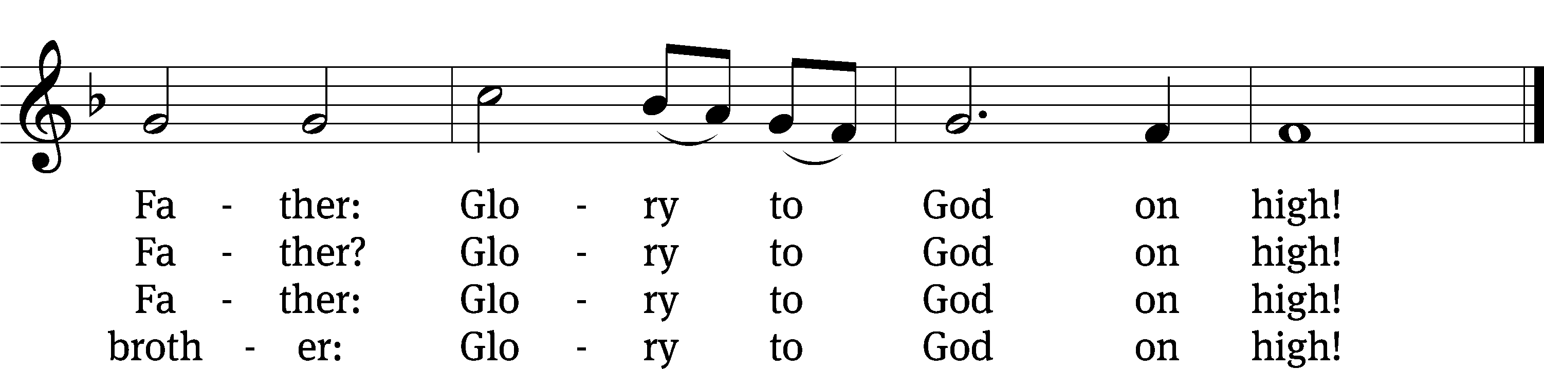
Text: Fred Pratt Green, 1903–2000, alt.
Tune: K. Lee Scott, b. 1950
Text: © 1969 Hope Publishing Co. Used by permission: OneLicense no. 727703
Tune: © 2004 Concordia Publishing House. Used by permission: License no. 130003540

Please stand, if you are able
Invocation
In the name of the Father and of the Son and of the Holy Spirit.
Amen.

Confession
If we claim to be without sin, we deceive ourselves and the truth is not in us.
If we confess our sins, God is faithful and just
and will forgive us our sins
and purify us from all unrighteousness.

Let us confess our sins to the Lord.
Holy God, gracious Father,
I am sinful by nature
and have sinned against you in my thoughts, words, and actions.
I have not loved you with my whole heart;
I have not loved others as I should.
I deserve your punishment both now and forever.
But Jesus, my Savior, paid for my sins
with his innocent suffering and death.
Trusting in him, I pray: God, have mercy on me, a sinner.

Our gracious Father in heaven has been merciful to us. He sent his only Son, Jesus Christ, who gave his life as the atoning sacrifice for the sins of the whole world. Therefore, as a called servant of Christ and by his authority, I forgive you all your sins in the name of the Father and of the Son and of the Holy Spirit.
Amen.

Lord, Have Mercy
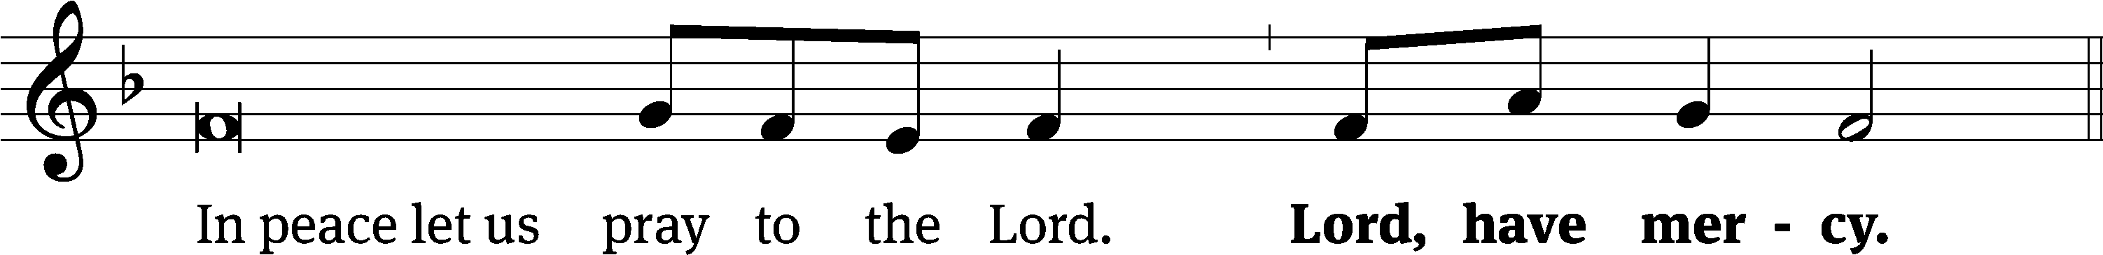
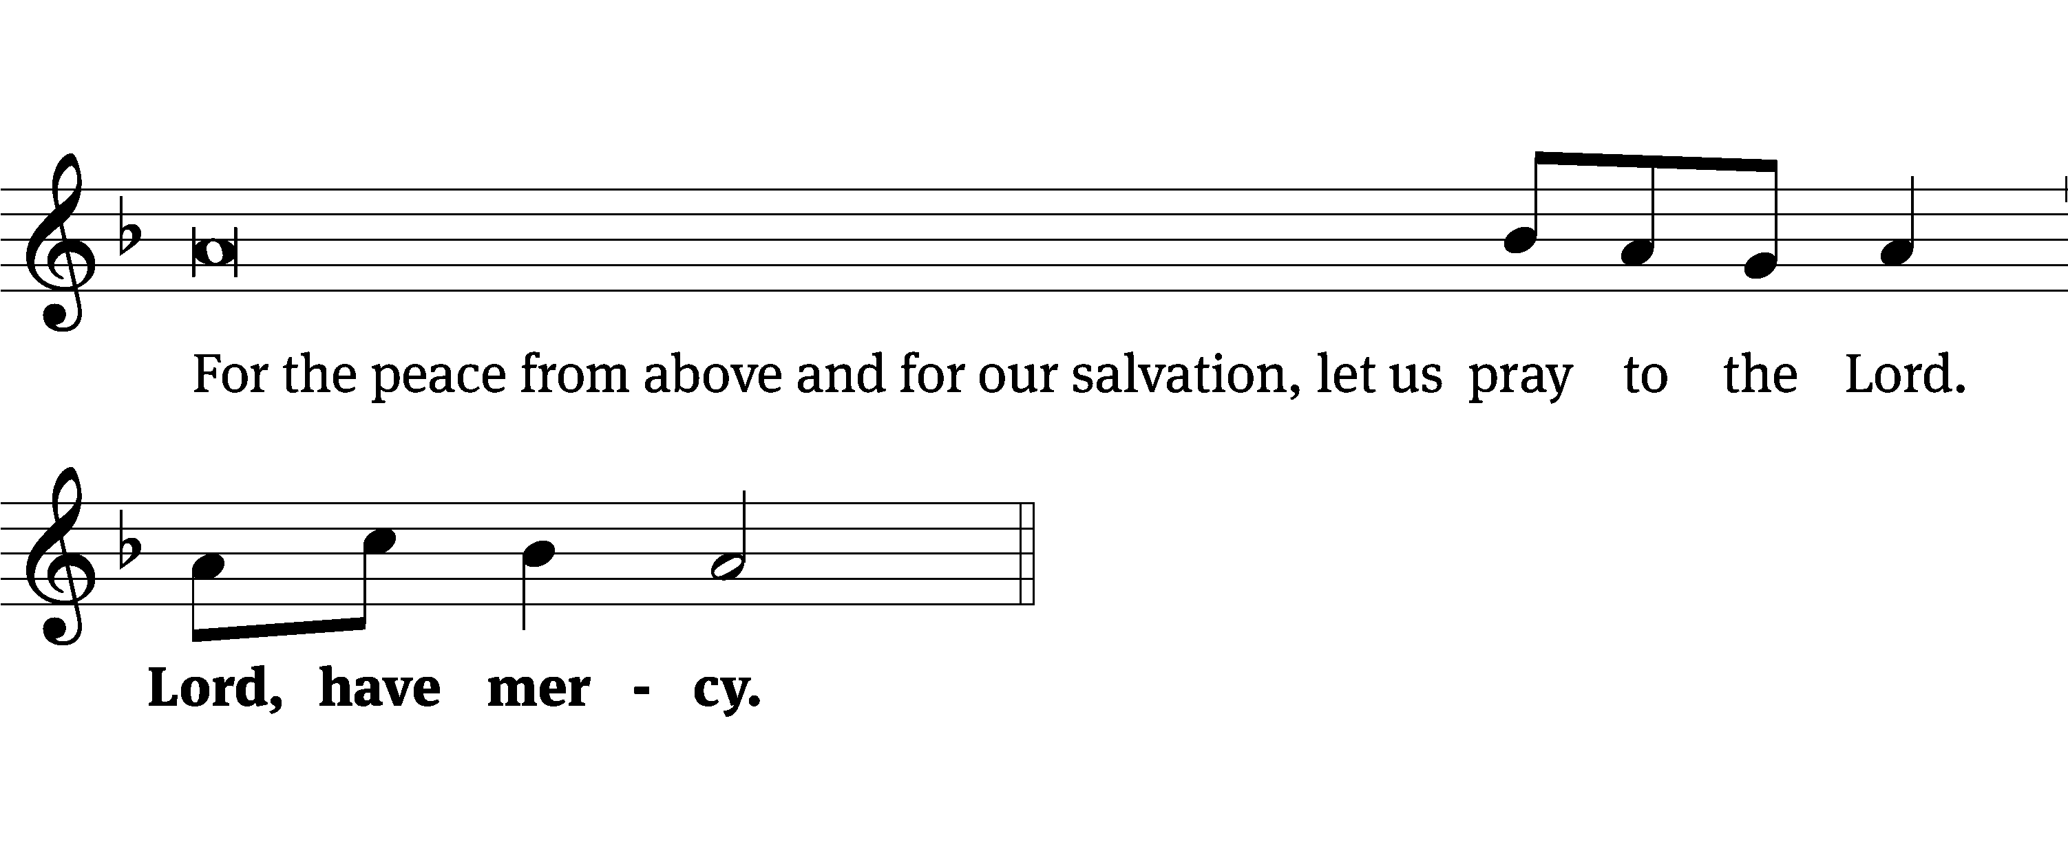
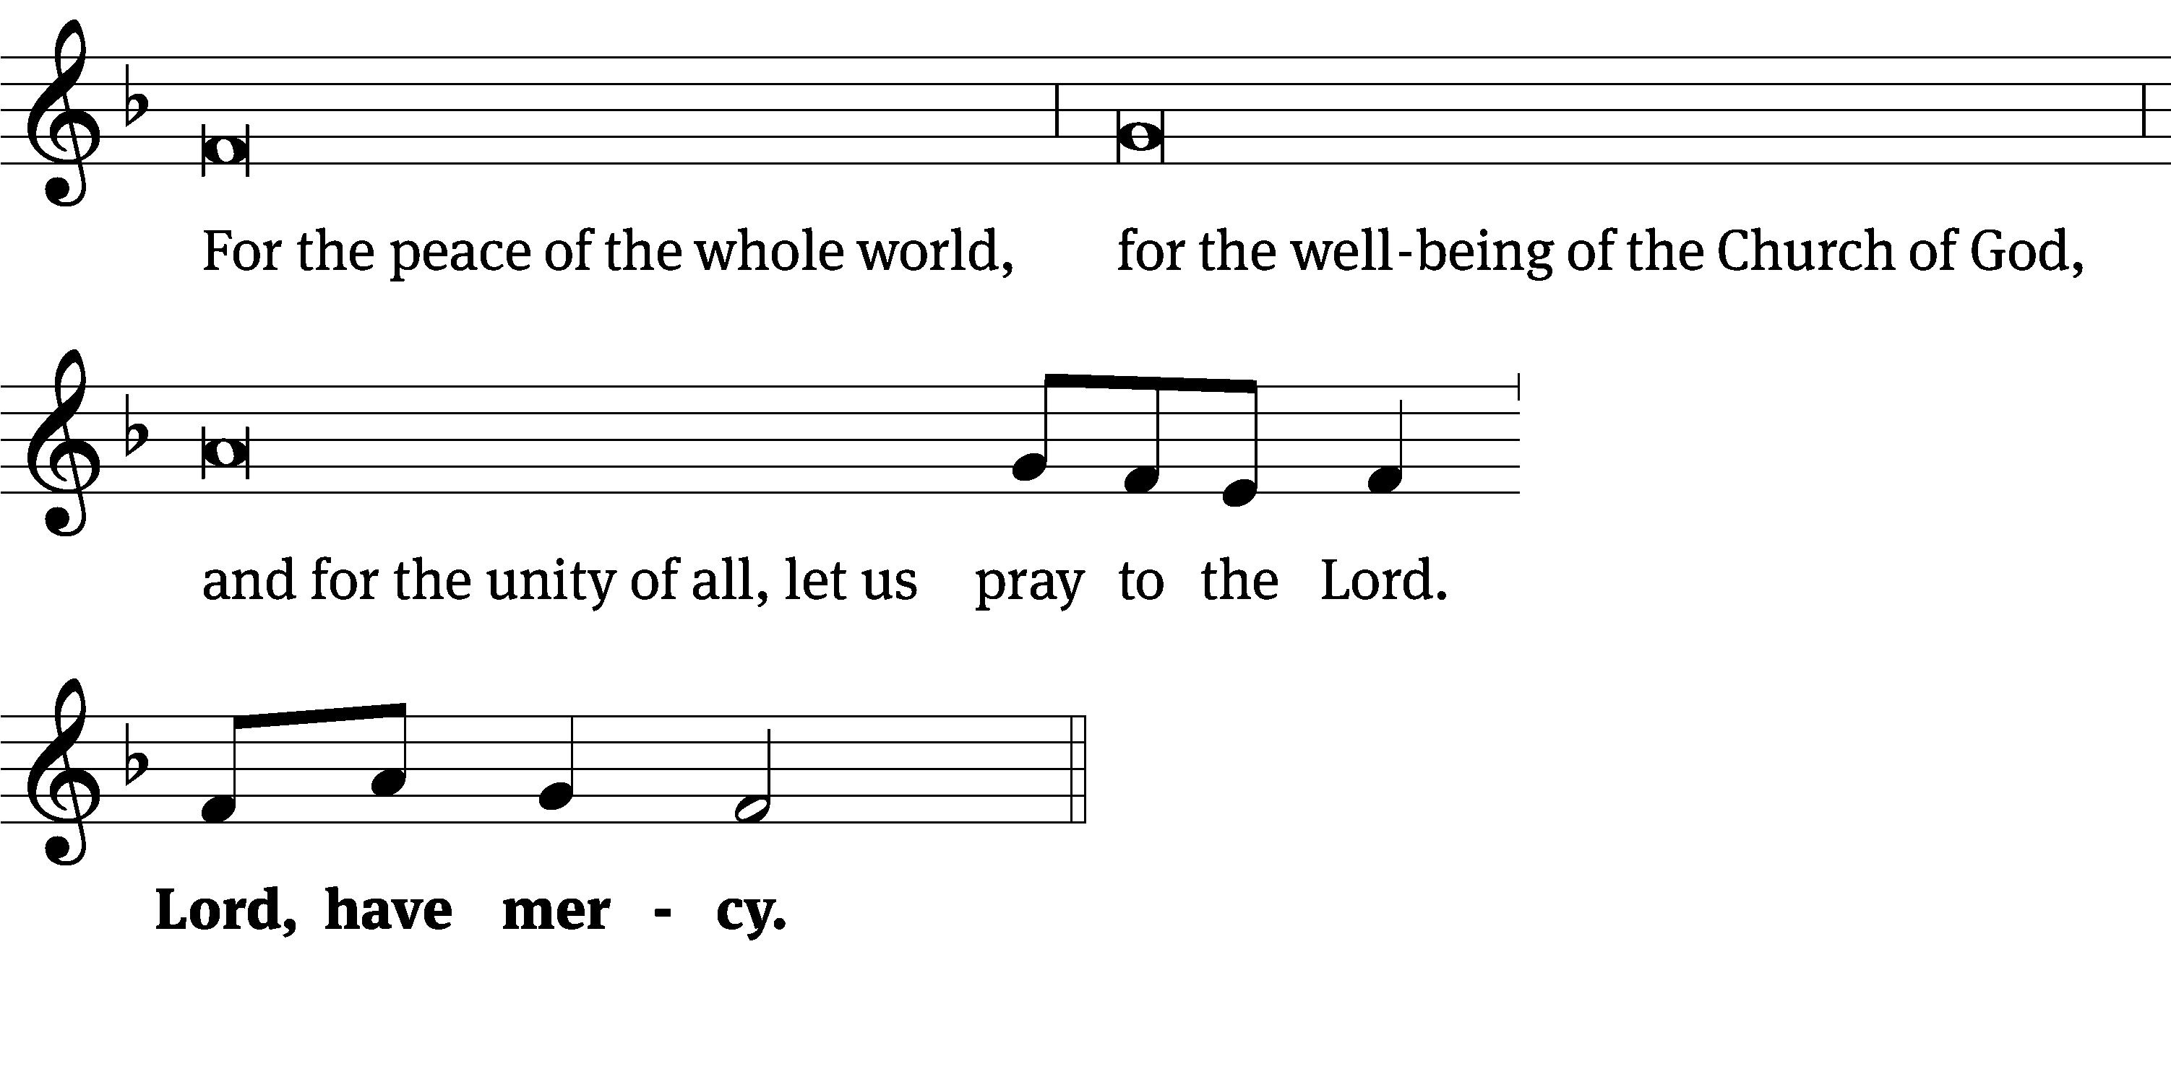
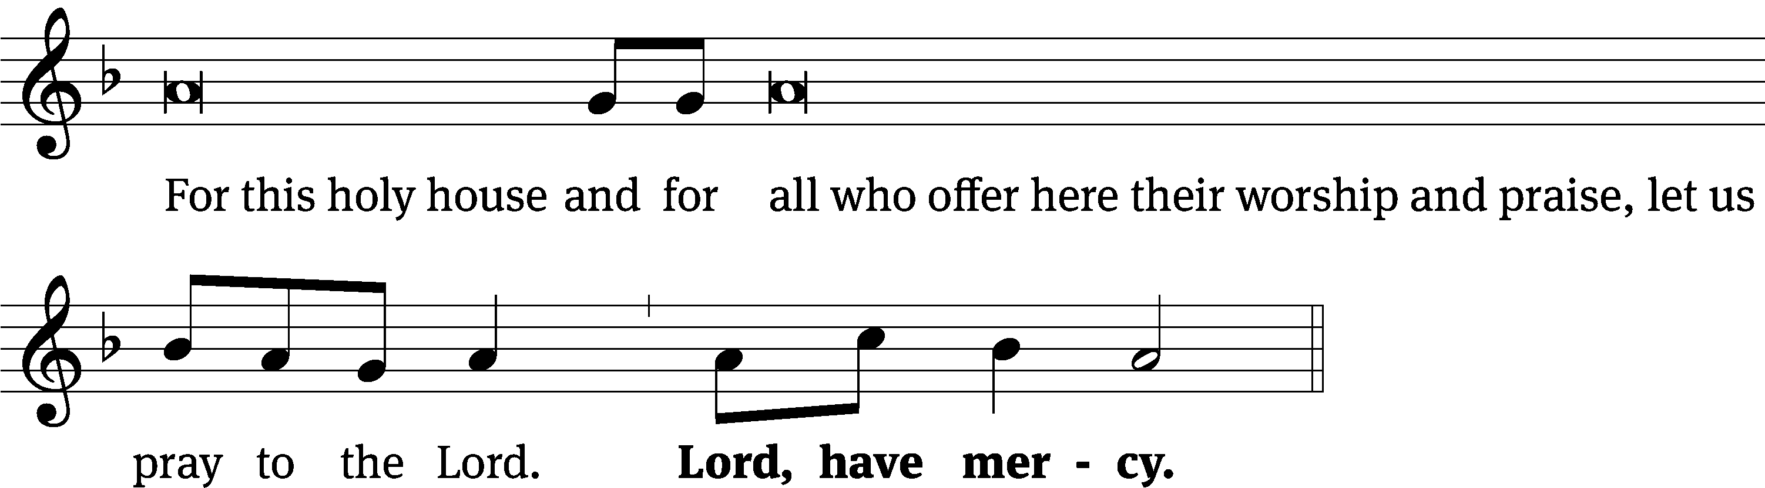
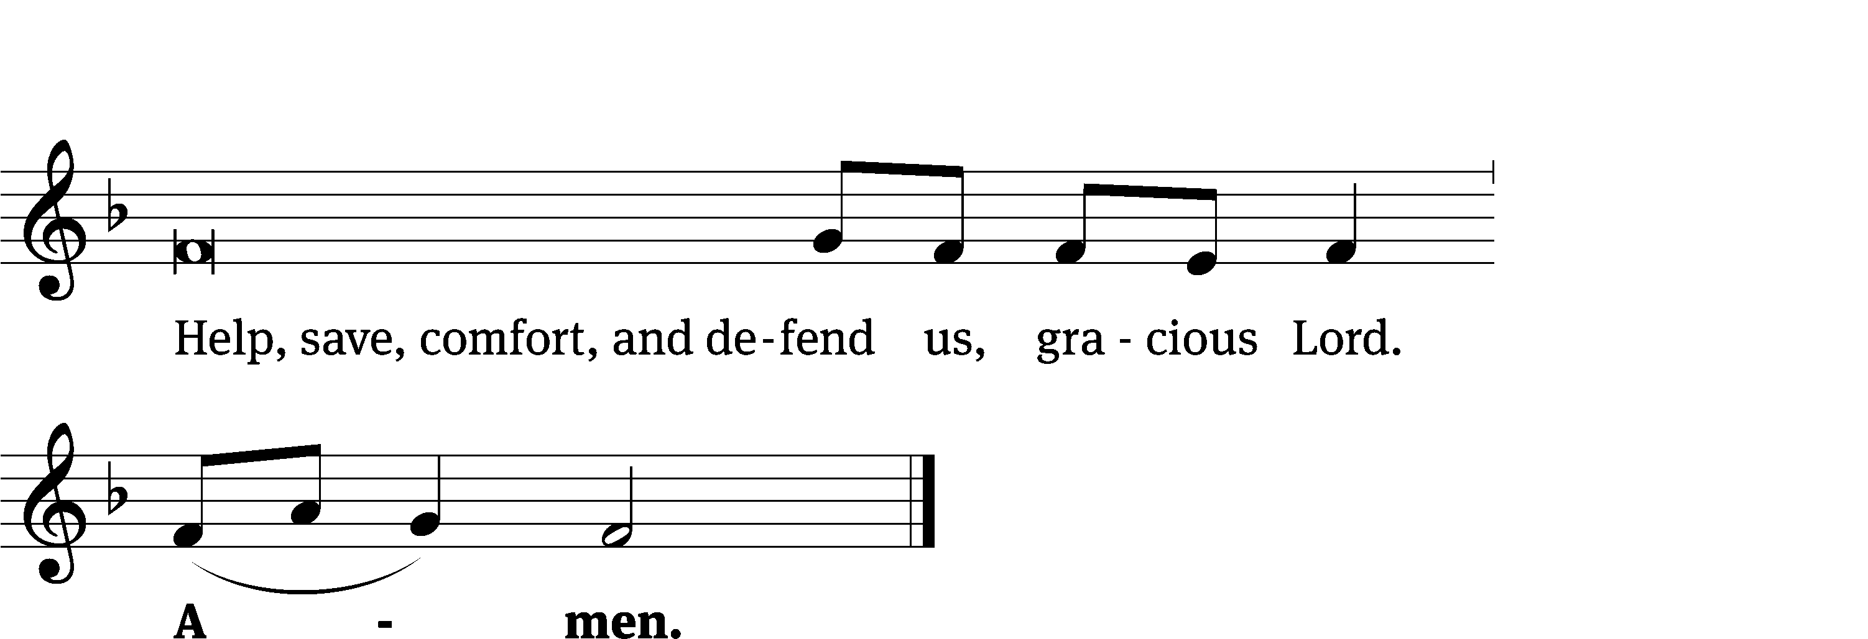
Tune: Kevin Becker
Tune: © 2021 Northwestern Publishing House. Used by permission: OneLicense no. 727703

Glory Be to God CW 157
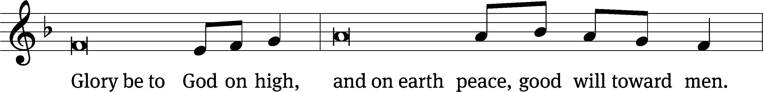
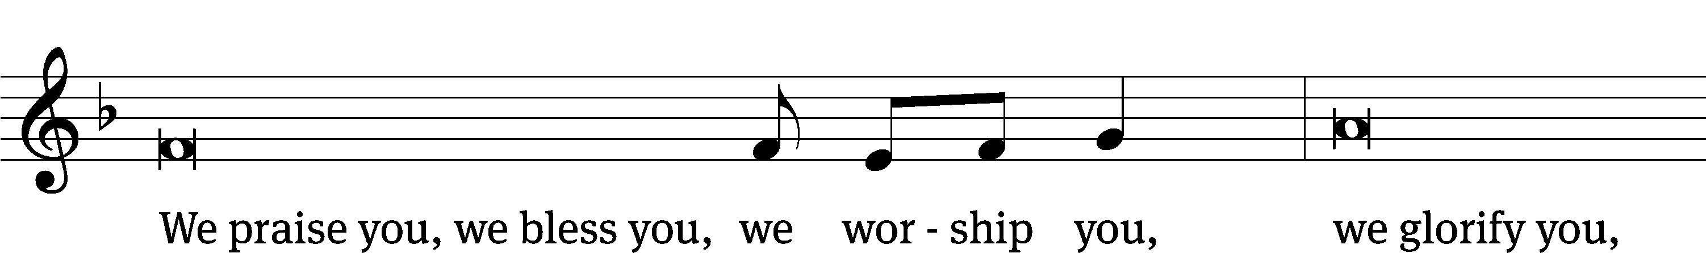
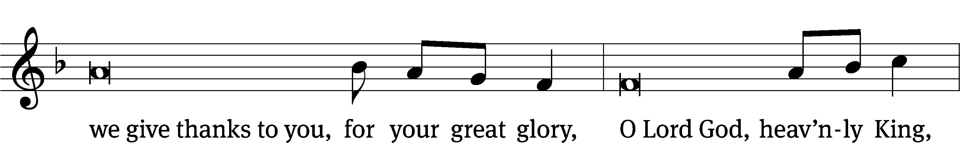
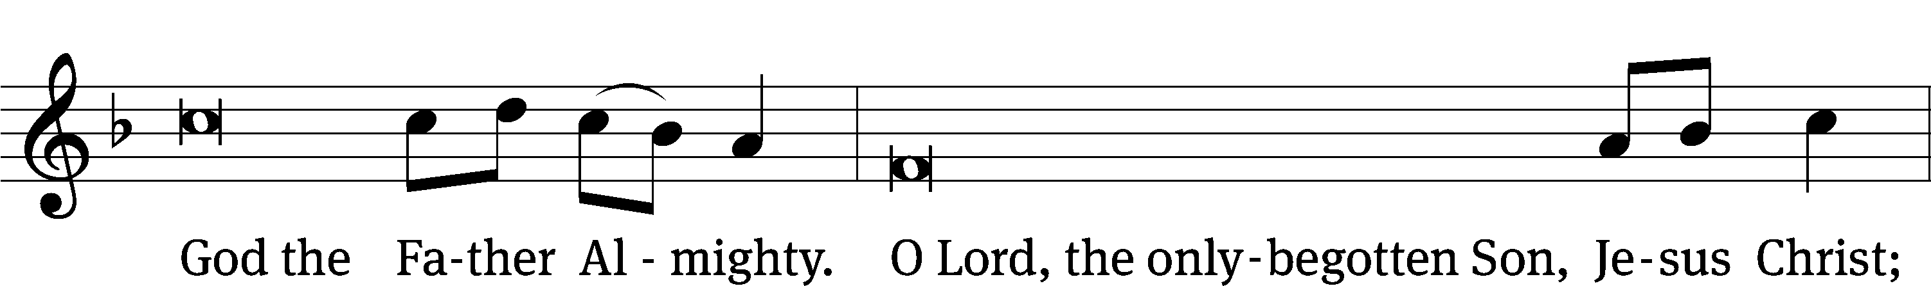
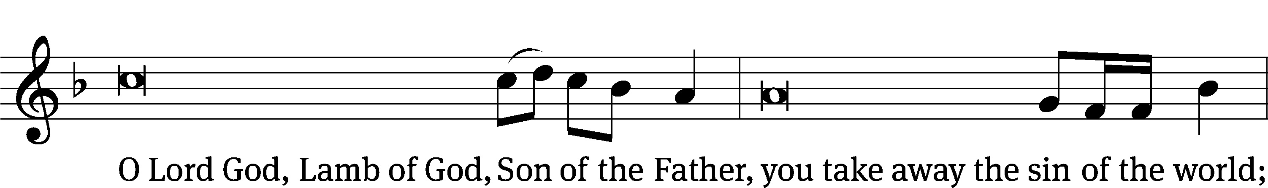
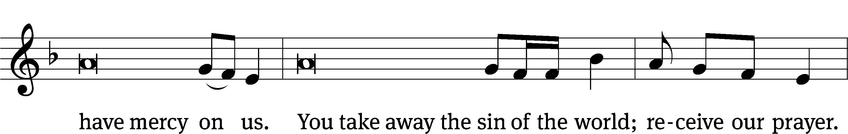
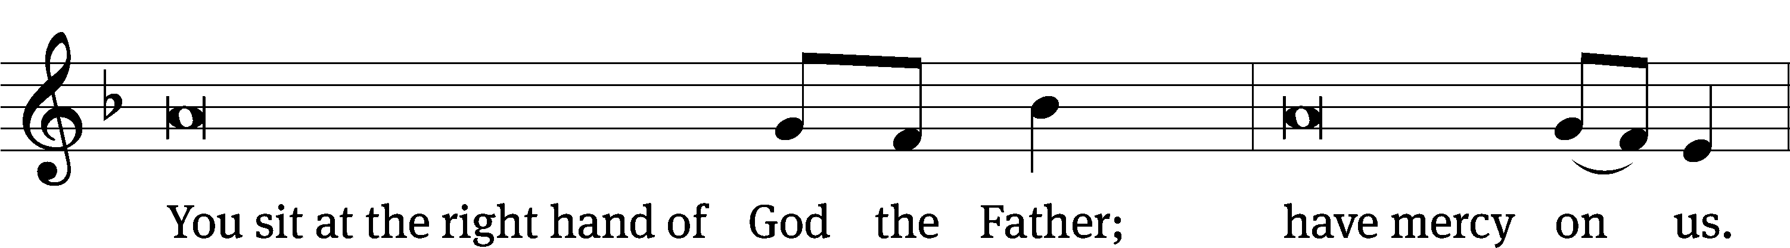
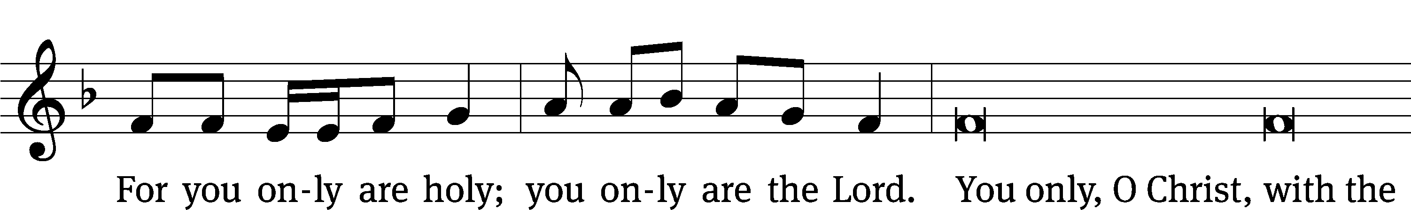
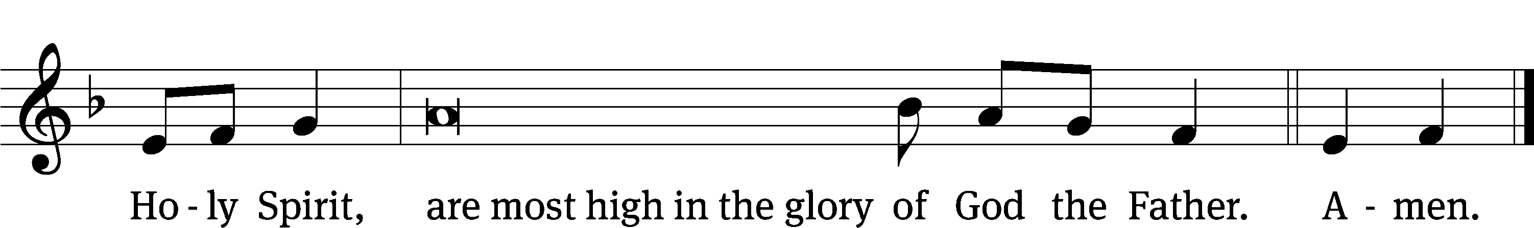

Tune: © 2021 Northwestern Publishing House. Used by permission: OneLicense no. 727703

The Lord be with you.
And also with you.
Prayer of the Day
Let us pray.

O God, so rule and govern our hearts and minds by your Holy Spirit that, ever mindful of your final judgment, we may be stirred up to holiness of living here and dwell with you in perfect joy hereafter; through your Son, Jesus Christ our Lord, who lives and reigns with you and the Holy Spirit, one God, now and forever.
Amen.

Please be seated

First Reading Isaiah 44:6-11

⁶ This is what the Lord, the King of Israel,
Israel’s Redeemer, the Lord of Armies, says.
I am the first, and I am the last.
Except for me, there is no god.
⁷ For who is like me? Let him declare it.
Let him recite in order for me the things that took place
since the time I established an ancient people.
Or let them declare what is yet to come,
and what is going to take place.
⁸ Do not tremble, and do not be frightened.
Did I not announce this to you,
and declare it already long ago?
You are my witnesses.
Is there any god except me?
There is no other Rock. I am not aware of any other.
⁹ All those who form an idol are good for nothing.
All the things which delight them provide no benefit.
As for their witnesses—they do not see.
They know nothing, so they will be ashamed.
¹⁰ Who is this who forms a god or casts a metal image that can provide no profit? ¹¹ Look at him! All his associates will be ashamed. The craftsmen are merely men. Let them all gather themselves and take a stand. They will be terrified and ashamed together.

The Word of the Lord.
Thanks be to God.
Psalm 19C Lord, You Have the Words of Everlasting Life Psalm 19C
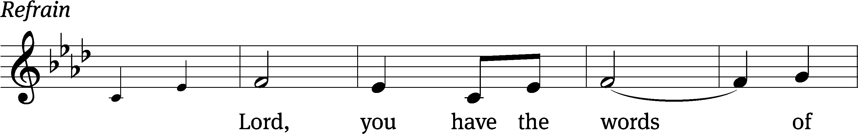
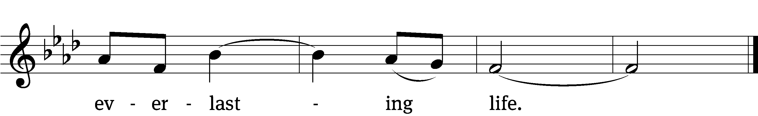
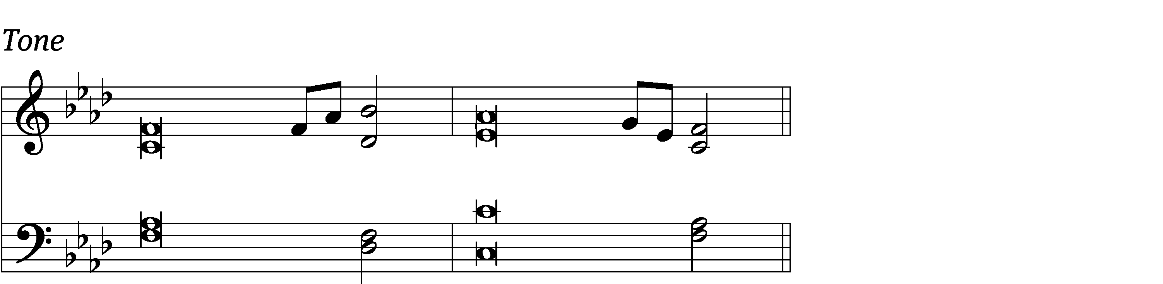

The heavens declare the glo- / ry of God;
the skies proclaim the work / of his hands.
Their voice goes out into / all the earth,
their words to the ends / of the world. Refrain
The law of the Lord is / perfect,
refresh- / ing the soul.
The commands of the Lord are / radiant,
giving light / to the eyes.
They are more pre- / cious than gold;
they are sweeter than / honey. Refrain

May these words of my mouth and this meditation / of my heart
be pleasing in your sight, Lord, my rock and my Re- / deemer.
Glory be to the Father and / to the Son
and to the Holy / Spirit,
as it was in the be- / ginning,
is now, and will be forever. / Amen. Refrain
Text: Lectionary for Mass
Tune: Richard T. Proulx
Text: © 1969, 1981, 1997 ICEL (refrain). Used by permission: OneLicense no. 727703
Tune: © 1975 GIA Publications, Inc. Used by permission: OneLicense no. 727703
Setting: © 1993 Kermit G. Moldenhauer, admin. Northwestern Publishing House. Used by permission: OneLicense no. 727703

Second Reading Romans 1:18-25

¹⁸ Indeed, God’s wrath is being revealed from heaven against all the ungodliness and unrighteousness of people who try to suppress the truth by unrighteousness. ¹⁹ This happens because what can be known about God is evident among them, because God made it evident among them. ²⁰ In fact, his invisible characteristics—his eternal power and divine nature—have been clearly seen since the creation of the world, because they are understood from the things he made. As a result, people are without excuse, ²¹ because, even though they knew God, they did not honor him or give him thanks as God. Instead, their thinking became nonsense, and their senseless heart was darkened.
²² Although they claim to be wise, they have become fools ²³ and exchanged the glory of the immortal God for images made to look like a mortal human, or like birds, four-footed animals, and crawling things. ²⁴ So, as they followed the sinful desires of their hearts, God handed them over to the impurity of degrading their own bodies among themselves. ²⁵ Such people have traded the truth about God for the lie, worshipping and serving the creation rather than the Creator, who is worthy of praise forever. Amen.

The Word of the Lord.
Thanks be to God.

Please stand, if you are able
Gospel Acclamation Romans 11:33
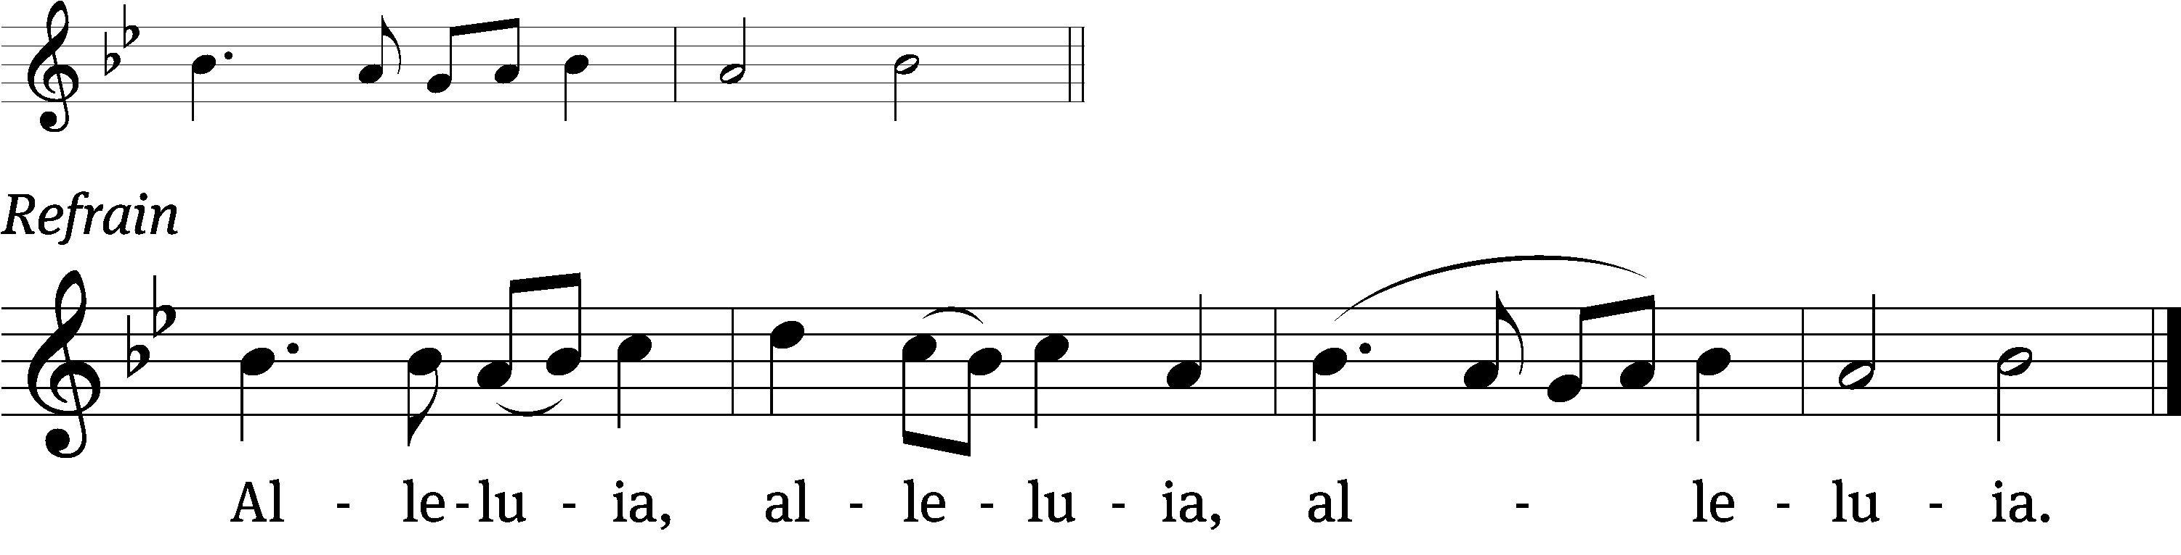
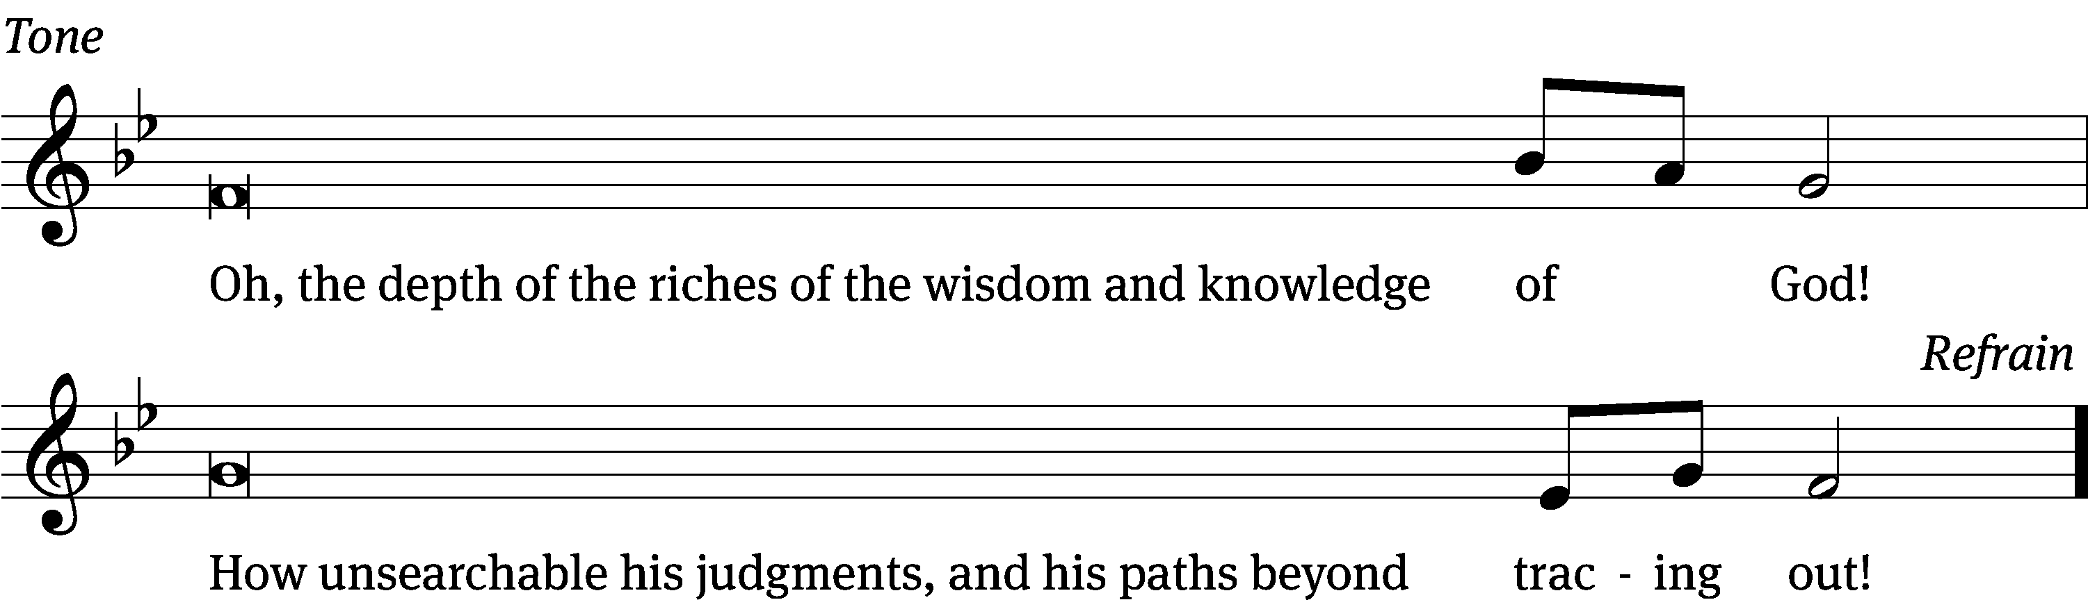
Gospel Matthew 13:24-30, 36-43

²⁴ He presented another parable to them: “The kingdom of heaven is like a man who sowed good seed in his field. ²⁵ But while people were sleeping, his enemy came and sowed weeds among the wheat and went away. ²⁶ When the plants sprouted and produced heads of grain, the weeds also appeared. ²⁷ The servants of the owner came and said to him, ‘Sir, did you not sow good seed in your field? Where did the weeds come from?’ ²⁸ He said to them, ‘An enemy did this.’ The servants asked him, ‘Do you want us to go and gather up the weeds?’ ²⁹ ‘No,’ he answered, ‘because when you gather up the weeds, you might pull up the wheat along with them. ³⁰ Let both grow together until the harvest, and at harvest time I will tell the reapers, “First, gather up the weeds, bind them in bundles, and burn them. Then, gather the wheat into my barn.”’”The Gospel of the Lord.
³⁶ Then Jesus sent the people away and went into the house. His disciples came to him and said, “Explain to us the parable of the weeds in the field.”
³⁷ He answered them, “The one who sows the good seed is the Son of Man. ³⁸ The field is the world. The good seeds are the sons of the kingdom. The weeds are the sons of the Evil One. ³⁹ The enemy who sowed them is the Devil. The harvest is the end of the world. The reapers are angels. ⁴⁰ Therefore, just as the weeds are gathered up and burned with fire, so it will be at the end of the world. ⁴¹ The Son of Man will send out his angels, and they will pull out of his kingdom everything that causes sin^{[d]} and those who continue to break the law. ⁴² The angels will throw them into the fiery furnace where there will be weeping and gnashing of teeth. ⁴³ Then the righteous will shine like the sun in the kingdom of their Father. Whoever has ears to hear, let him hear.

The Gospel of the Lord.
Praise be to you, O Christ!

Please be seated

470 Like the Golden Sun Ascending CW 470
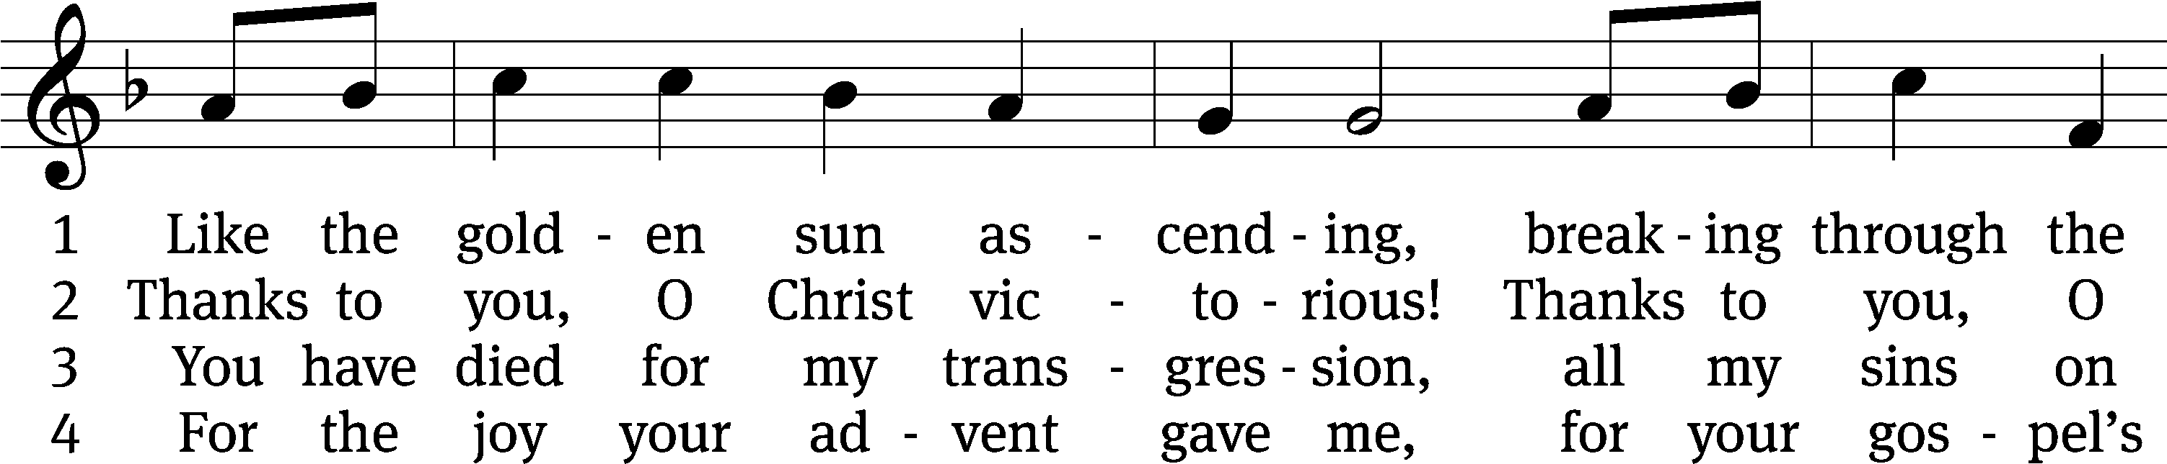
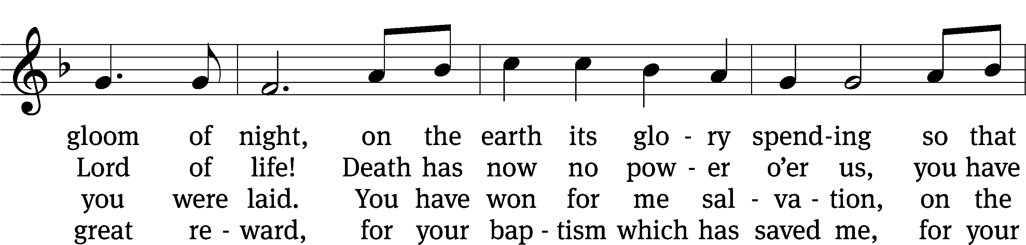
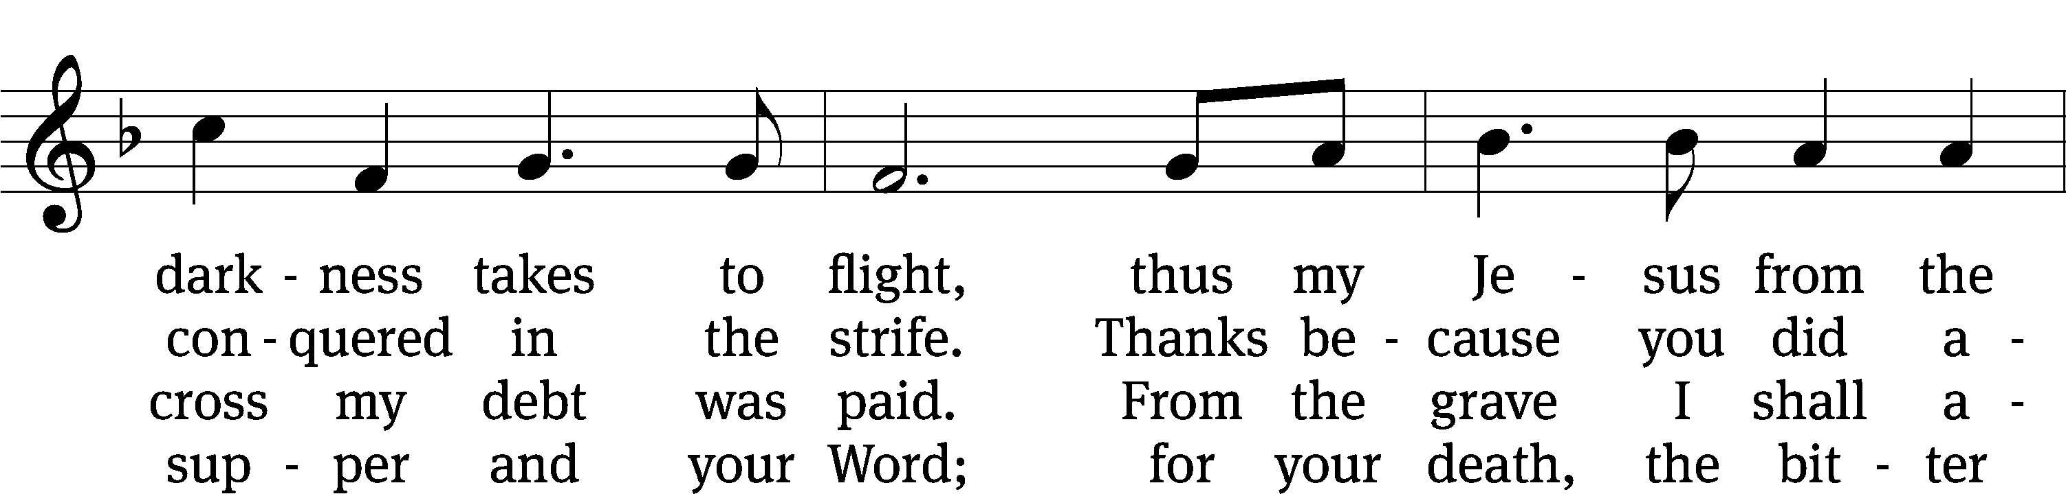
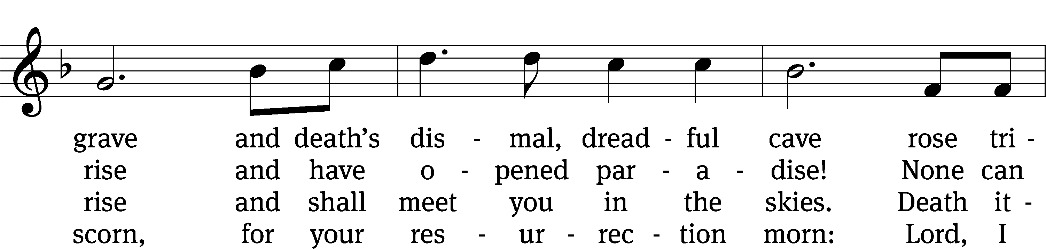
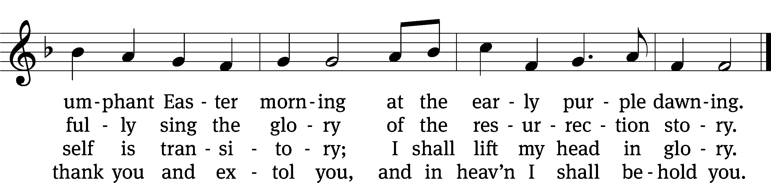
Text: tr. George A. T. Rygh, 1860–1942, alt.; Thomas H. Kingo, 1634–1703, abr.
Tune: Johann Schop, c. 1590–1667
Text and tune: Public domain

Sermon John 11:25-26a
“Jesus Says, “I AM the Resurrection and the Life”

²⁵ Jesus said to [Martha], “I am the resurrection and the life. Whoever believes in me will live, even if he dies. ²⁶ And whoever lives and believes in me will never perish.

Please stand, if you are able
Apostles’ Creed
I believe in God, the Father Almighty,
maker of heaven and earth.

I believe in Jesus Christ, his only Son, our Lord,
who was conceived by the Holy Spirit,
born of the Virgin Mary,
suffered under Pontius Pilate,
was crucified, died, and was buried.
He descended into hell.
The third day he rose again from the dead.
He ascended into heaven
and is seated at the right hand of God the Father Almighty.
From there he will come to judge the living and the dead.

I believe in the Holy Spirit,
the holy Christian Church,
the communion of saints,
the forgiveness of sins,
the resurrection of the body,
and the life everlasting. Amen.

Prayer of the Church

Please be seated

855 The Church’s One Foundation CW 855 sts. 1–5
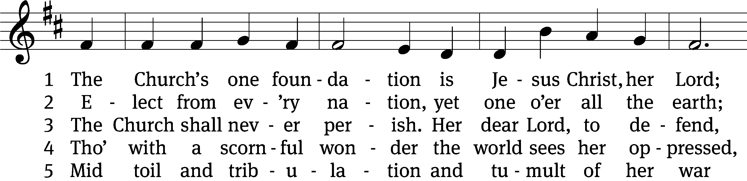
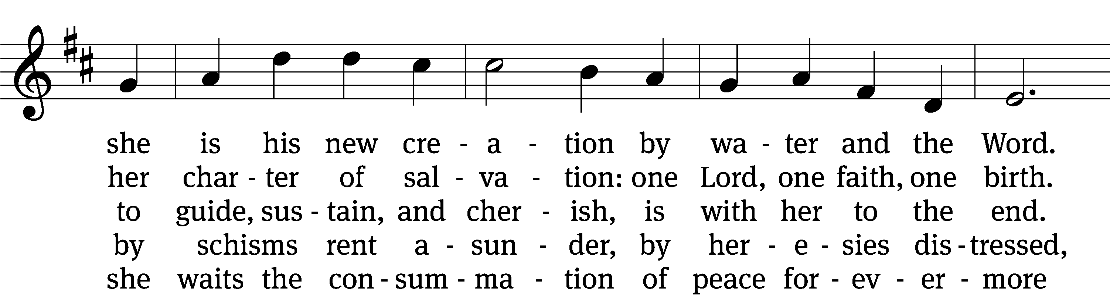
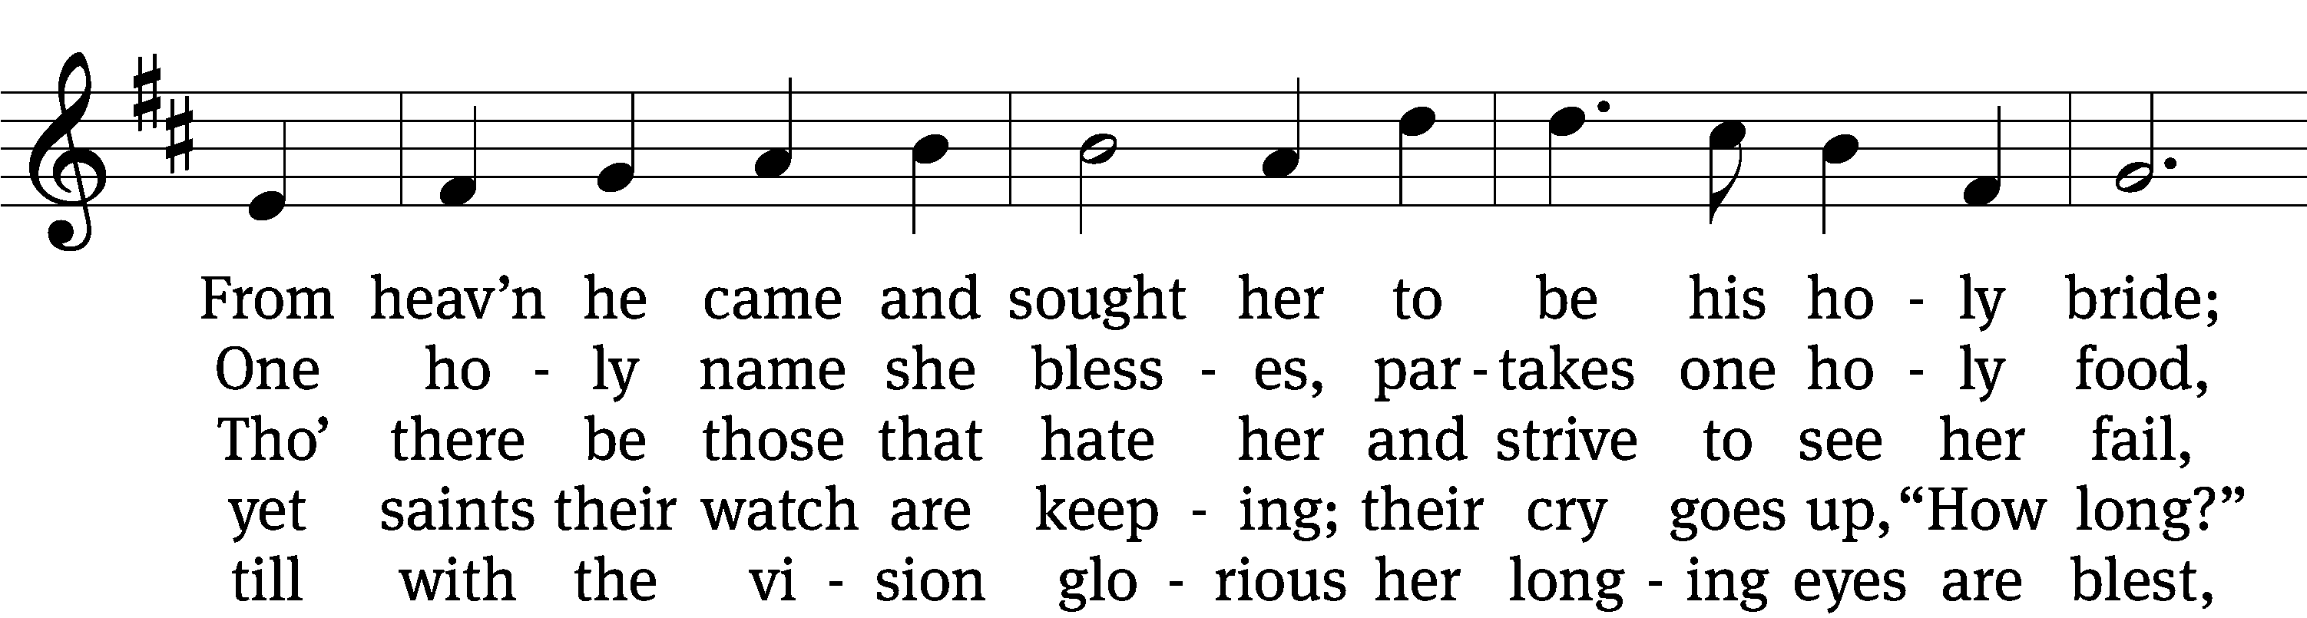
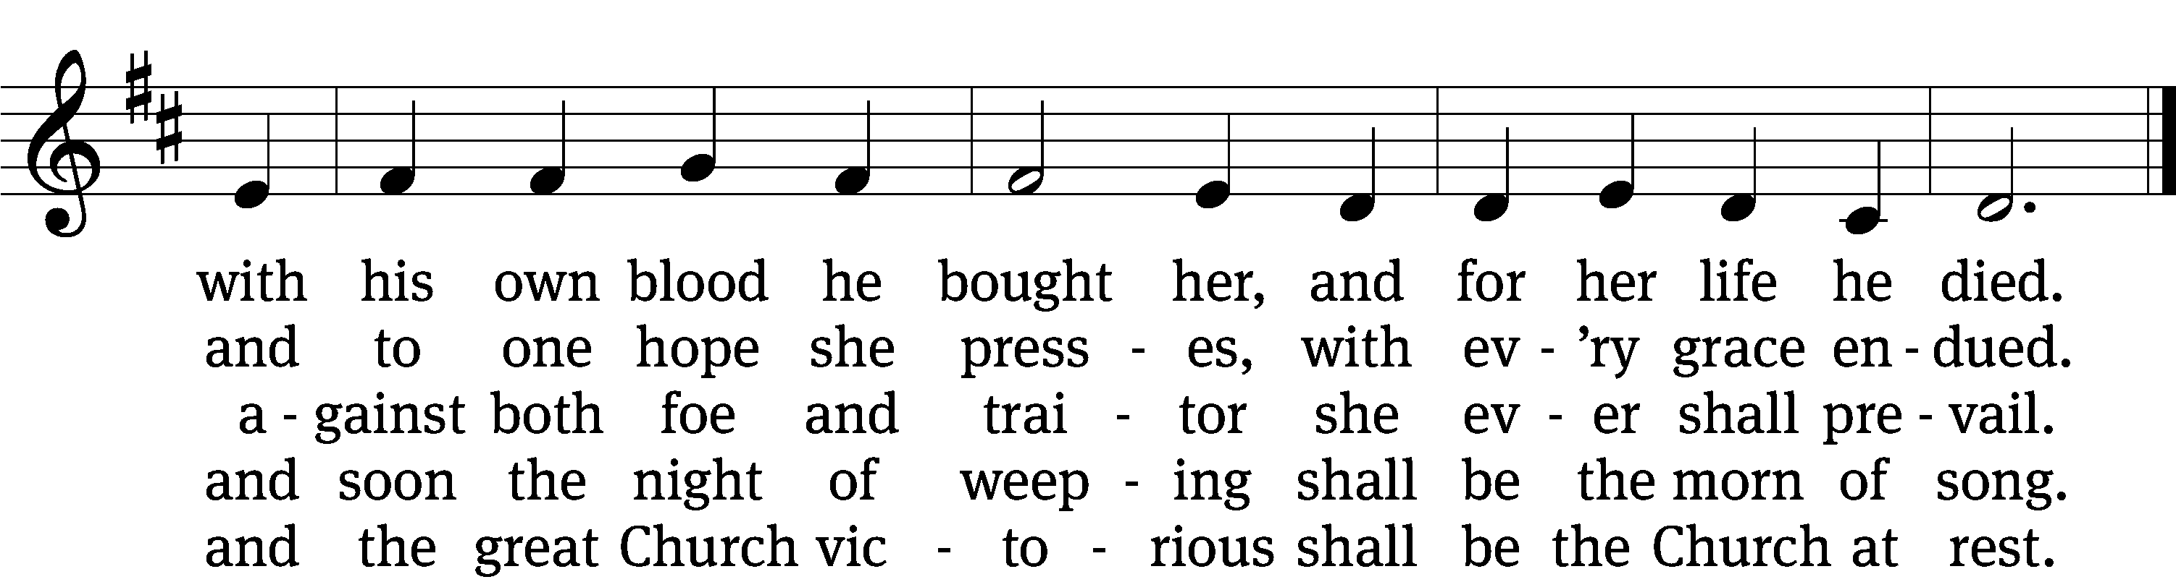
Text: Samuel J. Stone, 1839–1900, abr., alt.
Tune: Samuel S. Wesley, 1810–1876
Text and tune: Public domain

Please stand, if you are able

Prayer
Blessed Lord, you have given us your Holy Scriptures for our learning. May we so hear them, read, learn, and take them to heart that, being strengthened and comforted by your holy Word, we may cling to the blessed hope of everlasting life; through Jesus Christ our Lord, who lives and reigns with you and the Holy Spirit, one God, now and forever.
Amen.
Lord’s Prayer
Our Father, who art in heaven, hallowed be thy name, thy kingdom come, thy will be done on earth as it is in heaven. Give us this day our daily bread; and forgive us our trespasses, as we forgive those who trespass against us; and lead us not into temptation, but deliver us from evil. For thine is the kingdom and the power and the glory forever and ever. Amen.

Blessing
The Lord bless you and keep you.
The Lord make his face shine on you and be gracious to you.
The Lord look on you with favor and give you peace.
Amen.

Please be seated

528 Christ, the Word of God Incarnate CW 528 sts. 1, 6
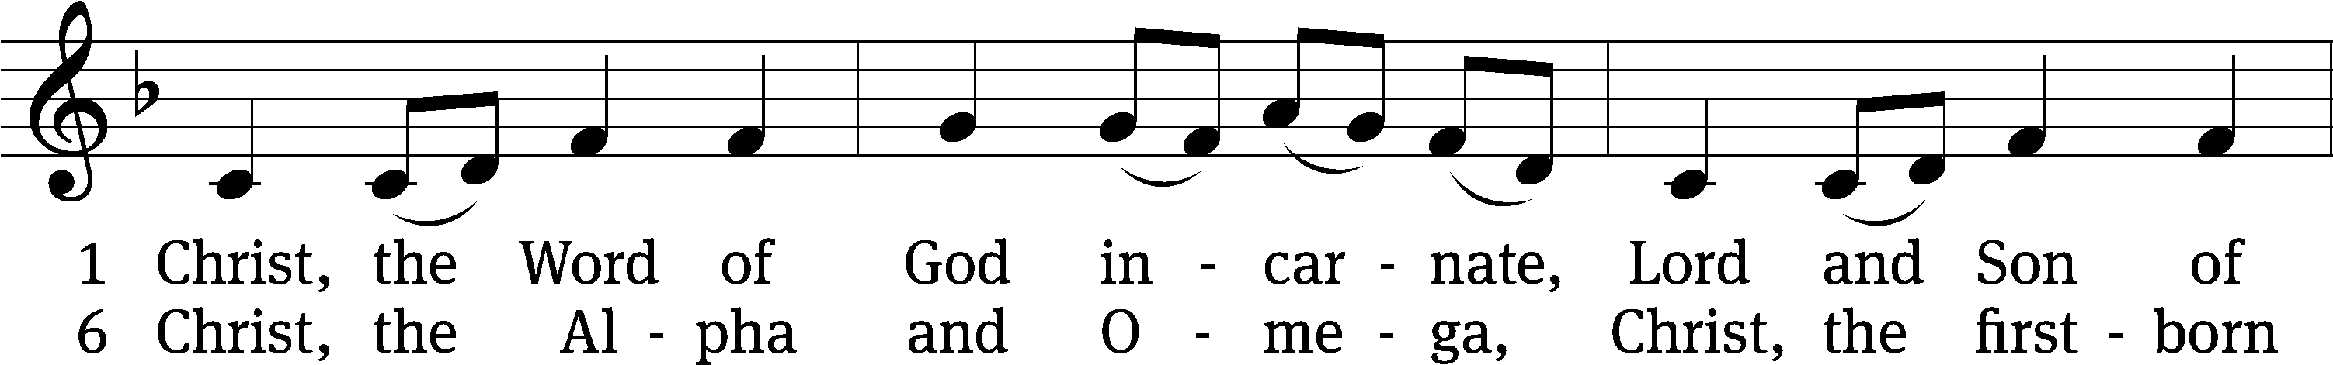
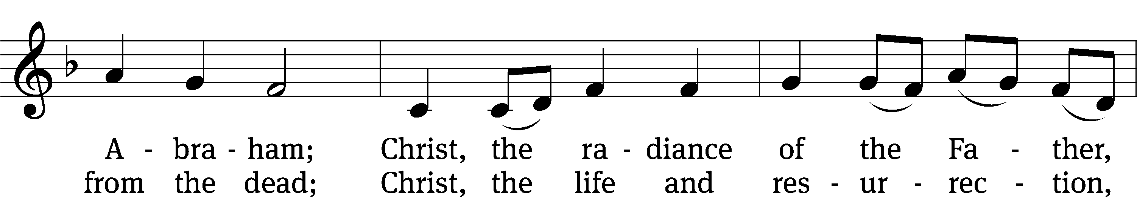
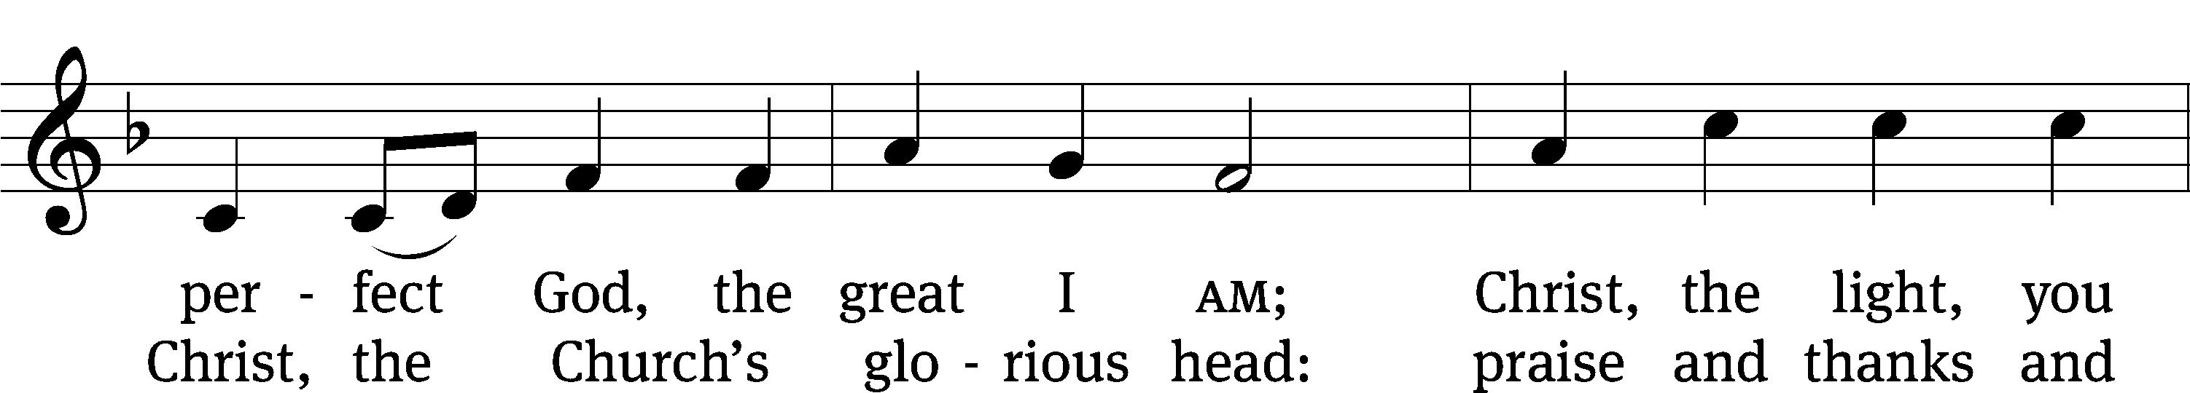
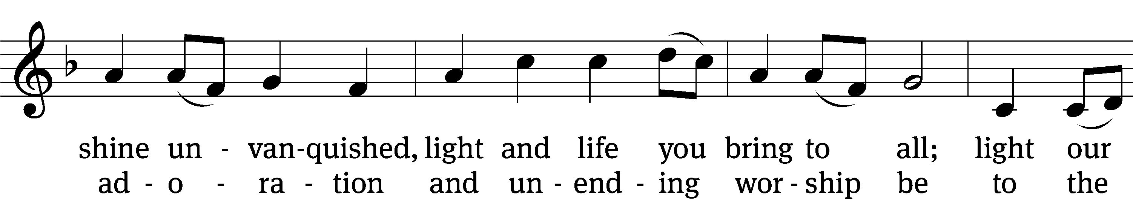
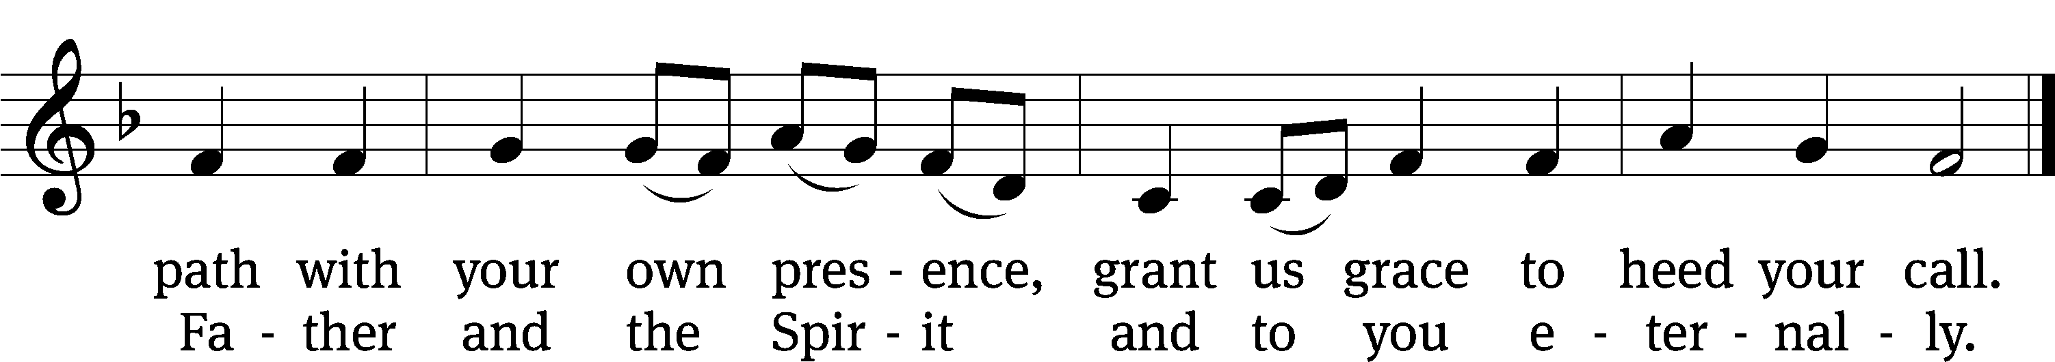
Text: Steven P. Mueller, b. 1964
Tune: Columbian Harmony, Cincinatti, 1825, ed. William Moore
Text: © 2001 Steven P. Mueller. Used by permission: OneLicense no. 727703
Tune: Public domain

Acknowledgments
Setting One from Christian Worship
Software distributed in partnership with Northwestern Publishing House.
Created by Christian Worship: Service Builder © 2022 Concordia Publishing House.

Serving in Worship
Officiant Pastor Natsis
Organist Sarah Hanke
Deacons (Thursday) Steve Hoeft and Jim Tice
(Sunday) Jeff Neuburger and Dave Stevenson
Ushers (Thursday) Dale Finkbeiner and Mark Finkbeiner
(Sunday) Al Whitley
Altar Guild Esther Gross and Diane Stevenson
Videographer Rick Schneider

