THE NINth SUNDAY
after pentecost
tRINITY EVANGELICAL LUTHERAN CHURCH | Saline, Michigan
July 27/30, 2023

WELCOME TO WORSHIP

Thank you for joining us in God’s house today! We cordially ask that our Guests with us this morning sign one of the guestbooks located at either the front or back entryways.

THANK OFFERING: Members of Trinity give their offering as an expression of love and thankfulness to the Lord and to help support the Lord’s work in our community and around the world. Visitors need not feel obligated to participate in this offering which supports our ministry.

Restrooms are located at the back of the upper level (the annex), and in the basement (down the back stairs of the sanctuary or annex). Handicap access is available, please ask an usher for assistance.

Young Families / Toddler Bags – We are GLAD YOU BROUGHT YOUR CHILDREN to our worship service. Jesus said: “Let the little children come to me and do not hinder them, for the kingdom of God belongs to such as these.” We know that having little children in church can be a challenge, but DO NOT WORRY about it. Many of your fellow worshippers have been in your shoes and are just happy you brought your children with you. For your convenience, we have reserved the back rows of seating for parents with small children. These areas provide more flexibility for your family, as well as, easy access to move downstairs if necessary. A closed-circuit TV system allows families to continue participating in the service while downstairs. Pre-school toddler bags and children’s bulletins are available for their enjoyment. Ask an usher for one to use during the service and please return the toddler bag afterwards.

SERVICE of the word
898 Send, O Lord, Your Holy Spirit CW 898
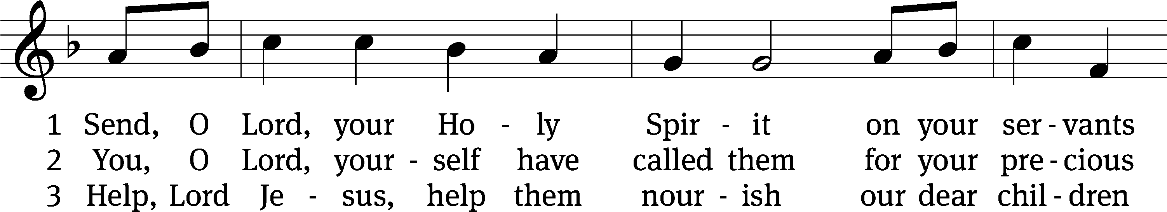
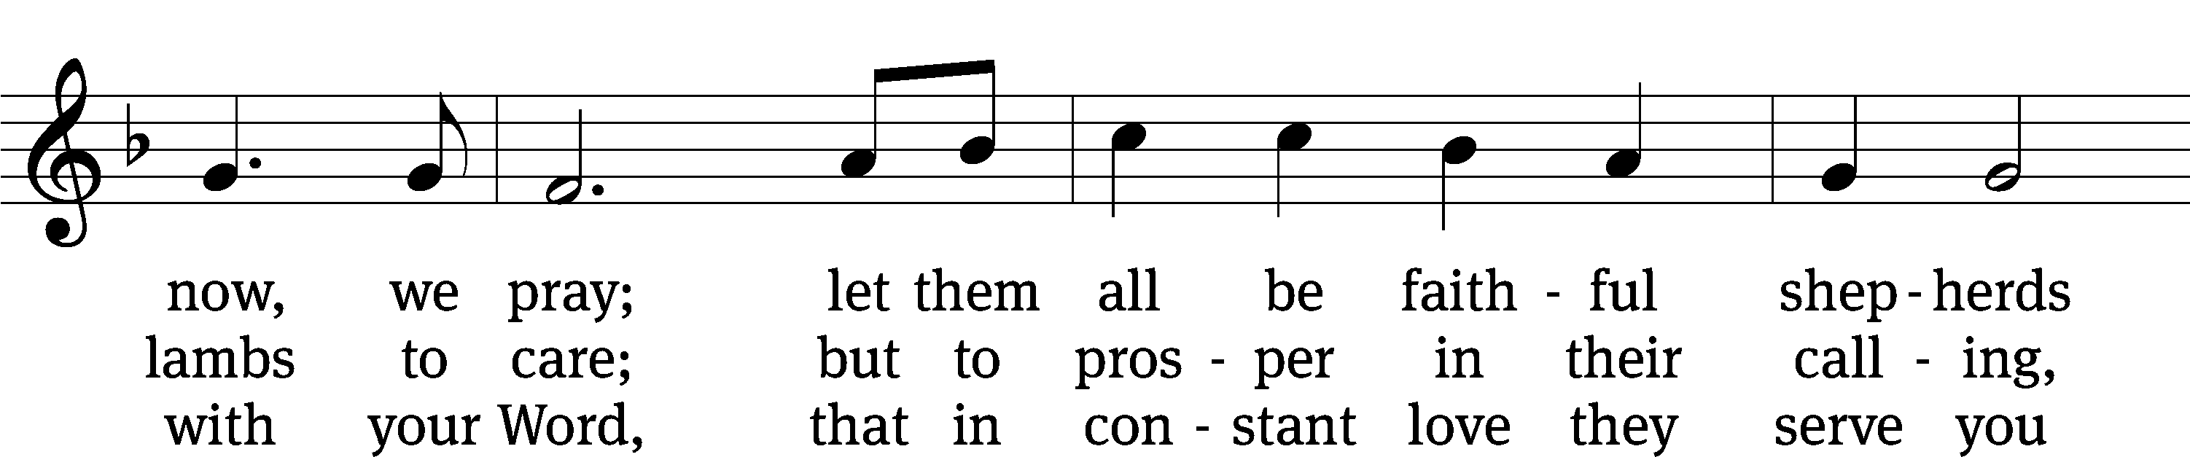
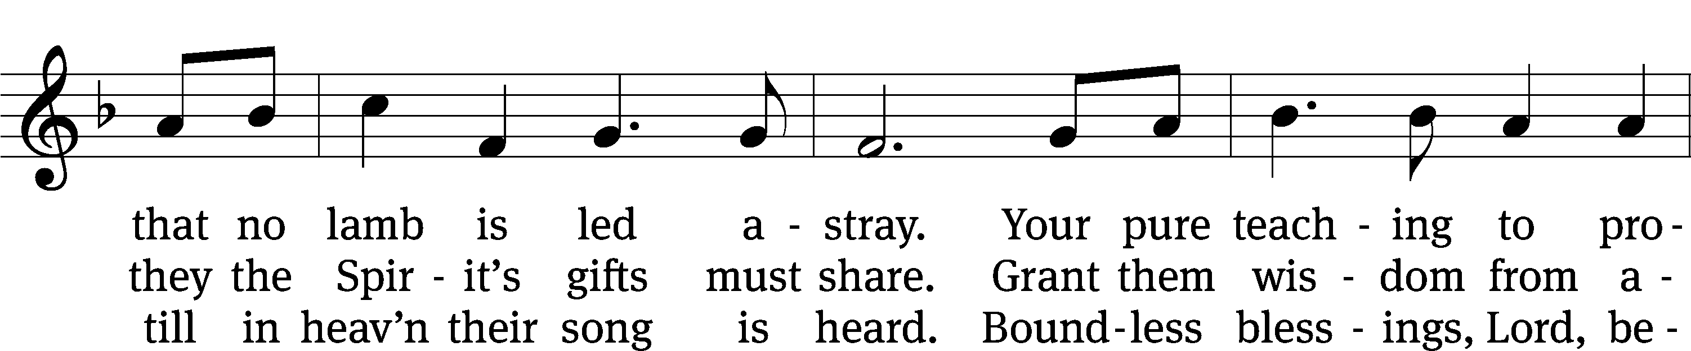
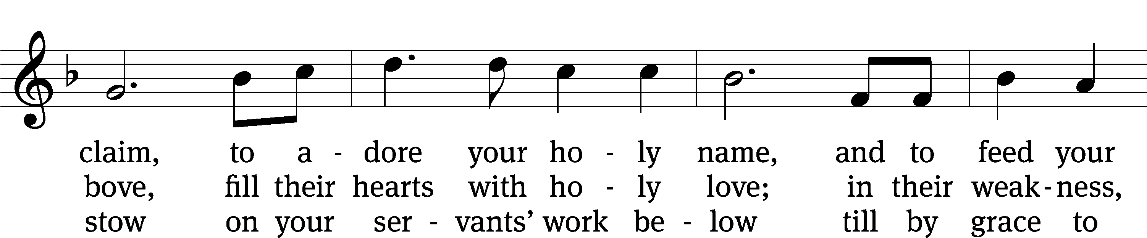
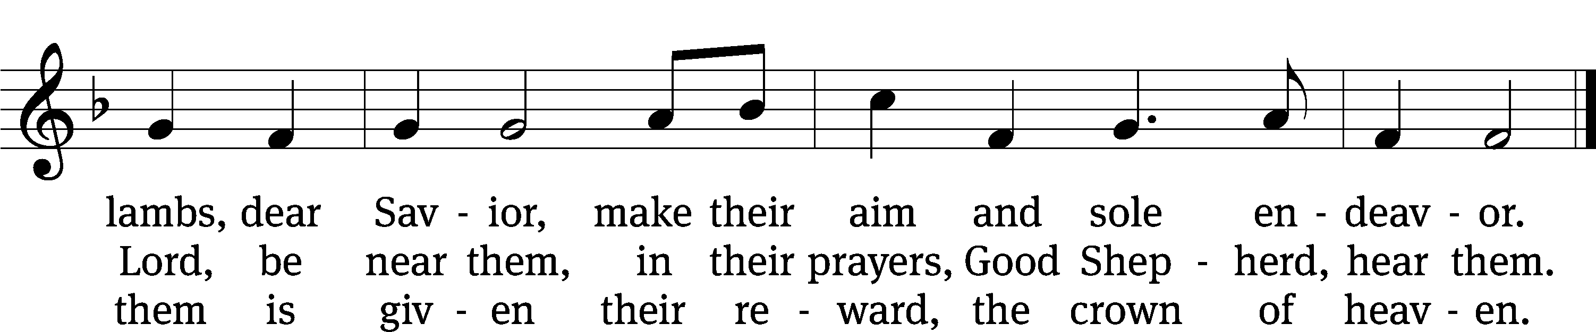
Text: tr. Frederick W. Herzberger, 1859–1930, alt.; Lieder-Perlen, St. Louis, 1905
Tune: Johann Schop, c. 1590–1667
Text and tune: Public domain

PLEASE STAND, IF YOU ARE ABLE

invocation
M: The grace of our Lord (+) Jesus Christ and the love of God and the fellowship of the Holy Spirit be with you.
C: And also with you.
CONFESSION OF SINS
M: We have come into the presence of God, who created us to love and serve him as his dear children. But we have disobeyed him and deserve only his wrath and punishment. Therefore, let us confess our sins to him and plead for his mercy.

C: Merciful Father in heaven, I am altogether sinful from birth. In countless ways I have sinned against you and do not deserve to be called your child. But trusting in Jesus, my Savior, I pray: Have mercy on me according to your unfailing love. Cleanse me from my sin, and take away my guilt.

M: God, our heavenly Father, has forgiven all your sins. By the perfect life and innocent death of our Lord Jesus Christ, he has removed your guilt forever. You are his own dear child. May God give you strength to live according to his will.

C: Amen.
PRAYER AND PRAISE

M: In the peace of forgiveness, let us praise the Lord.

OH, TASTE AND SEE

PRAYER OF THE DAY

Let us pray.

O God, you reveal your mighty power chiefly in showing mercy and kindness. Grant us the full measure of your grace that we may obtain your promises and become partakers of your heavenly glory; through your Son, Jesus Christ our Lord, who lives and reigns with you and the Holy Spirit, one God, now and forever.

PLEASE BE SEATED

The Word

the FIRST LESSON 1 Kings 3:5-12
⁵ The Lord appeared to Solomon in Gibeon in a dream at night.
God said, “Ask for whatever you want me to give you.”
⁶ Solomon said, “You have shown great mercy and faithfulness^{[a]} to your servant, my father David, just as he walked before you in truth, righteousness, and uprightness of heart toward you. You have shown this great mercy and faithfulness to him and have given him a son who is seated on his throne to this very day. ⁷ O Lord my God, now you have made your servant king in the place of my father David, but I am a little child. I do not know how to go out or come in. ⁸ And I, your servant, am among your people whom you have chosen, a great people, who cannot be counted or numbered because they are so many. ⁹ Now give to your servant a perceptive heart to judge your people, to distinguish between good and evil, for who is able to judge this great people of yours?”
¹⁰ In the eyes of the Lord, Solomon’s request was good. ¹¹ So God said to him, “Because you have asked for this, and you have not asked for a long life, nor have you asked for riches, nor have you asked for the lives of your enemies, but you have asked for discernment to reach just verdicts, ¹² therefore I will act according to your words. Yes, I will give you a wise and discerning heart, so that there will never have been anyone like you before you, nor will anyone like you rise up after you.

63B O Lord, My God, Now Hear My Plea Psalm 63B
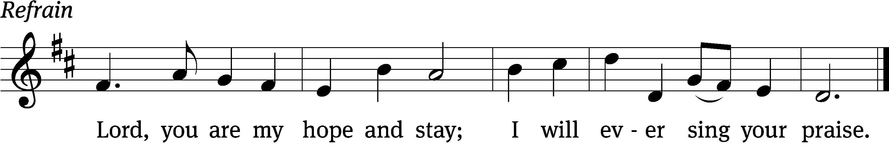
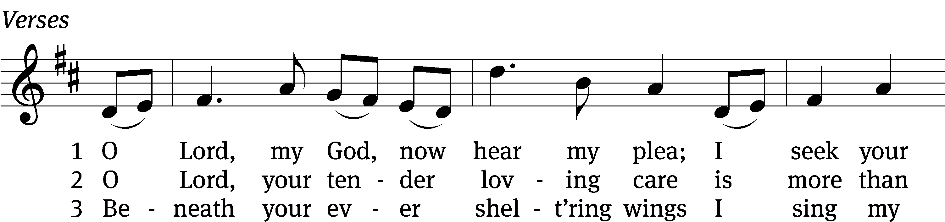
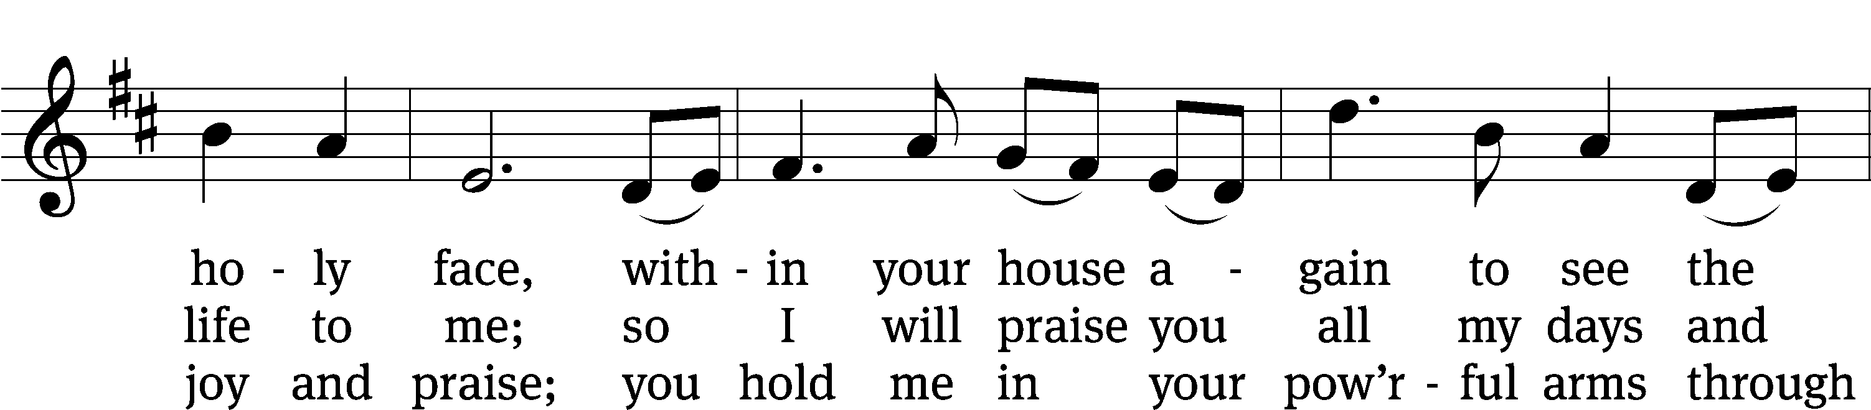
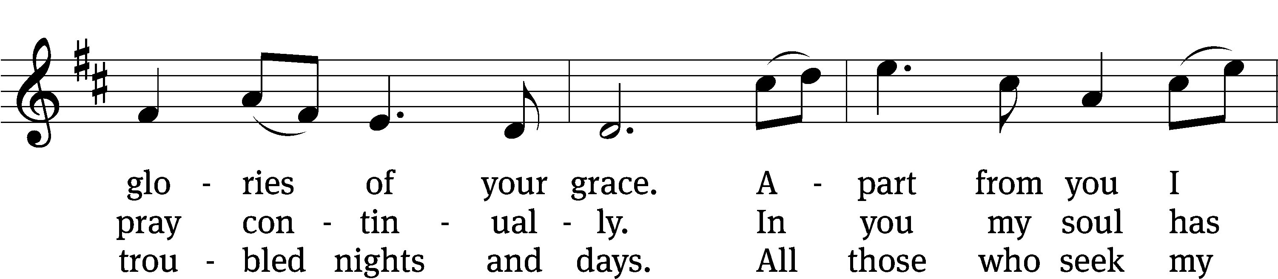
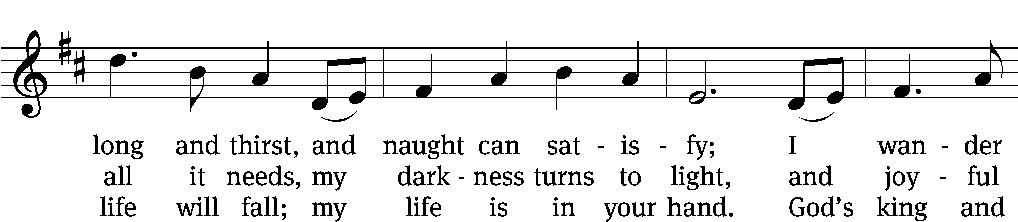
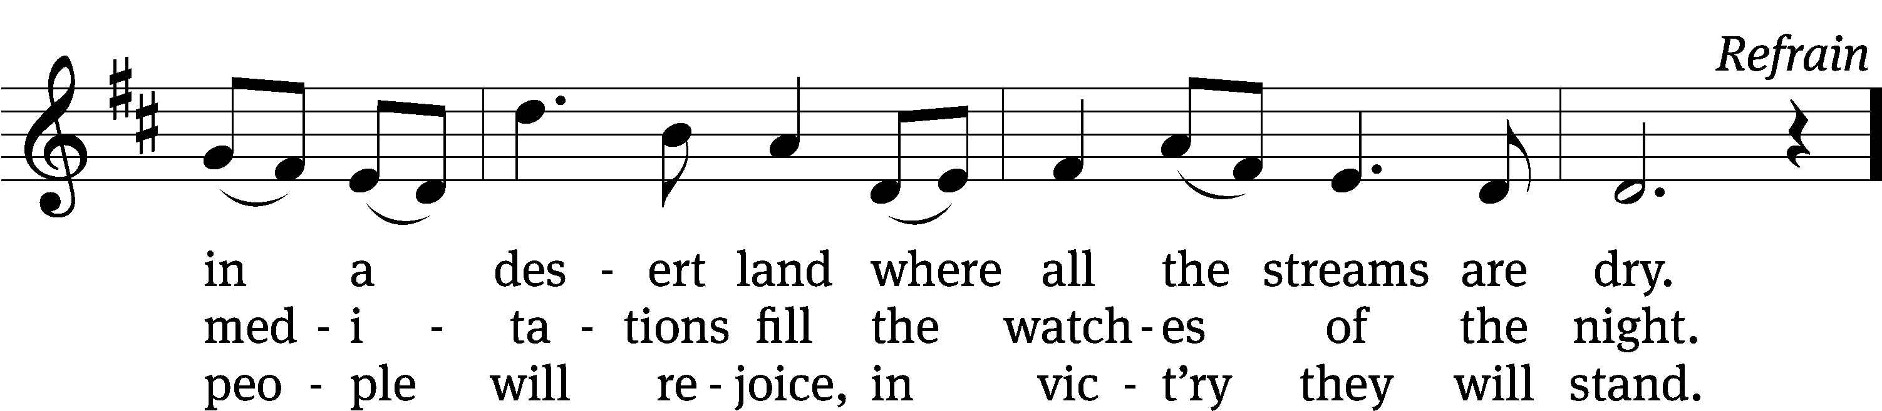
Text (sts. 1–3): Psalter, 1912, alt.; (Ref): Hal H. Hopson
Tune: (sts. 1-3) Psalter, 1912, alt.; (Ref) Hal H. Hopson
Text (sts. 1–3): Public domain
Text (Ref) and tune: © 2008 Birnamwood/MorningStar Music Publishers. Used by permission: OneLicense no. 727703

SECOND LESSON 1 Timothy 6:17-21
¹⁷ Instruct those who are rich in this present age not to be arrogant or to put their hope in the uncertainty of riches, but rather in God, who richly supplies us with all things for our enjoyment. ¹⁸ Instruct them to do good, to be rich in good works, to be generous and willing to share. ¹⁹ In this way they are storing up for themselves the treasure of a good foundation for the future, so that they may take hold of that which is truly life.
²⁰ O Timothy, guard what has been entrusted to you, turning away from godless, empty talk and the contradictions of what is falsely called “knowledge.” ²¹ By professing it, some have veered away from the faith. Grace be with you. Amen.

please stand, if you are able

Verse of the day Colossians 3:1-2
Alleluia. Since, then, you have been raised with Christ,
Set your minds on things above, not on earthly things. Alleluia.

THE GOSPEL LESSON Matthew 13:44-52

M: The Gospel according to Matthew chapter 13, verses 44-52

⁴⁴ “The kingdom of heaven is like a treasure hidden in a field, which a man found and hid again. In his joy, he goes away and sells all that he has and buys that field.
⁴⁵ “Again, the kingdom of heaven is like a merchant seeking fine pearls. ⁴⁶ When he found one very valuable pearl, he went and sold all that he had and bought it.
⁴⁷ “Again, the kingdom of heaven is like a dragnet that was cast into the sea and gathered fish of every kind. ⁴⁸ When the net was filled, they pulled it onto the shore. They sat down and gathered the good fish into containers, but threw the bad ones away. ⁴⁹ That is how it will be at the end of the world. The angels will go out and separate the wicked from the righteous who are among them. ⁵⁰ And they will throw the wicked into the fiery furnace where there will be weeping and gnashing of teeth.” ⁵¹ Jesus said to them, “Did you understand all these things?”
They answered him, “Yes.”
⁵² He said to them, “Therefore every expert in the law who has been trained as a disciple in the kingdom of heaven is like the owner of a house who brings out of his treasure both new things and old things.”

M: This is the Gospel of the Lord.

PLEASE BE SEATED

807 All Depends on Our Possessing CW 807
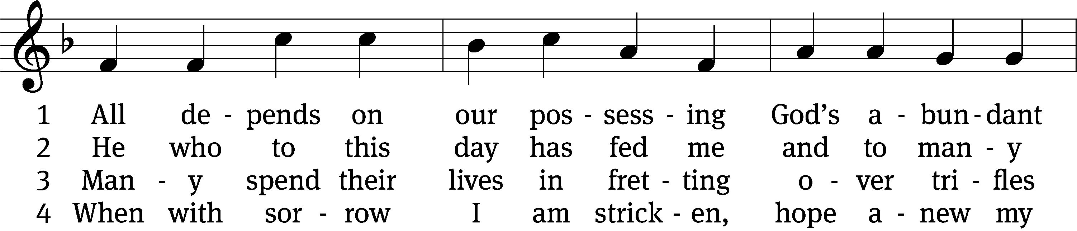
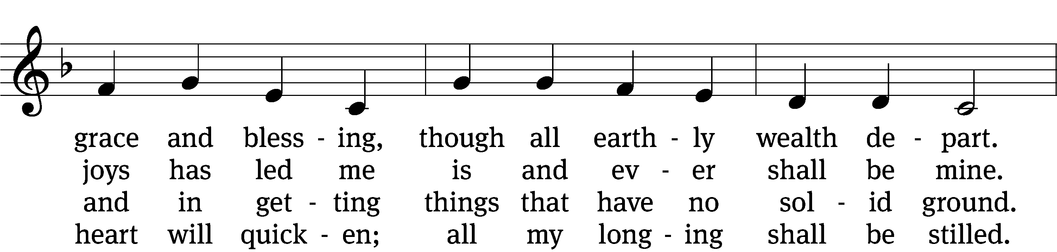
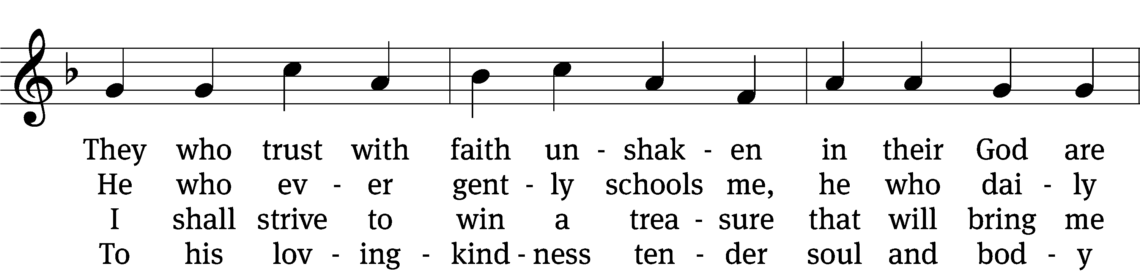
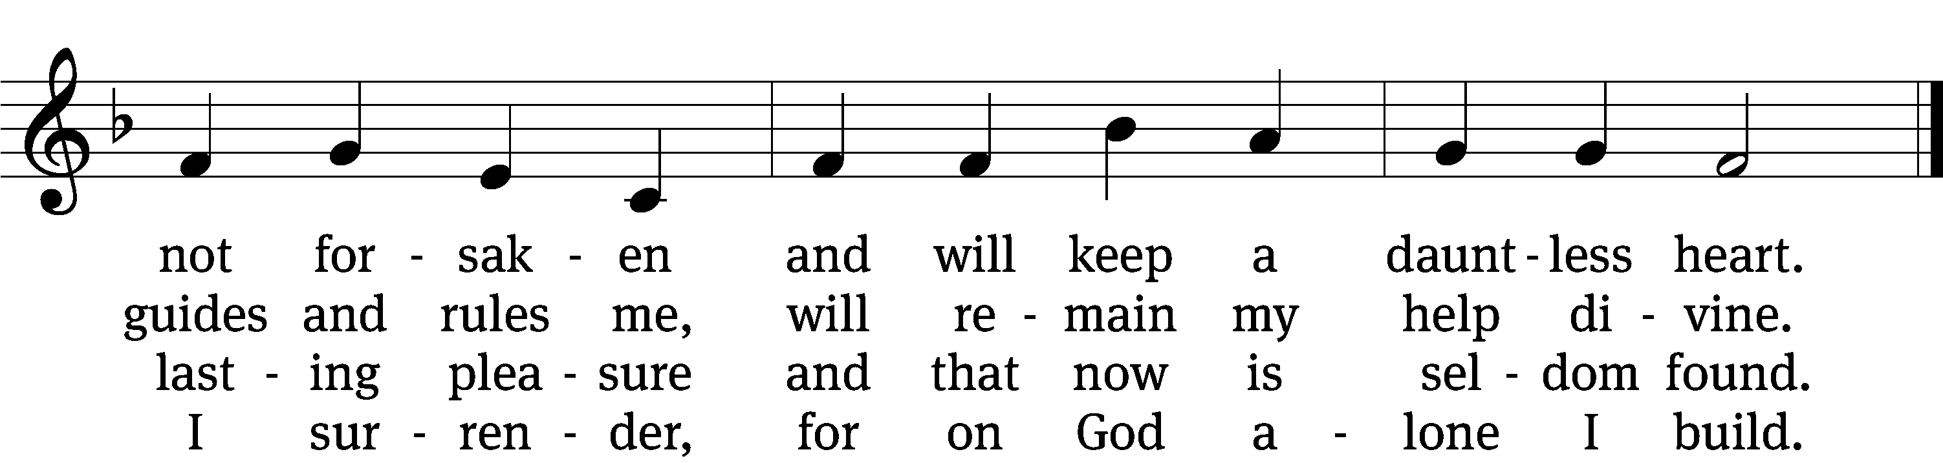

5 Well he knows what best to grant me; 6 If my days on earth he lengthen,
all the longing hopes that haunt me, he my weary soul will strengthen;
joy and sorrow, have their day. all my trust in him I place.
I shall doubt his wisdom never; Earthly wealth is not abiding,
as God wills, so be it ever; like a stream away is gliding;
I commit to him my way. safe I anchor in his grace.

Text: tr. Catherine Winkworth, 1827–1878, alt.; Andächtige Haus-Kirche, Nürnberg, 1676
Tune: adapt. Johann Balthasar König, 1691–1758; Johann Löhner, 1645–1705
Text and tune: Public domain

SERMON 1 Kings 3:5-12
“What Do You Want?”

PLEASE STAND, IF YOU ARE ABLE

THE APOSTLES’ CREED

I believe in God, the Father almighty,
maker of heaven and earth.
I believe in Jesus Christ, his only Son, our Lord,
who was conceived by the Holy Spirit,
born of the virgin Mary,
suffered under Pontius Pilate,
was crucified, died, and was buried.
He descended into hell.
The third day he rose again from the dead.
He ascended into heaven
and is seated at the right hand of God the Father almighty.
From there he will come to judge the living and the dead.
I believe in the Holy Spirit,
the holy Christian Church,
the communion of saints,
the forgiveness of sins,
the resurrection of the body,
and the life everlasting. Amen.

PRAYER OF THE CHURCH

THE LORD’S PRAYER

C: Our Father, who art in heaven, hallowed be thy name, thy kingdom come, thy will be done on earth as it is in heaven. Give us this day our daily bread; and forgive us our trespasses, as we forgive those who trespass against us; and lead us not into temptation, but deliver us from evil. For thine is the kingdom and the power and the glory forever and ever. Amen.
770 God of Grace and God of Glory CW 770
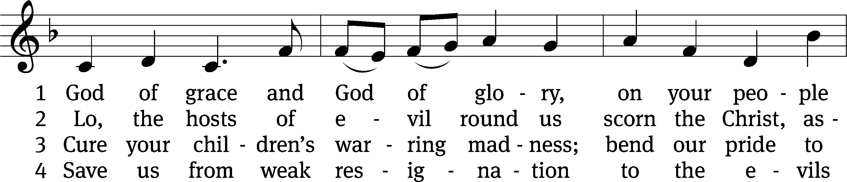
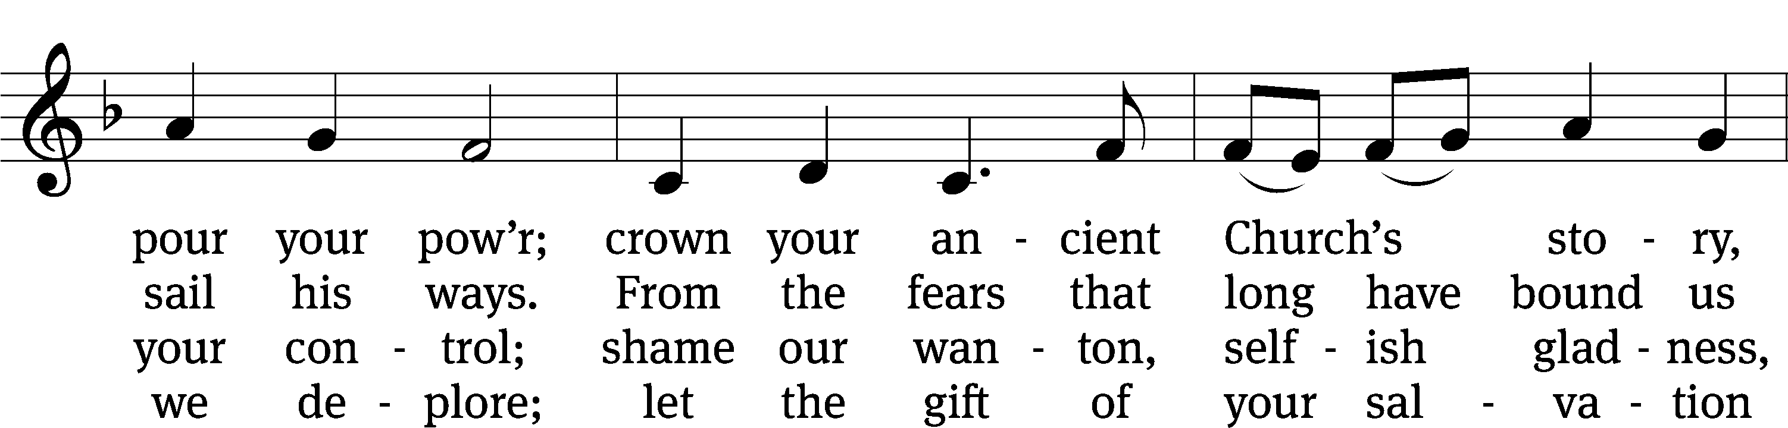
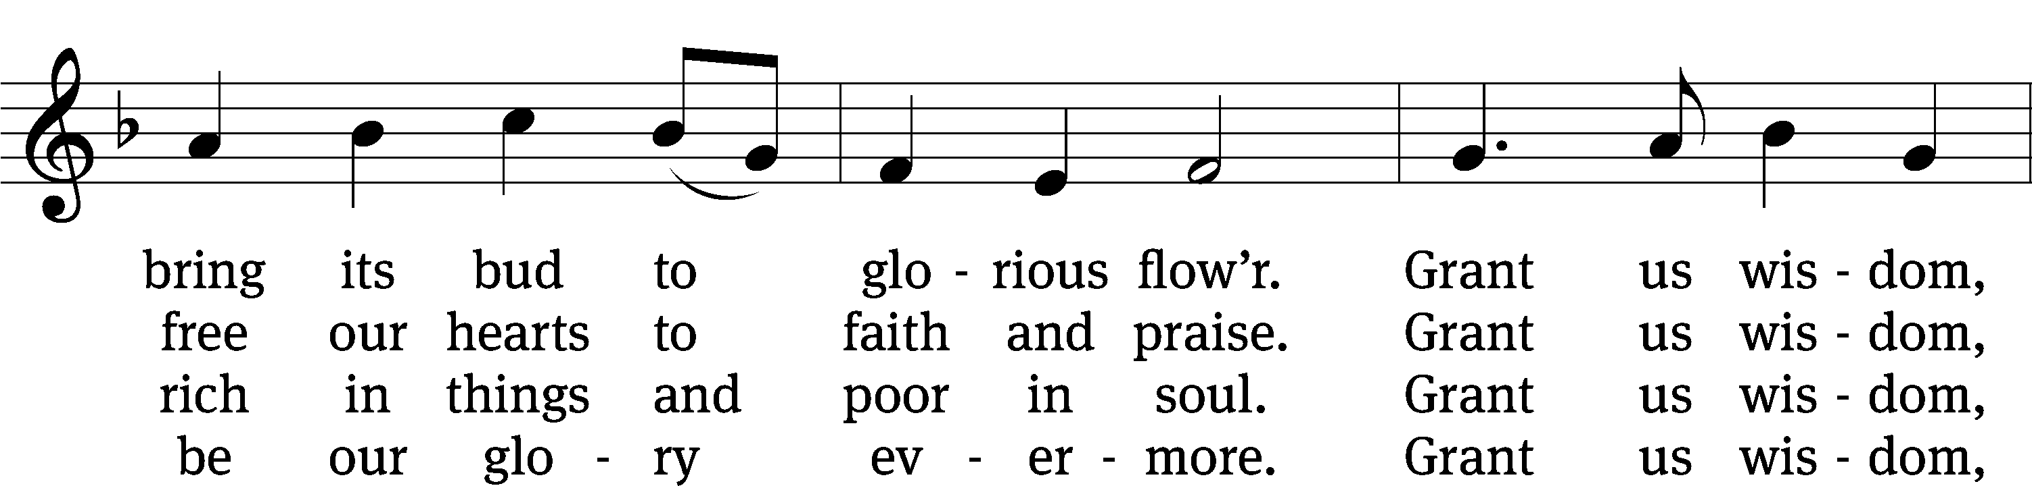
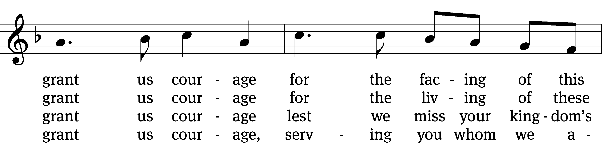
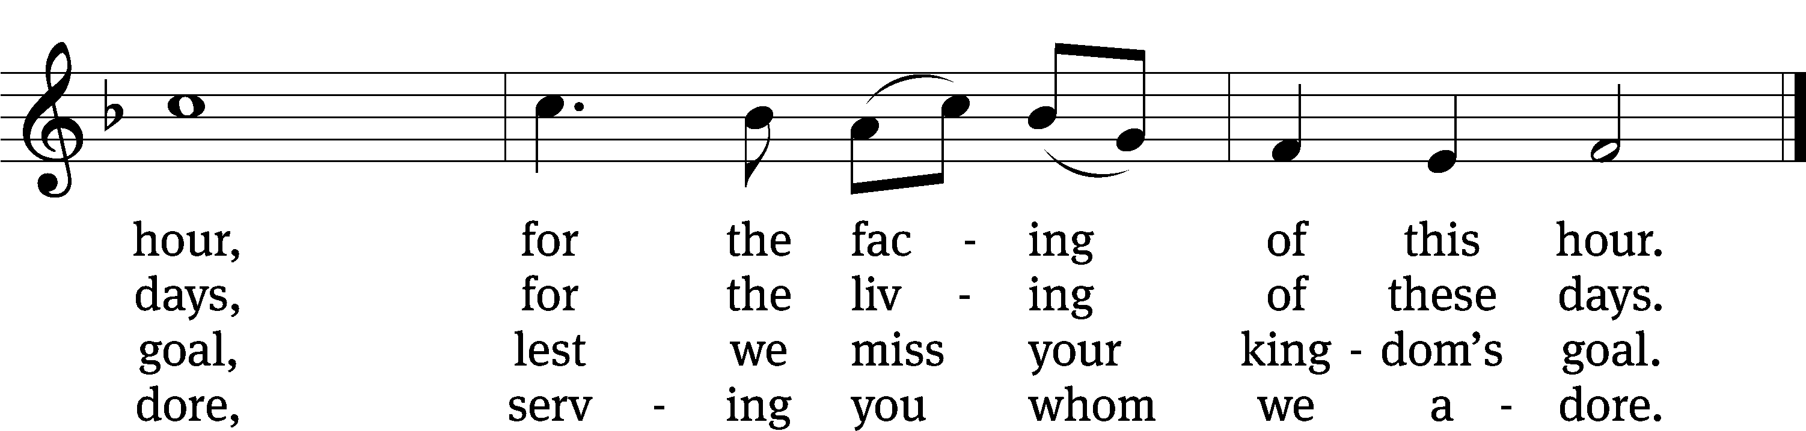
Text: Harry E. Fosdick, 1878–1969, abr., alt.
Tune: John Hughes, 1873–1932
Text and tune: Public domain

PLEASE STAND, IF YOU ARE ABLE
CLOSING PRAYER
M: Almighty God, we thank you for teaching us the things you want us to believe and do. Help us by your Holy Spirit to keep your Word in pure hearts that we may be strengthened in faith, guided in holiness, and comforted in life and in death, through Jesus Christ, our Lord, who lives and reigns with you and the Holy Spirit, one God, now and forever.

M: Brothers and sisters, go in peace. Live in harmony with one another. Serve the Lord with gladness.
The Lord bless you and keep you.
The Lord make his face shine on you and be gracious to you.
The Lord look on you with favor and (+) give you peace.

PLEASE BE SEATED

931 Savior, Again to Thy Dear Name We Raise CW 931
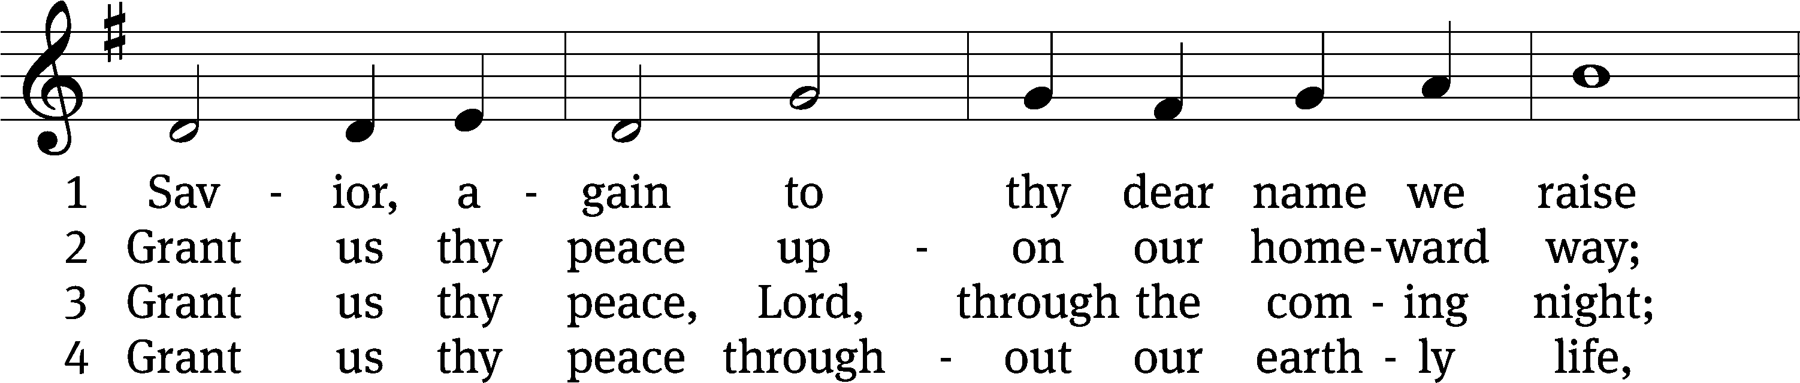
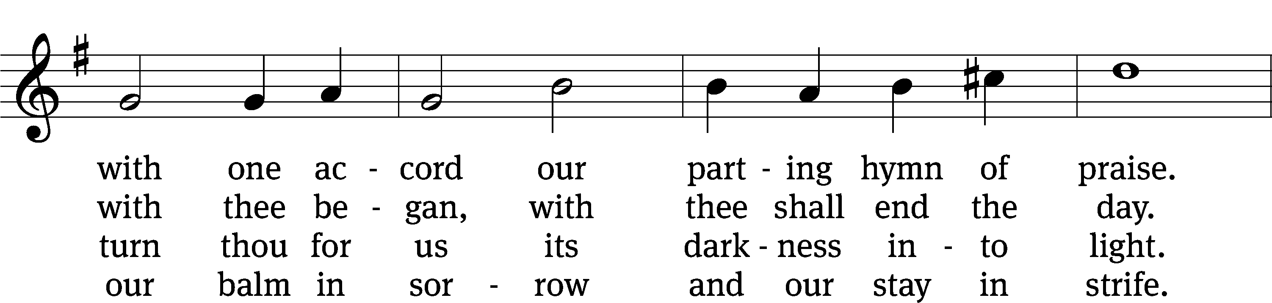
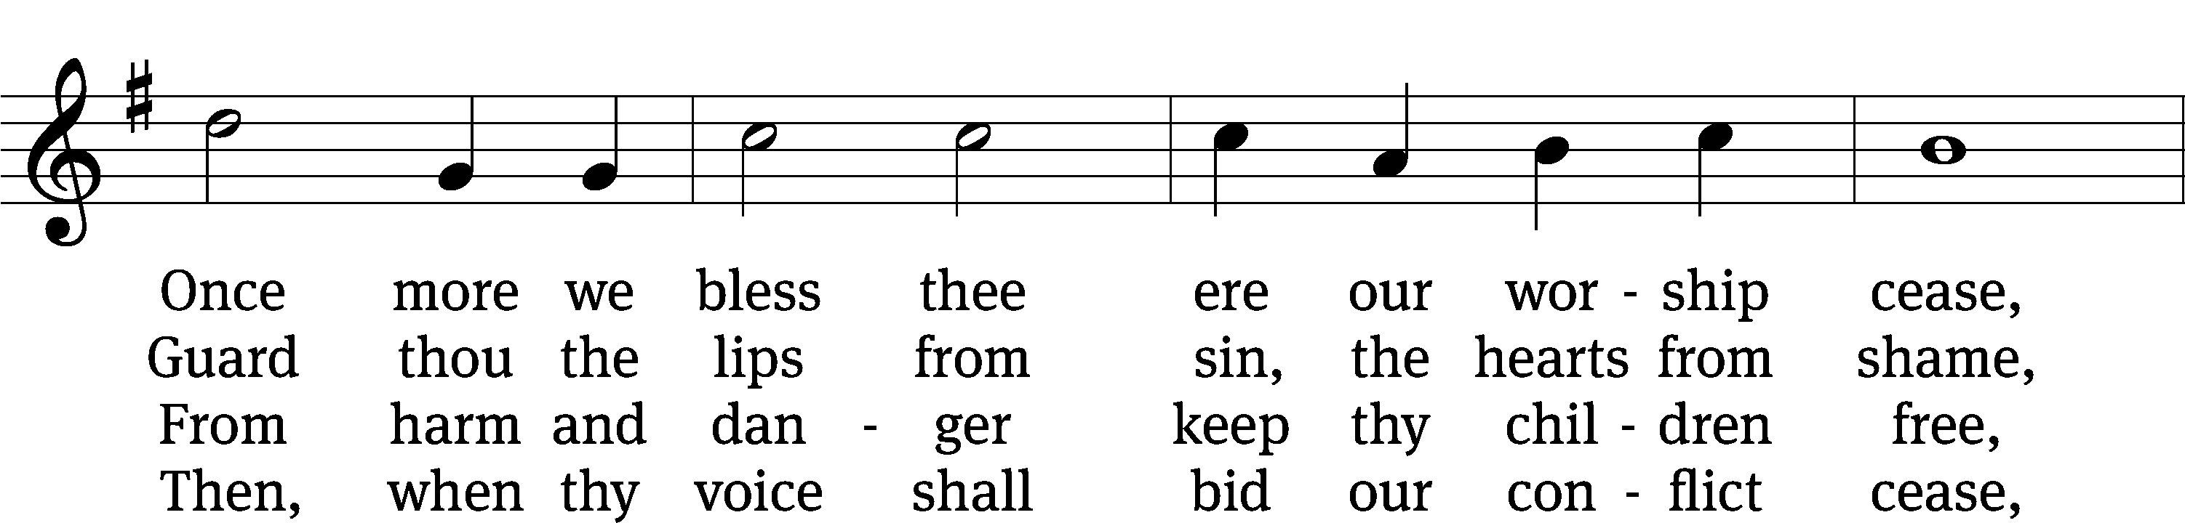
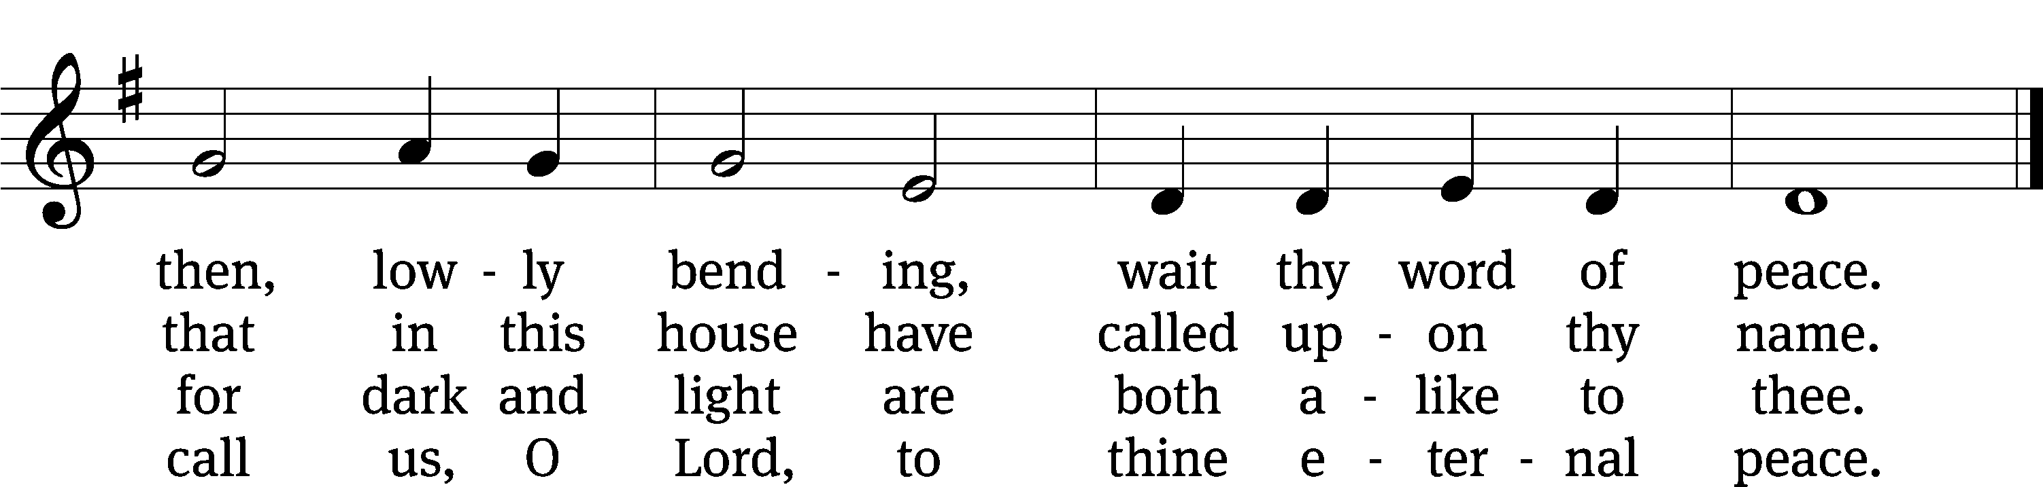
Text: John Ellerton, 1826–1893, abr.
Tune: Edward J. Hopkins, 1818–1901
Text and tune: Public domain

Serving In Worship
Officiant Pastor Natsis
Organist Marcia Marion Ackling
Deacons (Thursday) Steve Hoeft and Jim Tice
(Sunday) Jeff Neuburger and Dave Stevenson
Ushers (Thursday) Dale Finkbeiner and Mark Finkbeiner
(Sunday) Al Whitley
Altar Guild Esther Gross and Diane Stevenson
Videographer Cindy Dresch

Copyright information
Service of the Word: Christian Worship. © 1993 Northwestern Publishing House. All rights reserved.
Reprinted with permission under ONE LICENSE #A-727703 and CCLI #1151741/CSPL126093

Words and Music: All rights reserved. Reprinted with permission under ONE LICENSE #A-727703 and
CCLI #1151741/CSPL126093
tlcsaline.church

