THE FOURTEENth SUNDAY
AFTER PENTECOST

tRINITY EVANGELICAL LUTHERAN CHURCH | Saline, Michigan
September 11, 2022

WELCOME TO WORSHIP

Thank you for joining us in God’s house today! We cordially ask that our Guests with us this morning sign one of the guestbooks located at either the front or back entryways.

THANK OFFERING: Members of Trinity give their offering as an expression of love and thankfulness to the Lord and to help support the Lord’s work in our community and around the world. Visitors need not feel obligated to participate in this offering which supports our ministry.

Restrooms are located at the back of the upper level (the annex), and in the basement (down the back stairs of the sanctuary or annex). Handicap access is available, please ask an usher for assistance.

Young Families / Toddler Bags – We are GLAD YOU BROUGHT YOUR CHILDREN to our worship service. Jesus said: “Let the little children come to me and do not hinder them, for the kingdom of God belongs to such as these.” We know that having little children in church can be a challenge, but DO NOT WORRY about it. Many of your fellow worshippers have been in your shoes and are just happy you brought your children with you. For your convenience, we have reserved the back rows of seating for parents with small children. These areas provide more flexibility for your family, as well as, easy access to move downstairs if necessary. A closed-circuit TV system allows families to continue participating in the service while downstairs. Pre-school toddler bags and children’s bulletins are available for their enjoyment. Ask an usher for one to use during the service and please return the toddler bag afterwards.

SERVICE of the word
619 Praise the Almighty; My Soul, Adore Him CW 619
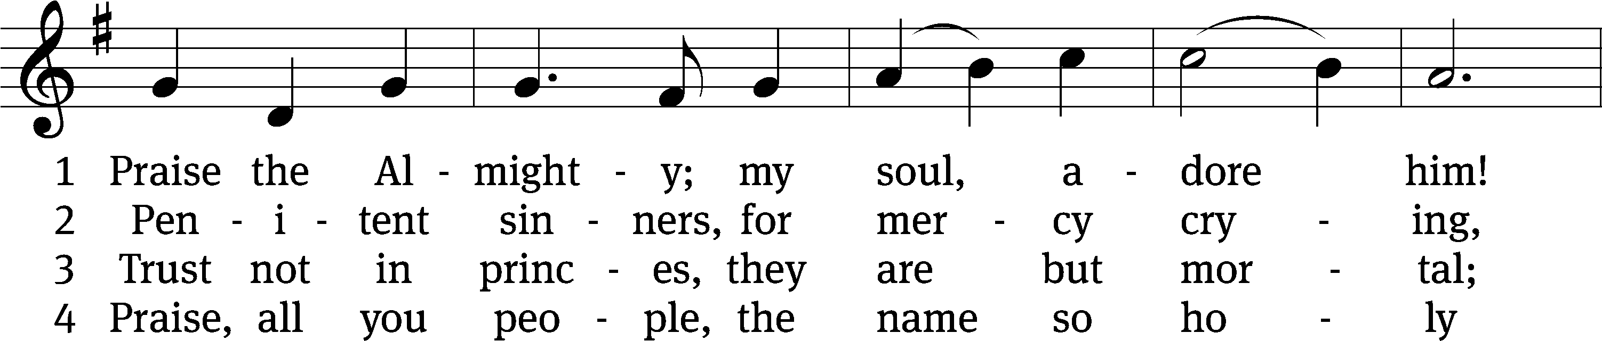
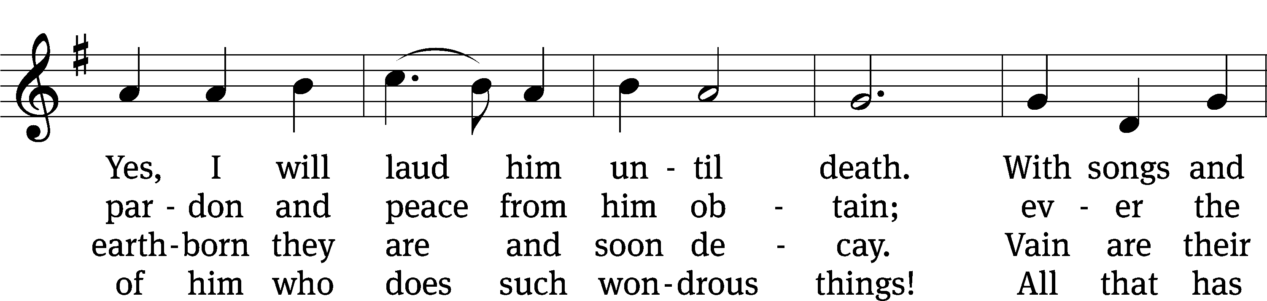
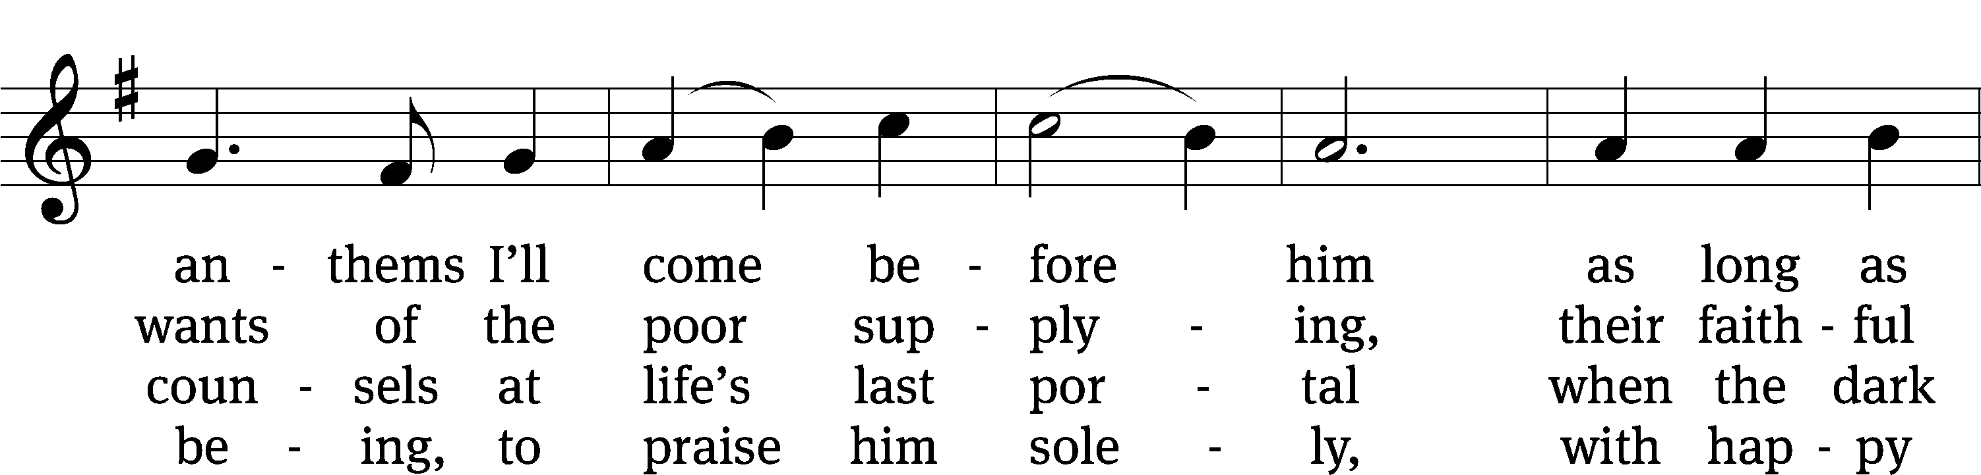
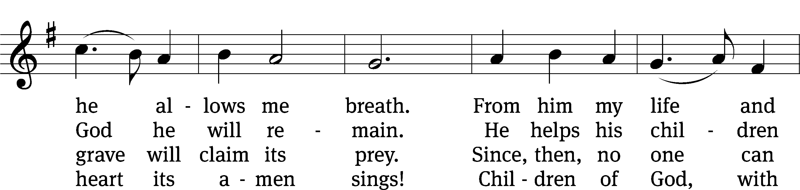
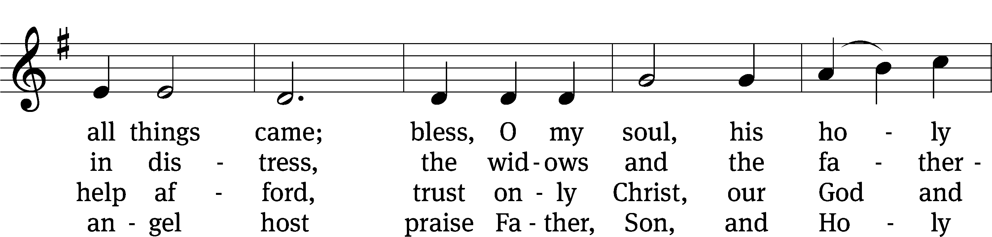
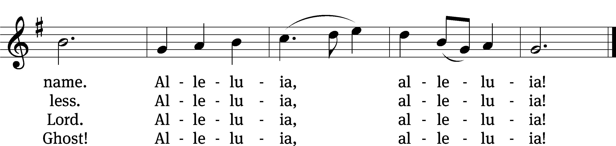
Text: tr. Alfred E. R. Brauer, 1866–1949, alt.; Johann D. Herrnschmidt, 1675–1723, abr.
Tune: New-vermehrte Christliche Seelenharpf, Ansbach, 1665
Text and tune: Public domain

PLEASE STAND, IF YOU ARE ABLE

invocation
M: The grace of our Lord (+) Jesus Christ and the love of God and the fellowship of the Holy Spirit be with you.
C: And also with you.
CONFESSION OF SINS
M: We have come into the presence of God, who created us to love and serve him as his dear children. But we have disobeyed him and deserve only his wrath and punishment. Therefore, let us confess our sins to him and plead for his mercy.

C: Merciful Father in heaven, I am altogether sinful from birth. In countless ways I have sinned against you and do not deserve to be called your child. But trusting in Jesus, my Savior, I pray: Have mercy on me according to your unfailing love. Cleanse me from my sin, and take away my guilt.
M: God, our heavenly Father, has forgiven all your sins. By the perfect life and innocent death of our Lord Jesus Christ, he has removed your guilt forever. You are his own dear child. May God give you strength to live according to his will.

C: Amen.
PRAYER AND PRAISE

M: In the peace of forgiveness, let us praise the Lord.

OH, TASTE AND SEE

PRAYER OF THE DAY

Let us pray.

Lord, we pray that your mercy and grace may always go before and follow after us that, loving you with undivided hearts, we may be ready for every good and useful work; through your Son, Jesus Christ our Lord, who lives and reigns with you and the Holy Spirit, one God, now and forever.

PLEASE BE SEATED

The Word

the FIRST LESSON Hosea 3:1-5
¹ The Lord said to me, “Go again. Show love to a woman who is loved by another man, a woman who keeps committing adultery. Show love just as the Lord loves the people of Israel, even though they keep turning to other gods and loving the raisin cakes.”
² So I bought her for myself for fifteen pieces of silver and nine bushels of barley. ³ I said to her, “You will stay with me for many days. You must not be promiscuous. You must not be with any other man, and I will also be for you.”
⁴ So the people of Israel will live many days without king or prince, without sacrifice or sacred memorial stones, and without the special vest or family idols. ⁵ Afterward the people of Israel will return and seek the Lord their God and David their king. They will come trembling to the Lord and to his goodness in the latter days.

51D God, Be Merciful to Me Psalm 51D sts. 1–4
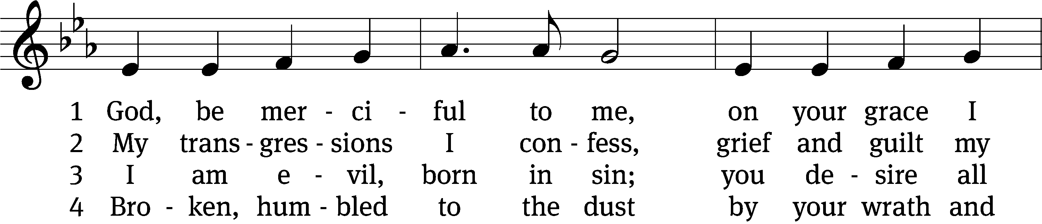
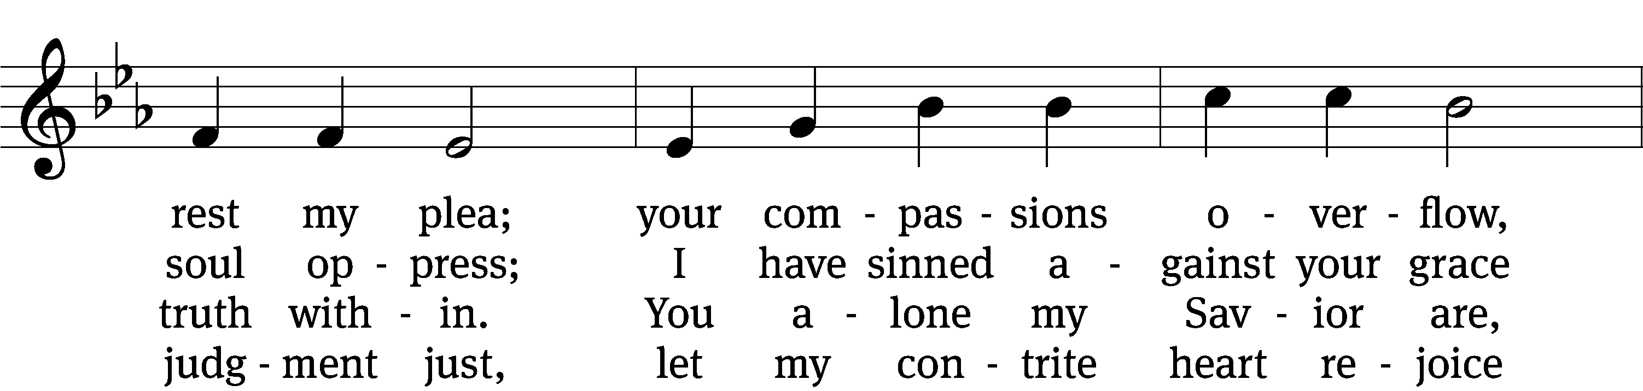
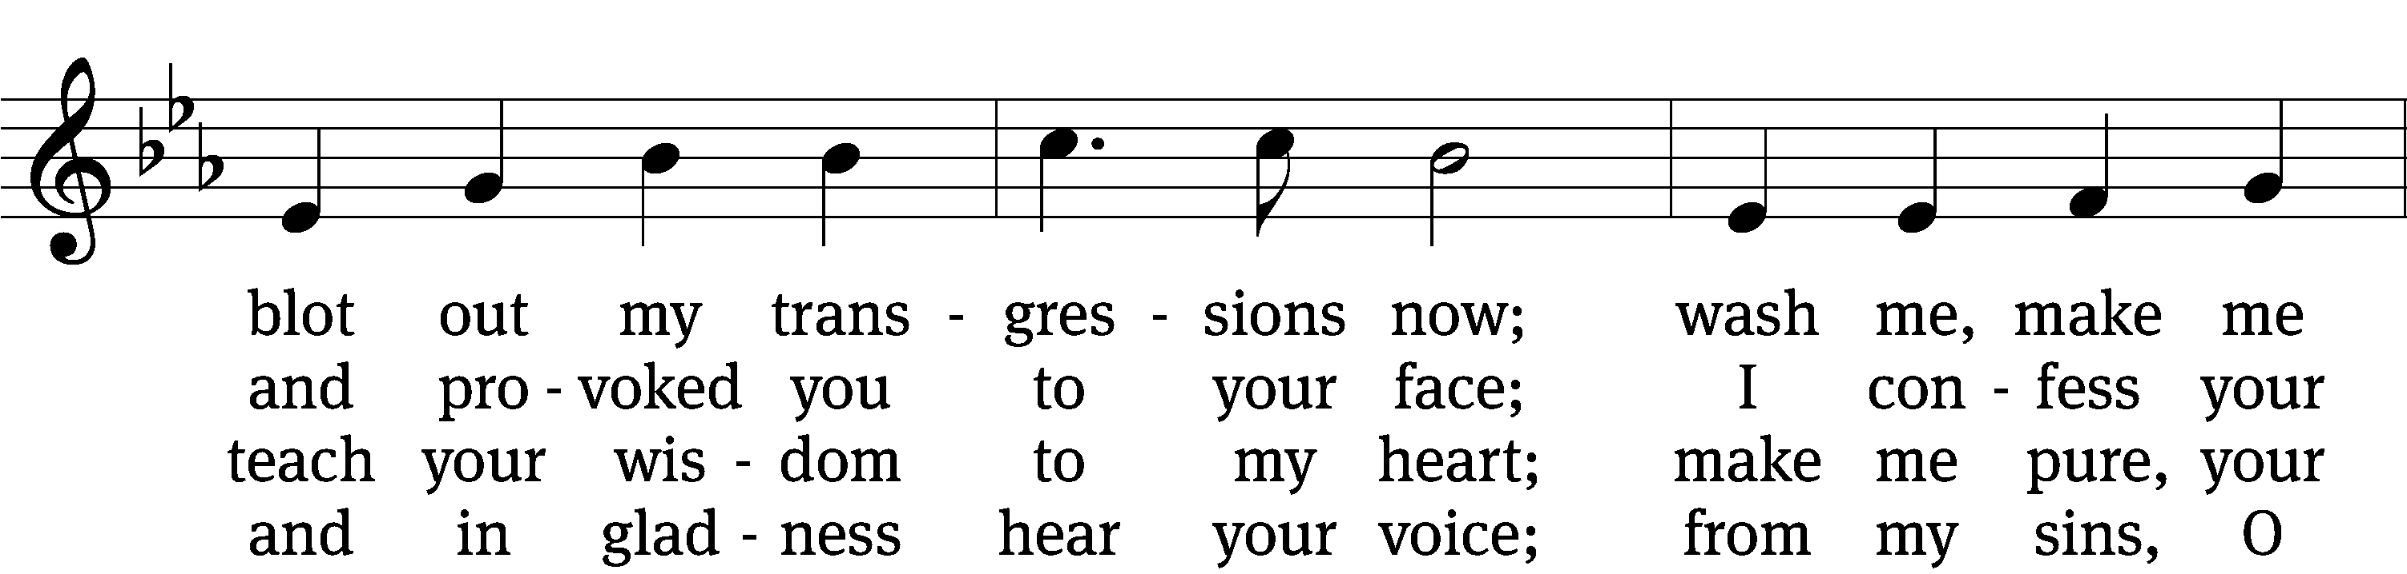
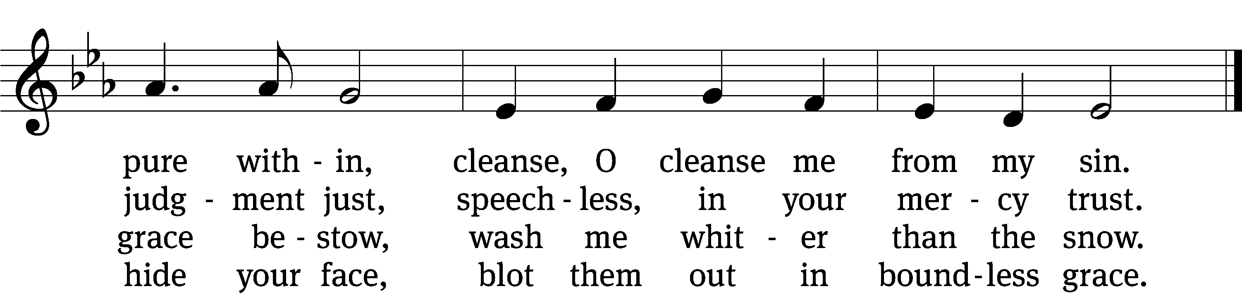
Text: Psalter, 1912, alt.
Tune: Richard Redhead
Text and tune: Public domain

THE SECOND LESSON 2 Corinthians 2:5-11
⁵ Now if anyone has caused sorrow, he has not done it to me, but to all of you to some extent (not to overstate it). ⁶ This punishment inflicted on such a person by the majority is enough, ⁷ so that instead you should rather forgive and comfort him, or else such a person could be overwhelmed by excessive sorrow. ⁸ For that reason, I urge you to reaffirm your love for him. ⁹ In fact, this was also the purpose of my writing: I wanted to know the result of your being tested, that is, if you are obedient in all things.
¹⁰ If you forgive anyone anything, I do too. To be sure, if I have forgiven anything, I have forgiven it in the presence of Christ for your sake, ¹¹ so that Satan would not take advantage of us. We are certainly not unaware of his schemes.

PLEASE Stand, if you are able

Verse of the day

THE GOSPEL LESSON LUKE 15:1-10
M: The Gospel according to Luke chapter 15, verses 1-10
¹ All the tax collectors and sinners were coming to Jesus to hear him. ² But the Pharisees and the experts in the law were complaining, “This man welcomes sinners and eats with them.”
³ He told them this parable: ⁴ “Which one of you, if you had one hundred sheep and lost one of them, would not leave the ninety-nine in the wilderness and go after the one that was lost until he finds it? ⁵ And when he finds it, he joyfully puts it on his shoulders ⁶ and goes home. Then he calls together his friends and his neighbors, telling them, ‘Rejoice with me, because I have found my lost sheep!’ ⁷ I tell you, in the same way there will be more joy in heaven over one sinner who repents than over ninety-nine righteous people who do not need to repent.
⁸ “Or what woman who has ten silver coins,^{[a]} if she loses one coin, would not light a lamp, sweep the house, and search carefully until she finds it? ⁹ And when she finds it, she calls together her friends and neighbors and says, ‘Rejoice with me, because I have found the lost coin.’ ¹⁰ In the same way, I tell you, there is joy in the presence of the angels of God over one sinner who repents.”
M: This is the Gospel of the Lord.

PLEASE BE SEATED

654 Jesus Sinners Does Receive CW 654
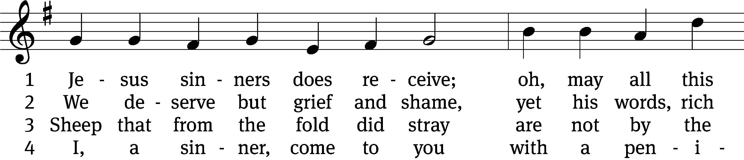
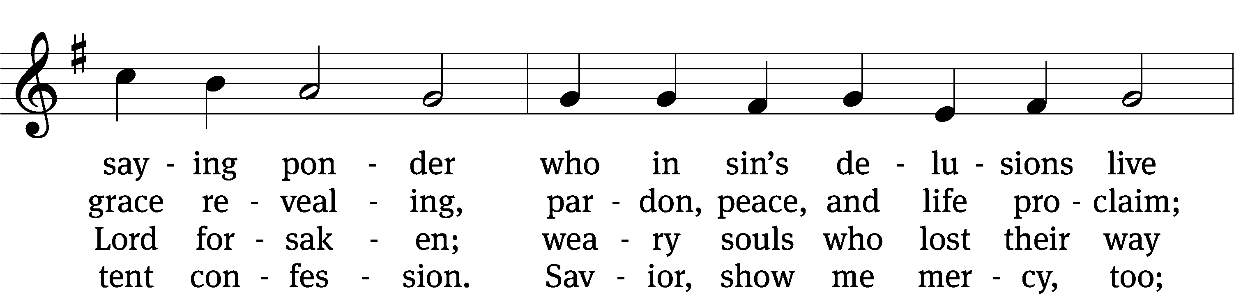
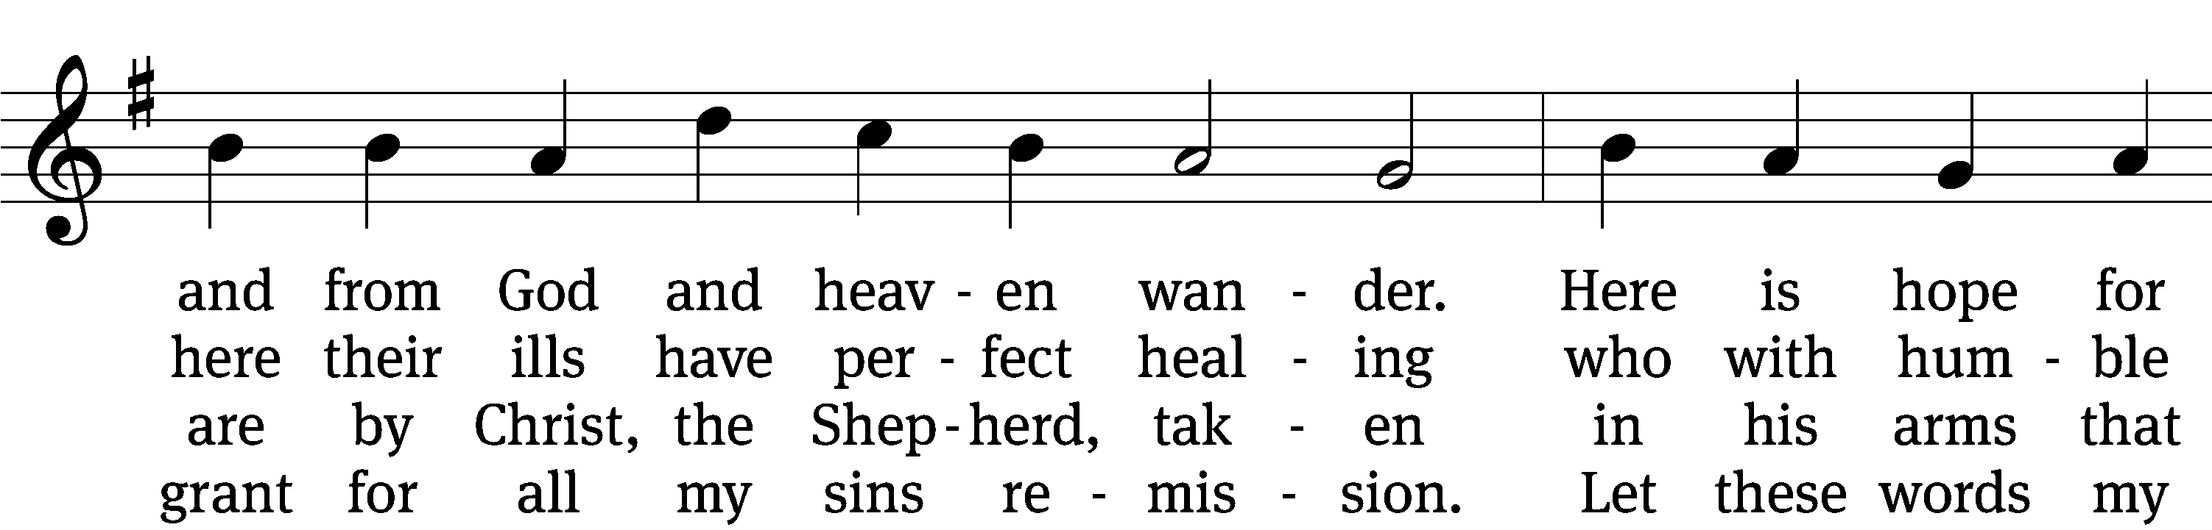
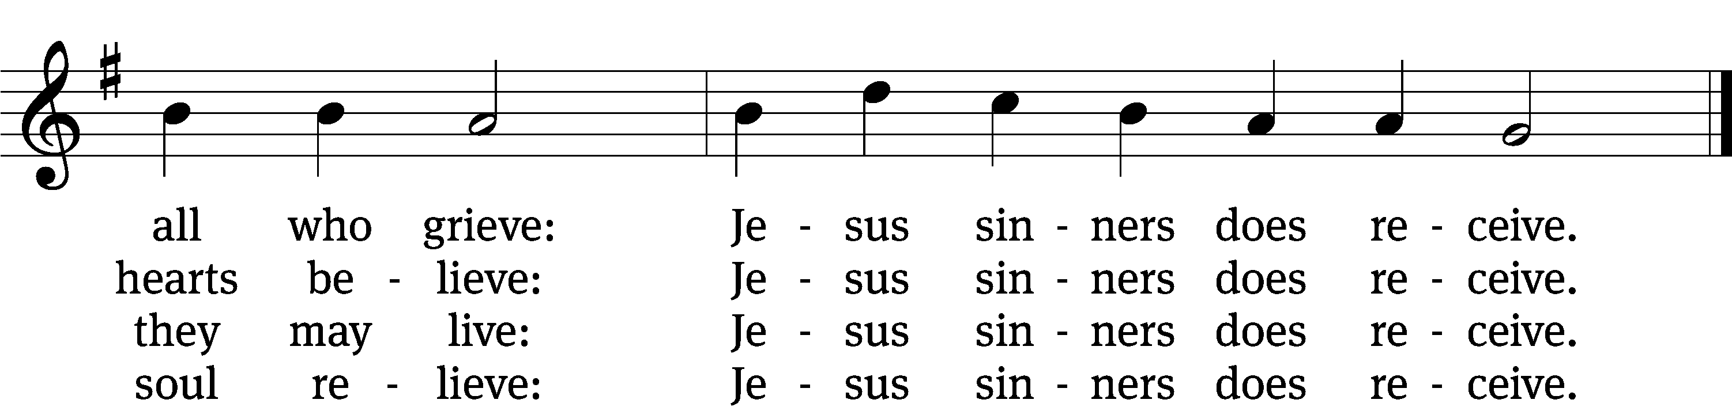

5 Oh, how blest it is to know,
were as scarlet my transgression,
it shall be as white as snow
by your blood and bitter passion,
for these words I do believe:
Jesus sinners does receive.

6 Now my conscience is at peace,
from the law I stand acquitted.
Christ has purchased my release
and my ev’ry sin remitted.
Naught remains my soul to grieve:
Jesus sinners does receive.

7 Jesus sinners does receive,
even I have been forgiven.
And when I this earth must leave,
I shall find an open heaven.
Dying, still to him I cleave:
Jesus sinners does receive.
Text: tr. The Lutheran Hymnal, 1941, alt.; Erdmann Neumeister, 1671–1756, abr.
Tune: Neu-verfertigtes Darmstädtisches Gesang-Buch, Darmstadt, 1699
Text and tune: Public domain

SERMON TEXT AND THEME Luke 15:1-7
“Are You the One?”

PLEASE STAND, IF YOU ARE ABLE

THE APOSTLES’ CREED
I believe in God, the Father almighty,
maker of heaven and earth.
I believe in Jesus Christ, his only Son, our Lord,
who was conceived by the Holy Spirit,
born of the virgin Mary,
suffered under Pontius Pilate,
was crucified, died, and was buried.
He descended into hell.
The third day he rose again from the dead.
He ascended into heaven
and is seated at the right hand of God the Father almighty.
From there he will come to judge the living and the dead.
I believe in the Holy Spirit,
the holy Christian Church,
the communion of saints,
the forgiveness of sins,
the resurrection of the body,
and the life everlasting. Amen.

PRAYER OF THE CHURCH

THE LORD’S PRAYER

C: Our Father, who art in heaven, hallowed be thy name, thy kingdom come, thy will be done on earth as it is in heaven. Give us this day our daily bread; and forgive us our trespasses, as we forgive those who trespass against us; and lead us not into temptation, but deliver us from evil. For thine is the kingdom and the power and the glory forever and ever. Amen.

PLEASE BE SEATED

706 Come Unto Me, Ye Weary CW 706
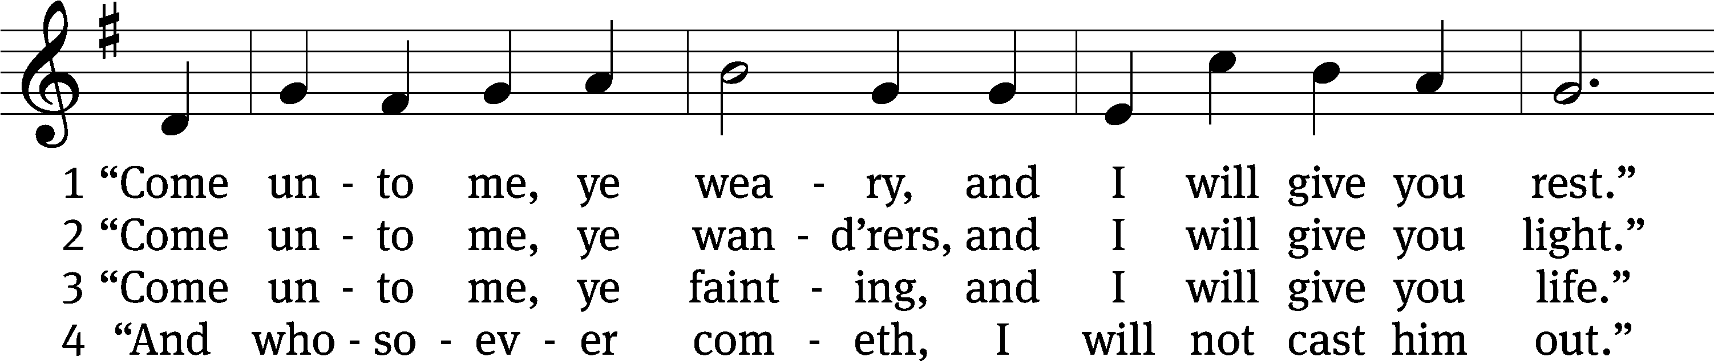
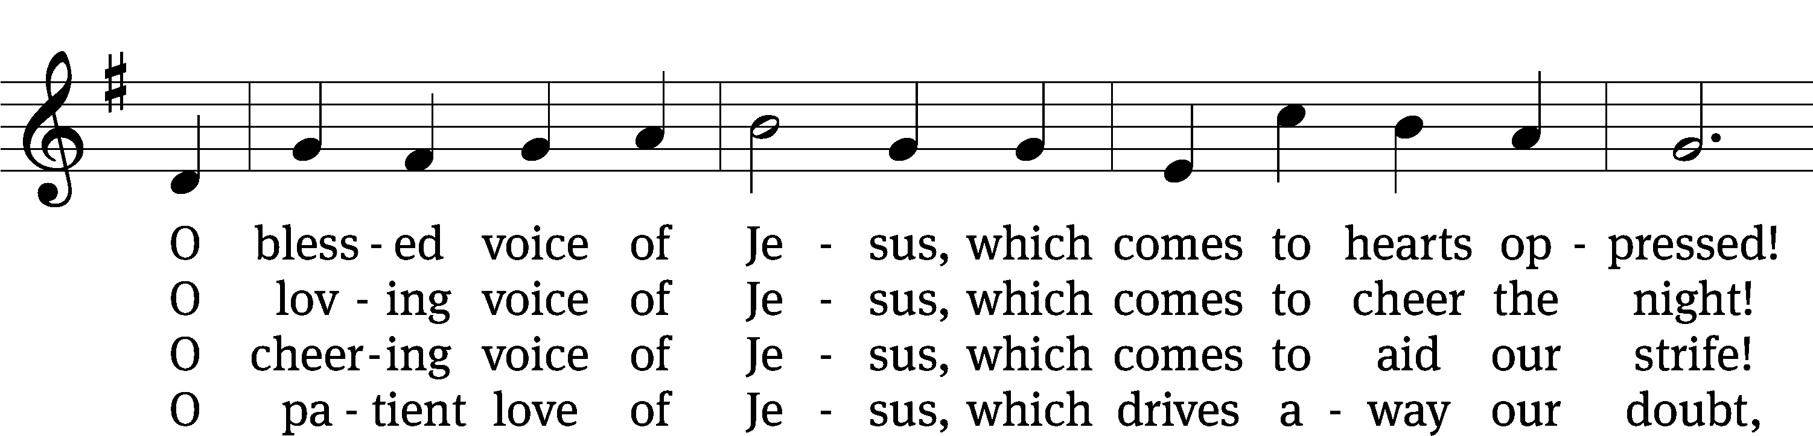
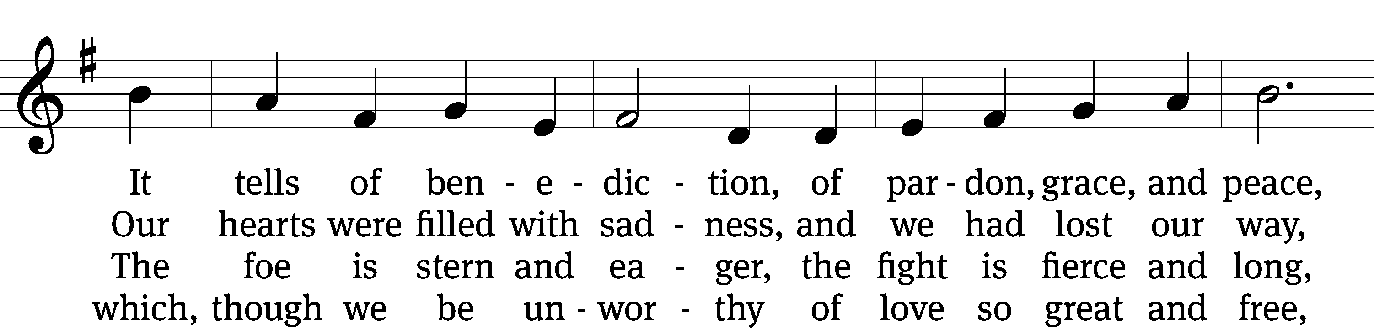
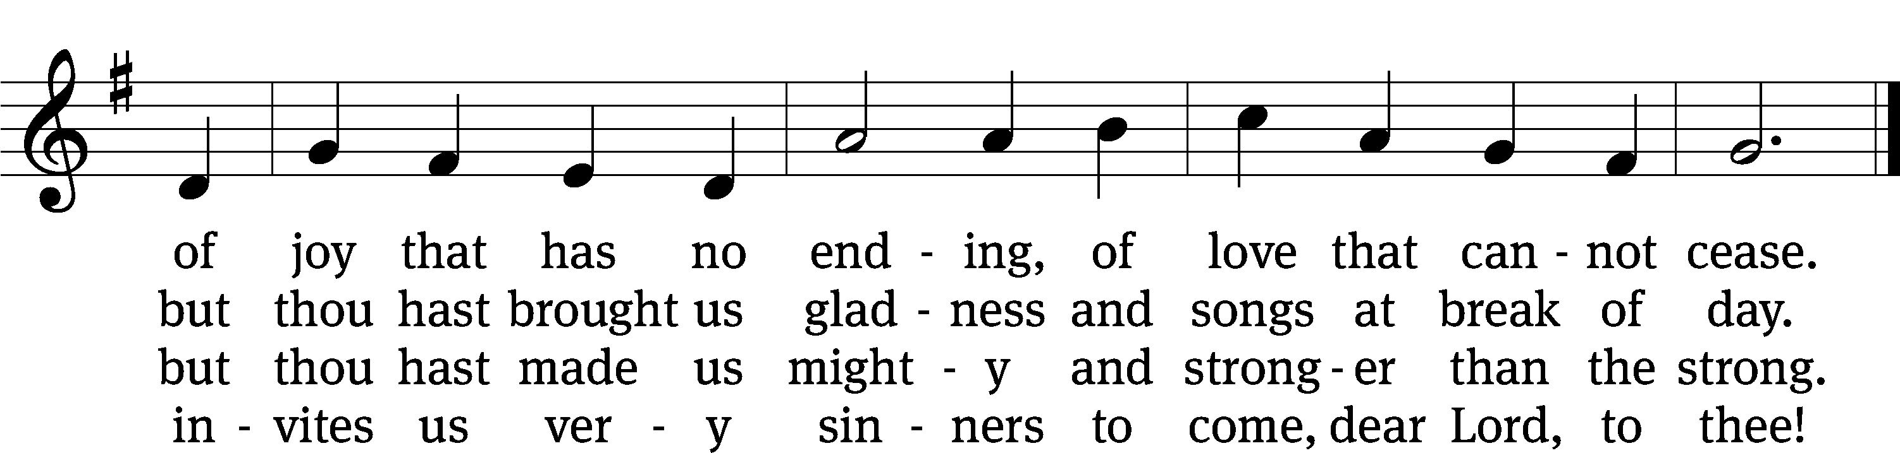
Text: William C. Dix, 1837–1898, alt.
Tune: Friedrich K. Anthes, 1812–after 1857
Text and tune: Public domain

PLEASE STAND, IF YOU ARE ABLE

CLOSING PRAYER
M: Almighty God, we thank you for teaching us the things you want us to believe and do. Help us by your Holy Spirit to keep your Word in pure hearts that we may be strengthened in faith, guided in holiness, and comforted in life and in death, through Jesus Christ, our Lord, who lives and reigns with you and the Holy Spirit, one God, now and forever.

M: Brothers and sisters, go in peace. Live in harmony with one another. Serve the Lord with gladness.
The Lord bless you and keep you.
The Lord make his face shine on you and be gracious to you.
The Lord look on you with favor and (+) give you peace.

PLEASE BE SEATED

708 Come, Thou Fount of Every Blessing CW 708
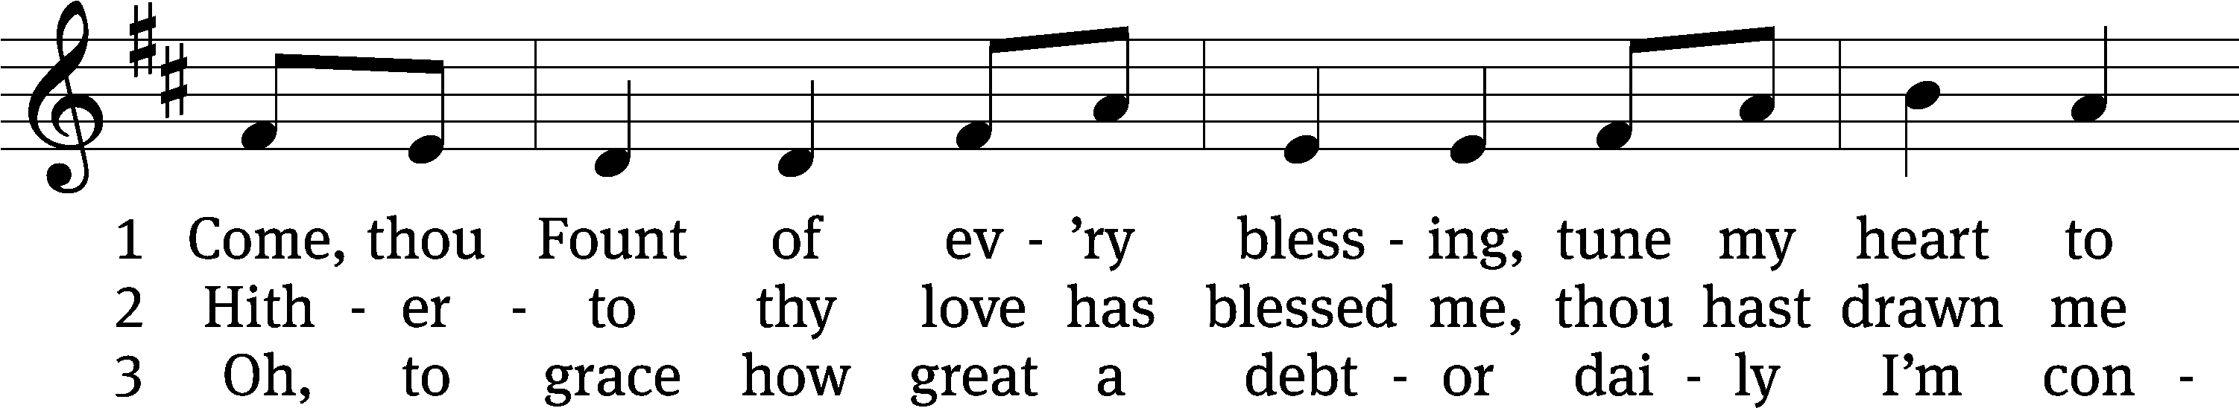
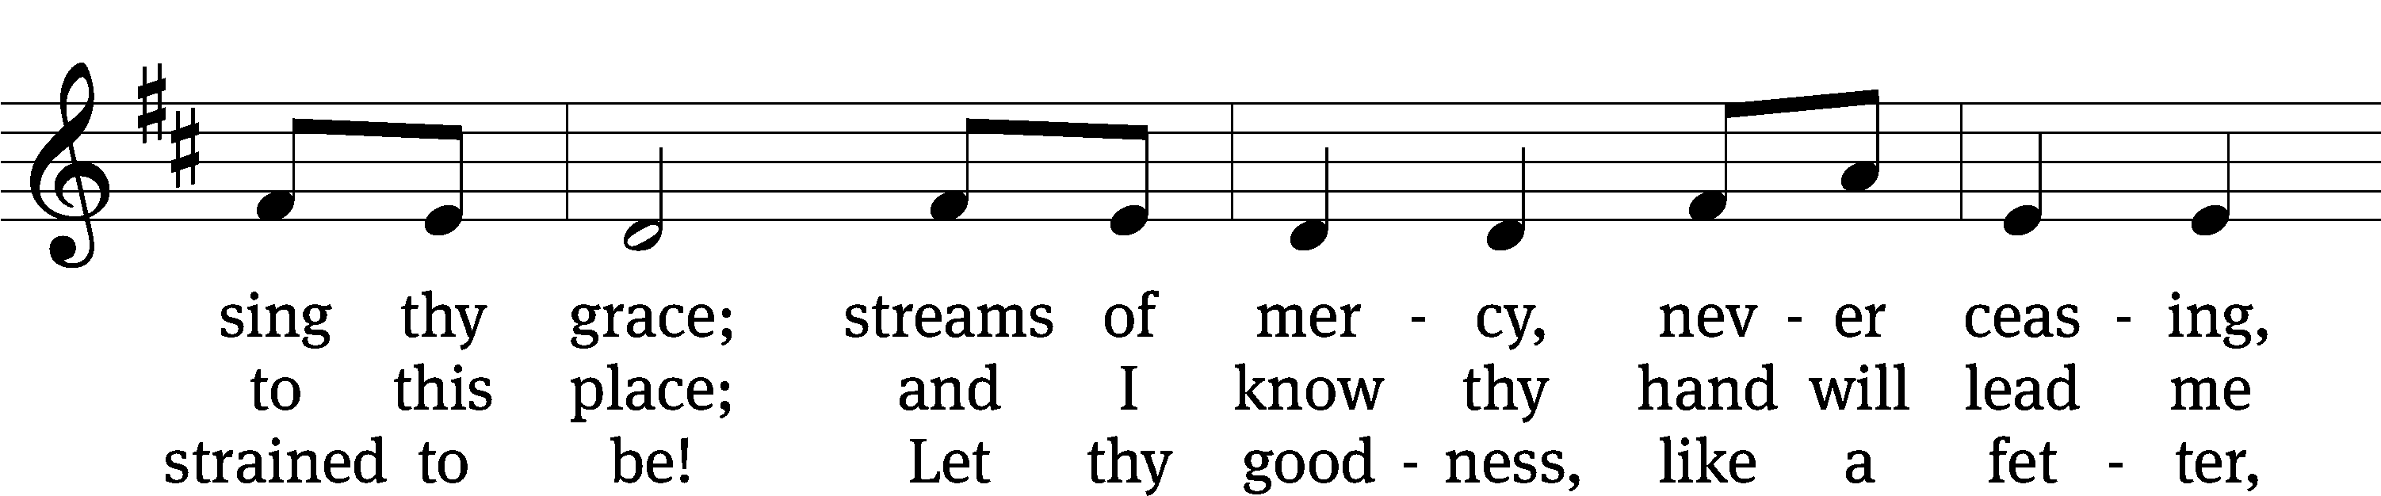
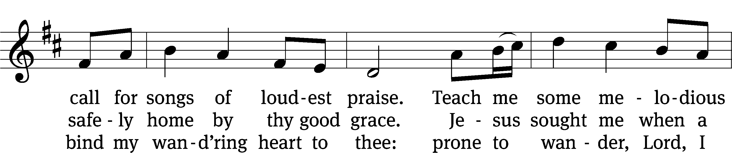
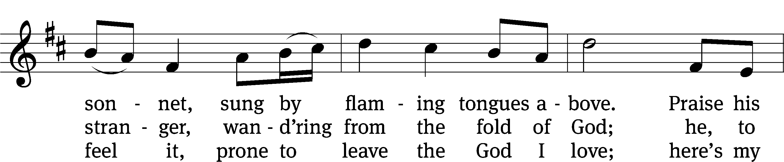
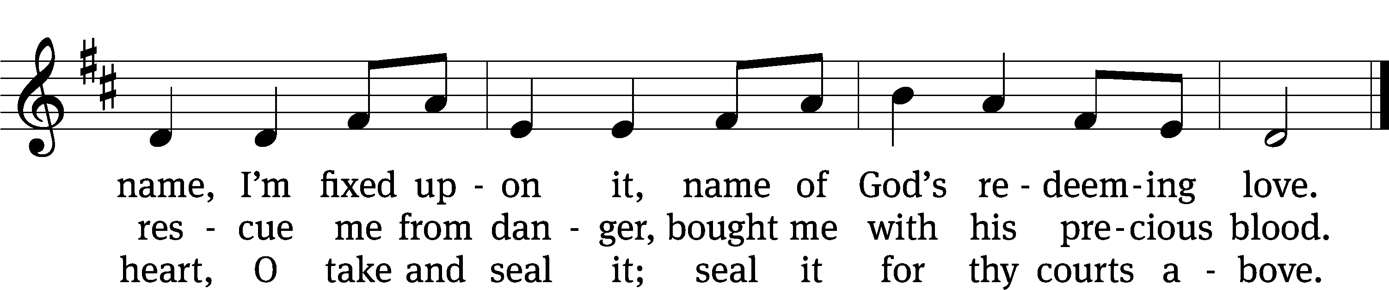
Text: Robert Robinson, 1735–1790, alt.
Tune: Repository of Sacred Music, Part Second, Harrisburg, 1813, ed. John Wyeth
Text and tune: Public domain

Serving In Worship
Officiant Pastor Natsis
Organist Sarah Hanke
Deacons (8:30) Dave Frey and Jim Tice
(11:00) Jeff Neuburger and Ed Wheeler
Ushers (8:30) Robert Newman and Henry Schneider
(11:00) Bill Barnett and Jacob Vershum
Altar Guild Marcia Marion Ackling and Judy Lindemann
Videographer Rick Schneider

Copyright information
Service of the Word: Christian Worship. © 1993 Northwestern Publishing House. All rights reserved.
Reprinted with permission under ONE LICENSE #A-727703 and CCLI #1151741/CSPL126093

Words and Music: All rights reserved. Reprinted with permission under ONE LICENSE #A-727703 and
CCLI #1151741/CSPL126093

tlcsaline.church

