Mission SUNDAY

TRINITY EVANGELICAL LUTHERAN CHURCH | Saline, Michigan
WELCOME TO WORSHIP September 24, 2023
Thank you for joining us in God’s house today! We cordially ask that our Guests sign one of the guestbooks located at either the front or back entryways, or fill out a “Let’s Get Acquainted” card located in the hymnal pew rack and place it in the collection plate.

THANK OFFERING: Members of Trinity give their offering as an expression of love and thankfulness to the Lord and to help support the Lord’s work in our community and around the world. Visitors need not feel obligated to participate in this offering which supports our ministry.

Restrooms are located at the back of the upper level (the annex), and in the basement (down the back stairs of the sanctuary or annex). Handicap access is available, please ask an usher for assistance.

Young Families / Toddler Bags – We are GLAD YOU BROUGHT YOUR CHILDREN to our worship service. Jesus said: “Let the little children come to me and do not hinder them, for the kingdom of God belongs to such as these.” We know that having little children in church can be a challenge, but DO NOT WORRY about it. Many of your fellow worshippers have been in your shoes and are just happy you brought your children with you. For your convenience, we have reserved the back rows of seating for parents with small children. These areas provide more flexibility for your family, as well as, easy access to move downstairs if necessary. A closed-circuit TV system allows families to continue participating in the service while downstairs. Pre-school toddler bags and children’s bulletins are available for their enjoyment. Ask an usher for one to use during the service and please return the toddler bag afterwards.

the SERVICE – setting one - WITHOUT HOLY COMMUNION CW, page 154

Hymn
743 I Hear the Savior Calling CW 743
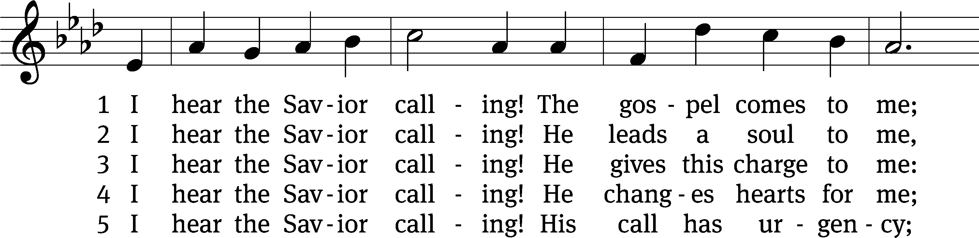
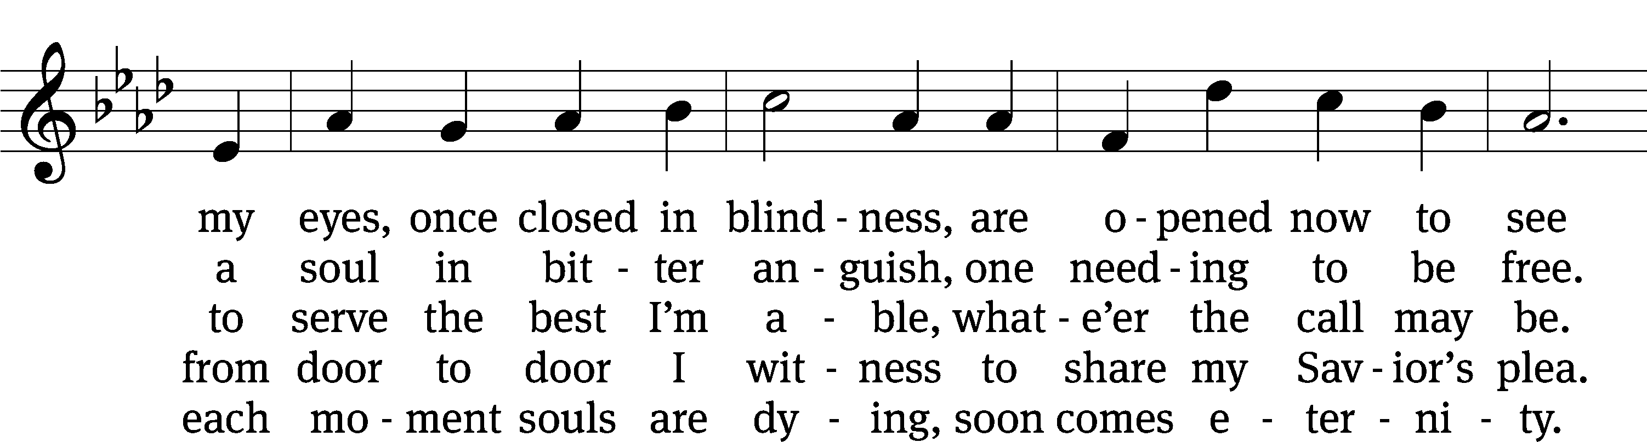
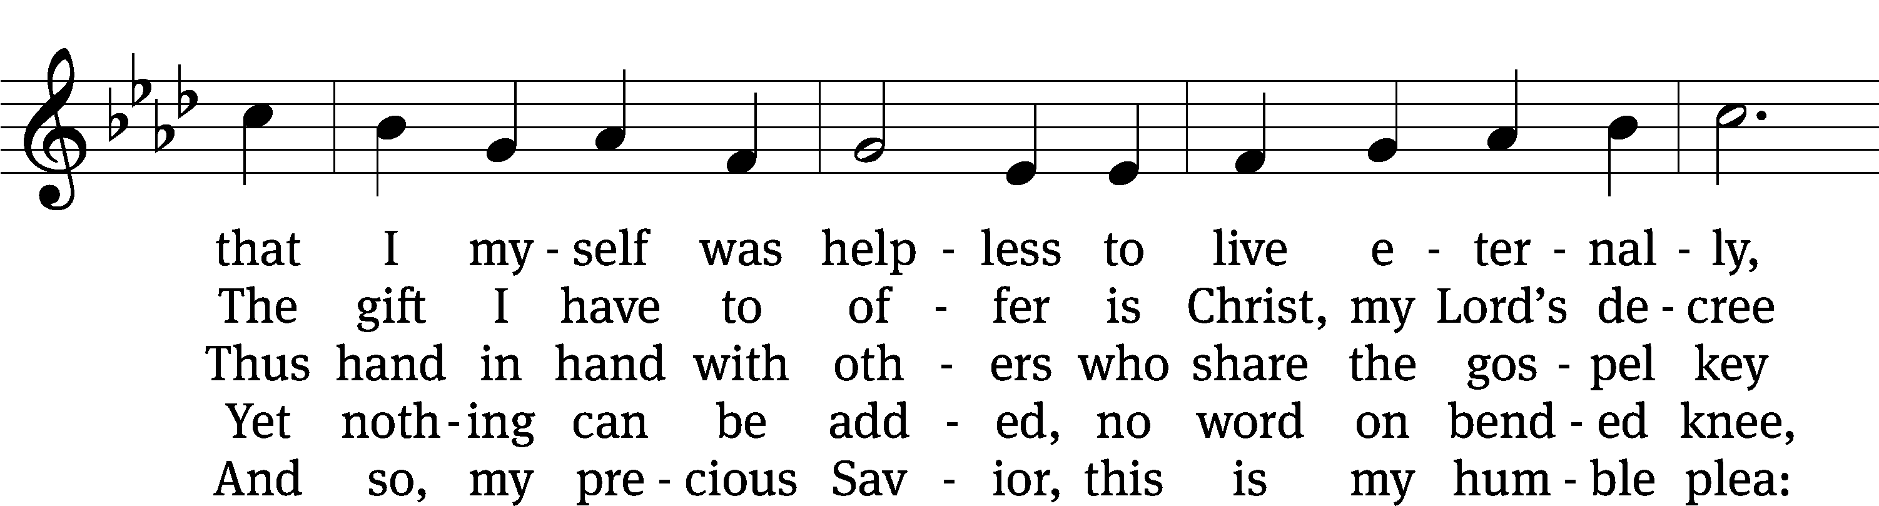
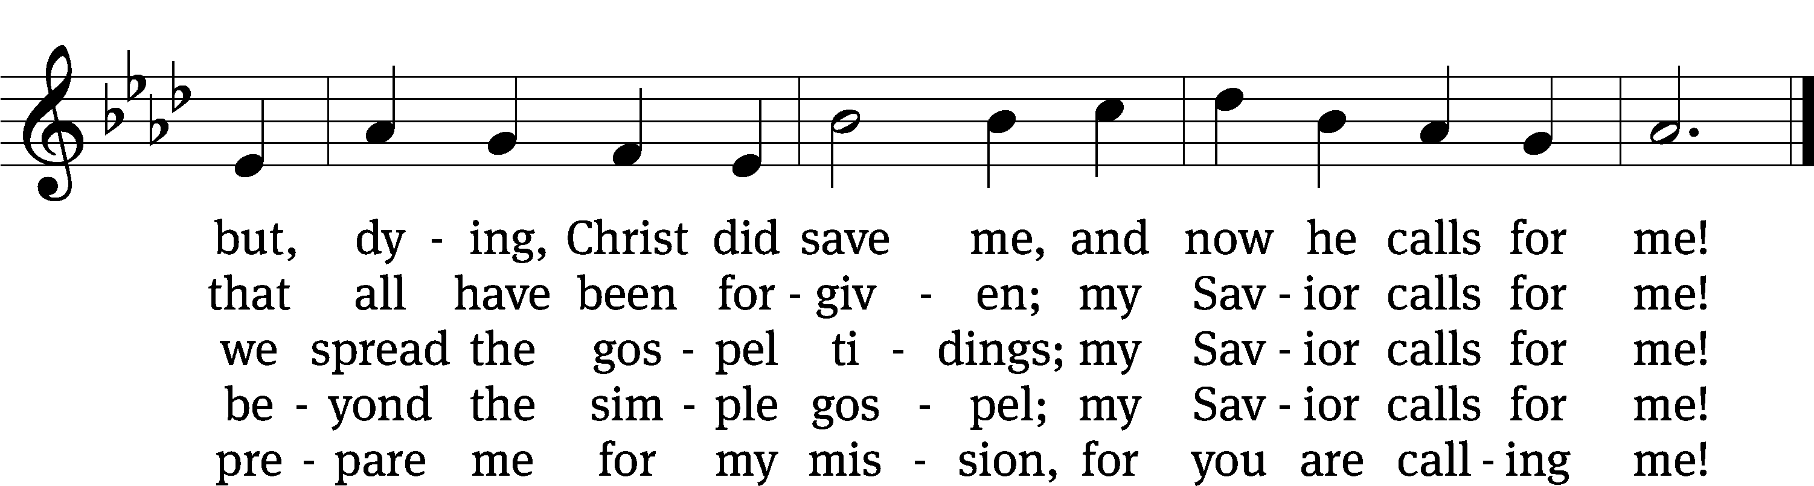
Text: John C. Lawrenz, b. 1943
Tune: Friedrich K. Anthes, 1812–1874
Text: © 1993 John C. Lawrenz, admin. Northwestern Publishing House. Used by permission: OneLicense no. 727703
Tune: Public domain

Please stand, if you are able
Invocation
In the name of the Father and of the Son and of the Holy Spirit.
Amen.

Confession
If we claim to be without sin, we deceive ourselves and the truth is not in us.
If we confess our sins, God is faithful and just
and will forgive us our sins
and purify us from all unrighteousness.

Let us confess our sins to the Lord.
Holy God, gracious Father,
I am sinful by nature
and have sinned against you in my thoughts, words, and actions.
I have not loved you with my whole heart;
I have not loved others as I should.
I deserve your punishment both now and forever.
But Jesus, my Savior, paid for my sins
with his innocent suffering and death.
Trusting in him, I pray: God, have mercy on me, a sinner.

Our gracious Father in heaven has been merciful to us. He sent his only Son, Jesus Christ, who gave his life as the atoning sacrifice for the sins of the whole world. Therefore, as a called servant of Christ and by his authority, I forgive you all your sins in the name of the Father and of the Son and of the Holy Spirit.
Amen.

Lord, Have Mercy
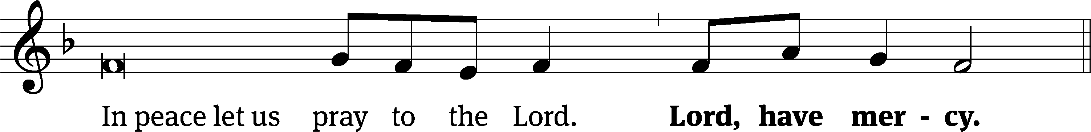
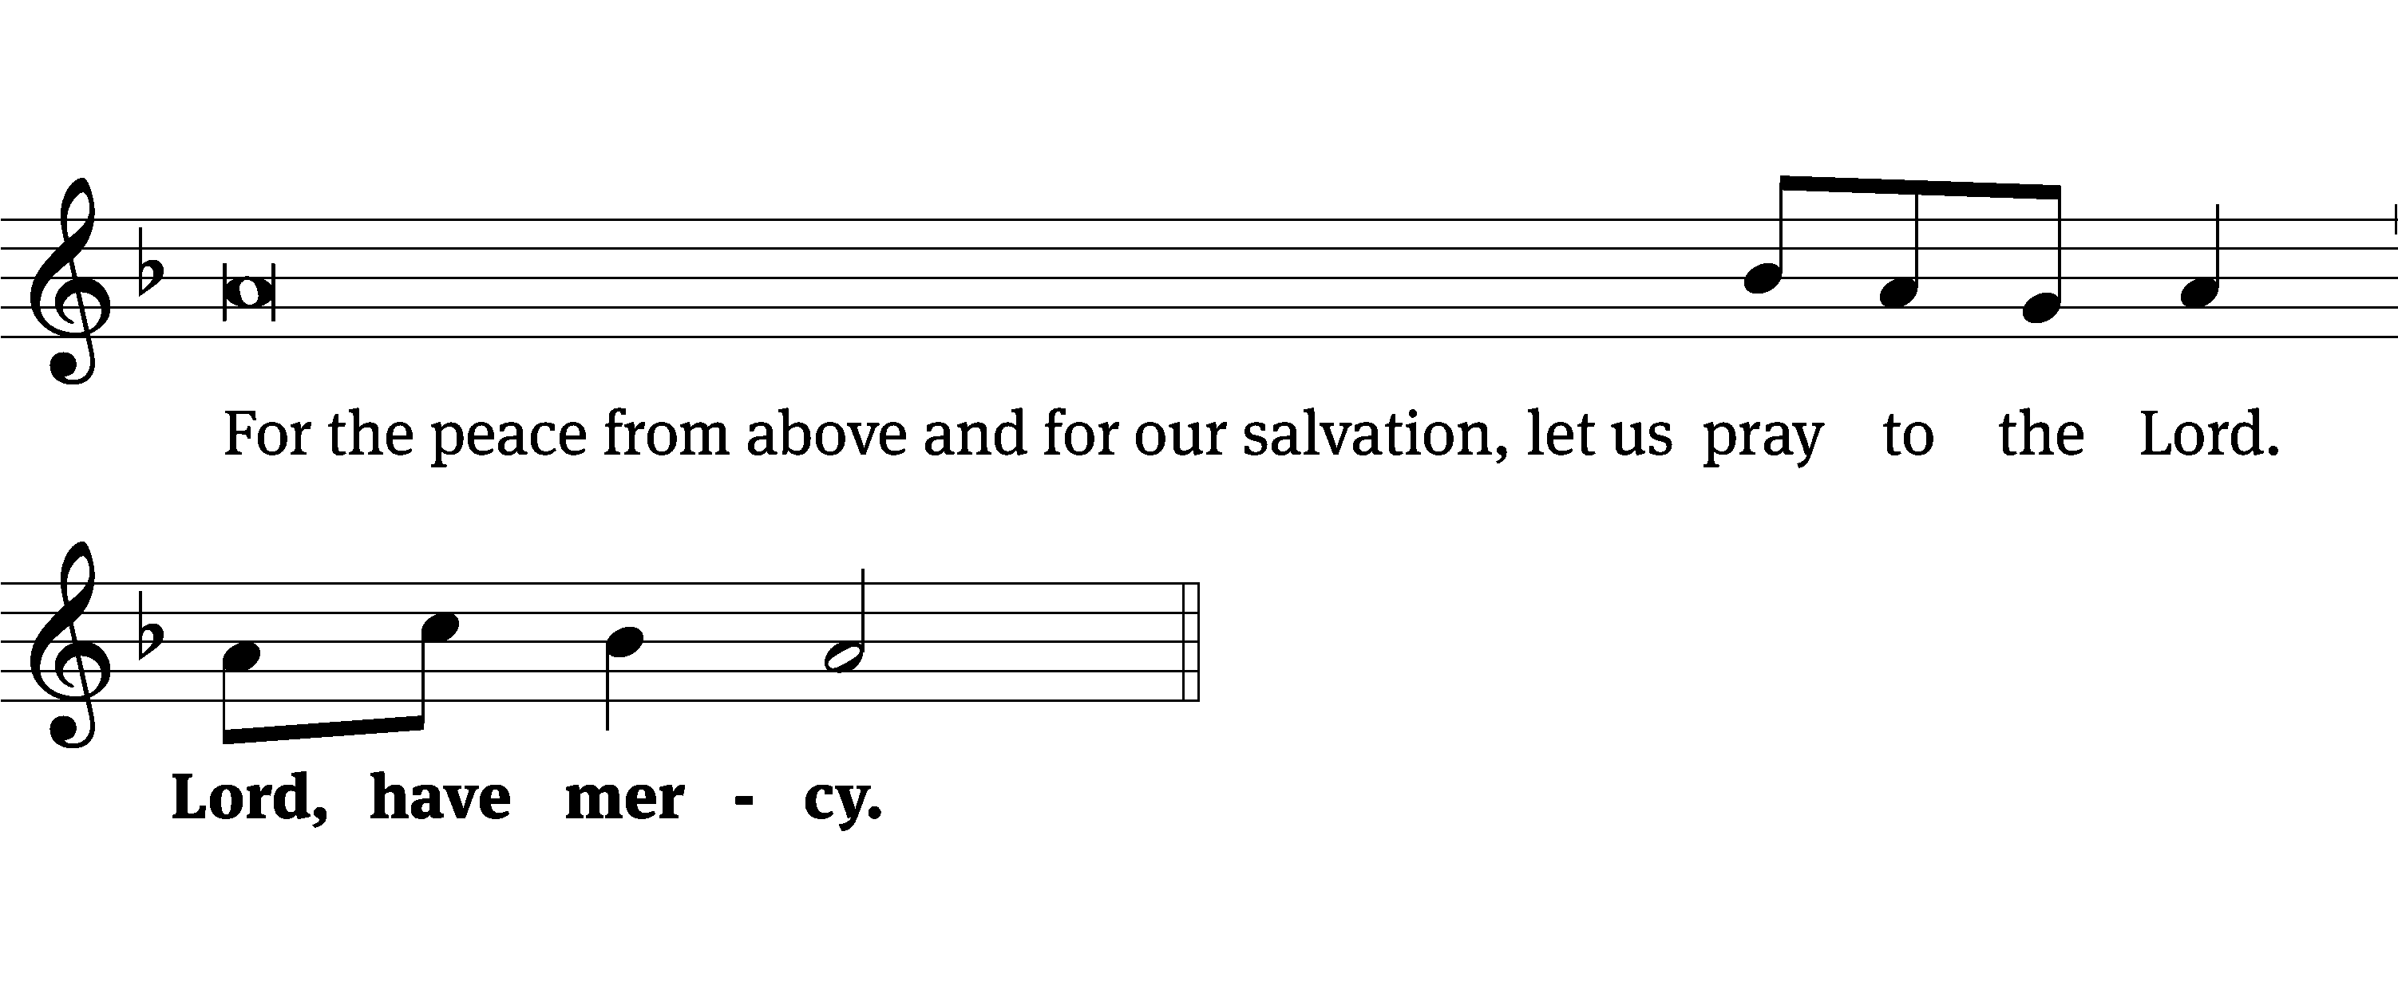
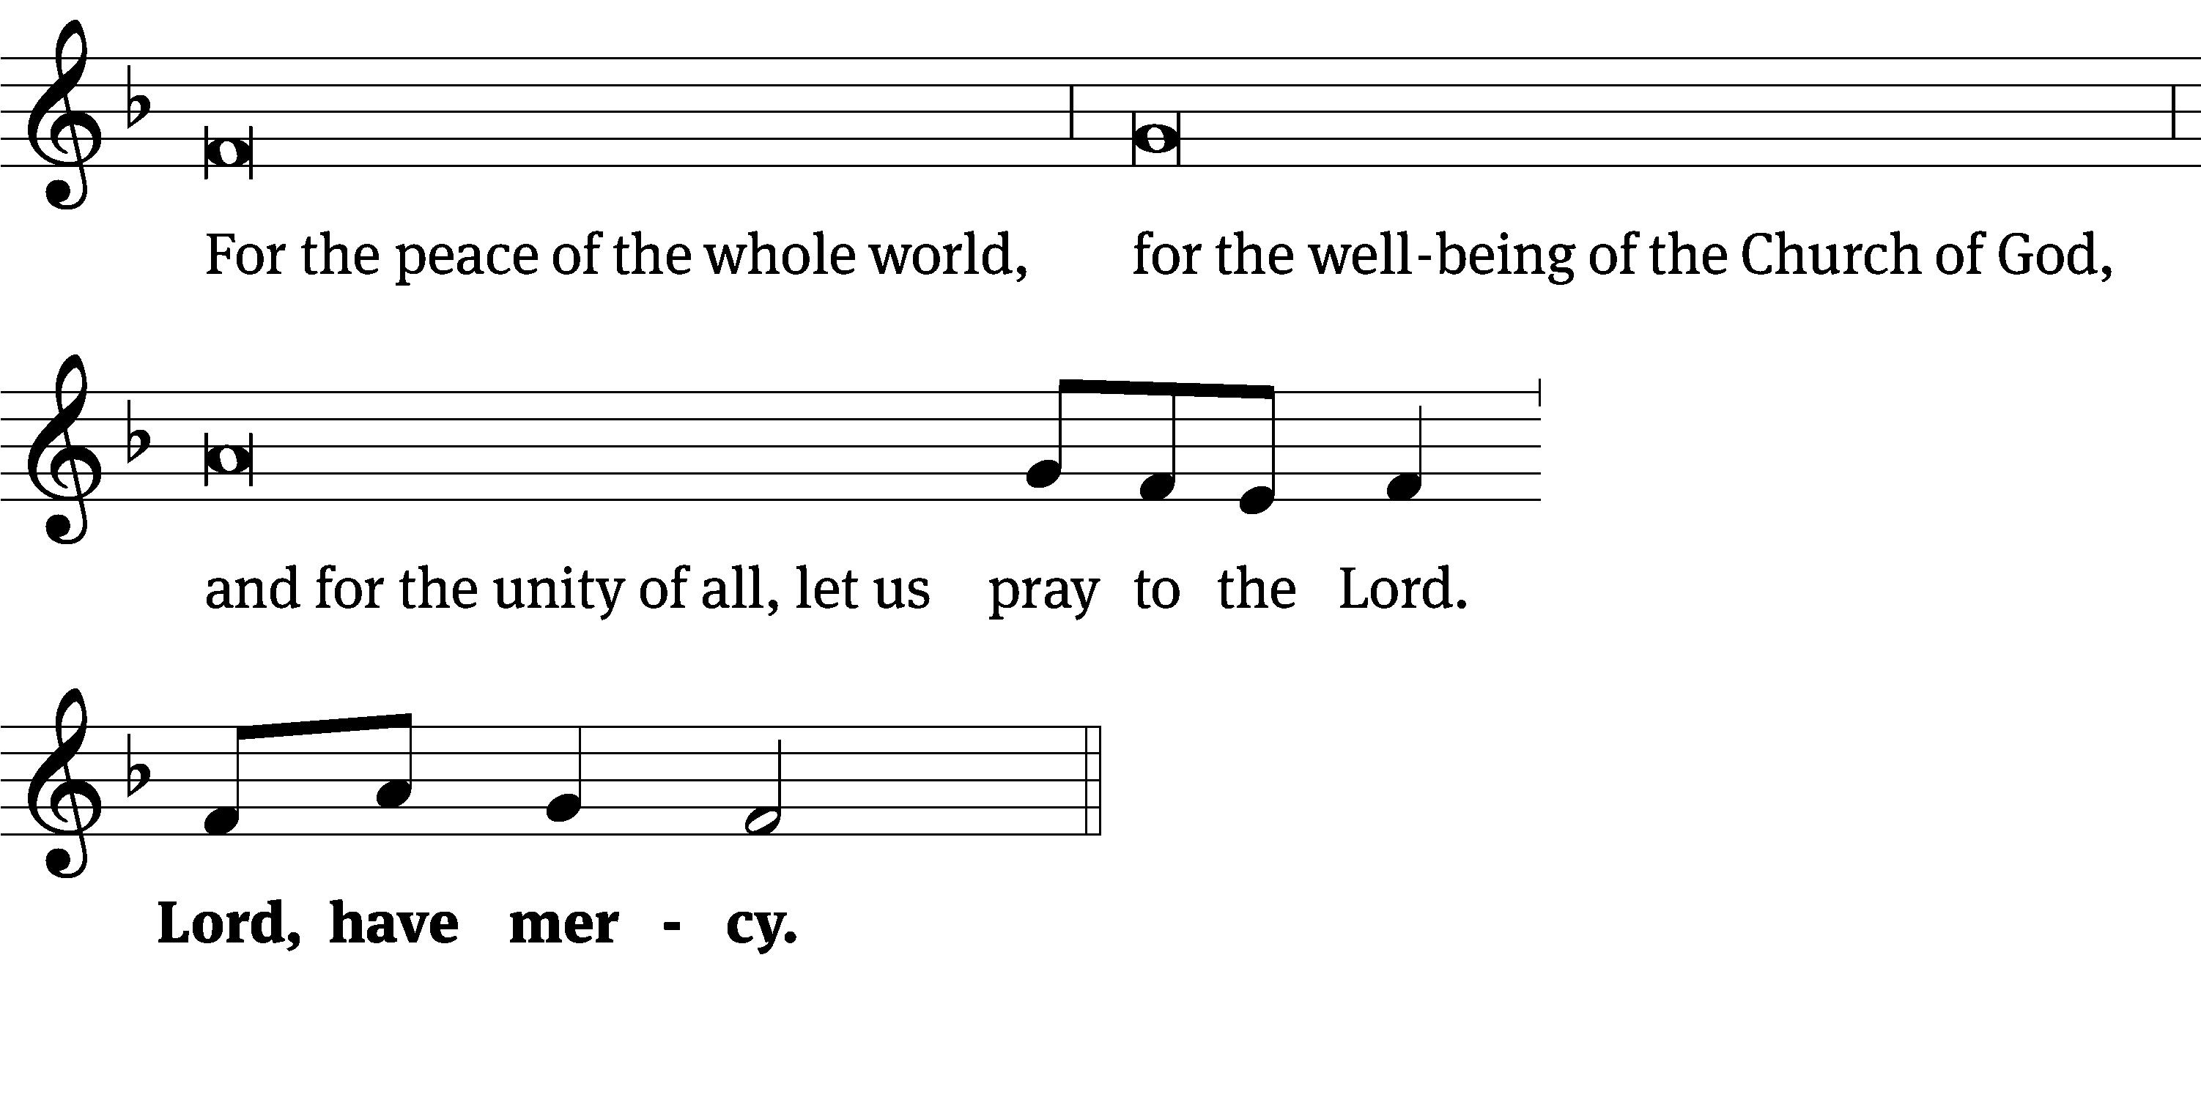
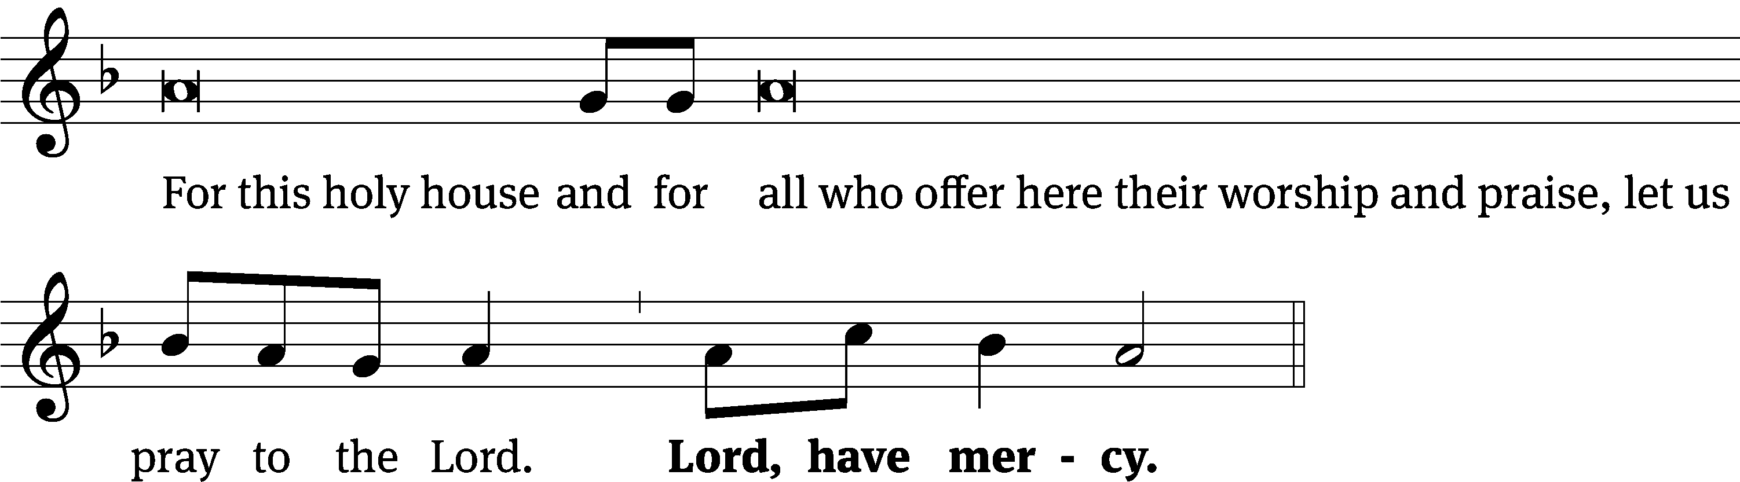
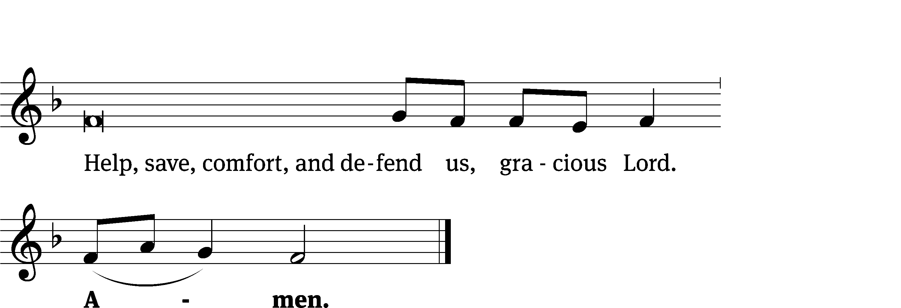
Tune: Kevin Becker
Tune: © 2021 Northwestern Publishing House. Used by permission: OneLicense no. 727703

Glory Be to God CW 157
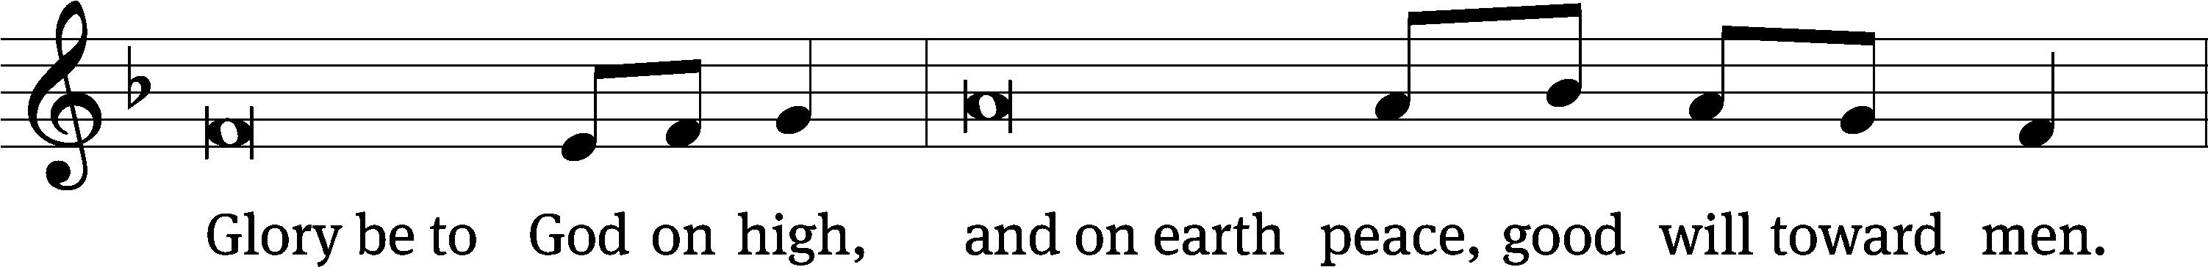
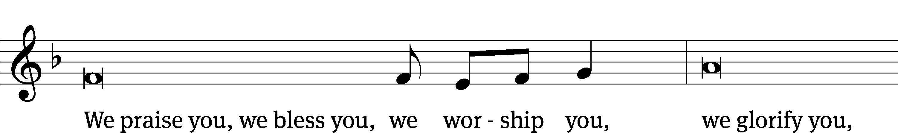
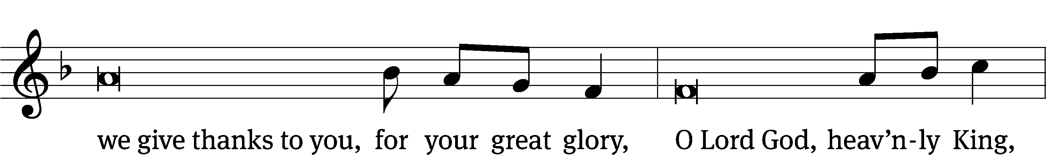
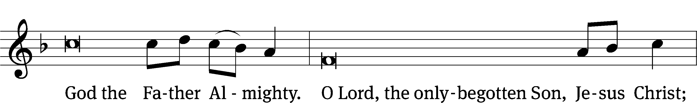
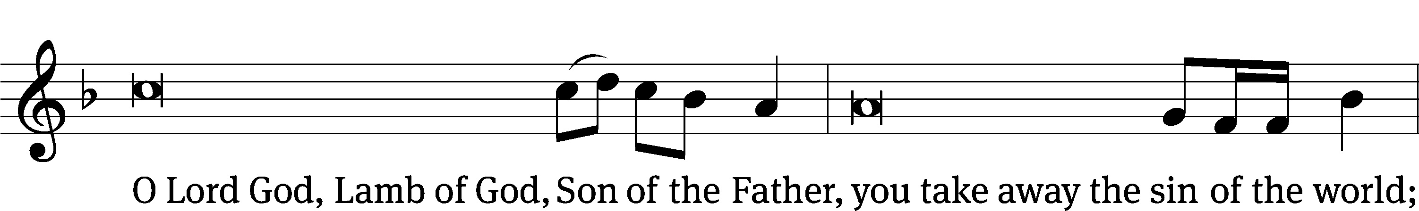
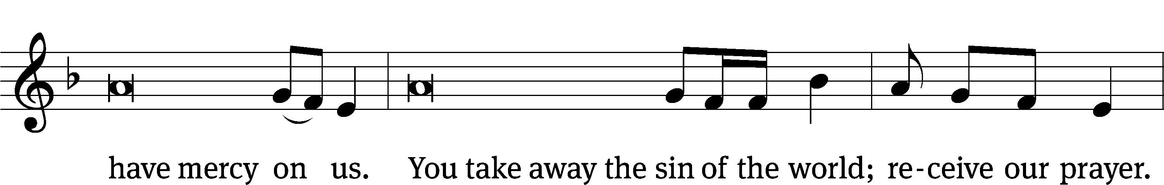
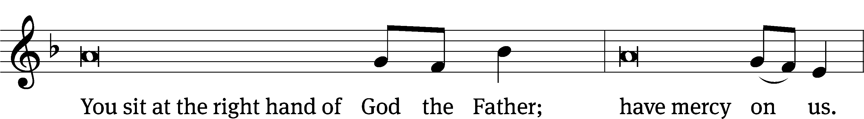
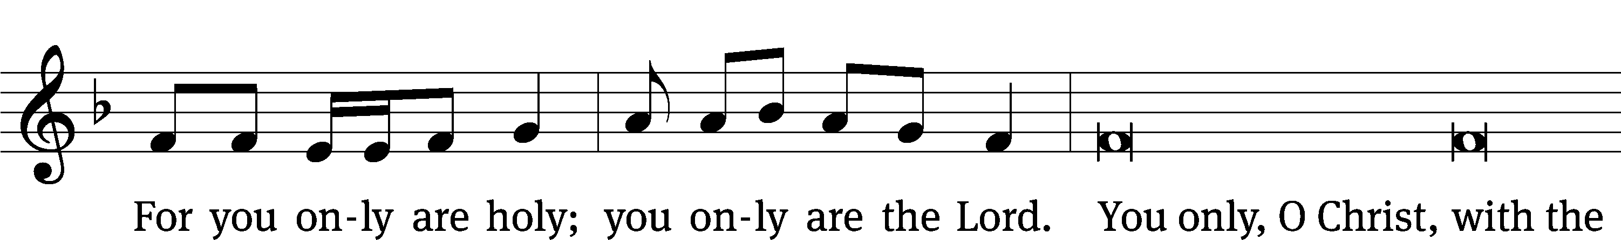
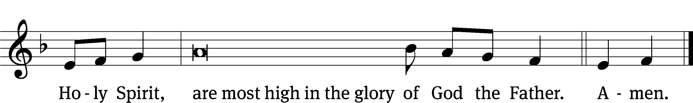

Tune: © 2021 Northwestern Publishing House. Used by permission: OneLicense no. 727703

The Lord be with you.
And also with you.
Prayer of the Day
Let us pray.

Merciful Father, your kindness caused the light of the gospel to shine among us. Use us now as instruments of your love to reach out with the message of salvation to all people. Bless those who labor in the mission fields far off and near, and grant success to their witness that many may be freed from sin; through Jesus Christ our Lord.
Amen.

Please be seated

First Reading Isaiah 6:1–8
In the year that King Uzziah died, I saw the Lord sitting on a throne, high and exalted, and the train of his robe filled the temple. ²Above him stood the seraphim. Each one had six wings. With two they covered their faces. With two they covered their feet. With two they flew. ³One called to another and said,
Holy, holy, holy is the Lord of Armies!
The whole earth is full of his glory!
⁴The foundations of the thresholds shook at the voice of the one who called, and the temple was filled with smoke.
⁵Then I said, “I am doomed! I am ruined, because I am a man with unclean lips, and I dwell among a people with unclean lips, and because my eyes have seen the King, the Lord of Armies!”
⁶Then one of the seraphim flew to me, carrying a glowing coal in his hand, which he had taken from the altar with tongs. ⁷He touched my mouth with the coal and said, “Look, this has touched your lips, so your guilt is taken away, and your sin is forgiven.”
⁸Then I heard the Lord’s voice, saying, “Whom shall I send? Who will go for us?”
Then I said, “Here I am. Send me!”

The Word of the Lord.
Thanks be to God.

Choir Oh, How Good It Is
Oh, how good it is when the family of God dwells together in spirit in faith and unity. Where the bonds of peace, of acceptance and love, are the fruit of His presence here among us. So with one voice we'll sing to the lord. And with one heart we'll live out His Word till the whole earth sees the redeemer has come, for he dwells in the presence of His people.

Oh, how good it is, on this journey we share, to rejoice with the happy and weep with those who mourn. For the weak find strength the afflicted find grace when we offer the blessing of belonging. So with one voice we'll sing to the lord. And with one heart we'll live out His Word till the whole earth sees the redeemer has come, for he dwells in the presence of His people.

Oh, how good it is to embrace His command, to prefer one another, forgive as He forgives. When we live as one, we all share in the love of the Son with the Father and the Spirit. So with one voice we'll sing to the lord. And with one heart we'll live out His Word till the whole earth sees the redeemer has come, for he dwells in the presence of His people.

Second Reading Colossians 4:2–6
Be persistent in prayer, and as you pray, be alert and thankful. ³At the same time, pray for us too, that God might open a door for our message, so that we can tell the mystery about Christ, for which I am in prison. ⁴Pray that I may make it known clearly, as it is necessary for me to speak. ⁵Walk in wisdom in the way you act toward those on the outside, making the most of your opportunity. ⁶Let your speech always be gracious, seasoned with salt, so that you know how you are to answer each person.

The Word of the Lord.
Thanks be to God.

Please stand, if you are able
Gospel Acclamation Isaiah 52:7
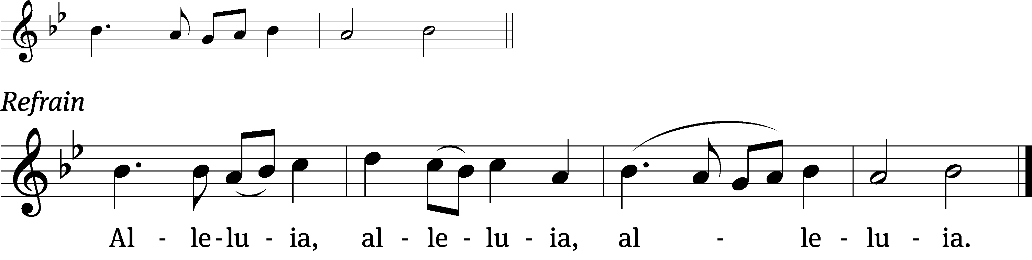
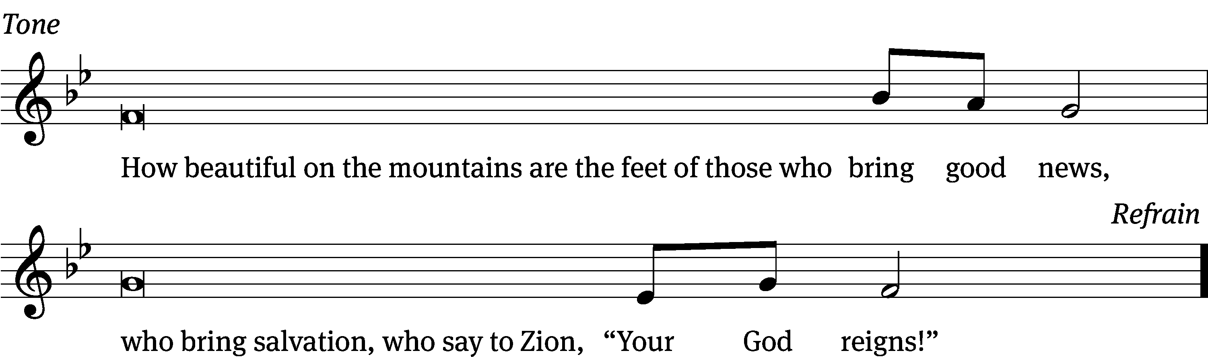
Tune: © 2021 Northwestern Publishing House. Used by permission: OneLicense no. 727703

Gospel Luke 24:45–48
Then He opened their minds to understand the Scriptures, and He said to them, “Thus it is written, that the Christ would suffer and rise again from the dead the third day, and that repentance for forgiveness of sins would be proclaimed in His name to all the nations, beginning from Jerusalem. “You are witnesses of these things.

The Gospel of the Lord.
Praise be to you, O Christ!
Please be seated
Hymn
747 Christ High-Ascended CW 747
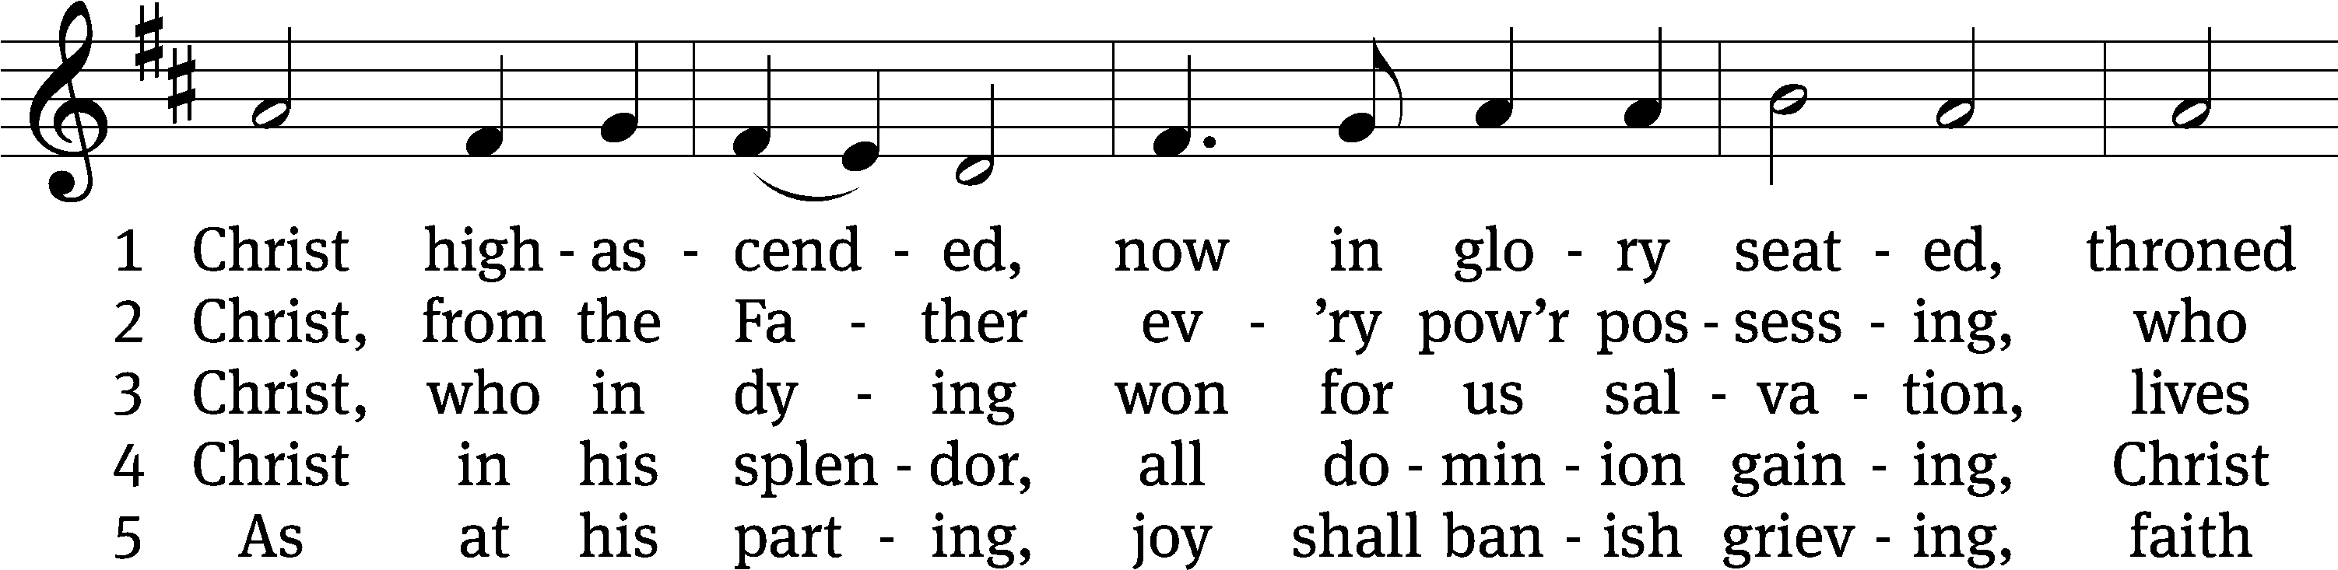
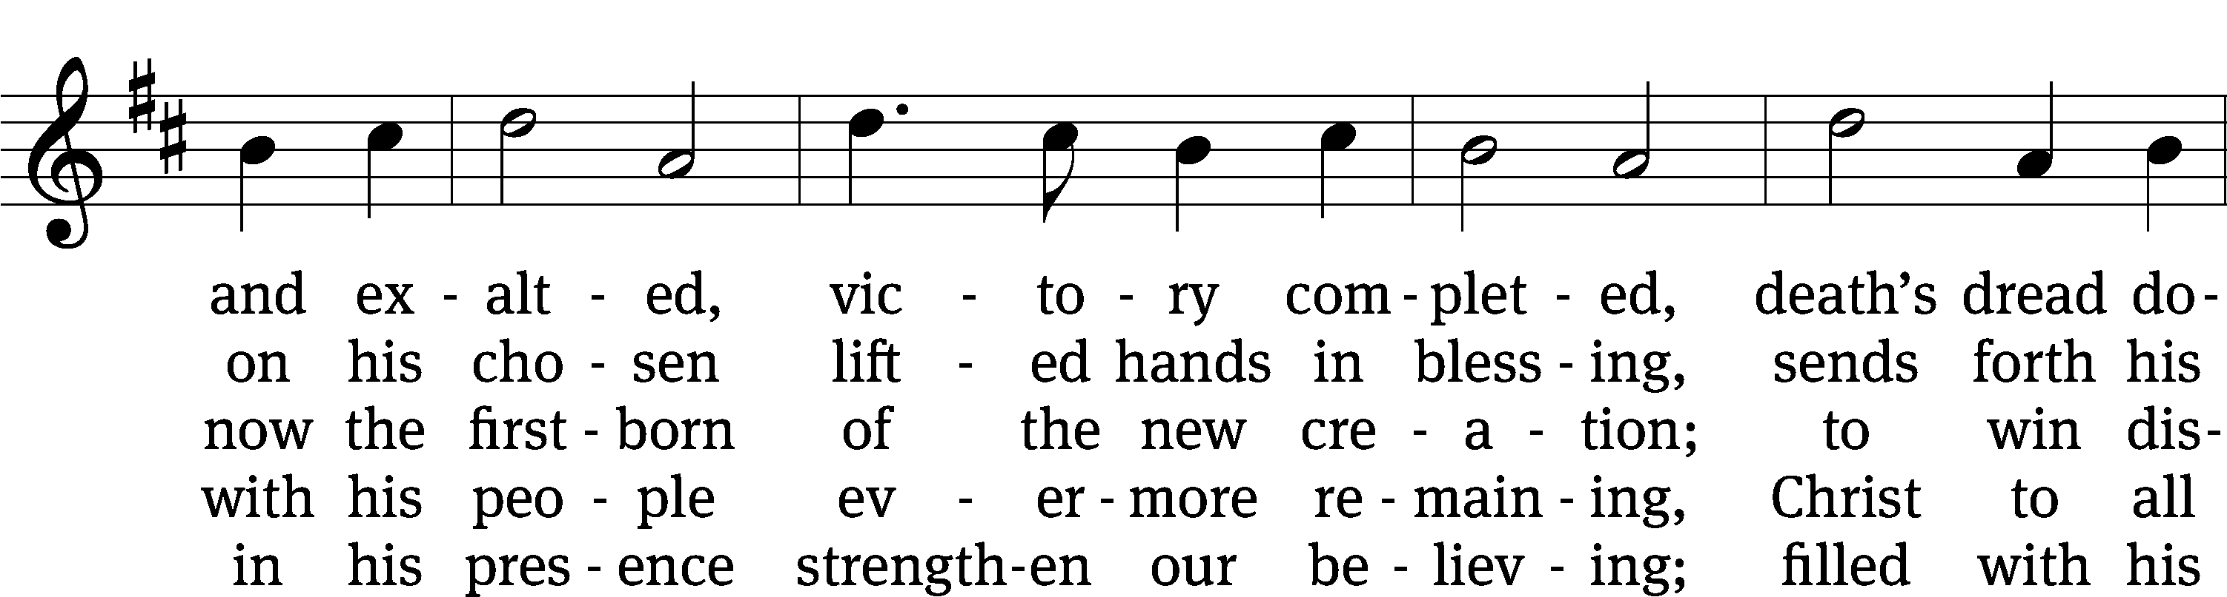
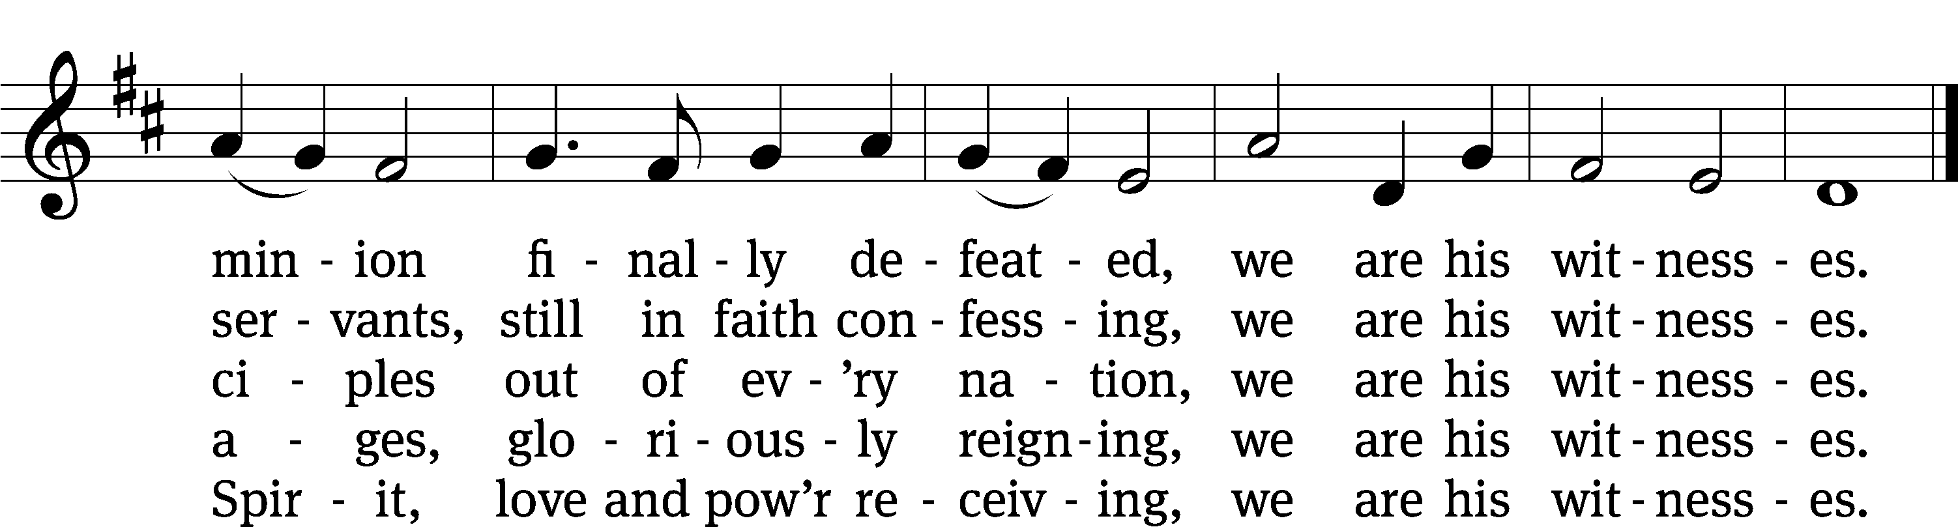
Text: Timothy Dudley-Smith, b. 1926, alt.
Tune: Antiphoner, Paris, 1681
Text: © 1984 Hope Publishing Co. Used by permission: OneLicense no. 727703
Tune: Public domain

Sermon Isaiah 6:1-8
Theme: HOLY, HOLY, HOLY
Please stand, if you are able
Apostles’ Creed
I believe in God, the Father Almighty,
maker of heaven and earth.

I believe in Jesus Christ, his only Son, our Lord,
who was conceived by the Holy Spirit,
born of the Virgin Mary,
suffered under Pontius Pilate,
was crucified, died, and was buried.
He descended into hell.
The third day he rose again from the dead.
He ascended into heaven
and is seated at the right hand of God the Father Almighty.
From there he will come to judge the living and the dead.

I believe in the Holy Spirit,
the holy Christian Church,
the communion of saints,
the forgiveness of sins,
the resurrection of the body,
and the life everlasting. Amen.

Prayer of the Church

Please be seated

Hymn
483 Holy, Holy, Holy! Lord God Almighty CW 483
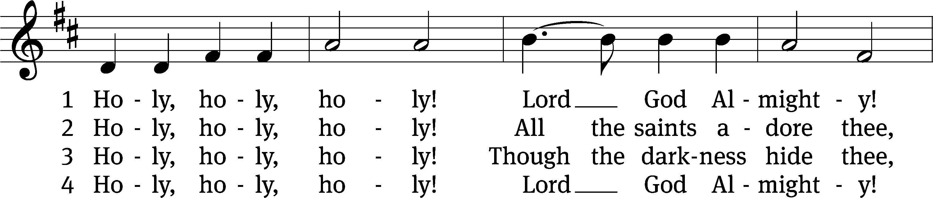
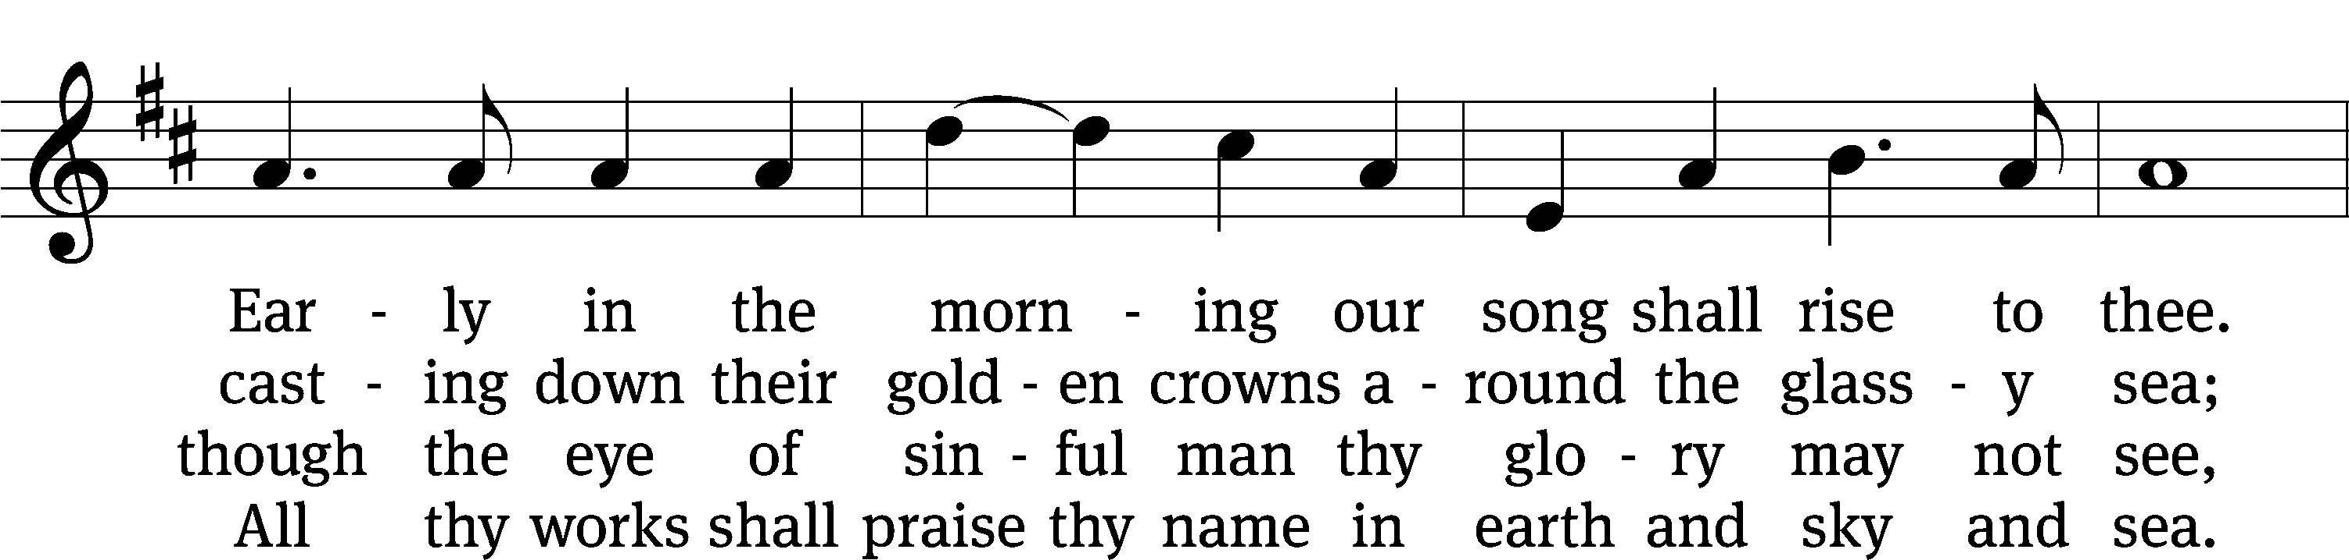
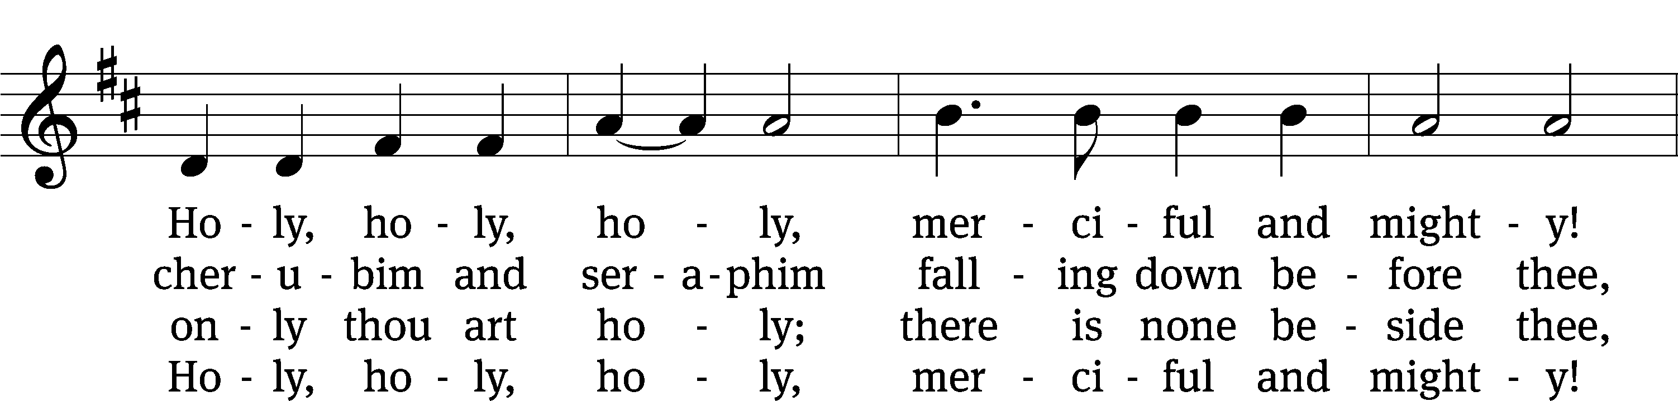
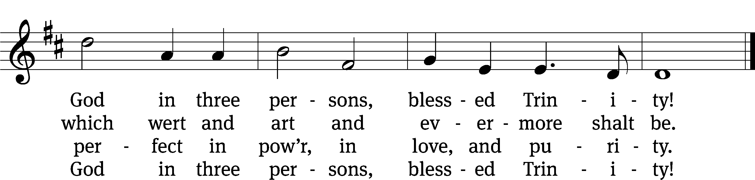
Text: Reginald Heber, 1783–1826, alt.
Tune: John B. Dykes, 1823–1876
Text and tune: Public domain

Please stand, if you are able
Prayer
Blessed Lord, you have given us your Holy Scriptures for our learning. May we so hear them, read, learn, and take them to heart that, being strengthened and comforted by your holy Word, we may cling to the blessed hope of everlasting life; through Jesus Christ our Lord, who lives and reigns with you and the Holy Spirit, one God, now and forever.
Amen.
Lord’s Prayer
Our Father, who art in heaven, hallowed be thy name, thy kingdom come, thy will be done on earth as it is in heaven. Give us this day our daily bread; and forgive us our trespasses, as we forgive those who trespass against us; and lead us not into temptation, but deliver us from evil. For thine is the kingdom and the power and the glory forever and ever. Amen.

Blessing
The Lord bless you and keep you.
The Lord make his face shine on you and be gracious to you.
The Lord look on you with favor and give you peace.
Amen.

Please be seated

Hymn
745 Hark, the Voice of Jesus Crying CW 745
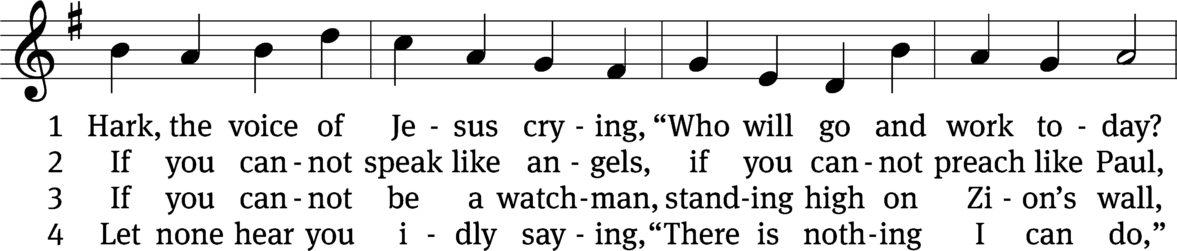
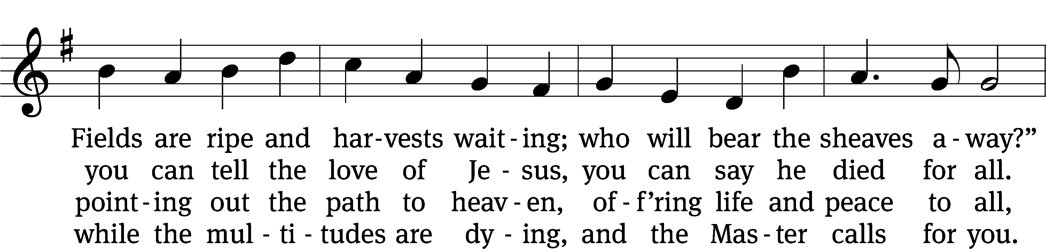
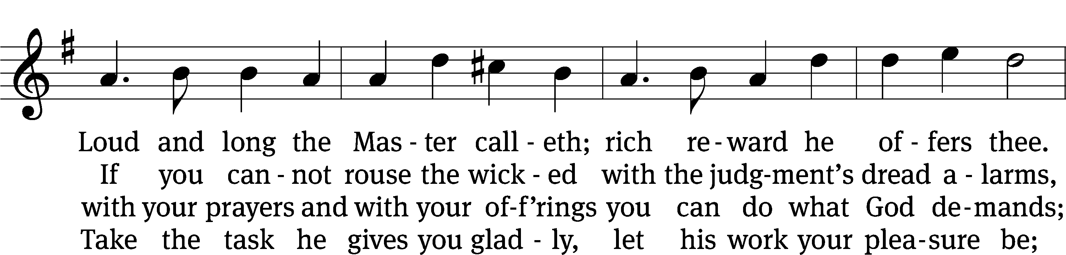
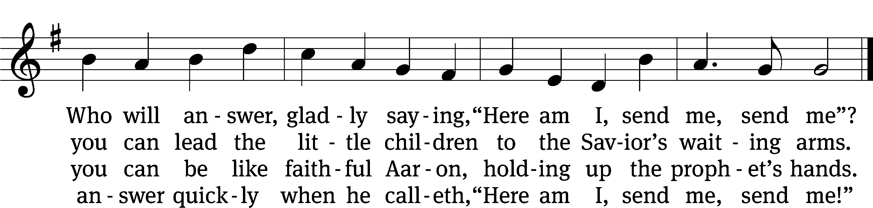
Text (sts. 1–2, 4): Daniel March, 1816–1909, sts. 1,2,4, abr., alt
Tune: Joseph Barnby, 1838–1896
Text and tune: Public domain

Acknowledgments
Setting One from Christian Worship
Software distributed in partnership with Northwestern Publishing House.
Created by Christian Worship: Service Builder © 2022 Concordia Publishing House.

Serving in Worship
Officiant Pastor Isaac Pappenfuss
Organist Marcia Marion Ackling
Deacons (Thursday) Duane Mason and Dave Stevenson
(Sunday) Jeff Neuburger and Robert Niethammer
Ushers (Thursday) Tim Phelps
(Sunday) Ron Zahn
Altar Guild Marcia Marion Ackling and Scott Ackling
Videographer Cindy Dresch

