the last sunday
AFTER PENTECOST -
christ the king

TRINITY EVANGELICAL LUTHERAN CHURCH | Saline, Michigan
WELCOME TO WORSHIP November 20, 2022

Thank you for joining us in God’s house today! We cordially ask that our guests sign one of the guestbooks located at either the front or back entryways.

THANK OFFERING: Members of Trinity give their offering as an expression of love and thankfulness to the Lord and to help support the Lord’s work in our community and around the world. Visitors need not feel obligated to participate in this offering which supports our ministry.

Restrooms are located at the back of the upper level (the annex), and in the basement (down the back stairs of the sanctuary or annex). Handicap access is available, please ask an usher for assistance.

celebration of holy communion:
In His Word, God makes it clear that the Lord’s Supper is to be shared by people of a common proclamation of faith (1 Corinthians 11:26; 1 Corinthians 10:16-17). Without judging anyone’s hearts, we invite those who share in our confession by their membership in our congregation or another congregation of the Wisconsin Evangelical Lutheran Synod (WELS) or the Evangelical Lutheran Synod (ELS) and who are properly prepared (1 Corinthians 11;27-29) to receive the Sacrament. Page 295 in the front of Christian Worship provides a guide for preparation.

Guests, we would love to have you join us in communion fellowship in the future, and for that to be possible, we ask that you speak with one of the pastors so that we may speak with you on how that would be possible. We thank you for respecting the way we celebrate the Lord’s Supper in our congregations.

SERVICE OF WORD AND SACRAMENT

offertory (bell choir – 11:00) “Praise and thanks to God”
511 Crown Him with Many Crowns CW 511
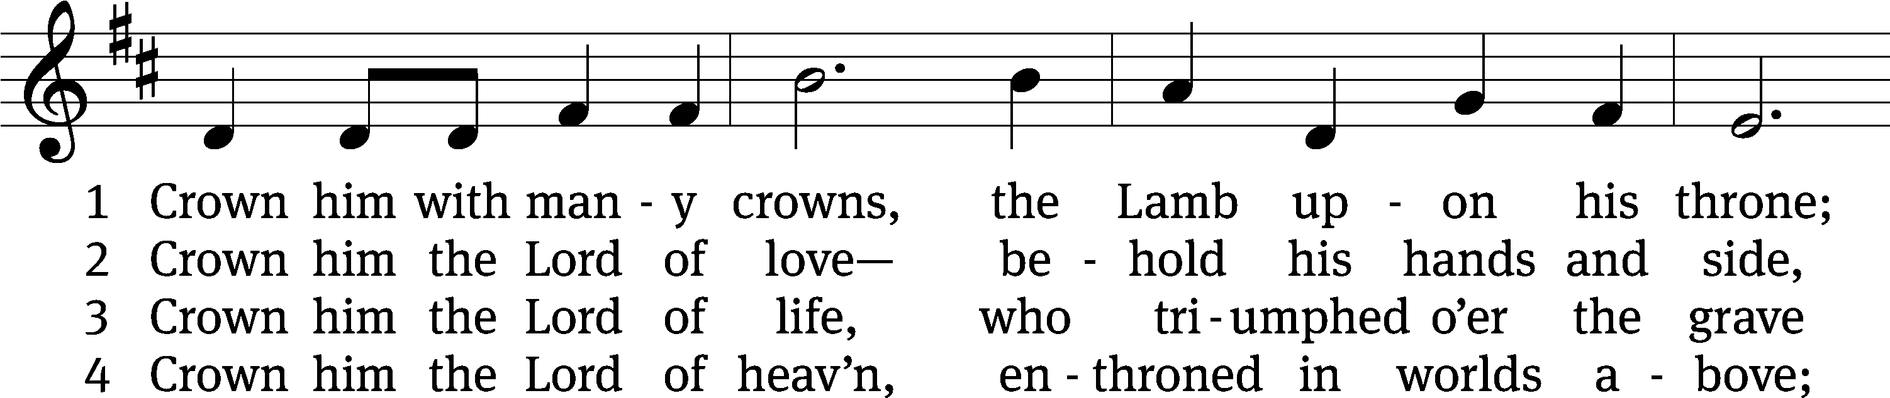
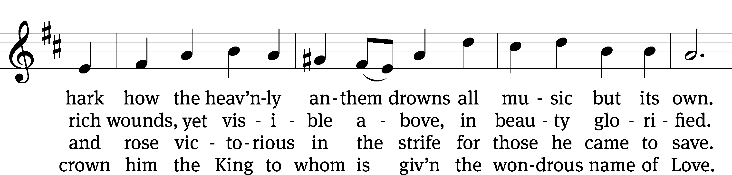
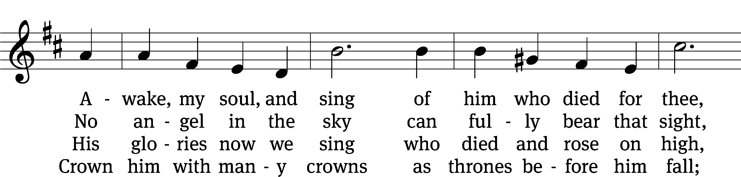
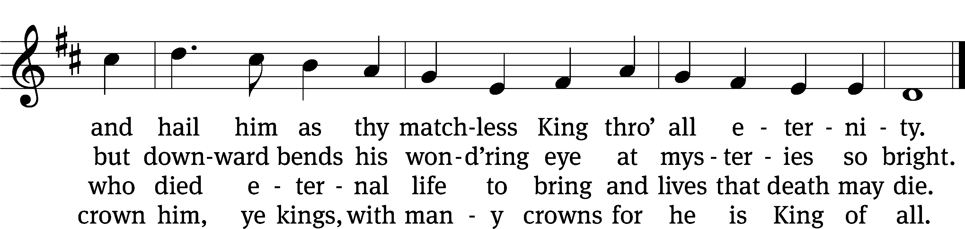
Text (sts. 1–2, 4): Matthew Bridges, 1800–1894, abr., alt.; (st. 3): Godfrey Thring, 1823–1903
Tune: George J. Elvey, 1816–1893
Text and tune: Public domain

PLEASE STAND, IF YOU ARE ABLE

invocation

M: The grace of our Lord (+) Jesus Christ and the love of God and the fellowship of the Holy Spirit be with you.
C: And also with you.
CONFESSION OF SINS
M: God invites us to come into his presence and worship him with humble and penitent hearts. Therefore, let us acknowledge our sinfulness and ask him to forgive us.
C: Holy and merciful Father, I confess that I am by nature sinful, and that I have disobeyed you in my thoughts, words, and actions. I have done what is evil and failed to do what is good. For this I deserve your punishment both now and in eternity. But I am truly sorry for my sins, and trusting in my Savior Jesus Christ, I pray: Lord, have mercy on me, a sinner.
M: God, our heavenly Father, has been merciful to us and has given his only Son to be the atoning sacrifice for our sins. Therefore, as a called servant of Christ and by his authority, I forgive you all your sins in the name of the Father and of the Son (+) and of the Holy Spirit.
C: Amen.
PRAYER AND PRAISE
LORD, HAVE MERCY
Kyrie
M: For all that we need in life and for the wisdom to use all your gifts with gratitude and joy, hear our prayer, O Lord.

M: For the steadfast assurance that nothing can separate us from your love and for the courage to stand firm against the assaults of Satan and every evil, hear our prayer, O Christ.

M: For the well-being of your holy Church in all the world and for those who offer here their worship and praise, hear our prayer, O Lord.

M: Merciful God, maker and preserver of life, uphold us by your power and keep us in your tender care:

M: The works of the Lord are great and glorious; his name is worthy of praise.

Prayer of the day

M: Let us pray.
The minister says the Prayer of the Day.

PLEASE BE SEATED

The Word
first lesson Jeremiah 23:1-6
¹ Woe to the shepherds who destroy and scatter the sheep of my pasture! declares the Lord.
² Therefore, this is what the Lord, the God of Israel, says about the shepherds who shepherd my people.
You have scattered my flock.
You have driven them away.
You have not taken care of them,
but I will certainly take care of you,
because of the evil things you have done,
declares the Lord.
³ I will gather what is left of my flock
out of all the countries where I have driven them,
and I will bring them back to their pastures.
They will be fruitful and multiply.
⁴ I will raise up shepherds over them
who will shepherd them.
They will no longer be afraid or terrified,
nor will any be missing, declares the Lord.
⁵ Listen, the days are coming, declares the Lord,
when I will raise up for David a righteous Branch,
who will reign wisely as king
and establish justice and righteousness on earth.
⁶ In his days Judah will be saved
and Israel will dwell securely.
This is his name by which he will be called:
The Lord Our Righteousness.

Senior Choir “When You Pass through the Waters”
Thus says the Lord, who created you, O Jacob,
Who formed you, O Israel:

Fear not, fear not,
For I have redeemed you; I have called you by name.
You are mine.
When you pass through the waters, I will be with you;
Through the rivers, they shall not overwhelm you;
When you walk through fire, you shall not be burned;
And the flame shall not consume you.
For I am the Lord your God, I am the Lord your God,
The Holy One, your Savior.

Fear not, fear not,
For I have redeemed you; I have called you by name.
You are mine.
When you pass through the waters, I will be with you;
Through the rivers, they shall not overwhelm you;
When you walk through fire, you shall not be burned;
And the flame shall not consume you.
For I am the Lord your God, I am the Lord your God,
The Holy One, your Savior.

Fear not, fear not,
For I have redeemed you; I have called you by name.
You are mine.

Fear not, you are mine.

second lesson Colossians 1:13-20
¹³ The Father rescued us from the domain of darkness and transferred us into the kingdom of the Son he loves, ¹⁴ in whom we have redemption, the forgiveness of sins.
¹⁵ He is the image of the invisible God, the firstborn over all creation, ¹⁶ for in him all things were created, in heaven and on earth, things seen and unseen, whether thrones or dominions or rulers or authorities; all things have been created through him and for him. ¹⁷ He is before all things, and all things hold together in him.
¹⁸ He is also the head of the body, the church. He is the beginning, the firstborn from the dead, so that in all things he might have the highest rank. ¹⁹ For God was pleased to have all his fullness dwell in him, ²⁰ and through him to reconcile all things to himself (whether things on earth or in heaven) by making peace through the blood of his cross.
PLEASE STAND, IF YOU ARE ABLE

VERSE OF THE DAY

GOSPEL John 18:28-38
²⁸ Early in the morning, the Jews led Jesus from Caiaphas to the Praetorium. They did not enter the Praetorium themselves, so that they would not become ceremonially unclean. (They wanted to be able to eat the Passover meal.) ²⁹ So Pilate went out to them and said, “What charge do you bring against this man?”
³⁰ They answered him, “If this man were not a criminal, we would not have handed him over to you.”
³¹ Pilate told them, “Take him yourselves and judge him according to your law.”
The Jews said, “It’s not legal for us to put anyone to death.” ³² This happened so that the statement Jesus had spoken indicating what kind of death he was going to die would be fulfilled.
³³ Pilate went back into the Praetorium and summoned Jesus. He asked him, “Are you the King of the Jews?”
³⁴ Jesus answered, “Are you saying this on your own, or did others tell you about me?”
³⁵ Pilate answered, “Am I a Jew? Your own people and chief priests handed you over to me. What have you done?”
³⁶ Jesus replied, “My kingdom is not of this world. If my kingdom were of this world, my servants would fight so that I would not be handed over to the Jews. But now my kingdom is not from here.”
³⁷ “You are a king then?” Pilate asked.
Jesus answered, “I am, as you say, a king. For this reason I was born, and for this reason I came into the world, to testify to the truth. Everyone who belongs to the truth listens to my voice.”
³⁸ Pilate said to him, “What is truth?”

M: This is the Gospel of the Lord.

PLEASE BE SEATED

512 All Hail the Power of Jesus’ Name CW 512
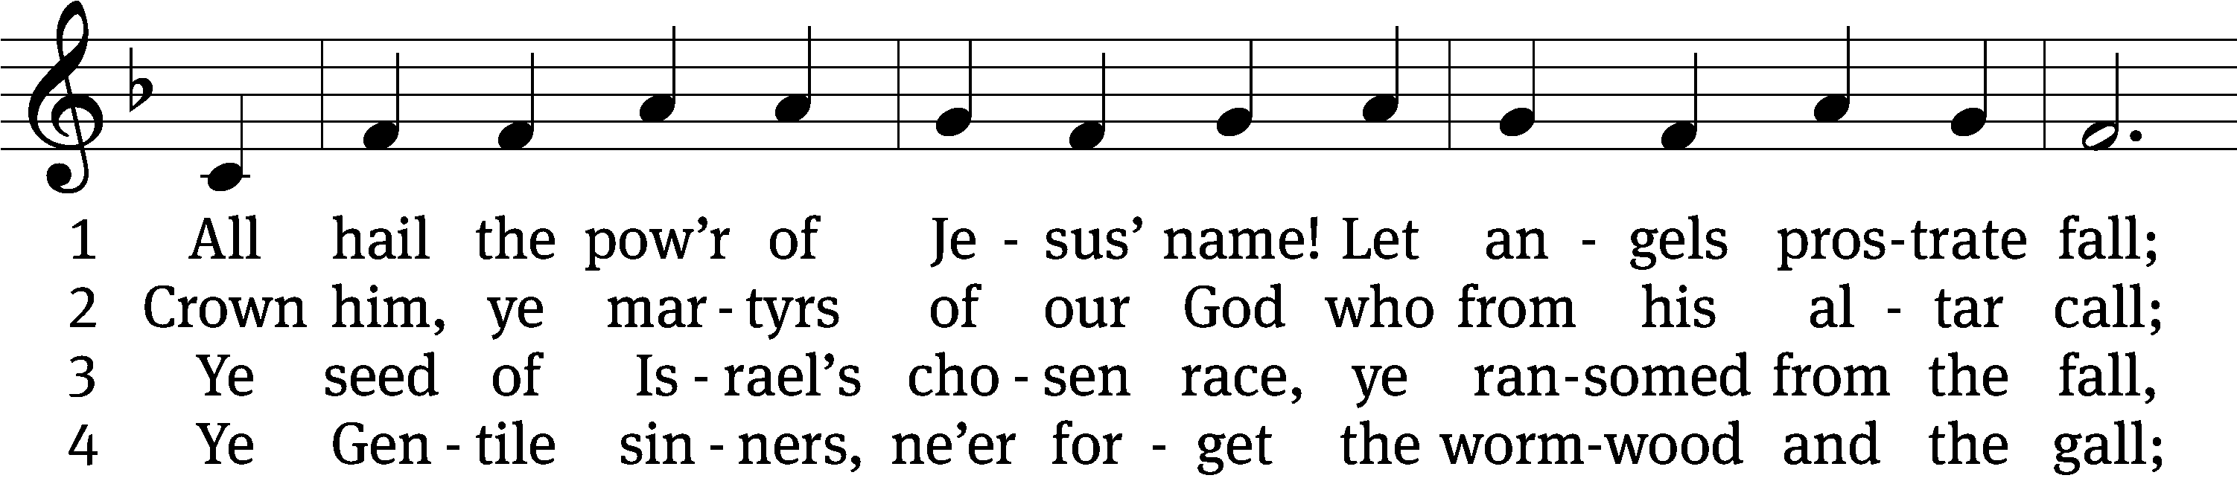
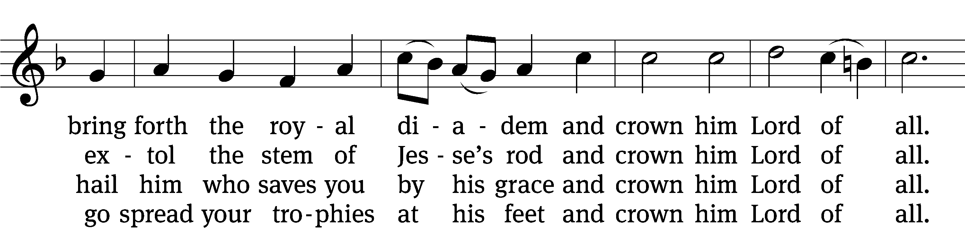
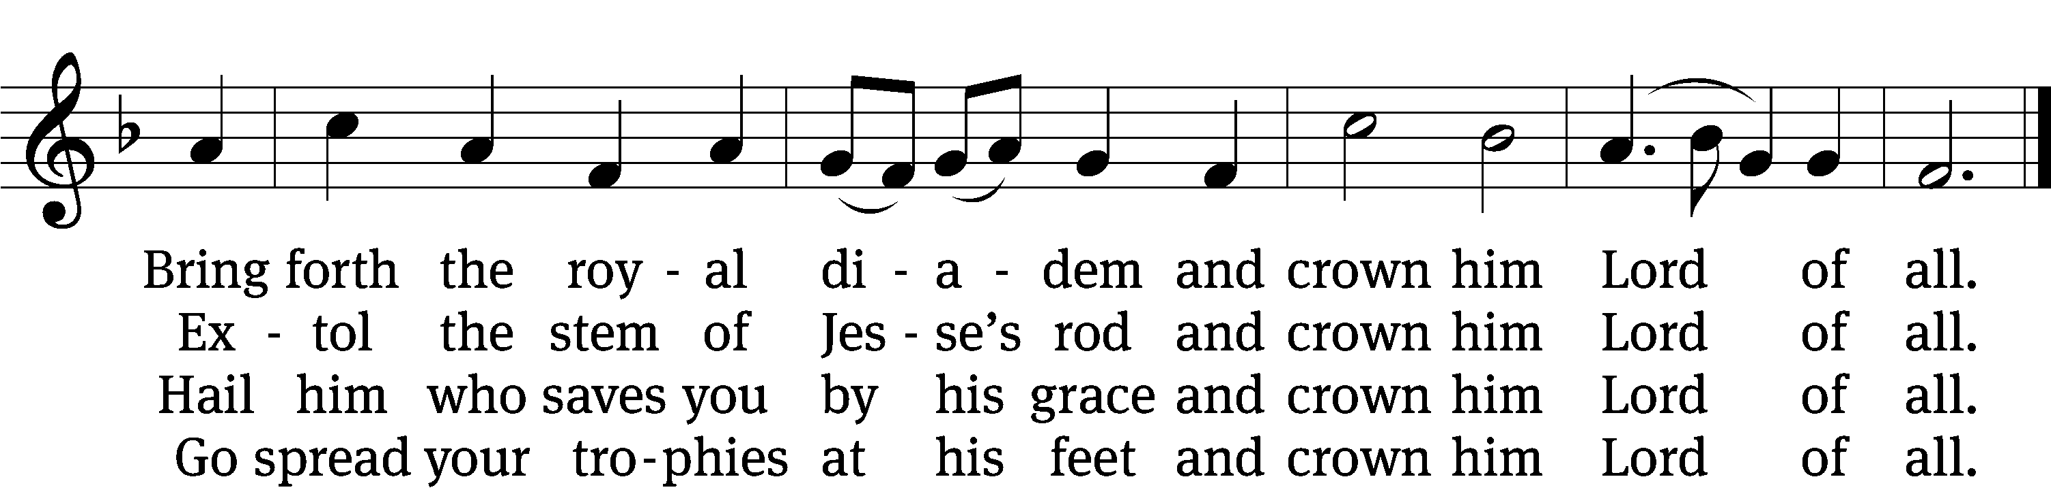

5 Let ev’ry kindred, ev’ry tribe
on this terrestrial ball
to him all majesty ascribe
and crown him Lord of all.
To him all majesty ascribe
and crown him Lord of all.

6 Oh, that with yonder sacred throng
we at his feet may fall!
We’ll join the everlasting song
and crown him Lord of all.
We’ll join the everlasting song
and crown him Lord of all.
Text (sts. 1–3): Edward Perronet, 1726–1792, abr., alt.; (sts. 4–6): A Selection of Hymns, London, 1787, alt.
Tune: Oliver Holden, 1765–1844
Text and tune: Public domain

Sermon John 18:28-38

“Pilate’s Words were right all along”

please stand, if you are able

nicene creed
We believe in one God, the Father, the Almighty, maker of heaven and earth, of all that is, seen and unseen.
We believe in one Lord, Jesus Christ, the only Son of God, eternally begotten of the Father, God from God, Light from Light, true God from true God, begotten, not made, of one being with the Father. Through him all things were made. For us and for our salvation, he came down from heaven, was incarnate of the Holy Spirit and the virgin Mary, and became truly human. For our sake he was crucified under Pontius Pilate. He suffered death and was buried. On the third day he rose again in accordance with the Scriptures. He ascended into heaven and is seated at the right hand of the Father. He will come again in glory to judge the living and the dead, and his kingdom will have no end.
We believe in the Holy Spirit, the Lord, the giver of life, who proceeds from the Father and the Son, who in unity with the Father and the Son is worshiped and glorified, who has spoken through the prophets. We believe in one holy Christian and apostolic Church. We acknowledge one baptism for the forgiveness of sins. We look for the resurrection of the dead and the life of the world to come. Amen.

PLEASE BE SEATED

offertory (bell choir – 8:30) “Praise and thanks to God”

PLEASE STAND, IF YOU ARE ABLE

prayer of the church

lord’s prayer

C: Our Father, who art in heaven,
hallowed be thy name,
thy kingdom come,
thy will be done
on earth as it is in heaven.
Give us this day our daily bread;
and forgive us our trespasses,
as we forgive those
who trespass against us;
and lead us not into temptation,
but deliver us from evil.
For thine is the kingdom
and the power and the glory
forever and ever. Amen.

The Sacrament of Holy Communion
Trinity Lutheran Church follows the historic Christian practice of close communion. We ask that only members of Trinity or one of our sister congregations partake of the sacrament. If you are not a member, please see the note about Holy Communion in the beginning of the Worship Folder.

M: The Lord be with you.

M: Lift up your hearts.

M: Let us give thanks to the Lord our God.

M: Praise to the God and Father of our Lord Jesus Christ! In love he has blessed us with every spiritual blessing. He sends the Holy Spirit to testify that we are his children and to strengthen us when we are weak. Now have come the salvation and the power and the kingdom of our God and the authority of his Christ. To him who sits on the throne and to the Lamb be praise and thanks and honor and glory for ever and ever:

Holy, Holy, Holy

Words of institution
M: Our Lord Jesus Christ, on the night he was betrayed, took bread; and when he had given thanks, he broke it and gave it to his disciples, saying: “Take and eat. This is my ✙ body, which is given for you. Do this in remembrance of me.”
Then he took the cup, gave thanks, and gave it to them, saying, “Drink from it all of you; this is my ✙ blood of the new covenant, which is poured out for you for the forgiveness of sins. Do this, whenever you drink it, in remembrance of me.”
The peace of the Lord be with you always.

O CHRIST, LAMB OF GOD

880 For All the Saints CW 880
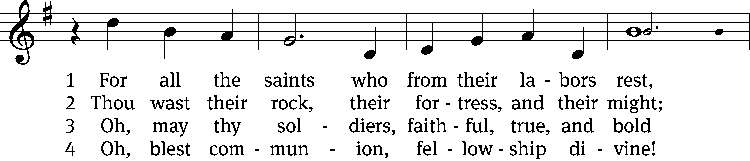
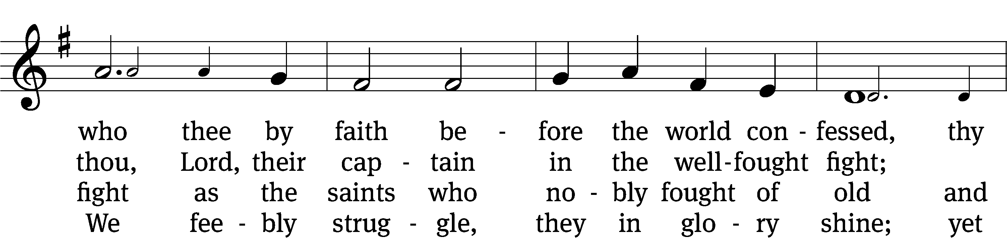
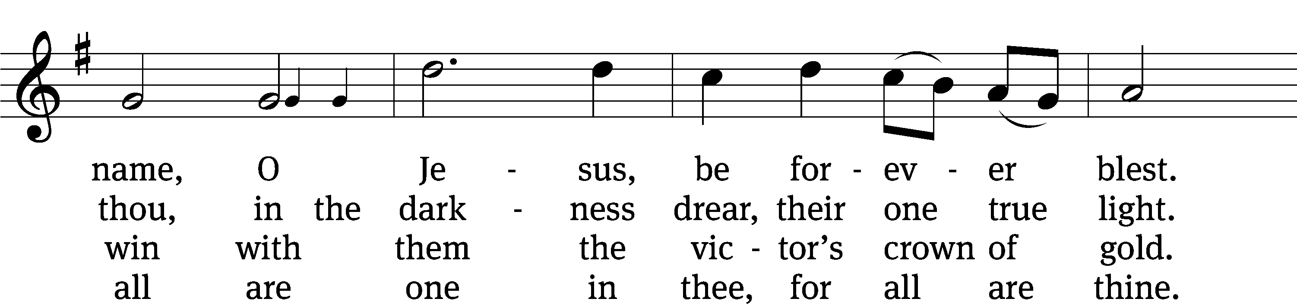
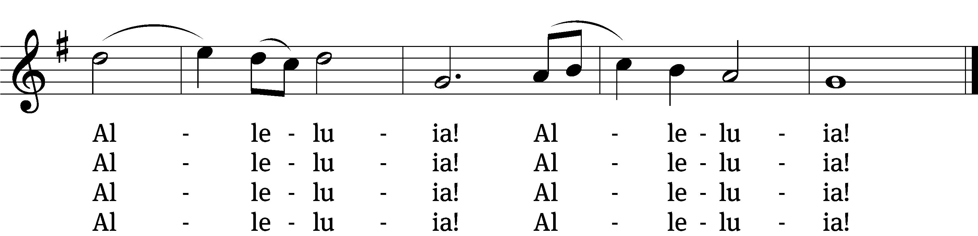

5 And when the fight is fierce, the warfare long,
steals on the ear the distant triumph-song,
and hearts are brave again and arms are strong.
Alleluia! Alleluia!

6 The golden evening brightens in the west;
soon, soon, to faithful warriors cometh rest;
sweet is the calm of paradise the blest.
Alleluia! Alleluia!

7 But, lo, there breaks a yet more glorious day:
the saints triumphant rise in bright array;
the King of glory passes on his way.
Alleluia! Alleluia!

8 From earth’s wide bounds, from ocean’s farthest coast,
through gates of pearl streams in the countless host,
singing to Father, Son, and Holy Ghost.
Alleluia! Alleluia!
Text: William W. How, 1823–1897, alt.
Tune: Ralph Vaughan Williams, 1872–1958
Text and tune: Public domain

PLEASE STAND, IF YOU ARE ABLE

THANKSGIVING

M: Hear the prayer of your people, O Lord, that the lips which have praised you here may glorify you in the world, that the eyes which have seen the coming of your Son may long for his coming again, and that all who have received in his true body and blood the pledge of your forgiveness may be restored to live a new and holy life, through Jesus Christ, our Lord, who lives and reigns with you and the Holy Spirit, one God, now and forever.

M: Brothers and sisters, go in peace. Live in harmony with one another.
Serve the Lord with gladness.

The Lord bless you and keep you.
The Lord make his face shine on you and be gracious to you.
The Lord look on you with favor and (+) give you peace.

PLEASE BE SEATED

543 O Jesus, King Most Wonderful CW 543
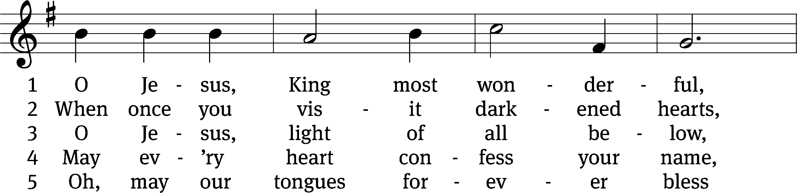
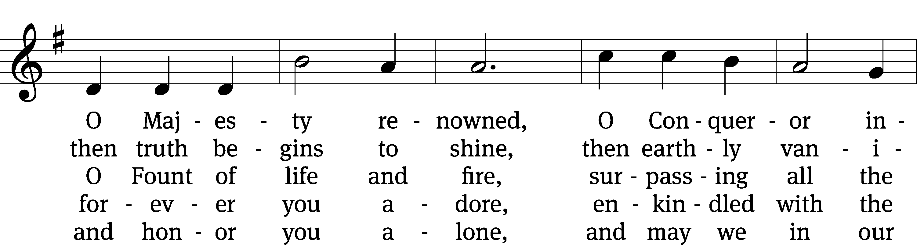
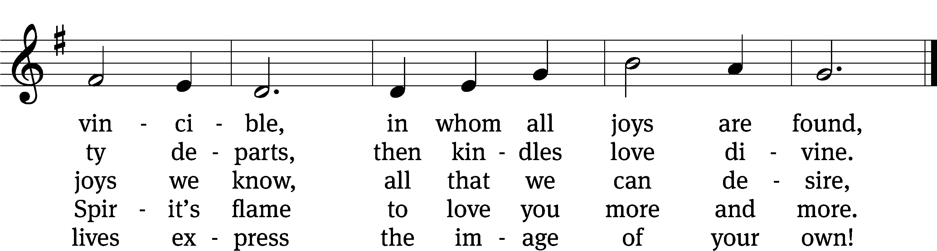
Text: tr. Edward Caswall, 1814–1878, alt.; attr. Bernard of Clairvaux, 1091–1153, abr.
Tune: John B. Dykes, 1823–1876
Text and tune: Public domain

Serving In Worship

Officiant Pastor Natsis
Organist Sarah Hanke
Bell Choir Director Meg Nortley
Choir Director Cynthia Natsis
Accompanist Laura Sala
Deacons (8:30) Dave Stevenson and Ed Wheeler
(11:00) Dave Frey and Steve Hoeft
Ushers (8:30) Dale Radak
(11:00) Ron Zahn
Altar Guild Margaret Hoeft and Brenda Stevenson
Videographer Ann Latowski

Copyright information
Service of Word and Sacrament: Christian Worship. © 1993 Northwestern Publishing House. All rights reserved. Reprinted under ONE LICENSE #A-727703 and CCLI #1151741/ CSPL126093
Words and Music: All rights reserved. Reprinted/Podcast/Streamed with permission under ONE LICENSE #A-727703 and CCLI #1151741/CSPL126093

