THE fifth SUNDAY
AFTER PENTECOST

tRINITY EVANGELICAL LUTHERAN CHURCH | Saline, Michigan
July 7/10, 2022

WELCOME TO WORSHIP

Thank you for joining us in God’s house today! We cordially ask that our Guests with us this morning sign one of the guestbooks located at either the front or back entryways.

THANK OFFERING: Members of Trinity give their offering as an expression of love and thankfulness to the Lord and to help support the Lord’s work in our community and around the world. Visitors need not feel obligated to participate in this offering which supports our ministry.

Restrooms are located at the back of the upper level (the annex), and in the basement (down the back stairs of the sanctuary or annex). Handicap access is available, please ask an usher for assistance.

Young Families / Toddler Bags – We are GLAD YOU BROUGHT YOUR CHILDREN to our worship service. Jesus said: “Let the little children come to me and do not hinder them, for the kingdom of God belongs to such as these.” We know that having little children in church can be a challenge, but DO NOT WORRY about it. Many of your fellow worshippers have been in your shoes and are just happy you brought your children with you. For your convenience, we have reserved the back rows of seating for parents with small children. These areas provide more flexibility for your family, as well as, easy access to move downstairs if necessary. A closed-circuit TV system allows families to continue participating in the service while downstairs. Pre-school toddler bags and children’s bulletins are available for their enjoyment. Ask an usher for one to use during the service and please return the toddler bag afterwards.

SERVICE of the word

605 From All That Dwell below the Skies CW 605
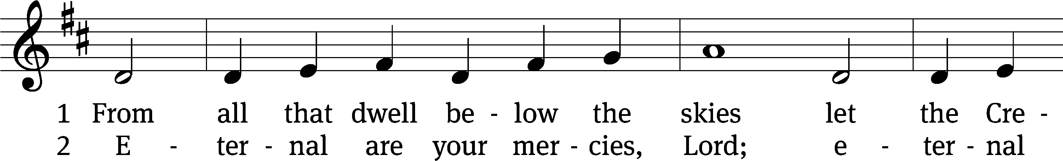
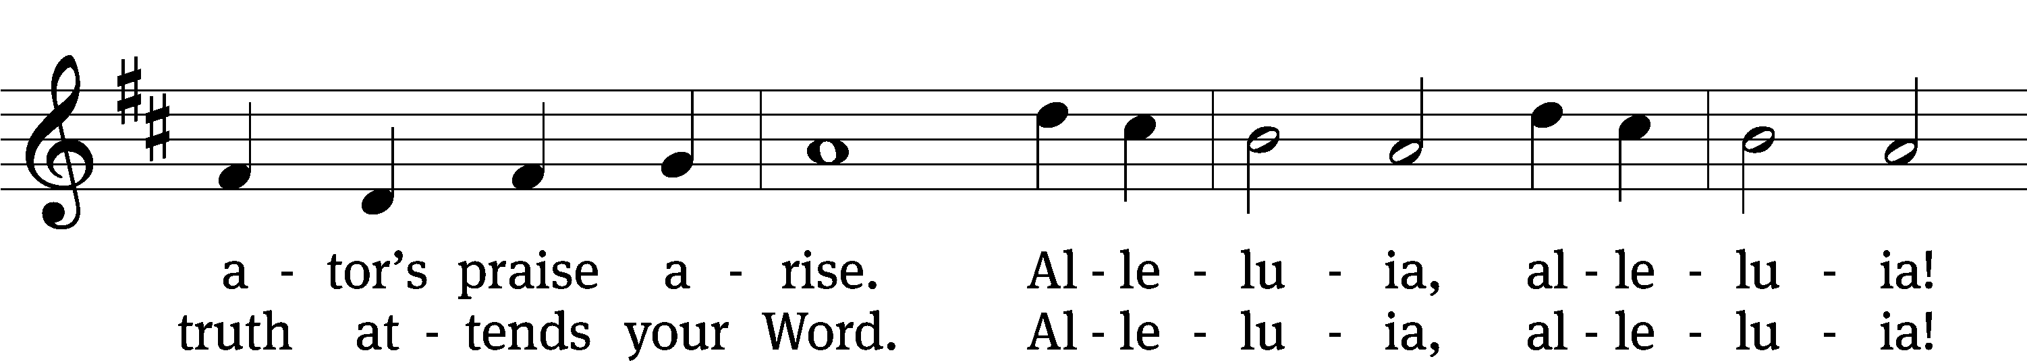
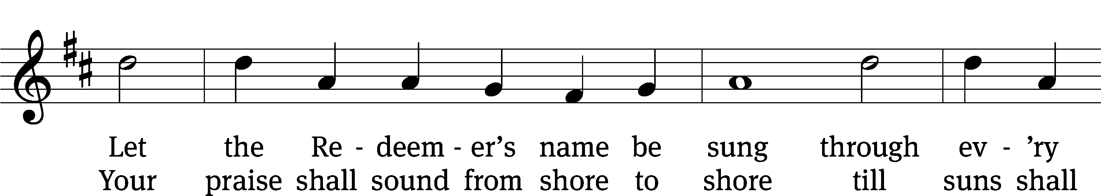
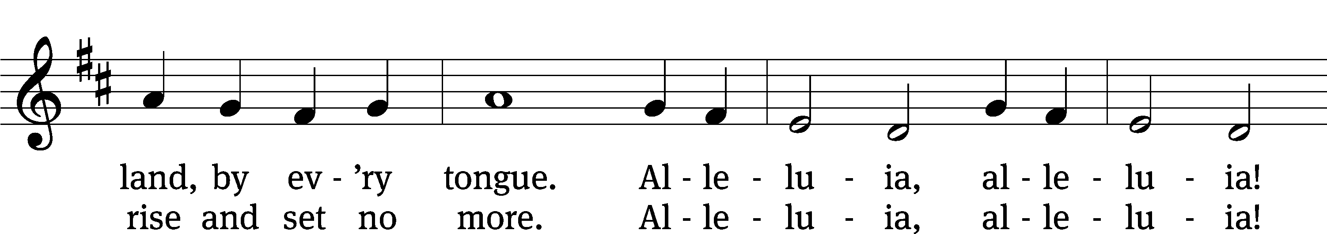
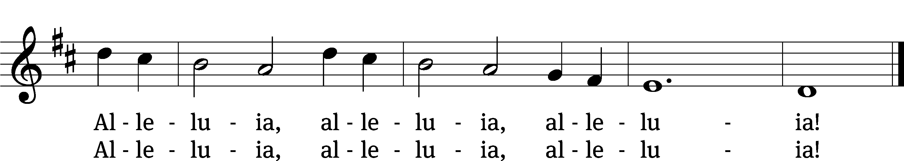
Text: Isaac Watts, 1674–1748, alt.
Tune: Geistliche Kirchengesäng, Köln, 1623
Text and tune: Public domain

PLEASE STAND, IF YOU ARE ABLE

invocation
M: The grace of our Lord (+) Jesus Christ and the love of God and the fellowship of the Holy Spirit be with you.
C: And also with you.
CONFESSION OF SINS
M: We have come into the presence of God, who created us to love and serve him as his dear children. But we have disobeyed him and deserve only his wrath and punishment. Therefore, let us confess our sins to him and plead for his mercy.

C: Merciful Father in heaven, I am altogether sinful from birth. In countless ways I have sinned against you and do not deserve to be called your child. But trusting in Jesus, my Savior, I pray: Have mercy on me according to your unfailing love. Cleanse me from my sin, and take away my guilt.
M: God, our heavenly Father, has forgiven all your sins. By the perfect life and innocent death of our Lord Jesus Christ, he has removed your guilt forever. You are his own dear child. May God give you strength to live according to his will.

C: Amen.
PRAYER AND PRAISE

M: In the peace of forgiveness, let us praise the Lord.

OH, TASTE AND SEE

PRAYER OF THE DAY

M: Let us pray.
The minister says the Prayer of the Day.

PLEASE BE SEATED
The Word

the FIRST LESSON ruth 1:1-19a
1 During the days of the judges, a famine occurred in the land. So a man left Bethlehem in Judah to stay awhile in the territory of Moab—he, his wife, and his two sons. ² The man’s name was Elimelek, his wife’s name was Naomi, and the names of his two sons were Mahlon and Kilion. They were from the clan of Ephrath from Bethlehem in Judah. They entered the territory of Moab and remained there.
³ But Elimelek, Naomi’s husband, died, so she was left with her two sons. ⁴ They then married Moabite wives. The name of the first was Orpah, and the name of the second was Ruth. They lived there for about ten years. ⁵ But Naomi’s sons, Mahlon and Kilion, also died. So the woman was left without her two children and without her husband.
⁶ Then Naomi set out with her daughters-in-law to return from the territory of Moab, because while she was in the territory of Moab, she had heard that the Lord had graciously visited^{[d]} his people by providing them with food. ⁷ So she left the place where she had been, and her two daughters-in-law left with her. They set out on the road to return to the land of Judah.
⁸ But Naomi said to her two daughters-in-law, “Go back. Both of you return to your mother’s house. May the Lord show you kindness^{[e]} as you have shown kindness to the dead and to me. ⁹ May the Lord grant that each of you finds security^{[f]} in the house of a husband.” Then she kissed them, and they wept loudly.
¹⁰ But they said to her, “No, we will return with you to your people.”
¹¹ Then Naomi said, “Turn back, my daughters. Why should you go with me? Am I going to give birth to any more sons^{[g]} who could become your husbands? ¹² Turn back, my daughters. Go! For I am too old to be married to another husband. Suppose I say, ‘I have hope, and I will be married to another husband tonight, and I will even give birth to sons.’ ¹³ Would you wait for them until they grow up? On the basis of that hope would you give up the chance to marry another husband? No, my daughters. It is much more bitter for me than for you, because the hand of the Lord has reached out against me.”
¹⁴ They once again wept loudly. Then Orpah kissed her mother-in-law, but Ruth would not let her go.
¹⁵ Naomi said, “Look, your sister-in-law has returned to her people and to her gods. Go back! Follow your sister-in-law.”
¹⁶ But Ruth said, “Do not urge me to abandon you or to turn back from following you. Because wherever you go, I will go, and wherever you make your home, I will make my home. Your people will be my people, and your God will be my God. ¹⁷ Wherever you die, I will die, and there I will be buried. May the Lord punish me severely and double it^{[h]} if anything but death^{[i]} separates me from you.”
¹⁸ When Naomi saw that Ruth was determined to go with her, she stopped urging her.
¹⁹ Then the two of them traveled until they arrived at Bethlehem.

Psalm 25A To You, O LORD, I Lift My Soul Psalm 25A
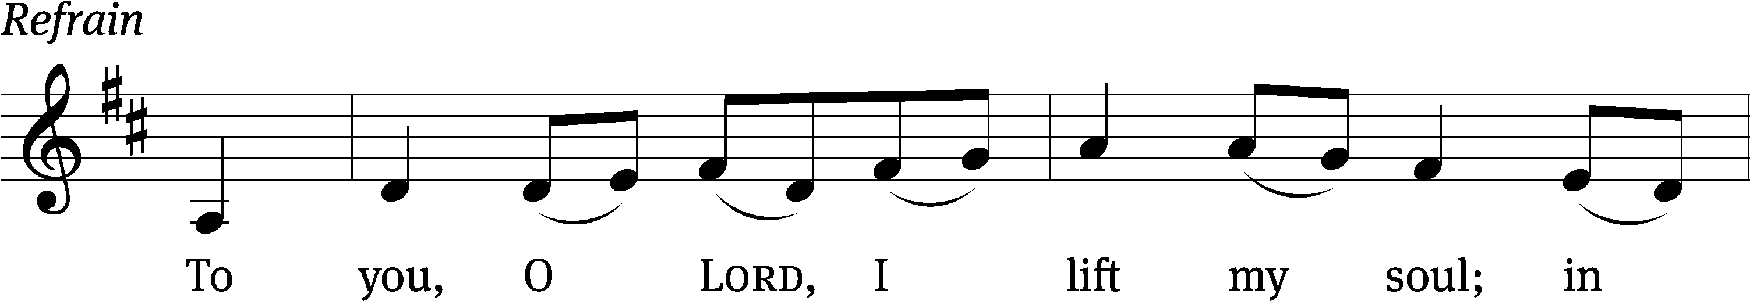
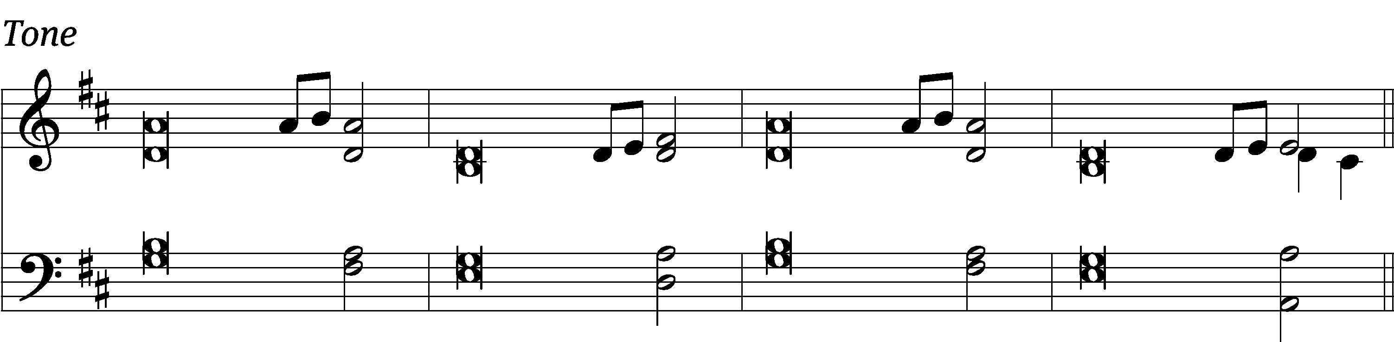

In you, Lord my God, I / put my trust.
I trust in you; do not let me be / put to shame.
Show me your ways, Lord, teach me / your paths.
Guide me in your truth and teach me, for you are God my / Savior.

Remember, Lord, your great mer- / cy and love,
for they are / from of old.
Do not remember the sins of my youth and my re- / bellious ways;
according to your love remember me, for you, Lord, / are good. Refrain

Lord, forgive my iniquity, though / it is great.
Turn to me and be gracious to me, for I am lonely and af- / flicted.
Look on my affliction and / my distress
and take away / all my sins.

Glory be to the Father and / to the Son
and to the Holy / Spirit,
as it was in the be- / ginning,
is now, and will be forever. / Amen. Refrain
Text: Public domain
Music: © 2014 Mark Haas. Used by permission: OneLicense no. 727703

THE SECOND LESSON GALATIANS 5:1, 13-25
¹ It is for freedom that Christ has set us free. Stand firm, then, and do not allow anyone to put the yoke of slavery on you again. ¹³ After all, brothers, you were called to freedom. Only do not use your freedom as a starting point for your sinful flesh. Rather, serve one another through love. ¹⁴ In fact, the whole law is summed up in this one statement: “Love your neighbor as yourself.” ¹⁵ But if you keep on biting and devouring one another, watch out that you are not consumed by one another.
¹⁶ What I am saying is this: Walk by the spirit, and you will not carry out what the sinful flesh desires. ¹⁷ For the sinful flesh desires what is contrary to the spirit, and the spirit what is contrary to the sinful flesh. In fact, these two continually oppose one another, so that you do not continue to do these things you want to do. ¹⁸ But if you are led by the spirit, you are not under the control of the law.
¹⁹ Now the works of the sinful flesh are obvious: sexual immorality, impurity, complete lack of restraint, ²⁰ idolatry, sorcery, hatred, discord, jealousy, outbursts of anger, selfish ambition, dissensions, heresies, ²¹ envy, murders,^{[c]} drunkenness, orgies, and things similar to these. I warn you, just as I also warned you before, that those who continue to do such things will not inherit the kingdom of God.
²² But the fruit of the spirit is love, joy, peace, patience, kindness, goodness, faithfulness, ²³ gentleness, and self-control. Against such things there is no law. ²⁴ Those who belong to Christ Jesus have crucified the sinful flesh with its passions and desires. ²⁵ If we live by the spirit, let us also walk in step with it.

PLEASE Stand, if you are able

Verse of the day

THE GOSPEL LESSON LUKE 10:25-37
M: The Gospel according to Luke chapter 10, verses 25-37

²⁵ Just then, an expert in the law stood up to test Jesus, saying, “Teacher, what must I do to inherit eternal life?”
²⁶ “What is written in the law?” he asked him. “What do you read there?”
²⁷ He replied, “Love the Lord your God with all your heart, with all your soul, with all your strength, and with all your mind;^{[a]} and, love your neighbor as yourself.”^{[b]}
²⁸ He said to him, “You have answered correctly. Do this, and you will live.”
²⁹ But he wanted to justify himself, so he asked Jesus, “And who is my neighbor?”
³⁰ Jesus replied, “A man was going down from Jerusalem to Jericho. He fell among robbers who stripped him, beat him, and went away, leaving him half dead. ³¹ It just so happened that a priest was going down that way. But when he saw the man, he passed by on the other side. ³² In the same way, a Levite also happened to go there, but when he saw the man, he passed by on the other side. ³³ A Samaritan, as he traveled, came to where the man was. When he saw him, he felt sorry for the man. ³⁴ He went to him and bandaged his wounds, pouring oil and wine on them. He put him on his own animal, took him to an inn, and took care of him. ³⁵ The next day, when he left, he took out two denarii,^{[c]} gave them to the innkeeper, and said, ‘Take care of him. Whatever extra you spend, I will repay you when I return.’ ³⁶ Which of these three do you think acted like a neighbor to the man who fell among robbers?”
³⁷ “The one who showed mercy to him,” he replied.
Then Jesus told him, “Go and do likewise.”
M: This is the Gospel of the Lord.

PLEASE BE SEATED
918 Lord Jesus Christ, Be Present Now CW 918
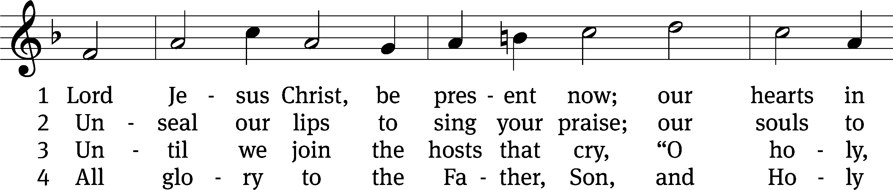
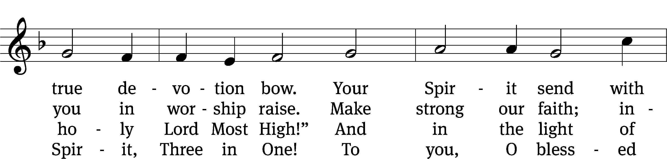
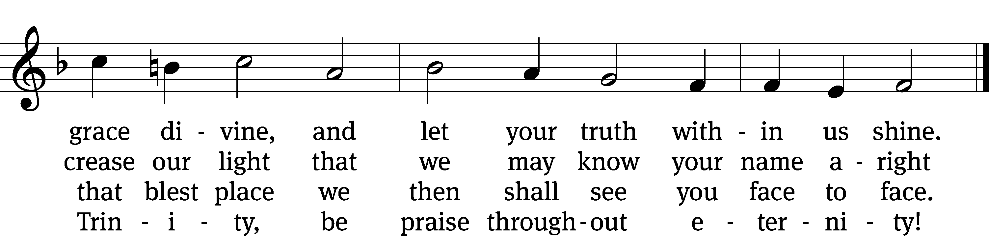
Text: tr. Catherine Winkworth, 1827–1878, alt.; Lutherisch Hand-Büchlein, Altenburg, 1648
Tune: Cantionale Germanicum, Gochsheim, 1628
Text and tune: Public domain

SERMON TEXT AND THEME PSALM 95:1-7
“We Bow before the LORD in Worship”

¹ Come, let us sing joyfully to the Lord.
Let us give a loud shout to the Rock who saves us.
² Let us approach his presence with thanksgiving.
With music we will shout to him.
³ For the Lord is the great God
and the great King above all gods.
⁴ He holds the unexplored places of the earth in his hand,
and the peaks of the mountains belong to him.
⁵ The sea belongs to him, for he made it,
and his hands formed the dry land.
⁶ Come, let us bow down. Let us revere him.
Let us kneel before the Lord our Maker,
⁷ for he is our God,
and we are the people of his pasture
and the flock in his hand.

PLEASE STAND, IF YOU ARE ABLE

THE APOSTLES’ CREED
I believe in God, the Father almighty,
maker of heaven and earth.
I believe in Jesus Christ, his only Son, our Lord,
who was conceived by the Holy Spirit,
born of the virgin Mary,
suffered under Pontius Pilate,
was crucified, died, and was buried.
He descended into hell.
The third day he rose again from the dead.
He ascended into heaven
and is seated at the right hand of God the Father almighty.
From there he will come to judge the living and the dead.
I believe in the Holy Spirit,
the holy Christian Church,
the communion of saints,
the forgiveness of sins,
the resurrection of the body,
and the life everlasting. Amen.

PRAYER OF THE CHURCH

THE LORD’S PRAYER

C: Our Father, who art in heaven, hallowed be thy name, thy kingdom come, thy will be done on earth as it is in heaven. Give us this day our daily bread; and forgive us our trespasses, as we forgive those who trespass against us; and lead us not into temptation, but deliver us from evil. For thine is the kingdom and the power and the glory forever and ever. Amen.

PLEASE BE SEATED

612 How Great Thou Art CW 612
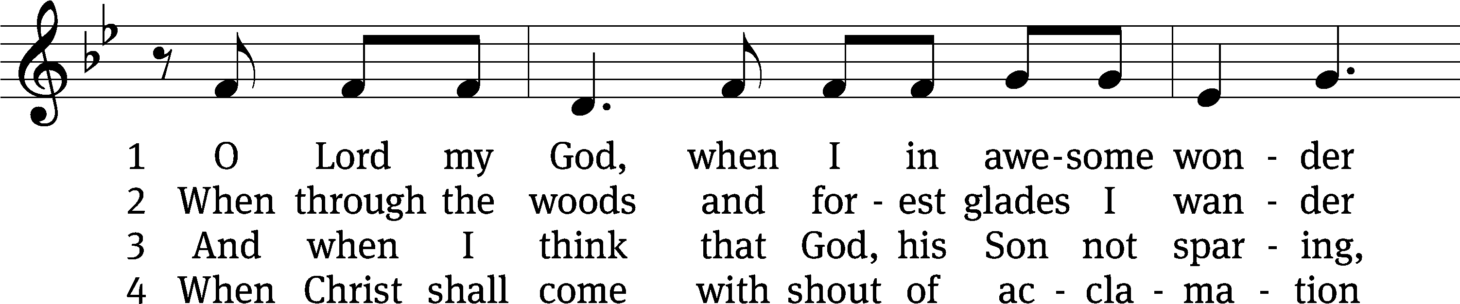
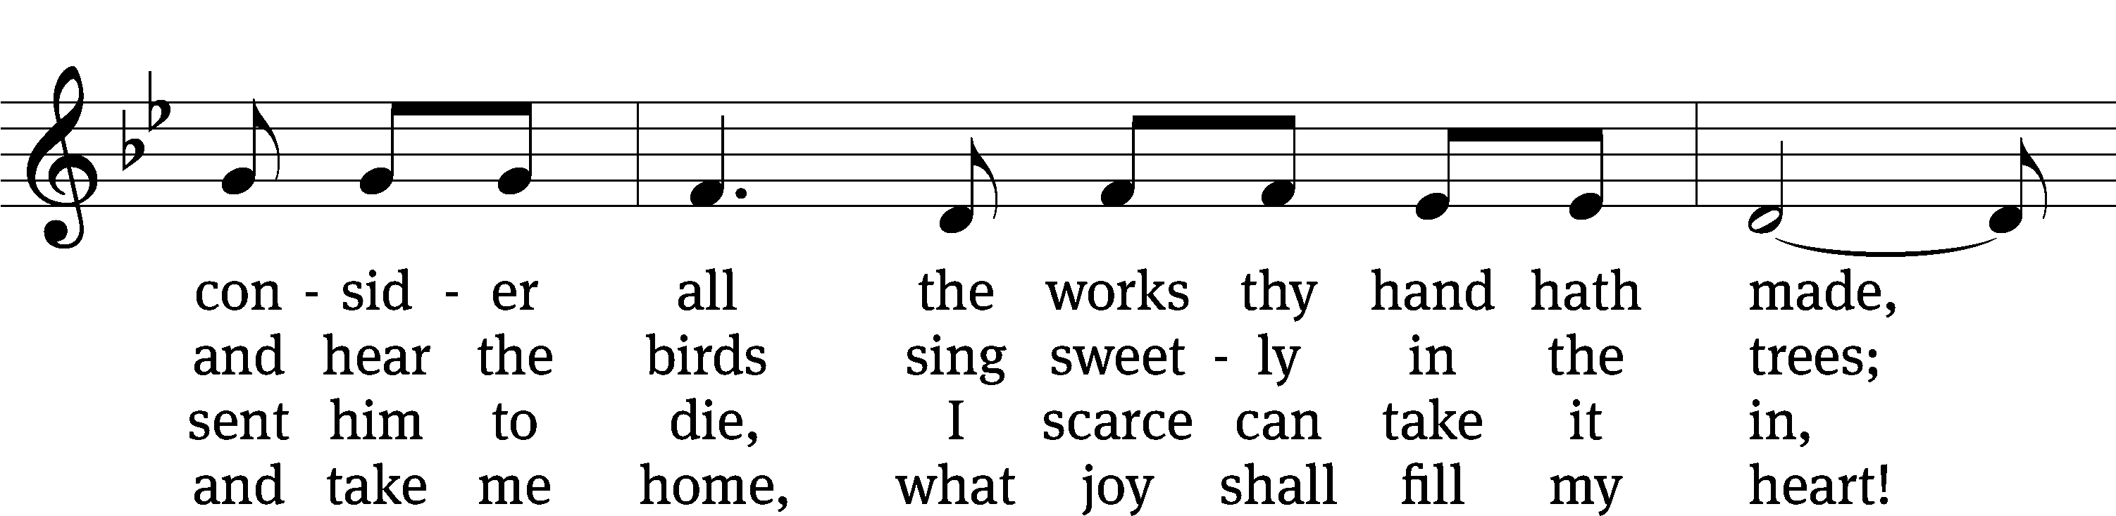
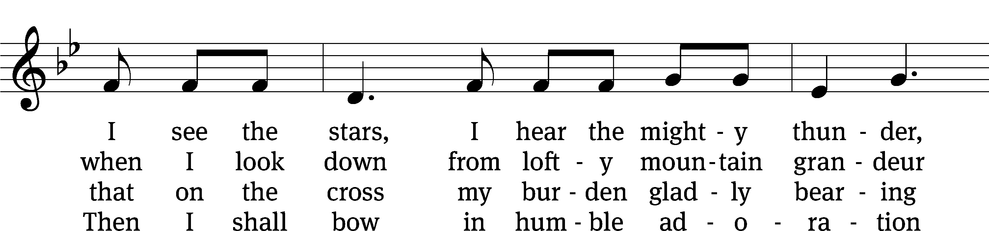
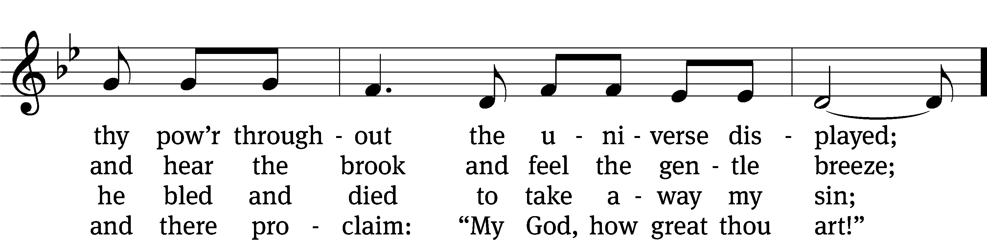
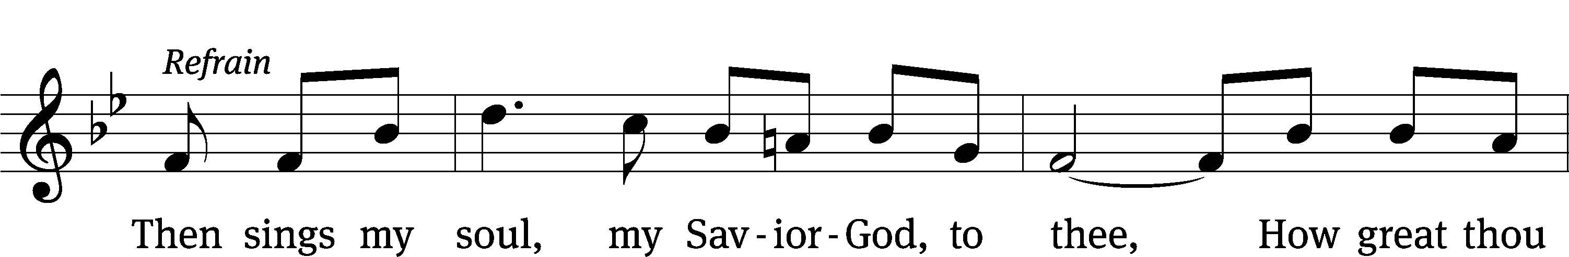
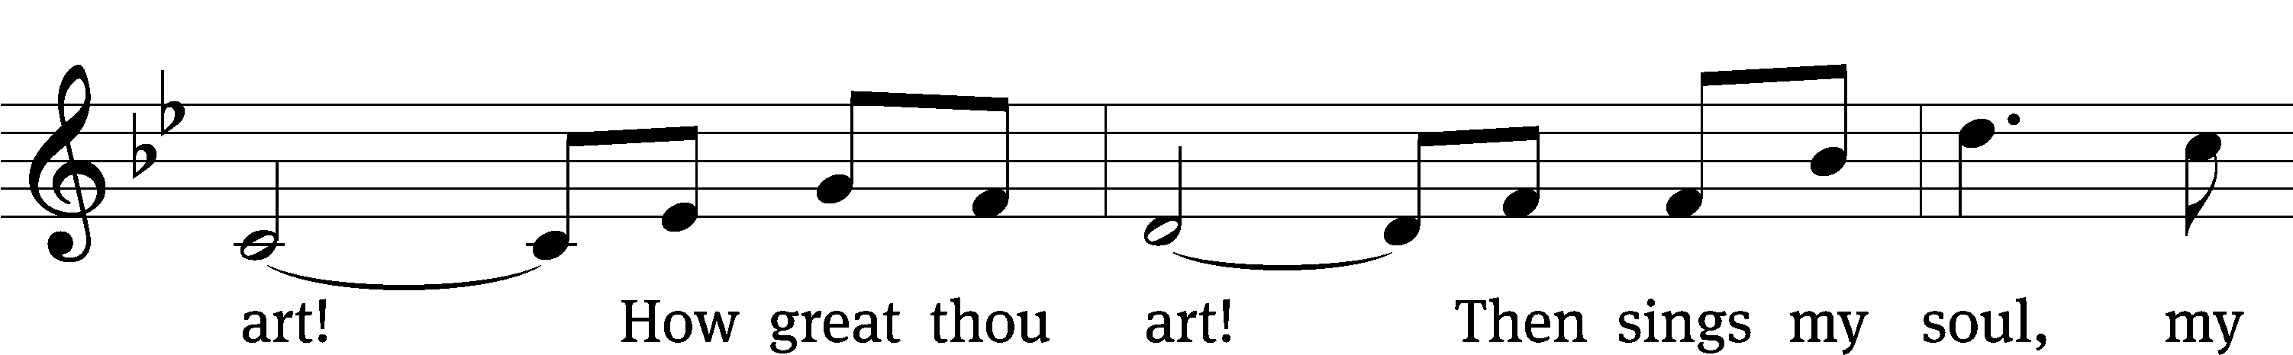
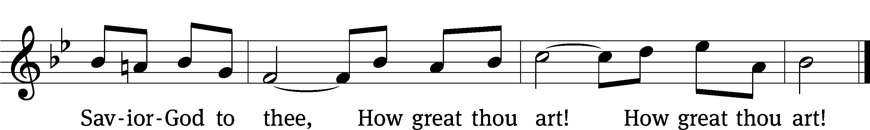
Text: Stuart W. K. Hine, 1899–1989
Tune: Swedish; setting: Stuart W. K. Hine, 1899–1989, alt.
Text: © 1949, 1953 The Stuart Hine Trust, admin. Hope Publishing Co. Used by permission: OneLicense no. 727703
Tune: © 1949, 1953 The Stuart Hine Trust, admin. CapitolCMGPublishing,com. Used by permission: OneLicense no. 727703

PLEASE STAND, IF YOU ARE ABLE

CLOSING PRAYER
M: Almighty God, we thank you for teaching us the things you want us to believe and do. Help us by your Holy Spirit to keep your Word in pure hearts that we may be strengthened in faith, guided in holiness, and comforted in life and in death, through Jesus Christ, our Lord, who lives and reigns with you and the Holy Spirit, one God, now and forever.

M: Brothers and sisters, go in peace. Live in harmony with one another. Serve the Lord with gladness.
The Lord bless you and keep you.
The Lord make his face shine on you and be gracious to you.
The Lord look on you with favor and (+) give you peace.

PLEASE BE SEATED

604 When All Your Mercies, O My God CW 604
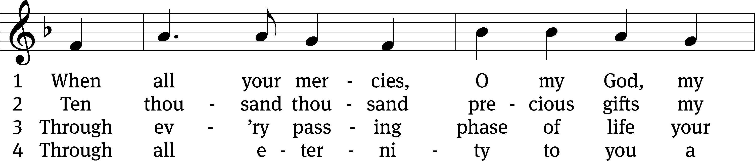
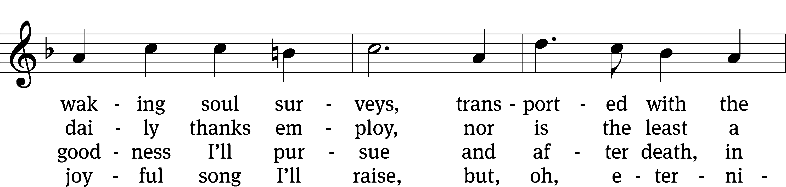
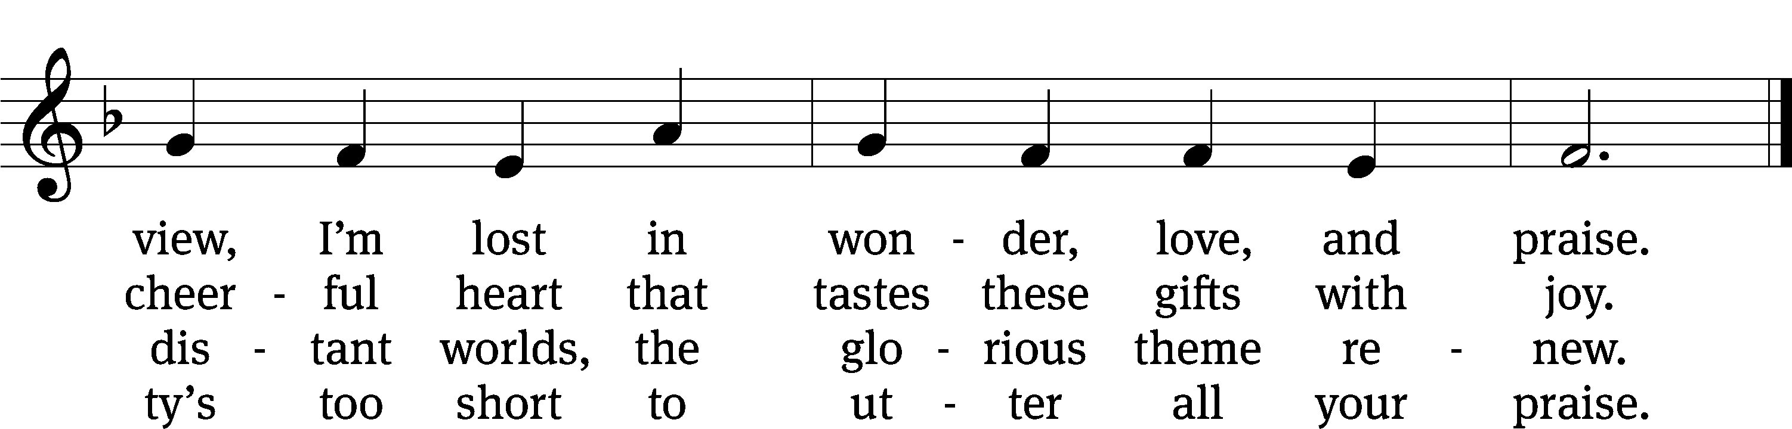
Text: Joseph Addison, 1672–1719, abr., alt.
Tune: attr. George Kirbye, c. 1560–1634; Este’s Psalmes, London, 1592
Text and tune: Public domain

Serving In Worship
Officiant Pastor Doug Hartley
Organist Sarah Hanke
Deacons (Thursday) Steve Hoeft and Jim Tice
(Sunday) Jeff Neuburger and Dave Stevenson
Ushers (Thursday) Dale Finkbeiner and Mark Finkbeiner
(Sunday) Ed Sala and Al Whitley
Altar Guild Esther Gross and Diane Stevenson
Videographer Jake Vershum

Copyright information
Service of the Word: Christian Worship. © 1993 Northwestern Publishing House. All rights reserved.
Reprinted with permission under ONE LICENSE #A-727703 and CCLI #1151741/CSPL126093

Words and Music: All rights reserved. Reprinted with permission under ONE LICENSE #A-727703 and
CCLI #1151741/CSPL126093

tlcsaline.church

