the SIXTH sunday
AFTER PENTECOST

TRINITY EVANGELICAL LUTHERAN CHURCH | Saline, Michigan
WELCOME TO WORSHIP July 14/17, 2022

Thank you for joining us in God’s house today! We cordially ask that our guests sign one of the guestbooks located at either the front or back entryways.

THANK OFFERING: Members of Trinity give their offering as an expression of love and thankfulness to the Lord and to help support the Lord’s work in our community and around the world. Visitors need not feel obligated to participate in this offering which supports our ministry.

Restrooms are located at the back of the upper level (the annex), and in the basement (down the back stairs of the sanctuary or annex). Handicap access is available, please ask an usher for assistance.

celebration of holy communion:
In His Word, God makes it clear that the Lord’s Supper is to be shared by people of a common proclamation of faith (1 Corinthians 11:26; 1 Corinthians 10:16-17). Without judging anyone’s hearts, we invite those who share in our confession by their membership in our congregation or another congregation of the Wisconsin Evangelical Lutheran Synod (WELS) or the Evangelical Lutheran Synod (ELS) and who are properly prepared (1 Corinthians 11;27-29) to receive the Sacrament. Page 295 in the front of Christian Worship provides a guide for preparation.

Guests, we would love to have you join us in communion fellowship in the future, and for that to be possible, we ask that you speak with one of the pastors so that we may speak with you on how that would be possible. We thank you for respecting the way we celebrate the Lord’s Supper in our congregations.

SERVICE OF WORD AND SACRAMENT

919 Blessed Jesus, at Your Word CW 919
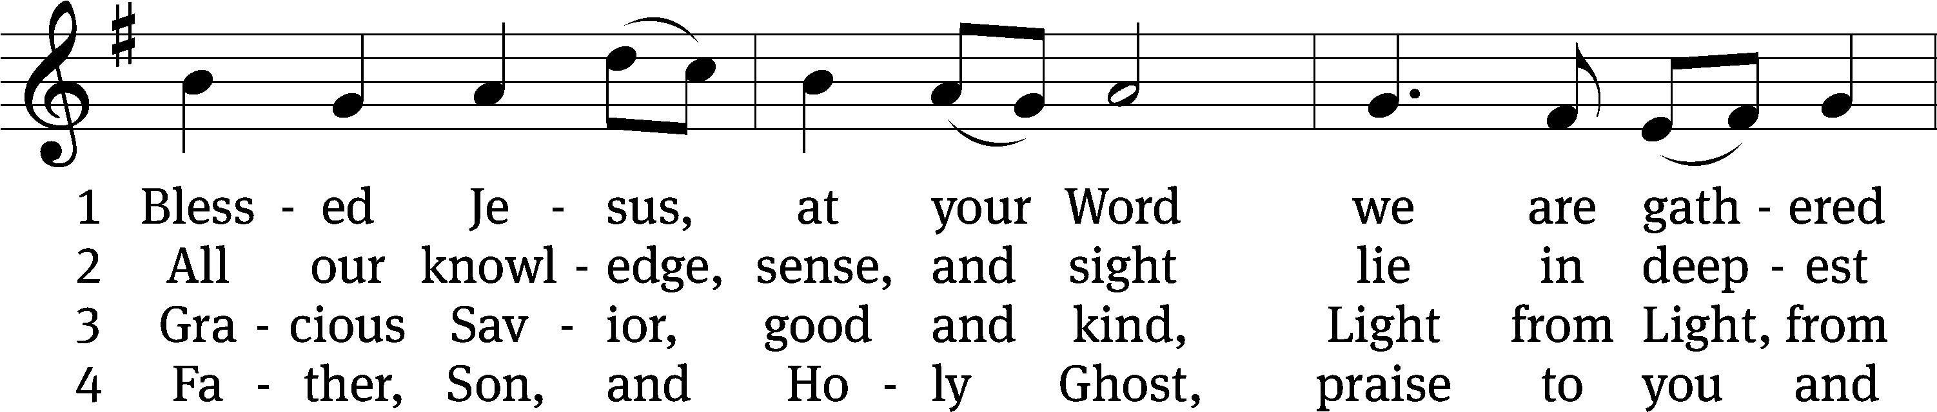
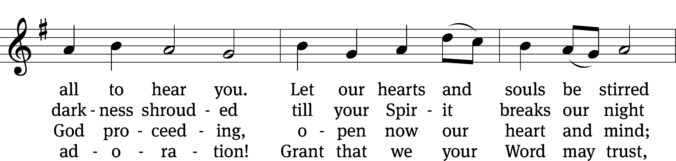
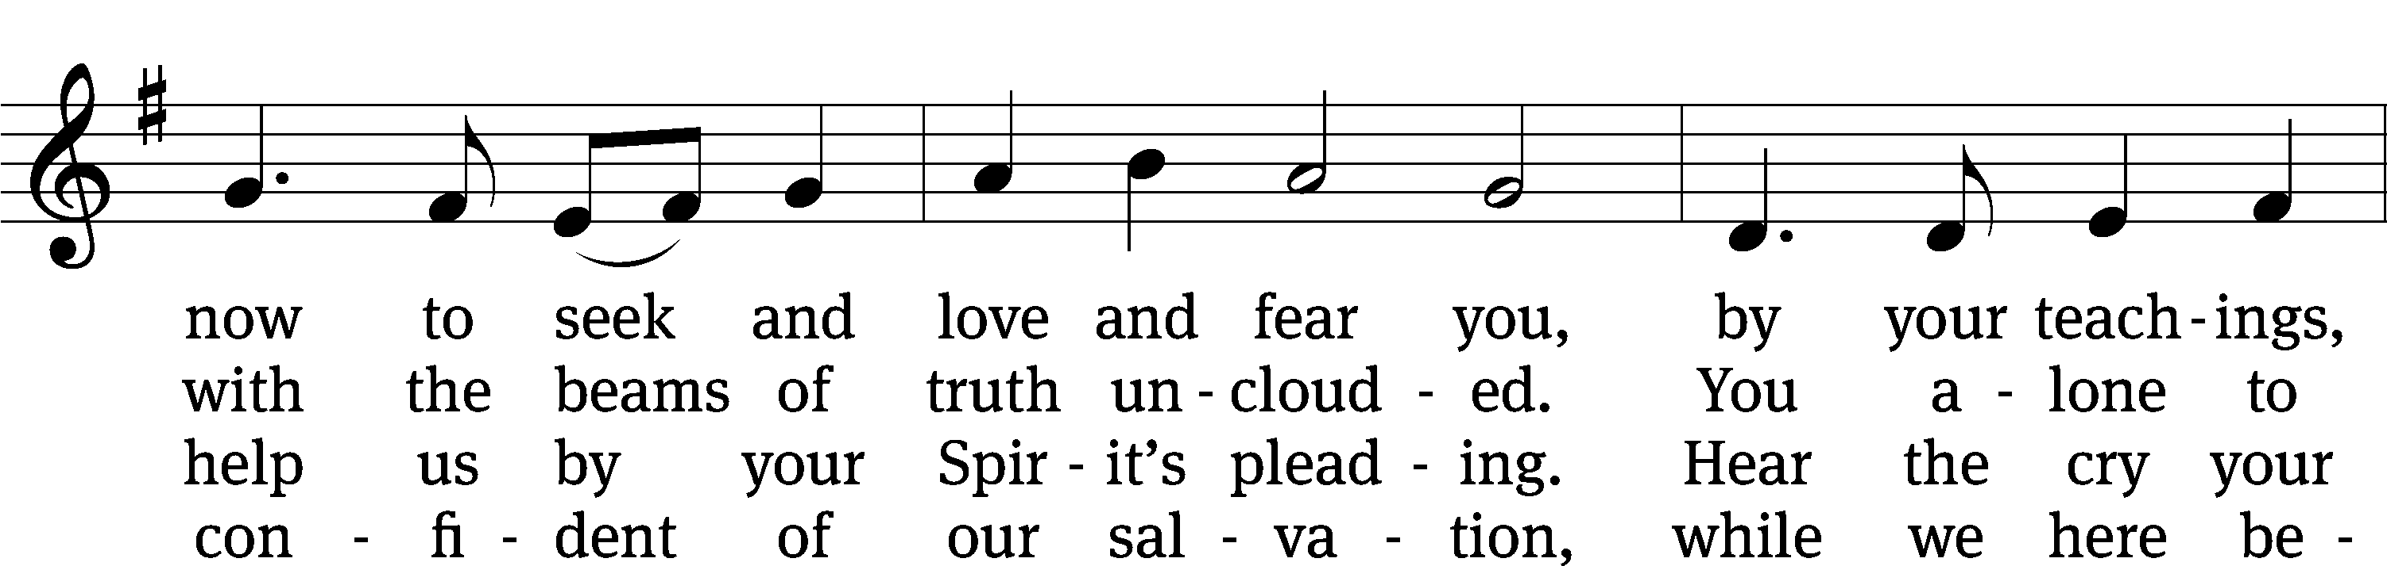
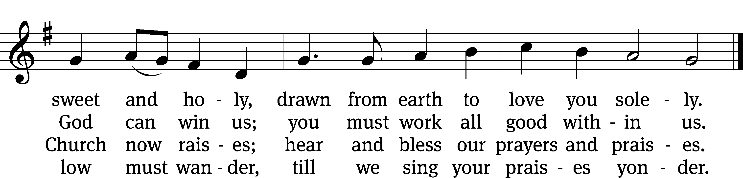
Text (sts. 1–3): tr. Catherine Winkworth, 1827–1878, alt.; (sts. 1–3): Tobias Clausnitzer, 1619–1684; (st. 4): tr. unknown, alt.; (st. 4): Geistreiches Gesang-Büchlein, Berlin, 1707
Tune: Johann R. Ahle, 1625–1673, alt.
Text and tune: Public domain

PLEASE STAND, IF YOU ARE ABLE

invocation

M: The grace of our Lord (+) Jesus Christ and the love of God and the fellowship of the Holy Spirit be with you.
C: And also with you.
CONFESSION OF SINS
M: God invites us to come into his presence and worship him with humble and penitent hearts. Therefore, let us acknowledge our sinfulness and ask him to forgive us.
C: Holy and merciful Father, I confess that I am by nature sinful, and that I have disobeyed you in my thoughts, words, and actions. I have done what is evil and failed to do what is good. For this I deserve your punishment both now and in eternity. But I am truly sorry for my sins, and trusting in my Savior Jesus Christ, I pray: Lord, have mercy on me, a sinner.
M: God, our heavenly Father, has been merciful to us and has given his only Son to be the atoning sacrifice for our sins. Therefore, as a called servant of Christ and by his authority, I forgive you all your sins in the name of the Father and of the Son (+) and of the Holy Spirit.
C: Amen.

PRAYER AND PRAISE

LORD, HAVE MERCY
Kyrie
M: For all that we need in life and for the wisdom to use all your gifts with gratitude and joy, hear our prayer, O Lord.

M: For the steadfast assurance that nothing can separate us from your love and for the courage to stand firm against the assaults of Satan and every evil, hear our prayer, O Christ.

M: For the well-being of your holy Church in all the world and for those who offer here their worship and praise, hear our prayer, O Lord.

M: Merciful God, maker and preserver of life, uphold us by your power and keep us in your tender care:

M: The works of the Lord are great and glorious; his name is worthy of praise.

Prayer of the day

M: Let us pray.
The minister says the Prayer of the Day.

PLEASE BE SEATED

The Word

first lesson gENESIS 18:1-14
The Lord appeared to Abraham by the oaks of Mamre, as he was sitting by the door to his tent during the heat of the day. ² Abraham looked up, and he saw three men standing in front of him. When he saw them, he ran from the tent door to meet them, and he bowed down to the ground. ³ He said, “My lord, if I have now found favor in your sight, please do not pass your servant by. ⁴ Now let me get a little water so that all of you can wash your feet and rest under the tree. ⁵ Let me get some bread so that you can refresh yourselves. After that you may go your way. That is why you have come to your servant.”
They said, “Yes, do as you have said.”
⁶ Abraham hurried into the tent to Sarah and said, “Quickly prepare twenty quarts of fine flour, knead it, and make some loaves of bread.” ⁷ Abraham ran to the herd, brought a good, tender calf, and gave it to the servant. He hurried to prepare it. ⁸ He took cheese curds, milk, and the calf that he had prepared and set it before them. He stood beside them under the tree while they ate.
⁹ They asked him, “Where is Sarah, your wife?”
He said, “She is over there in the tent.”
¹⁰ One of the men said, “I will certainly return to you when this season comes around next year. Then Sarah your wife will have a son.”
Sarah was listening to this from the tent door, which was behind him. ¹¹ Now Abraham and Sarah were old, well into old age. Sarah was past the age for childbearing. ¹² Sarah laughed to herself, saying, “After I am worn out, will I have pleasure, since my lord is also old?”
¹³ The Lord said to Abraham, “Why did Sarah laugh and say, ‘Will I really give birth to a child though I am old?’ ¹⁴ Is anything impossible for the Lord? At the set time next year I will return to you, and Sarah will have a son.”
Psalm 119H How Shall the Young Secure Their Hearts Psalm 119H
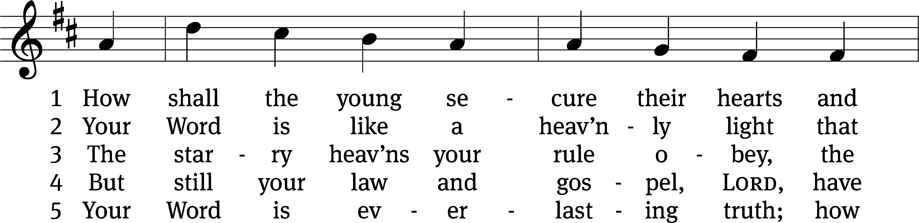
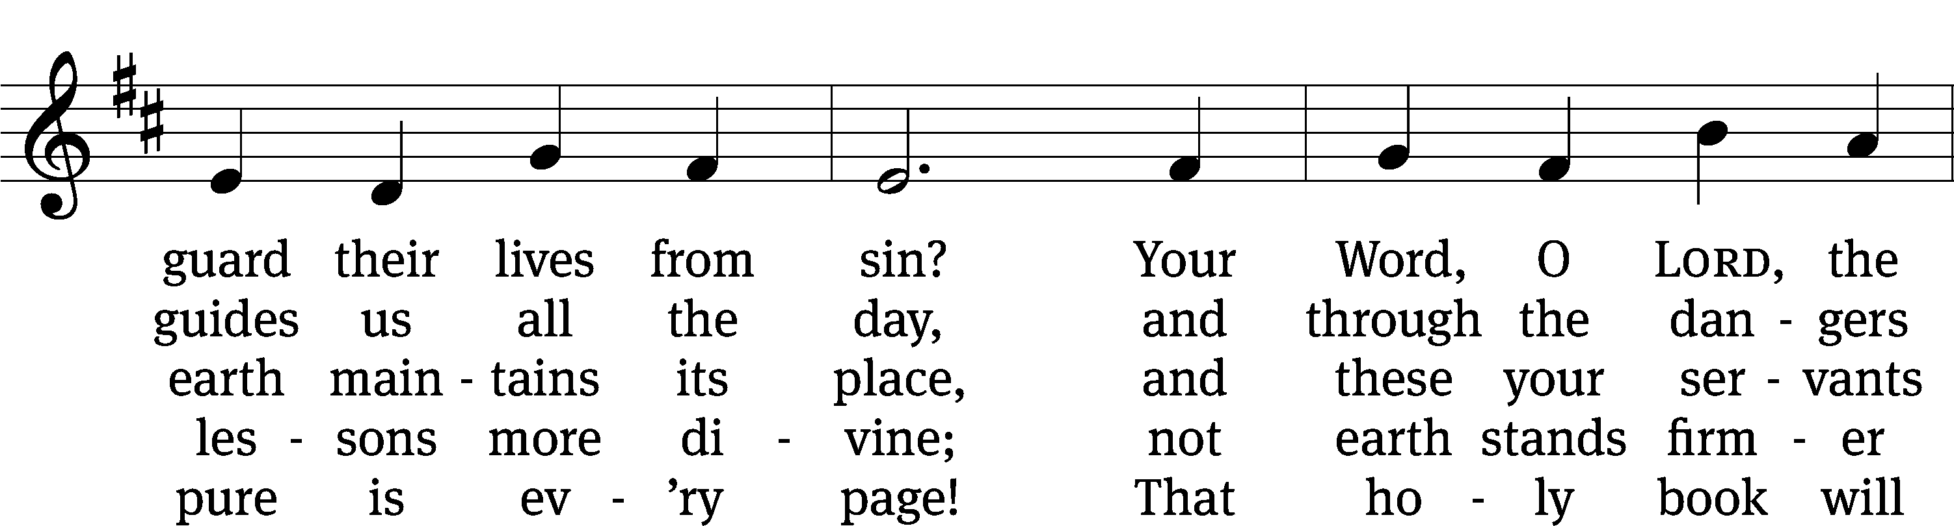
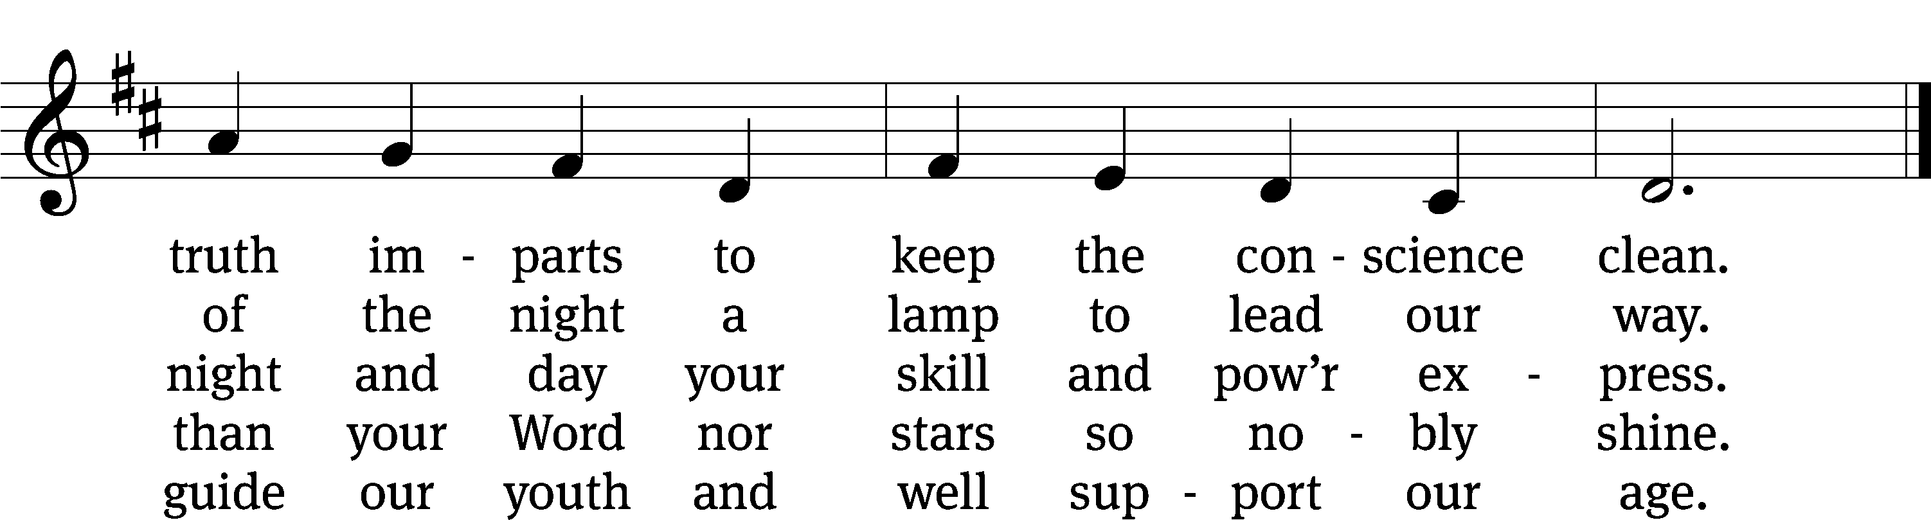
Text: Isaac Watts, abr.
Tune: Alexander R. Reinagle
Text and tune: Public domain

second lesson Colossians 1:1-14
Paul, an apostle of Christ Jesus by the will of God, and Timothy our brother,
² To the holy and faithful brothers in Christ at Colossae:
Grace to you and peace from God our Father.
³ We always thank God, the Father of our Lord Jesus Christ, when we pray for you, ⁴ because we have heard of your faith in Christ Jesus and the love that you have for all the saints ⁵ because of the hope that is stored up for you in heaven. You have already heard about this in the word of truth, the gospel ⁶ that is present with you now. The gospel is bearing fruit and growing in the entire world, just as it also has been doing among you from the day you heard it and came to know the grace of God in truth. ⁷ You learned this from Epaphras, our dear fellow servant, who is a faithful minister of Christ on your behalf. ⁸ He is the one who told us about your love in the Spirit.
⁹ For this reason, from the day we heard about your love, we also have not stopped praying for you. We keep asking that you would be filled with the knowledge of his will in all wisdom and spiritual understanding, ¹⁰ so that you might live in a way that is worthy of the Lord. Our goal is that you please him by bearing fruit in every kind of good work and by growing in the knowledge of God, ¹¹ as you are being strengthened with all power because of his glorious might working in you. Then you will have complete endurance and patience, joyfully ¹² giving thanks to the Father, who qualified us to share in the inheritance of the saints in the kingdom of light.
¹³ The Father rescued us from the domain of darkness and transferred us into the kingdom of the Son he loves, ¹⁴ in whom we have redemption, the forgiveness of sins.

PLEASE STAND, IF YOU ARE ABLE

VERSE OF THE DAY

GOSPEL LUKE 10:38-42
³⁸ As they went on their way, Jesus came into a village, and a woman named Martha welcomed him into her home. ³⁹ She had a sister named Mary, who was sitting at the Lord’s feet and was listening to his word. ⁴⁰ But Martha was distracted with all her serving. She came over and said, “Lord, don’t you care that my sister has left me to serve alone? Tell her to help me.”
⁴¹ The Lord answered and told her, “Martha, Martha, you are worried and upset about many things, ⁴² but one thing is needed. In fact, Mary has chosen that better part, which will not be taken away from her.”
M: This is the Gospel of the Lord.

PLEASE BE SEATED
645 One Thing’s Needful CW 645
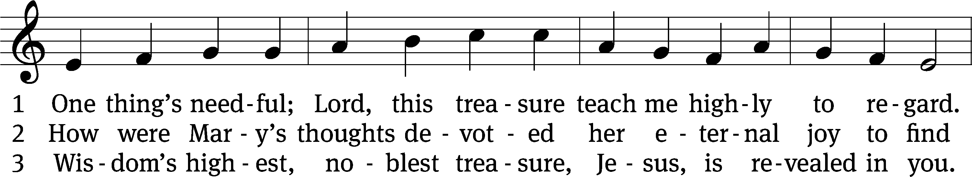
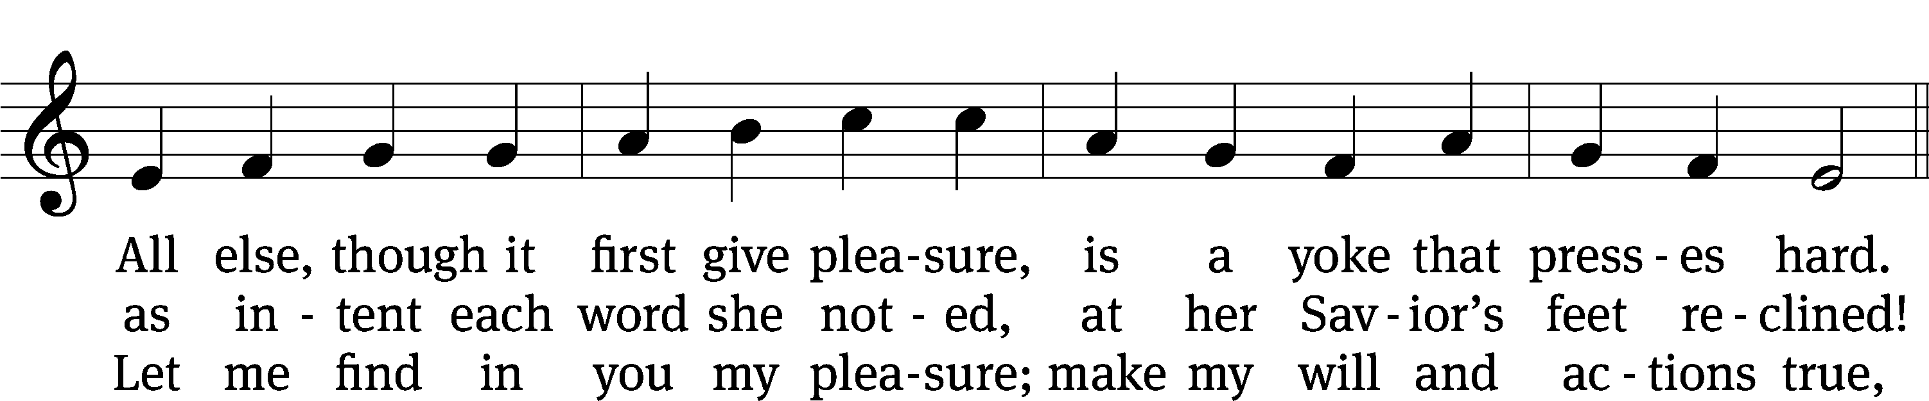
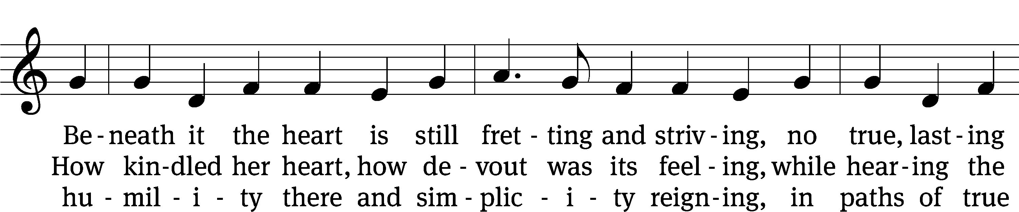
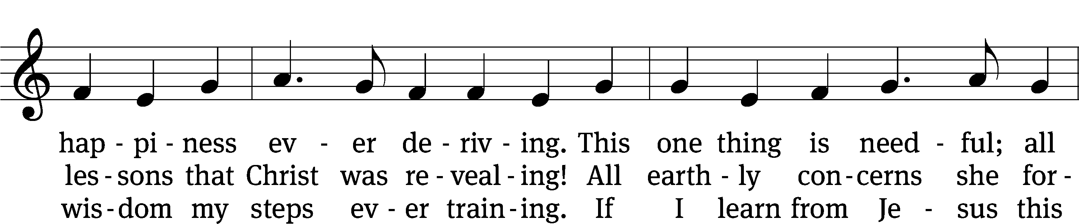
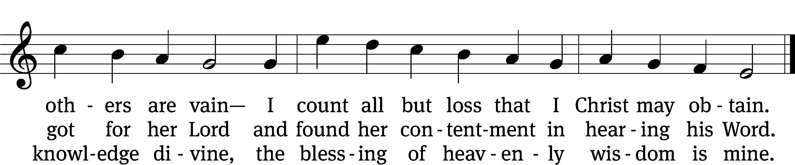
Text: tr. Frances E. Cox, 1812–1897, alt.; Johann H. Schröder, 1667–1699, abr., adapt.
Tune: Friedrich L. C. Layriz, 1808–1859
Text and tune: Public domain

Sermon Luke 10:38-42
“Good, Better, Best”

please stand, if you are able

nicene creed
We believe in one God, the Father, the Almighty, maker of heaven and earth, of all that is, seen and unseen.
We believe in one Lord, Jesus Christ, the only Son of God, eternally begotten of the Father, God from God, Light from Light, true God from true God, begotten, not made, of one being with the Father. Through him all things were made. For us and for our salvation, he came down from heaven, was incarnate of the Holy Spirit and the virgin Mary, and became truly human. For our sake he was crucified under Pontius Pilate. He suffered death and was buried. On the third day he rose again in accordance with the Scriptures. He ascended into heaven and is seated at the right hand of the Father. He will come again in glory to judge the living and the dead, and his kingdom will have no end.
We believe in the Holy Spirit, the Lord, the giver of life, who proceeds from the Father and the Son, who in unity with the Father and the Son is worshiped and glorified, who has spoken through the prophets. We believe in one holy Christian and apostolic Church. We acknowledge one baptism for the forgiveness of sins. We look for the resurrection of the dead and the life of the world to come. Amen.

PLEASE BE SEATED

offertory

PLEASE STAND, IF YOU ARE ABLE

prayer of the church

lord’s prayer

C: Our Father, who art in heaven,
hallowed be thy name,
thy kingdom come,
thy will be done
on earth as it is in heaven.
Give us this day our daily bread;
and forgive us our trespasses,
as we forgive those
who trespass against us;
and lead us not into temptation,
but deliver us from evil.
For thine is the kingdom
and the power and the glory
forever and ever. Amen.

The Sacrament of Holy Communion
Trinity Lutheran Church follows the historic Christian practice of close communion. We ask that only members of Trinity or one of our sister congregations partake of the sacrament. If you are not a member, please see the note about Holy Communion in the beginning of the Worship Folder.

M: The Lord be with you.

M: Lift up your hearts.

M: Let us give thanks to the Lord our God.

M: Praise to the God and Father of our Lord Jesus Christ! In love he has blessed us with every spiritual blessing. He sends the Holy Spirit to testify that we are his children and to strengthen us when we are weak. Now have come the salvation and the power and the kingdom of our God and the authority of his Christ. To him who sits on the throne and to the Lamb be praise and thanks and honor and glory for ever and ever:

Holy, Holy, Holy

Words of institution
M: Our Lord Jesus Christ, on the night he was betrayed, took bread; and when he had given thanks, he broke it and gave it to his disciples, saying: “Take and eat. This is my ✙ body, which is given for you. Do this in remembrance of me.”
Then he took the cup, gave thanks, and gave it to them, saying, “Drink from it all of you; this is my ✙ blood of the new covenant, which is poured out for you for the forgiveness of sins. Do this, whenever you drink it, in remembrance of me.”
The peace of the Lord be with you always.

O CHRIST, LAMB OF GOD

PLEASE BE SEATED
DISTRIBUTION HYMNS
671 Your Body, Given for Me, O Savior CW 671
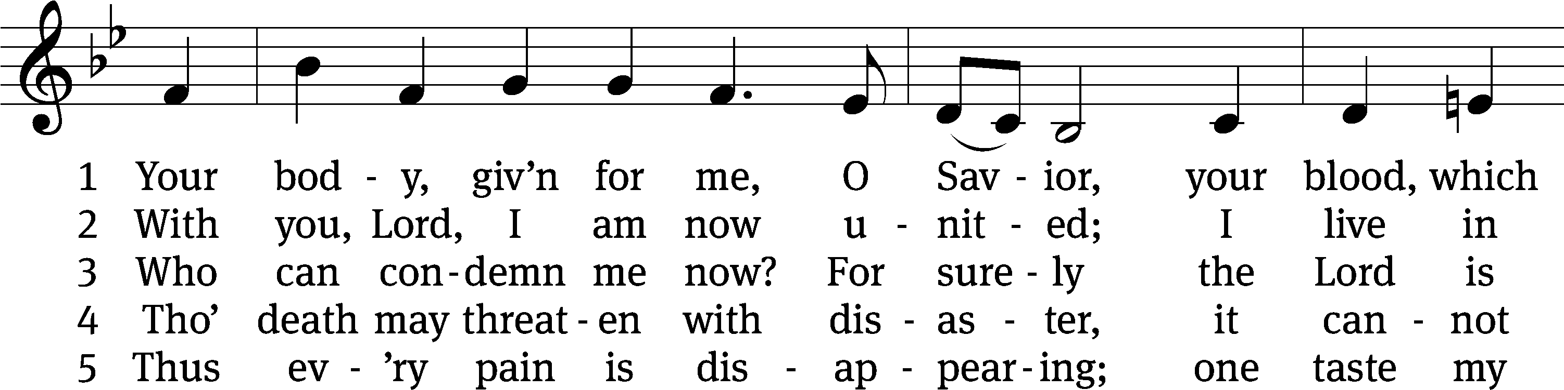
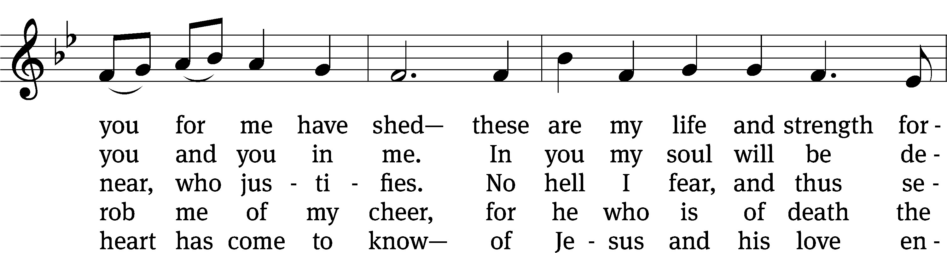
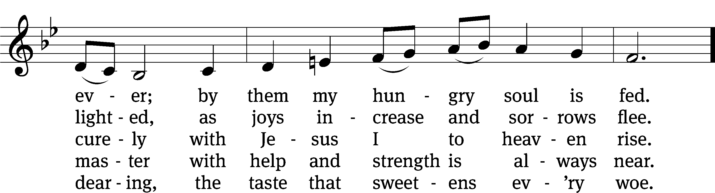
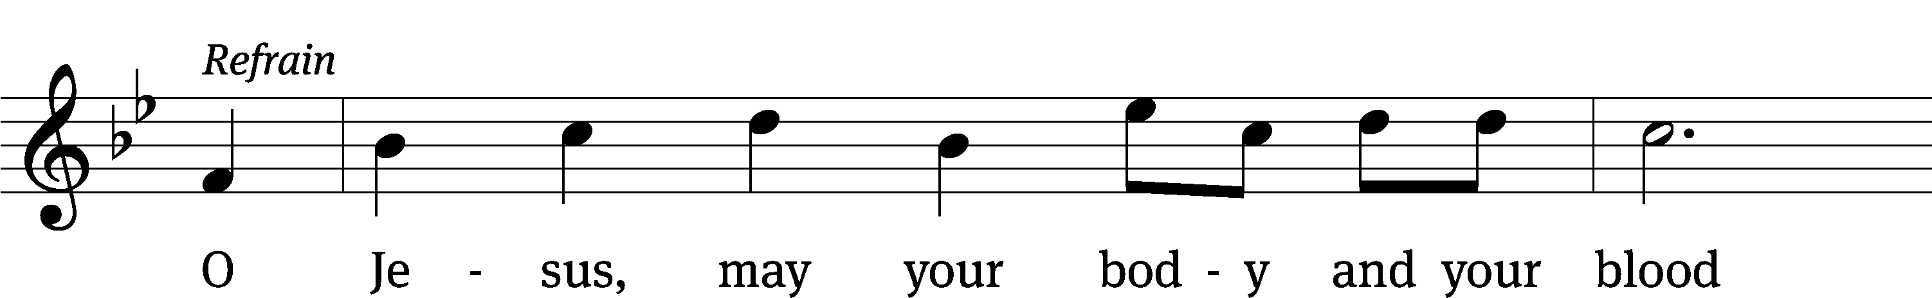
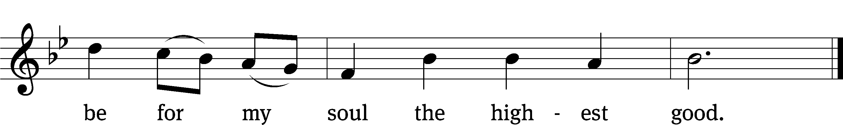
Text: Friedrich C. Heyder, 1677–1754, abr.; (sts. 1, Ref, 2–4): tr. The Lutheran Hymnal, 1941, alt.; (st. 5): tr. Matthew Carver, b. 1977, alt.
Tune: Musicalisch Hand-Buch der Geistlichen Melodien, Hamburg, 1690, alt
Text (sts. 1, Ref, 2–4): © 1941 Concordia Publishing House; (st. 5): © 2012 Matthew Carver. Used by permission: OneLicense no. 727703
Tune: Public domain

661 Draw Near and Take the Body of the Lord CW 661
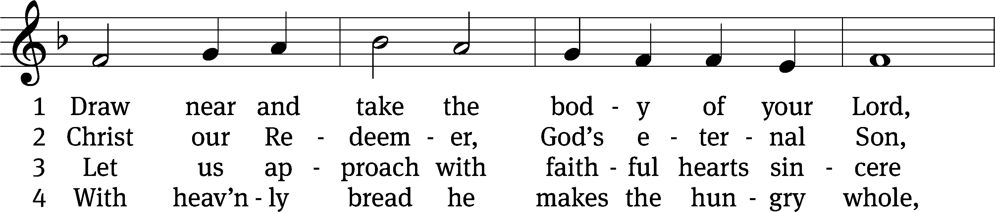
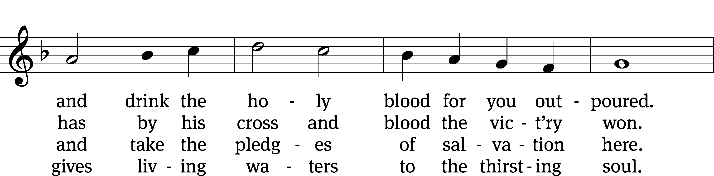
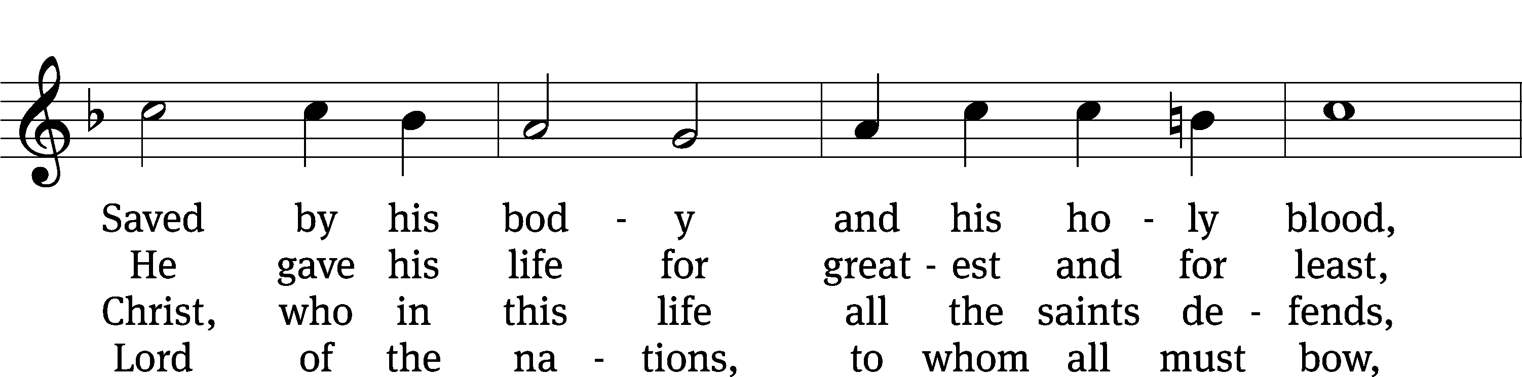
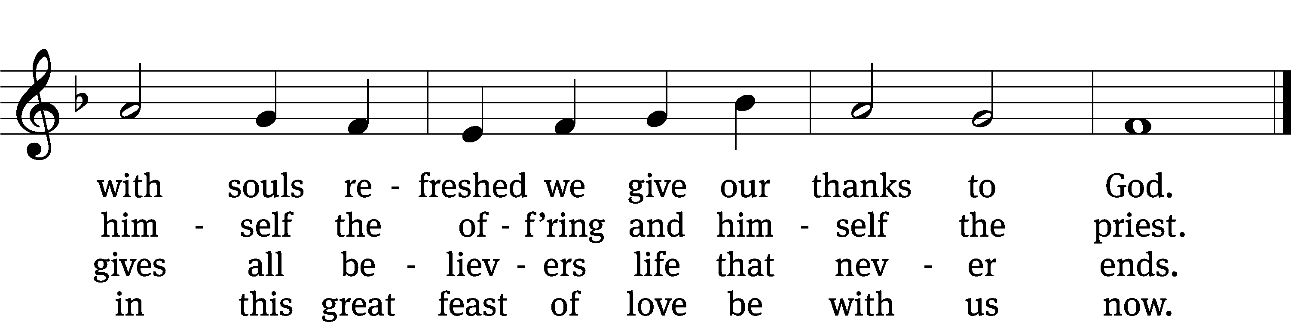
Text: tr. John Mason Neale, 1818–1866, alt.; Latin, 7th cent., abr.
Tune: Trente quatre Pseaumes de David, Geneva, 1551, ed. Louis Bourgeois
Text and tune: Public domain

PLEASE STAND, IF YOU ARE ABLE

THANKSGIVING

M: Hear the prayer of your people, O Lord, that the lips which have praised you here may glorify you in the world, that the eyes which have seen the coming of your Son may long for his coming again, and that all who have received in his true body and blood the pledge of your forgiveness may be restored to live a new and holy life, through Jesus Christ, our Lord, who lives and reigns with you and the Holy Spirit, one God, now and forever.

M: Brothers and sisters, go in peace. Live in harmony with one another.
Serve the Lord with gladness.

The Lord bless you and keep you.
The Lord make his face shine on you and be gracious to you.
The Lord look on you with favor and (+) give you peace.

PLEASE BE SEATED

543 O Jesus, King Most Wonderful CW 543
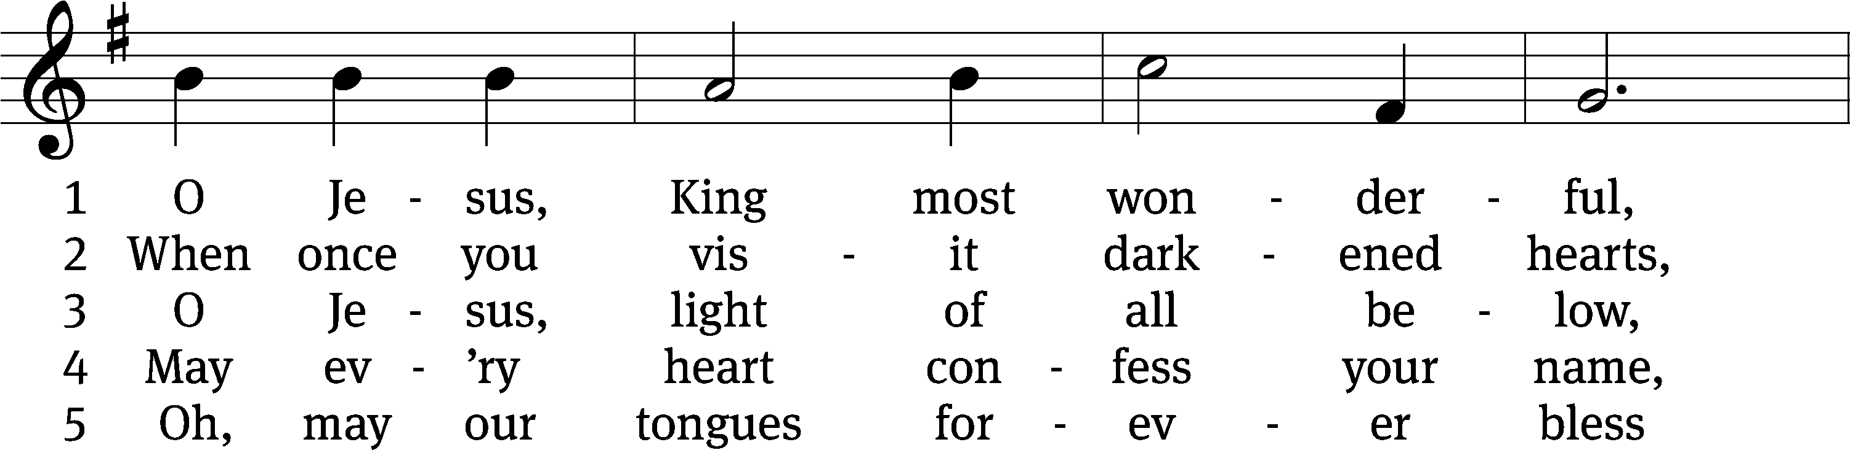
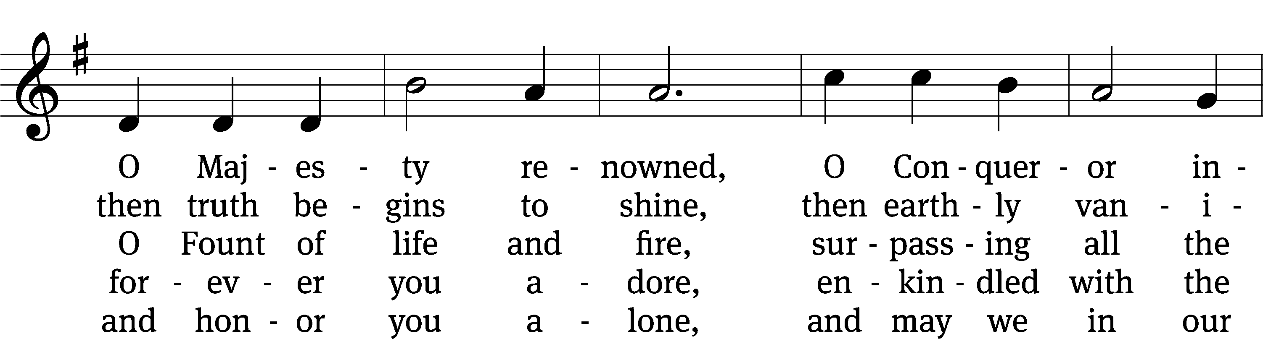
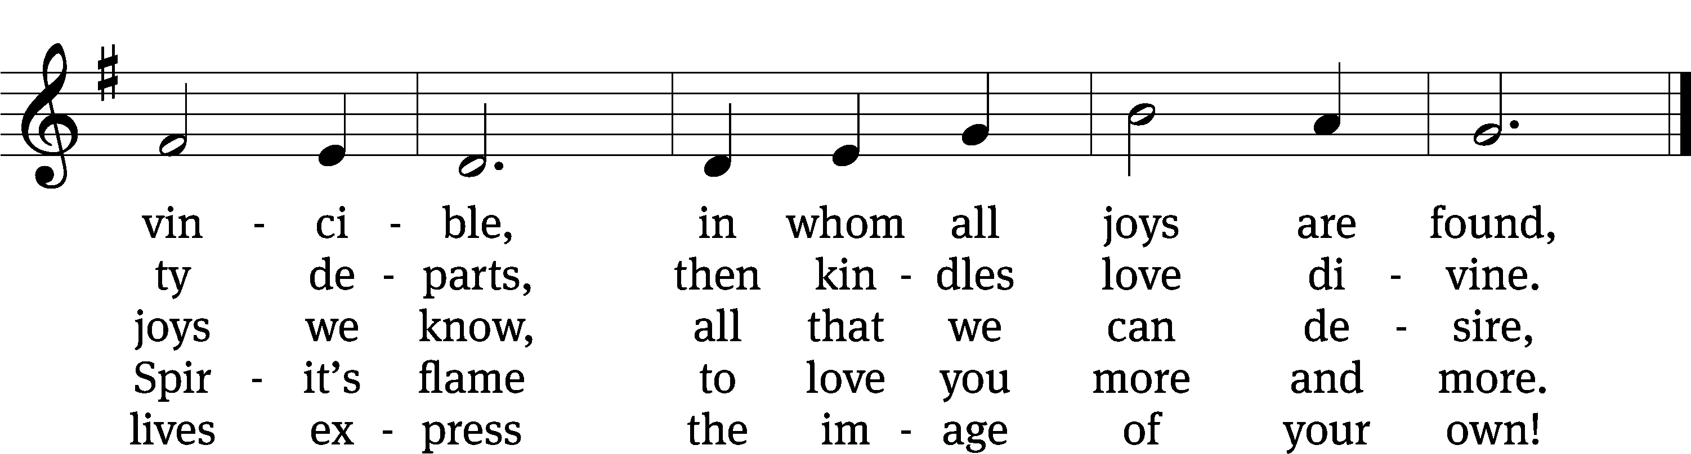
Text: tr. Edward Caswall, 1814–1878, alt.; attr. Bernard of Clairvaux, 1091–1153, abr.
Tune: John B. Dykes, 1823–1876
Text and tune: Public domain

Serving In Worship

Officiant Pastor Natsis
Organist Marcia Marion Ackling
Deacons (Thursday) Steve Hoeft and Jim Tice
(Sunday) Jeff Neuburger and Dave Stevenson
Ushers (Thursday) Dale Finkbeiner and Mark Finkbeiner
(Sunday) Ed Sala and Al Whitley
Altar Guild Esther Gross and Diane Stevenson
Videographer Rick Schneider

Copyright information
Service of Word and Sacrament: Christian Worship. © 1993 Northwestern Publishing House. All rights reserved. Reprinted under ONE LICENSE #A-727703 and CCLI #1151741/ CSPL126093
Words and Music: All rights reserved. Reprinted/Podcast/Streamed with permission under ONE LICENSE #A-727703 and CCLI #1151741/CSPL126093

